**Department of the Army TRADOC Memorandum 58-1**

**Headquarters, United States Army**

**Training and Doctrine Command**

**Fort Eustis, Virginia 23604-5700**

**18 November 2016**

**Motor Transportation-General**

**E-ZPass® TRANSPONDERS MANAGEMENT**

DAVID G. PERKINS

General, U.S. Army

Commanding



RICHARD A. DAVIS

Senior Executive

Deputy Chief of Staff, G-6

**History.** This publication is a new U.S. Army Training and Doctrine Command (TRADOC) memorandum.

**Summary.** This memorandum establishes policy and provides procedures for the management and use of E-ZPass® transponders for Headquarters (HQ) TRADOC organizations located at Fort Eustis, Virginia and those geographically separate.

**Applicability.** This memorandum applies to all TRADOC personnel, including military personnel, Government civilian employees, and other non-Federal individuals using the E-ZPass® transponders in direct support of HQ TRADOC missions. Paragraph 2-7b of this memorandum prescribes punitive actions and violations that may subject offenders to judicial or non-judicial punishment under Article 92 of the Uniform Code of Military Justice or appropriate disciplinary action under regulations governing civilian employees.

**Proponent and exception authority.** The proponent of this memorandum is HQ TRADOC, Deputy Chief of Staff G-1/4. The proponent has the authority to approve exceptions or waivers to this memorandum that are consistent with controlling laws and regulations. Activities may request a waiver to this regulation by providing justification that includes a full analysis of the issue and a formal review by the TRADOC Office of the Staff Judge Advocate (OSJA). All waiver requests will be endorsed by the senior leader of the requesting activity and forwarded to the policy proponent.

**Supplementation.** Supplementation of this memorandum is prohibited unless specifically approved by HQ TRADOC, Deputy Chief of Staff, G-1/4 (ATBO-HS), 661 Sheppard Place, Fort Eustis, VA 23604-5759.

**Suggested improvements.** Users are invited to send comments and suggested improvements on Department of the Army Form 2028 (Recommended Changes to Publications and Blank Forms) directly to HQ TRADOC, Deputy Chief of Staff, G-1/4 (ATBO-HS), 661 Sheppard Place, Fort Eustis, VA 23604-5759.

**Distribution.** This publication is available in electronic media only and is published on the TRADOC Homepage at <http://www.tradoc.army.mil/tpubs/>.

**Summary of Change**

TRADOC Memorandum 58-1

E-ZPass® Transponders Management

This is new publication, dated 18 November 2016-

o Prescribes policies and procedures for the management and use of the E-ZPass® transponders at Headquarters, United States Army Training and Doctrine Command organizations.

o This memorandum applies to all United States Army Training and Doctrine Command personnel, including military personnel, government Civilian employees, and other non-Federal individuals using the E-ZPass® transponders in direct support of Headquarters, United States Army Training and Doctrine Command mission.

o Addresses administrative and disciplinary actions (para 2-7b).

o Prescribes the use of United States Army Training and Doctrine Command Form 1022, E-Z Pass® Tracking Log.

**Contents**

**Page**

Chapter 1 Introduction 5

1-1. Purpose 5

1-2. References 5

1-3. Explanation of abbreviations and terms 5

1-4. Responsibilities 5

1-5. Recordkeeping requirements 5

Chapter 2 Responsibilities 5

2-1. Commander, U.S. Army Training and Doctrine Command 5

2-2. Deputy Chief of Staff, G-1/4 5

2-3. Deputy Chief of Staff, G-8 5

2-4. Commanders, deputy chiefs of staff, and directors 6

2-5. TRADOC Fleet Manager 6

2-6. Transponder account managers 8

2-7. Vehicle operators 9

Chapter 3 Procedures 10

3-1. Acquiring E-ZPass® transponders 10

3-2. Control and use of E-ZPass® transponders 10

3-3. Verifying transaction account statements 11

Appendix A References 11

Appendix B TRADOC Form 1022, E-ZPass® Transponder Tracking Log 12

Glossary 15

List of Figures

Figure 2-1. E-ZPass® transponder 7

Figure 2-2. E-ZPass® Flex transponder 7

Figure B-1. TF 1022, E-ZPass® Transponder Tracking Log sample 13

**This page intentionally left blank**

# Chapter 1

# Introduction

## 1-1. Purpose

This memorandum prescribes policies and procedures for the management and use of the E-ZPass® transponders at Headquarters (HQ), U.S. Army Training and Doctrine Command (TRADOC) organizations.

## 1-2. References

Required and related publications and prescribed and referenced forms are listed in Appendix A.

## 1-3. Explanation of abbreviations and terms

Abbreviations and special terms used in this memorandum are explained in the glossary.

## 1-4. Responsibilities

See Chapter 2 for responsibilities.

## 1-5. Recordkeeping requirements

This memorandum requires the creation of records to document and support the business processes of the Army. Records created under the purview of this memorandum, regardless of content or format, will be kept in accordance with the retention schedules in accordance with Army Regulation 25-400-2 and The Army Records Information Management System at <https://www.arims.army.mil/>.

# Chapter 2

# Responsibilities

## 2-1. Commander, U.S. Army Training and Doctrine Command (TRADOC)

The Commander, TRADOC provides policy guidance for the effective management and control of TRADOC personnel and equipment.

## 2-2. Deputy Chief of Staff, G-1/4

The DCS, G-1/4 will—

a. Establish policy and procedures to provide oversight of the HQ TRADOC E-ZPass® Transponders Management Program.

b. Appoint the TRADOC Fleet Manager to administer and manage the HQ TRADOC

E-ZPass® Transponders Management Program.

## 2-3. Deputy Chief of Staff, G-8

The DCS, G-8 will include E-ZPass® funding requirements in the annual HQ TRADOC budget.

## 2-4. Commanders, deputy chiefs of staff, and directors

Enforcement and oversight of the actions required by this memorandum is a responsibility of commanders, DCSs, and directors at all levels. Commanders, DCSs, and directors will—

a. Ensure that Soldiers and Civilians issued an E-ZPass® transponder are properly counseled and trained on the appropriate use of the transponder. The best way to prevent transponder misuse is through proper selection of vehicle operators, training, and leadership by example. Commanders, DCSs, and directors will further monitor use of the E-ZPass® transponder to detect abuse and take appropriate corrective or disciplinary action. When misuse of E-ZPass® transponders occur, commanders, DCSs, and directors will take appropriate action. Commanders, DCSs, and directors should consult their servicing OSJA when misuse occurs.

b. Appoint a primary Transponder Account Manager (TAM) and a secondary TAM in writing for each E-ZPass® transponder assigned to their organization or directorate. The secondary TAM will serve as a backup TAM in the event the primary TAM is temporarily unable to perform his or her duties.

c. Establish procedures for the assignment and use of E-ZPass® transponders within their organization or directorate.

d. Ensure their organization’s future year E-ZPass® planning requirements (transponder quantity and projected toll fees) are accurately identified.

## 2-5. TRADOC Fleet Manager

The TRADOC Fleet Manager will—

a. Prepare and oversee a contract to acquire transponders from the applicable E- ZPass®/Toll Agency.

b. Act as the TRADOC representative to sign the E-ZPass®/Toll Agency application or agreement.

c. Ensure that each TRADOC organization identifies their future year E-ZPass® planning requirements (transponder quantity and projected toll fees). Based on this information, the TRADOC Fleet Manager will determine the number of E-ZPass® transponders and E-ZPass® Flex transponders required based on each organization’s feedback. See figure 2-1, for an

E-ZPass® transponder. See figure 2-2, for an E-ZPass® Flex transponder.

d. Download E-ZPass® monthly transaction account statements from the E-ZPass®/Toll Agency website at the end of each month. The TRADOC Fleet Manager will provide the E-ZPass® transaction account statement to each organization’s TAM within five (5) days after the end of each month to confirm the statements’ accuracy.

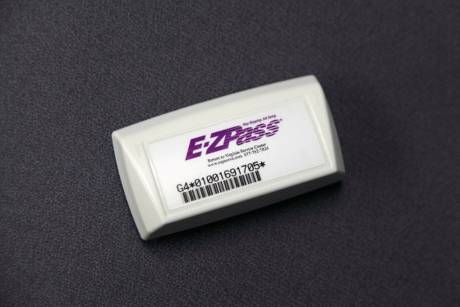

Figure 2-1. E-ZPass® transponder

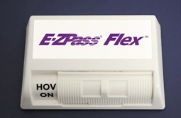

Figure 2-2. E-ZPass® Flex transponder

e. Maintain and manage life-cycle recordkeeping of all E-ZPass® records.

(1) Document receipt of transponders on [Department of Defense (DD) Form 250](http://www.dtic.mil/whs/directives/forms/eforms/dd0250.pdf), Material Inspection and Receiving Report. Maintain all DD Form 250s until the transponders are returned or need to be replaced due to wear, tear, or breakage.

(2) Maintain TRADOC Form (TF) 1022, E-ZPass® Transponder Tracking Logs for one year. See Appendix B for guidance on completing TF 1022 and a sample (figure B-1).

(3) Maintain E-ZPass® monthly transaction account statements for 6.25 years.

f. Review each E-ZPass® Tracking Log Sheet submitted by the TAMs within five (5) days after receipt.

g. Verify, certify, and sign the E-ZPass® transaction account statement after TAMs return statements. The TRADOC Fleet Manager will then forward the certified statements to G-1/4 Purchase Request Processor, G-1/4 Level 1 Approver, and G-8 Level 4 Approver for payment.

h. Provide guidance to TAMs on how to account for and manage E-ZPass® transponders. Ensure transponders are functioning properly and accounts are active.

i. Ensure that E-ZPass® transponders are assigned to vehicles based on Virginia Department of Transportation Vehicle Class Codes.

j. Update the established E-ZPass® transponder account immediately when vehicle inventory changes.

k. Issue a transponder to users that utilize the Transportation Motor Pool “U Drive It” fleet. User/Driver must notify the Fleet Manager at least 48 hours in advance that they will require a transponder for their trip to ensure the vehicle is associated with the transponder.

## 2-6. Transponder account managers (TAMs)

The TAMs will—

a. Maintain oversight of their organizational E-ZPass® transponders and account.

b. Record receipt of assigned E-ZPass® transponders on a DD Form 250 and forward the form to the TRADOC Fleet Manager.

c. Ensure positive control of all transponders, store them securely in a General Services Administration (GSA) approved safe, and use them for official use only.

d. Verify each transaction account statement is accurate, sign the statement, and return the statement to the TRADOC Fleet Manager within five (5) days of receipt. If the statement contains discrepancies, the TAM will inform the TRADOC Fleet Manager in writing.

e. Maintain, verify, and sign information on the TRADOC Form (TF) 1022, E-ZPass® Transponder Tracking Log used to record the use of assigned transponders. Submit the certified TF 1022 to TRADOC Fleet Manager within ten (10) days after the end of each month.

f. Physically inventory transponders once every four (4) months and provide a written report of the inventory results to his or her supervisor and the TRADOC Fleet Manager.

e. Ensure transponders are functioning properly, and notify the TRADOC Fleet Manager when they are not.

f. Promptly investigate toll violations and determine whether the vehicle in question was listed on transponder account and whether it was working properly; notify the operator’s supervisor if it is determined the operator is at fault.

g. Notify the TRADOC Fleet Manager of any unresolved E-ZPass® transponder toll violations.

h. Notify the TRADOC Fleet Manager to update established E-ZPass® transponder account immediately when vehicle inventory changes.

i. Ensure there is no damage or markings on the transponder. TAMs will only affix removable stickers to the transponders.

j. Ensure transponders are allocated only to support valid Government Owned/Leased Vehicles dispatches by reviewing and comparing dispatch log data against the E-ZPass® Tracking Log Sheet.

## 2-7. Vehicle operators

a. Misuse of the E-ZPass® transponders is prohibited. Misuse of a E-ZPass® transponders is defined as using the E-ZPass® transponders for other than official duties. Vehicle Operators will not misuse E-ZPass® transponders. E-ZPass® transponders will not be used for personal, family, or household purposes. Vehicle Operators will—

(1) Request an E-ZPass® transponder from his or her organization’s TAM when the vehicle operator intends to use a transponder during travel.

(2) Inspect the transponder upon receipt from the TAM and identify any damage or markings.

(3) Return the transponder to the TAM when the mission is complete.

(4) Pay tolls and submit vouchers for reimbursement, as authorized, when an E-Z Pass® transponder was not available to support the vehicle operator’s request.

(5) Use E-ZPass® transponders only while performing official Agency business in Government Owned/Leased Vehicles registered in the transponder E-ZPass® account.

(6) Ensure the transponder is mounted properly in the vehicle.

(7) Notify the TAM immediately of any indications the transponder is not working properly. An indication of malfunction may be that a red, blue, white, or yellow light is emitted when the transponder is used at a toll booth.

(8) Avoid causing any damage to the transponder. If a transponder is damaged or marked during use, the vehicle operator will immediately inform the TAM.

(9) Accept responsibility for toll violation payments as the vehicle operator, unless the fault was due to equipment malfunction or other situations as described in the policy. Toll violations are not payable with appropriated funds and are the responsibility of the vehicle operator.

b. This paragraph is punitive. Soldiers who violate this memorandum may be subject to punishment under the Uniform Code of Military Justice or adverse administrative action. Personnel not subject to the Uniform Code of Military Justice who violate this memorandum may also be subject to adverse action, discipline, or criminal prosecution in accordance with applicable laws and regulations.

# Chapter 3

# Procedures

## 3-1. Acquiring E-ZPass® transponders

a. The TRADOC Fleet Manager determines the requirement and develops a contract package in accordance with TRADOC Regulation (TR) 5-14 for the procurement.

b. The TRADOC Fleet Manager forwards the approved contract package to the Mission Installation Contracting Command Fort Eustis Contracting Officer.

c. The Mission Installation Contracting Command Fort Eustis Contracting Officer awards a contract for the acquisition of E-ZPass® transponders.

## 3-2. Control and use of E-ZPass® transponders

a. Once payment is rendered, the TRADOC Fleet Manager receives the transponders identified in the contracting package and issues them to the TAMs. Each TAM signs for their organization’s transponder(s) on a DD Form 250 to acknowledge receipt.

b. Before issuing a transponder, the TRADOC Fleet Manager ensures that each transponder account balance reflects the most current payment rendered.

c. Transponders can only be used on vehicles registered in the account associated with that transponder. Toll stations record and compare the transponder identification number and the vehicle license plate number. Transponders shall be used only for the execution of official business by HQ TRADOC directorates, organizations, and activities. Personnel may use transponders for travel near Fort Eustis and to the Pentagon area. For travel outside Fort Eustis and the Pentagon area and other similarly located areas, transponders will be acquired in accordance with the Joint Travel Regulations and the Federal Travel Regulation.

d. Toll violations are issued based on the license plate. Notice of violations are sent to GSA; GSA will send the violation notice through channels to the G-1/4 Fleet Manager. This can take up to four (4) months. Toll violations are not payable with appropriated funds and are the responsibility of the vehicle operator.

e. TAMs will review transponder Vehicle Tracking Logs and reconcile the log sheet with the E-ZPass®/Toll Agency transaction account statement within five (5) days of receipt each month.

f. Transponders will be stored in secured in a GSA approved safe.

## 3-3. Verifying transaction account statements

a. Each TAM reconciles E-ZPass® invoices/statements with the TF 1022 to ensure the transponders were only used for official purposes within five (5) days of receipt each month.

b. Each TAM maintains, verifies, and signs information the TF 1022 used to record the use of assigned transponders. TAMs send a copy to the TRADOC Fleet Manager within ten (10) days after the end of each month.

c. The TRADOC Fleet Manager verifies, certifies, and signs the E-ZPass® transaction account statement and forwards the certified statement to G-1/4 Purchase Request Processor,

G-1/4 Level 1 Approver, and G-8 Level 4 Approver for payment.

d. The TRADOC Fleet Manager ensures the transponder account balance and usage are recorded and reported appropriately. The balance should not fall below the minimum amount required by the E-ZPass®/Toll Agency to prevent fees, second payment method requirement, and inoperable transponders.

e. If the balance runs below $35 for each transponder, the TRADOC Fleet Manager requests to obtain additional funding and requests submitted to G-1/4 Purchase Request Processor, G-1/4 Level 1 Approver, and G-8 Level 4 Approver to increase the account balance, subject to availability, of the contract or amend funding request to increase account balance.

f. To ensure compliance with the bona fide needs rule in 31 U.S.C. § 1502(a), the TRADOC Fleet Manager will coordinate with the Contracting Officer to identify the availability of funds in transponder account balances every six (6) months. Any expired, unexpended funds will be deobligated from the transponder account(s).

# Appendix A

# References

**Section I**

**Required Publications**

Army regulations, Department of the Army pamphlets, and Department of the Army forms are available at <http://www.apd.army.mil/>.

Army Regulation 58-1

Acquisition, Management and Use of Motor Vehicles

**Section II**

**Related Publications**

This section contains no entries.

**Section III**

**Referenced Forms**

DD Form 250

Material Inspection and Receiving Report (Prescribed in para 2-5e(1).)

**Section IV**

**Prescribed Forms**

TF 1022

E-ZPass® Transponder Tracking Log

# Appendix B

# TRADOC Form (TF) 1022, E-ZPass® Transponder Tracking Log

**B-1. Transponder use.** Transponders can only be used on vehicles registered in the account associated with that transponder.

**B-2. Transponder Logs.**

a. TAMs will use TF 1022 to record all usage of assigned transponders. An entry will be made every time a transponder is issued.

b. At the end of each month, TAMS will certify the accuracy of their log by electronically signing and dating the TF 1022. They will then submit the signed and dated TF 1022 to the TRADOC Fleet Manager within 10 days of the end of the month.

**B-3. Guidance on filling in TF 1022**

a. Form is to be typed, not handwritten.

b. Use a separate form for each calendar month.

c. Time Period, Organization, Certified By, and Date fields must all be filled in.

1. Use the drop down date selector for the two Time Period fields.

2. Organization field should be to most specific level of the TAM. For example, DCS, G-3-5-7, G-33 Operations.

3. Use the drop-down date selector to pick the date of certification prior to signing.

4. Once signed the form will be locked to prevent changes being made after certification by the TAM.

d. For each logged entry, every column should be filled in the format shown in the example row.

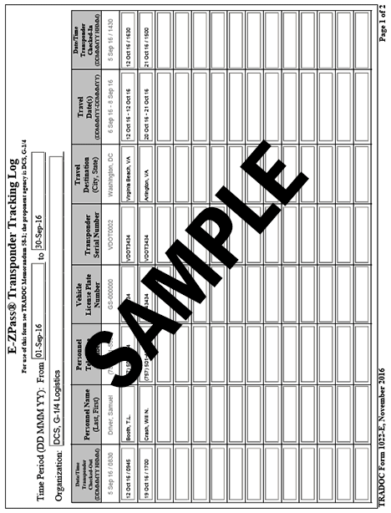

Figure B-1. TF 1022, E-ZPass® Transponder Tracking Log sample

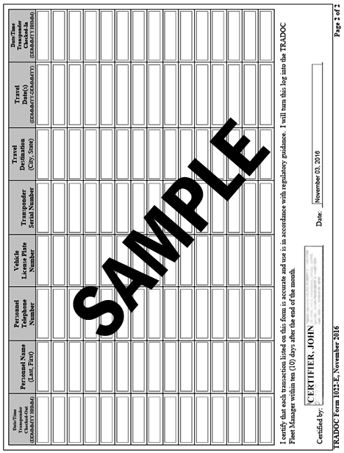

**Figure B-1. TF 1022, E-ZPass® Transponder Tracking Log sample, continued**

# 

# Glossary

**Section I**

**Abbreviations**

GSA General Services Administration

HQ headquarters

TAM transponder account manager

TF TRADOC form

TRADOC U. S. Army Training and Doctrine Command

**Section II**

**Terms**

**E-ZPass®**

An electronic toll collection system that uses a transponder affixed to the windshield or license plate issued by an authorized agency. The E-ZPass® transponders covers toll roads in the following states (Delaware, Illinois, Indiana, Maine, Maryland, Massachusetts, New Hampshire, New Jersey, New York, North Carolina, Ohio, Pennsylvania, Rhode Island, Virginia, and West Virginia).

**E-ZPass® Flex**

A switchable transponder that will allow toll-free travel on the I-95 and I-495 Express Lanes in Northern Virginia. If there are three or more people in the vehicle, switch the E-ZPass Flex to the “HOV ON” mode before accessing I-95 or I-495.

**E-ZPass® Tracking Log**

Provides accountability for the use of E-ZPass® transponders.

**Section III**

**Special Abbreviations and Terms**

**Transponder Account Manager (TAM)**

A person who is designated to maintain oversight responsibility for the daily use of E-ZPass® transponders assigned to their organization. Each organization has identified primary TAMs and secondary TAM