Department of the Army TRADOC Memorandum 672-6
Headquarters, United States Army C1
Training and Doctrine Command
Fort Eustis, Virginia 23604-5733

15 September 2011

Decorations, Awards, and Honors

U.S. ARMY TRAINING AND DOCTRINE COMMAND CERTIFICATES

FOR THE COMMANDER:

OFFICIAL: JOHN E. STERLING, JR.
Lieutenant General, U.S. Army
Deputy Commanding General/
Chief of Staff
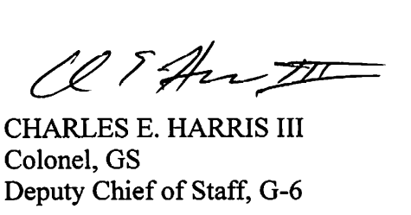

History. This is an administrative change to United States Army Training and Doctrine Command Memorandum 672-6.

Summary. This change prescribes the use of TRADOC Form 1020, dated September 2011.

Applicability. This memorandum applies to all HQ TRADOC organizations.

Proponent and exception authority. The proponent of this regulation is the Deputy Chief of Staff (DCS), G-1/4. The TRADOC Deputy Commanding General/Chief of Staff (DCG/CoS) has the authority to approve exceptions or waivers to this memorandum that are consistent with controlling law and regulations. Activities may request a waiver to this regulation by providing justification that includes a full analysis of the expected benefits and must include formal review by the activity’s senior legal officer. All waiver requests will be endorsed by the senior leader of the requesting activity and forwarded through the Deputy Chief of Staff, G-1/4 (ATBO-BP), 661 Sheppard Place, Fort Eustis, VA 23604-5744.

Distribution. This publication is available only on the TRADOC Homepage http://www.tradoc.army.mil.

Summary of Change

TRADOC Memorandum 672-6
U.S. Army Training and Doctrine Command Certificates

Change 1, dated 15 September 2011-

TRADOC Form 1020, dated September 2011, supersedes TRADOC Form 1020, dated April 2011. TRADOC Form 1020 is located on the TRADOC Homepage at
http://www.tradoc.army.mil/tpubs/TRADOCForms.htm.

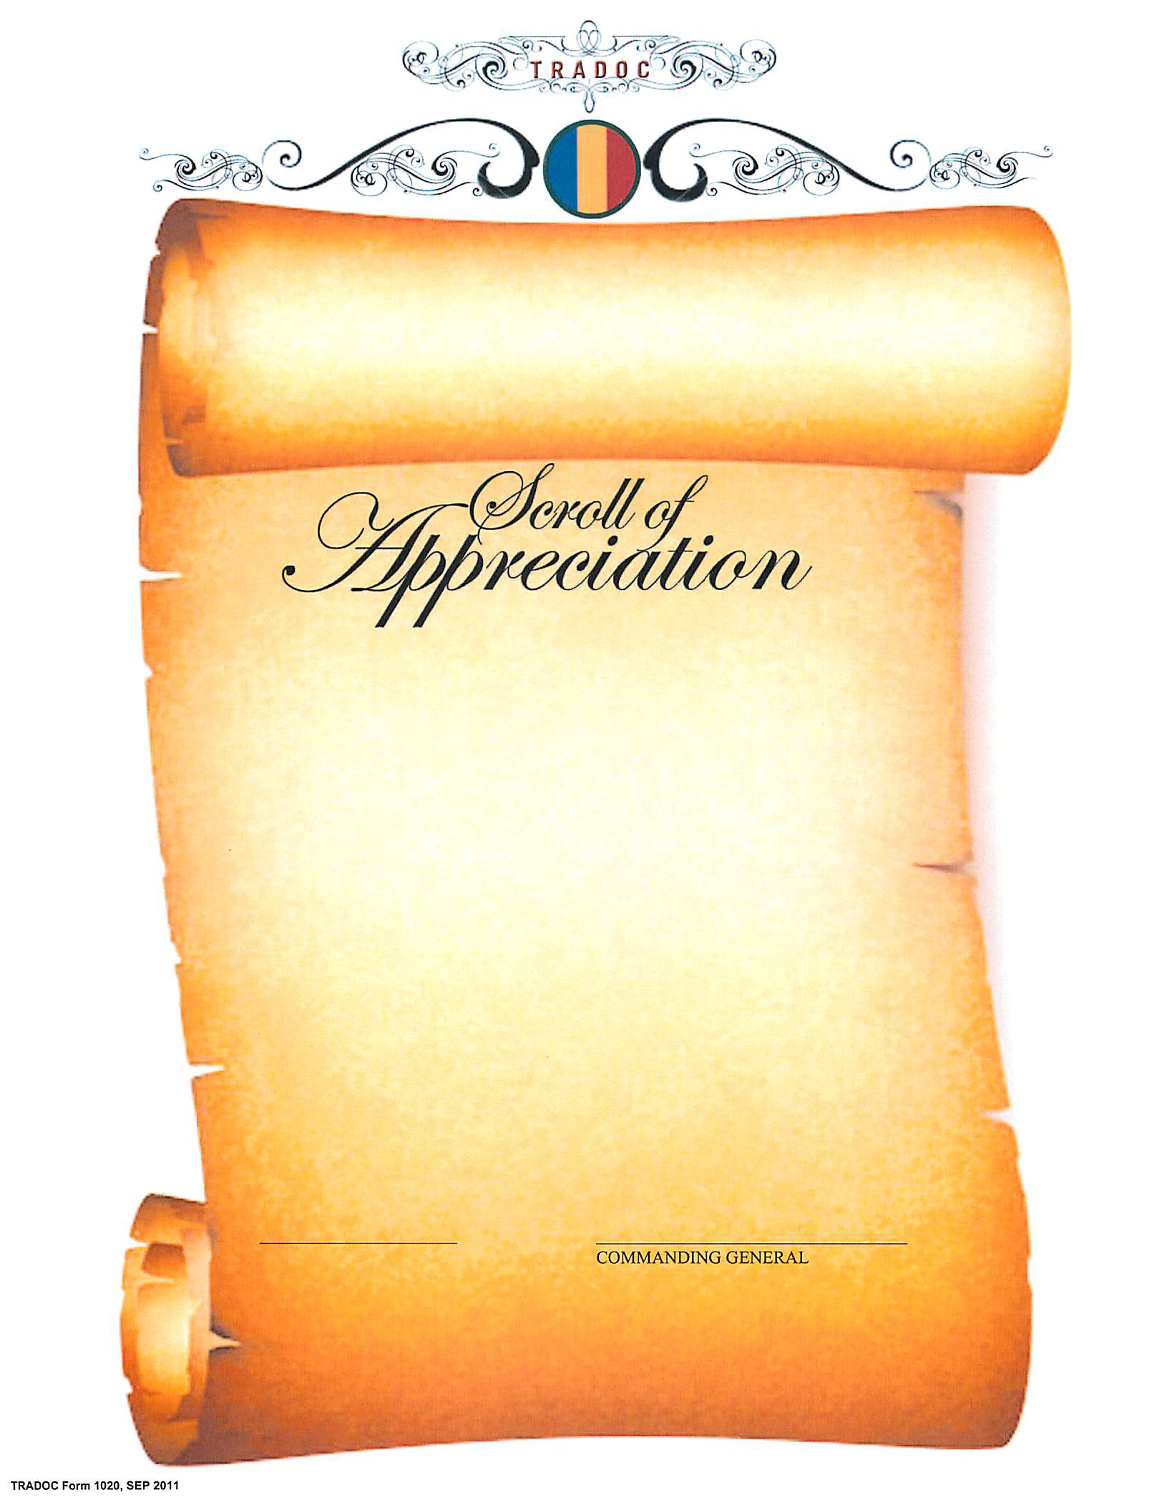
For use of this form, see TRADOC Memo 672-6. The proponent is TRADOC, Deputy Chief of Staff, G-1/4.

