**Department of the Army *TRADOC Pamphlet 350-70-1**

**Headquarters, United States Army**

**Training and Doctrine Command**

**Fort Eustis, Virginia 23604-5000**

**12 February 2019**

**Training**

**Training Development in Support of the Operational Training Domain**

FOR THE COMMANDER:

OFFICIAL: THEODORE D. MARTIN

Lieutenant General, U.S. Army

Deputy Commanding General/

Chief of Staff



WILLIAM T. LASHER

Deputy Chief of Staff, G-6

**History.** This publication is a major revision from the 24 February 2012 version. The summary of change lists the portions affected by this revision.

**Summary.** This update provides guidance and examples for the development of unit training products. This pamphlet contains specific guidance for the development of combined arms training strategies (CATS), warfighter training support packages (WTSP), collective tasks, individual tasks, drills, and Soldier Training Publications (STPs).

**Applicability.** The procedures outlined in this pamphlet apply to all Army organizations generating Army learning products used by the Active Army (AA), U.S. Army National Guard (ARNG), and U.S. Army Reserve (USAR).

**Proponent and Exception Authority.** The proponent for this pamphlet is the U.S. Army Combined Arms Command (CAC), Army University (ArmyU), Director, Learning Systems (DLS). The proponent has the authority to approve exceptions or waivers to this pamphlet that are consistent with controlling law and regulations.

**Suggested Improvements.** Submit changes for improving this publication on Department of the Army (DA) Form 2028 (Recommended Changes to Publications and Blank Forms) and send directly to the Provost, Army University (ATTN: Director for Learning Systems (DLS), Policy

*This pamphlet supersedes TRADOC Pamphlet 350-70-1, dated 24 February 2012.

and Governance Division (PGD) (ATZL-AUL), Fort Leavenworth, KS 66027-2300 or electronically to [armyu@mail.mil](mailto:armyu@mail.mil).

**Distribution.** This pamphlet is available in electronic media only at the TRADOC Administrative Publications website (<http://adminpubs.tradoc.army.mil/>).

**Summary of Change**

TRADOC Pamphlet 350-70-1

Training Development in Support of the Operational Training Domain

This major revision dated 12 February 2019-

o..Removes Army Mission Essential Task List Review Board and explains the role of its replacement by the Standards for Training and Readiness Advisory Group and training development in support of the operational training domain. (chaps 1, 2, 5 and 9)

o..Adds and synchronizes content on mission analysis and needs analysis, and refines job analysis and personnel roles of the Critical Task Site Selection Board with corresponding content found in United States Army Training and Doctrine Command Pamphlet 350-70-14. (chap 2 and app F)

o..Updates combined arms training strategies development and standards. (chap 3)

o..Introduces new numbering by echelon for collective tasks (changing from numbers to an abbreviation associated with a numerical identification code within collective tasks). (chap 5)

o..Integrates and applies Field Manual 7-0(Train to Win in a Complex World) doctrine. (chap 5)

o..Updates Live-Fire categories, statements and collective task linkages. (chap 5)

o..Updates Opposing Forces tasks and standards. (chap 5)

o..Updates military occupation specialty code structure to accommodate Warrant Officers and unique organizations. (chap 7)

o..Updates Soldier Training Publicationsin coordination with Maneuver Center of Excellence.   
(chap 8)

o..Removes standard verb list for task titles from this pamphlet and places the list electronically on the Training and Education Developers Toolbox. (app E)

o..Incorporates all Building and Assessing Training Readiness business rule requirements regarding Training & Evaluation Outline development. (throughout)

o..Updates force generation terminology, processes and description. (throughout)

o..Formalizes Training Development Capability as the Combined Arms Center approved automated development system to produce and revise Army learning products. (throughout)

o..Removes and/or replaces outdated references. (throughout)

This page intentionally left blank

Contents

**Page**

Chapter 1 Introduction 9

1-1. Purpose 9

1-2. References 9

1-3. Explanation of Abbreviations and Terms 9

1-4. Scope 9

1-5. Generating Force Support for Unit Training 9

1-6. Operational Domain Training Products 11

1-7. Integration of Generating Force Support and Operational Training Products into Training and Readiness 12

1-8. Army Learning Policy and Systems emphasis on Analysis, Design, Development, Implementation, and Evaluation (ADDIE) 13

Chapter 2 Generating Force Support and Mission Analysis for Unit Training Products 15

2-1. Introduction 15

2-2. Mission Analysis for Unit Training Products 18

2-3. The Mission Analysis Process 20

2-4. Safety and Environment Responsibilities 26

2-5. Unit Task List Approval 26

2-6. Mission Analysis Automation Support 27

2-7. Mission Analysis Quality Control (QC) 28

2-8. Mission Analysis Management 28

Chapter 3 The Combined Arms Training Strategy (CATS) 28

3-1. Introduction 28

3-2. Overview 29

3-3. CATS Types 30

3-4. CATS Interface with Army Processes and Models 30

3-5. CATS Development 32

3-6. CATS Management 51

Chapter 4 Warfighter Training Support Packages (WTSP) 51

4-1. Introduction 51

4-2. Analysis for WTSPs 53

4-3. Design the WTSP 54

4-4. Develop the WTSP 56

4-5. QC 56

Chapter 5 Collective Tasks 56

5-1. Introduction 56

5-2. Analysis for Collective Tasks 58

5-3. Design the Task Conditions 63

5-4. Design the Task Standard 65

5-5. Develop the Performance Steps and Performance Measures 71

5-6. Identify the supporting Individual Tasks 75

5-7. Identify the supporting Collective Tasks 76

5-8. Identify the supporting Drills 77

5-9. Safety and Environment Statements 77

5-10. Opposing Forces (OPFOR) Tasks and Standards 77

5-11. Equipment and Materiel 79

5-12. Training Aids, Devices, Simulators, and Simulations (TADSS) 79

5-13. References 80

5-14. Date/Time Stamp 80

5-15. Unit Type and Echelon 80

5-16. Remarks 80

5-17. Task/Performance Evaluation Summary Block 80

5-18. Synopsis Report 80

5-19. Training & Evaluation Outline 80

5-20. Quality Control 80

Chapter 6 Drills 81

6-1. Introduction 81

6-2. Analysis for Drill Development 82

6-3. Design the Drill 83

6-4. Develop the Drill Body 86

6-5. Drill Synopsis Report 90

6-6. Quality Control 90

Chapter 7 Individual Tasks 91

7-1. Introduction 91

7-2. Individual Task Analysis 93

7-3. Design the Individual Task Condition 96

7-4. Design the Individual Task Standard 97

7-5. Develop Performance Steps 98

7-6. Develop Performance Measures 100

7-7. Identify Task Linkages 100

7-8. Identify Military Occupational Specialty (MOS) and Skill Level 101

7-9. Identify Skills and Knowledge 102

7-10. Identify Evaluation Guidance 102

7-11. Identify Evaluation Preparation 103

7-12. Identify Equipment 103

7-13. Safety and Environment Statements 103

7-14. TADSS 104

7-15. Synopsis Report 104

7-16. Individual Task Report 104

7-17. Quality Control 104

7-18. Additional Information 104

Chapter 8 Soldier Training Publications (STPs) 105

8-1. Introduction 105

8-2. Analysis for STPs 107

8-3. Design an STP 107

8-4. Develop the STP 109

8-5. Quality Control 111

Chapter 9 Managing Unit Training Products 112

9-1. Introduction 112

9-2. Use of Collective Tasks 114

9-3. Collective Training Product Management 114

9-4. Proponent Guidance for Individual Task Management 117

9-5. Soldier Training Publications 118

9-6. Approval and Distribution of Unit Training Products 120

9-7. Validation 120

Appendix A References 121

Appendix B Unit Training Material Examples 126

Appendix C Product Checklists 162

Appendix D Standard Verb Rules for Task Titles 181

Appendix E Critical Task And Site Selection Boards (CTSSB) 183

Glossary 186

Table List

Table 5-1 Live-Fire statements 71

Table 6-1 Types of Drills 82

Table 7-1 Task types and descriptions 91

Table 8-1 STP types and descriptions 105

Table 8-2 Task summary format for an STP 110

Table 9-1 STP staffing 119

Table B-3 WTSP elements 133

Table C-1 CATS QC checklist 163

Table C-2 WTSP checklist 167

Table C-3 Collective task checklist 168

Table C-4 Drill Checklist 172

Table C-5 Individual task checklist 176

Table C-6 Individual critical task list (ICTL) checklist 179

Table C-7 STP checklist 180

Table D-1 Task title business rules 181

Table E-1 CTSSB members 183

Figure List

Figure 1-1. ADDIE process with management components 13

Figure 2-1. Major elements of a unit task list 20

Figure 2-2. Sample type unit organization chart 25

Figure 3-1. Elements of a CATS 33

Figure 3-2. The CATS task set elements 36

Figure 3-3. CATS task set numbering 37

Figure 3-4. CATS event elements 39

Figure 3-5. CATS execution guidance example 41

Figure 3-6. CATS task set example 43

Figure 3-7. Iteration example 45

Figure 3-8. Duration example 46

Figure 3-9. Training audience example 47

Figure 3-10. Example of resources allocated to a training event 49

Figure 3-11. CATS notional calendar example 51

Figure 4-1. WTSPs relationship to CATS events 52

Figure 4-2. WTSP numbering 54

Figure 5-1. New collective task creation guidelines 59

Figure 5-2. Collective task numbering format 61

Figure 5-3. Developing collective task titles 62

Figure 5-4. Writing collective task condition statements 63

Figure 5-5. Writing collective task standards 67

Figure 5-6. Task proficiency standards 68

Figure 5-7. Example objective task evaluation criteria matrix 69

Figure 5-8. Performance steps and performance measures 74

Figure 5-9. Collective task linkage 76

Figure 5-10. Environmental statement 77

Figure 5-11. OPFOR tasks and standards example 79

Figure 6-1. Drill ID number format 83

Figure 6-2. Considerations for writing drill conditions 84

Figure 6-3. Considerations for drill standard statements 86

Figure 6-4. Setup instructions example 87

Figure 6-5. Talk-through instructions example 88

Figure 6-6. Task(s) to drill linkage example 89

Figure 7-1. Individual task number format 94

Figure 7-2. Developing individual task titles 95

Figure 7-3. Writing individual task condition statements 97

Figure 7-4. Writing individual task standards 98

Figure 7-5. Individual task performance steps example 99

Figure 7-6. Writing individual task performance measures 100

Figure 7-7. Task linkages with individual tasks 101

Figure 7-8. Skills and knowledge sample 102

Figure 7-9. Individual task equipment example 103

Figure 8-1. STP content organization 108

Figure 9-1. Review boards 113

Figure 9-2. The task management process 115

Figure B-1. Unit task list (UTL) example 127

Figure B-2. Task set report example 129

Figure B-3. Event example (conduct an attack – staff exercise (STAFFEX)) 130

Figure B-4. CATS culminating training event (CTE) example 132

Figure E-1. Roles of personnel affecting the CTSSB 185

# Chapter 1 Introduction

## 1-1. Purpose

This pamphlet provides detailed guidance for developing unit-training products for primary use in the operational training domain. This guidance follows the instructional system design process: analysis, design, development, implementation, and evaluation (ADDIE). This pamphlet is primarily for training developers (TNGDEV) and others in the Army Learning Enterprise that analyze unit missions, design and develop collective and individual tasks as well as design, develop, and/or evaluate products to support unit training.

## 1-2. References

See appendix A for required and related publications and referenced forms.

## 1-3. Explanation of Abbreviations and Terms

See glossary for explanations of abbreviations and terms used in this pamphlet.

## 1-4. Scope

This pamphlet provides "how-to" guidance for proponent Centers of Excellence (COEs) and schools to create and revise unit-training products for use by the operational force. This pamphlet explains mission analysis applied to the unit training development process and the unit task list (UTL). It describes the linkage regarding the Sustainable Readiness Process (SRP) and development of operational training products affecting the following four training readiness components described throughout this pamphlet: Army Mission Essential Tasks (METs) proficiency; weapon systems proficiency (individual, crew-served, and platform weapons); collective Live-Fire task proficiency; and the methodology to calculate Days-to-Train to achieve (T). This pamphlet provides guidance for analyzing, designing, developing and evaluating unit training products including combined arms training strategies (CATS), warfighter training support packages (WTSP), collective tasks, drills, individual tasks, Soldier training publications (STPs), and individual critical task lists (ICTL). It discusses management and resources for the aforementioned products.

## 1-5. Generating Force Support for Unit Training

a. Background. One purpose of the generating force is to support the Army by providing mission-focused and outcome-based training and education to Soldiers and Army Civilians who protect this nation. This is accomplished by synchronizing training in the operational, institutional, and self-development domains to provide an effective overall training strategy. Effective Army training and education serve as the cornerstone of success in decisive action. Through training and education, Soldiers, Army Civilians, and units achieve the tactical and technical competence that builds confidence and agility. These characteristics enable Army forces to conduct successfully Unified Land Operations in support of the Joint Force.

(1) Training in the operational domain encompasses activities that units, organizations, and individuals undertake. Unit training reinforces individual Soldiers' foundations established in the institutional training domain and introduces additional skills needed to support collective training and organizational performance. Unit training develops and sustains an organization's readiness by achieving and sustaining proficiency in performing MET. Unit training focuses on performing tasks to approved standards under specified conditions. Unit training does the following:

(a) Prepares forces for decisive action.

(b) Incorporates conditions that realistically replicate the projected operational environment as much as possible.

(2) Follows a systematic process of what is trained, who gains the training, what is the training environment presented, and what is the assessment of training outcomes. The process also determines the training support resources required to develop, distribute, implement, and evaluate the training products.

b. Requirements. The requirements of generating force support to operational domain training development are below:

(1) Ensure compliance with United States (U.S.) Army Training and Doctrine Command (TRADOC) Regulation (TR) 350-70 and supporting pamphlets.

(2) Incorporate current and relevant doctrine, organization, training, materiel, leadership and education, personnel, facilities, and policy (DOTMLPF-P) changes into operational domain training products.

(3) Ensure changes in any specific training product reflect systematically throughout all related products.

c. Units execute effective individual and collective training based on the Army’s principles of training enumerated below. See Field Manual (FM) 7-0 (Train to Win in a Complex World) for a discussion of each training principle.

(1) Train as you fight.

(2) Training is commander driven.

(3) Trained officers and noncommissioned officers (NCOs) lead training.

(4) Train to standard.

(5) Train using appropriate doctrine.

(6) Training is protected.

(7) Training is resourced.

(8) Train to sustain.

(9) Train to maintain.

(10) Training is multi-echelon and combined arms.

## 1-6. Operational Domain Training Products

a. This pamphlet briefly describes operational domain training products below; then, this pamphlet will detail the training products in the subsequent chapters. CATS, WTSPs, collective tasks, drills, and individual tasks are the products that must be developed and delivered for implementation by the operating force. Proponents develop STPs as needed. Proponent Centers of Excellence (COEs)/schools use automated information systems to develop, read, maintain and deliver all learning products, and to improve efficacy and efficiency. TNGDEVs use the automated system, Training Development Capability (TDC) to develop learning products, share tasks with other COEs/schools, and maintain learning products as the database of record in accordance with TR 350-70. COEs/schools and Army proponents deliver learning products to the operational force through the Central Army Registry (CAR) and the Army Training Management System (ATMS), which includes both the Army Training Network (ATN) and the Digital Training Management System (DTMS) for inclusion in unit training plans and training assessment processes.

b. CATS. CATS are the Army’s overarching strategies for training the force. The basis of the CATS program is a series of proponent-developed unit strategies describing recommended training events, frequencies, and resources required to train to standard. CATS are descriptive unit training strategies that suggest a path for a unit to achieve and sustain training proficiency. CATS provide a means for unit commanders to develop their training plans. The CATS identify recommended training strategies that include associated collective tasks, training events, and the major resources to train. Chapter 3 describes CATS in more detail.

c. WTSP. A WTSP is a complete, stand-alone, exportable training package that integrates all training products, resources, and materials necessary to support operating force training. Based on specific CATS training events, a WTSP meets the broader scope of what the collective training community requires for training events. WTSPs may vary greatly in size and depth of content, training environment, audience, and available training aids, devices, simulators, and simulations (TADSS). A WTSP provides variable levels of detail for describing a unit training event for use in live, virtual (including gaming), and constructive environments, or any combination thereof. A WTSP contains the information needed to plan, prepare, execute, and assess an event. The elements of a WTSP include WTSP identification, overview, tactical materials, control materials, setup materials, administrative materials, evaluation plan, and references. Chapter 4 provides details for the WTSP.

d. Collective tasks. Collective tasks are clearly defined, observable, and measurable activities or actions that require organized team or unit performance leading to the accomplishment of a mission or function. Collective task accomplishment requires the performance to standards of supporting individual or collective tasks. A collective task describes the performance required of a unit under the conditions a TNGDEV has identified to replicate the anticipated operational environment. The training and evaluation outline (T&EO) is the output of the development of the collective task. Leaders use T&EOs to identify other supporting collective and individual tasks that support higher level tasks. These T&EOs provide summary information concerning collective task training and individual and leader tasks that support the successful execution of collective training. The emphasis is on unit performance of collective tasks performed primarily in the operational training domain. Chapter 5 provides details for collective tasks.

e. Drills. A drill is a collective action or task performed without the application of a deliberate decision making process. Initiate a drill on a cue, such as enemy action or a simple leader command, and is a trained response to the given stimulus. A drill requires minimal leader orders to accomplish, and is usually performed by lower echelons and battle staffs, and is standard throughout the Army. Use a drill to train one action, one way. Chapter 6 explains the development of drills.

f. Individual tasks. An individual task is a clearly defined, observable, and measurable activity accomplished solely by an individual. It is the lowest action, skill, or knowledge level in a job or duty. An individual task supports one or more collective tasks or drills and often supports another individual task. An individual task must be specific, and have a definite beginning and ending. It is generally performed in a relatively short time; however, there may or may not be a specific time limit. Chapter 7 provides the details for individual tasks.

g. STPs. An STP is an Army-wide Doctrine and Training Literature Program (ADTLP) publication that contains critical tasks and other training information used to train Soldiers. STPs serve to standardize individual training for the whole Army; provide information and guidance in conducting individual training in the unit; and aid the Soldier, NCO, officer, and commander in training critical tasks. Unit trainers use STPs to train and sustain both leader and Soldier task proficiency. Chapter 8 provides the procedures for producing STPs.

## 1-7. Integration of Generating Force Support and Operational Training Products into Training and Readiness

This paragraph introducesthe Standards for Training and Readiness Advisory Group **(**STRAG).

a.Headquarters (HQ) Department of the Army (HQDA) established the STRAG to provide a management process for resolving issues related to operational product design and training readiness requirements. The STRAG guides the development of the four training readiness components for T-Level readiness reporting: Army MET proficiency; weapon systems proficiency (individual (I), crew-served (CS), and platform (P) weapons); collective Live-Fire (LF) task proficiency; and the methodology to calculate Days-to-Train to achieve T-1.

b. STRAG exercises purview over tasks and metrics used to assess the four components of training readiness reporting. Development and modification of operational products must comply with STRAG business rules to maintain alignment with Army Senior Leader guidance, table of organization and equipment (TOE) missions, doctrine, and readiness reporting requirements. Proponents must notify the STRAG when changes occur to tasks and metrics used to assess the four training readiness-reporting components.

c. STRAG membership consists of representatives from the operational force that serve as voting members, and representatives from the generating force that serve as subject matter experts (SME). The STRAG meets quarterly to develop vetted recommendations through the Operational Portfolio Council of Colonels and the Training General Officer Steering Committee for submission to the HQDA Deputy Chief of Staff, G-3/5/7 for approval. Refer to chapter 9 for more information on STRAG as an Army Review Board.

## 1-8. Army Learning Policy and Systems emphasis on Analysis, Design, Development, Implementation, and Evaluation (ADDIE)

a. Army Learning Policy and Systems and ADDIE. The Army Learning Policy and Systems design process emphasizes the ADDIE process. ADDIE provides for effectiveness and efficiencies by developing continuous awareness of the relationships among the component parts, rather than a linear approach. The five phases of ADDIE enable the creation of integrated, mission essential products that support any type of learning and professional growth. ADDIE is the basis of a systematic, non-linear, ongoing approach to conceiving, planning, organizing, and documenting all unit and individual learning products. Army Learning Policy and Systems adds management as an overarching and integral component (see figure 1-1).

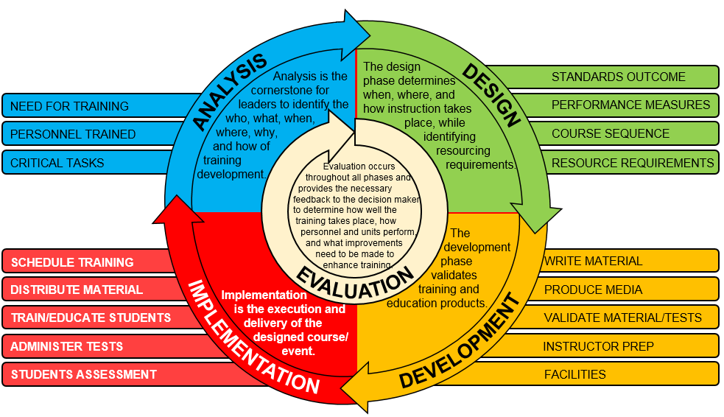

Figure 1-1. ADDIE process with management components

b. Applying ADDIE to unit training products. Developing operational domain training products requires awareness that these five phases can be applied repeatedly at many levels, on a broad or narrow scope. A TNGDEV must determine at what level to enter the training development process and ensure that the process does not drift from the original intent. Needs analysis, mission analysis, and job analysis are the primary analysis processes used to identify the unit training products to be designed (revised or created), developed, implemented, and evaluated. To successfully create a training product that meets all requirements at the appropriate level, the developer must maintain focus on the end product or training objective.

c. ADDIE considerations specific to operational domain training products.

(1) The analysis phase is for defining the training needs (goals or objectives) and the ways to measure success. Conducting a thorough analysis is essential for making training/ instruction as relevant as possible. Analysis provides information about what skills or knowledge need to be trained or learned, under what conditions they are performed and used as well as the standard of performance that needs to be achieved. The results of analysis form the basis for creating and/or revising unit-training products. During analysis, a developer primarily focuses on understanding the expected outcome of the development efforts while determining what information to draw upon. In determining a new unit-training product, the triggering circumstance may come from a variety of sources in the form of a problem to be resolved. Depending on the circumstance, the developer must draw upon relevant information to create a new training product or revise an existing training product. Once the developer analyzes the problem, the developer then moves into the design phase.

(2) In the design phase, the TNGDEV must identify or create the performance objective(s), which vary according to the type of product implemented. Once the TNGDEV confirms the training or learning objectives with the proper authority, the TNGDEV plans the training/instruction end state, and the context in which the task or learning will successfully occur. The goal is to create a learning situation that helps people move from what they already know, to gaining mastery of the new material. In task-based training development, this includes providing the conditions and standards needed. As an example, in the task *Defeat an Improvised Explosive Device (IED)*, the TNGDEV must address the conditions (such as equipment, materials, weather, darkness, threat involvement, and civilians on the battlefield) which may affect the task’s successful accomplishment. The standards for the IED defeat task may include a time element for attaining successful task accomplishment, and/or the determination that the task is completely accomplished with no additional danger from the IED. In the design phase, the TNGDEV may determine any additional performance measures, training strategies, resource requirements, and/or other criteria needed to perform a task.

(3) The development phase constitutes determining the details about the intended training, instruction, or learning product. The TNGDEV chooses the structure and methods to form a comprehensive strategy to help the intended audience achieve the learning objectives. The development strategy should include grouping or sequencing materials, instructional methods or tactics, class types, delivery options, and assessments to measure success. In task-based training, development includes identifying performance steps and performance measures that apply. Although TNGDEVs primarily revise unit-training products rather than create them, development of unit-training products is the primary focus of this pamphlet. In the event a TNGDEV needs a new unit-training product, all steps for development of each product are included in this pamphlet.

(4) The implementation phase is the act, performance, or execution of unit training. After the unit-training product is designed, developed, and the validation activities completed, the training is implemented. This pamphlet’s purpose is not to address implementation. Therefore, operating forces implement unit training in accordance with FM 7-0.

(5) Once unit-training products are identified, designed, and developed, appropriate management processes are needed to implement and evaluate these products. Chapter 9 provides management guidance for operational domain training products. It also defines the Combined Arms Center's (CAC’s) role for managing training requirements for training, which encompasses training support in accordance with TR 10-5. Chapter 9 notes proponent guidance for task management, approval, and distribution of operational domain training products and validation of training products. Subject matter expert (SME) training validations also provide valuable feedback and can identify necessary training improvements.

(6) Evaluation is a continuous process that starts during the analysis phase and continues throughout the life cycle of the training product. The evaluation phase consists of both formative and summative parts. Formative evaluation is the monitoring of a training product in each phase of ADDIE to make sure it achieves the desired outcome/objective. This is a check-on development to control the quality and implementation of training products. Summative evaluation usually occurs after completion of the ADDIE process, and determines whether the training product development and implementation meet established Army standards. Observations, lessons learned, best practices, after-action reviews and reports (AARs), and feedback provided from unit observations serve as the primary summative evaluation points used to modify unit training. Use evaluation of unit execution at combat training centers (CTC) also as a means of feedback.

# Chapter 2 Generating Force Support and Mission Analysis for Unit Training Products

## 2-1. Introduction

a. This chapter provides information regarding the relationship between the generating force's learning products and operational Army training requirements. Spanning the two forces is the Army collective training enterprise led by U.S. Army Forces Command (FORSCOM). The operational Army consists primarily of units whose main purpose is to conduct or support decisive action. Force Generation is how the Army manages the development, preservation, and provision of ready and responsive forces to the Combatant Commander and includes the Army’s institutional procedures, plans, and systems for resourcing unit and strategic readiness and supporting Global Force Management. The Force Generation process focuses on the four phases of the operations process – plan, prepare, execute, and assess. Sustainable Readiness is the process that postures the Army to manage risk while preparing a force that is more agile, adaptive, and necessary to win in a complex world. The process maximizes opportunities, builds readiness for both potential future demands and contingency demands and accounts for contingency Joint Requirements while fulfilling the statutory requirement to Train, Equip, and Man units for future conflicts. The SRP applies a framework to convey unit readiness. These building blocks are the basis of the Sustainable Readiness Model (SRM) and unit level reporting directly influences them. The SRM uses modules to depict unit readiness information, identify resourcing requirements and each module represents a given unit’s activity over the three months of a designated fiscal year quarter on the five-year time horizon for planning. There are three modules: ***prepare***, ***ready***, and ***mission***, with additional descriptive categories in prepare and mission modules.

(1) Prepare Modules. Units in prepare modules are not available for decisive action without significant risk to mission. Units in this module execute an approved training plan resourced to build decisive action readiness. Additionally, units in this module are categorized as ‘building readiness’, with transitory or limited resources based on expected resourcing level for a particular unit.

(2) Ready Modules. Units in ready modules are available to plan for decisive action. The goal for units in this module is to sustain C1 or command and control (C2) levels of readiness for immediate mobilization or deployment. This module also includes Reserve Component (RC) units resourced to achieve a C2 level of decisive action readiness.

(3) Mission Modules. Units in mission modules are projected to be in receipt of mission orders based on known demands. Expected decisive action readiness levels are dependent on mission requirements and include C1, C2 as well as mission-specific A-level requirements. Additionally, units are categorized in this module as prepare to deploy, mission allocated, and assigned forces demand.

b. Force generation applies to Active Army (AA) and RC (Army National Guard (ARNG) and United States Army Reserve (USAR)) units, except for those forces the Army designates as theater committed units designed to meet enduring theater commitments. Additionally, the generating force participates in and responds to force generation requirements. While operating force commanders plan for achieving proficiency in the four training readiness components, the generating force supports operational force training by adjusting their level of support to meet Army Senior Leader guidance, TOE missions, doctrine, and readiness reporting requirements. The STRAG provides a management and oversight process for integrating generating force support with operational force training and readiness reporting requirements. See Army Regulation (AR) 525-29 for additional information on force generation.

c. The generating force's TNGDEVs produce and manage learning products based on unit mission, capabilities and triggering circumstances, and in response to the training requirements of the operational Army. The fluidity of the operating environment requires the development or revision of training products that dynamically receive updates and are deliverable electronically. Proponents develop and update products in TDC and published in the CAR. ATMS delivers products to Soldiers and units for inclusion in unit training plans and training assessment processes. TRADOC proponents continuously monitor unit-training products to ensure they remain current.

d. Training development begins when a needs analysis indicates a training deficiency that necessitates a change or modification to a current training product(s). A needs analysis may be directed or a triggering event may cause it. Needs analysis triggering circumstances may originate from a wide variety of sources such as unit feedback, organizational changes, new doctrine, or a change in the operational environment, and they may be presented to TNGDEVs in formal or informal reports. Follow additional guidance on conducting a needs analysis as described below.

e. Needs analysis. A needs analysis identifies gaps between current and required Army operational capabilities or performance. A needs analysis may indicate a required change or modification to training and education learning products. Actual or perceived deficiencies may be in any area of the DOTMLPF-P domains. Training or education is not always the solution, although it may sometimes be part of a combined solution. A needs analysis may also identify training and education no longer needed. TNGDEVs will conduct a needs analysis to produce the following outputs:

(1) Training and education solutions or improvements (as applicable).

(2) Recommendations for non-training and education solutions (as applicable).

(3) Learning product development requirements.

f. A needs analysis is usually initiated (or triggered) when the proponent receives notification of an actual or perceived performance deficiency. The TNGDEV then determines what initiated the unacceptable performance, or what cue is missing that hinders performance of the required action. See TR 350-70 for additional information on triggering circumstances.

(1) The needs analysis process includes but is not limited to the following steps (see TRADOC Pamphlet (TP) 350-70-14 for detailed information on the needs analysis process):

(a) Review the literature.

(b) Identify and describe the problems/deficiencies in exact terms to determine a solution.

(c) Acquire related documentation and data.

(d) Determine the requirements.

(e) Describe the current situation.

(f) Identify the problem by describing the difference between the requirement and the current situation.

(g) Identify the major causes or combination of causes of the problems/deficiencies.

(h) Identify the responsible DOTMLPF-P domain for correcting the problem(s)/ deficiencies.

(i) Identify and analyze courses of action.

(j) Recommend the best solutions and alternatives to correct problem(s)/deficiencies.

(k) Submit courses of action and recommended solutions to the command authority for approval.

(2) Needs analysis quality control (QC). Follow the guidance in TP 350-70-14 to ensure the effective application of the needs analysis process and the products developed. The TNGDEV’s supervisor has overall responsibility for conducting a thorough, efficient, and effective needs analysis. The supervisor keeps appropriate managers informed on needs analysis status and provides assurance that the needs analysis outputs are valid. In accordance with TR 350-70, if the needs analysis indicates a required change or modification in training, then perform a mission analysis.

g. A mission analysis identifies a unit's mission and capabilities from which the entire set of tasks are developed. Base the analysis on a unit’s mission, organization, personnel, and equipment. The collective tasks make up the UTL. A MET is a collective task on which an organization trains to be proficient in its designed capabilities or assigned mission. Select METs from a unit’s UTL to create the unit’s Mission Essential Task List (METL). METL is a tailored group of mission-essential tasks. Army proponents develop unit HQDA standard METLs for designated units for HQDA G-3/5/7 approval through the STRAG process. Unit CATS support the METL by using the unit mission and capabilities from the UTL. AR 220-1 directs operating forces to report readiness based on their HQDA standard METL and assigned mission METL (if applicable).

## 2-2. Mission Analysis for Unit Training Products

a. Mission analysis overview. The TNGDEV or subject matter expert (SME) initiates a mission analysis resulting from of either a needs analysis or an update of a unit collective training strategy to include mission requirements. The mission analysis process identifies the following: the unit's mission; all the specified, implied, and supporting capabilities and functions that a unit and its subordinate units should perform; and the tasks to perform to accomplish those missions. Factors that may trigger a requirement for a mission analysis include changes in the following areas:

(1) An operational concept and employment doctrine.

(2) The mission, capabilities, tasks, or performance requirements of an existing unit.

(3) Threat, weapon systems, other military hardware, or personnel requirements in an existing unit.

(4) Trends in the operational environment that impact future Unified Land Operations. For example, operations conducted in and around dense urban terrain.

b. Mission analysis and managerial judgment. Apply managerial judgment when deciding whether to conduct a new mission analysis or revise an existing one. Revising a mission analysis is much more efficient than conducting a new mission analysis. A revised mission analysis may not require all steps. The TNGDEVs may streamline the process to the steps necessary in each situation to identify valid tasks to support the mission and capabilities.

(1) Initiate a new mission analysis after a needs analysis. A new mission analysis is necessary when establishing a new type of AA or RC unit, or for a solution to a major performance deficiency that affects a proponent-type unit.

(2) Most mission analysis actions are revisions. Review and update a mission analysis when a needs analysis identifies a change in the tasks a unit performs. A change in task(s) may result from such items as:

(a) Unit feedback.

(b) New or revised doctrine; for example, tactics, techniques, and procedures (TTPs).

(c) New or improved systems or equipment operation procedures.

(d) Operational lessons learned data from unit visits, unit task review boards, the Center for Army Lessons Learned (CALL), and the primary system to gain lessons learned information is to go to the Joint Lessons Learned Information System (JLLIS). To gain assistance in finding specific information, submit a request for information (RFI) on JLLIS or the CALL website.

(e) Evaluation feedback.

c. Mission analysis on all proponent-type units. Although these are TOE units and modified table of organization and equipment (MTOE) units, conducting a mission analysis for table of distribution and allowances (TDA) units may be a requirement.

d. Mission analysis preparation and tools. A mission analysis uses the following information as tools:

(1) Identification of unit organizational and functional structure.

(2) Identification of all the specified, implied, and supporting capabilities.

(3) A capabilities and functions-by-echelon list.

(4) Identification of collective tasks that compose the UTL.

(5) Collective task to reference matrix (shows references that support the collective tasks).

(6) Identification of individual tasks that support system employment training (shows individual tasks that support the collective tasks).

e. UTL. The UTL is the primary output of mission analysis. Develop a UTL in the CATS Development Tool to provide the baseline for all unit products. A TNGDEV creates the UTL by linking all existing collective tasks (shared and unique), or identifying collective tasks for design and development for a specific unit supporting its mission requirements and capabilities. This process ensures that units train the appropriate tasks to readiness proficiency levels. Figure 2-1 identifies major elements of the UTL (an example UTL appears in appendix B-1).

*Note.*There is a requirement to input the organizational data prior to creating and developing the UTL using the CATS Development Tool.

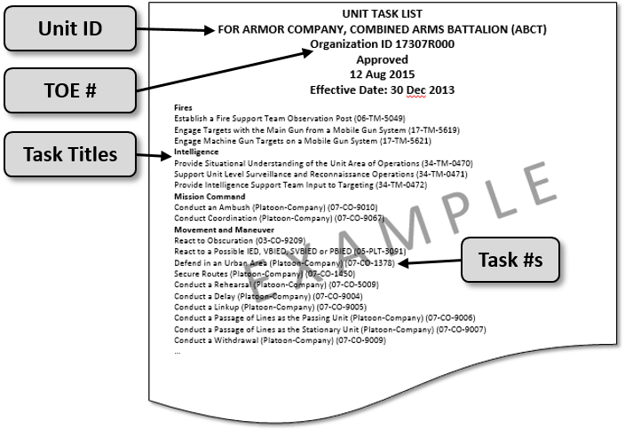

Figure 2-1. Major elements of a unit task list

## 2-3. The Mission Analysis Process

Following the needs analysis, the TNGDEV or SME utilizes the mission analysis process as applied to training development for creating the UTL. The level of effort will vary, depending on whether it is conducting a new mission analysis or updating an existing mission to collective task list.

a. Identify the specific type unit to analyze. The procedures for analyzing a TOE are as follows: identify the unit and document by the TOE(s) or TDA identification number and name; identify the number of units by AA and RC; and document the current address, location, and point of contact in each unit, if available.

b. Conduct detailed unit research. In order to gain a thorough understanding of the unit, the TNGDEV or SME conducts detailed research on the unit. The TNGDEV or SME researches to identify, locate, and acquire all documentation related to the specific unit being analyzed. The TNGDEV or SME researches the literature, documentation, and resources to identify the specified and implied capabilities, functions, and collective tasks to perform to accomplish the unit’s missions. The TNGDEV or SME conducts the following:

(1) Compiles all available literature, documentation, and resources that guide, direct, or explain the activities of the unit(s) to include TTPs. Check the Army Publishing Directorate (APD) list of electronic Department of the Army (DA)-level publications to verify the currency of references.

(2) Acquires a copy of all of the documentation as it relates to or describes how the specific unit operates, and/or assigns missions or tasks to the unit.

(3) Acquires the appropriate TOEs, TOE narratives for the unit, and TDAs for the unit, the next higher level unit, and supporting units. Army TOEs are available on the U.S. Army Force Management Support Agency Force Management System Web Site (FMSWeb) (<https://fmsweb.fms.army.mil>).

(4) Acquires regulatory documents (paper or electronic) providing policy, guidance, rules, and laws directly affecting unit operations. Requisition hard copy documents through appropriate channels. Documents include, but are not limited to ARs, DA pamphlets (DA Pams) and circulars, joint publications, United States Code, and Federal regulations. These documents are accessible electronically on the following Web sites:

(a) The Army Publishing Directorate web site (<http://www.apd.army.mil/>) provides access to Army publications, such as Army regulations and DA Pams.

(b) The TRADOC web site provides access to TRADOC administrative publications (<http://www.tradoc.army.mil/tpubs/>).

(c) The Joint Electronic Library web site (<http://www.dtic.mil/doctrine/>) provides access to Joint Doctrine.

(d) The Department of Defense (DoD) Washington Headquarters Services web site (<http://www.dtic.mil/whs/directives>) makes issuances available. Issuances include DoD instructions, directives, and publications.

(e) The Military Education Research Library Network (<http://ndu.libguides.com/merln/>) and (@MERLN.ndu.edu) provides access to current U.S. Government policy statements on selected key topics.

(f) The National Archives and Records Administration provides access to the Federal Register (<http://www.archives.gov/federal_register/publications/government_manual.html>), allowing inspection of the record of government actions and access to essential evidence that documents government actions.

(g) The Pentagon Library (<http://www.whs.mil/library/>) provides access to many military references.

(h) The Library of Congress web site (<http://lcweb.loc.gov/>) provides access to civilian publications.

(5) Identifies and interviews SMEs, and documents discoveries.

(6) Acquires feedback from operational units and Soldiers in the field, as well as training centers that pertain to the unit to analyze. This information includes, but is not limited to Basic Leader Training Reports, DA Forms 2028, command directives and taskers, and critical operational lessons learned reports. The CALL web site (<http://call.leavenworth.army.mil>) can assist in this effort along with the Joint Lessons Learned Information System.

(7) Acquires the relevant lessons learned data for operational missions, CTCs, and exercises from the Joint Lessons Learned Information System.

(8) Acquires and studies new, approved doctrine.

(9) Acquires information on new or improved systems and equipment that will be assigned to the unit analyzed.

(10) Acquires and accounts for evaluation feedback.

(11) Acquires the evaluation reports that apply directly to the unit analyzed.

(12) Acquires a copy of or access to the current standard operating procedures (SOP) for the type unit analyzed.

(13) Acquires AARs, or other similar reports that directly pertain to the analyzed unit. These reports are sanitized before receipt (all evidence of the specific unit mentioned is removed).

c. Conduct additional research. The mission analysis team looks beyond what the existing unit is required to accomplish, and looks at documents reflecting current and planned changes to the doctrine, equipment, or manning of the type unit. Acquire a copy of, or electronic access to documentation that describes or implies that the missions of the unit that will, or may change based on current TOE. This documentation includes, but is not limited to the following:

(1) Operational concepts; for example, an operational and organizational plan, and a concept and evaluation plan.

(2) Base development plan, mission area analysis and development plan, and capabilities issues.

(3) Military occupational restructures found in the DA Pam 611 series and job analysis data.

(4) DA Pam 611-21.

(5) Army-wide studies and reports such as AR 5-5 studies, Army Research Institute, and Human Resources Research Organization data.

(6) Equipment documentation and publications such as:

(a) Mission needs statements.

(b) Basis of issue plans (BOIP).

(c) System training plans (STRAPs).

(d) New equipment training plans and displaced equipment training plans.

(e) Technical manuals (TM).

(f) Integrated logistics support.

(g) Training effectiveness analysis.

(h) FMs and doctrinal publications.

(i) Applicable threat studies and analysis.

(j) Capability developer’s (CAPDEV’s) database; coordinate with CAPDEVs for database results.

(k) Chemical, Biological, Radiological, and Nuclear (CBRN) reports and videos.

d. Identify the unit mission. The TNGDEV or SME should study the core TOE and UTLs of the next higher echelon. This will aid in identifying the tasks and capabilities of the subordinate echelon, which should serve to support the higher echelon’s accomplishment of its core mission. The TNGDEV or SME should research DTMS to find mission and task data to support the unit. Identify the HQDA standard METL for the higher echelons because of the nested impact on the mission of units (see FM 7-0).

e. Identify type unit capabilities and functions. The TNGDEV works with the SME to identify valid capabilities and functions, both specified and implied for a specific type unit or grouping of type (TOE) units. To accomplish this, the TNGDEV or SME works with CAPDEVs and doctrine staff to coordinate actions and activities relating to TOE and doctrine issues, and communicates findings, suggestions, and recommendations to the mission analysis team.

(1) The TNGDEV or SME coordinates with CAPDEVs and acquires a copy of the unit’s Operational and Organizational (O&O) concept to gain a better understanding of the unit’s capabilities, functions, and responsibilities.

(2) The TNGDEV or SME studies the literature, documentation, and resources to identify the specified and implied capabilities and functions the unit needs to accomplish its mission.

(3) Review the mission and capabilities from the next higher echelon, which will help identify supporting units and elements.

(4) Develop organization charts to show type unit structure and relationship to other units. See figure 2-2 for a sample type unit organization chart.

(5) Identify all type unit echelons/elements.

(6) Review the mission, capabilities, and functions from each supporting unit and element. Compile a capabilities and functions list for the unit’s highest echelon and each supporting subordinate echelon (from highest to lowest echelon unit).

(7) Staff the draft capabilities and functions lists to the appropriate organizations and individuals for critical review and comment. Prepare the appropriate documentation and provide to such organizations as the threat management, combat development, and unit command elements for their critical review and comment. Limit staffing to the smallest community possible while still ensuring acquisition of valid, useful information.

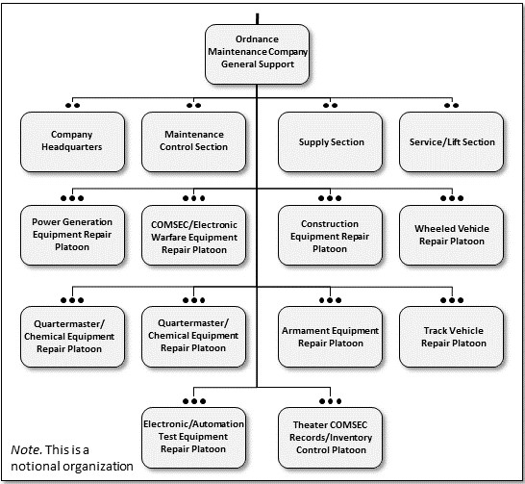

Figure 2-2. Sample type unit organization chart

f. Identify the collective tasks for the UTL. Identify all collective tasks that the unit's echelons or elements perform to support mission requirements, capabilities, and functions. A collective task does not describe an operation and is developed to articulate only one activity or action in support of a mission. Task proponents must develop follow-on collective training for collective tasks to ensure accomplishment of assigned missions, METL, and decisive operations.

(1) After conducting research, the team identifies the collective tasks. The team can either extract tasks from reference material or identify tasks while interviewing selected SMEs. Before conducting interviews with SMEs, the TNGDEV should prepare to ask effective questions by conducting a detailed review of all available information. Interviews are performed via electronic media (video teleconference or Internet), telephonically, or in person as resources allow. Obtain data from the following individuals that currently or recently served in the type unit analyzed:

(a) AA, ARNG, and USAR Soldiers.

(b) Civilian job incumbents.

(c) Job incumbent supervisors.

(2) Establish the content of an interview before conducting the mission analysis. Review [TR 350-70](http://www.tradoc.army.mil/tpubs/pams/p350-70-4/p350-70-4.htm) and supporting pamphlets for the process and details to conduct interviews. TRADOC Quality Assurance Office (QAO) provides the most current information and procedures on the development and administration of interviews and questionnaires. For example, interview preparation should include preparation of specific questions in which each question has an intent based on the person to interview. Document information provided by the SME and observations made during a unit’s performance of the mission.

(3) Identify gaps as a result of the analysis process. Provide results in terms of doctrinal deficiencies in the proponent tasks or missions in order to conduct collective task analysis. Before creating new collective tasks, the developer or SME must review the DA-approved standard METL and the appropriate proponent UTL, as well as existing collective tasks in TDC.

g. Identify and document any individual tasks that directly support mission accomplishment to the appropriate proponent or office for further analysis.

h. Identify the supported Universal Joint Task List (UJTL)/Army Universal Task List (AUTL) collective tasks. Compile a UTL of existing collective tasks, and/or proposed new collective tasks for design and development. The CATS Development Tool is used to create and manage UTLs.

## 2-4. Safety and Environment Responsibilities

a. During mission analysis, identify and include safety hazards the unit may encounter when performing the mission and tasks. Document all safety hazards or issues to consider for the unit's performance of tasks; this includes acquiring pertinent safety reports, regulations, and other data, and coordinating with the branch safety office or supporting safety professional.

b. During mission analysis, identify and document all environmental factors the unit may encounter while performing the mission and tasks. The TNGDEV or SME must acquire pertinent environmental documentation (reports, regulations, and other data) and coordinate with the environmental protection office. This information is especially important for creating the follow-on training.

## 2-5. Unit Task List Approval

a. Due to its importance and criticality, the task proponent commander/commandant or their designated representative approves the UTL.

b. Prior to seeking approval, prepare the UTL so approvers can easily discern what they are approving. Prepare other documents for record:

(1) List all of the tasks recommended for approval. Consider grouping the tasks by warfighting function (WFF) so the list is understood.

(2) Identify tasks considered but not recommended as critical to mission accomplishment.

(3) Document any controversial issues, decisions, remarks, or issues that could surface as potential problems in the future.

c. Prepare a memorandum and attachments for signature, and distribute the approved list as appropriate. Add appropriate guidance for conducting the follow-on collective task analysis. The signature of the commander/commandant or their designated representative signifies approval of the UTL.

d. Once the commander/commandant or their designated representative approves the UTL, distribute the list to all individuals and organizations responsible for the collective task analysis.

(1) Provide a copy to the proponents responsible for the follow-on collective task analysis of the approved collective tasks.

(2) Provide a copy to the individual training analysis office or equivalent.

(3) Notify offices responsible for producing training materials and products based on this UTL. It is the responsibility of the proponent to keep the approved UTL current. Minor changes to the UTL (deleting or adding a collective task) which modify the intent of the approved UTL require a commander/commandant or designated representative-signed memorandum detailing the change.

e. Coordinate shared collective tasks with the proponent of those tasks.

(1) Figure 5-2 provides a list of proponents assigned primary responsibility for training development material (based on subject matter).

(2) Provide information concerning identified shared collective tasks to the appropriate training development task proponent for follow-on individual analysis.

## 2-6. Mission Analysis Automation Support

The completed and approved UTL must be available to the appropriate users and organizations for use in conducting the collective task analysis. The collection (capturing) of analysis data from ATMS and TDC is the preferred method of conducting the analysis. Automated systems provide some concrete outputs for several types of analysis—most notably mission analysis—and help in the maintenance of those outputs.

*Note.* The programming of a database always takes additional time after the identification of requirements; as such, there are analysis requirements that the database will not meet at any given time. However, the proponent must still meet those requirements. The capabilities of automated programs are constantly requiring updates. It is important to keep current on these capabilities and enter analysis data appropriately.

## 2-7. Mission Analysis Quality Control (QC)

Ensure the quality of the application of the mission analysis process and the products developed. The TNGDEV or SME branch chief has overall responsibility for ensuring conduct of a thorough, efficient, and effective mission analysis, and that valid tasks are identified. The branch chief keeps the division chief informed on mission analysis status, and provides assurance to the division chief that the mission analysis outputs are valid. To maintain the quality of the mission analysis products, apply QC procedures continuously. All individuals involved in the mission analysis are responsible for and exercise QC over the process and products developed.

## 2-8. Mission Analysis Management

a. Provide the mission analysis data to the user(s) for it to be of value. Make completed and approved analysis data and information available to appropriate users and organizations for use in designing and developing training products. The proponent’s final approval of the analysis data makes that product ready for availability or distribution.

b. Use the following options for the distribution process:

(1) Database accessibility. Distribution of data via electronic means is the most efficient method for sharing proponent-approved data external to the organization, and unapproved data internal to the organization. The proponent controls access rights.

(2) Central Army Registry (CAR). CAR (<https://rdl.train.army.mil/>) is the primary means for distribution of approved learning data and information across the Internet. This is a distributed library with training and education proponents controlling their own data and information. The CAR interfaces also with DTMS and ATN, and provides learning products to the force.

(3) Manual distribution. Manual distribution is still an option. It is the most labor-intensive distribution means; use only when necessary.

# Chapter 3 The Combined Arms Training Strategy (CATS)

## 3-1. Introduction

This chapter describes the CATS program, strategy development, CATS interface with Army processes, and how to develop CATS. It supports and amplifies guidance found in AR 350-1, AR 220-1, and TR 350-70, and follows the ADDIE process. The CATS is an Army-wide program in which each proponent develops their respective CATS. Although CAC-Training (CAC-T), Training Management Directorate (TMD) is the Army's functional proponent for CATS, the individual proponents hold the decision authority and approval for their CATS. The proponents provide CAC-T, TMD with recommendations and guidance in unit-specific CATS development. Proponents use CATS to prioritize current and future training resource requirements for submission to the appropriate integrating command. CAC-T, TMD as the functional proponent for CATS, is responsible for quality control and consistency of all CATS products across the proponents regarding development standards per this TRADOC Pamphlet.

## 3-2. Overview

CATS focuses on unit training throughout the SRM and identifies training resource requirements. Proponents develop CATS to enable commanders, staffs, and leaders to develop unit-training plans (UTP) and inform resourcing for operational training requirements throughout the SRP. CATS are designed to train the mission, functions and capabilities identified in unit TOE and TDA documents. CATS support unit collective training proficiency and readiness; they are both holistic and METL-focused. CATS identify resources for training events that assist HQDA in determining training resource requirements and assist in quantifying, justifying, and allocating the resources necessary to execute training. HQDA uses CATS event data for applicable resourcing models that provide input to the program objective memorandum process. The CATS Development Tool is the only platform in which proponents can develop CATS. The CATS Development Tool supports the electronic publication of proponent approved CATS into DTMS for use by commanders and trainers in developing unit training plans. Commanders and trainers access DTMS for CATS implementation and ATN for CATS information viewing.

a. Characteristics. CATS are descriptive, task-based, and event-driven. Units use the CATS to provide commanders and leaders with a unit training strategy to assist them in developing training plans that build or sustain unit-training readiness throughout the SRP. CATS are developed based on a thorough review of mission, doctrine, and organization. Every CATS consists of a menu of task sets for both a base (holistic) strategy, and a METL-focused strategy. The base strategy provides a complete strategy using Collective Tasks on the UTL for training all of the missions, functions, and capabilities that a given unit is designed to perform, which has a first order effect or direct impact on the mission accomplishment. The commander may then tailor it to meet unit-training needs. The METL-focused strategy identifies the task sets required to train the METL and enables the commander to focus unit training on METL specific proficiency. These two variants of the CATS work together to allow the commander to develop a unit-training plan that can range across a broad spectrum of unit training capabilities and functions to a very limited METL focused training plan based on the commander’s assessment of unit training proficiencies and assigned mission requirements. CATS incorporate existing material resources such as ammunition; fuel (time or mileage); training land; time; ranges; facilities; training support personnel; and TADSS to enhance the training. By required design, CATS provide the ways (tasks and associated task sets) and the means (events and event resources) to train a unit to proficiency on missions, capabilities and functions.

b. Task sets. TNGDEVs analyze the mission, doctrine, and the UTL to determine which collective tasks to train together in a task set. A task set describes a specific function or capability to train. It includes all the collective tasks that support training that function or capability. TNGDEVs recommend the frequency of training and the events to use to train to achieve or maintain training proficiency. Task sets are trained utilizing a progressive series of events.

c. Event sequencing and integration. Events provide options to commanders to accommodate training at the appropriate level of difficulty based on their training readiness assessment. TNGDEVs design events to train in a logical sequence starting with the lowest echelon or staff level and adding echelons or staff sections as the events get increasingly more complex and involve more advanced training as training proficiency builds. CATS follow a progressive series of training events that should provide an increasing level of collective task proficiency. The CATS training strategy builds to a culminating training event (CTE) that is conducted at “run-level” proficiency designed to train or evaluate the entire unit in at least the Mission Essential proficiencies as identified by METL-related task sets. CATS are vertically integrated from the lowest to the highest echelon (squad through brigade) so that training of lower echelon units nests with the parent unit’s training strategy. Each event provides recommendations for whom and how to train, and include the resources that support that training. HQDA G-3/5/7 is reviewing and updating all CATS event types. However, this information is not yet available.

## 3-3. CATS Types

There are two types of CATS: Unit CATS are those that are TOE-based and unique to unit type, and Function CATS that address a functional capability common to multiple units and echelons.

a. Unit CATS. Unit CATS development considers organizational structure, higher headquarters specific UTL, METL, and doctrine to organize the unit’s collective tasks into task sets that include tasks that logically should be trained together, and establishes a path to train them to proficiency that is synchronized and supports the Sustainable Readiness Process. Unit CATS consist of task sets that provide unit commanders a base strategy to prepare unit training plans. Unit CATS integrate functions required for readiness reporting as well as support the Unit Readiness Cycles. Unit CATS estimate resource requirements to support event-driven training, and provide commanders with a strategy to train all collective tasks. CATS provide unit commanders with tools to plan, prepare, execute, assess, manage and report unit training.

b. Function CATS. Function CATS support training functional missions that are not unique to a specific unit type, or they may support training of WFFs or missions that support the range of military operations. Two examples of Function CATS are Peacekeeping and Protection. Function CATS contain the same data elements as Unit CATS.

## 3-4. CATS Interface with Army Processes and Models

The CATS program interfaces with other Army processes and models such as capabilities development, training resourcing, ADDIE, Standards in Training Commission (STRAC), TADSS development, and readiness reporting.

a. Capability development interface. The capabilities development process is the Army's process for determining requirements. This threat and capability-driven process is how TRADOC accomplishes its mission as it identifies new unit or organizational capabilities to meet today’s and tomorrow’s threats. As part of this process, the TNGDEVs and CAPDEVs work together to identify training product requirements. Some of the documents CATS developers may review with CAPDEVs include Joint Capabilities Integration and Development System (JCIDS) documents, STRAP, and new equipment training plans.

(1) The JCIDS is a key supporting process for DoD acquisition and for planning, programming, budgeting, and execution processes. The primary objective of the JCIDS process is to ensure the joint warfighter receives the capabilities to execute successfully the mission HQDA assigns to them.

(2) A STRAP is the system training plan for new or modified materiel systems. The STRAP provides important information pertaining to learning, planning, programming, budgeting, concepts, and strategies. In the STRAP, the proponent uses current CATS requirements to ensure that all current and future resources, TADSS, gaming, ranges and facilities, and support personnel required to execute training are identified for new equipment or systems.

b. CATS interface with training resourcing.

(1) CATS identify how the Army plans to train and the resource requirements for executing the training that assists in quantifying and justifying training resources during and after the program objective memorandum period. Current and emerging doctrine and operational concepts also influence Unit CATS requirements, and identify tasks to train. CATS enable proponents and integrating commands to develop a list of priority training resource requirements. This list enables TRADOC to assist the Army in determining the priority for application of funds to train the force.

(2) TNGDEVs also work with the STRAC, which drives investment and resourcing decisions in areas such as range modernization, range instrumentation, and TADSS. The STRAC mission is to determine the quantities and types of munitions for Soldiers, crews, and units to attain and sustain weapon proficiency relative to readiness levels. HQDA uses the events in the CATS and STRAC as the basis for programming and budgeting these training resources.

c. CATS incorporate TADSS, which provide support across the entire training spectrum. TADSS development interface includes simulation, ranges, facilities, and support personnel. Through CATS development for future training, proponents identify new TADSS requirements to support training on new systems or unique organizations. Where appropriate, proponents identify trade-offs of training resources (operational tempo, ammunition, and others) in order to obtain funding for the TADSS. If a TADSS requirement does not receive funding, the unit may not be able to train to standard the task that the TADSS supports. In conjunction with future warfighting concepts, CATS can assist in preparing the JCIDS documents for systems and non-systems training devices. TADSS support system training as well as unit training events. The CATS assist in identifying TADSS that can be cost-effective collective training enablers.

d. Readiness reporting. Unit CATS provide strategies that assist commanders with readiness assessment in DTMS. As Commanders utilize the strategies, they will make assessments to collective tasks that are automated and integrated into the readiness reporting system in accordance with AR 220-1.

## 3-5. CATS Development

a. Overview of the CATS development process. The process applies to both Unit and Function CATS. The CATS Development Tool, which is resident in ATMS is the automated system that captures and documents the process. CATS development follows three general steps: initial analysis and documentation of the unit TOE data, development of the Front End Analysis (FEA) which will become the baseline design for the CATS, and then CATS development.

(1) In the initial step, proponents load the TOE data and information from their mission analysis documentation into the CATS Development Tool. This provides the basic information required to begin design of the training strategy for each TOE for which the proponent is responsible, including duty position data, structure, equipment, unit capabilities, METL, and the UTL.

(2) In the second step, the developer creates the FEA in the CATS Development Tool. During the construction of the FEA, the developer uses the identified missions, functions and capabilities, and the supporting UTL to identify or develop task sets that form the building blocks for the training strategy. The appropriate proponent commander/commandant or delegated representative reviews and approves the FEA (with the collective data this becomes the baseline design for the CATS), the coordinating draft, and the Final CATS. Detailed guidance for constructing the FEA and task sets follows later in this chapter.

(3) Once the proponent commander/commandant or designated representative approves the FEA, the developer creates the initial CATS from the FEA design. The developer uses the previous analysis to develop and document the detailed information that turns the CATS design into an executable unit collective training strategy. Figure 3-1 identifies the elements of the CATS. Once the developer documents elements of the CATS in the CATS Development Tool, an initial draft is then ready for quality control check before the CATS proponent review. Once a developer makes corrections to the initial draft, the developer will submit a coordinating draft to the proponent for review and approval. The developer will make proponent directed adjustments to the CATS and provide the proponent a final draft for their review and approval.

(4) Prior to publishing the approved CATS, the developer constructs a notional training calendar in the CATS Development Tool that is both doctrinally sound and aligned with the SRM. An exception to SRM alignment would be AA units that perform their mission daily in which a one-year model that sustains proficiency is acceptable. The training calendar will provide a visual representation of progressive event training over time. The unit user can tailor the calendar to the unit’s needs or use it as a start point to guide development of the unit’s own unique unit training plan and training calendar. The CATS is ready for publishing in DTMS for using units following proponent commander/commandant approval and calendar development.

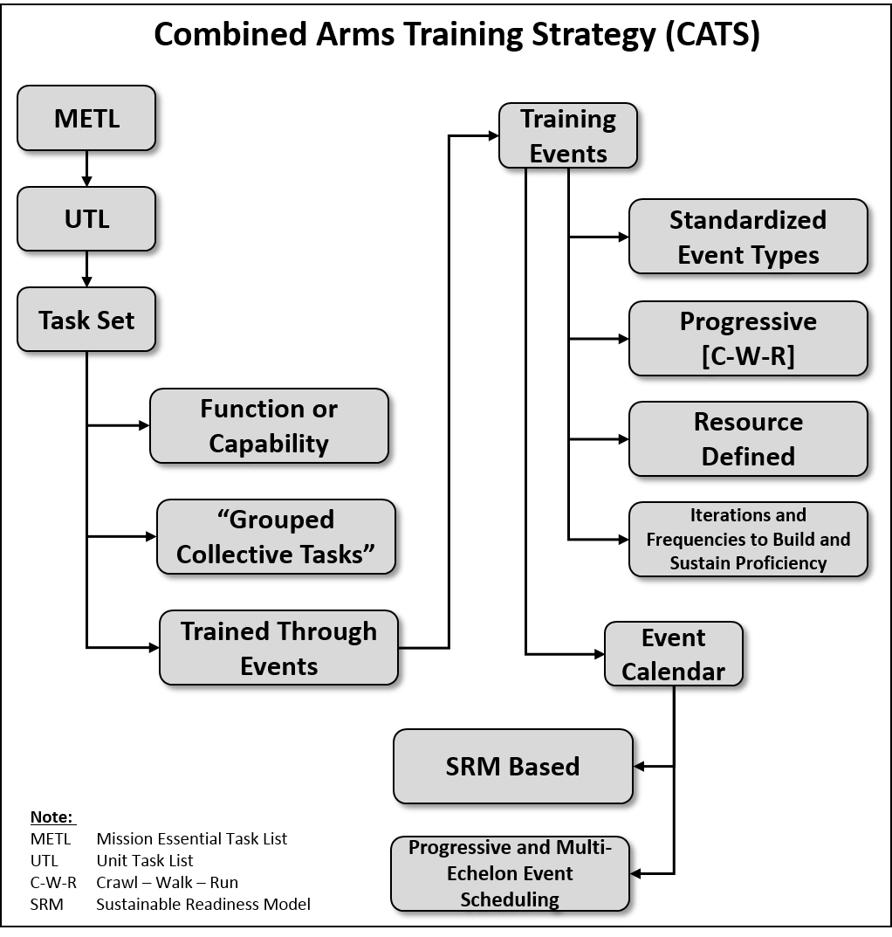

Figure 3-1. Elements of a CATS

b. The first step is initial analysis and documentation. This is critical before the design and development begins in the CATS Development Tool. This analysis is a collaborative process between the TNGDEV and the proponent agent that results in an accurate start point to develop a CATS in the CATS Development Tool.

(1) The TNGDEV must access and analyze key documents and information to gain an understanding of the unit’s METL, mission and capabilities, functions, organization, personnel and equipment, and the applicable doctrine that describes how the unit executes its mission, functions, and capabilities. The analysis or crosswalk of these documents associates the UTL to the appropriate task set(s) in a CATS. Baseline documents and information for analysis include:

(a) TOE.

(b) UTL.

(c) Appropriate ARs/Army doctrine publications (ADPs)/ Army doctrine reference publication (ADRPs)/FMs; Army Tactics, Techniques and Procedures (ATTP); and training circulars. As a minimum, this includes AR 350-1, ADP 7-0, ADRP 7-0, and FM 7-0.

(d) HQDA standard METL for designated organizations, to include METs, and supporting collective tasks (SCT).

(e) Previously developed CATS for this and like units.

(f) Parent headquarters’ TOEs, UTLs and CATS.

(g) ATN, <https://atn.army.mil/>.

(h) CALL documents.

(i) HQDA, FORSCOM, and United States Army Special Operations Command (USASOC) resourcing consumption models.

(j) The proponent Force Modernization Plans.

(k) Other materials influencing documents as determined by the responsible proponent.

(2) The TNGDEV must also obtain and review other key documents that will provide the necessary understanding of future requirements that may impact CATS development. Some of these documents include the following:

(a) The training strategy for an organizational concept and design for a new unit. Normally, this is a separate chapter in a new unit operation and organization plan such as those found in the TP 525 series of publications that identify future concepts.

(b) A DOTMLPF-P integrated change recommendation.

(c) Basis of Issue Plans (BOIP) and other TOE equipment relevant documents such as STRAP and new equipment training documents.

(3) Using the documents accessed, the proponent works in conjunction with the developer to document the required TOE and mission analysis data into the CATS Development Tool. The data includes the baseline TOE mission, functions, and capabilities, Standard METL, UTL, task sets if a prior CATS existed, TOE organizational paragraphs, equipment, duty positions, and subordinate units (this includes recording the TOE under the higher headquarters CATS subordinate table).

c. Development of FEA. Once the developer updates the TOE and mission analysis information in the CATS Development Tool, the TNGDEV begins the FEA for the TOE that will become the baseline development design for the CATS. The developer documents the FEA in the CATS Development Tool, and once approved by the proponent, the FEA will provide the initial data to begin constructing the CATS.

(1) The FEA includes the following activities:

(a) Validation of TOE data to include mission and capabilities.

(b) Verification of Standard METL.

(c) Identification of gaps, excess tasks, or errors in the UTL.

(d) Identification and development of task sets. Task sets are groupings of tasks that should be logically trained together to achieve training proficiency in a function or capability. During the FEA the developer will determine if a task set(s) needs developed. The process begins by identifying which UTL tasks logically need to be trained together to achieve a training progression appropriate by echelon for a specific function or capability. Organize these tasks into task sets. The task set documentation provides administrative data such as proponent and echelon; the collective tasks to trained; and it provides narrative information that includes the task set description, capabilities, and functions to be trained, and training guidance to progressively train the overall task set. A summarized list of the elements in a task set is at figure 3-2.

(e) Collective task to task set crosswalk. Account for every UTL task in at least one task set. Capture unit design functions or capabilities in a grouping of tasks in a task set(s) that ensures the function or capability is trained proficiently. This creates a direct audit trail between the task sets and the unit's TOE functions/capabilities that will frame the unit's holistic training strategy. A new task set must be created or an existing one modified if the crosswalk identifies a task, function, or capability cannot be fully trained to proficiency in the strategy.

(f) MET and SCT crosswalk to METL focused task sets. The developer aligns the task sets that are METL focused with the appropriate MET to enable the user to later tailor the strategy to more specific METL focused training plans. Each task set will have specific events that provide a progressive means to achieve training proficiency for the grouped tasks. Some task sets may build on training proficiencies in other events and other task sets, such as staff section events providing progressive staff training proficiencies for full staff training. The developer assigns an initial number of iterations and a duration to each event associated with the task sets that are in the Training Event Matrix (TEM). The METs tab crosswalk ensures every MET and SCT is included and trained in a task set. Identifying and linking the METL and task sets enable the CATS user to identify those minimum task sets and events needed to create METL focused training plans.

(g) Identification of task set event iteration and duration. The Training Event Matrix captures the recommended number of iterations and the duration for each training event to achieve and maintain the task proficiency for each task set applied to the specific TOE. The iterations and durations should account for a reasonable assessment of skill atrophy, personnel turn-over, and training progression as well as other factors affecting the strategy. The TEM also provides the ability to designate specific events that count as part of the SRM for that TOE, which at a minimum should include METL-focused training events. CTE are possible to develop and integrate into the FEA while working in the TEM tab (accomplished during the CATS development). The analyst can select the Add CTE button when they scroll to the bottom of the TEM data entry window. A general information tab will appear, and then enter the required base data for a CTE. Once complete, the analyst selects the OK button, and the CTE is on the TEM page. The CTE will require iterations and duration entered on the FEA TEM data entry window, and task sets aligned with the event during CATS development in the Events page. Paragraph d(3) describes culminating training events, below.

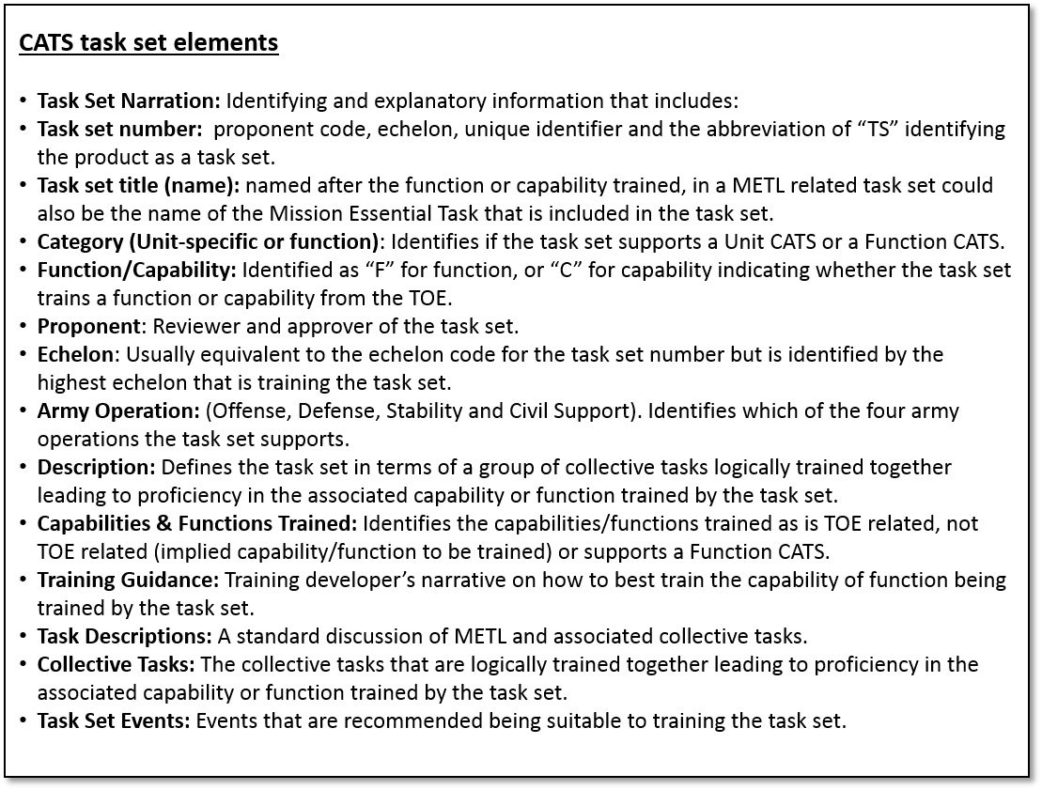

Figure 3-2. The CATS task set elements

(2) The detailed development of the task set begins with the task set narration.

(a) Task Set Number. Assign the task set a unique number using the protocol depicted in figure 3-3. Parts of a task set number are as follows:

* The first two numbers are the proponent code. Figure 5-2 lists the Proponent codes.
* The second two letters distinguish a CATS task set from a collective task number. Use TS for CATS task sets.

*Note.* When developing Function CATS, the two-letter abbreviation uses an appropriate descriptor such as FID for Foreign Internal Defense or other military operation or WFF.

* The proponent designates the final four numbers to ensure the task set number is unique to the specific task set. The first of the four numbers is the echelon code and the last three are sequence numbers. Task set codes appear in figure 3-3. An example of a complete task set number is 01-TS–6717.

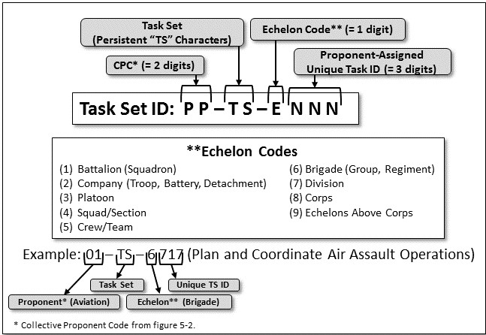

Figure 3-3. CATS task set numbering

(b) Task Set Title (name). Title is descriptive of the capability/function to train. The basis for linking the collective tasks that can logically train together is the task set title. Write the task set name in title case and the name is a descriptive name for the entire selection of collective tasks. When naming the task set, avoid the use of multiple verbs. However, the task set name may include multiple verbs by exception, such as *coordinate and manage*, or *establish and maintain*. The task set name sums up the entire unit or echelon focus as the training progresses through events of varying degrees of difficulty. For METL-related task sets, the task set name should use the same title as the MET training when it clearly identifies the focus of the task set training.

(c) Task set category. Identifies whether the task set is unit specific (i.e. TOE) or trains a Function, (i.e. Function CATS).

(d) Function/Capability. This indicates whether the task set trains a capability (C) or a function (F), and the TOE provides this. If the task set trains both, use capability (C). The guiding principle is that if the focus of the task set is on a MET, or the task set focus is on providing a service or support to an outside organization, and it is the primary reason for the existence of the organization, then it is most likely a capability. For Function CATS, it will also most likely be a “capability” (C). If a task set trains tasks that primarily focused on internal operations or the internal functioning of the organization (internal staff processes, providing internal sustainment of a headquarters), the task set will most likely be a “function.”

(e) Proponent. Identify the proponent that has review and approval authority of the task set.

(f) Echelon. Identify the echelon that trains the task set and this is usually equivalent to the echelon code for the task set number.

(g) Army Operation(s). Identify all of the operations to which the task set could apply: Offense, Defense, Stability, and Defense Support to Civil Authority (DSCA).

(h) Description. Identifies the MET, capability or function(s) trained within the task set that the TOE defines, and that when executed to standard allows the unit to perform that MET, capability, or function.

(i) Capabilities and functions trained. If the task set is TOE related, then the developer pulls the primary capabilities/functions the task set trains from the TOE(s) that the task set supports. If not TOE related, e.g. an implied function or capability that the Task Set trains, then a developer notes the function is not based on a specific capability, but describes the capability to be trained. If it is a Function CATS, support it with a doctrinal reference since there is not a TOE associated with the capability to train. Function CATS will most likely train capabilities.

(j) Training Guidance. The developer recommends the best progression to train-to-task proficiency. The training guidance should provide a roadmap of events for the tasks to train from the crawl to run proficiency. If the task set does not contain a “walk” or “run” level event, the developer must identify where the tasks will move through walk or run events in order to achieve appropriate levels of training proficiency. An example is the geographic information system **(**GIS) Topographic Engineer element which moves from a walk level squad situational training exercise (STX) within the task set to a run level proficiency in an advanced staff exercise (STAFFEX) defined in another task set (see figure 3-6, CATS task set example). If there is no “run” level event required, the developer notes it. The training guidance should also highlight any unique training considerations such as specific recommended external participants, special coordination, or special equipment requirements integral to training the task set.

(k) Tasks Descriptions (collective tasks): These are the collective tasks logically trained together in an event. Some tasks can be trained in more than one task set and in multiple task set events (for instance, at a lower level of training progression, i.e. specific staff element team training versus a full staff exercise event). There could be as many as three types of tasks within a task set: standardized MET, SCT, and associated tasks. METs are collective tasks an organization must train to be mission or capability proficient. SCTs are proponent developed and are tasks that enable, or may enable the successful performance of the MET; these tasks are SCTs in the METs T&EO. Associated tasks are all the tasks that make up a task set. They are tasks that are logically trained together to give a unit a complete and holistic capability or function. Commanders may exclude or add collective tasks to focus training according to their readiness assessments. The collective tasks cover the entire spectrum of activities a unit performs and are drawn from the UTL. Train all collective tasks in a UTL in at least one task set.

(l) Types of events: The central effort during CATS development is to construct the events for the task sets that will provide the means to train the tasks to standard. Figure 3-4 identifies the event components and includes critical defining information such as the training audience, resources, and training gates. The developer selects the event(s) that are suitable for training the task set to a specified level of training proficiency. Each listed event provides a means to train the selected task(s) for a specific task set. When FEA development creates the event, the basic elements of a task set supporting event are defined and remain constant for all CATS utilizing the task set. The remaining elements are defined during CATS development and are unique to each unit CATS that utilizes the task set for collective training. The basic elements include the event type, condition, title, training environment, purpose, outcome, and execution guidance. Figure 3-4 contains the full listing of diagramed event elements.

*Note.* Lower level task set events should lead to a higher fidelity event such as the Culminating Training Event.

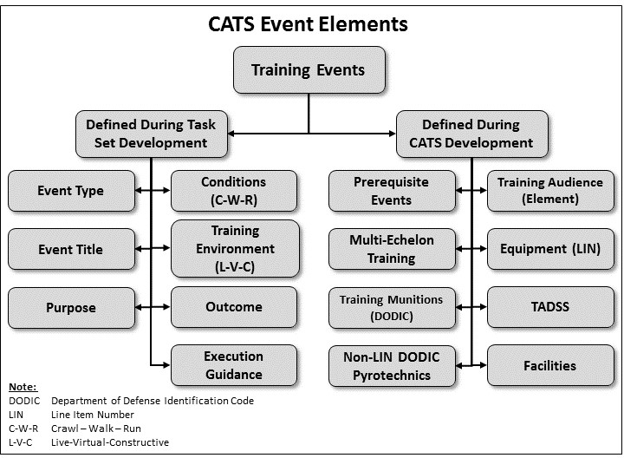

Figure 3-4. CATS event elements

(m) The descriptions below explain the event base elements and the unit unique event elements are explained within the descriptions in the CATS development paragraphs that follow.

* Event Type. Awaiting updated and new definitions of event types following a HQDA G-3/5/7 review.
* Conditions. The events’ design uses the progressive training methodology per FM 7-0 to build and sustain training proficiency known as crawl, walk, run (C-W-R).
* Event Title. The event name is followed by the task set name; for example, command post exercise (CPX) for Conduct Combat Operations. The CATS Development Tool provides a training event matrix by task set.
* Training Environment. Used as a category in the CATS Development Tool and refers to the training environments of live, virtual (includes gaming), and constructive (L-V-C).
* Purpose. This describes the event’s training design and training objective; these are short and concise statements.

*Example*: Attain battalion leadership proficiency in the tasks associated with conducting combat operations under simulated operational conditions.

* Outcome. Outcome is a concise statement to assist the commander or unit trainer in selecting the best event to achieve the required training proficiency.

*Example*: The battalion leadership attains proficiency in planning, preparing, and executing combat operations and associated tasks, and is prepared to train under more complex and challenging conditions.

* Execution guidance. Execution guidance is information to assist the commander to determine if this training event is appropriate to achieve unit readiness requirements. The guidance includes information to assist in planning and execution of the event, such as conditions, incorporation of multi-echelon training, specified standards to achieve, TADSS and facilities details, and specific requirements or information in other components of the CATS. Figure 3-5 is an example of an execution guidance statement.

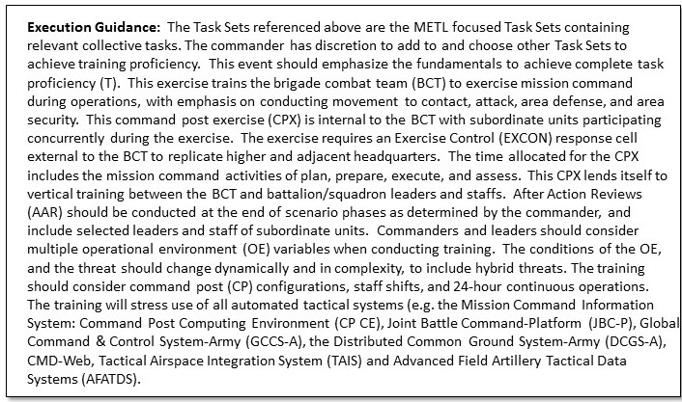

Figure 3-5. CATS execution guidance example

(1) Include execution guidance comments as appropriate concerning the follow-on related information:

(a) The relevance of this event to training the specific audience and its relation to higher echelon training events.

(b) The required higher HQ support.

(c) The participation of attachments/supporting units (such as coordination, gates).

(d) The commander’s guidance on: suitability of the TADSS to support the training of the task, use of WTSPs, special conditions that need to be implemented or emphasized, and coordinating instructions for all members of the target audience and support elements.

(e) Any workarounds if the TADSS does not train all tasks/task steps.

(f) Additional information for execution of the training event.

(g) Duty position or unit responsible for conducting the training.

(h) Focus of training during the event.

(i) Additional functions or activities that should be included.

(j) Special conditions that should be implemented or emphasized.

(k) Related actions in which this action could be included/trained.

(2) An example of a complete task set is in figure 3-6.

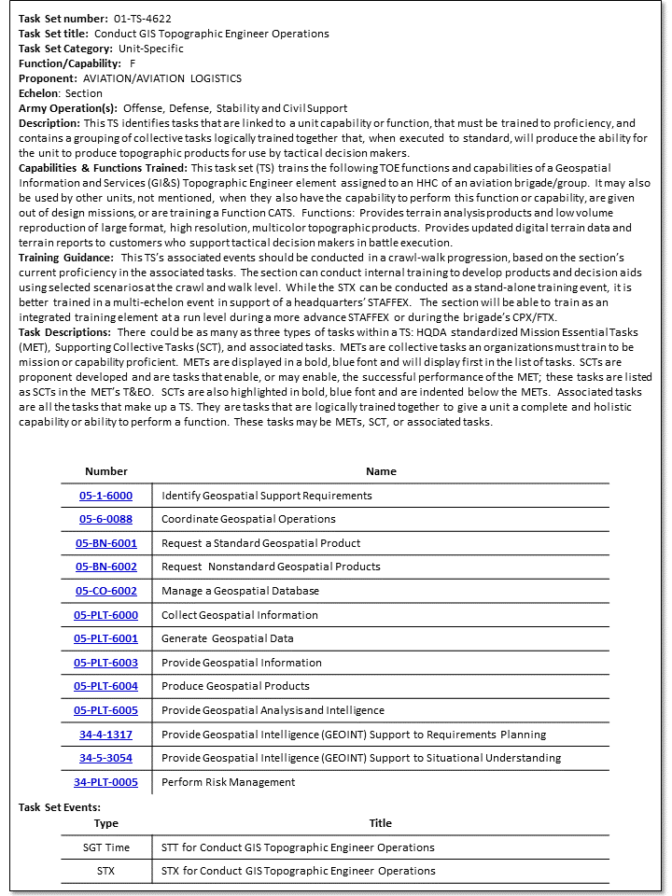

Figure 3-6. CATS task set example

(3) Once all of the requirements for the CATS design are completed to include development of new task sets as required, the FEA is documented in the CATS Development Tool where it can be reviewed, approved and then used as the baseline to develop the CATS.

(4) The FEA helps ensure a viable training strategy is developed and it provides the means through which the proponent confirms and approves the baseline design in order to continue development of the CATS. This analysis is a collaborative process between the TNGDEV and the proponent agent. The developer submits the FEA in the CATS Development Tool for the proponent agent to review and approve. Once approved, create the initial draft CATS and the unit CATS development can begin.

d. CATS Development. CATS development begins when the unit CATS is created from the FEA. During initial CATS development, on the CATS development page in CATS Development Tool, the developer confirms and updates CATS baseline data; unit METL, UTL, and task sets to include confirming that all collective tasks are included. Once baseline data has been updated, the central effort of the CATS development is to mature and complete the task set event data. All of the following CATS Development Tool references are to the tabs on the CATS development page unless noted otherwise.

1. Basic event data. Review and update the basic event data from both the Task Sets tab while editing a task set or on the Events Tab by editing a specific event. Be careful when editing any base event data because it will affect every CATS that utilizes the task set for training. Only the proponent or proponent developer who has responsibility for the task set should make modifications. Make changes only following coordination among other developers utilizing the task set.
2. Unit unique task set event elements.

(a) Iterations (Frequency in the current Event Edit window). The iterations reflect the recommended number of times to conduct this event is during each SRM phase. Iterations for training must be different for AA and RC units. Examples for an event for an AA and an RC unit could look like those in figure 3-7.

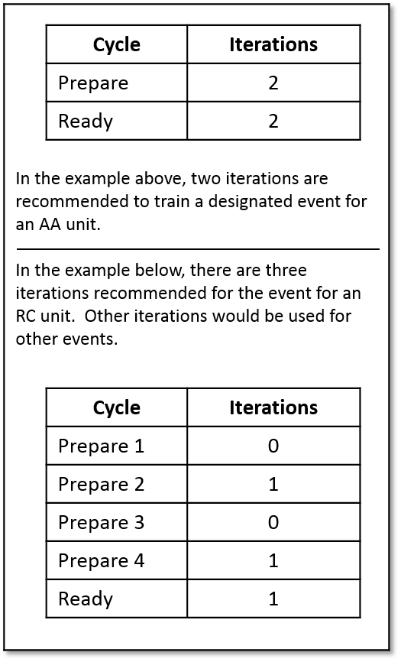

Figure 3-7. Iteration example

(b) Duration. The duration is the projected number of hours to conduct the event to include AARs throughout an entire Sustainable Readiness Cycle. See figure 3-8 for an example.

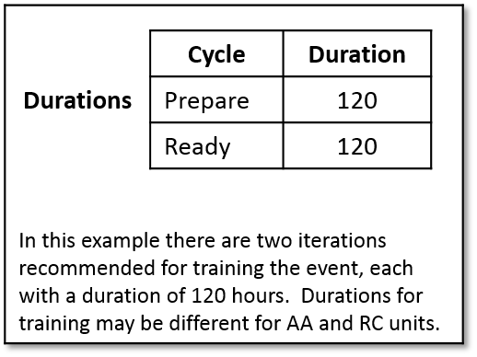

Figure 3-8. Duration example

*Note.* To input data for each of the event elements on the CATS Development Tool Events tab, the developer selects the blue number at the intersection of the event line and the appropriate column of specified data. A data entry window will open for each of the data columns to enter data specific to that event.

(c) Prerequisite events (training gates). The identification of training gates provides a progression to achieve a level of task proficiency before training the next higher level event. Gates identify a level of proficiency necessary to accomplish the following: preclude serious personal injury or equipment damage; ensure the training audience is qualified enough to benefit from participation in the current event; and ensure the training audience will be proficient enough not to hinder training for other participants. When determining training gates, the CATS developer should consider the following:

* A preliminary event to achieve an appropriate level of training proficiency before conducting the event.

*Example*: Accomplish planning a STAFFEX event before a CPX.

* Train supporting and enabling task proficiency required to effectively train in a more complex event.

*Example*: Accomplish a Sergeants Time Training event to train the operation and supervision of digital systems at the crawl level in order to utilize digital systems in support of a unit force protection, walk level, STX event.

(d) Training audience (Element). Identify elements of a unit, individuals, or subordinate units who should participate in the event to achieve the required level of proficiency. Identify units or individuals as part of the training audience that are not included in a unit’s TOE and that participate in the event training; and, include their TOE numbers. Figure 3-9 provides an example.

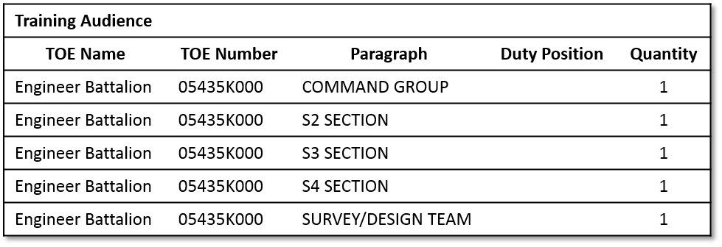

Figure 3-9. Training audience example

(e) Multi-echelon training (if applicable). Multi-echelon training is the simultaneous conduct of training events by a unit’s subordinate elements under the umbrella of a higher echelon event. For example, while the battalion headquarters participates in a brigade CPX, subordinate companies of the battalion are conducting other training such as a company STX or live-fire exercise (LFX). Multi-echelon training includes other task sets and events for subordinate elements that may be trained in conjunction with this training event. Identify multi-echelon training opportunities for all echelons within the unit for which one is developing a strategy.

(f) Resources. Resources are the estimated quantity of fuel, munitions and pyrotechnics needed to complete this event. The resource data is based on the unit TOE (STRAC) and DA usage factors that are automatically generated for the event. Actual resource usage may differ from the projected usage rates based on the training conditions, training areas, environment available to the unit to train, and duration of the training event. At this time, resource data reflects only major end items (Class VII) that consume Class III and V supplies. An example of resources allocated to a training event is at figure 3-10.

*Note.* The line item number (LIN) equipment data, the associated mileage and hour data for CL III estimates, Department of Defense identification code (DODIC) munitions consumption estimate data, and the non-LIN DODIC data (pyrotechnics) consumption estimates, provide the basis for estimating and forecasting Army-wide training resource requirements. At the unit CATS level, it ensures identification of appropriate consumable resources in order to train the tasks in the task set to standard.

* LIN (Equipment). The developer selects the equipment to use to train the specific event from the unit's TOE equipment listed under the LIN column on the CATS event development page. When selecting weapons or weapon systems, the CATS Development Tool will auto populate the DODIC column with specific munitions based on the STRAC allocation for the type event. The developer will provide estimated mileage or hour usage estimates for each piece of TOE equipment that will consume CL III supplies for the event. The CATS Development Tool will automatically calculate the estimated CL III consumption based on consumption factors established for each LIN of equipment.
* DODIC (Munitions). Use the STRAC tables (DA Pam 350-38) to determine the quantities and types of munitions required for Soldiers, crews, and units to attain and sustain weapon proficiency relative to readiness levels. The developer follows the guidelines in DA Pam 350-38, and proponent gunnery and qualification requirements to project munitions for conducting the CATS training events. The CATS Development Tool will auto populate the DODIC column data fields for the type event based on the STRAC allocation once the weapons or weapon systems are identified by LIN in the LIN column. It will use the number of weapons assigned or a number specified by the developer in the LIN data fields. However, the developer ensures accurate entry of DODIC data and must input DODIC data for weapons or weapon systems that have not been loaded into the STRAC tables, such as newly fielded weapons.
* Non-LIN Items (Pyrotechnics). The developer selects appropriate non-LIN items based on STRAC and training event requirements. Some items are required in order to use TADSS or to meet specified conditions of training (LA06 Simulator, Main Tank Gun M30, and LA07 Simulator, Direct-Indirect Fire M40, are required to utilize the TADSS, 05-113 Improvised Explosive Device Effect Simulator (IEDES)). The STRAC for these items is based on an annual allocation by type unit for field training. The developer should determine what Non-LIN items are required to achieve the training conditions for each specific event. The commander needs to know what is required to train effectively and can make distribution decisions across the events to stay within the unit STRAC allocation. The Non-LIN items allocated for one event, such as a culminating event, should never exceed the annual STRAC allocation for the unit.

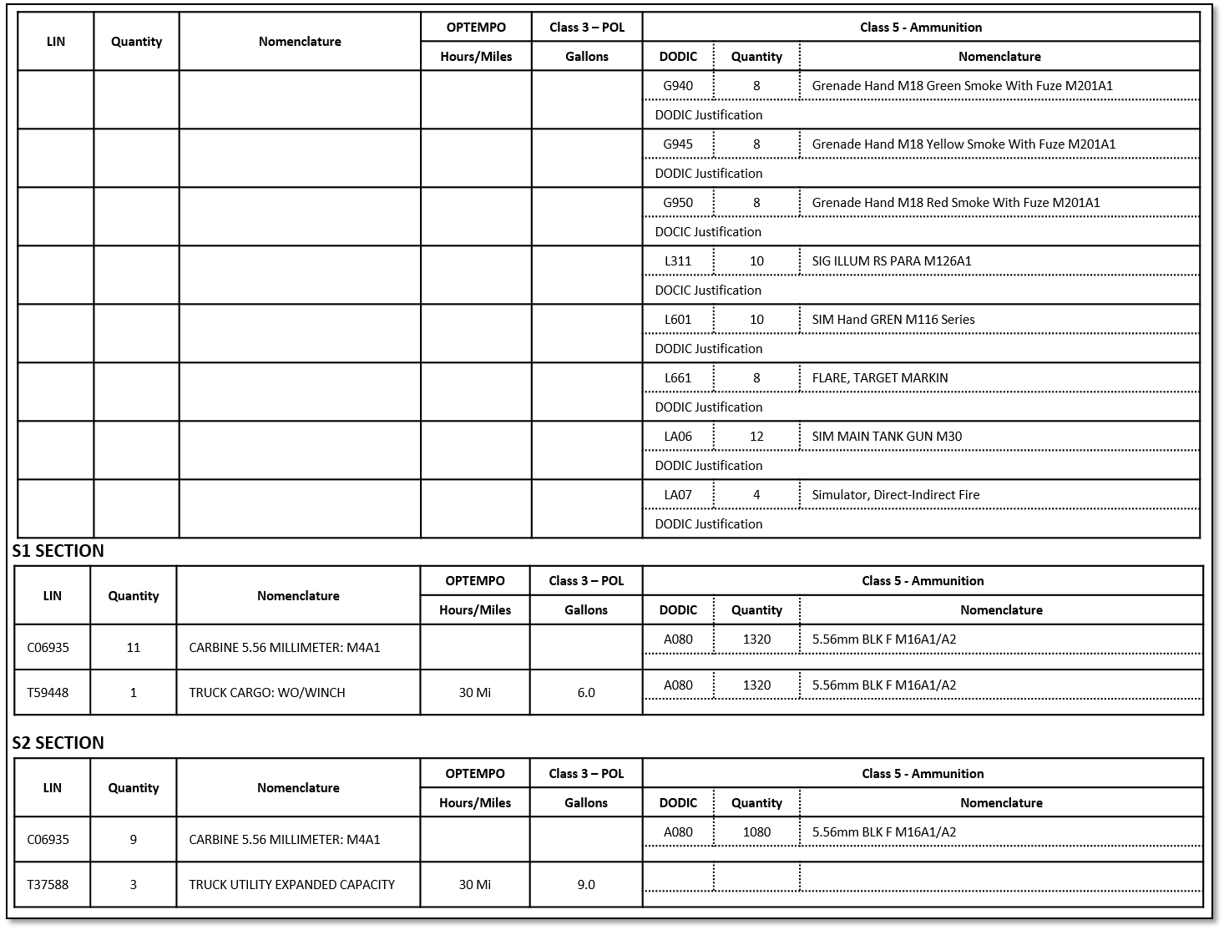

Figure 3-10. Example of resources allocated to a training event

(g) TADSS (if applicable). If utilization of a TADSS is required to establish a specific condition of training (IED simulator during a react to an IED force protection event) or the TADSS will provide an appropriate level of training fidelity, note the TADSS title and device number(s). Pre-populate the supporting TADSS resource data in DTMS. TADSS data is drawn from the Training Support Materiel Armywide Tracking System. The developer should employ a TADSS sub-paragraph to describe the details of training for the event within the Execution Guidance section.

*Example*: Improvised Explosive Device Effects Simulator (IEDES), 05-113. Use this TADSS to simulate a broad range of potential IED environments and provides the noise and visual effects to cause an individual and collective training response. This TADSS provides an example where other resources are required to make it work or are required to help establish the training conditions (Non-LIN pyrotechnics).

(h) Facilities. The developer must identify training support requirements such as range facility requirements, classrooms, maneuver area requirements, and other Training Support System requirements not addressed in the TADSS section. Required training facilities necessary to conduct the training (simulation center for a simulation based event) should be indicated in the facilities column and should be described in the Execution Guidance section of event.

*Examples*: Multipurpose range complex to support tank gunnery; a classroom with seating for 25 personnel; and a projection device with computer interface.

(3) CTEs. A culminating training event is a unique event that is not associated with a task set. The CTE is a run level event that is focused on training primarily the METL related or critical task sets. The event is intended to provide the resources and fidelity to enable a unit to culminate a METL focused training strategy and achieve proficiency on the unit METL. The commander may choose to train other tasks from the UTL or other task sets, but the design focus is on METL proficiency. Deployment training is the only common exception. It is normally developed within one task set and progresses through crawl, walk, and run proficiency with the deployment exercise (DEPEX) as its culminating event. If the CTE is developed during CATS development, it is done while working in the Events tab of the CATS Development Tool. Once the Add button is selected at the bottom of the page, an Add-New-Event window opens that allows the developer to create the CTE base elements just like events are created for a task set. The CTE base elements and the unit unique event elements are entered in the same manner as described for other events with one exception. In column TS on the Events tab window, the developer identifies and selects the METL focused task sets (excluding deployment) that would comprise a logical progressive METL focused training strategy leading to the CTE. Unlike other events that are associated with a specific task set, these METL focused task sets now become associated with the CTE.

(4) The CATS is complete, as a draft training strategy when the final CTE is developed and all basic and unit elements have been developed. Provide the initial draft of the CATS to the internal quality control team for review. Once corrections to the initial draft are complete, submit a coordinating draft to the proponent agent for review and approval. The developer will make proponent directed corrections and submit a final draft to the proponent for review and approval. Once the final draft is approved, the CATS is finished. All CATS draft reviews may be completed entirely utilizing the CATS Development Tool. However, the developer will provide the draft CATS in a format that meets the reviewers requirements.

e. CATS notional calendar. Once the CATS are finished, the developer has one more responsibility before the strategy is ready to be published in DTMS for units to use. The developer uses the event calendar function in the CATS Development Tool to create a notional training calendar for each CATS. Once the calendar is complete and is approved by the proponent, the CATS is ready to be published in DTMS.

(1) The notional calendar is a visual representation of the strategy over time that progressively builds unit training proficiency. The notional training calendar is laid out and synchronized with the Sustainable Readiness Cycles, two-year cycles for the AA (Prepare, and Ready) and a five year cycle for the RC (Prepare 1, Prepare 2, Prepare 3, Prepare 4, and Ready). The calendar represents how the TNGDEV would schedule the events in the CATS during the Sustainable Readiness Cycle to build proficiency per benchmarks established per SRM. Where AA units perform their mission daily, a one-year cycle is acceptable that sustains readiness vice building proficiency. Designated Special Forces, Signal, Cyber and Sustainment units would be examples of units that could have a one-year sustainment model. With a one-year model that focuses on sustaining readiness, the CATS will still include crawl level events to provide an option for commanders and trainers for possible inclusion into their respective training plans.

(2) The current version of the CATS Development Tool calendar is drag and drop enabled, and each training month contains 30 days. The TNGDEV populates the events by month. The TNGDEV further refines the placement of events within the training month, which is expandable in the calendar function of the CATS Development Tool. Events will automatically cover the total number of days in accordance with the suggested duration of each event. Figure 3-11 illustrates the CATS event calendar function.

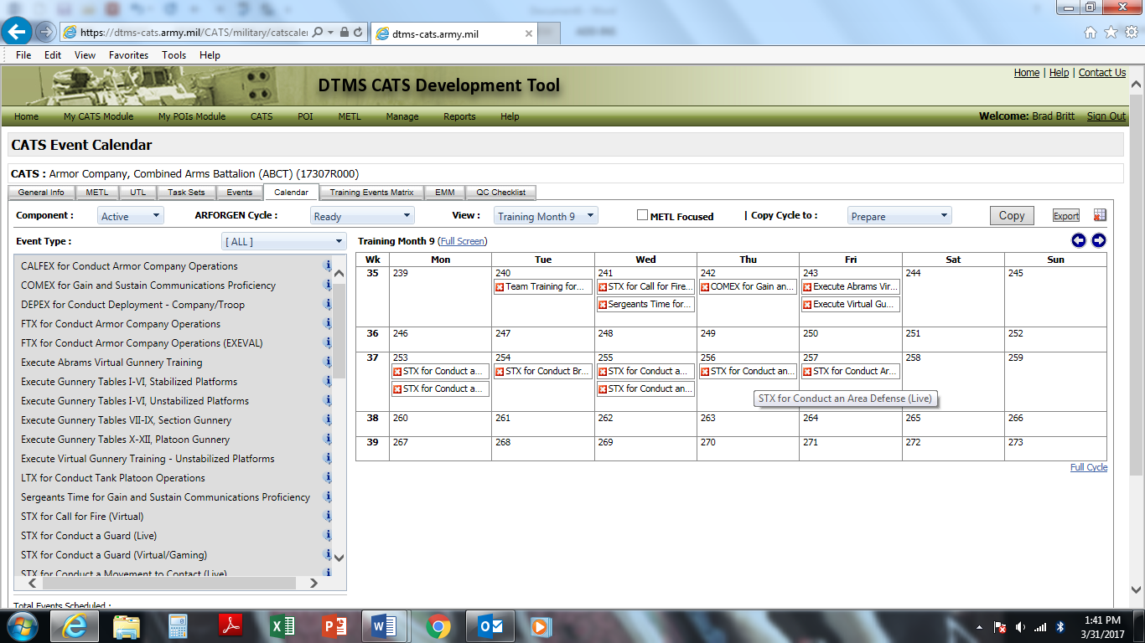

Figure 3-11. CATS notional calendar example

## 3-6. CATS Management

Table C-1 provides a CATS QC review checklist to manage and document control measures, identify areas to improve, and facilitate timely delivery of the CATS. The checklist facilitates tracking CATS from design approval through release to the field in DTMS. The checklist will serve as a tool for proponent and program manager CATS management, and the TRADOC QAO accreditation team may employ it.

# Chapter 4 Warfighter Training Support Packages (WTSP)

## 4-1. Introduction

a. WTSP definition. A WTSP is a complete, detailed, exportable package integrating training products, materials, and information necessary to support operating force training. WTSPs provide the actual details for securing the materials, training venues, and other necessary resources identified in each Unit CATS training event supporting the Standard METL for designated units. Use ADDIE when developing WTSPs.

b. WTSP relationship to CATS event(s). Develop WTSPs to support the operating force with execution of the CATS event(s) identified in a task set. The creation or revision of a CATS task set drives the need to develop or revise a WTSP. The WTSP provides higher headquarters with the information to allow the training unit to plan, prepare, execute, and assess the event(s) identified in the CATS task set. The WTSP also provides the training unit with identification of the support materials necessary for the event planning and coordination process. The more complex the event(s), the more robust the WTSP needs to be to support it. Figure 4-1 depicts the three categories of events; generally, develop WTSPs only for scenario-driven events. More information on CATS events will appear following the HQDA G-3/5/7 review and update of all CATS event types.



Figure 4-1. WTSPs relationship to CATS events

c. WTSP relationship to required resources. The commander’s assessment of resources available impacts which CATS event(s) to train. This in turn affects which portions, if any, of the WTSP is used to support event training.

d. Characteristics of a WTSP.

(1) Contains cues. A WTSP includes a set of materials that cues the unit to take certain actions, or causes certain events to occur.

(2) Linked to Unit CATS. The TNGDEV must link the WTSP to the Unit CATS Event as enabled by DTMS. For example, the design of the armor brigade combat team (ABCT) WTSP (17-TS-6106) supports training for and the execution of the CATS recommended event for the ABCT to conduct a CPX for the ABCT task set Conduct an Attack (17-TS-6106). Since the WTSP is developed to support the CATS task set, linking the WTSP to the Unit CATS describes the support needed for the brigade HQ staff to meet the collective training requirements described in the SRM prepare module.

(3) Flexible to change. The WTSP contains flexibility to allow latitude during implementation to meet the unit’s training objectives. The WTSP predefines the training environment options and resources to alleviate the burden of development from the training and training support units.

(4) Robust. Develop the WTSP at the most robust level to support potential environments and complex events for unit training; units tailor the robustness of the WTSP to fit less complex event training.

## 4-2. Analysis for WTSPs

a. The TNGDEV identifies the training focus by analyzing the CATS task set the WTSP needs to support.

b. The TNGDEV determines any additional requirements for virtual and/or constructive environments based on whether a CATS event is live, virtual (including gaming), and/or constructive. Table B-3 provides guidance to the TNGDEV as to whether a component is limited to a certain environment(s).

c. Questions to consider for determining additional requirements based on environment include:

(1) Do the tasks trained require a digital cue or response?

(2) Is there embedded training to provide the appropriate cue or response?

(3) Is a simulation/stimulation capability available?

d. Upon determining the complexity of the events to train, the TNGDEV identifies and develops the components needed for the WTSP.

e. The numbering system for all WTSPs must utilize a standard format based on the CATS TS number. Since the CATS TS number is developed to specifically include the proponent code, task set identifier, and echelon designation with additional unique identifier, the WTSP that supports the task set simply adds "WTSP" prior to the CATS TS number. For example, the WTSP for the CATS task set Conduct Combat Operations (07-TS-1052) would be Conduct Combat Operations (WTSP 07-TS-1052). Figure 4-2 depicts WTSP numbering.

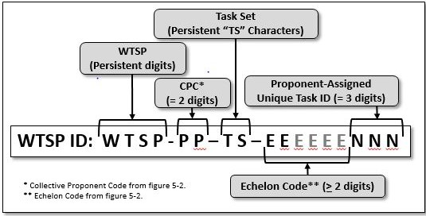

Figure 4-2. WTSP numbering

f. The title for the WTSP uses the same numeral scheme as the task set name. The WTSP title is different from the CATS task set due to the "WTSP" added to the number.

## 4-3. Design the WTSP

a. The TNGDEV utilizes the pre-designed WTSP format. The WTSP design identifies the components of the nine elements needed to support the training event. This determines the robustness of the WTSP. For standardization, developers include each WTSP element and component. However, all WTSPs may not need all elements or components of each element; indicate "Not Required" for any element or component containing no data. For example, a section-level certification WTSP may not require a complete operations order (OPORD) or TADSS.

b. The major elements of a WTSP and components are below. Descriptions and examples of the components appear in table B-3.

(1) Identification. Identification provides a description of the event including details specific to unit, mission, and security classification. The TNGDEV details the identification information for all events. This element’s components are the following: Event Title, Event Security Classification, Echelon(s), Unit Type, Unit Designation, Mission Type, Event Type, TADSS, Developer/Point of Contact (POC) name(s), Developer/POC Unit Identification Code and/or Organization(s), Developer/POC phone number(s)/E-mail address, WTSP Development Status, and Date.

(2) Event overview. Event overview provides background information and the event narrative of the standards to meet. For the event overview element, the following components apply to all events: Conditions, Nature of the Threat, Event Difficulty, Training Objective, Cues, and event AAR notes. This element’s other components are the following: Event Narrative, Event Storyline, Task Groups/METL Tasks Supported, Task Number, Task Title, Task Date, Collective Tasks Trained, Task Number, Task Title, Task Condition, Task Standard, Task Date, Task Performance Support Codes, Individual Tasks Trained, Task Number, Task, Title, Event Diagram, and Event Development Notes.

(3) Tactical materials. Tactical materials are materials needed to describe tactical operations. This element’s components are listed below and include the following: Orders/Plans, Map Sheets, Overlays, Tactical Reports, Reports, Transmission Methods, Road to War, Geographical Location, Geographical Setting, Political Factors, Economic Factors, Social Factors, Military Factors, and Infrastructure Factors.

(4) Event control materials. Event control materials delineate the description and guidance for conducting the event. The Cues and Unit Responses/Tasks components of this element apply to all events. The element’s other components include: Event Storyboard, the Event, Event Execution Timeline, Event Support Personnel Guidelines, Role Duties, Location, Tactical Purpose, Execution Guidance, Unit Starting Locations, Unit ID, Unit Type, Grid Coordinate, Control Measures List, Control Measure Type, Control Measure ID, Control Measure Grid Coordinate, Target Array, Target Type, Target Quantity, Target Position, Target Ignition, Exposure Time, Engagement Criteria, Rules of Engagement, Administrative Training Rules, Army Aviation, Air Defense, Civilians on Battlefield, Combat Electronic Warfare, Combat Service Support, Mission Command, Direct Fire Engagements, Dismounted Operations, Fire Support, Mobility and Survivability, CBRN, Enemy Prisoners of War Considerations, Tactical Air (TACAIR), Communication, Call Signs, Communication Network Diagram, and Simulation Workarounds (virtual/constructive).

(5) Event setup materials. Event setup materials include descriptions and information for setting up the training of the event based on the training environment. This element’s components include Training Area/Range (live), Terrain Database (virtual/constructive), Initialization Data for Mission Command Information Systems, Training Site/Range Preparation, Event Date & Time Group, Force Structure, Blue Force (BLUFOR) Task Organization, Opposing Forces (OPFOR) Task Organization, Black Elements, Gray Elements, White Elements, Green Elements, Classes of Supply, Starting Locations (virtual/constructive), Starting Conditions (virtual/constructive), Environmental Conditions (virtual/constructive), Communication Plan (radio nets, radio frequencies), Simulation, and File(s) (virtual/constructive).

(6) Evaluation plan. The Evaluation plan identifies observer details, tasks to be accomplished, and after action reporting considerations. The components of this element that apply to all events are the following: Observation Plan, Supporting Collective Tasks, Supporting Individual Tasks, Observation Tools, AAR Plan, AAR Focus, AAR Technique, AAR Facilitators, AAR Attendees, AAR Schedule, AAR Locations, AAR Type, and AAR Tools. The additional components of this element include the following: Observation Role, Observation Duties, Observation Location, Observation Schedule, Observation Focus, METL Tasks Supported, and Collective Tasks Trained.

(7) Administrative materials. Administrative materials provide timelines leading to the event, related agencies, and safety considerations. The components of this element that apply to all events include the following components: Personnel Requirements, Personnel Required, Observer/Controller, Higher/Adjacent/Subordinate Units, Risk Management, Environmental Considerations, and Safety Considerations. The other components of this element include the following: Planning Timeline, Event Schedule, OPFOR Units, Civilians/Government Agencies, Administrative Support, Personnel Qualifications, Military Occupation Specialty, Rank, and Military Education/Experience.

(8) References. References include resource documents and related materials. Components of this element include the Document List and the Key Word Index. A document list must be included with all events.

(9) Glossary. The glossary lists terms, acronyms, and needed definitions.

## 4-4. Develop the WTSP

Each element of the WTSP has a number of components. In this phase, the developer determines the level of detail in each component. The developer imports support information and details for the WTSP from the events developed in the CATS Development Tool. The TNGDEV includes each WTSP element and component in all WTSPs and indicates *Not Required* for any element or component containing no data. See table B-3 for component descriptions, details, and examples.

## 4-5. QC

Table C-2 provides a WTSP QC review checklist designed to: manage and document control measures, identify areas to improve, and facilitate timely delivery of WTSPs.

# Chapter 5 Collective Tasks

## 5-1. Introduction

a. Purpose. This chapter provides guidance for the analysis, design, and development of collective tasks. This chapter supports and amplifies the regulatory guidance found in AR 350-1 and TR 350-70.

b. Collective task definition. A collective task is a clearly defined, discrete, and measurable activity or action that requires organized team or unit performance and leads to accomplishment of the task to a defined standard. A collective task describes the performance of a group of Soldiers in the field under actual operational conditions and contributes directly to mission accomplishment.

c. Collective task characteristics.

(1) Derived from a mission, core capability, or higher-level collective task.

(2) Fully observable.

(3) Reflects current and emerging Army, multiservice, or joint doctrine.

(4) Has a definitive beginning and ending, and articulates the minimum acceptable performance of an activity or action.

(5) Measurable quantitatively and/or qualitatively.

(6) Is specific enough and occurs only once for each echelon in the inventory of Army collective tasks.

(7) Execute from beginning to end during a single training event. For example, a collective task cannot require the use of a tactical exercise without troops (TEWT) to conduct planning-related performance steps and then require the use of a field training exercise (FTX) to conduct tactical execution-related performance steps. A collective task requiring two training event types in order to conduct the task from beginning to end indicates the requirement for two separate tasks. However, this does not apply to the use of different training events designed to build progressively individual and collective task proficiency using the crawl-walk-run-approach to training.

d. Collective task types.There are two types of collective tasks, shared and unique.

(1) Shared collective task. A shared collective task is a task developed by one designated proponent, and other proponents share in its use. Multiple types of units perform a shared task doctrinally in the same manner and provide multi-echelon training opportunities for multiple career management fields (CMFs). Developing tasks that parallel this doctrine ensures Army units train and fight the same way and can efficiently consolidate their efforts in response to conflict. Only one task written by one proponent represents shared collective tasks across the Army in order to ensure standardized training. Examples of shared collective tasks include the following tasks: *Conduct Troop Leading Procedures, Prepare Personnel for Deployment, Reconnoiter a Route, Perform Passive Air Defense Measures, Conduct an Area Defense,* and *Conduct a Tactical Convoy.*

(2) Unique collective task. A unique collective task is a clearly defined collective task that provides training opportunities for a single CMF. The designated proponent is solely responsible for the development and maintenance of a unique collective task. Incorporate these tasks into other proponents’ UTLs when the assigned CMFs are outside the unit’s proponency. An example of a unique collective task is *Install Underground Pipeline.*

e. Mission essential tasks. A MET is a collective task on which an organization trains to be proficient in its designed capabilities or assigned mission. A METL is a tailored group of METs. The STRAG reviews HQDA standard METs and METLs that proponents develop under the rules specified in the STRAG charter.

## 5-2. Analysis for Collective Tasks

a. Collective task analysis occurs as a direct result of a mission analysis identifying gaps in unit training. The developer/development team provides the results of the mission analysis to the proponent in terms of doctrinal deficiencies in the proponent tasks/missions. The development team also identifies and documents the collective tasks, and any individual tasks directly supporting mission accomplishment, and provides them to the appropriate proponent or office for further analysis. Identify and document the supported UJTL tasks to facilitate synchronization with joint training, as necessary. Before creating new collective tasks, the TNGDEV or SME must review the Standard METL, the appropriate proponent UTL as well as existing collective tasks in TDC. Identify and document the supported AUTL tasks for possible synchronization with joint training.

b. The collective task analysis process defines the collective training needs (performance goals or objectives) and the ways to measure successful performance of the collective task(s) identified. Conducting a thorough analysis is essential for making training/instruction relevant to unit performance. Analysis provides information about what skills or knowledge need to be trained or learned, the conditions under which that should occur, and the standard of performance that must be achieved. The results of analysis form the basis for creating and revising unit- training products. During analysis, a developer primarily focuses on understanding the expected outcome of the development efforts, while determining what information to draw upon.

c. During collective task analysis, the developer must determine if a new task is to be created, or if an existing task can be modified to fill a training gap. Figure 5-1 lists some of the considerations for determining whether a new collective task is necessary.

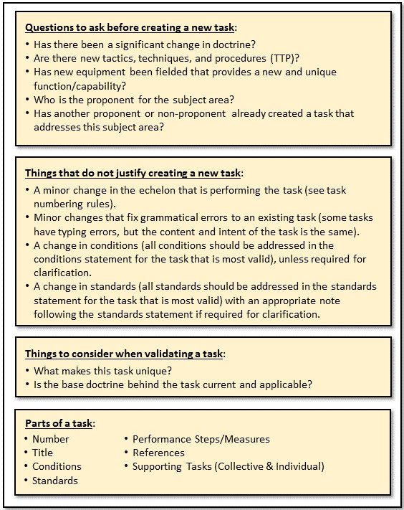

Figure 5-1. New collective task creation guidelines

d. Collective task analysis includes:

(1) Review doctrine. All collective tasks reflect current and emerging doctrine. The TNGDEV reviews the mission analysis data, appropriate ADPs/ADRPs/FMs, and related TTPs. Ensure all collective tasks are linked to an Army tactical task (ART) that supports the appropriate UTL/UJTL. Linking the collective task to the ART and UJTL/AUTL establishes a common language and reference.

(2) References. The review of doctrine results in the creation of task references. List only the minimum number of references for a collective task to aid Soldiers in locating the most appropriate reference(s). If using more than one reference to provide the doctrinal basis for the task, identify at least one primary reference using appropriate means. When possible, avoid including an expansive list of references simply because the document makes some degree of reference to the performance of the task.

(a) Training Circulars provide the standards for collective tasks that require live-fire, and they are an authorized reference.

(b) TMs may be a reference listed if the task is technical.

(c) STPs and WTSPs are not appropriate references.

(d) This guidance applies at both the task and performance step levels.

(3) Identify the target population. Consider the echelon when considering target population. Conduct the analysis of the collective task with the broadest applicable target population in mind. The developer must consider the needs of each unit and/or proponent that may use a particular task; there is no implication that a task should be developed generically. In order to satisfy the requirements of multiple proponents, the collective task analysis is detailed and the task must define standards that ensure high quality training for all applicable units. The analysis for a unique collective task is specific to a relatively small target population. For example, *Repair Underwater Pipelines* is unique to the engineers.

(4) Number the collective task(s). The numbering system for all collective tasks must use a standard format (PP-EEE-NNNN). All collective tasks use an alpha-numeric system for identification. The letters in the middle of the task identify the echelon. As a rule, developers should assign collective task echelon based on the echelon performing the task, and not where the task is performed. For example, a company-level collective task such as 10-CO-4000, *Conduct Force Provider Company Operations* is coded at an echelon level of company. Figure 5-2 displays the collective proponent codes (CPCs)/identification numbers and echelon abbreviation codes to create a task number. The CPCs listed in the figure below are not inclusive and represent the most common elements used for collective task development. Submit any new CPC request to Army University, Director of Learning Systems for approval. As a rule, Army University follows AR 71-32 (Force Development and Documentation) for CPCs and assigns them according to the Standard Requirement Code HQDA, DAMO-FMZ designates.

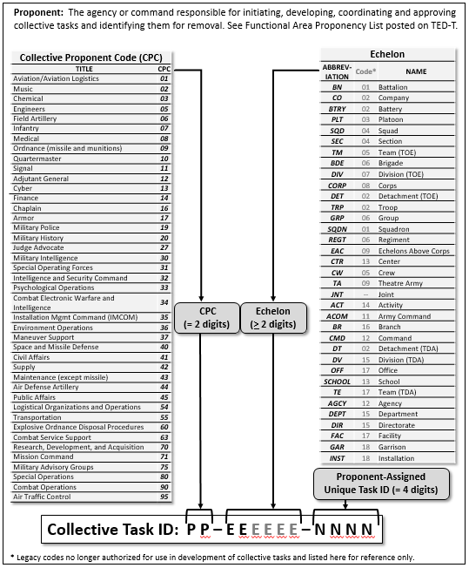

Figure 5-2. Collective task numbering format

(5) Create the task title(s). The task title must consist of one appropriate, present tense action verb and object only. Avoid the use of conjunctions or "/" and the task title must be stated in terms that will be directly understood by anyone reading the title. Omit qualifiers and/or parenthetic statements other than acronyms. An example of a good task title would be *Occupy an Assembly Area*.

(a) Specificity. Include only the necessary general information of terms and equipment requirements when writing a collective task title. This allows for the use of the task by other proponents. Too much specificity, particularly in terminology or equipment, restricts the use of the collective task by another proponent or unit. For example, it is not necessary to say *infantry company commander* when the term *company commander* would be equally appropriate and allow the task to be applicable to other units and proponents. Regarding equipment, it is not necessary to say *Position the M2 Heavy Machine Gun* when *Position Crew-served Weapons* allows a *Conduct a Defense* task to be applicable to multiple units and proponents. Write a unique collective task specifically to the type of equipment or capability addressed.

*Note.* Use only the necessary general information of terms and equipment requirements when writing the collective task content as well. Again, this allows for the use of the task by other proponents.

(b) Figure 5-3 provides examples of correct and incorrect task title formats. It is important to note that the use of standard, well-defined verbs is essential for providing clarity, preventing duplicate work, and providing quality training. A list of approved task title verbs is located on ATN/Training and Education Developer Toolbox (TED-T) website.

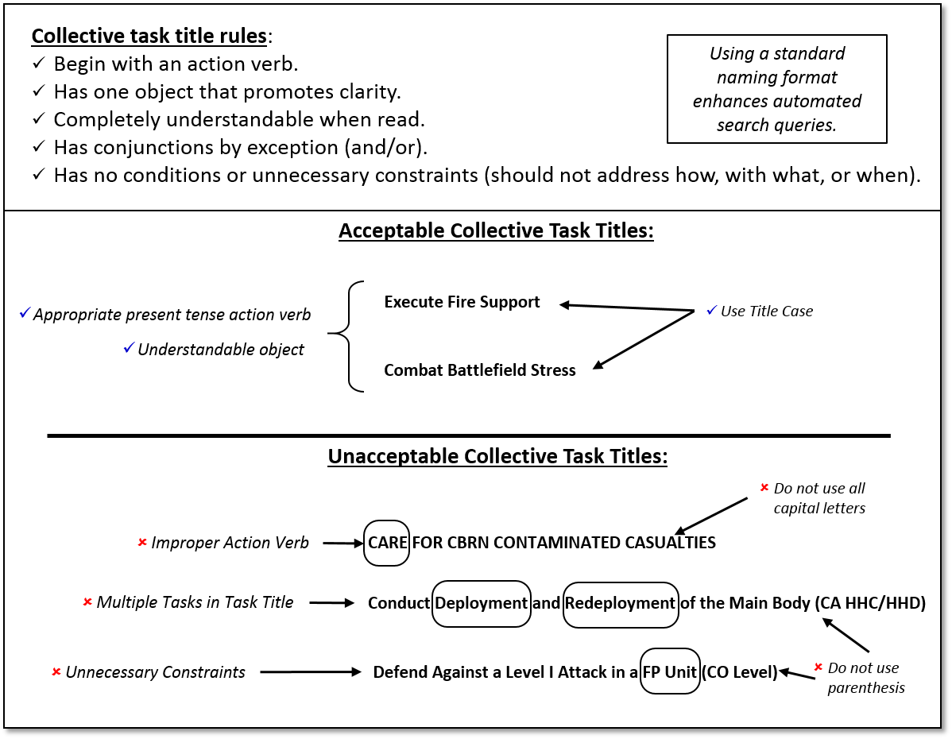

Figure 5-3. Developing collective task titles

## 5-3. Design the Task Conditions

a. A task condition statement must provide the general information required to allow multiple units to perform a task to standard based on a common doctrinal basis. The conditions statement identifies the situation and describes the operational environment in which the unit should be able to perform the task to standard; it does not limit task performance by including unnecessary equipment or environmental requirements. Write a task condition concisely in paragraph format and in the present tense. Figure 5-4 gives further guidance on writing condition statements.

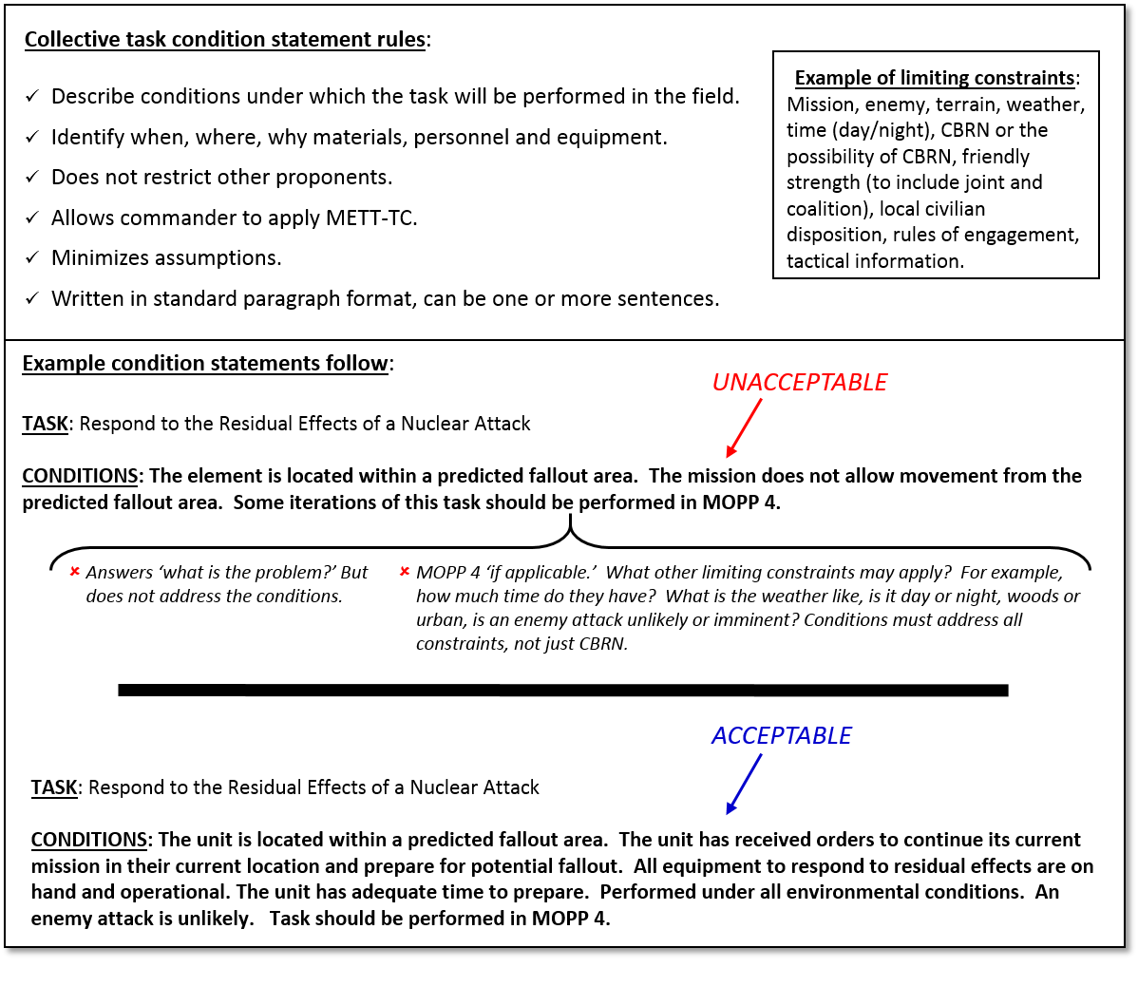

Figure 5-4. Writing collective task condition statements

b. There are nine elements to consider when writing a condition statement. Six of the elements are mission, enemy, terrain and weather, troops and support available, time available, and civil considerations (METT-TC) variables; *mission* is the only variable not expressed as part of the condition statement. The remaining three elements are the trigger (or cue), current actions or situation, and historical information. The following paragraphs provide definitions and examples of these elements.

(1) Trigger or cue. The developer must include a trigger or cue indicating why the task is performed, and the aiding and limiting factors appropriate to setting the stage for conducting the task. This is the only mandatory element in the Conditions statement. Without the trigger/cue, the Conditions statement is incomplete.

*Examples*: The maintenance officer in charge (OIC)/NCO in charge (NCOIC) requests recovery assistance from supported units; the unit has fatalities; the unit requests supplies from subordinate elements. The unit prepares to reorganize an infantry battalion; the unit has an OPORD or fragmentary order (FRAGORD) from higher to (*Insert Task Title here*).

(2) Current actions or situation. This includes what the echelon is currently doing.

*Examples*: The unit provides field maintenance in support of operations from its established field or urban location; the unit conducts operations as part of a larger force; the unit conducts operations as part of a higher headquarters.

(3) Historical information. Describe important tasks that have a first-order effect on setting the conditions for the task, and these important tasks are completed prior to the start of this mission or task. Refer to these tasks as prerequisite collective tasks; they are tasks that may have an impact on setting the conditions for the task and performing the task to Standards. Additionally, these tasks inform the Conditions statement (e.g. condition: The main command post is established. Cite the prerequisite task in the T&EO: *Establish a Battalion Command Post in an Operational Environment*). Prerequisite collective tasks apply to the majority of the population trained.

*Examples*: Have identified the location and the route to the equipment to recover; the unit has communications with appropriate elements; the higher HQ OPORD, the unit, and higher HQ SOPs are available; the unit has been provided guidance on the rules of engagement and the rules of interaction.

(4) Enemy. Include current information that impacts performing the task to standard such as strength, location, activity, and capabilities.

*Examples*: Threat Level I forces may attack the unit; the enemy may attack the unit using an aerially-delivered CBRN attack or the unit may be subject to radiological fallout; the unit is subject to CBRN and ground Level I threat forces attack; the enemy can attack by air, indirect fire, and ground (mounted or dismounted); guards report sighting one to three unidentified individuals attempting to infiltrate the area.

(5) Terrain and weather. Note any terrain and weather conditions that will affect training regarding ground maneuver, precision munitions, air support, and sustainment operations.

*Examples*: Perform this task under all environmental conditions; higher HQ analysis of the area of operations (AO) is available; field expedient and natural shelters are available; conduct some iterations of this task during limited visibility conditions.

(6) Troops and support available. Note the quantity, training level, and psychological state of friendly forces if they impact training the task to standard.

*Examples*: All equipment to perform the recovery mission is on hand and operational; all required maintenance equipment, tools, publications and personnel are available; all necessary personnel and equipment are available; engineer support is available; indirect fires are available.

(7) Time available. Note the time available for planning, preparing, and executing the mission if it affects training the task to standard.

*Example*: The OPORD states the latest time by which to complete recovery operations, and time is available for a deliberate occupation of defensive positions.

(8) Civil considerations. Identify the impact of civil considerations (civilian populations, culture, organizations, and leaders within the AO) for training the task to standard. Use the following definitions:

(a) Static: Aspects of operational variables such as political, military, economic, social, information, infrastructure, physical environment, and time (PMESII-PT), stimulate mission variables (METT-TC) and exist throughout the unit’s execution of the task.

(b) Dynamic: Operational variables and Threat TTPs for assigned counter-tasks change in response to BLUFOR’s execution of the task.

(c) Complex: Requires a minimum of four or more operational variables; brigade and higher units require all eight operational variables (PMESII-PT) be replicated in varying degrees based on the task being trained.

(d) Single Threat: Regular, irregular, criminal, or terrorist.

(e) Hybrid Threat: The diverse and dynamic combination of regular forces, irregular forces, terrorist forces, and/or criminal elements unified to achieve mutually benefitting effects.

*Examples*: Coalition partners, noncombatants, and media are present in the AO; coalition forces and noncombatants may be present in the operational environment.

*Note.* Write the elements cited in sub-paragraphs (3) through (8) as either aiding or limiting factors.

## 5-4. Design the Task Standard

1. The task standards provide the criteria for determining the minimum acceptable level of task performance under operating conditions. The criteria must not restrict the commander’s ability to manage varied unit configurations and to respond to METT-TC. Task standards must be concise, written in present tense, contain only one action verb, be nested with the title of the task and the performance steps, and give the ‘why’ or the ‘to’ of the task. Standards statements are composed of several sentences or a bulleted list that describes actions.

b. Proponents insert a note addressing leader requirements. In order for units to identify what leadership positions are used for evaluation on the Objective Task Evaluation Criteria Matrix, the standard statement will identify the leaders by leadership position. Generally, leadership positions should be at the echelon level of the task performed and one echelon level below (see examples of potential leadership positions below). Specific MTOE leadership positions will vary by unit type and echelon. The TNGDEV should review the development of various unit MTOEs to ensure consistency with the echelon and to understand the leadership positions required for the successful completion of the task.

*Examples of potential leadership positions of tasks at different echelons:* Leaders in leadership positions for a platoon task *Conduct an Attack* could be Platoon Leader, Platoon Sergeant, and Squad Leaders. For a battalion task *Control Field Artillery Operations* the leaders identified could be Battalion (BN) Commander, BN CSM, BN XO, BN S3, BN AS3, BN OPS SGM, BN Fire Direction Officer, BN S4, and BN LNO. For a Division level task, the commander could identify/designate leaders such as commander, deputy commander, commanders of assigned/attached units (brigades and battalions), chief of staff (CoS), command sergeant major, G-1, G-2, G-3, operations sergeant major, battle captains, G-4/chief of sustainment, G-5, G-6, fire support coordinator, electronic warfare officer, and chief of protection.

*Examples of Notes used on a standards statement:*

*Note.*The leaders for evaluation of the rifle company (IBCT) are the following positions: Company Commander, XO, 1SG, Platoon Leaders, and Platoon Sergeants.Notice this note follows the general rule.

*Note.*The leaders for evaluation of this task are the following positions: Division Commander, DCO, CoS, CSM, G-1, G-2, G-3, OPS SGM, G-4, G-5, G-6, and FIST Coordinator. Notice this note does not follow the general rule because it did not include Brigade Commanders and CSMs***.***

c. There are three elements to consider when writing a standards statement:

(1) Describe the action in present tense.

*Examples*: Unit personnel complete fallout preparation; distribute equipment and supplies; unit crosses the start point.

(2) Include a quantitative or qualitative remark.

*Examples*: No later than time prescribed in OPORD, within 20 minutes of arriving in new area, before arrival of fallout, and without interfering with mission requirements.

1. List the authority.

*Note.* The standards for tasks are the Army standards; the standards may be increased, but not lowered.

*Examples*: In accordance with the tactical SOPs and directives provided by the higher headquarters or commander; and/or, in accordance with the maintenance SOP and commander’s guidance.

d. Figure 5-5 provides guidelines for writing task standards statements.

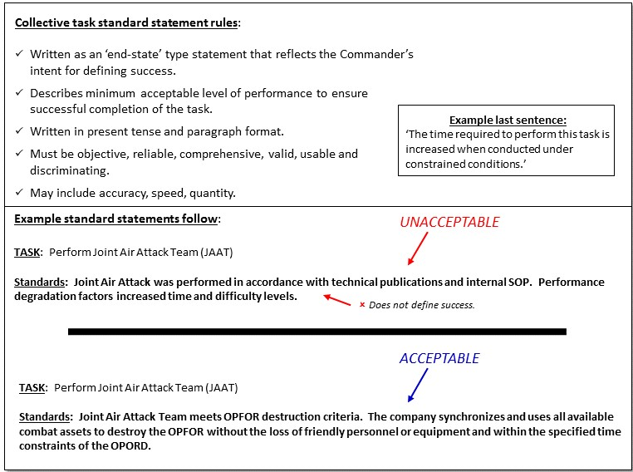

Figure 5-5. Writing collective task standards

e. Task Proficiency Standards and Criteria. To enable unit leaders to evaluate unit proficiency on METs, the Army will establish task proficiency standards and task proficiency criteria that unit leaders will use when evaluating unit proficiency on a task. TRADOC proponent schools will incorporate task proficiency standards and criteria into T&EOs, accordingly.

(1) Task Proficiency Standards. In order to allow leaders to differentiate the level of training a unit has achieved, the Army will stratify task proficiency standards to include T/T-/ P/P-/U, as described in Figure 5-6. Proponents are responsible for determining the percentages associated with T, T-, P, P-, and U, and commandants approve the standard.

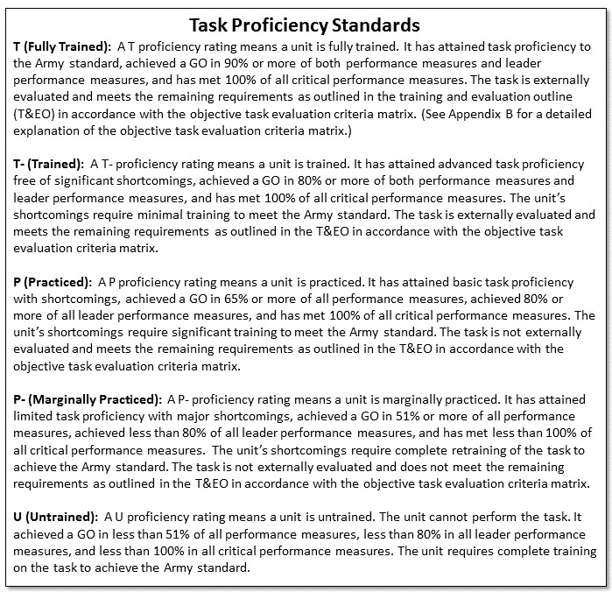

Figure 5-6. Task proficiency standards

(2) Objective Task Evaluation Criteria Matrix. To enable unit leaders to objectively evaluate unit task proficiency, proponents will apply the task proficiency criteria to all T&EOs described in figure 5-7 (Objective task evaluation criteria matrix). The proponent tailors the Plan and Prepare section to the task (task dependent), but the section must still be based on DA standards. The Execute section (task independent) performance measures are set by HQDA and will be applied in all T&EOs. Regarding leaders present, record the percentage of unit key leaders present at the training as compared to the MTOE authorized strength to gain the requisite percentile. In the Plan and Prepare section, the proponent will select the column that matches the unit performing the collective task, which hides the other columns on the T&EO (e.g. if the T&EO is conduct a bridge crossing for a Company, only the column selected will be visible on the T&EO. In TDC, the other two columns labeled ‘SQD & PLT’ and ‘BDE (brigade) & ABOVE’ will not be visible).

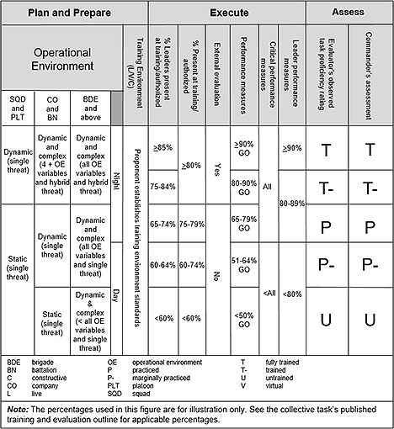

Figure 5-7. Example objective task evaluation criteria matrix

f. Live Fire: Proponents will determine if a task has a live-fire requirement. If the proponent determines no requirement for the task, the live-fire statement will say *No*. If a proponent determines the task has a live-fire requirement, then the proponent will decide whether to perform the task under the proposed operational environment during live-fire conditions. If the proponent determines the proposed operational environment is too restrictive for use under live-fire conditions, the proponent may develop a new task for use under live-fire conditions only. Write an additional performance step and performance measure to train and evaluate the live-fire portion of the task when tasks have a live-fire requirement. The proponent will utilize one of three “live-fire” Statements when a task has a live-fire requirement. The statements are in Table 5-1. The live-fire statements direct the user to the correct task to conduct under live-fire conditions. If the development of another task with less restrictive operational environment is needed, proponents use the same task name and add “live-fire” to the end of the task name (e.g. *Conduct an Attack Live-Fire*). The proponent will also issue a new task number for the developed task. Table 5-1 describes live-fire statements.

g. Collective live-fire task proficiency is based on evaluation of a task(s) trained and evaluated under live-fire conditions and standards as defined in the task(s) T&EOs. All deployable units (MTOE, TDA) with weapons on their authorization documents have a live-fire requirement. Company echelon units and below must conduct live-fire at night to achieve a T-proficiency. Battalion and above echelons are required to conduct live-fire during the day to achieve a T- proficiency. Live-fire requirements for units fall into two different categories.

(1) Category 1 includes company or larger deployable units that can organically execute a collective task under live-fire conditions. Proponents have developed collective live-fire gates that depict the collective live-fire progression from the lowest collective training echelon to the highest. See Appendix D in Leader’s Guide to Objective Assessment of Training Proficiency, located on ATN (refer to Key Links in the Glossary) for a listing of Collective Live-Fire Gates applicable by a unit’s Standard Requirement Code arranged by proponent and category.

(2) Category 2 includes deployable units, generally below the company level that cannot perform independently a collective task under live-fire conditions until integrated into a higher headquarters (e.g. Quartermaster Rigger Support Team). These units have two options for their live-fire: Integrate into a supported or non-organic organization’s collective live-fire event; or conduct a commander designed event based on appropriate live-fire tasks and skills to meet the commander’s training guidance.

Table 5-1   
Live-Fire statements

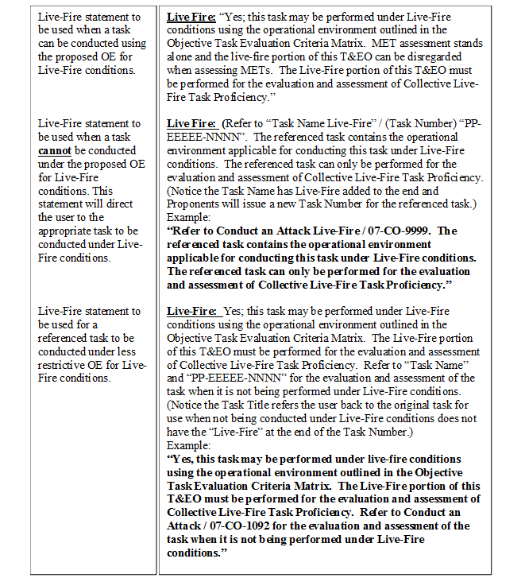

## 

## 5-5. Develop the Performance Steps and Performance Measures

Performance Steps and Performance Measures are the broad terms that refer to the portion of the T&EO that includes the Performance Steps and Performance Measures. Write and sequence Performance Steps using the Plan, Prepare, Execute, Assess framework to reinforce the operations process.

a. Performance Steps are discrete actions that compose and/or inform the completion of a task and may or may not be measured. Performance Steps are generally written sequentially and follow a step-by-step description of actions that accomplish and/or inform the task. Performance Steps may have multiple sub-steps that support and/or inform the respective Performance Step. Write Performance Steps with as many sub-levels (tiers) or sub-steps as needed. Write sub-steps as bulletized lists. Number and letter performance steps by tiers in accordance with TDC.

(1) Critical Performance Steps, Leader Performance Steps, and Live-Fire Performance Steps are sub-categories of Performance Steps.

(a) A Critical Performance Step is a Performance Step the proponent determines is crucial to the completion of the task and if not completed would result in failure of the collective task as a whole. The proponent identifies Critical Steps by marking them with a plus (+).

(b) A Leader Performance Step is a Performance Step performed by one or more of the leaders identified by the proponent in the leader statement in the task standards. The proponent identifies Leader Steps by marking the step with an asterisk (*). Proponents identify the leaders responsible for performing the Leader Performance Step within the step or in a note under the Performance Step to clarify the most likely leadership position that would perform the step. However, any leader identified in the Leader's statement performing the step would receive a "GO." No note is required if the leadership position is identified in the Leader Performance Step; *Example - Leader Performance Step:*Coordinates with S-4 to ensure that ammunition is replenished, adjusted, and/or redistributed to support current, planned, or pending operations. Supporting Note. The S3 or AS3 are the likely leadership positions to perform this Leader Performance Step, and others identified in the leader’s statement could perform the step.*

(c) A Live-Fire Performance Step is a step performed under live-fire conditions in a live and/or virtual training environment. Live-Fire Performance Steps are only required when ‘Yes’ is selected for “Live Fire Training Required” in TDC. Live-Fire Performance Steps are the last steps added as in the Performance Steps and Performance Measures section of the T&EO.

(2) Identify a performance step as both a Leader Performance Step and Critical Performance Step, and it may appear within a left-most justified numbered step or one tier below. Critical Performance Steps and Leader Performance Steps appearing in sub-steps make the left most justified numbered step a Critical Performance Step and/or Leader Performance Step.

(3) Write performance steps using a subject, present tense action verb, and object format. Omit the subject if assumed or implied due to sub-step hierarchy. Include a description of the action and a quantitative or qualitative remark in the performance steps. Write performance steps in the present tense. The use of terms and specific equipment must be appropriate to the entire target population when developing performance steps.

(4) Use notes only when necessary to provide caveats that may clarify minor differences between units or proponents. Before adding a note to a performance step, assess the applicability of adding the information to an existing performance step or as an additional performance step.

(5) Link individual tasks to a performance step(s) rather than integrating them as performance steps within the collective task. Within the task *Perform Route Reconnaissance and Clearance,* the performance step *The RCP leader issues an OPORD to all RRC team personnel,* is trained through the individual task *Prepare an Operation Order (OPORD) at the Company, Platoon or Squad Level*.

(6) Link supporting collective tasks to a performance step(s) rather than writing them as performance steps within the collective task.

b. The proponent identifies Performance Steps for measurement and evaluation. Performance Measures provide the GO/NO GO/NA boxes for the evaluator for evaluation. A TNGDEV will not place *N/A* in any of the performance measures. All Critical Performance Steps, Leader Performance Steps, Live-Fire Performance Steps, and left most justified numbered steps are mandatory for measurement and evaluation, and by default become Performance Measures. A Critical Performance Measure is the mandatory measurement and evaluation of a Critical Performance Step. A Leader Performance Measure is the mandatory measurement and evaluation of a Leader Performance Step. A Live-Fire Performance Measure is the mandatory measurement and evaluation of a Live-Fire Performance Step. Annotate Live Fire Performance Steps as critical Performance Steps (+) in TDC, and evaluate them as critical Performance Steps on the T&EO. See figure 5-8 below for an illustration of Performance Steps and Performance Measures.

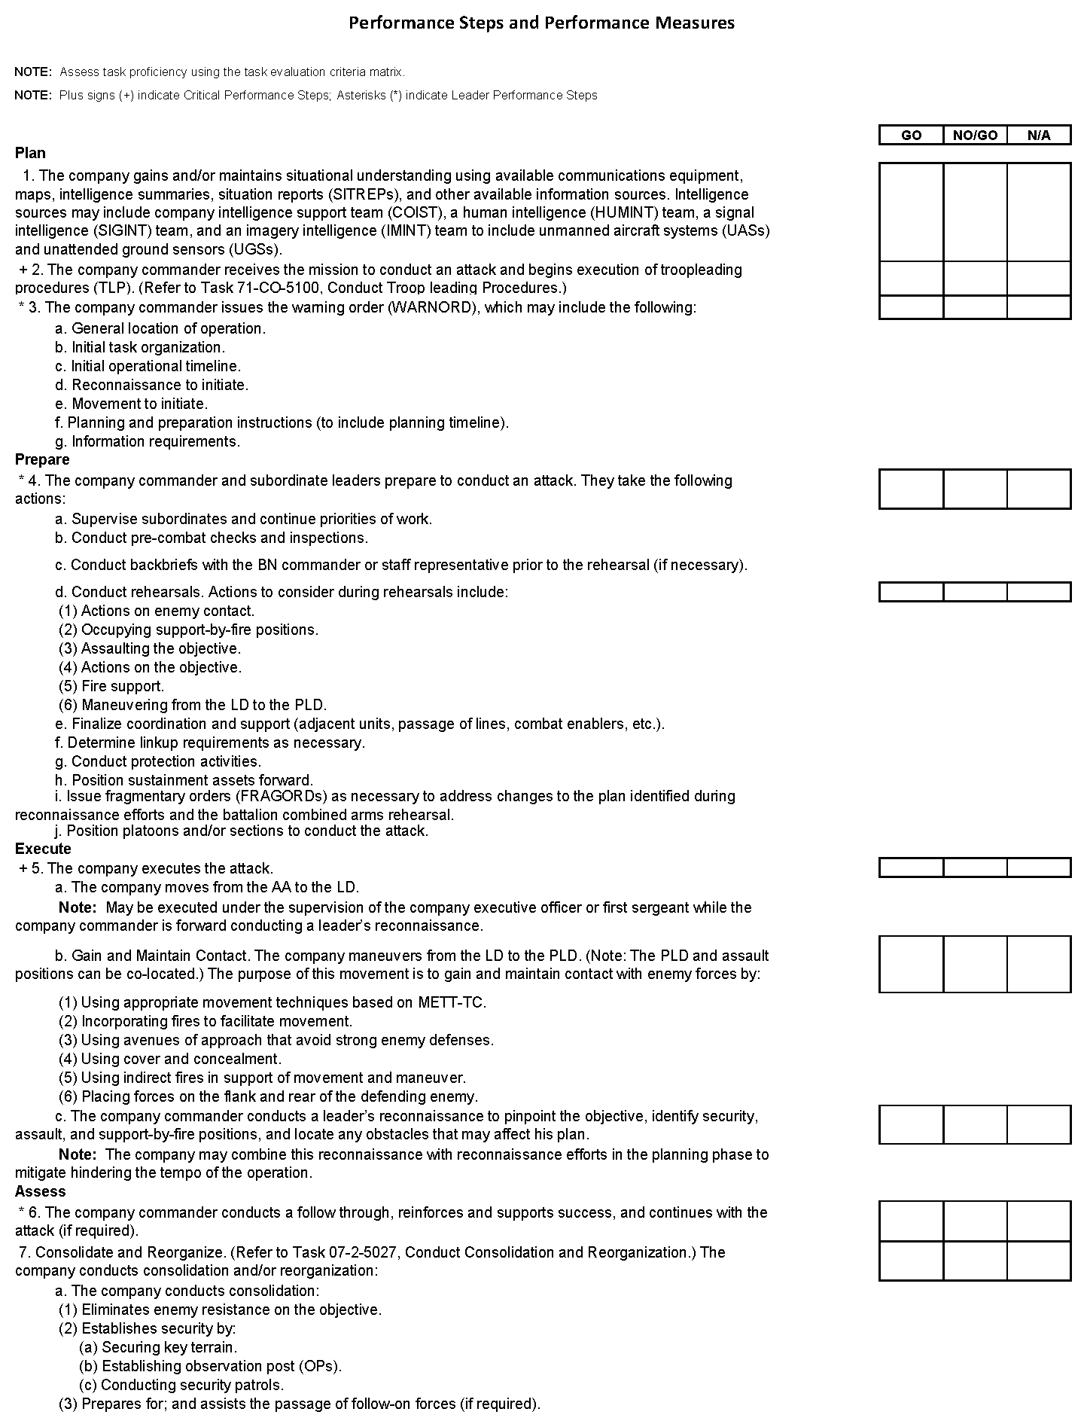

Figure 5-8. Performance steps and performance measures

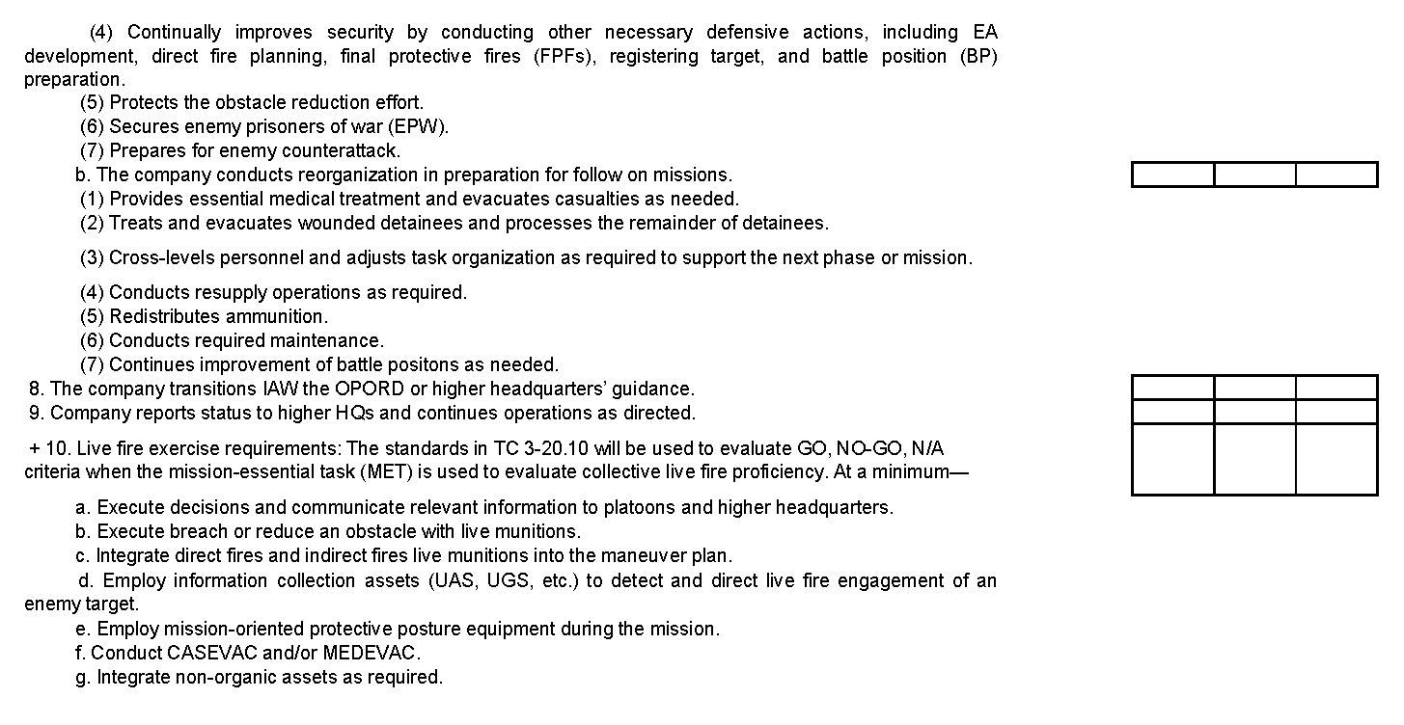

**Figure 5-8. Performance steps and performance measures (continued)**

## 5-6. Identify the supporting Individual Tasks

Perform supporting individual tasks to enable the successful performance of the supported collective task. These tasks assist leaders in the accomplishment of the collective task and TNGDEVs identify them as such. Proficiency must occur at the individual task level before it can occur at the collective task level. Therefore, when developing a collective task, the TNGDEV works with a SME to identify and link individual tasks that support that collective task. As a rule, each collective task should have one or more individual tasks linked to it in TDC. Link the individual task to a specific performance step(s) in the collective task. For example, the company-level task *Conduct an Attack - Rifle Company (IBCT)* requires the individual task *Plan Unit Movement at Company Level*. This is an individual task performed during the actual execution or is a direct prerequisite to the performance of the supported collective task. Supporting individual tasks must be applicable to all or the majority of the target population. In order to reduce the amount of supporting individual tasks, do not consider a task not linked to a specific performance step(s) within the collective task developed. An example collective task linkage appears in figure 5-9.

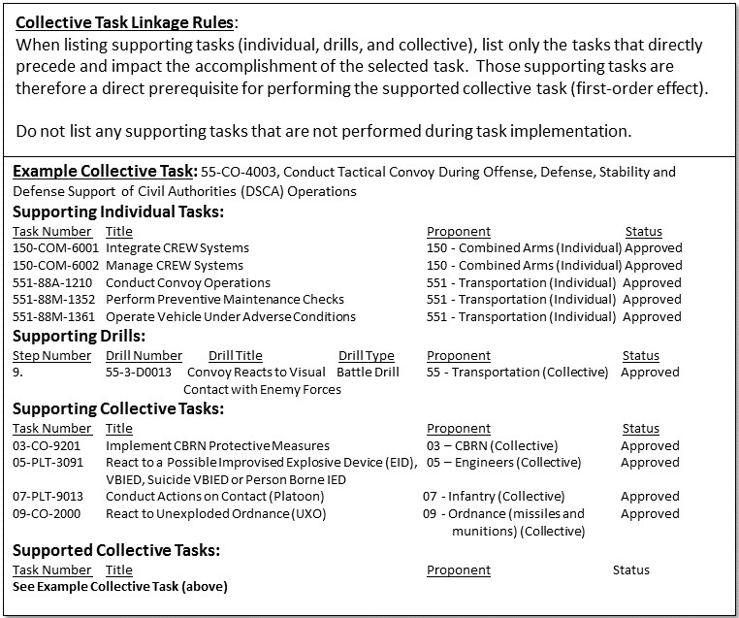

Figure 5-9. Collective task linkage

## 5-7. Identify the supporting Collective Tasks

a. Supporting collective tasks (SCT) are collective tasks that have a direct effect on the successful completion of one or more performance steps in the supported collective task. Developers identify these tasks as a reference for leaders, trainers, and evaluators. Obtain a degree of measured proficiency (P-, P, T-, and T) with SCTs for a unit to accomplish the supported task in a successful manner. An example of a SCT for the supported company level task *Conduct an Attack – Rifle Company (IBCT)*, would be *Conduct Support by Fire (Platoon)*. The support by fire task of the supported task directly affects the performance step, “The company executes the attack”.

b. When developing a collective task, identify and link the SCTs to the performance step they are supporting. Do not consider a collective task a supporting collective task if not linked to a specific performance step(s) within the collective task supported. Figure 5-9 provides an example list of supporting individual and collective tasks linked to the supported collective task.

c. Standard METL Business Rules govern supporting collective tasks for HQDA approved Standard METL.

## 5-8. Identify the supporting Drills

Supporting drills are those performed during the execution of the supported collective task. Drills must be applicable to the majority of the population. This guidance applies at both the task and performance step levels. An example of a supporting drill appears in figure 5-9.

## 5-9. Safety and Environment Statements

a. The TNGDEV includes the safety and environment statements to alert trainers to their responsibilities regarding Soldier safety and environmental concerns during training. Leaders and trainers are required to perform a risk assessment using Department of Defense Form (DD Form) 2977, Deliberate Risk Assessment Worksheet (DRAW).

b. The TNGDEV performs the following actions to integrate safety, risk, and environmental protection considerations into training materials where appropriate:

(1) Includes appropriate safety, risk, and environmental protection statements; cautions; notes; and warnings in all training products.

(2) Identifies the risk and assigns an initial risk assessment to every training product designated in TDC.

(3) Coordinates with and obtains approval from the branch safety manager or supporting safety professional for all training products regarding safety and risk management issues with an initial assessed risk above LOW. Figure 5-10 shows the required minimum environment statements that must appear in each collective task. Address safety, risks, or additional environmental issues as necessary as an addition to the required statements below.

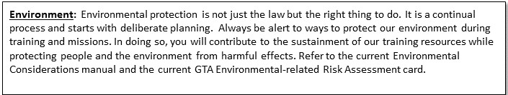

Figure 5-10. Environmental statement

## 5-10. Opposing Forces (OPFOR) Tasks and Standards

a. The OPFOR tasks are those tasks that have an oppositional relevance to the collective task performed. OPFOR tasks and the associated numbers are in accordance with the operational environment found on the Objective Task Evaluation Criteria Matrix such as echelon (SQD and platoon, company and BN, or BDE and above) positioned above and against a scale of increasingly difficult type of threats and OE conditions of limited visibility (static, dynamic, or dynamic and complex) and day versus night.

b. Choose at least one OPFOR task that has the most opposing relevance to the collective task. Current OPFOR tasks consist of task numbers 71-XX-85xx; tasks with "OPFOR" in the task number are obsolete. The XX represents the two-digit echelon code listed in figure 5-2. OPFOR echelons and tasks may be above BN level to facilitate providing Army Mission Training Complexes OPFOR tasks to portray the Decisive Action Training Environment (DATE)-doctrinal enemy in simulation. Limit the list of OPFOR tasks to those that are the most likely threat courses of action rather than creating an exhaustive list of OPFOR options. For example, if the collective task is *Conduct an Attack*, the OPFOR task with the most opposing relevance would be *Execute Defense of a Complex Battle Position.* Do not list an OPFOR task that would require a unit to stop performing the collective task and begin performing a different collective task to respond appropriately to the OPFOR. For example, *Execute an Ambush* would not be an appropriate OPFOR task for a BLUFOR *Conduct Operational Decontamination* task because it would require the unit to stop performing the decontamination task in order to respond to the ambush. Figure 5-11 depicts an example of OPFOR tasks, conditions, and standards.

c. Find OPFOR tasks and standards in Training Circular (TC) 7-101 (Exercise Design Guide), and they are available in the CATS library via the Virtual OPFOR Academy (refer to Glossary, Key Links). The tasks executed are available in TC 7-100.2 (Opposing Force Tactics) with the TTPs and the tasks available via recorded instruction and virtual replication in the Virtual OPFOR Academy.

d. Brigade mission command tasks and echelons above may often be technical. These tasks must nonetheless be supported/balanced by OPFOR tasks to accurately and effectively understand, teach, and apply the relationships between intelligence preparation of the battlefield, information collection, reconnaissance, decision points, and commander’s critical information requirements. Army combat and/or mission command training centers need OPFOR tasks developed in support of organizations up to a U.S. Army corps-level attack to portray the Decisive Action doctrinal enemy division defense and guide the OPFOR in all environments, and particularly simulations.

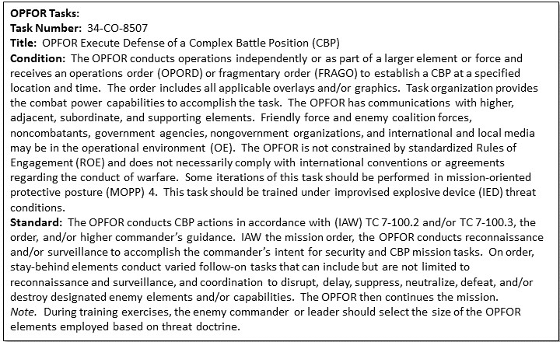

Figure 5-11. OPFOR tasks and standards example

## 5-11. Equipment and Materiel

Equipment and materiel are the resources that have relevance to the task trained. For collective tasks, the inclusion of equipment and materiel items is limited to those that have relevance to the target population trained. For example, it would be appropriate to add the M256A1 Chemical Agent Detector Kit to a *Conduct an Operational Decontamination* task, but it would not be appropriate to add an M1A2 Abrams tank as an equipment item to the task. All elements will require the M256A1 Chemical Agent Detector Kit to perform the decontamination, but the M1A2 Abrams tank is only relevant in describing the table of equipment for a few specific units that must perform the task.

## 5-12. Training Aids, Devices, Simulators, and Simulations (TADSS)

The TNGDEV selects any appropriate TADSS to support collective task training. If applicable, the TADSS title and numbers are required. TADSS selected from a search menu in TDC are available to print out as part of the synopsis report. The TNGDEV should identify trade-offs of training resources (such as equipment, ammunition, and others) in order to identify TADSS as cost-effective training enablers. When appropriate, the TNGDEV links TADSS to support the training of the collective task developed. Pre-populated in TDC is resource information that is required to support TADSS training (such as contractor personnel requirements, special facilities unique to the TADSS). The TADSS requirements information will not display for field users, but is used to determine TSS resourcing requirements. TDC links TADSS to the T&EO as appropriate to support collective training.

## 5-13. References

Each collective task may have more than one reference. List only essential references and identify at least one primary doctrinal reference.

## 5-14. Date/Time Stamp

Each collective task will include a date/time stamp to ensure Soldiers are using the most current version.

## 5-15. Unit Type and Echelon

The proponent will ensure collective tasks are written by unit type and echelon.

## 5-16. Remarks

The remarks section provides a location for the proponent to include further guidance and/or clarifying details to the evaluator and/or unit.

## 5-17. Task/Performance Evaluation Summary Block

The Task/Performance Evaluation Summary Block is a TDC templated table that allows an evaluator to record their evaluations of performance measures as a unit conducts training. The evaluator can then record the evaluation on the Objective Task Evaluation Criteria Matrix at the end of the training event.

## 5-18. Synopsis Report

TDC allows printing a synopsis report for a collective task. The synopsis report includes all the information entered into the system and facilitates a review of all collective task information.

## 5-19. Training & Evaluation Outline

The T&EO provides the major procedures a unit must accomplish to perform a collective task to standards. TDC provides a template that systematically guides the TNGDEV through completing the appropriate data fields to generate the T&EO. The task performance specifications in TDC include design elements to describe precisely how a specific task or drill are performed, under what conditions the task or drill is performed, and how well a unit must perform the task or drill. A unit evaluator uses a T&EO to determine, at a given time, whether the task performed was to the standards under the prescribed conditions.

## 5-20. Quality Control

Table C-3 provides a collective task QC review checklist designed to manage and document control measures, identify areas to improve, and facilitate timely delivery of collective tasks to ensure compliance.

# 

# Chapter 6 Drills

## 6-1. Introduction

a. Purpose. This chapter provides guidance for the analysis, design, and development of drills. A TNGDEV follows the ADDIE process to develop a drill, and follows the basic structural format of a collective task. The purpose of a drill is standardizing actions and responses to one specific situation.

b. Drill definition. A drill is a collective action (collective task or task step) performed without the application of a deliberate decision making process. A drill initiated on a cue, such as enemy action or a leader’s command is a trained response to the given stimulus. A drill requires minimal leader orders to accomplish and is standard throughout the Army. A drill is developed from a collective task but may be developed as a stand-alone product.

c. Drill types. There are only two formats for developing drills: battle drills and crew drills. However, there are three types of drills: battle drills, staff drills, and crew drills. Battle drills and staff drills are formatted the same. This chapter describes the formats for developing drills.

(1) Battle drill. A battle drill is a collective action (or task) performed by a platoon or smaller element without the application of a deliberate decision making process, initiated on a cue, accomplished with minimal leader orders, and performed to standard throughout like units in the Army. The action is vital to success in combat operations or critical to preserving life. It usually involves fire or maneuver. Initiate the drill on a cue, such as an enemy action or a leader’s brief order, and it is a trained response to the given stimulus.

(2) Staff drill. A staff drill is an action rehearsed to support the efficiency of staffs. A staff drill is a collective action (or task) performed by staffs at battalion and above.

(3) Crew drill. A crew drill is a collective action (or task) performed by a crew of a weapon or piece of equipment to use the weapon or equipment successfully in combat or to preserve life. A crew drill initiated on a cue, accomplished with minimal leader orders, is performed to standard throughout like units in the Army. This action is a trained response to a given stimulus such as an enemy action, a leader’s brief order, or the operating status of the weapon or equipment.

d. Applicability. The echelon that the drill applies to is key in determining the type of drill required. Company and below do not have staffs, and therefore, train their subordinate units exclusively on battle drills and crew drills. Battalion and above develop staff drills designed to solve a problem or react to a specific situation. See table 6-1.

| Table 6-1  Types of Drills | |
| --- | --- |
| **Drill type** | **Echelon** | | **Purpose** | **Example** |
| Crew drill | Section/‌team/‌crew | | Actions on a specific piece of equipment or weapon. | Lay a Howitzer. |
| Battle drill | Platoon or below | | Action involving fire and/or maneuver. | React to indirect fire. |
| Staff drill | Battalion or above | | Physical performance and/or problem-solving. | React to a FRAGORD. |

e. Advantages of drills.

(1) After practiced repetitively, Soldiers can perform tasks with rapid efficiency when the task has been practiced repetitively.

(2) Reduce the communication requirements because Soldiers know what they have to do.

(3) Build teamwork.

(4) Save time, resources, and lives.

(5) Minimize the impact caused by personnel turnover.

(6) Help maintain a unit’s training readiness and proficiency.

## 6-2. Analysis for Drill Development

a. When analyzing a drill, the TNGDEV must determine if a new drill needs to be created or if an existing drill modified will fill a training gap. If a product review resulting from observations, lessons or best practices identifies a revision requirement, then revise the drill. Use figure 5-1 to determine some considerations for determining if a new drill is necessary.

b. Drill requirements include a drill identification number and a drill title:

(1) Drill identification number. TNGDEVs number drills for identification and for Army-wide automation of drill production.

(a) Number drills in the same manner as collective tasks; however, the identification number for a drill begins with a "D." Figure 6-1 shows an example of a correctly formatted drill number.

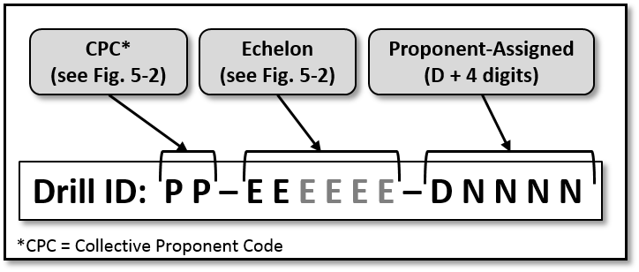

Figure 6-1. Drill ID number format

(b) To number a drill, assign the proponent ID number to the first position. Assign the echelon ID abbreviation to the second position. See figure 5-2 for proponent and echelon codes.

(c) Assign the drill identification number to the last four digits. Begin with the letter "D" to identify it as a drill, and follow with a four-digit sequential number.

*Note.* Drill identification numbers range from D0001-D9999.

(2) Drill title. The drill title must consist of one approved, present tense, action verb and object only. The use of conjunctions or "/" must be avoided and the drill title must be stated in terms that will be directly understood by anyone reading the title. Include no qualifiers or parenthetic statements other than for the purpose of abbreviation. An example of an appropriate drill title is *React to Indirect Fire.*

## 6-3. Design the Drill

a. Condition statement. A drill condition statement must provide the general information required to allow multiple units to perform a drill based on a common doctrinal basis. As such, the condition statement does not limit drill performance by including unnecessary equipment or environmental requirements. The drill condition must include a trigger or cue indicating why the drill needs to be performed and include appropriate aiding and limiting factors to set the stage for the conduct of the drill. A drill condition is concise and written in paragraph format. Figure 6-2 gives further guidance on writing condition statements. The condition statement should include all applicable elements, but only in the context that they support the drill.

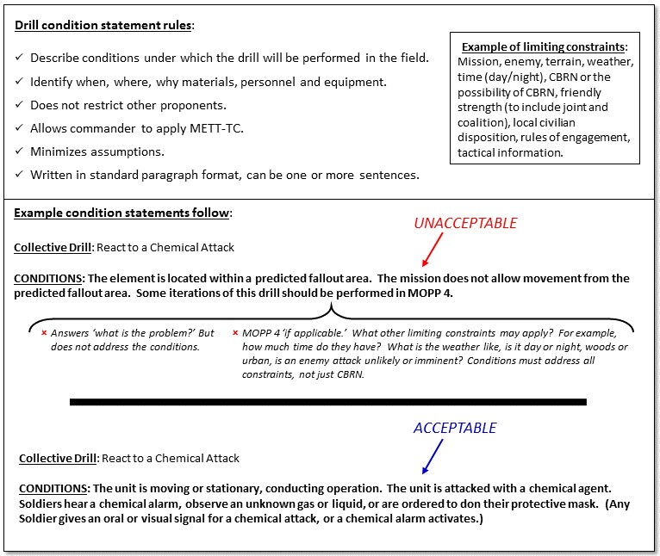

Figure 6-2. Considerations for writing drill conditions

b. Elements of condition statements. There are eight elements to consider when writing a drill condition statement:

(1) Trigger or cue. A drill condition must include a trigger or cue indicating why the drill needs to be performed and the aiding and limiting factors appropriate to set the stage for the conduct of the drill. The TNGDEV must state what triggered the need to perform this drill. This is the only mandatory required entry. Without the trigger, the condition statement is incomplete.

(2) Current actions or situation. This includes what the echelon is currently doing.

(3) Historical information. Describe important (first order) and completed activities that prior to the start of this mission or task.

(4) Enemy. Include current information about strength, location, activity, and capabilities that affect performing the drill.

(5) Terrain and weather. Note any terrain and weather conditions that will affect training regarding ground maneuver, precision munitions, air support, and sustainment operations.

*Examples*: This task is performed under all environmental conditions; higher HQ analysis of the AO is available; field expedient and natural shelters are available; some iterations of this task should be conducted during limited visibility conditions.

(6) Troops and support available. Note the quantity, training level, and psychological state of friendly forces if they affect training the drill.

(7) Time available. Note the time available for planning, preparing, and executing the mission if it affects training the drill.

(8) Civil considerations. Identify the impact of civil considerations (civilian populations, culture, organizations, and leaders within the AO) for training the drill.

*Note.* Elements (3) through (8) either aid or have limiting factors.

c. Drill standards. The drill standards statement provides the quantitative and qualitative criteria for determining the minimum acceptable level of drill performance. The criteria must not restrict the leader’s ability to manage varied unit configurations and to respond to varied METT-TC. Drill standards statements are composed of several sentences that describe actions. The drill standard must be concise, written in the present tense, and include a quantitative or qualitative remark. Figure 6-3 provides considerations for writing drills standards statements.

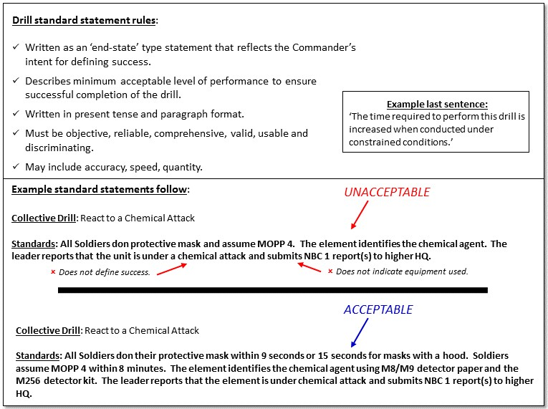

Figure 6-3. Considerations for drill standard statements

## 6-4. Develop the Drill Body

The TNGDEV can choose to develop the various sections of the drill in almost any order in TDC. The development sections in this chapter appear as aligned in the drill synopsis report. Paragraph 6-5 describes the drill synopsis report located at the end of this chapter.

a. Develop performance measures. In a drill, performance measures are actions that are objectively observable, qualitative or quantitative, and used to determine if performance is satisfactorily achieved. Performance measures are sequentially numbered in accordance with TDC. Write performance measures in subject, past tense verb, and object format. The performance measures are past tense because the evaluator is concerned with determining if the step or steps comprising the measure were performed. Omit the subject if assumed or implied. When developing performance measures for a drill, ensure they are constructed using terms and equipment names that are not too restrictive or too specific for the units and proponents that perform the drill. Prior to adding a note to a performance measure, assess the applicability of adding the information to an existing performance measure or as an additional performance measure.

b. Develop performance statement (optional). A performance statement is an optional statement that can clarify when to evaluate a drill at the next higher proficiency level. For example, a drill performance statement might read, *When Soldiers can perform the drill according to established standards, unit leaders should evaluate the unit as a whole to determine unit proficiency in performing the drill.*

c. Develop setup instructions. Setup instructions consist of all essential items needed to complete the drill. Setup should include resources such as training site requirements, personnel, maps with overlays, and equipment. Setup instructions should also include any unit-specific instructions such as, "The team leader will ensure all necessary convoy orders, site maps, signal operating instructions, and cryptography (crypto) are on hand." Figure 6-4 provides an example of setup instructions.

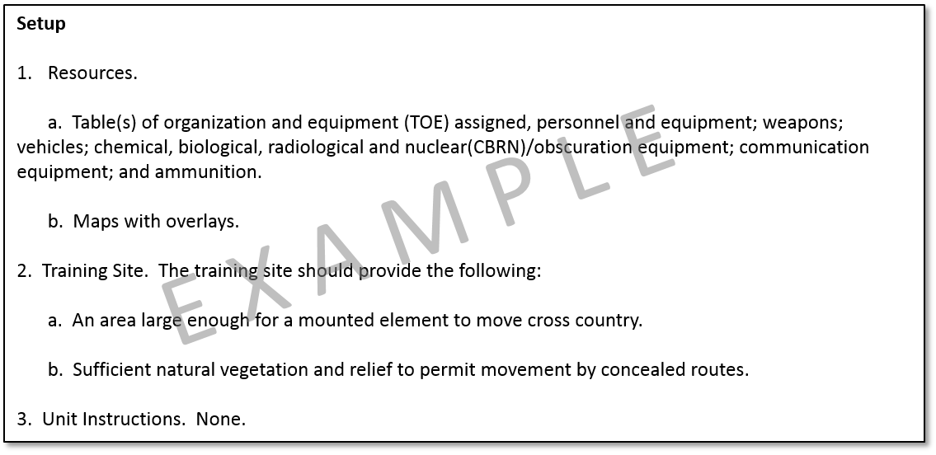

Figure 6-4. Setup instructions example

d. Develop talk-through instructions.

(1) Orientation. Orientation gives a short explanation of the mission and what the drill is intended to accomplish. The key factor to successfully complete each drill to standard is to have little or no subsequent decision-making process or orders from unit leaders. The orientation gives a brief description of the conditions or situations under which to execute the drill.

(2) Demonstrations (optional). When used, a demonstration explains the critical actions performed and why these actions are critical and essential to the performance of this training. A sample demonstration comment is, "If another team has mastered this drill, have them demonstrate it. Explain the demonstration team’s actions during the execution of this drill. Summarize the actions of the demonstration team."

(3) Explanation. Explanation information should strive to ensure that everyone knows his duties and responsibilities pertaining to each portion of the drill. Explanation information should include a sketch or diagram that explains the action required by each member in the squad or platoon. Explanation information must clarify all unsolved issues and questions of the unit members pertaining to the drill.

(4) Example. Figure 6-5 provides an example of talk-through instructions.

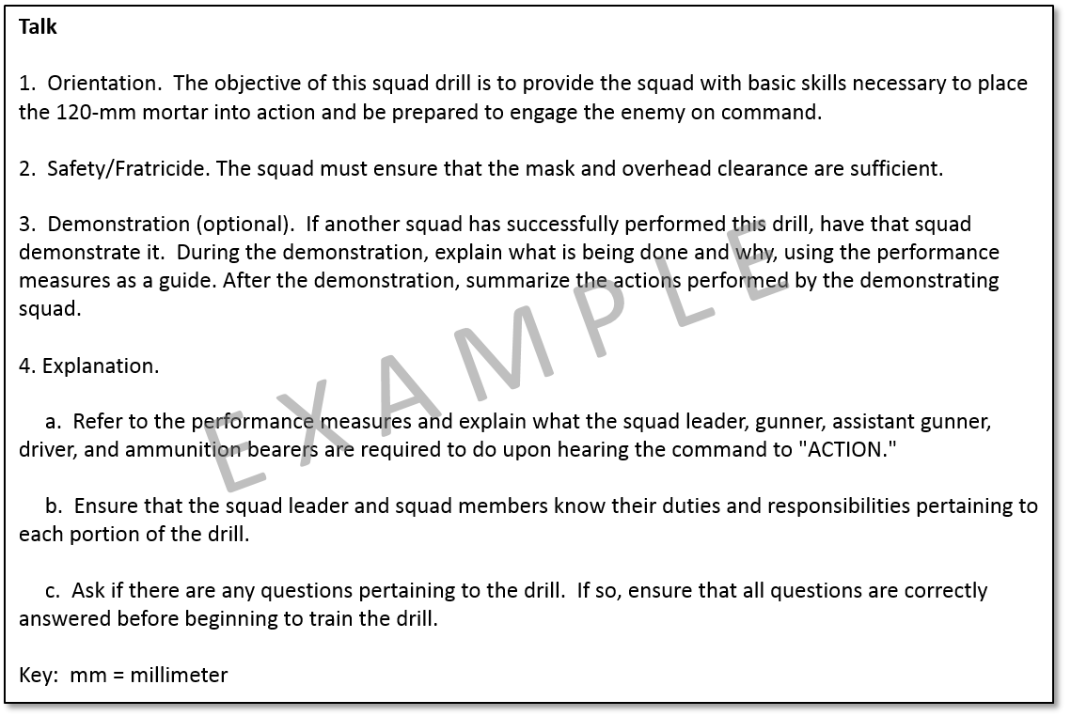

Figure 6-5. Talk-through instructions example

e. Develop walk-through instructions. Walk-through instructions must define how to move through the task deliberately to ensure that the unit is performing the drill and all of the task steps and performance measures to standard. The walk-through instructions begin with the initiating cue. Write the initiating cue as a description of the signal that unit leaders give that causes the unit to perform the drill. Write the cue as a description of the trained response to an enemy action that causes the unit to perform the drill.

*Examples*: Refer to the performance measures and have each squad member perform their part slowly at first as the leader talks them through; The squad leader gives the order to conduct wash down after meeting the contaminated unit at the contact point.

f. Develop run-through instructions (optional). Run-through instructions include any additional instructions needed to perform the drill at the run level of proficiency.

*Example:* The Soldiers should practice this drill until they can perform the drill to the standards from memory. Conduct the initial run-through slowly. The Soldiers should change positions in order to learn all steps and standards.

g. Develop a coaching point. A coaching point allows the drill developer to provide additional tips and hints to the drill manager on how to conduct a successful drill.

*Example*: Every Soldier of the squad/platoon must know if the distance to cover is less than or greater than 50 meters. All Soldiers must know what driving technique to use when driving toward cover. Unit leader establishes rally points.

h. Supporting individual tasks. Supporting individual tasks are those tasks performed during the execution or are a direct prerequisite to the successful performance of the drill. Drills must have supporting individual tasks linked and, in most cases linked to a collective task. Drills must be applicable to the majority of the target population. Figure 6-6 provides an example of task linkages for a drill.

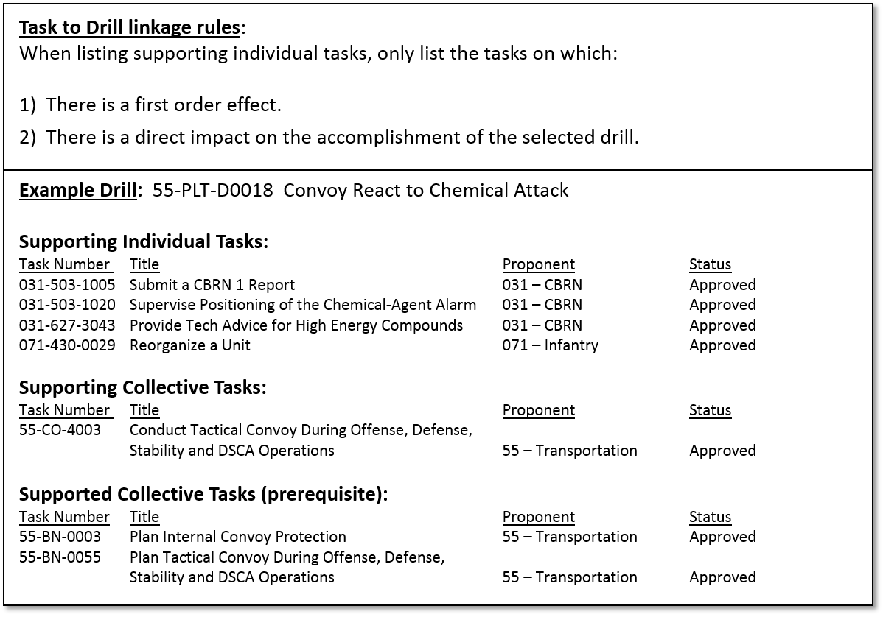

Figure 6-6. Task(s) to drill linkage example

i. Equipment and materiel. Equipment and materiel are the resources that have relevance to the drill trained. For drills, the inclusion of equipment and materiel items is limited to those that have relevance to the target population trained.

j. TADSS. The TNGDEV selects any appropriate TADSS to support drill training. If applicable, the TADSS title and numbers are required. Select TADSS from a search menu in TDC and print out as part of the synopsis report. The TNGDEV should identify trade-offs of training resources (such as equipment, ammunition, and others) in order to identify TADSS as cost-effective training enablers. When appropriate, the TNGDEV links TADSS to support the training of the drill. Pre-populated in TDC is resource information required to support TADSS training (such as contractor personnel requirements, special facilities unique to the TADSS). The TADSS requirements information does not display for field users, but is used to determine TSS resourcing requirements.

k. Safety and environmental statements. The TNGDEV includes the safety, risks associated with the training product and environment statement to alert trainers to their responsibilities regarding Soldier safety and environmental concerns during training. Leaders and trainers are required to perform a risk assessment using DD Form 2977 Deliberate Risk Management Worksheet (DRAW). TNGDEVs integrate safety, risk, and environmental protection considerations into training materials where appropriate. The TNGDEV does the following activities:

(1) Includes appropriate safety, risk, and environmental protection statements, cautions, notes, and warnings in all training products.

(2) Identifies the risk and assigns an initial risk assessment to every training product designated in TDC.

(3) Coordinates with and obtains approval from the branch safety manager or supporting safety professional for all training products regarding safety and risk management issues. Figure 5-10 shows the required environment statement that must appear in each drill. Address additional safety or environmental issues as additions to these statements.

## 6-5. Drill Synopsis Report

The synopsis report is an output of TDC after the TNGDEV fills in all the appropriate fields. The system is set up with a template that walks the TNGDEV through populating the fields and generating the report. Drill performance specifications in the system include design elements that describe precisely how to perform a specific drill, under what conditions to perform the drill, and how well a unit must perform the drill.

## 6-6. Quality Control

Table C-4 provides a QC review checklist designed to manage and document control measures, identify areas to improve, and facilitate timely delivery of the drills.

# Chapter 7 Individual Tasks

## 7-1. Introduction

a. Purpose. This chapter provides guidance for the analysis, design, and development of individual tasks. This chapter supports and amplifies the regulatory guidance found in TR 350-70. Follow additional guidance regarding analysis as published.

b. Individual task definition. An individual task is a clearly defined and measurable activity accomplished by an individual. It is the lowest behavior or action in a job or duty that is performed for its own sake. Individual tasks provide the detail to design and develop individual learning products and provide the framework for individual skills and knowledge to support collective training. Table 7-1 identifies and defines the types of individual tasks. The TNGDEV uses the appropriate numbering system per regulation in TDC.

| Table 7-1  Task types and descriptions | |
| --- | --- |
| **Type** | **Description** |
| 1. Unique (military occupational specialty (MOS)-specific) task | An MOS-specific individual task. Unique task numbers use a proponent code, a three or four-character MOS ID, and a four-digit number unique to the proponent.  For example, 071-11C-1001, where 071 = infantry and 11C = MOS ID.  See figure 7-1 for proponent codes for individual task numbering. |
| 2. Common Soldier (or common civilian) task | An individual task performed by all Soldiers (and all Army Civilians in selected positions). Common tasks numbers use a proponent code, the three characters "COM," and a four-digit unique number.  For example, 071-COM-1001, where 071 = infantry. |
| 3. Shared individual task | An individual task shared between MOSs within CMFs (example: 11B and 11C perform the same task). Shared task numbers use a proponent assigned three digit number code (based on task type, equipment type, or series), and a four-digit unique number. The proponent determines the three digit number code because TDC allows the task to be marked as shared.  For example, 071-000-1001, where 071 = infantry. |
| 4. Skill level/‌CMF and officer rank task | An individual task performed by:  (a) Every enlisted Soldier in a specific skill level, regardless of MOS or CMF; or  (b) Every officer in a specific rank, regardless of grade or branch. Denoted in TDC is the skill level. |
| 5. Leader task | An individual task performed by leaders from different branches or jobs, or a task shared by different skill levels at the same organizational level (for example, captains and company first sergeants may perform the same tasks). The leader task is designated a leader task within TDC. |
| 6. Staff task | An individual task performed by a unit staff member.  The staff task is designated a staff task within TDC. |

c. Individual task characteristics. Individual tasks:

(1) Must be observable and measurable.

(2) Must be specific and have a definite beginning and ending. They are generally performed in a relatively short time; however, there may or may not be a specific time limit.

d. The job analysis (and individual critical tasks). A job analysis is the process used to identify all the individual critical tasks to be trained/taught in order for jobholders to accomplish their duties. Conduct a job analysis on all new and existing jobs in the Army. A job is a collection of unique, specific, and related activities (tasks or skill sets) performed by a unique, defined set of personnel (TP 350-70-14). The outcome of a job analysis is to identify the skills and knowledge, duties and responsibilities, education and/or experience required for the jobs (skill levels), and the criticality of each task, to determine what the jobholder should know or do on the job. Proponents must conduct a new job analysis when a needs analysis identifies a learning requirement to create a new job, merge or consolidate jobs, realign a career field, or divide a job into two or more jobs. Proponents must conduct a job analysis revision when there are major changes in the job and the tasks performed as part of the job. (See TR 350-70 and TP 350-70-14 for more information on job analysis triggering circumstances.) Job analysis outputs include the following information and products:

1. The total task inventory (TTI) and/or learning objectives.
2. Field survey data.
3. Task selection model data.
4. Individual task performance data.
5. ICTL (the primary output of a job analysis).

e. The job analysis process. To ensure that the Army is providing the right training and/or education to Soldiers, conduct a new or update an existing job analysis before the development of individual training products. The job analysis process consists of the following (see TP 350-70-14 for a detailed description of the job analysis process):

1. Identify/select the job to analyze.
2. Collect and analyze task performance data.
3. Develop/update the target audience description.
4. Compile the TTI.
5. Select and nominate individual critical tasks to the critical task and site selection board (CTSSB).
6. Conduct the CTSSB to review and select all critical and potential critical individual tasks.
7. Develop the ICTL in TDC and submit it to proponent commander/commandant for approval. An ICTL is the minimum essential requirement/output of a CTSSB.
8. Publish the approved ICTL to the CAR and to associated STP, as required. Refer to chapter 8 for analysis, design and development of an STP.

## 7-2. Individual Task Analysis

Individual task analysis identifies all the steps involved as well as the desired outcome. After collecting all the information about the tasks, break the tasks down to their basic components, each task performance step/action and the expected outcome. TNGDEV will identify the step and each individual action for the step. In advance, consider all the skills and knowledge required to perform the task, and identify them in the task. TNGDEV should be familiar with learning domains and the action verbs to assist to identify skills and knowledge. Tasks are observable and have measureable outcomes. By observing the performance of the jobholder and using the evaluation criteria, a definite determination is made that the task has been accomplished. When writing the task performance step/action, start each task in sequence with a verb. Write the evaluation criteria in the past tense for each performance step/action.

a. Addressed later in the chapter is designing and writing the task, condition, and standard, and the critical analysis information in determining the performance steps and performance measures. These are the outcomes of the analysis.

b. Data currency. Current, complete, and comprehensive individual task analysis is critical for training and education. It is the responsibility of the TNGDEV to keep individual task analysis data current. Changes in DOTMLPF-P or safety issues may initiate revisions to a task.

c. Individual task numbering. Individual task numbers assist to identify each individual task. The standardized number format in figure 7-1 is for all individual enlisted, warrant officer, and commissioned officer tasks.

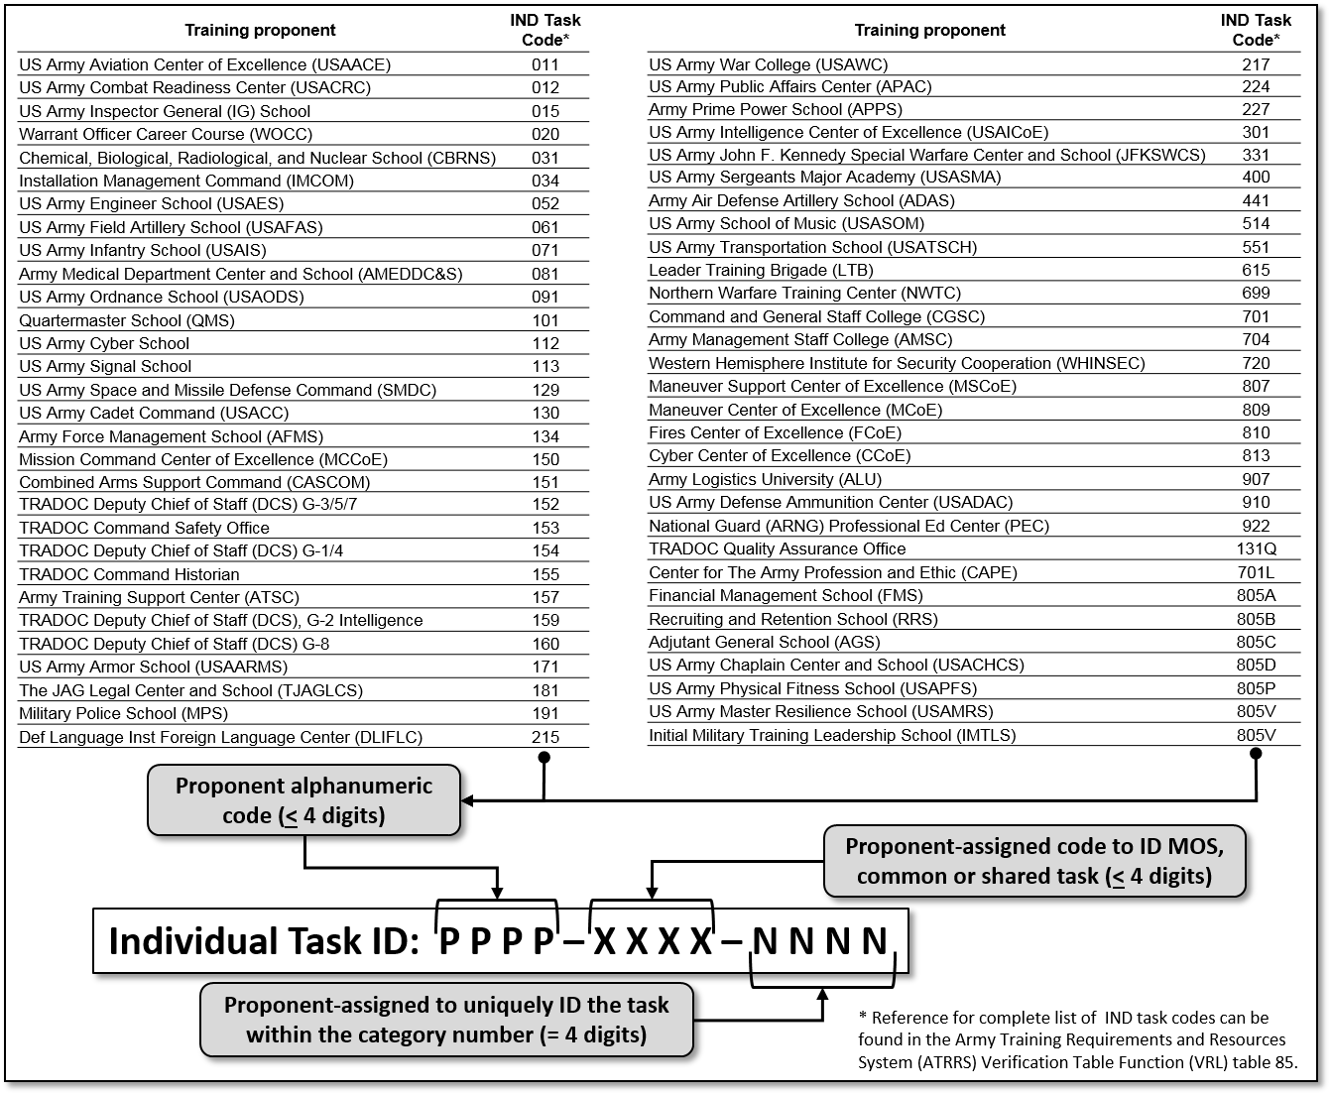

Figure 7-1. Individual task number format

(1) The first set of characters (PPPP) is the proponent or school code (three or four alphanumeric characters). Proponent code listing in figure 7-1 is not inclusive and reflects codes that are most commonly used.

(2) The proponent assigns the second set of characters (XXXX), a three or four digit code to identify tasks based on three criteria below identifying whether the task is:

(a) MOS-specific. MOS-specific tasks use the proponent-assigned three or four-character alphabetic, numeric, or alphanumeric code that identifies the MOS the task supports.

*Example*: 071-11C-1001.

(b) Common to all Soldiers (or Army Civilians). These tasks use "COM" for the second set of characters.

*Example*: 071-COM-1001.

(c) Shared between MOS within CMFs. These tasks use a proponent assigned three-digit number based on task type, equipment type, or series/category.

*Example*: 071-030-0003.

*Example*: 071-000-1001.

(3) The third set of characters (NNNN) is a proponent-assigned four-digit number identifying the task within the category number.

(4) Do not use task numbers of obsolete or superseded tasks for 5 years.

d. Individual task title. The task title sums up the action that is to be performed. The title should be completely understandable in terms of the expected outcome by anyone reading it. Write the title in a standard format, using title case. The title must consist of one appropriate present tense action verb and one object. This is very important when it comes to evaluating the task. For example, *Maintain an M16 Series Rifle* is an appropriate individual task title because it specifies a single action performed by one Soldier. See figure 7-2.

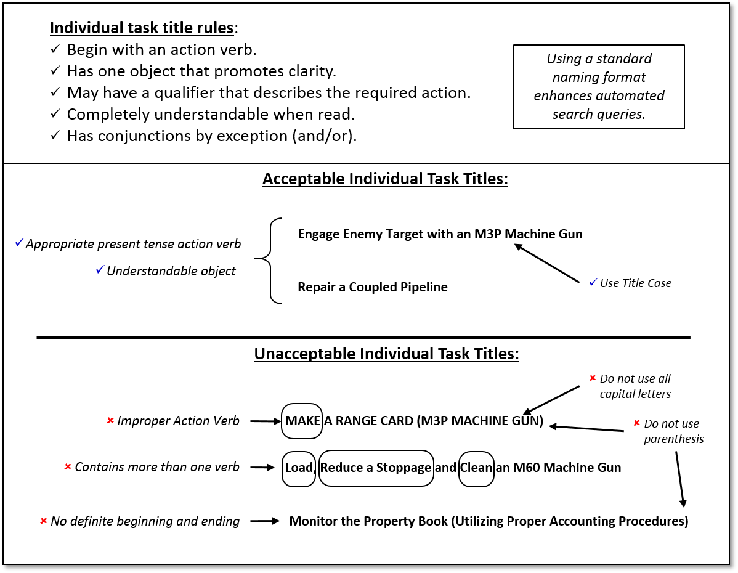

Figure 7-2. Developing individual task titles

e. Task references. The review of doctrine results in the creation of task references. List only the minimum number of references for a collective task to aid Soldiers in locating the most appropriate reference(s). If using more than one reference to provide the doctrinal basis for the task, identify at least one primary reference using appropriate means. When possible, avoid including an expansive list of references simply because the document makes some degree of reference to the performance of the task.

(1) Training Circulars provide the standards for collective tasks that require Live-Fire, and they are an authorized reference.

(2) TMs may be a reference listed if the task is technical.

(3) STPs and WTSPs are not appropriate references.

(4) This guidance applies at both the task and performance step levels.

## 7-3. Design the Individual Task Condition

a. The individual task condition describes under what circumstances to perform the task. It also lists the materials, personnel, and equipment provided for task accomplishment. The condition statement contains the when, where, why and resources required.

*Example*: Given an operational petroleum laboratory in a field or garrison environment.

b. Special conditions. A special condition is an aiding or limiting factor that occasionally occurs and affects a Soldier’s ability to perform the task to the established standard. These special conditions include, but are not limited to, wearing of mission oriented protective posture (MOPP) level 4, night vision devices (NVD), or self-contained breathing apparatus when performing the task. Identify these unique circumstances are separate special condition statements when conducting the individual task analysis, and enter them under the Conditions tab in TDC.

c. Writing special condition statements. Once TNGDEV identify changes to the task performance standard caused by performing the task under a special condition, TNGDEV must include changes in the special condition statement. When writing a special condition statement, be aware of the following conditions:

(1) More than one special condition simultaneously may affect task performance.

(2) A special condition may affect such standards as speed or accuracy.

d. See figure 7-3 for rules and information about writing individual task condition statements.

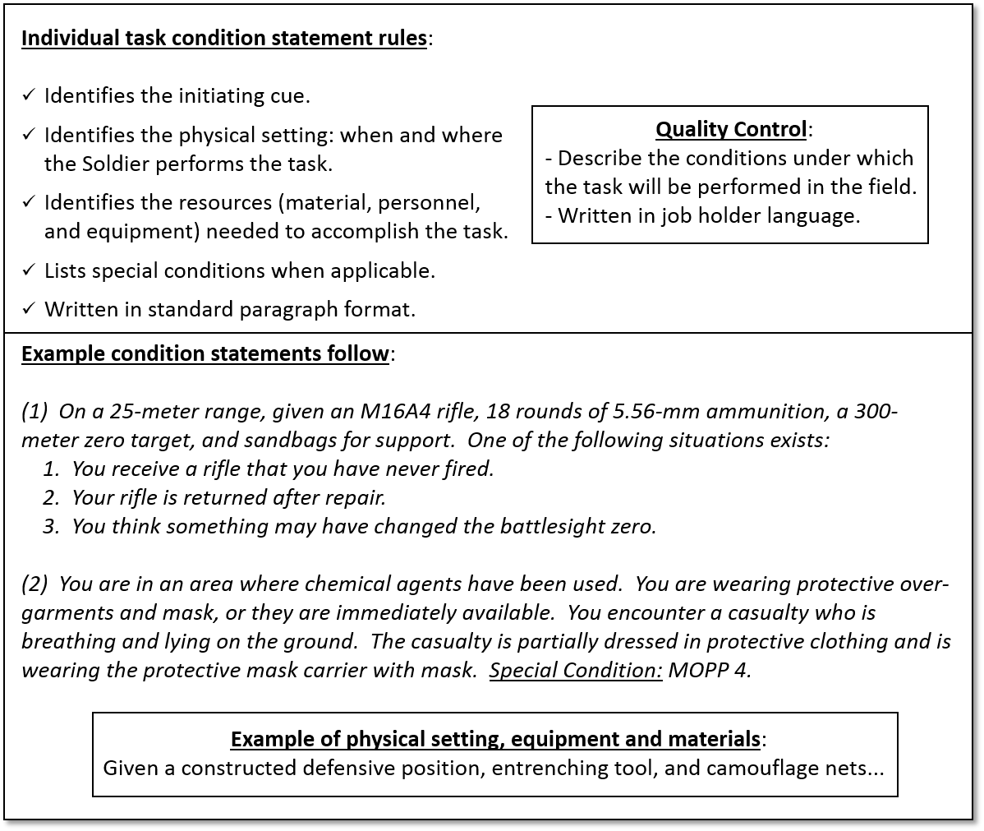

Figure 7-3. Writing individual task condition statements

## 7-4. Design the Individual Task Standard

The standard describes the ultimate outcome criteria for performance of the individual task. It notes how well someone should perform the task and be competent under the prescribed condition statement. The standard must include both the performance and the criteria. Criteria may include, but are not limited to, accuracy, quantity, speed, and quality. Parts of an example standard statement might be as follows: Fire all 18 rounds (performance) and hit the target at least nine times (criterion). See figure 7-4 for rules and information about writing individual task standard statements.

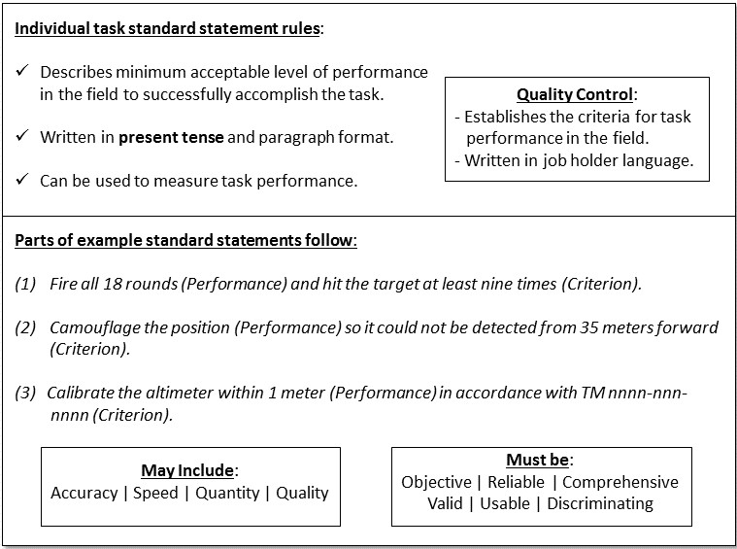

Figure 7-4. Writing individual task standards

## 7-5. Develop Performance Steps

A task is composed of procedures that represent interim outcomes achieved during the completion of the task (for example, *Set the rear sight to the center*). Each procedure describes the action and decision steps necessary to achieve the interim outcome in language detailed enough that the target audience will understand how to perform the step. A performance step is an action or decision that an individual must accomplish in order to perform an individual task to standard. Each performance step is a single discrete operation, movement, action or decision that composes part of a procedure or task. When developing performance steps, the steps should meet the following criteria:

* Write using a present tense verb and object format.
* Ensure the use of terms and level of detail are appropriate for the target population.
* Include a description of the present tense action and a quantitative or qualitative object.
* Use language detailed enough that the target audience will understand how to perform the step.
* Number all performance steps alphanumerically in the sequence performed.

a. Include a description of the present tense action and a quantitative or qualitative remark for a performance step.

b. Use notes only when necessary. Before adding a note to a performance step, assess the applicability of adding the information to an existing performance step or as an additional performance step. Refer to TR 25-30 for definitions on safety matters.

c. Individual tasks may be linked to another individual task rather than integrated as performance steps in some circumstances.

d. An example of performance steps and sub steps from an approved individual task appears in figure 7-5.

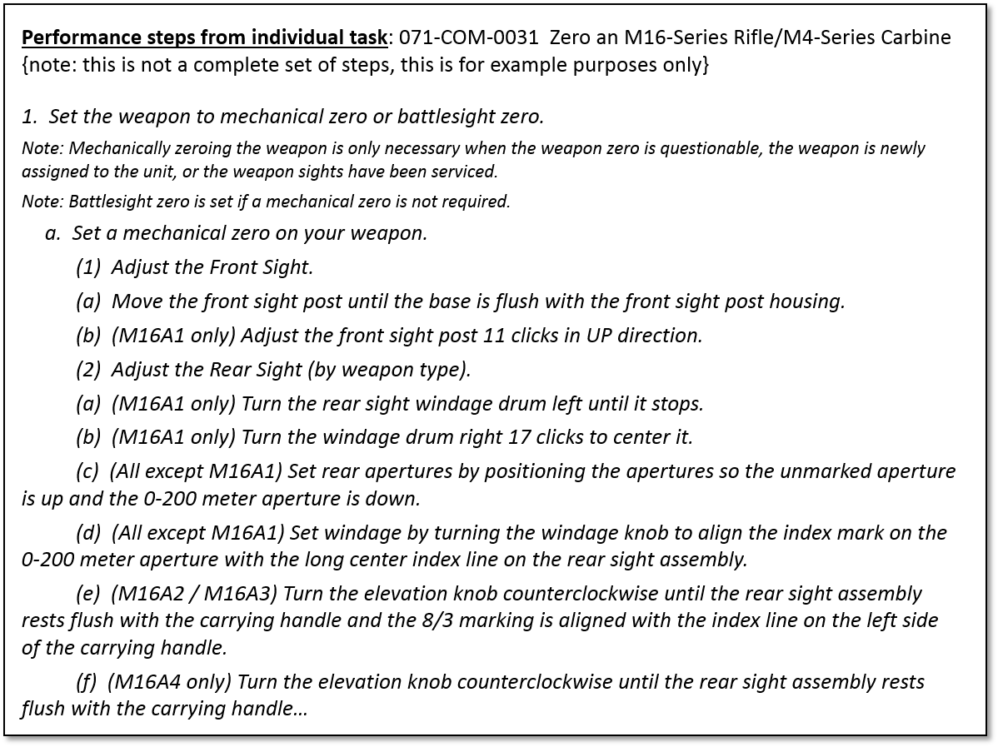

Figure 7-5. Individual task performance steps example

## 7-6. Develop Performance Measures

Performance measures are actions that are objectively observable, qualitative, and quantitative, and used to determine if a performance step or sub-step is achieved. Number Performance measures alphanumerically. Write Performance measures using a past tense verb and object format. Before adding a note to a performance measure, assess the applicability of adding the information to an existing performance measure or as an additional performance measure. These measures are derived from the task performance steps and sub steps during individual task analysis. At a minimum, all performance steps must have a corresponding performance measure. See figure 7-6.

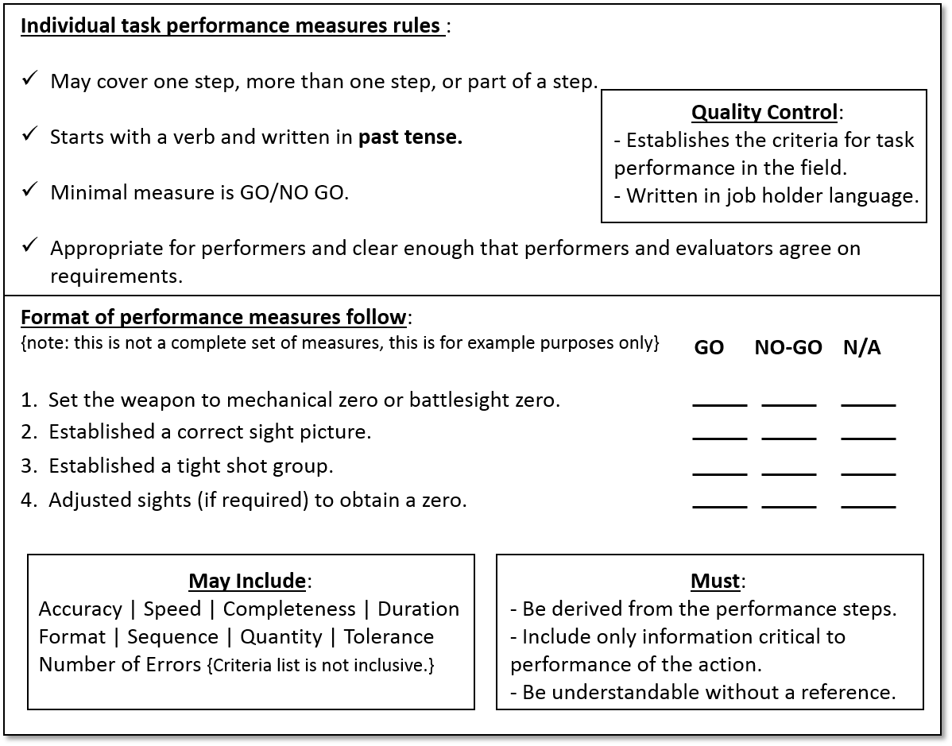

Figure 7-6. Writing individual task performance measures

## 7-7. Identify Task Linkages

a. An individual task should support one or more collective task(s) and may support one or more individual task(s) or drill(s).

b. Any prerequisite individual tasks need to be linked to the individual task being developed. For example, the prerequisite task *Perform a Function Check on an M16/M4-Series Rifle* would be linked to the task *Zero an M16-Series Rifle/M4-Series Carbine*. Each task must reflect current and emerging doctrine.

c. An individual task must be linked to any supported collective task on which it has a first order effect.

*Example*: The individual task *Zero an M16-Series Rifle/M4-Series Carbine* would have a first order effect on the collective tasks *Prepare for Combat*.

d. An individual task should be linked to a supported drill on which it has a first order effect. The TNGDEV works with a SME to identify the appropriate tasks.

*Example*: *Engage Targets with an M16A4 Rifle/M4-Series Carbine* would have a first order effect on the drill task *React to Ambush (Near)*.

e. The example in figure 7-7 illustrates task linkages.

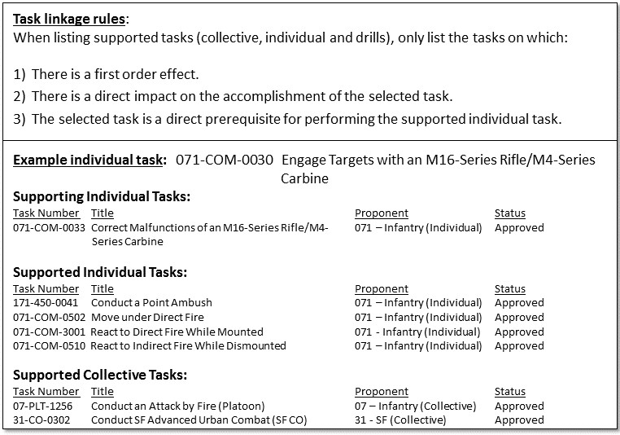

Figure 7-7. Task linkages with individual tasks

## 7-8. Identify Military Occupational Specialty (MOS) and Skill Level

This activity allows the proponents to identify the tasks required for competence in an MOS and skill level. The MOS identifies the primary occupational specialty or area of concentration.

## 7-9. Identify Skills and Knowledge

a. Identify all of the skills and types of knowledge required to perform the step that is analyzed. This identification is the critical, detailed work the developer performs to ensure the task performer possesses the requisite skills and knowledge needed to perform the task.

b. Skill. A skill designates one’s ability to perform a job-related activity that contributes to the effective performance of a task performance step. There are two types of skills: physical and cognitive.

c. Knowledge. Knowledge is information analyzed to provide meaning, value, and understanding. Knowledge is required to perform a skill and/or supported task.

d. A sample of skills and knowledge from an approved individual task appears in figure 7-8.

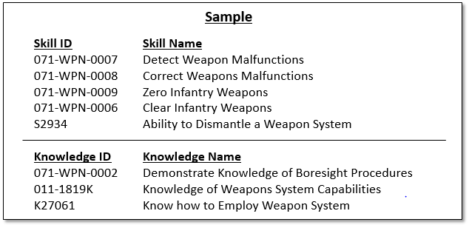

Figure 7-8. Skills and knowledge sample

## 7-10. Identify Evaluation Guidance

Provide a statement identifying the evaluation guidance needed for the task to be performed to standard.

*Example*: Score the Soldier GO if the Soldier passes (P) all performance measures. Score the Soldier NO GO if any performance measure is failed (F). If the Soldier scores NO GO, show the Soldier what was done wrong and how to do it correctly.

*Example:* Higher-level rubric evaluations/leader:After task completion explain the performance measures that the leader performed that were exemplary. Explain the performance measures the leader performed that were satisfactory. Explain the performance measures the leader performed that were unsatisfactory and add justifiable comments. Challenge the Soldier's critical thinking and ask the leader to explain how he/she could improve.

## 7-11. Identify Evaluation Preparation

Provide a statement that identifies the evaluation preparation needed to execute the task.

*Example*: Setup: Test this task in conjunction with other radiation measurement testing. Ensure that an AN/VDR-2 with batteries is available. Brief Soldier: Tell the Soldier to perform preventive maintenance checks and services on the AN/VDR-2.

## 7-12. Identify Equipment

Identify and link all equipment that enables successful completion of this task. Equipment can be linked using the pre-populated information in TDC. The example in figure 7-9 displays an equipment example.

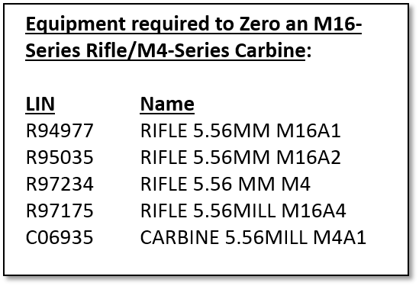

Figure 7-9. Individual task equipment example

## 7-13. Safety and Environment Statements

The proponent integrates safety, risk management, and environment protection considerations into learning materials. The proponent:

a. Includes appropriate safety, risk, and environmental protection statements, cautions, notes, and warnings in all learning products.

b. Identifies the risk and assigns an initial risk assessment to every learning product as designated in TDC.

c. Coordinates with the branch safety manager and obtains approval for all learning products with an initial risk assessment above low. Figure 5-10 shows the required environmental statements that must appear in each individual task. The TNGDEV may address safety, risks, or additional environmental issues as additions to these statements.

## 7-14. TADSS

The TNGDEV selects any appropriate TADSS to support individual task training and performance. If applicable, the TADSS title and numbers are required. Select TADSS from a search menu in TDC and print out as part of the synopsis report. The TNGDEV should identify trade-offs of training resources (such as, equipment, ammunition, and others) in order to identify TADSS as cost-effective training enablers. When appropriate, the TNGDEV links TADSS to support the training of the individual task developed. Resource information required to support TADSS training (such as contractor personnel requirements, special facilities unique to the TADSS) is pre-populated in TDC. The TADSS requirements information does not display for field users, but must be used to determine TSS resourcing requirements. TDC links TADSS to the T&EO as appropriate to support training.

## 7-15. Synopsis Report

TDC allows printing out a synopsis report for an individual task. The synopsis report includes all the information entered into the system, allowing review of all individual task information. The report includes the associated critical task list (CTL), personnel, and MOS data for those that train or perform the task. This report also identifies if the task is common, shared, unique, leader task, staff task, mandatory tasks, the effective date, if the task was routed to ArmyU, and if ArmyU reviewed or provided comments.

## 7-16. Individual Task Report

The individual task report provides the major procedures a Soldier must accomplish to perform an individual task to standard. TDC is set up with a template that systematically guides the developer through completing the appropriate data fields to generate the individual task report. The task performance specifications in the system include design elements to describe precisely how a specific task is performed, under what conditions the task or drill is performed, and how well a Soldier must perform the task. A unit evaluator uses an individual task report to determine, at a given time, whether the task was performed to the standard under the prescribed conditions.

## 7-17. Quality Control

Table C-5 provides a QC review checklist designed to manage and document control measures, identify areas to improve, and facilitate timely delivery of individual tasks.

## 7-18. Additional Information

Additional information regarding the analysis, design, development, implementation, evaluation, and management of individual tasks (particularly for training in the institutional domain) is found in other TRADOC 350-70 series pamphlets.

# 

# Chapter 8 Soldier Training Publications (STPs)

## 8-1. Introduction

a. This chapter provides guidance for the analysis, design, and development of STPs using the ADDIE process. This chapter supports and amplifies the regulatory guidance found in TR 350-70. Additional guidance covering management, editing, publishing, printing/replicating, and distributing ADTLP publications is in AR 25-30. DA PAM 25-40 provides procedures for policies established in AR 25-30. DA PAM 25-40 contains instructions, processes, formats, reporting requirements, and guidelines to carry out the Army’s publishing program.

b. STPs are developed, produced and disseminated at the discretion of school commanders/commandants. Additionally, ICTLs are available electronically in the CAR.

c. STPs are publications that contain critical tasks and other training information used for job training and serve as a basis for individual training in units. The STP identifies individual MOS/area of concentration (AOC) training requirements. STPs serve to standardize individual training for the whole Army; provide information and guidance for conducting individual training in the unit; and aid the Soldier, officer, NCO, and commander in training critical tasks. STPs can be categorized as either Soldier’s manuals (SMs), for skill level 1 tasks, or Soldier’s manual and trainer’s guides (SM-TGs), for skill levels 2, 3, and 4; or officer foundation standards (OFS), for officer common tasks. *Note.* The officer foundation standard system does not support branch manuals. Unit trainers use STPs to train and sustain both leader and Soldier task proficiency per table 8-1.

| Table 8-1  STP types and descriptions | |
| --- | --- |
| **STP type** | **Description** |
| 1. Soldier’s Manual of Common Tasks (SMCT) | Base documents for all common Soldier and common skill level individual task training and evaluation.  *Found in*: SMCT, STP 21-1-SMCT, Warrior Skill Level 1, and STP 21-24-SMCT, Warrior Leader Skill Levels 2, 3, and 4. |
| 2. SM | Base document for Branch MOS/ AOC-specific tasks, skill level 1.  *Example*: STP 5-12B1SM, Soldier's Manual and Trainer's Guide, MOS 12B, Combat Engineer, Skill Level 1. |
| 3. SM-TG | Document that provide commanders and unit trainers information needed to plan and conduct Soldier training and evaluations, for MOS-specific tasks in the unit, skill level 2, 3, and 4.  *Example*: STP 5-12B234-SM-TG, Soldier’s Manual and Trainer’s Guide MOS 12B, Combat Engineer, Skill Levels 2/3/4. |
| 4. OFS | For officer common tasks, the sub-number must consist of the OFS level (I. II, or III) minus the officer specialty.  *Example:* STP 21-I-OFS or STP 21-II-OFS. |

*Note.* See DA PAM 25-40, para 8-19 for specific guidance on numbering STPs.

d. The following are content requirements by STP type:

(1) STP 21-1-SMCT, Warrior Skill Level 1, is the only SM printed under the ADTLP. Training development (TD) proponents may publish branch-specific STPs. The ADTLP publishes all other STPs in electronic form. Electronic publications of STPs in ADTLP link to other unit-training products in DTMS for user-friendly access.

(2) SMCT content includes:

(a) Standardized common critical task summaries that include the conditions, standards, performance steps, and performance measures for each critical common task.

(b) Task summaries are referenced appropriately.

(c) Information that leaders need to train and sustain task proficiency.

(d) A common critical task-training plan and DA Form 5165-R (Field Expedient Squad Book) (in STP 21-24-SMCT, which contains skill levels 2, 3, and 4).

(3) Branch (MOS/AOC)-specific SM content includes the following products:

(a) All branch-specific critical tasks for a specific MOS/AOC for skill level 1.

(b) A task summary for every branch-specific critical task grouped by subject area.

(c) Information trainers need to plan and conduct individual training.

(4) Commanders, trainers, and Soldiers use SM-TGs to plan, conduct, and evaluate individual training in units. SM-TGs contain task summaries for all critical tasks specific to the MOS and skill level, and contain information needed to plan training requirements.

(a) The trainer's guide:

* Identifies subject areas in which Soldiers must train.
* Identifies critical tasks for each subject area.
* Specifies where Soldiers initially train on each task.
* Recommends the training frequency for each task to sustain proficiency.
* Recommends a strategy for cross-training Soldiers.
* Recommends a strategy for training Soldiers to perform higher-level tasks.

(b) The trainer's guide helps to ensure the following:

* Horizontal and vertical alignment of training across related career paths.
* Non-duplication of training and training products.
* Efficient use of training technology and multimedia (if applicable).

## 8-2. Analysis for STPs

a. Requirement. Proponents produce STPs when identified as a requirement based on job analysis and the CTSSB. STP analysis begins and ends with the TNGDEV obtaining the approved ICTL.

b. Start points for new, review, and revise actions for STPs:

(1) New. During needs analysis, proponents determine the criticality of and need to develop a new STP to support a new job.

(2) Review. A review is a detailed study of an existing STP to determine the adequacy/inadequacy of an existing future training strategy and current task analysis data.

(3) Revise. Revise STPs based on major changes to tasks within the STP or requirements for new tasks based on changes to doctrine, materiel, organization, and/or personnel. If a product review identifies a revision requirement, then an STP is revised. Proponents determine the criticality and requirement to develop or revise STPs, including SMs SM-TGs, and OFS. An output of job analysis (CTSSB) and individual task analysis is completion of an STP.

(4) ICTL. When creating or revising an ICTL for an MOS, the common tasks (found in STP 21-1-SMCT and STP 21-24-SMCT, Soldier’s Manuals of Common Tasks) should be included as a resource during the TTI and/or ICTL review. *Note*. TNGDEVs should ensure the STP is comprehensive and ensure to provide a link for the common task.

## 8-3. Design an STP

a. STP requirements. Since an STP is a publication with a predetermined format, the STP content design is provided. STP information and format are pre-populated and generated in TDC. Therefore, the requirements for designing an STP are based on compiling the individual critical tasks to develop the STP. Figure 8-1 depicts how an STP is designed and organized in TDC. Proponents may modify the format and content of the STP based on needs/requirements.

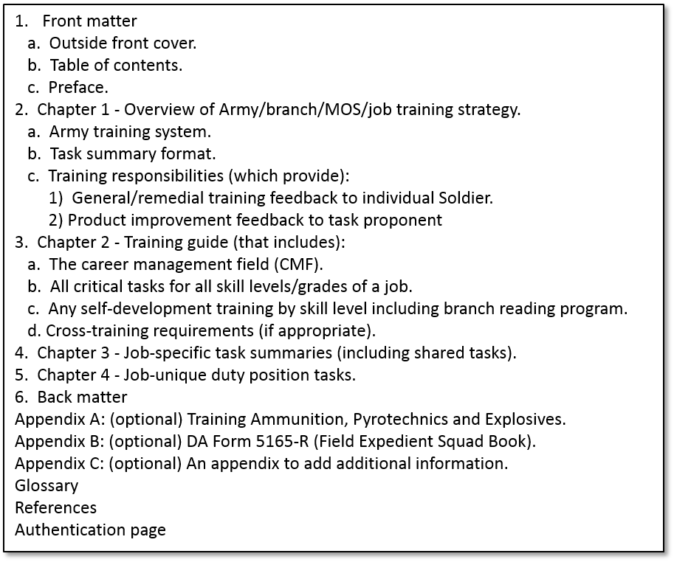

Figure 8-1. STP content organization

b. Chapter 1 explains how to use the STP in establishing an effective individual training program, including an overview of the Army/branch/MOS/job training strategy. The end of this chapter includes the professional development model. This model demonstrates for a Soldier the education and training needed throughout the Soldier's entire career.

c. Chapter 2 lists the subject area numbers and titles used throughout the MOS/branch training plan, defines the training requirements for each duty position, and provides a recommendation for cross-training and train-up or merger requirements. The STP lists, by subject areas, the critical tasks to be trained, task numbers, task titles, training locations, sustainment training frequencies, and sustainment training skill levels.

d. Chapters 3 and 4 contain the individual task summaries—the job-specific and job-unique position tasks. Task summaries outline the performance requirements of each individual critical task included in the STP. They provide the Soldier and the trainer with the information necessary to prepare, conduct, and evaluate critical task training in the unit. At a minimum, task summaries include information on the tasks the Soldier must be able to perform to prescribed standards.

e. The glossary and references are the final two sections of the STP. The glossary contains a comprehensive list of acronyms and abbreviations that are in the STP. The references section identifies references that provide additional information.

## 8-4. Develop the STP

a. Current STP development requirements are as follows:

(1) Acquire the approved ICTL.

(2) Develop STP from the approved ICTL using the TDC database template.

(3) Review/staff the STP to target audience and course managers.

(4) Adjudicate staffing comments.

(5) Submit for approval (proponent approving authority).

(6) Prepare a DA Form 260-1 and submit to Commander, Army Training Support Center (ATSC), (ATTN: TRADOC Departmental Publications Control Officer) for review.

(7) Adjudicate the TRADOC Publications Control Office comments, and submit to APD for final publishing.

b. The proponent determines the cyclic basis for STP revision using an ICTL published following completion of a job analysis/CTSSB and the Descriptions of Work (DOW).

*Note.* There is no analysis phase for STP development; however, the analysis phase is complete on ICTL approval. The TDC database determines the design phase.

(1) STP development begins with the task summary. Task summaries outline performance requirements for each critical task in the STP. They provide the Soldier and trainer with the information necessary to prepare, conduct, and evaluate critical task training. At a minimum, task summaries include information Soldiers must know and skills they must perform to standard for each task.

(2) TDC automatically generates much of the content and format of an STP or it is pre-populated. However, much of the TDC pre-populated STP content is not updated. The STP development requirements are based on compiling the individual critical tasks developed in this system. The ADDIE development phase of an STP is the compilation of the job-specific task summaries appearing as chapter 3 in the STP, and compilation of any job-unique duty position tasks appearing as chapter 4. Information extracted from the individual critical tasks developed in TDC is the basis for task summaries as table 8-2 depicts.

| Table 8-2  Task summary format for an STP | |
| --- | --- |
| **Part** | **Description** |
| 1. Task title | Describes the required action with an action verb-object-qualifier. |
| 2. Task number | Provides a unique, permanent identification number from the approved ICTL. |
| 3. Condition | The condition expands on the information in the task title by identifying when, where, and why the Soldier performs the task as well as what materials, personnel, and equipment the Soldier must have to perform the task. |
| 4. Standard | The standard specifies how well, completely, or accurately a process is performed or product developed. |
| 5. Training and evaluation guide | Contains two sections:  (a) Task performance steps, which provide details required to perform the task.  (b) Performance evaluation guide that contains the following items:  (1) Evaluation preparation. Provides special setup procedures and instructions for evaluating task performance (if required).  (2) Performance measures with GO/NO GO criteria.  (3) Evaluation guidance. Indicates requirements for receiving a GO and other special guidance (if required). |
| 6. References | Identifies required and related references. |
| 7. Integrated safety, risks, and environmental considerations | Safety and environmental factors and considerations are included in the task steps as identified during individual task analysis. |
| *Note.* Extract task summary information verbatim from the individual task analysis. See chapter 7 for development of an individual task. | |

c. Appendix B, Paragraph B-4 STP Example provides a sample of part of the task summary portion of an STP (a portion of an SM-TG, chapter 3). Refer to Appendix B Unit Training Material Examples.

d. The proponent agencies that prepare the STP for publication and distribution further develop the STP. The proponent/preparing agencies have the following requirements:

(1) Plan, manage, and develop new and revised STPs in accordance with this pamphlet and the policy and procedures in required references.

(2) Establish local procedures to staff, manage, coordinate, and approve STPs.

(3) Proponents perform QC functions before submitting a product to ATSC/APD or staffing. Table C-7 provides a QC review checklist designed to manage and document control measures, identify areas to improve, and facilitate timely delivery of STPs.

(4) Ensure STPs (for publications in both print and electronic media) comply with the copyright laws of 17 USC as well as with governing copyright policy, to include, but not limited to, AR 25-30, paras 2-11 and 5-3, AR 27-60, chapter4, DA PAM 25-40, para 2-7, and TR 25-35, paras 1-4 and 5-4. Determine and apply appropriate foreign disclosure restriction statements on ADTLP publications containing classified military information and controlled unclassified information in accordance with applicable DA and TRADOC regulations, training product classification, and foreign disclosure restriction statements.

(5) Staff STP for comments and recommendations.

(6) Adjudicate comments from staffing.

(7) Determine and assign to all STPs the following markings, numbers, and statements in accordance with AR 25-30:

(a) Security classification markings (also in accordance with AR 380-5).

(b) Distribution restriction statement.

(c) Publication number.

(8) Submit for approval.

(9) Prepare and submit DA Form 260-1 (Request for Publishing-DA Training, Doctrinal, Technical, and Equipment Publications) and STP to APD for publication.

(10) Adjudicate APD comments.

(11) Export to the CAR and DTMS.

(12) Validate export to the CAR and DTMS.

(13) APD publishes the STP.

e. Management of STPs includes preparing and submitting DA Form 260 (Request for Publishing) for use of this form see AR 25-30. Prior to submission, the preparing agency will submit DA Form 260 to Commander, ATSC (ATTN: TRADOC Departmental Publications Control Officer), who verifies the DA Form 260 to ensure conformity to AR 25-30 and required TRADOC regulatory guidance.

## 8-5. Quality Control

Proponents perform QC functions before submitting STPs to ATSC. Table C-7 provides a QC checklist designed to manage and document control measures, identify areas to improve, and facilitate timely delivery of STPs. Following QC, the proponent submits the final product along with the DA Form 260-1 (Request for Publishing-DA Training, Doctrinal, Technical, and Equipment Publications), and TR 25-36-1-E, (TRADOC Doctrine Publication Checklist), to Commander, ATSC (ATTN: PCO/FMO, 3306 Wilson Avenue, Rm 2, Joint Base Langley-Eustis, VA 23604-5168).

# Chapter 9 Managing Unit Training Products

## 9-1. Introduction

a. The purpose of this chapter is to present management guidance for the production of operational domain training and education products. This chapter supports and amplifies the regulatory guidance found in TR 350-70.

b. CAC serves as the TRADOC functional proponent for Army training and education development. This includes functional proponency for Army training and education: regulations and guidance, QC of products, standardization of products, and development of functional requirements for automation.

c. ArmyU, Director for Learning Systems (DLS) executes the role of theCAC responsible agent for Army training and education through the performance of the following:

(1) Serves as the Army’s collective and individual task and learning products manager.

(2) Coordinates with institutions and proponents to develop policy and guidance.

d. CAC-T, TMD

(1) Proponent for developing and publishing the Army’s training doctrine, ADP 7-0, ADRP 7-0, and FM 7-0. Develops unit training management strategy and integrates associated doctrine and TTPs into training and education products.

(2) Establishes review boards in coordination with institutions and proponents, as needed. Review boards develop, recommend, revise, approve, and achieve consensus on training and education products used across multiple units, proponents, or COEs. Review boards establish and maintain standardized learning products that support commanders, facilitators, and trainers in planning, preparing, executing, assessing, and evaluating training. The end-state of all review boards is to enable TRADOC to provide current and relevant training and education products for Soldiers in the operating force, resulting in fully prepared Soldiers for decisive action. Common components and actions of all review boards include the following members and actions:

(a) Members of the review boards nominate task issues for consideration prior to each review board.

(b) Coordinates with review board members to clarify submissions or to reach early resolution on issues.

(c) Review boards forward recommendations to the appropriate proponent approval authority to update the associated learning products and TDC or as the Board’s issue resolution requires.

(d) Review boards address training and education products used in coordination with and as the responsible proponent approves.

(e) Review boards convene in a variety of venues based on purpose, membership, resources, and end-state. Viable options for conducting the business of a review board are collaboration sites supporting document management systems, video teleconferences, other like means, and face-to-face venues.

(f) Figure 9-1 describes the STRAG as an example of a review board. See paragraph 9-1d(2)(g) below.

|  |
| --- |
|  |
| **Board**: Standards for Training Readiness Advisory Group (STRAG). |
| **Responsibility**: Training Readiness proficiency assessments for Mission Essential Task Lists (METL), weapon systems, collective Live-Fire tasks; and Days-to-Train to T1.  *Note.* Unit training readiness is based on Training Readiness proficiency assessments. |
| **Frequency:** Quarterly or as directed by HQDA. |
| **Purpose:** To provide a management process for identifying issues associated with the four training readiness metrics and associated assessment tools, metric calculations, or resource support; and to recommend resolution of issues to the Operational Portfolio Council of Colonels and Training General Officer Steering Committee, in accordance with AR 350-1. Ensures training readiness metrics and associated assessment tools, metric calculations, and resource support are standardized and aligned with changes in the following:  a. Operating environment as defined by Army Senior Leader Guidance.  b. TOE missions/design.  c. Joint and Army doctrine.  d. Unit training readiness reporting requirements. |
| **Approval Authority:** CAC is the HQDA Executive Agent for STRAG. |

Figure 9-1. Review boards

(g) The STRAG recommends changes to the training readiness components based upon efficacy and fidelity. The HQDA G-3/5/7 has the final approval authority for all recommended changes. The STRAG does not develop component standards for training readiness. This responsibility lies with TRADOC and their subordinate COEs as outlined in the respective proponent-approved training products such as T&EOs and TCs.

## 9-2. Use of Collective Tasks

a. A proponent can only revise or develop collective task products (CATS, WTSPs, collective tasks, drills) for which they are responsible. TR 350-70 contains an electronic product that lists the training development proponencies and responsibilities. This list title is Functional Area Proponency List and is located on ATN/TED-T/References. The development or revision of non-proponent tasks is coordinated with and approved by the responsible proponent that will incorporate the task(s) into any training product.

b. If another proponent requests a change to a task, the responsible proponent may elect to make the change or may leverage the efforts of the requesting proponent. Responsible proponents are encouraged to use the efforts of other proponents to achieve consensual improvement of their tasks. A base task developed or revised by a proponent is provided to the responsible proponent, given the responsible proponent base task ID number, and approved by the responsible proponent before being incorporated into another proponent’s training product.

c. It is the proponent’s responsibility to use TDC to develop and/or deliver a mission and/or collective task analysis.

d. ArmyU, DLS coordinates with TRADOC G-3/5/7, training development proponents and ATSC for the TDC requirements. This system must provide all training development proponents with one collective data source for training development. It must also incorporate business practices and capability improvements that enhance the efficient and standardized development of collective training products.

## 9-3. Collective Training Product Management

a. Managing collective training products. Collective training product management involves each proponent monitoring triggering circumstances that affect their products, and responding to the following events (see figure 9-2 for the task management process):

(1) Monitoring collective training product triggering circumstances.

(2) Assessing the impact of the circumstances.

(3) Applying modifications to the collective training product, as applicable.

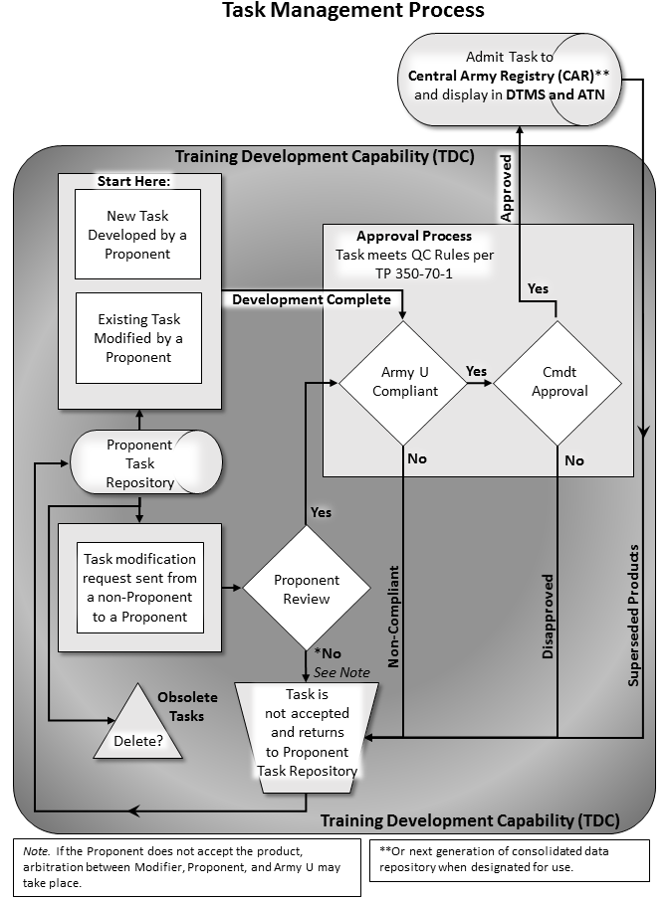

Figure 9-2. The task management process

b. Monitoring collective training products.

(1) Monitor commander/field user feedback.

(2) Monitor CTC feedback.

(3) Monitor laws and DA directives that impact training.

(4) Monitor DA and Army command-directed training requirements.

(5) Monitor training resourcing.

(6) Monitor doctrine changes.

(7) Monitor improvements and/or constraints in the training environment.

(8) Monitor leader development and leader tasks.

(9) Monitor organizational TOE and proponent TDA changes.

(10) Monitor equipment (materiel) development or modifications.

(11) Monitor feedback from the CALL.

(12) Monitor changes in related training products, for instance, collective tasks of other proponents, DA PAM 350-38, TADSS, and WTSPs.

(13) Monitor changes in other proponents**'** combined arms doctrine or tasks.

c. Assessing the impact of triggering circumstances.

(1) Determine if and how collective training products are affected.

(2) Determine if the triggering event warrants modifications or updates of the collective training products, or thedevelopment of a new collective training product.

d. Applying/revising collective training products.

(1) Identify, apply, and review the applicable change(s) to the collective training product(s).

(2) Determine the impact of the change(s) on all related collective training products.

(3) Update the collective task analysis, if applicable (see chapter 5).

(4) Obtain the respectivecommandant’s approval of thechanged product(s).

(5) Revise the collective training product(s).

e. Centers and schools' knowledge managers provide a continuous review of the center/schools' intended TDC product submissions prior to their delivery to the CAR to ensure delivery of quality products and to confirm receipt of all products delivered to the CAR. Centers and schools determine the frequency of the product delivery standards review and receipt confirmation based on their requirements. Additionally, centers and schools should develop procedures that address product checks and delivery, receipt verification at the CAR, and removal of obsolete products and material. Specifically, the review should address the following product and delivery issues:

(1) Validated all learning products are properly approved.

(2) Ensure all learning products are in the proper format.

(3) Identify and remove obsolete learning products and/or material from TDC and the CAR.

## 9-4. Proponent Guidance for Individual Task Management

Proponents maintain and store individual tasks in TDC. The Army’s consolidated task repository is the CAR from which DTMS and ATN can access and display the tasks.

*Note.* Army University has rescinded TP 350-70-16 and this former pamphlet has become a digital appendix supporting TR 350-70. The electronic product (Functional Area Proponency List) is located on ATN/TED-T.

a. The proponents that TR 350-70 designates in the Functional Area Proponency List may revise, develop, or combine the tasks for which they are responsible. The product provides electronic access to the current proponency alignment and includes the training proponent leads for mandatory training. Proponents do the following activities:

(1) Identify and manage all individual tasks for which they are the designated proponent.

(2) Ensure the accuracy of all task performance specifications and supporting products.

(a) Monitor changes in doctrine and equipment to identify the impact of changes on the task.

(b) Revise the task(s) and supporting products that require minor modifications in conditions or performance steps.

*Example*: A change in the order of performance steps; rewording. This does not require a change in task number or title.

(c) Eliminate the task(s) and supporting products that are no longer valid or that have major changes in the action performed, the conditions of performance, or the standard of performance.

*Examples*: The introduction of a new task step, or an addition to or subtraction from the standard criteria. This does not require a change in task number or task title.

*Note.* An addition or deletion of a critical task necessitates the approval of a revised critical task list.

* Supersede the obsolete task(s) and products with revised task(s) and supporting products.
* Rescind the obsolete task(s) and products not replaced.
* Archive the superseded and rescinded task(s) (number and title) and products for 5 years.

(d) Inform users of changes in a task or supporting product.

(e) Prior to deleting, determine what other operational domain learning products (individual or collective tasks, CATS, WTSPs) reference the obsolete task.

(f) Remove obsolete products and send the identified replacement product (if any) to other users and proponents.

b. Other proponents must submit requests for change and modifications of individual task(s) to the responsible proponent as designated by the Functional Area Proponency List that is located on TED-T. The task must have an appropriate designated proponent ID task number and receive proponent approval prior to incorporation into the responsible proponent’s learning product. If another proponent requests development of a new task, the responsible proponent may elect to develop the new task or may leverage the efforts of the requesting proponent. Responsible proponents must work with requesting proponents to achieve consensual improvement/development of their tasks.

c. Proponents should conduct an administrative review of their ICTL every 3 years or as directed due to triggering circumstances.

## 9-5. Soldier Training Publications

STPs contain critical tasks and other training information used to train Soldiers and serve to standardize individual training for the whole Army; provide information and guidance in conducting individual training in the unit; and aid the Soldier, officer, noncommissioned officer, and commander in training critical tasks. They consist of Soldier’s Manuals, Training Guides, Military Qualification Standards Manuals, and Officer Foundations Standards Systems manuals. Per AR 25-30, the ADTLP prioritizes training and doctrine publications for printing, replication (including digital copies of the products) and distribution.

a. ArmyU, DLS oversees the production of STPs by taking the following actions:

(1) Establishing the STP format and content requirements.

(2) Approving STP proponency, including proponent exemption requests.

b. An STP can be developed for every enlisted MOS, every officer branch (at school commandant’s discretion), and critical common skill level tasks (for example, STP 21-1).

c. Prioritize STP development to accomplish workloads within resource constraints.

d. Use TDC to manage STP development, plan for STP revision, and develop STPs.

e. Identify STP fielding dates. Use fielding dates to do the following tasks:

(1) Determine internal development milestones.

(2) Enter scheduled completion dates into TDC.

f. Staff the STP draft digitally. Submit only one draft digital copy per each addressee.

(1) HQ TRADOC, ATTN: ATTG-IL, Fort Eustis, VA 23604-5000.

(2) Commander, ATSC (ATTN: PCO/FMO, 3306 Wilson Avenue, Rm 2, Joint Base Langley-Eustis, VA 23604-5168).

(3) Staff according to table 9-1 STP staffing.

| Table 9-1  STP staffing | |
| --- | --- |
| **If** | **Submit to** |
| Officer STP | Commandant, USACGSC, ATTN: ATZL-SWC-LE, Fort Leavenworth, KS 66207-6900. |
| Enlisted STP | Commandant, US Army Sergeants Major Academy, ATTN: ATSS-DC, Fort Bliss, TX 79918-5000. |
| Warrant Officer STP | Commandant, Warrant Officer Career Center, ATTN: ATZQ-WCC, Fort Rucker, AL 36362-5000. |
| SMCT | Army command commanders. |

(4) Staffing draft STPs with field units is optional.

g. Prepare final electronic (digital) files.

(1) Review, correct, and incorporate approved staffing comments and changes.

(2) Develop final electronic files for digital staffing according to the following regulations and pamphlets:

(a) AR 25-30.

(b) TR 25-30.

(c) TP 350-70-12.

h. The following actions are the criteria for product completion:

(1) Proponents complete STP development when they forward the proponent-approved final electronic (digital) files to ATSC in accordance with ADTLP product management.

(2) ATSC completes STP responsibilities when they forward final electronic files (digital) to the Army Publishing Directorate for replication and distribution. See TR 350-70 and TP 350-70-12 for more information on ADTLP Product Management, print/replication, reprint/replication, distribution, and database storage requirements.

## 9-6. Approval and Distribution of Unit Training Products

Upon completion of the final draft of all new learning products, the proponent must route via TDC to ArmyU, DLS to review the product for policy compliance. If non-compliant, ArmyU, DLS must provide appropriate comments to the submitting proponent. The proponent must complete corrections in TDC and re-submit to ArmyU, DLS for further review and compliance. The proponent’s commander/commandant or delegated representative is the approval authority for all operational products proponent personnel develop. Although not a requirement, it is highly recommended that proponents also route to ArmyU, DLS any reviewed or revised learning products. This ensures all learning products are standardized across the learning enterprise.

*Note.* ArmyU, DLS must comply with the product in TDC before proponents can change the product to an approved status and publish to the CAR for display on DTMS, ATN, or any other approved Army or TRADOC automated site.

## 9-7. Validation

a. As part of theQC process, developers should validate learning products to determine if the products accomplish their intended purposes efficiently and effectively. Validation and revisions are continuous actions in the improvement process.

b. Product and material validation involves:

(1) Individual or group validation trials, depending upon the nature of the learning product.

(2) Verification of learning effectiveness.

(3) Determination of beneficial improvements in the quality of learning products and materials.

(4) Identification of learning product deficiencies.

(5) Identification of currency and relevancy of learning products and material.

# Appendix A References

**Section I** **Required Publications**

ARs, DA Pams, ADPs, ADRPs, Army Techniques Publications (ATP), FMs, and DA Forms are available at [www.apd.army.mil](http://www.apd.army.mil). TRADOC publications and forms are available at <http://www.tradoc.army.mil/publications.htm>.

DOD Dictionary of Military and Associated Terms

**ADRP 1-02**

Terms and Military Symbols

**ADRP 1-03**

Army Universal Task List

**Army Training Network (ATN**)**:** <https://atn.army.mil>

**AR 25-30**The Army Publishing Program

**AR 71-32**

Force Development and Documentation

**AR 220-1**Army Unit Status Reporting and Force Registration – Consolidated Policies

**AR 350-1**Army Training and Leader Development

**AR 380-5**

Department of the Army Information Security Program

**FM 7-0**Train to Win in a Complex World

**TP 350-70-12**The Army Distributed Learning (DL) Guide

**TR 10-5**U.S. Army Training and Doctrine Command

**TR 25-30**Preparation, Production, and Processing of Armywide Doctrinal and Training Literature (ADTL)

**TR 350-50-3**Mission Command Training Program

**TR 350-70**Army Learning Policy and Systems

**Section II** **Related Publications**

A related publication is a source of additional information. The user does not have to read it to understand this publication.

**ADP 7-0**

Training Units and Developing Leaders

**ADRP 7-0**

Training Units and Developing Leaders

**AR 5-5**Army Studies and Analyses

**AR 5-13**Total Army Munitions Requirements and Prioritization Policy

**AR 5-14**Management of Contracted Advisory and Assistance Services

**AR 5-22**The Army Force Modernization Proponent System

**AR 11-33**Army Lessons Learned Program

**AR 25-1**Army Information Technology

**AR 25-55**The Department of the Army Freedom of Information Act Program

**AR 70-1**Army Acquisition Policy

**AR 71-32**Force Development and Documentation

**AR 95-1**Flight Regulations

**AR 140-1**Mission, Organization, and Training

**AR 140-483**Army Reserve Land and Facilities Management

**AR 200-1**Environmental Protection and Enhancement

**AR 350-28**Army Exercises

**AR 350-38**Policies and Management for Training Aids, Devices, Simulators, and Simulations

**AR 350-50**Combat Training Center Program

**AR 380-10**Foreign Disclosure and Contacts with Foreign Representatives

**AR 385-10**The Army Safety Program

**AR 420-1**Army Facilities Management

**AR 525-29**Army Force Generation

**AR 530-1**Operations Security

**AR 600-20**Army Command Policy

**AR 600-100**Army Profession and Leadership Policy

**[ATP 2-22.2-1](javascript:void(0);" \o "Click to open the superseding document: ATP 2-22.2-1 - Counterintelligence Volume 1: Investigations, Analysis, and Production, and Technical Services and Support Activities (U))**

[Counterintelligence Volume 1: Investigations, Analysis, and Production, and Technical Services and Support Activities (U)](javascript:void(0);" \o "Click to open the superseding document: ATP 2-22.2-1 - Counterintelligence Volume 1: Investigations, Analysis, and Production, and Technical Services and Support Activities (U))

**ATP 5-19**

Risk Management

**Chairman of the Joint Chiefs of Staff Instruction 3170.01G**Joint Capabilities Integration and Development System

**DA Pam 25-40**Army Publishing Program Procedures

**DA Pam 350-38**Standards in Weapons Training

**DA Pam 350-58**Army Leader Development Program

**DA Pam 611-21**Military Occupational Classification and Structure

**FM 3-0**Operations

**FM 3-20.21**Heavy Brigade Combat Team (HBCT) Gunnery

**FM 3-90-1**

Offense and Defense Volume 1, w/C 1 & 2

**FM 3-90-2**

Reconnaissance, Security, and Tactical Enabling Tasks, Volume 2

**FM 6-22**Leader Development

**FM 7-100.1**Opposing Force Operations

**FM 27-10**

The Law of Land Warfare (includes C 1)

**Joint Publication (JP) 1**Doctrine for the Armed Forces of the United States

**JP 1-02**Department of Defense Dictionary of Military and Associated Terms

Leader’s Guide to Objective Assessment of Training Proficiency

**STP 21-1-SMCT**

Soldier’s Manual of Common Tasks Warrior Skills Level 1

**STP 21-24-SMCT**

Soldier’s Manual of Common Tasks (SMCT) Warrior Leader Skill Level 2, 3, and 4

**TC 7-101**

Exercise Design

**TC 7-100.2**

Opposing Force Tactics

**TC 7-100.3**

Irregular Opposing Forces

**The Army Campaign Plan**

**TP 350-70-3**  
Faculty and Staff Development

**TP 350-70-6**

Systems Approach to Training: Analysis

**TP 350-70-7**  
Army Educational Processes

**TP 350-70-9**  
Budgeting and Resourcing

**TP 350-70-13**  
System Training Integration

**TP 525 Series**Military Operations

**TR 25-36**The TRADOC Doctrine Publication Program

**Section III** **Prescribed Forms**

This section contains no entries.

**Section IV** **Referenced Forms**

**DA Form 260-1**Request for Publishing-DA Training, Doctrinal, Technical, and Equipment Publications

**DA Form 2028**Recommended Changes to Publications and Blank Forms

**DA Form 5165-R**Field Expedient Squad Book

**DD Form 67**Form Processing Action Request

**DD Form 565**

Statement of Recognition of Deceased

**DD Form 567**

Record of Search and Recovery

**DD Form 1074**

Questionnaire of Local Inhabitants

**DD Form 2977**

Deliberate Risk Assessment Worksheet (DRAW)

**TR 25-36-1-E**

TRADOC Doctrine Publication Checklist

# Appendix B Unit Training Material Examples

**B-1. Unit task list (UTL)**

The following is an example of UTL example.

*Note.* This view is an example only and not a complete UTL.

**UNIT TASK LIST**

**FOR RIFLE COMPANY, INFANTRY BATTALION (IBCT)**

**Organization ID 07217R000**

**Approved – 12 Aug 2015**

**Effective Date: 23 Dec 2013**

**Fires**

Establish a Fire Support Team Observation Post (06-TM-5049)

Displace a Mortar Unit by Echelon (Section-Platoon) (07-PLT-1306)

Fire Mortars by Direct Alignment (Section-Platoon) (07- PLT-3018)

Fire a Mortar Final Protective Fire Mission (Section-Platoon) (07- PLT-3027)

Fire a Mortar Coordinated Illumination Mission (Section-Platoon) (07- PLT-3063)

Conduct Simultaneous Mortar Fire Missions (Section-Platoon) (07- PLT-3117)

Fire a Time on Target Mortar Fire Mission (Section-Platoon) (07- PLT-3126)

Operate a Mortar Fire Direction Center (Section-Platoon) (07- PLT-5072)

Adjust Mortar Final Protective Fire (Section-Platoon) (07-PLT-3001)

**Intelligence**

Provide Situational Understanding of the Unit Area of Operations (34-TM-0470)

Support Unit Level Surveillance and Reconnaissance Operations (34-TM-0471)

Provide Intelligence Support Team Input to Targeting (34-TM-0472)

**Mission Command**

Conduct an Ambush (Platoon-Company) (07-CO-9010)

**Movement and Maneuver**

React to Obscuration (03-CO-9209)

Conduct a Dismounted Tactical Road March (Platoon-Company) (07-CO-1189)

Conduct an Airborne Assault (Platoon-Company) (07-CO-1234)

Conduct Tactical Movement (Platoon-Company) (07-CO-1342)

Figure B-1. Unit task list (UTL) example

**B-2. CATS Example (Extracts)**

The following tables provide extracts from a Task Set Report (Figure B-2), an event example (Figure B-3.) and an example of a CTE (Figure B-4.).

**Task Set Report**

**Report Date:** X OCT 20XX

**Task Set Number:** 17-TS-1008

**Task Set Title:** Conduct an Attack - BN

**Task Set Category:** Unit-Specific

**Proponent:** INFANTRY

**Echelon:** Battalion

**Army Operation(s):** Offense

**Description:**

This task set contains a group of collective tasks, linked to the standard METL and logically trained together, that when executed to standard will produce the ability to Conduct an Attack.

**Capabilities/Functions Trained:**

This task set trains the following TOE capabilities: Close with and destroy enemy forces using fire, maneuver, and shock effect.

The task set may also be used by other units when they also have the capability to perform this function or capability, are given an “out of design” mission, or are training a Function CATS.

**Training Guidance:**

This task set’s events are conducted in a crawl-walk-run training progression, based on the unit’s current proficiency. A TEWT is conducted at the crawl-level of training, with personnel demonstrating their knowledge, skills, and abilities to Conduct an Attack. A STAFFEX is conducted at the walk-level of training, with the unit demonstrating P-level proficiency in planning, preparing, executing, and assessing Conduct an Attack. T-level run training occurs as part of a multi-echelon event during CPX and FTX.

**Task Descriptions:**

There could be as many as four types of tasks within a TS: HQDA standardized MET, SCT, associated tasks, and tasks that must be performed to standard in order to master the TS capability. METs are collective tasks an organization must train to be mission or capability proficient. Display METs in a bold, blue font and display them first in the list of tasks. SCTs are proponent developed and are tasks that enable, or may enable the successful performance of the MET; list these tasks as SCTs in the MET T&EO. Highlight SCTs in bold, blue font and indent below the METs. Associated tasks are all the tasks that make up a TS; train associated tasks logically together to give a unit a complete and holistic capability or ability to perform a function. Finally, perform tasks annotated with an asterisk to standard in order to master the TS (these tasks may be METs, SCT, or associated tasks).

**Task Set Tasks:**

|  |  |
| --- | --- |
| **Number** | **Name** |
| 06-BN-5076 | Synchronize Fires |
| 07-BN-6082 | Conduct Mobility Activities (BN) |
| 17-BN-0308 | Synchronize Close Air Support (BN) |
| 17-BN-1007 | Conduct Reconnaissance Activities (BN) |
| 17-BN-1094 | Conduct an Attack - Combined Arms BN (CAB) (ABCT) |
| 17-BN-1254 | Conduct a Combined Arms Breach of an Obstacle - CAB (ABCT) |
| 63-BN-4878 | Provide Internal Sustainment for Battalion |
| 71-BN-4021 | Provide Internal Sustainment for Headquarters Battalion |
| 71-BN-5100 | Conduct the Mission Command Operations Process for Battalions |

**Task Set Events:**

|  |  |
| --- | --- |
| **Type** | **Title** |
| STAFFEX | STAFFEX for Conduct an Attack |
| TEWT | TEWT for Conduct an Attack |

*Note.* Development of “Run” level proficiency is conducted via Culminating Training Event(s).

Figure B-2. Task set report example

**Combined Arms Training Strategy (CATS)**

**07315K100 - COMBINED ARMS BATTALION (ARMOR)(ABCT)**

**Event:** STAFFEX for Conduct an Attack

**Task Sets: Number Name**

17-TS-1008 Conduct an Attack - BN

**Active Cycle Iteration Duration**

**Iterations:** Prepare Semi-Annually (2) 8 hours

Ready Semi-Annually (2) 8 hours

**Reserve Cycle Iteration Duration**

**Iterations:** Prepare 1 None 0 hours

Prepare 2 Annually (1) 8 hours

Prepare 3 Annually (1) 8 hours

Prepare 4 Annually (1) 8 hours

Ready Annually (1) 8 hours

**Condition: Walk**

**Training Audience:** COMMAND GROUP, CURRENT OPS-INTEL/S-2, CURRENT OPS - OPS/S-3, CURRENT OPS-FIRE SUPPORT, CURRENT OPS-FIRE SPT/TACP, CURRENT OPS-LNO, SUSTAINMENT-S-1, SUSTAINMENT-S-4, SUSTAINMENT-UMT, SUSTAINMENT-C-4 OPS/S-6, RETRANS TM, COMPANY HEADQUARTERS, SCOUT PLATOON HEADQUARTERS, HEAVY MORTAR PLATOON HEADQUARTERS, SNIPER SQUAD, MEDICAL TREATMENT PLATOON HEADQUARTERS, MINE ROLLER SECTION

**Training Aids, Devices, Simulators, and Simulations** (**TADSS):** 11-105 - Joint Conflict and Tactical Simulation (JCATS) (1), 71-30 - JOINT LAND COMPONENT CONSTRUCTIVE TRAINING CAPABILITY (JLCCTC) OBJECTIVE SYSTEM (1).

**Multi-Echelon Training:** No multi-echelon events suggested **Concurrent Training:** No concurrent training suggested **Domain:** Constructive

**Training Gates:**

**Action Gates:** STAFFEX for Conduct the Operations Process, TEWT for Conduct an Attack.

**Facilities:** Simulation Center, Mission Training Complex (MTC)

**Purpose:** To train the unit leaders and staff on the tasks associated with conducting an attack.

**Outcome:** The unit leaders and staff demonstrate basic proficiency in applying tactics, techniques, and procedures, SOP items, and tasks related to conducting an attack in a constructive training environment.

**Execution Guidance:** This event should emphasize the fundamentals to achieve a basic proficiency (P) for conducting an attack while operating in a dynamic and complex environment against a hybrid threat Tactics, Techniques, and Procedures should be executed for gaining and maintaining contact, disrupting, fixing, maneuvering against the threat once contact is made, and conducting a follow-through. Training should include determining information requirements, providing relevant information and analysis, maintaining running estimates and making recommendations, preparing plans and orders, monitoring and controlling operations, and assessing the progress of operations. Mission command systems should be used to facilitate planning, preparation, situational awareness during execution, and consolidation/ reorganization. The estimated duration for the STAFFEX should include time to plan, prepare, execute, assess and retrain as necessary. Inject more complex and challenging conditions as proficiency increases.

**Resources:** Omitted for brevity purposes in this table.

Figure B-3. Event example (conduct an attack – staff exercise (STAFFEX))

**Combined Arms Training Strategy (CATS)**

**07315K100 - COMBINED ARMS BATTALION (ARMOR)(ABCT)**

**Event:** Field Training Exercise **(**FTX) for Conduct Combined Arms Battalion Operations

**Task Sets: Number Name**

07-TS-1272 Conduct Area Security – BN

17-TS-1007 Conduct a Movement to Contact – BN

17-TS-1008 Conduct an Attack - BN

17-TS-1011 Conduct an Area Defense - BN

**Active Cycle Iteration Duration**

**Iterations:** Prepare Semi-Annually (2) 240 hours

Ready Semi-Annually (2) 240 hours

**Reserve Cycle Iteration Duration**

**Iterations:** Prepare 1 None 0 hours

Prepare 2 None 0 hours

Prepare 3 Annually (1) 240 hours

Prepare 4 None 0 hours

Ready Annually (1) 240 hours

**Condition:** Run

**Training Audience:** COMMAND GROUP, CURR OPS-INTEL/S2, CURR OPS - OPS/S3, CURR OPS-FIRE SPT, CURR OPS-FIRE SPT/TACP, CURR OPS-LNO, SUSTAINMENT-S1, SUSTAINMENT-S4, SUSTAINMENT-UMT, SUSTAINMENT-C4 OPS/S6, RETRANS TM, COMPANY HEADQUARTERS, SCOUT PLATOON HEADQUARTERS, SCOUT SECTION, SCOUT SECTION, HEAVY MORTAR PLATOON HEADQUARTERS, MORTAR SECTION, MORTAR SQUAD, SNIPER SQUAD, MEDICAL TREATMENT PLATOON HEADQUARTERS, MEDICAL TREATMENT SQUAD, AMBULANCE SQUAD, COMBAT MEDIC SECTION, MINE ROLLER SECTION.

**TADSS:** 05-113 - IMPROVISED EXPLOSIVE DEVICE EFFECTS SIM, (IEDES) (1), MILES -MILES/Simulated Area Weapons Effects (SWE) Group (1)

**Multi-Echelon Training:** FTX for Conduct Armor Company Operations (17307K000, ARMOR COMPANY, COMBINED ARMS BATTALION (ABCT)), FTX for Conduct Rifle Company Operations (07317K000, RIFLE COMPANY, COMBINED ARMS BATTALION (ABCT))

**Concurrent Training:** No concurrent training suggested.

**Domain:** Live

**Training Gates:**

**Action Gates:** CPX for Conduct Combined Arms Battalion Operations, STAFFEX for Conduct a Movement to Contact, STAFFEX for Conduct an Area Defense, STAFFEX for Conduct an Attack, STAFFEX for Conduct Area

Security - BN, STAFFEX for Conduct the Operations Process, situational training exercise (STX) for Conduct Battalion/Squadron Command Post Operations.

**Facilities:** Field Training Area  
**Purpose:** To train the battalion in the full range of combined arms battalion operations.

**Outcome:** The battalion demonstrates proficiency of tasks associated with the full range of combined arms battalion operations, in a live environment, to doctrinal standards.

**Execution Guidance:***The Task Sets referenced above are the Standard METL focused Task Sets containing relevant Collective Tasks. The Commander has discretion to add to and choose other Task Sets to achieve training proficiency.* This event should emphasize the fundamentals to achieve complete task proficiency (T) for conducting battalion operations. This event trains the battalion to exercise Mission Command, with emphasis on conducting a movement to contact, attack, area defense, and area security. The brigade combat team and combined arms battalion (CAB) provide all needed resources to conduct the exercise, to include exercise control, training support package, sufficient training areas, observer/controllers, and OPFOR. The FTX should enable coordination, integration, and synchronization of all Warfighting Functions. Training with other units of the brigade combat team serves to train the coordination and exchange of information required for vertical integration of training and information processing/dominance. Information gained and processed by the battalion should affect how the combined arms battalion positions forces and executes operations. Staff training should focus on those staff tasks that the CAB commander assesses as critical to his ability to exercise Mission Command and as described in the commander's concept and intent. The intent of training is to ensure that the battalion staff is proficient in acquiring information, analyzing and assessing information, providing recommendations to the battalion command group, and disseminating guidance and instructions to subordinate units as received from the battalion commander and other key leaders in the squadron. The CAB staff maintains running estimates and can support the performance of the time-constrained decision making process, which results in issuance of timely and complete battalion FRAGORD. Accomplish sustainment operations training by active training with the Forward Support Company. Operations during the FTX should occur over realistic distances. Commanders and leaders should consider multiple OE variables when conducting training. The OE conditions and the threat should change dynamically and in complexity to include hybrid threats. CAB personnel should achieve and maintain proficiency on those automated tactical systems for which they have primary operational responsibility or may employ Mission Command Information Systems such as the following (e.g., All Source Analysis System Light, Maneuver Control System/Maneuver Control System Light, Force XXI Battle Command Brigade and Below (FBCB2)/Blue Force Tracker (BFT), Army Field Artillery Tactical Data System (AFATDS), Command Post of the Future (CPOF), Battle Command Sustainment and Support System (BCS3)), and some of the training should occur with degraded communications. The introduction of new systems and technologies should require that sub-tasks and task steps to the training of automated systems be refined. Sustainment training on the use of appropriate automated tactical systems should be a part of this event. The estimated FTX duration includes time to plan, prepare, and execute, and perform AAR. Conduct training during both day and night and in various MOPP conditions, with risk analysis/ mitigation performed prior to each mission. The CAB commander and executive officer should use the results of this training event to structure future training for all elements of the squadron.

**Resources: (Excluded for brevity for this table).**

Figure B-4. CATS culminating training event (CTE) example

**B-3. WTSP Element List**

Application. Refer to chapter 4 for information on the application of WTSPs.

Elements.Table B-3 contains WTSP elements and components with applicable definitions, examples of the elements/components of WTSPs for illustrative purposes, and what type of CATS event situations are applicable for that element/component. Additionally, the last column denotes which environments (live, virtual, constructive models and simulations) the component occurs in by exception. The "All" designation means the component may occur in any environment.

| Table B-3  WTSP elements | | |
| --- | --- | --- |
| **Components and Descriptions** | **Examples** | **Applicable events (and environments (live, virtual, constructive) by exception**) |
| 1. **EVENT IDENTIFIER** |  | All |
| * 1. Event Title: The name and number the developer assigns to the event. | * Aerial Gunnery * A Close Combat Tactical Trainer event – Warrior Focus Joint Army Navy Uniform Simulation (JANUS) Staff Peacemakers | All |
| * 1. Event Security Classification: Security classification of the event. | * UNCLASSIFIED * SECRET * TOP SECRET | All |
| * 1. Echelon(s): The event is designed to train what echelon(s)? | * Brigade * Battalion * Company/Team * Platoon | All |
| * 1. Unit Type: What type of unit is the event designed to train? | Armor, Mechanized Infantry, Scout | All |
| * 1. Unit Designation: What unit is the event designed to train? | A Company, 2-34 AR, 1 BDE, 234 ID (M) | All |
| * 1. Mission Type -The mission the event supports. Unit CATS provide the links to mission, collective tasks, and event type. | * Movement to Contact * Defense, Deliberate Attack | Only multitask events |
| * 1. Event Type: The type of event as defined in the Unit CATS and/or gunnery tables. | LFX, CPX, STX, STAFFEX | All |
| * 1. TADSS: The training aids, devices, simulators, and simulations needed to support the event. Link TADSS to the Event Type in CATS. | * Close Combat Tactical Trainer - Multiple Integrated Laser Engagement System (MILES) * Aviation Combined Arms Tactical Trainer – Brigade/Battalion Battle Simulation * JANUS – One SAF | All |
| * 1. WTSP Developer/POC Information: |  |  |
| * 1. Developer/POC Name(s): The name(s) of the WTSP developer/POC(s). | Major John Smith | All | |
| * 1. Developer/POC Unit Identification Code and/or Organization(s): The alphanumeric code that uniquely identifies the WTSP developer’s/POC’s unit. | * WA9LAA * HQ 7th Engineer BDE | All | |
| Developer/POC Phone Number(s)/E-Mail Address: The direct support number and/or commercial telephone number and electronic mail address of the WTSP developer/POC. | 555-555-5555  John.Smith.civ@army.mil | All | |
| * 1. WTSP DEVELOPMENT STATUS |  |  | |
| Status: The state of development for a given WTSP. | * Initial draft * Training draft * Final draft | All | |
| Date: The WTSP development status date. | 22 June 2019 | All | |
| 1. **EVENT OVERVIEW** |  |  | |
| * 1. Event Narrative: A brief description of the event’s tactical storyline (including the unit’s mission or actions) and a general statement of the storyline conditions key to supporting the training objectives. | Platoon maneuvering to objective encounter opposition and take action. | Only multitask events | |
| * 1. Event Storyline: A general overview of the history leading up to the event and the expected actions that will occur during the event. | Following a tactical road march from AA TANK to the line of departure, platoon maneuvers as the left flank platoon of the lead team in a TF movement to contact. Team Alpha moves along AXIS WEASEL to defeat forces in zone and secure OBJ CHEVY. On order, the team occupies battle position (BP) 3 orienting from Target Reference Point (TRP) 02 to TRP 04. | Only multitask events | |
| * 1. Conditions: A general description of the environmental conditions and/or starting status as it impacts training. Derive conditions from the collective tasks to train. | The event begins at 170445JAN19 requiring the unit to perform the tasks during limited visibility. | All | |
| * 1. Nature of Threat: The OPFOR organization, equipment, and tactics employed in the event as defined in FM 7-100.1 are determined from the collective tasks. | The enemy in the event consists of a BMP-II equipped Military Intelligence (MI) BN deployed with two Combat Reconnaissance Patrols (CRP), a fire support element, and an advance guard. A tank company and a start point Howitzer battalion (-) reinforce the MI BN. | All | |
| * 1. Event Difficulty: A developer-provided estimate of the general difficulty of the event relative to unit’s current capabilities. Note the level of difficulty. |  | All | |
| * 1. Training Objective: A statement that describes the desired participant outcomes in terms of the tasks, conditions, and standards for the specified event. Refer to Execution Guidance in Unit CATS. | Develop reconnaissance and surveillance tasking(s) using all feasible enemy courses of action (ECOA).  Also, there may be supporting objectives:  1. Conduct intelligence preparation of the battlefield (IPB) to analyze the urban environment.  2. Conduct IPB to develop feasible urban ECOAs.  3. Identify urban reconnaissance and surveillance requirements.  4. Develop urban specific information requirements.  5. Determine named areas of interest for all urban ECOAs.  6. Allocate assets using a reconnaissance and surveillance (R&S) tasking matrix. | All | |
| * 1. Task Groups/METL Tasks Supported: The CATS collective task sets or unit METL tasks supported by the event. | * Mobilize and Deploy * Defend | Only multitask events | |
| * 1. Task Number: The alphanumeric identification assigned by the proponent. | 71-8-1200 | Only single-task events | |
| * 1. Task Title: The name of the task assigned by the proponent. | Conduct Tactical Movement | Only single-task events | |
| * 1. Task Date: The date the proponent published and approved the task. |  | Only single-task events | |
| * 1. Collective Tasks Trained: The tasks trained in the event, drawn from the appropriate unit task list, which support the METL tasks trained. | * 17-2-0222 Conduct Fire and Movement * 07-3-9013 Conduct Actions on Contact * 07-2-9003 Conduct a Defense | Only multitask events | |
| * 1. Task Number: The alphanumeric identification assigned by the proponent. | 17-3-3070 |  | |
| * 1. Task Title: The name of the task assigned by the proponent. | Execute Actions on Contact |  | |
| * 1. Task Condition: The field conditions under which the task is performed. This may include the when, where, and why the unit performs the task, and what materials, personnel, and equipment the unit must have to perform the task. | The platoon is conducting tactical operations as part of a company team or cavalry troop. It makes enemy contact by receipt of direct/indirect fires, direct observation of enemy forces or obstacles, or from reports sent to, or coming from, higher headquarters. | Only single-task events | |
| * 1. Task Standard: A statement that establishes the criteria for the standard to which a task must be performed. | The platoon reacts to the contact, deploys as required, and reports the contact to the commander. It develops the situation, based on the commander’s intent, while retaining sufficient combat power to continue the mission. The platoon successfully accomplishes the course of action directed by the commander. | Only single-task events | |
| * 1. Cues: Stimuli prompting action. An initiating cue is a signal to begin performing a task. A terminating cue indicates task completion. | The battalion staff receives a warning order on the upcoming change of mission. | All | |
| * 1. Task Date: The date the proponent published and approved the task. |  | Only single-task event | |
| * 1. Task Performance Support Codes: Task Performance Support codes indicate the degree to which a simulation provides the necessary cues and responses one would expect in a field training environment, when performing the task in simulation. | See CATS Condition Codes | Only for simulations | |
| * 1. Individual Tasks Trained: The key individual tasks trained in the event. |  | All by task number and title | |
| * 1. Task Number: The alphanumeric identification assigned by the proponent. |  |  | |
| * 1. Task Title: The name of the task assigned by the proponent |  |  | |
| * 1. Event Diagram: A graphic depiction of the event. |  | Primarily for multitask events | |
| * 1. Event Development Notes: Information provided by the developer to clarify the event design and development decisions. This should include modifications of doctrinal tasks, conditions, and standards | "This event focuses on movement techniques, formations, and mission command procedures; thus, no enemy contact was included." | Only for multitask events | |
| * 1. Event After Action Review ***Notes:*** Knowledge learned from event execution. | When we ran the event, all the OPFOR was on one workstation; it would have been easier to control the OPFOR if we had used two workstations. | All | |
| 1. **TACTICAL MATERIALS** |  |  | |
| * 1. Orders/Plans:  A directive issued to affect the coordinated execution of an operation, as defined in ADRP 1-02. It may contain a description of the task organization, situation, mission, execution guidance, administrative and logistics support, and command and signal information for the specified operation. | CJTF-79 OPORD 2145-09 (GRIFFON JUSTICE) | Only for multitask events | |
| * 1. Orders/Plans:  The specific order/plan needed to support the event. | CJTF-79 OPORD 2145-09 (GRIFFON JUSTICE) | Only for multitask events | |
| * 1. Map sheets: Scale, series, and description of map sheets required for the event. | * 1:250,000, Series JOG 1501 Air, Sheet NK 34-5, Edition 6, February 1999 * 1:50,000: SERBIA Series M709, Sheet: 3178 I | Primarily for multitask events | |
| * 1. Transmission Methods: The means, electronic or otherwise, by which a HQ sends an order/plan to its subordinates. | * CPOF | Only for multitask events | |
| * 1. Overlays: A printing or drawing scaled to a map to show graphics for combat and sustainment operations, as defined in ADRP 1-02 when describing a course of action sketch.  Overlays and sketches are graphics drawn on top of a map, sketch, or photograph. To ensure accurate alignment, the overlay must have at least two reference marks at opposite locations. (ADRP 1-02 provides the minimum labeling requirements for a course of action sketch and overlay). On automated displays, overlays are graphical information that is joined electronically so it can be "turned on or off" over or in front of the primary digital display, such as a map, sketch, or photograph |  | Primarily for multitask events | |
| * 1. Overlays: The specific overlay needed to support the event. | * Operation overlay * Fire support overlay * Engineer overlay | Primarily for multitask events | |
| * 1. Transmission Methods: The means, electronic or otherwise, by which a HQ sends an overlay to its subordinates. | * CPOF * All Source Analysis System * Hardcopy | Primarily for multitask events | |
| * 1. Tactical Reports: Oral and/or written communication delivered in an appropriate military format, as defined in FM 3-90-1 and -2. | Report any increased level of communications between key suspected terrorist leaders operating in named area of interest 8 between 200600 and 300200SEP. LTIOV. 00600SEP. | Primarily for multitask events | |
| * 1. Reports: The specific tactical report needed to support the event. | * Intelligence summary * Situation report * Spot report | Primarily for multitask events | |
| * 1. Transmission Methods: The means, electronic or otherwise, by which a HQ sends a report to its subordinates. | * Maneuver Control System hardcopy * All Source Analysis System * Radio TACFAX | Primarily for multitask events | |
| * 1. Road to War: A graphic and/or narrative description of the events leading up to the situation at the start of the event. | Selected example segment: **2007-2008 -** The overall instability of Afghanistan worsens as various democratic milestones (that is, presidential elections in October 2004 and parliamentary elections in September 2005) are inaugurated and realized. Regional leaders such as …. | Primarily for multi- task events | |
| * 1. Geographical Location: The area in which the events of an event take place. | The area adjacent to the boundary between Kentucky and Indiana | Primarily for multitask events | |
| * 1. Geographical Setting: The surroundings or environment in which the event takes place. | This area has been hotly disputed since 1992. In 1993, the United Nations (UN) established a multinational peacekeeping force to patrol the area. Constant violence along the border has been escalating until March 2000.  Elements of the People’s Democratic Republic of Kentucky sent forces across the Kentucky Canal, prompting the deployment of U.S. forces to assist in reestablishing peace in the region. | Primarily for multitask events | |
| * 1. Political Factors: Issues and considerations related to the government of the area. | Since the mid-1930’s, Kentucky has been ruled by a Marxist-inclined political party. It tolerates little or no dissent. A series of center-left coalitions has ruled Indiana during the same time. Indiana tolerates a broader range of political debate than Kentucky tolerates. | Primarily for multitask events | |
| * 1. Economic Factors: Financial considerations of the area. | Kentucky’s economic power is based on agriculture commodities and is subject to significant price fluctuations, based on the international market. Indiana’s economy is based on a mix of manufacturing, small business, and agriculture. Indiana is a net exporter. Kentucky has relied on a series of large loans from the International Monetary Fund to finance its military hardware purchases. | Primarily for multitask events | |
| * 1. Social Factors: Cultural characteristics of the location. | Although nominally egalitarian, Kentucky has two very different social classes. Social power and prestige are actually vested in the ruling party’s hierarchy. Indiana was original ruled by a land-owning minority; however, over the last 30 years it has developed a middle class that now includes approximately one-third of Indiana’s population. | Primarily for multitask events | |
| * 1. Military Factors: Characteristics of the armed forces in the area. | Kentucky’s armed forces consist of 500,000 personnel in uniform. Eighty percent of those people are members of Kentucky’s ground component that consists of a mix of modernized infantry and armored forces. Kentucky’s air power is a mix of helicopters and fixed-wing aircraft, with a close air support mission. Indiana’s armed forces are similar to Kentucky’s, but only half the size. | Primarily for multitask events | |
| * 1. Infrastructure Factors: Utilities, communication network, sewerage, and transportation networks of the area. | The major arteries run north and south, 31W and I-65. Each has a paved surface and is viable in all weather conditions. The roads have from two to six lanes. Railroads run parallel to these roads. Coal-generated electricity is available for the operations. All cities and villages throughout area of operation have adequate sewerage. | Primarily for multitask events | |
| 1. **EVENT CONTROL MATERIALS** |  |  | |
| * 1. Event Storyboard: The script for the event. It identifies the events (that is, what is going to happen in the event in terms of cues/responses) and the approximate event times. | |  |  |  |  |  |  | | --- | --- | --- | --- | --- | --- | | Ac­tivity Num­ber | Ac­tivity | Activity Descrip­tions | Activity Partici­pants | Activity Location | Activity Narrative | | 240001 | IED Attack | IED attack on convoy MSR | Inter-national security assistance force (ISAF) Forces and Taliban Insurgents | Northern Ghazni province | A CLP convoy of five 5,000-gallon fuel tankers enroute to Ghazni was hit by a string of IEDs. 42SVC 45961 13437. | | Primarily for multitask events | |
| * 1. Event: Small, well-defined segments of an event. Each event uses cues to cause a specified unit action that represents performance of one or more tasks. | * Occupation of a BP * Displacement rehearsal * Rearm and refuel | Primarily for multitask events | |
| * 1. Cues: Stimuli that prompt unit performance. Derive the cues from the collective task analysis and link them to the evaluation plan to ensure the task is evaluated properly. | * Reports and orders * Scripted messages * Tactical and administrative occurrences or actions | All | |
| * 1. Unit Responses/Tasks: Unit performances expected to occur in response to cues. | 0800 – Unit crosses Phase Line (PL) Alpha | All | |
| * 1. Event Execution Timeline: The timeline for the occurrence of events (that is, cues/responses) included in the event storyboard. | 0800 – Send FRAGORD #1 | Only for multitask events | |
| * 1. Event Support Personnel Guidelines: Execution-focused instructions for all supporting personnel that direct performance of activities that support the training unit’s performance. | (a) Conduct the event with full-scale fidelity to the maximum extent possible. Clearly identify instances when the event sequence must be interrupted for an "academic" situation.  (b) Interdict all unapproved personnel to prevent unscripted interruptions or events to maintain event integrity.  (c) Develop a list of key teaching/learning points for debrief. Ensure accurate documentation to permit complete dissection and maximum learning. | Only for multitask events | |
| * 1. Role: The function an individual provides or portrays during the event. | * OPFOR Commander * Field Artillery BN Tactical Operations Center Workstation Operator * Refugee | Only for simulations and multitask events | |
| * 1. Duties: Activities required for performing a role or function during the event. | * Initialize workstation * Verify OPFOR starting locations * Conduct security zone reconnaissance * Conduct a strong point defense | Only for simulations and multitask events | |
| * 1. Location: The location(s) of the supporting personnel by role. | OPFOR Semi-automated Forces (SAF) Room – OPFOR Workstation B | Only for simulations and multitask events | |
| * 1. Tactical Purpose: The mission and/or concept of the operation for the elements controlled and represented during the event. | An OPFOR MI BN (+) supported by a Tank Company and 2S1 Battery will conduct an attack through Brown Pass, vicinity NK337180, to key the actions of the training unit. | Only for simulations and multitask events | |
| * 1. Execution Guidance: Specific instructions for accomplishing the tactical purpose in the event. | At the start of the event, the OPFOR Combat Reconnaissance Patrol (CRP) is located at NK461132 in a traveling formation with the T80s leading, with the nuclear, biological, and chemical recon squad and an engineer recon section following. When the BLUFOR platoon passes command post (CP) 56, start the 2 HIND-Ds and let them run their course. At the direction of the observer/controller (O/C) (after the BLUFOR platoon passes CP 51), you will execute OPFOR PLATOON movement. When the CRP (+) makes contact with the BLUFOR, it will engage the tank platoon. When one vehicle from the Motorized Infantry Platoon is lost, withdraw the CRP (+) toward CP 8. | Only for simulations and multitask events | |
| * 1. Unit Starting Locations: Locations of the elements controlled and represented by the workstations, as well as any other related graphic control measures. | Artillery Battery – NK600500 | For simulations and multitask events | |
| * 1. Unit ID: The alphanumeric identification of a unit controlled by a workstation. | 1/A/1-5F | For simulations (virtual/‌constructive) | |
| * 1. Unit Type: The type of unit controlled by the workstation. | * BLUFOR mechanized platoon * BLUFOR artillery unit * OPFOR dismounted infantry squad * OPFOR tank platoon | For simulations (virtual/‌constructive) | |
| * 1. Grid Coordinate: A grid coordinate for the unit location. | NK 4500011000 | For simulations (virtual/‌constructive) | |
| * 1. Control Measures List: List or sketch used to depict actions, units, and tactical tasks. It may also include obstacles, boundaries, fire support control measures, and targets. | * Target reference points * Unit boundaries * Coordinating point | Only for multitask events | |
| * 1. Control Measure Type: The type of control measure needed to support the event. | * Target reference points * Boundaries * Coordinating point * Contact points | Only for multitask events | |
| * 1. Control Measure ID: The name or numbers identifying a control measure. | * AL2011, CP24 * PL PHOENIX | Only for multitask events | |
| * 1. Control Measure Grid Coordinate: The grid coordinate for a control measure. | NK3353620698 | Only for multitask events | |
| * 1. Target Array: The type, location, and sequence of targets, including the amount of time a target is displayed on a range. | 4 BMPs arrayed in a wedge formation.  2 tanks arrayed independently.  Total time displayed is < 1 minute per target. | Only for multitask events | |
| * 1. Target Type: An object, vehicle, and/or individual that is the aiming point of any weapon or weapons system. | * Frontal tank * Moving flank tank * Rocket propelled grenade team | Primarily for simulation events | |
| * 1. Target Quantity: The number of targets needed to support the event. | * 4 BMPs * 2 Tanks | Primarily for simulation events | |
| * 1. Target Position: The range of a target from the firing line. | * 600-800 meters * 400-600 meters | For events including Gunnery, LFX, combined arms live fire exercise (CALFEX) | |
| * 1. Target Ignition: The point in the event, by time or event, when the target is exposed. | * Unit crosses over PL ALPHA. * 0930-Range crew emplaces frontal tank. | Primarily for simulation events | |
| * 1. Exposure Time: The length of time a target is available to engage. | * 9 seconds * 60 seconds | Primarily for simulation events | |
| * 1. Engagement Criteria: Those circumstances that allow engagement of a force without a specific command to do so. This may include a point or line on the ground that a force crosses, or an event or action that a force does. | Direct fire engagements will begin when BLUFOR main body elements are between TRP 001 and TRP 002. | Only for multitask events | |
| * 1. Rules of Engagement: Directives that delineate the circumstances and limitations under which forces initiate and/or continue combat engagements. | Recon elements will use direct fire only for self-defense. | Only for multitask events | |
| * 1. Administrative Training Rules: The basic guidelines and procedures for the use of combat and sustainment systems, within the limitations and restrictions of the training environment. | Ground maintenance and evacuation priorities are to combat systems, then sustainment vehicles above the Brigade/Regimental level. Priority for aviation maintenance and evacuation is utility, heavy lift, observation, and then all others. | Only for multitask events | |
| * 1. Army Aviation: Administrative rules to define the use and the results of Army Aviation activities during the event. | Helicopters assessed as casualties are directed to land by O/Cs, as near to the engagement location as safety considerations will allow. After the pilot informs the helicopter's unit of its status, a "killed" helicopter is allowed no further radio communications. | Only for multitask events | |
| * 1. Air Defense: Administrative rules to define the use and results of air defense during the event. | Aircraft engaged by Stinger missiles will be assessed as killed, unless the aircraft disperses flares and takes evasive action. | Only for multitask events | |
| * 1. Civilians on Battlefield: Administrative rules to define the use and results of civilians on the battlefield during the event. | All civilians must wear MILES on the battlefield. | Only for multitask events | |
| * 1. Combat Electronic Warfare: Administrative rules to define the use and results of combat electronic warfare during the event. | Tactical medical evacuation frequencies may not be jammed. | Only for multitask events | |
| * 1. Combat Service Support: Administrative rules that define the use and results of sustainment activities during the event. | Killed in action (KIA) reconstituted 1 hour after casualty feeder reports have been submitted to BDE S-1. | Only for multitask events | |
| * 1. Command & Control: Administrative rules that define the use and results of mission command activities during an event. | Single-Channel Ground and Airborne Radio System frequency hopping may not be used during the event. | Only for multitask events | |
| * 1. Direct Fire Engagements: Administrative rules that define the use and results of direct fire engagements during an event. | Crewmen of vehicles assessed as direct fire hits are considered KIA. | For simulations and  multitask events | |
| * 1. Dismounted Operations: Administrative rules that define the use and results of dismounted operations and reconnaissance during the event. | Blanks will never be fired at personnel within 20 feet. | For events with OPFOR | |
| * 1. Fire Support: Administrative rules that define the use and results of fire support during the event. | O/Cs or fire markers throw ground burst and fire air burst simulators to replicate incoming artillery. Casualties are assessed based on the number and type of rounds falling in the impact area. Personnel and vehicles are assessed based on the battle damage assessment table. | Only for multitask events | |
| * 1. Mobility & Survivability: Administrative rules that define the use and results of mobility and survivability operations during the event. | All mines are assumed to have antihandling capability. | Only for multitask events | |
| * 1. CBRN: Administrative rules that define the use and results of CBRN activities during the event. | During decontamination operations, commercial laundry detergent will be used in lieu of decontamination agents STP and DS2. | Only for multitask events | |
| * 1. Enemy Prisoners of War Considerations: Administrative rules that define the treatment and activities associated with the handling of enemy prisoners of war (EPW) during the event. | The upper right-hand pocket is a "safe" pocket and may not be searched. | For events with OPFOR | |
| * 1. TACAIR: Administrative rules defining the use and results of TACAIR activities during the event. | Battle damage assessments will be based on aircraft altitude at the time of release. | Only for multitask events | |
| * 1. Communication: | Units will maintain communication with ISAF MAIN at all times. Hourly communication checks will be communicated in order to ensure mission command. | Primarily for multitask events | |
| * 1. Call Signs: The call signs for the training unit and supporting personnel. | * Black 6 * Saber 7 | Primarily for multitask events | |
| * 1. Communication Network Diagram: A diagram that identifies the stations on the tactical and administrative network and the hierarchy of communications for the event. |  | Only for multitask events | |
| * 1. Simulation Workarounds : Guidelines that explain how to overcome simulation limitations. | Manned module crews can detect and cross over tunnels during the event. However, when crews cross over tunnels, the module "falls" through the database, flipping the module and killing the crew. If this occurs, you must pause the event, reposition the module in a new grid location, and restart the event. | For simulation events only  (virtual/ constructive) | |
| 1. EVENT SETUP MATERIALS |  |  | |
| * 1. Training Area/Range : The range or maneuver area for which the event was developed. | * FT Hood Training Area 41-47 * Drop Zone Zulu | For multitask events  Live | |
| * 1. Terrain Database : The digital terrain for which the event was developed. | * Close Combat Tactical Trainer Primary 2 – Central Europe * Brigade/Battalion Battle Simulation – National Training Center | For simulations  (virtual/ constructive) | |
| * 1. Initialization Data for Army Battle Command System: Initialization data is determined before starting the event and is in the format of the automation system being used. | * Unit locations * Unit status | For multitask events | |
| * 1. Training Site/Range Preparation: The unit and/or site activities required for conducting the event. | OPFOR needs to set up obstacles and traps prior to the unit FTX. | For multitask events | |
| * 1. Event Date & Time Group: The date and time of event activities. | 021300MAR022 | All | |
| * 1. Force Structure | See examples below. |  | |
| * 1. BLUFOR Task Organization: The composition of the friendly forces in the event. | Armor Heavy Task Force (2 Tank Co, 1 Mechanized Co), Engineer Co, and an Air Defense Artillery Platoon (Plt) | For multitask events | |
| * 1. OPFOR Task Organization: The composition of the enemy forces in the event | A MI BN supported by the mine warfare Plt of its parent BDE’s Engineer Co | For multitask events | |
| * 1. Black Elements: actual, suspected, or potential enemy collaborators, sympathizers, intelligence agents, and other persons whose presence threatens the security of the friendly forces (see JP 1-02 and ATP 2-22.2-1). | 10 local tribal leaders who are known to be hostile to ally nation forces |  | |
| * 1. White Elements: The civilian agencies and elements involved in the event. | * 40 Red Cross relief workers * Electrical team from the city public works department * 300 refugees with 50 goats | For multitask events | |
| * 1. Gray Elements: The identities and locations of those personalities whose inclinations and attitudes toward the political and military objectives of the U.S. cannot be determined based upon current intelligence. | 75 members of "Clan XYZ" have resisted the enemy government and may be willing to cooperate with U.S. forces. | For multitask events | |
| * 1. Green Elements: The noncombatants involved in the event. | UN Peacekeeping Forces | For multitask events | |
| * 1. Classes of Supply: Lists the logistic requirements (live or simulated) in terms of the amount of classes of supply required for the event. Resources required to conduct the event may be determined from Unit CATS. The WTSP must clearly identify the difference between the actual resources and the classes of supply for the simulation. Each separate supply item required should include the nomenclature, national stock number, unit of issue, and quantity as shown for the subsistence items. | Classes of Supply components are explained in the Descriptions column. See examples below. |  | |
| * 1. Class I: Subsistence items and gratuitous-issue health and comfort items. |  |  | |
| * 1. Subsistence Items: The types of meals ready to eat, T-rations, fresh fruits, and vegetables. |  |  | |
| * 1. Nomenclature: The names/descriptions of items needed to support the event. |  |  | |
| * 1. National Stock Number: The stock numbers of the items. |  |  | |
| * 1. Unit of Issue: The item quantity as issued. |  |  | |
| * 1. Quantity: The amount issued. |  |  | |
| * 1. Gratuitous-Issue Health Items . |  |  | |
| * 1. Nomenclature: The names/descriptions of items needed to support the event. |  |  | |
| * 1. National Stock Number: The stock numbers of the item. |  |  | |
| * 1. Unit of Issue: The item quantity as issued. |  |  | |
| * 1. Quantity: The amount issued. |  |  | |
| * 1. Gratuitous-Issue Comfort Items. |  |  | |
| * 1. Class II: Clothing, individual equipment, tentage, organizational tool sets and kits, hand tools, maps, and administrative and housekeeping supplies and equipment. |  |  | |
| * 1. Clothing. | Army combat uniform |  | |
| * 1. Individual Equipment. |  |  | |
| * 1. Tentage. |  |  | |
| * 1. Organizational Tool Sets and Kits. |  |  | |
| * 1. Hand Tools. |  |  | |
| * 1. Maps. |  |  | |
| * 1. Administrative and Housekeeping Supplies. |  |  | |
| * 1. Administrative and Housekeeping Equipment. |  |  | |
| * 1. Class III: Petroleum fuels, lubricants, hydraulic and insulating oils, preservative, liquids and gases, bulk chemical products, coolants, deicer and antifreeze compounds, components and additives of petroleum and chemical products, and coal. |  |  | |
| * 1. Petroleum Fuels. |  |  | |
| * 1. Lubricants. |  |  | |
| * 1. Hydraulic and Insulating Oils. |  |  | |
| * 1. Preservative. |  |  | |
| * 1. Liquids and Gases. |  |  | |
| * 1. Bulk Chemical Products. |  |  | |
| * 1. Coolants. |  |  | |
| * 1. Deicer and Antifreeze Compounds. |  |  | |
| * 1. Additives of Petroleum. |  |  | |
| * 1. Chemical Products. |  |  | |
| * 1. Coal. |  |  | |
| * 1. Class IV: Construction materials including installed equipment, and all fortification and obstacle materials. |  |  | |
| * 1. Class V: Ammunition of all types, including chemical, bombs, explosives, mines, fuses, detonators, pyrotechnics, missiles, rockets, propellants, and other associated items. |  |  | |
| * 1. Class VI: Personal demand items, such as health and hygiene products. (Nonmilitary items). |  |  | |
| * 1. Class VII: Major end items, such as launchers, tanks, mobile machine shops, and vehicles. |  |  | |
| * 1. Class VIII: Medical materials including repair parts peculiar to medical equipment and management of blood. |  |  | |
| * 1. Class IX: Repair parts and components, to include kits, assemblies, and subassemblies (repairable or non-repairable) that are required for maintenance support of all equipment. |  |  | |
| * 1. Class X: Material required for supporting nonmilitary programs, such as agricultural and economic development projects (not included in Classes I-IX). |  |  | |
| * 1. Miscellaneous (MISC): Water, captured enemy material, and salvage material. |  |  | |
| * 1. Starting Locations (Virtual/ Constructive): The individual Soldier, vehicle, or unit grid locations at the start of the event. | See examples below. |  | |
| * 1. BLUFOR: The friendly Solider, vehicle, or unit grid locations at the start of the event. | NK600553 |  | |
| * 1. OPFOR: The enemy solider, vehicle, or unit grid locations at the start of the event. | NK600542 |  | |
| * 1. White: The civilian agency and/or element grid locations at the start of the event. | NK600500 |  | |
| * 1. Green: The noncombatant grid locations at the start of the event. | NK123999 |  | |
| * 1. Starting Conditions (Virtual/‌Constructive): The initial status for all entities at the start of the event. | See examples below. | Simulation events (virtual/ constructive) | |
| * 1. Orientation: The initial azimuth in degrees/mils for all entities at the start of the event. | 270 Degrees | Simulation events (virtual/ constructive) | |
| * 1. Formation: The formation the entities will be in at the start of the event. | * Column * Wedge * Line | Simulation events (Virtual/ constructive) | |
| * 1. Spacing: The distance between entities at the start of the event. | 200 Meters | Simulation events (virtual/ constructive) | |
| * 1. Posture: The specific operational status and activities of the entities in the event. | * Defend * Halt * Traveling overwatch * Defilade | Simulation events (virtual/ constructive) | |
| * 1. Maintenance Status: The readiness of material/‌equipment that is in fact, or administratively classified as, unserviceable, pending completion of required servicing or repairs. It is used to determine the probability of a maintenance fault. | * Tanks 50% mission capable * Bradley Fighting Vehicles 85% mission capable | Simulation events  (virtual/ constructive) | |
| * 1. Equipment Status: The initial equipment state for entities at the start of the event. | * Mobility-kill * Firepower-kill * Mobility/Firepower-kill * Catastrophic-kill | Simulation events  (virtual/ constructive) | |
| * 1. Personnel Status: The condition of personnel. | * KIA * Wounded In Action | Simulation events  (virtual/ constructive) | |
| * 1. Gunnery Competency: The skill level of the entities at the start of the event. | * Novice * Competent * Marksman | Simulation events  (virtual/ constructive) | |
| * 1. Environmental Conditions (Virtual/Constructive): The weather conditions at the start of the event. | See examples below. | Simulation events  (virtual/ constructive) | |
| * 1. Barometric Pressure: The measure of atmospheric pressure specified at the start of the event. | 29.7millibars (mb) | Simulation events  (virtual/ constructive) | |
| * 1. Cloud Ceiling: The range of cloud cover specified at the start of the event. | 5000 feet | Simulation events  (virtual/ constructive) | |
| * 1. Density Altitude: The height above mean sea level at which the existing density of the atmosphere is duplicated in the standard atmosphere. | 435 ft. mean sea level | Simulation events  (virtual/ constructive) | |
| * 1. Fog: The range of fog visibility specified at the start of the event. | 500 meters | Simulation events  (virtual/ constructive) | |
| * 1. General Visibility: The range of visibility specified at the start of the event. | 4000 meters | Simulation events  (virtual/ constructive) | |
| * 1. Haze: The range for haze visibility specified at the start of the event. | 200 meters | Simulation events  (virtual/ constructive) | |
| * 1. Relative Humidity: The ratio, usually expressed as a percentage of air’s water vapor content, to its water vapor capacity, at a given temperature and pressure. | 72% | Simulation events  (virtual/ constructive) | |
| * 1. Absolute Humidity: A ratio of the quantity of water vapor present per unit volume of air, usually expressed as grams per cubic meter (g/m3) or grains per cubic feet. | .01g/m3 | Simulation events  (virtual/ constructive) | |
| * 1. Illumination: The light levels specified at the start of the event. This may include ambient light, lunar light (no moon, half moon, full moon, starlight), and solar light (dawn, dusk, high noon). | Full moon | Simulation events  (virtual/ constructive) | |
| * 1. Precipitation: The measured, or estimated, rate of rainfall or snowfall specified at the start of the event. | Rainfall 0"/hr. | Simulation events  (virtual/ constructive) | |
| * 1. Surface Wind: The wind speed, direction, and gust speeds measured over the land or water, specified at the start of the event. | ESE 12K, G to 20K | Simulation events  (virtual/ constructive) | |
| * 1. Temperature: A measure of hotness or coldness of the air near the ground, specified at the start of the event. | * Dry/Cold * Dry/Hot * Wet/Cold * Wet/Hot * May include exact temperatures at various altitudes | Simulation events  (virtual/ constructive) | |
| 1. **COMMUNICATION PLAN** | See examples below. | For multitask events | |
| * 1. Radio Nets: The radio nets for the training unit and supporting personnel. | * A Co Command * A Co Platoon (Plt) | For multitask events | |
| * 1. Radio Frequencies: The radio frequencies for the training unit and supporting personnel. | * 31.000 * 31.100 | For multitask events | |
| * 1. Simulation File(s): The electronic file(s) that load event starting data into the simulator. | Service validation criteria (SVC) files on approved electronic media | Simulation events  (virtual/  constructive) | |
| 1. **EVALUATION PLAN** |  |  | |
| * 1. Observation Plan: The plan for observing and recording unit task performance. | See examples below. | All | |
| * 1. Observation Role: List of individuals who act as O/Cs and their roles in the event. | * S2 O/C * S3 O/C * Tank crew evaluator * Scout Plt observer | Multitask | |
| * 1. Observation Duties: The tasks required for performing the observation role or function during the event. | * Observe S2 and S2 section. * Apply battlefield effects near Main CP, as required or on order. | Multitask | |
| * 1. Observation Location: The location or point-of-view, by task or event, the O/C needs to observe during the event. | Main CP | Multitask | |
| * 1. Observation Schedule: A list of observation events or activities, and when they occur. | * Planning 0900-1200 * BDE Rehearsal 1400 * Line of departure 2100 | Multitask | |
| * 1. Observation Focus: The task objectives and outcomes, as well as any other information the O/C should be aware of, while observing unit task performance. | Observe interaction between the S2 and the BDE engineer during the development of the situation template as part of BDE staff task 71-TS-6010 Conduct IPB. | Multitask | |
| * 1. METL Tasks Supported: The METL tasks supported by the event. | * Mobilize and Deploy * Defend | Multitask | |
| * 1. Collective Tasks Trained: The tasks, drawn from the appropriate unit task list trained in the event, that support the METL tasks trained. | * 07-CO-1342 Conduct Tactical Movement * 07-PLT-9013 Conduct Actions on Contact * 07-CO-1256 Attack by Fire | Multitask | |
| * 1. Supporting Collective Tasks: The subordinate unit tasks trained in the event that support the collective tasks trained. | 71-CO-5100 Troop-Leading Procedures for Companies | All | |
| * 1. Supporting Individual Tasks: The individual tasks trained in the event that support the collective tasks trained. | 171-194-0051 Conduct Breaching of Obstacles | All | |
| * 1. Observation Tools: The devices the O/C uses to collect and record observations on unit task performance. | * Training and evaluation outlines * Score sheets * Observation forms | All | |
| * 1. AAR Plan: The plan for providing focused feedback to the training unit. | See examples below. | All | |
| * 1. AAR Focus: Key points to discuss during the AAR. | * Family of Scatterable Mines employment and S-2, Fire Support Officer, and engineer coordination * Combat power regeneration and logistics operations in BDE | All | |
| * 1. AAR Technique: The method used to organize the AAR discussion. | * Chronological * Key event * WFF | All | |
| * 1. AAR Facilitators: The individuals who facilitate the AARs. | * S-2 O/C * Senior O/C | All | |
| * 1. AAR Attendees: The training unit and supporting personnel who attend and participate in the AAR(s). | * Troop Commanders * Battery Commanders * First Sergeant (1SG) * Executive officer (XO) * Maintenance platoon sergeant * Mortar section sergeant * Fire support team (FIST) NCOIC * Troop commanding officer | All | |
| * 1. AAR Schedule: List, by time or event occurrences, when AARs are conducted. |  | All | |
| AAR Locations: A diagram or narrative identifying the location of the AARs, and any special setup requirements. |  | All | |
| AAR Type: The form of AAR being conducted for the event. This can include both an informal and formal AAR. | * Staff Section AAR * Key Leaders AAR | All | |
| AAR Tools: The devices used to support the AAR discussion. | * Training and Evaluation Outlines * AAR Worksheet * Data Analysis Recording Reports | All | |
| 1. **ADMINISTRATIVE MATERIALS** |  |  | |
| * 1. Planning Timeline: A schedule of major activities involved in the development, preparation, and execution of the event. It may include activities completed by unit personnel, training site personnel, and/or supporting personnel. | * 3 December Squadron Commander’s Guidance * 15 March Brief the Concept * 26 April WTSP to JANUS Site * 30 May JANUS Team Sets Up Site * 3 June JANUS Event | Multitask | |
| * 1. Event Schedule: A timetable for the training unit to plan that indicates when to arrive at the site, and when major events will occur during the training. | 2 June 0800-0900 JANUS Concept Brief  3 June 0800 First Formation  1100-1145 Lunch  1200-1300 Squadron AAR  4 June 0800-0900 Issue FRAGORD  1200-1300 Squadron AAR  1330 Event Complete  1400 Unit Departs | Multitask | |
| * 1. Personnel Requirements: The logistic and personnel requirements necessary for the event. |  | All | |
| * 1. Personnel Required: Lists the personnel and quantity needed to support the event. |  | All | |
| * 1. Observer/Controller: Individuals who observe the unit’s task performance, control the event, and provide focused feedback, based on the observations. | * 1 Tank Crew Evaluator * 1 S-2 O/C | All | |
| * 1. Higher/Adjacent/ Subordinate Units: Individuals who represent the higher, adjacent, and/or subordinate units in the event. | * 1 G-3 52nd Division * 1 201st Armored Calvary Regiment | All | |
| * 1. OPFOR Units: Individuals or units that represent the OPFOR in the event. | 1 OPFOR Workstation Operator | Multitask | |
| * 1. Civilians/Government Agencies: Individuals who represent civilians on the battlefield, and/or government agencies in the event. | 1 Refugee | Multitask | |
| * 1. Administrative Support: Individuals who support the training unit during the event. | * Range Detail (1 NCO, 5 Soldiers) * 1 Range Officer in Charge (OIC)/NCOIC * 1 Range Safety Officer * 1 Fire Support Workstation Operator | Multitask | |
| * 1. Personnel Qualifications: The prerequisite knowledge, experience, skills, and abilities an individual must possess to fill a specific event position. |  | Multitask | |
| * 1. Military Occupation Specialty: An alphanumeric code that describes the skill level and military job title required for filling the specific event position. | 12B30 Combat Engineer Staff Sergeant | Multitask | |
| * 1. Rank: The military grade title required for filling the specific event position. | * Lieutenant Colonel (LTC) * Major (MAJ) * Captain | Multitask | |
| * 1. Military Education/ Experience: The military schools and previous experience required for filling the specific event position. | The O/C must be a Command and General Staff College graduate and have previous brigade-level staff experience. | Multitask | |
| * 1. Risk Management: The decision-making process to identify, assess, and control and/or mitigate risk associated with all hazards in order to make informed decisions that balance risk costs (losses) against mission benefits (potential gains). | CRM Form.jpg | All | |
| * 1. Environment Considerations: Administrative rules that define the environmental precautions to observe during the event. | Wildlife  Do not feed wildlife. Feeding wildlife will cause them to lose their fear of humans and may cause them to become more aggressive. | Multitask | |
| * 1. Safety Considerations: Administrative rules that define the safety precautions to observe during the event. | Heat Exhaustion  Symptoms. Profuse sweating, headache, tingling sensations in the extremities, pallor, nausea, vomiting, weakness, and rapid pulse.  Treatment. Remove the patient to a cool place and request a medic. Elevate the patient’s legs, and give cool water. Seek medical attention. | All | |
| 1. **REFERENCES** |  |  | |
| * 1. Document List: A list of documents (electronic and/or paper) used to develop the event, or needed to support the event. It may include Army regulations, field manuals, maps, tactics, techniques, procedures, and unit and site SOPs. | * ATP 3-20.15, Tank Platoon w/C1 * ATP 3-20.97, Cavalry Troop * ATP 3-20.98, Reconnaissance Platoon * ATP 3-21.91, Stryker Brigade Combat Team Weapons Troop | All | |
| * 1. Key Word Index: A metafile of words produced automatically by the "WTSP tool" for the purpose of electronic search. |  | Multi-task | |
| 1. **GLOSSARY** |  |  | |
| Glossary: the lists of terms, acronyms, and needed definitions. |  | All | |

**B-4. STP Example**

The following partial SM-TG is an example of an STP (for illustrative purposes only). Refer to chapter 8 for information on the full development of STPs.

STP 10-92M15-SM-TG MOS/Skill Level Tasks

Chapter 3

Skill Level 1: Subject Area 1: Search and Recovery

Search for Remains 101-515-1104

**Conditions:** You are assigned to a mortuary affairs collection point. Your NCOIC tells you to prepare individual and organizational equipment for movement to a given recovery site to search and locate remains not recovered by the combat elements. Given map of search area, lensatic compass, global positioning system (GPS), if available, GPS operation and maintenance, map overlay indicating area(s) to be searched, first aid equipment, remains pouches, litters, personal effects bags, rubber gloves, sketch paper, zip lock bags, screen sifter, clipboard, twine, tarpaulins, permanent markers, spray paint, measuring tape, long and short handle shovels (spade and flat edge), a single-bit axe, a pick mattock, pin flags, a protractor, buckets (2.5-gallon), trowel, insecticide, numbered seal(s), machete, designated vehicle(s), TC 3-25.26, ADRP 1-02, Joint Tactics, Techniques, and Procedures (JTTP) 4-06, and blank copies of DD Form 567 and DD Form 1074.

**Standards:** Search given area(s) to locate remains not recovered by the combat elements. The number of remains, condition of remains, distance from start point, terrain, weather, enemy, and other factors will determine your mission accomplishment. In accordance with JTTP 4-06, maintain appropriate search techniques continuously to ensure that all remains are recovered. List supplies and equipment in the quantities needed to perform a specific search and recovery operation. Determine the serviceability of, and take corrective actions needed, before equipment is ready for deployment. Load TOE and TDA equipment on the vehicle(s). Determine magnetic azimuth from your assembly area to recovery site within 1 degree. Arrive within 10 meters of recovery area.

Performance Steps

1. Prepare personnel, equipment, and supplies for search and recovery operations.

a. Obtain information from your section chief about the search operations. Make notes of the following during the briefing:

(1) Type of recovery.

(2) Number of remains. Check with the NCOIC to determine the number of remains.

(3) Description of area to be searched.

(4) Terrain conditions.

(5) Climatic conditions.

(6) Search area's security requirements.

(7) Type of transportation used to and from the recovery site.

b. Determine the equipment and supplies needed.

(1) Obtain quantity of equipment and supplies required to support the search and recovery mission.

(2) Obtain one human remains pouch for each remains.

(3) Obtain one litter for each remains.

(4) Obtain personal effects bags.

(5) Obtain wooden pegs for each remains.

(6) Obtain the following forms:

(a) DD Form 565 (Statement of Recognition of Deceased).

(b) DD Form 567 (Record of Search and Recovery).

(c) DD Form 1074 (Questionnaire of Local Inhabitants).

(7) Obtain sketch and overlay paper.

c. Check items of equipment for condition and serviceability such as rips, tears, missing handles, broken handles, broken zippers, mildew, bloodstains, cracks, chips, rust, condition of paint, and maintenance of equipment and records.

d. Count items and compile list.

e. Give NCOIC a list of supplies and equipment.

f. Determine individual equipment needed for search and recovery operation.

2. Prepare and move to recovery site.

a. Load equipment and supplies in vehicle(s) according to unit's SOP.

(1) Load items last that are needed right away at the recovery site.

(2) Secure equipment and supplies with tie down straps and braces when required.

b. Select and prepare individual equipment.

(1) Take only the equipment needed for the mission.

(2) Fit and adjust equipment.

(3) Balance load-bearing equipment.

c. Plot the grid azimuth on the military map to within 1 degree of accuracy.

(1) Orient map with compass and terrain features.

(2) Align sighting wire and notches at front and rear of compass over any north-south grid line. This places the index line on the face of the compass parallel to grid north.

(3) Rotate map and compass until compass needle matches the direction shown in the declination diagram.

(4) Find present position on the map and pinpoints it. At least two prominent features are usually needed for orientation.

(5) Pinpoint recovery site on map.

(6) Draw a straight line through these two points from present location on the map to the recovery site. This is the grid direction line.

(7) Place the index of the protractor at the point where the line crosses the north and south grid line. Align the protractor so that the "0 degree - 180 degree" line of the protractor is on the vertical grid line.

d. Convert grid azimuth to a magnetic azimuth.

(1) Find the declination diagram at the bottom of the map.

(2) Determine the number of degrees between grid north and magnetic north (grid magnetic (GM) angle).

(3) Add or subtract the degrees from grid north depending upon the position of magnetic north.

(4) Record magnetic north.

e. Perform a map reconnaissance of the route.

(1) Determine the distance to the recovery site using distinctive terrain features.

(2) Select prominent terrain features. Inspect the map along the line of direction to find those same terrain features.

(3) Find out if the terrain will affect the mission. If so, determine need to plan a new route to the recovery site.

(4) Determine the best route to the recovery site.

f. Move personnel to the recovery site by the best route.

g. Use land navigation skills to move across country to the recovery site. Use the GPS, if available.

*Note.* See task 101-515-160, Plot Position using GPS.

(1) Hold the compass level and fixed with both hands. Using the magnetic azimuth, move to the recovery site.

(2) Sight the compass by turning the operator's body in the direction of magnetic north.

(3) Align the compass sight wire with a selected prominent terrain feature.

(4) Show the selected feature to the point or pace man and tell him or her to guide on it.

h. Halt the team when the point or pace man reaches the prominent terrain feature.

i. Repeat performance measures 2e, 2f, and 2g until the objective is reached (recovery site).

j. Check the location periodically by orientation of map and perform resection when required to determine if position is still on course.

k. Check calculation at the recovery site to confirm location (resection and intersection).

3. Search for remains.

a. Determine if local inhabitants have knowledge of remains in the area.

(1) Question local inhabitants to see if they know the location of any remains.

*Note.* See task 101-515-1604, Record Data on DD Form 1074 (Questionnaire of Local Inhabitants).

(2) Record information obtained from local inhabitants on DD Form 1074.

b. Determine best search methods to use in the particular area.

(1) Use open formation, but keeps in sight of the other team members (double arm interval).

*Note.* The open formation is useful where the area to search is large, and the terrain is moderate.

(2) Use closed formations in which the team members are within arm's reach of each other (close interval).

*Note.*The closed formation is useful in areas where many remains are expected to be recovered.

Closed formation is also useful in jungle or wooded areas with undergrowth.

c. Search areas to locate remains.

(1) Conduct a systematic search of area(s).

(2) Search areas where Soldiers could conceal themselves while in combat; for example, fighting positions, bunkers, or trenches.

(3) Search all tactical vehicles, vessels, landing craft, and aircraft.

(4) Search ground where wounded Soldiers may hide; for example, hedgerows, behind banks, mounds, trees, or fallen logs.

d. Search ground for signs of isolated and unmarked graves, such as freshly-turned earth, sunken areas, or man-made mounds.

e. Extend the search area beyond the immediate recovery area if remains/personal effects are found on the perimeter of recovery area.

**Evaluation Preparation:** Use a predetermined site and provide the Soldier with all required materials and equipment. Tell the Soldier that a mannequin(s) or skeleton is used in place of a deceased Soldier for training purposes. The Soldier should treat the mannequin or skeleton as though it were an actual fatality.

|  |  |  |  |
| --- | --- | --- | --- |
| **Performance Measures** | **GO** |  | **NO GO** |
| 1. Prepared personnel, equipment, and supplies for search and recovery operations.  a. Obtained information from your section chief about the search operations.  b. Determined the equipment and supplies needed.  c. Checked items of equipment for condition and serviceability such as rips, tears, missing handles, broken handles, broken zippers, mildew, bloodstains, cracks, chips, rust, condition of paint, and maintenance of equipment and records.  d. Counted items and compiled list.  e. Gave NCOIC a list of supplies and equipment.  f. Determined individual equipment needed for search and recovery operation. |  |  |  |
|  |  |  |
|  | **GO** |  | **NO GO** |
| 2. Prepared and moved to recovery site.  a. Loaded equipment and supplies in vehicle(s) according to unit's SOP.  b. Selected and prepared individual equipment.  c. Plotted the grid azimuth on the military map to within 1 degree of accuracy.  d. Converted grid azimuth to a magnetic azimuth.  e. Performed a map reconnaissance of the route.  f. Moved personnel to the recovery site by the best route.  g. Used land navigation skills to move across country to the recovery site. Used the GPS, if available.  h. Halted the team when the point or pace man reached a prominent terrain feature.  i. Repeated performance measures 2e, 2f, and 2g until the objective was reached (recovery site).  j. Checked location periodically by orientation of map and performed resection when required to determine if position is still on course.  k. Checked calculation at the recovery site to confirm the location by a detailed terrain analysis (resection and intersection) |  |  |  |
|  |  |  |
|  | **GO** |  | **NO GO** |
| 3. Searched for remains.  a. Determined if local inhabitants have knowledge of remains in the area.  b. Determined best search methods to use in the particular area.  c. Searched areas to locate remains.  d. Searched ground for signs of isolated and unmarked graves, such as freshly-turned earth, sunken areas, or man-made mounds.  e. Extended the search area beyond the immediate recovery area. |  |  |  |
|  |  |  |

**Evaluation Guidance:** Score the Soldier GO if all steps are passed (P). Score the Soldier NO GO if any step is failed (F). If the Soldier fails any step, demonstrate or show what was done wrong and how to do it correctly.

Required:

ADRP 1-02 Terms and Military Symbols

TC 3-25.26 Map Reading and Land Navigation

JTTP 4-06

# Appendix C Product Checklists

**C-1. CATS QC Checklist**

The checklist in table C-1 is a means for proponent institutions to document QC measures to ensure their CATS meet requirements and facilitate timely delivery. A QC review is required for each CATS.

| Table C-1  CATS QC checklist | | | | | | | | | | |
| --- | --- | --- | --- | --- | --- | --- | --- | --- | --- | --- |
| CATS Title: | | | TOE # (from Unit TOE): | | | | **Approver** (Name and contact information): | | | |
| Projected Delivery Date: | | Date Development Strategy Received: | | Date Front End Analysis Approved: | | | | Date Coordinating Draft Received: | | Date Vetted: |
| Date Coordinating Draft Approved: | | Date Final Draft Received: | | Date Final Draft Approved: | | | |  | |  |
| **Instructions:** Enter tracking dates must be in the blocks above. QC review items follow. Reviewers must enter "Yes," "No," or "NA" for each item. ‘No’ responses for an item must be explained in the comments column. Provide specific comments or recommendations to support the response. Use the space provided following each section for additional comments. | | | | | | | | | | |
| **CATS DESIGN** | | | | | | | | | | |
| **Development Strategy** | | | | | | | | | | |
| **#** | **Item** | | | | **Yes/No/NA** | | | | **Comments** | |
| 1. | Is the Unit TOE data correct? | | | |  | | | |  | |
| a. Is the correct TOE selected for the unit and are there still units projected to need this TOE during the coming Training Year? | | | |  | | | |  | |
| b. Are there subordinate TOEs identified/required to support this CATS? | | | |  | | | |  | |
| 2. | Has the Proponent provided an approved UTL for this TOE? | | | |  | | | |  | |
| Has a Standardized METL been developed and approved for this TOE? If unit is below company level, please enter N/A and provide comments. | | | |  | | | |  | |
| 3. | Does the **task set design** appear to be sufficient to train the unit to achieve the required training standard? | | | | |  | | |  | |
| a. Are the task set names descriptive of the TOE missions, capabilities, tactical tasks, and/or warfighting functions described in appropriate FMs or DA regulations? | | | | |  | | |  | |
| b. Do they provide a basis for logically linking the collective tasks that would be trained together to develop a capability? | | | | |  | | |  | |
| c. Are all the task sets collective tasks accounted for? | | | | |  | | |  | |
| 4. | Are collective tasks associated with **DA designated TOE missions/tasks** consistent with the capabilities, missions, and/or functions requiring training? | | | | |  | | |  | |
| 5. | Do the initial recommended **types of events** associated with the task sets provide an appropriate progressive strategy? | | | | |  | | |  | |
| 6. | Have **proponent-specific requirements** been included in the design? | | | | |  | | |  | |
| 7. | Has the **approver completed the review** and provided feedback? | | | | |  | | |  | |
| Additional Front End Analysis Comments or Guidance: | | | | | | | | | | |
| **COORDINATING DRAFT** | | | | | | | | | | |
| **The TASK SET** | | | | | | | | | | |
| 8. | Is the task set **name sufficiently descriptive** and does it provide a basis for linking the supporting collective tasks logically trained together to execute a capability, or the selected warfighting function, competency, and/or TOE mission? | | | | |  | | |  | |
| 9. | Is the task set **numbe**r in accordance with the numbering protocol established in TR 350-70 and TP 350-70-1? | | | | |  | | |  | |
| 10. | Is the task set training **frequency** sufficient to achieve/maintain the desired level of training readiness? | | | | |  | | |  | |
| 11. | Are the **collective tasks associated** with each task set sufficient to execute a TOE capability, or the selected warfighting function and/or operational theme or mission? | | | | |  | | |  | |
| a. Are the tasks appropriate to train the task set capability? | | | | |  | | |  | |
| b. Are the tasks active in DTMS? | | | | |  | | |  | |
| 12. | Have the METs been cross-walked to one or more Task Sets? | | | | |  | | |  | |
| 13. | Do the **types of events** provide a progressive strategy? | | | | |  | | |  | |
| Additional Task Set Comments or Guidance: | | | | | | | | | | |
| **Supporting CATS EVENTS** | | | | | | | | | | |
| 14. | Are the **events** selected appropriate to support each task set in accordance with the approved EVENTS List? | | | | |  | | |  | |
| 15. | Are the recommended event **iterations** sufficient for each event? | | | | |  | | |  | |
| 16. | Are the total number **of recommended iterations** for all events selected to train a task set equal to or less than the recommended task set **training frequency?** | | | | |  | | |  | |
| 17. | Are event **durations** sufficient for each event? | | | | |  | | |  | |
| 18. | Is the condition C-W-R identified for each event? | | | | |  | | |  | |
| 19. | Are the training environments identified for each event? | | | | |  | | |  | |
| 20. | Is the **training audience** (unit(s), sections, and positions) for each event appropriate? | | | | |  | | |  | |
| 21. | Do the selected **TADSS** adequately support task set training? | | | | |  | | |  | |
| 22. | Is **multi-echelon training** included where appropriate? | | | | |  | | |  | |
| 23. | Are **training gates** identified where relevant? | | | | |  | | |  | |
| 24. | Are the **facilities** identified where relevant? | | | | |  | | |  | |
| 25. | Does the **purpose** statement for each event clearly describe the event training design? | | | | |  | | |  | |
| 26. | Does the **outcome** statement clearly describe the training event achievement required? | | | | |  | | |  | |
| 27. | Does the **execution guidance** for each event provide: | | | | |  | | |  | |
| a. Information for a commander to determine if the event is appropriate to train and achieve the desired readiness requirement? | | | | |  | | |  | |
| b. The appropriate level of detail to execute the event is based on the identified training conditions? | | | | |  | | |  | |
| 28. | Are the estimated **resources** for each event sufficient to support the desired conditions and level of training? | | | | |  | | |  | |
| a. Is the line item number (LIN) correct for and in great enough quantity for each item selected to support the event? | | | | |  | | |  | |
| b. Is the operational tempo Class III (miles, hours) data associated with each event appropriate? | | | | |  | | |  | |
| c. Is DODIC (Class V) data associated with each event appropriate? | | | | |  | | |  | |
| d. Are the LIN DODICs (Class V) correct, adequate for the event, and consistent with STRAC? | | | | |  | | |  | |
| e. Are required non-LIN DODICs correct and sufficient for the event? | | | | |  | | |  | |
| 29. | Does the total number of training days support SRM and fall within the maximum allowable training days for each component. | | | | |  | | |  | |
| 30. | When possible, a unit/unitshas/have reviewed the coordinating draft andincorporated thefeedback? | | | | |  | | |  | |
| 31. | The **approver has completed the review** and provided feedback within 10 duty days of receipt? | | | | |  | | |  | |
| Additional Events Comments or Guidance: | | | | | | | | | | |
| **FINAL DRAFT** | | | | | | | | | | |
| 32. | Has the **proponent completed the review** and provided all final corrections or changes? | | | | |  | | |  | |
| 33. | Are theproponent specified **changes** complete? | | | | |  | | |  | |
| Negative replies on any area of the final draft require specific comments or guidance: | | | | | | | | | | |
| **SUBMISSION and VERIFICATION** | | | | | | | | | | |
| 34. | Has the proponent **approved** the **strategy**? | | | | |  | | |  | |
| 35. | Published the strategy in DTMS? | | | | |  | | |  | |
| Additional Comments/Recommendations: | | | | | | | | | | |

**C-2. WTSP Checklist**

See Table C-2 for the WTSP checklist.

| Table C-2  WTSP checklist | | | | | | |
| --- | --- | --- | --- | --- | --- | --- |
| Title: | Number: | | | | Date: | |
| **Checklist item** | | **Yes** | **No** | **NA** | | **Remarks** |
| 1. Does the WTSP development support the approach? | |  |  |  | |  |
| 2. Does the WTSP design reduce planning time? | |  |  |  | |  |
| 3. Was there a valid requirement for a WTSP to be developed? | |  |  |  | |  |
| 4. Did the TNGDEV select the appropriate components of the WTSP? | |  |  |  | |  |
| 5. Is the WTSP flexible, allowing tailoring to meet the needs of the organization? | |  |  |  | |  |
| 6. Does the WTSP identify the events and methods most appropriate for the echelon? | |  |  |  | |  |
| 7. Does the WTSP list only those approved collective and individual tasks that apply? | |  |  |  | |  |
| 8. If applicable, does the WTSP adequately define any required training gates? | |  |  |  | |  |
| 9. Does the WTSP include role player requirements? | |  |  |  | |  |
| 10. Does the WTSP include support for the role players? | |  |  |  | |  |
| 11. Does the WTSP reflect the required preparation for the exercise? | |  |  |  | |  |
| 12. Does the WTSP include detailed execution guidance? | |  |  |  | |  |
| 13. Does the WTSP include environmental impacts? | |  |  |  | |  |
| 14. Does the WTSP include safety/risk management? | |  |  |  | |  |

**C-3. Collective Task Checklist**

See Table C-3 for the collective task checklist.

| Table C-3  Collective task checklist | | | | | |
| --- | --- | --- | --- | --- | --- |
| Title: | Number: | Date: | | | |
| **Checklist Item** | | **Yes** | **No** | **NA** | **Remarks** |
| **Administrative Data** | | | | | |
| 1. **Required**: Does the task number reflect the designated proponent responsible for the task area? **Para 5-2d(4)** | |  |  |  |  |
| 2. **Required**: Does the task number comply with the PP-EEEEEE-NNNN format? **Para 5-2d(4)** | |  |  |  |  |
| 3. **Required**: Does the task area belong to the Proponent? **Para 5-2d(4)** | |  |  |  |  |
| 4. Does the task title have a common doctrinal basis? **Para 5-2(d)(1)** | |  |  |  |  |
| 5. Does another proponent have a task already approved for this purpose? | |  |  |  |  |
| 6. **Required**: Does the task title consist of one appropriate, present tense, action verb? **Para 5-2d(5)** | |  |  |  |  |
| 7. Does the task behavior/title contain only one object? This is the rule but in some cases, it may not apply. **Para 5-2d(5)** | |  |  |  |  |
| 8. Does the task behavior/title provide complete clarity when read? **Para 5-2d(5)(a)** | |  |  |  |  |
| 9. Does the title avoid using terminology that would restrict the task from use by other proponents? Example: Avoids using Infantry commander and uses unit leader. **Para 5-2d(5)(a)** | |  |  |  |  |
| 10. Does the title avoid using equipment? Example: Avoids using M2 Machine Gun and uses the term crew served weapon. **Para 5-2d(5)(a)** | |  |  |  |  |
| 11. Does the task behavior/title have no conjunctions or conjunctions by exception (and/or)? **Figure 5-3** | |  |  |  |  |
| 12. Does the task behavior/title have no parenthesis unless enclosing an acronym, or for the purpose of identifying multiple echelons? **Figure 5-3** | |  |  |  |  |
| 13. Does the task behavior/title contain no conditions or unnecessary constraints? (Should not address ‘who’, ‘how’, ‘with what’, or ‘when.’) **Figure 5-3** | |  |  |  |  |
| 14. Is there another task with an identical title? If yes, please provide comments. | |  |  |  |  |
| 15. **Required**: Does it identify the type of task? | |  |  |  |  |
| 16. **Required**: Does it identify the WFF? | |  |  |  |  |
| 17. **Required**: Is the task identified as a Staff task? | |  |  |  |  |
| 18. **Required**: If task is marked as staff, is the echelon numbered in accordance with the mission and task analysis? (Echelon codes in Figure 5-2) | |  |  |  |  |
| 19. **Required**: Is the task category identified as an Army Unit? | |  |  |  |  |
| 20. **Required**: Is the Safety Level identified? | |  |  |  |  |
| 21. **Required**: Is the Security Domain identified? | |  |  |  |  |
| 22. **Required**: Is the Security Sub domain identified? | |  |  |  |  |
| 23. **Required**: Is the Action Officer data filled out? | |  |  |  |  |
| 24. Is the address filled out? | |  |  |  |  |
| **25. Required:** Are the task statements for MOPP, NVG, Warning, Danger, Environmental, and Safety included? | |  |  |  |  |
| **Condition(s) Information**  A task condition statement must provide the general information required to allow multiple units to perform a task to standard based on a common doctrinal basis. There are eight elements to consider when writing a conditions statement. Only the trigger or cue is mandatory. | | | | | |
| 26. **Required**: Does it include a trigger or cue indicating why the task is to be performed? **Para** **5-3b(1)** | |  |  |  |  |
| 27. Does it identify the current actions or situation? What is the echelon currently doing? **Para 5-3b(2)** | |  |  |  |  |
| 28. Would the task unnecessarily restrict other proponents from using the task? | |  |  |  |  |
| 29. Does it include historical information? It should describe important first order activities that have been completed prior to the start of this task. **Para 5-3b(3)** | |  |  |  |  |
| 30. Does it identify the enemy? Current information about strength, location, activity, and capabilities that impact performing the task to standard. **Para 5-3b(4)** | |  |  |  |  |
| 31. Does it identify the terrain and weather? Any terrain and weather conditions that will affect training regarding ground maneuver, precision munitions, air support, and sustainment operations. **Para 5-3b(5)** | |  |  |  |  |
| 32. Does it identify troops and support available? Does it note the quantity, training level, and psychological state of friendly forces if they impact training the task to standard? **Para 5-3b(6)** | |  |  |  |  |
| 33. Does it identify time available? **Para 5-3b(7)** | |  |  |  |  |
| 34. Does it identify civil considerations? **Para 5-3b(8)** | |  |  |  |  |
| **Standard(s) Information**:  The task standard provides the criteria for determining the minimum acceptable level of task performance under operating conditions. There are three elements to consider when writing a standards statement. | | | | | |
| 35.Does it describe the action in present tense? Example: Unit personnel complete fallout preparation, equipment and supplies are distributed, and unit crosses the start point. **Para 5-4c(1)** | |  |  |  |  |
| 36. **Required:** Does it include a quantitative remark? Example: No later than time prescribed in OPORD, within 20 minutes of arriving in new area, before arrival of fallout, without interfering with mission requirements. **Para 5-4c(2)** | |  |  |  |  |
| 37. **Required**: Does it list the authority? Example: in accordance with the tactical standard operating procedures and directives provided by the higher headquarters or commander and in accordance with the maintenance SOP and commander’s guidance.) **Para 5-4c(3)** | |  |  |  |  |
| 38. **Required**: Does it list the Leader Statement? | |  |  |  |  |
| 39. **Required**: Does it contain the Objective Task Evaluation Criteria Matrix? | |  |  |  |  |
| 40. **Required**: Are leaders identified? | |  |  |  |  |
| **Task Steps/Measures:**  Performance steps are the major actions a unit must accomplish to perform a collective task to standard. Performance steps provide a (typically sequential) step-by-step description of the discrete actions that comprise a task. | | | | | |
| 41. **Required**: Performance steps written in present tense and subject, verb, and object format? (Omit the subject, if implied). **Para 5-5** | |  |  |  |  |
| 42. Are the Performance steps that are critical/leader marked with an asterisk or “+” symbol? Example: Platoon leader ensures the pre-combat checks have been conducted. **Para 5-5** | |  |  |  |  |
| 43. If they have sub-steps, are they in the right format? *Example:* If there is an (a), there must be a (b). | |  |  |  |  |
| **Supporting Products** | | | | | |
| 44. **Required**: If more than one reference listed, is at least one identified as a primary reference(s)? Check *yes* block in step 14, supporting references in TDC. **Para 5-2d(1)(a)** | |  |  |  |  |
| 45. **Required**: Are all references marked ‘*Required*’? Check the *Yes* block in step 14, supporting references in TDC. | |  |  |  |  |
| 46. Are references valid? | |  |  |  |  |
| **Organizations**:  All collective tasks should be linked to an organization | | | | | |
| 47. Are organizations identified? | |  |  |  |  |
| **Additional Links** | | | | | |
| 48. **Required**: Is the Distribution Restriction included? | |  |  |  |  |
| 49. **Required**: Is the Foreign Disclosure statement included? | |  |  |  |  |
| 50. **Required**: UJTL linked? May link to the AUTL, also. | |  |  |  |  |
| 51. Optional: Exercises linked? | |  |  |  |  |
| 52. Optional: Elements/Missions linked? | |  |  |  |  |
| 53. Optional: Elements/Frequency linked? | |  |  |  |  |
| **Supporting Individual Tasks, Supporting Drills, Prerequisite Collective Tasks, Supporting Collective Tasks:**  Each collective task should have one or more individual tasks linked to it. | | | | | |
| 54. **Required in most cases**: Is there an individual task linked? **Para 5-6** | |  |  |  |  |
| 55. Would the individual task have a first order effect on the collective task? | |  |  |  |  |
| 56. Are the individual linked tasks approved? | |  |  |  |  |
| 57. Are supporting drills linked? **Para 5-8** | |  |  |  |  |
| 58. Are prerequisite collective tasks linked? | |  |  |  |  |
| 59. **Required**: Are supporting collective tasks linked to a performance step? **Para 5-7** | |  |  |  |  |
| 60. Is each supporting collective task (SCT) linked to a performance step that is within the collective task being supported; meeting this linkage criteria makes the SCT valid. | |  |  |  |  |
| 61. Is each supporting collective task performed during (first order effect) the supported collective task? | |  |  |  |  |
| **Required Statements** | | | | | |
| 62. **Required**: Considerations/Notes - Environmental Statement identified? **Para 5-9** | |  |  |  |  |
| 63. **Required**: Safety Statement identified? **Para 5-9** | |  |  |  |  |

**C-4. Drill Checklist**

See table C-4 below for the Drill analysis checklist.

| Table C-4 Drill Checklist | | | | | | |
| --- | --- | --- | --- | --- | --- | --- |
| Title: | Number: | | | Date: | | |
| **Checklist Item\*** | | **Yes** | **No** | | **NA** | **Remarks \*\*** |
| **Administrative Data** | | | | | | |
| 1. **Required:** Is the general information data filled out completely? | |  |  | |  |  |
| 2. **Required:** Is the number in the correct format (PP-EE-DNNNN)? **Figure 6-1** | |  |  | |  |  |
| 3. **Required:** Does the drill area belong to the recommending proponent? | |  |  | |  |  |
| 4. **Required:** Does the title consist of only one appropriate, present tense, action verb and object? Example: React to Indirect Fire. **Para 6-2b2** | |  |  | |  |  |
| 5. **Required:** Type of Drill: There are three types of drills from which to select: Staff, Battle, or Crew. Use the criteria below to identify each drill correctly. | |  |  | |  |  |
| 5a. Battle Drill: Is it performed by a platoon or smaller element without the application of a deliberate decision making process? **Para 6-1c1** | |  |  | |  |  |
| 5b. Staff Drill: Does the staff at battalion and above perform this? **Para 6-1c2** | |  |  | |  |  |
| 5c. Crew Drill: Does the crew of a weapon or piece of equipment perform this? **Para 6-1c3** | |  |  | |  |  |
| **Condition Statement** | | | | | | |
| 6. **Required:** Does the condition statement provide the information necessary to prepare for the successful conduct of the drill? **Para 6-3** | |  |  | |  |  |
| 7. **Required:** Is the condition statement concise and written in paragraph format? **Para 6-3** | |  |  | |  |  |
| 8. **Required:** Does the condition include a trigger or cue to indicate why the drill is performed? **Para 6-3b1** | |  |  | |  |  |
| 9. Optional: Are the current actions or situation included? **Para 6-3b2** | |  |  | |  |  |
| 10. Optional: Does it include historical data? **Para 6-3b3** | |  |  | |  |  |
| 11. Optional: Does it include the current information in regards to the enemy? **Para 6-3b4** | |  |  | |  |  |
| 12. Optional: Does it include the terrain and weather that might affect training? **Para 6-3b5** | |  |  | |  |  |
| 13. Optional: Troops and support available. Does it identify the quantity, training level, and psychological state of friendly forces? **Para 6-3b6** | |  |  | |  |  |
| 14. Optional: Does it identify time available? **Para 6-3b7** | |  |  | |  |  |
| 15. Optional: Does it identify the impact of civil considerations? **Para 6-3b8** | |  |  | |  |  |
| **Standard Statement** | | | | | | |
| 16. **Required:** Does the standard statement provide the quantitative and/or qualitative criteria for determining the minimum acceptable level of drill performance? **Para 6-3c** | |  |  | |  |  |
| 16a. Is the standard concise and written in present tense? **Para 6-3c** | |  |  | |  |  |
| 16b. Does the standard describe actions? **Para 6-3c** | |  |  | |  |  |
| 16c. Is it written as an end state type statement that reflects the commander’s intent for detaining success? **Figure 6-3** | |  |  | |  |  |
| 16d. Does it describe the minimum acceptable level of performance to ensure successful completion of the drill? **Figure 6-3** | |  |  | |  |  |
| 17. **Required:** Coaching Point Statement: Does it provide additional tips and hints on how to conduct the drill successfully? **Para 6-4g** | |  |  | |  |  |
| 18. **Required:** Safety and risk management: Integrated safety and risk management into the statement? **Para 6-4k** | |  |  | |  |  |
| 19. **Required:** Environmental Statements identified. **Para 6-4k** | |  |  | |  |  |
| **Task Steps** | | | | | | |
| 20. **Required:** Does it include steps? | |  |  | |  |  |
| **Performance Measures** | | | | | | |
| 21. **Required:** Performance measures if applicable: Are they written in subject, past tense verb, and object format? Omit the subject if assumed or implied. **Para 6-4a** | |  |  | |  |  |
| **Talk**  Talk through instruction that includes an orientation, safety/fratricide, and a demonstration with an explanation. | | | | | | |
| 22. **Required:** Orientation: Does it provide a short explanation of the mission and what the drill is intended to accomplish? **Para 6-4d1** | |  |  | |  |  |
| 23. Orientation: Does it provide a brief description of the conditions or situations under which the drill is executed? **Required** **Para 6-4d1** | |  |  | |  |  |
| 24. Safety: Are safety and risks associated with the training product identified? | |  |  | |  |  |
| 25. Optional Demonstrations: Does it explain the critical actions performed and why these actions are critical and essential. Example: "If another team has mastered this drill, they demonstrate it. Explain the actions of the demonstration team during the execution of this drill. Summarize the actions of the demonstration team." **Para 6-4d2** | |  |  | |  |  |
| 26. **Required:** Explanations: Does it strive to ensure that everyone knows his duties and responsibilities pertaining to each portion if the drill. **Para 6-4d3** | |  |  | |  |  |
| **Walk** | | | | | | |
| 27. **Required:** Walk through Instructions: Does it define how to move through the task deliberately to ensure that the unit is performing the drill and all of the steps and performance measures to standard? **Para 6-4e** | |  |  | |  |  |
| 27a. Do walk through instructions begin with a cue? **Para 6-4e** | |  |  | |  |  |
| **Run** | | | | | | |
| 28. **Required:** Run Through Instructions: Does it include any additional instructions needed to perform the drill at the run level. Example: "The Soldiers should practice this drill until they can perform the drill to the standards from memory. Conduct the initial run-through slowly. The Soldiers should change positions in order to learn all steps and standards. **Para 6-4f** | |  |  | |  |  |
| 29. **Required:** Does it provide coaching points? | |  |  | |  |  |
| 30. **Required:** Does it contain performance instructions? **Para 6-4b** | |  |  | |  |  |
| 30a. Does the performance statement clarify when to evaluate a drill at the next higher proficiency level? Example: When the Soldiers can perform the drill according to established standards, the unit leaders should evaluate the unit as a whole to determine unit proficiency in performing the drill." **Para 6-4b** | |  |  | |  |  |
| **Equipment/Material** | | | | | | |
| 31. Does equipment and material (resources) have relevance to the drill being trained? | |  |  | |  |  |
| **Links** | | | | | | |
| 32. **Required:** Supporting Individual Task Linkages: Are there individual tasks linked? **Para 6-4h** | |  |  | |  |  |
| 33. Are TADSS linked? **Para 6-4j** | |  |  | |  |  |
| 34. Optional: Are there prerequisite individual tasks linked? | |  |  | |  |  |
| 35. Optional: Collective Task Linkages: Are there supporting collective tasks linked? | |  |  | |  |  |
| 36. Optional: Are there prerequisite collective tasks linked? | |  |  | |  |  |
| 37. Optional: Are there supporting drills linked? | |  |  | |  |  |
| 38. Optional Are there OPFOR tasks linked? | |  |  | |  |  |
| 39. **Required:** Are references linked? | |  |  | |  |  |
| 40. **Required:** Are references valid? | |  |  | |  |  |
| **Training Setup** | | | | | | |
| 41. **Required:** Does it contain setup instructions? **Para 6-4c** | |  |  | |  |  |
| 41a. Does the setup statement include resources? Example: training site requirements, personnel, maps and overlays, and equipment. **Para 6-4c** | |  |  | |  |  |
| 41b.Do the setup instructions provide unit specific instructions? Example: "The team leader will ensure all necessary convoy orders, site maps, signal operating instructions, and cryptography (crypto) are on hand." **Para 6-4c** | |  |  | |  |  |
| * Do not import a task if the task is missing condition, standard, steps/measures or has duplicate steps/measures. Refer to TRADOC Pamphlet 350-70-1 Chapter 6 for clearer definitions.  ** Proponents provide feedback on ArmyU remarks in the appropriate section below. | | | | | | |

**C-5. Individual Task Checklist**

See Table C-5 for an example of an individual task checklist.

| Table C-5  Individual task checklist | | | | | | |
| --- | --- | --- | --- | --- | --- | --- |
| Title: | Number: | | | Date: | | |
| **Checklist Item** | | **Yes** | **No** | | **NA** | **Remarks** |
| **Administrative Data** | | | | | | |
| 1. **Required:** Is the Proponent properly identified? | |  |  | |  |  |
| 2. **Required**: Does the task follow the correct numbering format: PPPP-XXXX-NNNN? Middle three or four digits (XXXX) are proponent assigned and should be 3-4 letters/ digits representing shared (XXX),"COM”, or MOS/category specific. The last four digits are unique. **Fig 7-1** | |  |  | |  |  |
| 3.Is the title completely understandable in terms of the expected outcome**? Para 7-2c** | |  |  | |  |  |
| 4. **Required**: Does the task behavior/title consist of one present tense action verb? **Para 7-2c** | |  |  | |  |  |
| 5. **Recommended**: Does the verb in the task title match the verb in the Standard Statement and the Standard Verb in the Task Data? | |  |  | |  |  |
| 6. Does the task behavior/title contain only one object? **Para 7-2c** | |  |  | |  |  |
| 7. Does the title sum up the action performed by the Soldier? **Para 7-2c** | |  |  | |  |  |
| 8. **Required**: Is the task type marked shared, unique, or common? | |  |  | |  |  |
| 9. Is the task identified as a Staff, Leader, Skill Level/CMF and Officer Rank Task? | |  |  | |  |  |
| 10. **Required**: Is Supervision required? | |  |  | |  |  |
| 11. **Required**: Is Night Vision required? | |  |  | |  |  |
| 12. **Recommended**: Does it identify an ICTL? | |  |  | |  |  |
| 13. **Required**: Is the Safety Level indicated? | |  |  | |  |  |
| 14. **Required**: Is the Security Domain indicated? | |  |  | |  |  |
| 15. **Required**: Is the Security Sub domain provided? | |  |  | |  |  |
| **Administrative Data** | | | | | | |
| 16. **Required**: Is the administrative data filled out? Creator/Developer/Manager/Approver. | |  |  | |  |  |
| **Condition Statement** | | | | | | |
| 17. **Required**: Is the condition written in present tense and paragraph format? | |  |  | |  |  |
| 18. Does it identify the initiating cue? (Why the Soldier performs the task.) **Figure 7-3** | |  |  | |  |  |
| 19. Does it identify the physical setting? (When and where the soldier performs the task.) **Figure 7-3** | |  |  | |  |  |
| 20. Does it identify the resources (materials, personnel, and equipment needed to accomplish the task? **Para 7-3a** | |  |  | |  |  |
| 21. Does it list any special conditions? When applicable. **Para 7-3b** | |  |  | |  |  |
| **Standard** | | | | | | |
| 22. **Required**: Is the standard written in present tense and paragraph format? **Para &** **Figure 7-4** | |  |  | |  |  |
| 23. **Required**: Does the standard describe the acceptable level of performance? **Para &** **Figure 7-4** | |  |  | |  |  |
| 24. **Required**: Can the standard be used to measure to the task performance? **Para &** **Figure 7-4** | |  |  | |  |  |
| 25. **Required**: Is the standard objective, valid, reliable, usable, comprehensive, discriminating, quantitative, and qualitative? **Para & Figure 7-4** | |  |  | |  |  |
| **Performance Steps** | | | | | | |
| 26. Is each performance step a single discrete operation, movement, or action that comprises part of a task? **Para 7-5** | |  |  | |  |  |
| 27. **Required**: Is each performance step written in present tense verb and object format? **Para 7-5** | |  |  | |  |  |
| **Performance Measures** | | | | | | |
| 28. Are the performance measures objectively observable, qualitative and/or quantitative? **Para & Figure 7-6** | |  |  | |  |  |
| 29. **Required**: Does each measure start with a verb? Is it written in past tense? **Para &** **Figure 7-6** | |  |  | |  |  |
| 30. **Required**: Do the number of performance measures equal the number of performance steps? Performance measures are derived from the performance steps. **Para & Figure 7-6** | |  |  | |  |  |
| **Evaluation Guidance** | | | | | | |
| 31. **Required**: Does it provide an Evaluation Guidance statement identifying what is needed for the task to be performed to standard? Example: Score the Soldier GO if the Soldier passes (P) all performance measures. Score the Soldier NO GO if the Soldier fails (F) any performance measure. **Para 7-10** | |  |  | |  |  |
| **Evaluation Preparation** | | | | | | |
| 32. **Required**: Evaluation Preparation: Does it provide a statement that identifies the evaluation preparation needed to execute the task. Example: Setup: Test this task in conjunction with other radiation measurement testing. Ensure that an AN/VDR-2 with batteries is available. Brief Soldier: Tell the Soldier to perform preventive maintenance checks and services on the AN/VDR-2. **Para 7-11** | |  |  | |  |  |
| **Distribution Restriction** | | | | | | |
| 33. **Required**: Does it identify a restriction? | |  |  | |  |  |
| **Foreign Disclosure** | | | | | | |
| 34. **Required**: Does it identify one? | |  |  | |  |  |
| **Supporting References** | | | | | | |
| 35. **Required**: Is there a reference linked? **Para 7-2e.** Check *yes* block in step 15, supporting references in TDC. | |  |  | |  |  |
| 36. **Required**: If more than one reference is identified, is at least one identified as primary? **Para 7-2e.** Check *yes* block in step 15, supporting references in TDC. | |  |  | |  |  |
| 37. **Required**: Are the references valid and available in APD or other authoritative site? **Para 7-2e** | |  |  | |  |  |
| **Knowledge Elements** | | | | | | |
| 38. **Recommend**: Are knowledge elements identified? **Para 7-9** | |  |  | |  |  |
| **Skills** | | | | | | |
| 39. **Recommend**: Are skills identified? **Para 7-9** | |  |  | |  |  |
| **Prerequisite/Supporting Related Tasks** | | | | | | |
| 40. Linked to a prerequisite individual task? | |  |  | |  |  |
| 41. Linked to a supporting individual task? | |  |  | |  |  |
| **Equipment** | | | | | | |
| 42. Does it identify equipment that enables successful completion of this task? **Para 7-12** | |  |  | |  |  |
| **Material Items** | | | | | | |
| 43. Does it list any material items? | |  |  | |  |  |
| **Supported** | | | | | | |
| 44. Linked to a supported individual task? **Para 7-7** | |  |  | |  |  |
| **Consideration/Notes** | | | | | | |
| 45. **Required**: Are the environmental considerations identified? **Para 7-13** | |  |  | |  |  |
| 46. **Required**: Does the safety statement accurately describe the risk? **Para 7-13** | |  |  | |  |  |
| Attach is a marked up copy of the task summary or a comments page describing the following:  □ All non-editorial changes made.  □ All deletions in detail to include why they were made.  □ A list of all SMEs who concurred with deletions (make sure to include shared task SMEs).  I verify all of the above items have been performed. (Each reviewer signs below.)  _____________________________________  _____________________________________ | | | | | | |

**C-6. Individual Critical Task List (ICTL) Checklist**

See table C-6 for the ICTL checklist.

| Table C-6  Individual critical task list (ICTL) checklist | | | | | | |
| --- | --- | --- | --- | --- | --- | --- |
| Title: | Number: | | | Date: | | |
| **Checklist Item** | | **Yes** | **No** | | **NA** | **Remarks** |
| **Task Data** | | | | | | |
| 1. **Required:** Does the ICTL title clearly identify the MOS/additional skill identifier, title, and skill level to which it applies?  Example: 68B Orthopedic Specialist – SL1 | |  |  | |  |  |
| 2. **Required**: Is Distribution Restriction identified? | |  |  | |  |  |
| 3. **Required**: Is Foreign Disclosure Identified? | |  |  | |  |  |
| **Target Audience** | | | | | | |
| 4. **Required**: Is Target Audience filled in and identified? | |  |  | |  |  |
| **Tasks** | | | | | | |
| 5. **Required**: Are tasks linked to the ICTL? | |  |  | |  |  |
| 6. **Required**: Do the identified tasks fall within the correct proponency? A TR 350-70 product, Functional Area Proponency List is located in ATN/TED-T/References and TP 350-70-1 (Chapter 9) | |  |  | |  |  |
| 7. **Required**: Are all tasks identified by subject area? | |  |  | |  |  |
| 8. **Required**: Is the Training Domain/location identified? | |  |  | |  |  |
| 9. **Required**: Is the Sustainment Training Frequency identified? | |  |  | |  |  |
| 10. **Required**: Is the Sustainment Training Level identified? | |  |  | |  |  |
| 11. **Required**: All tasks will show the .pdf linkage icon? | |  |  | |  | Tasks accepted by TDC and exported to CAR are in the report as a .pdf icon and link. |
| *Note*. TRADOC Pamphlet (TP) 350-70-1 (Chapter 9) states proponents must conduct an administrative review of their ICTL every 3 years or as directed due to a triggering circumstance.  *Note*. TP 350-70-14 mentions ICTL analysis in chapter 4 and Appendix C. The term “Required” indicates an element of information that must be included in TDC. | | | | | | |

**C-7. STP Checklist**

See table C-7 for the STP checklist. The TRADOC Form 25-36-1-E (TRADOC Doctrine Publication Checklist) that is submitted to ATSC with an STP is hyper-linked and located below Table C-7.

| Table C-7 STP checklist | | | |
| --- | --- | --- | --- |
| **Proponent quality control functions**  **(performed prior to submission to ATSC)** | **Yes** | **No** | **Comments** |
| 1. The appropriate training proponent has approved tasks listed in the STP. |  |  |  |
| 2. The appropriate STP includes all individual critical tasks. |  |  |  |
| 3. The STP reflects the results of a valid job and task analysis. |  |  |  |
| 4. Electronic copy meets established standards in AR 25-30 and DA Pam 25-40. |  |  |  |
| 5. The STP is in the correct format in accordance with TR 25-30. |  |  |  |
| 6. The STP uses proper language, including spelling, grammar, and punctuation. |  |  |  |
| 7. Graphics comply with regulatory standards in TR 25-30, Chapter 9. |  |  |  |
| 8. The STP contains summaries of critical tasks, not knowledge or skills. |  |  |  |
| 9. Training proponents followed ADTLP analysis, planning, programming, design, development, and implementation/fielding policy and guidance, as well as the STP-specific policy and guidance. |  |  |  |
| 10. SMEs', trainers', and Soldiers' validation of task summaries: |  |  |  |
| a. Determined effectiveness of task summaries as training and evaluation guides. |  |  |  |
| b. Determined enough detailed information is in task summaries for trainers, evaluators, and Soldiers to be able to train and measure task performance. |  |  |  |
| 11. ArmyU/proponent have set review cycles (suggested every 36 months) or upon a triggering circumstance such as a change in ICTL. |  |  |  |

The TRADOC Form 25-36-1-E (TRADOC Doctrine Publication Checklist) is hyper-linked and located in the Glossary under Key Links.

# Appendix D Standard Verb Rules for Task Titles

**D-1. Business Rules for Task Titles**

a. The standard verbs posted on TED-T are the only approved verbs for use in the development of collective task titles and common individual task titles. The standard verb list applies to the development of individual tasks except the development of unique (MOS-specific) individual tasks and learning objectives. This list is located electronically on ATN/TED-T.

b. Table D-1 denotes the task title business rules.

| Table D-1  Task title business rules | |
| --- | --- |
| **Collective task title rules** | **Individual task title rules (except unique)** |
| 1. The present tense action verb and object must capture a doctrinal concept, or portion of a doctrinal concept, but not an equipment-specific capability or individual Soldier performance. | Task title may be equipment-specific, or specify an individual Soldier performance. |
| 2. Task title should describe organized team or unit performance that leads to accomplishment of a mission. | Task title should depict the lowest action, skill or knowledge in a job or duty that is performed for its own sake. |
| 3. Title has one action verb and one object (with doctrinal-based exception such as *Search and Rescue*) that together describe the desired collective end state. There should not be a qualifier at the end of the task title.  *Example*:  Occupy (*verb*) an Assembly Area (*object*)  Collective task titles must avoid answering "with what" in the task title. | Has one action verb, an object, and may have a qualifier that describes the required action. Often the qualifier at the end of the task title is equipment-specific. The task title should describe the performance required of the Soldier on the job.  *Example*: Engage (verb) Targets (object) with an M45B submachine gun (qualifier).  Individual task titles often answer the "with what" in the qualifier. |
| 4. Avoid using conjunctions or "/" in all task titles. Task titles should have no conditions or constraints. | |
| 5. Many words may appear to be action verbs, but don't actually refer to an observable action (such as "know," "understand," "appreciate," and so on.) By using standard verbs, you will avoid these words and develop sound, observable tasks. | |

**D-2. Standard verbs for task titles**

a. The standard verbs for task titles shall adhere to the following criteria:

(1) Verbs on the standard verb list must be useable across several areas of tasks; that is, they are not unique to a particular task area or MOS specialty. For example, "excavate" is a unique collective task title verb in the engineering area, and "x-ray" is an MOS-specific individual task title verb in the medical area. Neither of these verbs are on the standard verb list, but may be used for unique or MOS-specific task titles, respectively.

(2) Verbs must be transitive, and must correlate to an observable action so as to create measurable tasks. For example, "perform" is an observable action verb, but "participate" is not observable or measurable.

(3) Verbs must indicate a task or action to be trained, not a function. For example, "oversee"is a function of a position, not a task to be trained.

(4) Verbs need to describe an action performed by personnel, not equipment.

(5) Related verbs on the approved list must not be defined the same or so closely that they become easily interchangeable.

(6) Verbs must provide or promote clarity without being vague. For example, "use" does not describe a clear action.

(7) Verbs must allow developers, trainers, and Soldiers to understand the scope of the task title.

(8) Standard verbs help prevent duplication and promote application of sound training principles. The verbs on the standard list (which is posted on ATN/TED-T/References as an electronic product in TR 350-70) may be used for task performance steps, if appropriate.

a. The verbs on the standard list are cross-referenced with other approved verbs to provide the user with related verbs for task titles. The verbs on the standard list may be used, if appropriate, for task performance steps.

b. The standard verb list identifies appropriate verbs for task titles according to the type of task (individual or collective), and the level of physical or cognitive performance required. These verb levels serve as guidelines, but there may be exceptions based on skill levels.

c. The five psychomotor levels are from the work of R.H. Dave, 1970. The six cognitive levels are from B. Bloom, 1956.

d. The verbs on the standard list are cross-referenced with other approved verbs to provide the user with synonyms for use in task titles. Synonyms on the approved verb list have been reviewed to eliminate words that are defined the same or so closely that they become easily interchangeable.

e. Submit recommendations for standard task title verb changes along with justification using the DA Form 2028 to: ArmyU, DLS, PGD, Fort Leavenworth, KS 66027. Recommendations must include a sample task title(s) that uses the proposed verb with an associated object.

# Appendix E Critical Task And Site Selection Boards (CTSSB)

**E-1. Job Analysis**

As a part of the Army learning approach, the CTSSB begins with job analysis. Job analysis identifies individual tasks job incumbents must perform to successfully accomplish their mission and duties as well as survive in the full range of military operations. The job analysis data is collected from surveys (sent through e-mail, Internet, or regular mail), interviews, and/or site visits; additionally, current observations, lessons learned, best practices from the operational force and the utilization of proponent professional networking are examples of best practices used to collect information about job tasks. The job analysis may be generated by a triggering event such as major changes to tasks, requirements for new tasks based on doctrine, materiel, organization, personnel changes, or a course manager’s annual review of the ICTL during which the ICTL may be assessed as no longer current. Following the collection of all related job tasks into a TTI, the job analysis team nominates tasks as critical to the CTSSB which then reviews each task and votes as to whether the tasks are critical or not. The critical tasks are individual tasks for that job. See TR 350-70 and supporting pamphlets for further information on job analysis.

**E-2. CTSSB**

A CTSSB provides systematic selection and prioritization of tasks for job requirements in accordance with TR 350-70. Results of the CTSSB provides data on appropriate tasks skill level and training site selection, and present an accurate audit trail. The CTSSB is a management and synchronization device that serves as a quality control function for the process. Table E-1 provides the membership and responsibilities of the board members.

| Table E-1  CTSSB members | |
| --- | --- |
| **Regular members** | **Responsibilities** |
| 1. Chairman  (tie-breaker: casts tie breaking vote only) | a. Convenes the individual board.  b. Ensures adequate AA and RC representation.  c. Selects board members (approximately 5-7 SMEs).  d. Leads the discussions on critical task selection.  e. Advises board on procedural matters.  f. Is a SME. |
| 2. Developers  (non-voting members) | a. Advise board on educational, analysis, and procedural matters, to include explaining:  b. Learning product development process, especially the job analysis.  c. Task and critical task definitions.  d. Task performance data.  e. Task selection model. |
| 3. SME  (voting members) | a. Recommend changes, such as rewording, combining, additions, or deletions of tasks to the TTI.  b. Provide technical information and advice to the board.  c. Determine criticality of each task based on the task selection model.  d. Recommend (rate) each task as critical or non-critical.  *Note.* To serve on this board, SMEs should be one skill level higher than the job for which the tasks are being recommended. |
| 4. Evaluator  (non-voting member) | a. Ensures recommendation of tasks as critical/non-critical based on an appropriate task selection model.  b. Ensures task title meets the regulation requirements. |
| 5. RC representative(s)  (voting member(s)) | a. Ensures RC requirements are included in the decision.  b. Functions as a SME. |

**E-3. Critical Task Determination**

The CTSSB members determine the critical tasks for their MOSs. Individual training is training of individuals to prepare them to perform critical tasks to standard, accomplish their mission and duties, and to survive on the battlefield. Critical tasks must be trained, and they may be trained either in the institution or unit, or through self-development. Board members are composed mainly of SMEs who include AA and RC personnel, as well as adequate civilian representation. All voting members of the CTSSB must come from operational units of each of the following components as applicable:

a. FORSCOM

b. USAR

c. ARNG

d. All other Army commands as applicable.

e. The consolidated services provide a representative when a specific critical task(s) is/are integrated within an Interservice Training Review Organization course.

*Note.* RC (either USAR or ARNG) members must currently hold the specific MOS or higher echelon MOS. They must have formerly held the MOS under review prior to promotion. It is vital that the members of a CTSSB be highly skilled and experienced Soldiers. This ensures that the Army trains Soldiers with the right critical task to perform their jobs to standard. Figure E-1 depicts the roles of the members of a CTSSB.

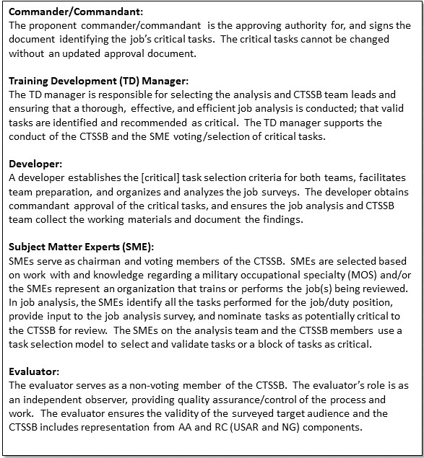

Figure E-1. Roles of personnel affecting the CTSSB

# Glossary

**Abbreviations & Terms**

This glossary is specific to and represents the Learning Enterprise abbreviations and terms; therefore, the same abbreviations and terms may be defined differently outside of the Learning Enterprise. The information in this glossary applies to Army organizations generating learning products used by the AA, Army National Guard of the U.S., ARNG, and USAR.

**Section I****Abbreviations**

AA Active Army

AAR after-action review and/or after-action report

ABCT armor brigade combat team

ADDIE analysis, design, development, implementation, and evaluation

ADP Army doctrine publication

ADRP Army doctrine reference publication

ADTLPArmy-wide Doctrine and Training Literature Program

AOarea of operation(s)

AOCarea of concentration

APDArmy Publishing Directorate

AR Army regulation

ARNG Army National Guard

ATN Army Training Network

ATSCArmy Training Support Center

ATTN attention

AUTLArmy Universal Task List

BDEbrigade

BLUFORblue force

BN battalion

C2 command and control

CAC Combined Arms Center

CAC-T Combined Arms Center – Training

CALL Center for Army Lessons Learned

CAPDEV capability developer

CATScombined arms training strategy

CBRNchemical, biological, radiological, nuclear

CMFcareer management field

COE center of excellence

CPcommand post

CPC collective proponent code

CPOFcommand post of the future

CPXcommand post exercise

CTC combat training center

CTE culminating training event

CTSSB critical task and site selection board

DADepartment of the Army

DA Pam Department of the Army pamphlet

DCS Deputy Chief of Staff

DD Form Department of Defense Form

DoDDepartment of Defense

DODIC Department of Defense identification code

DOTMLPF-Pdoctrine, organization, training, materiel, leadership and education, personnel, facilities and policy

DTMSDigital Training Management System

FMfield manual

FORSCOMUnited States Army Forces Command

FRAGORDfragmentary order

FTX field training exercise

GPSglobal positioning system

HQheadquarters

HQDA Headquarters Department of the Army

ICTL individual critical task list

IPBintelligence preparation of the battlefield

JCIDSJoint Capabilities Integration and Development System

JTTPjoint tactics, techniques, and procedures

LFXlive fire exercise

LIN line item number

METmission-essential task

METLmission essential task list

METT-TCmission, enemy, terrain and weather, troops and support available, time available, and civil considerations

MOPPmission oriented protective posture

MOS military occupation specialty

MTOEmodified table of organization and equipment

NCO noncommissioned officer

NCOIC noncommissioned officer in charge

O/C observer/controller

OEoperational environment

OFS officer foundation standards

OPFOR opposing forces

OPORD operations order

POC point of contact

POI program of instruction

PMESII-PT political, military, economic, social, information, infrastructure, physical environment, and time

QC quality control

RC Reserve Component

SMSoldier's manual

SMCTSoldier's manual of common tasks

SMEsubject matter expert

SM-TG Soldier's manual and trainer's guide

SOPstandard operating procedures

SRM sustainable readiness model

SRP sustainable readiness process

STAFFEXstaff exercise

STPSoldier training publication

STRACStandards in Training Commission

STRAG Standards for Training Readiness Advisory Group

STRAPsystem training plan

STXsituational training exercise

T&EO training and evaluation outline

TADSS training aids, devices, simulators, and simulations

TC training circular

TDA table of distribution and allowance

TDC training development capability

TED-T training and education developer toolbox

TM technical manual

TMD Training Management Directorate

TOE table of organization and equipment

TP TRADOC pamphlet

TR TRADOC regulation

TRADOC U.S. Army Training and Doctrine Command

TRP target reference point

TSS training support system

TTI total task inventory

TTP tactics, techniques, and procedures

U.S. United States

UJTL Universal Joint Task List

USAR United States Army Reserve

UTL unit task list

WFF warfighting function

WTSP warfighter training support package

**Section II****Terms**

**Army Collective Task List (ACTL)**

The Army Collective Task List consists of the total list of collective sic [tasks] within the Army and from which mission essential tasks and supporting collective tasks are derived in order to develop METL for Army units. (AR 350-1)

**Collective Task**

A clearly defined, discrete, and measurable activity or action which requires organized team or unit performance and leads to accomplishment of the task to a defined standard. A collective task describes the performance of a group of Soldiers in the field under actual operational conditions, and contributes directly to mission accomplishment.

**Cue**

Cue is an element of a drill condition. It indicates why the drill is to be performed and the aiding and limiting factors appropriate to set the stage for the conduct of the drill. The TNGDEV must state what triggered the need to perform this drill. This is the only mandatory required entry. Without the trigger, the condition statement is incomplete.

**Decisive Action**

The continuous, simultaneous combinations of offensive, defensive, and stability or defense support of civil authorities tasks. (ADRP 3-0) Decisive action operations entail two core competencies as outlined in ADP 3-0: combined arms maneuver and wide area security.

**Decisive Action Training Environment (DATE)**

DATE is a tool for the training community to use across training events ranging from rotations at the CTCs to individual home station training (HST) events and the Centers of Excellence and schools. The DATE is centered on a single region of fictitious countries and provides a range of geographical features and conditions.

**Digital Training Management System (DTMS)**

The DTMS is a web-based commercial off the shelf software application customized to implement the concepts in ADP 7-0/ADRP 7-0/FM 7-0, Training Units and Developing Leaders. Optimized for use at brigade level and below, DTMS provides the ability to plan, resource, and manage unit, institutional and individual training at all levels. The DTMS is used for METL development and can track Standard METLs and commander-developed unit METLs. The DTMS can produce after action reviews and commanders' assessments of training events. It compiles and displays a unit roll-up of training conducted through a series of customizable tabs to track weapons qualification, Army Physical Fitness Test, Army Warrior Training, AR 350-1 Common Military Training, MOS training, and deployment tasks. The DTMS Course Manager is used to administer Army courses and provides course completion data to Army training requirements and resources system. (TP 350-70-13)

**Drill**

A collective action (or task) performed without the application of a deliberate decision making process. A drill is initiated on a cue, such as enemy action or a leader's simple command, and is a trained response to the given stimulus. It requires minimal leader orders to accomplish and is standard throughout the Army. The three types of drills are battle, crew, and staff.

**Formative evaluation**

The monitoring of a learning product as it proceeds through the ADDIE process to make sure the product achieves the desired outcome/objective. This is a check-on-development to control the quality of the learning products developed and their implementation. (TR 350-70)

**Function CATS**

Task-based event driven training strategies that are designed to assist the unit commander in planning, and executing training events that enable the unit to build and sustain Soldier, leader, and unit proficiency in collective tasks that support a mission or a functional capability common to multiple units and echelons. (TR 350-70)

**GO/NO GO**

GO/NO GO are applied to performance measures that are actions that are objectively observable, qualitative and quantitative to the extent possible, and that can be used to determine if a performance step or sub-step is satisfactorily achieved. GO/NO GO can be applied when assessing an individual or collective task.

**Individual task**

A clearly defined, observable, and measurable activity accomplished by an individual. An individual task supports one or more collective tasks or drills and often supports another individual task. An individual task must be specific and have a definite beginning and ending. It is the lowest behavior or action level in a job or duty that is performed for its own sake.

**Individual task standard.** The individual task standard must be objective, valid, reliable, usable, comprehensive, discriminating, and quantifiable.

**Job analysis**

A type of analysis used to identify individual tasks (including leader tasks) and learning objectives a job incumbent must perform to successfully accomplish the mission and duties of a specific MOS. The output of a job analysis is a task inventory and a commander or commandant approved individual critical task list.

**Learning step activity (LSA)**

LSAs are the foundation for a lesson and support learning objectives. LSAs also provide a structured means to focus learning on a small part of what a student needs to learn. LSAs provide the basis for identifying specifications including such items as the method of instruction and resources required to present the lesson. LSAs are sequenced to maximize learning. (TR 350-70)

**Mission analysis**

A process to review mission requirements and develop a UTL. This process identifies unit, organizational, and functional structure, stated and implied missions, and collective and individual tasks.

**Mission-essential task**

A collective task on which an organization trains to be proficient in its designed capabilities or assigned mission. Also called MET. (FM 7-0)

**Mission-Essential Task List (METL)**

A tailored group of mission-essential tasks. (FM 7-0)

**Performance measures**

Actions objectively observed and measured to determine if a task performer has performed the task to the prescribed standard. These measures are derived from the task performance steps during task analysis. (TP 350-70-10)

**Performance steps**

Performance Steps are discrete actions that compose and/or inform the completion of a task and may or may not be measured. Performance Steps are generally written sequentially and follow a step-by-step description of actions that accomplish and/or inform the task. Performance Steps may have multiple sub-steps that support and/or inform the respective Performance Step.

**Procedure**

Standard, detailed steps that prescribe how to perform a specific task. (ADRP 1-02)

**Risk**

Probability and severity of loss linked to hazards. (ATP 5-19)

**Risk assessment**

The identification and assessment of hazards (the first two steps of the risk management process). (ATP 5-19)

**Standard METL**

A METL that has been vetted by a HQDA-chartered board (that is Army METL Review Board (AMRB), Army METL Working Group (AMWG), or Standards for Training Readiness Advisory Group (STRAG)) and approved by HQDA (Deputy Chief of Staff, G-3/5/7).

**Summative evaluation**

A process that occurs after implementation. The evaluation serves two main purposes. First, a

summative evaluation determines if the learning product(s) achieved their purpose and produced the desired outcomes in the target audience. Second, a summative evaluation determines if the processes and procedures followed, and the training or education delivered, met established standards on a program level.

**Supported individual task**

The individual tasks that must be performed to accomplish the collective task.

**Sustainable readiness model**

The Sustainable Readiness Model replaced ARFORGEN as the Army’s sustaining readiness concept for force generation. The purpose of SRM is to maximize available resources in order to generate and maintain a higher level of overall readiness, while minimizing risk to meet current operational demands and remaining postured for contingency operations.

**Sustainable Readiness Process (SRP)**

The Army’s strategic process for planning, synchronizing, governing, and executing Sustainable Readiness across the Total Force. The SRP enables informed senior leader readiness decision-making, shaping the annual planning, programming, and budgeting process to maximize readiness and generate forces in support of Global Force Management. SRP replaces the Army’s progressive readiness process known as Army Force Generation (ARFORGEN). (AR 525-29)

**Task-based training**

Training developed and implemented to train units and Soldiers to perform tasks to an established standard.

**Unit Task List**

The set of collective tasks that a unit is doctrinally designed to perform. The mission analysis’ primary output is the UTL. The UTL provides the baseline for all unit training and education products. A TNGDEV creates the UTL by linking all existing collective tasks (shared and unique), or identifying collective tasks for design and development for a specific unit supporting its mission requirements and capabilities.

**Walk-through instructions**

Define how to move through the task deliberately to ensure that the unit is performing the drill and all of the task steps and performance measures to standard. The walk-through instructions begin with the initiating cue. The initiating cue can be written as a description of the signal that unit leaders give that causes the unit to perform the drill. The cue may also be written as a description of the trained response to an enemy action that causes the unit to perform the drill.

**Warfighter TSP (WTSP)**

A complete, task-based, exportable package integrating training products, materials, and information necessary to train one or more collective tasks and/or one or more individual tasks. WTSPs support one or more CATS events. The WTSP is a separate product that goes through the ADDIE process; however, it is a part of the development phase of other unit training products.

**Section III  
Special Abbreviations and Terms**

This section contains no entries.

**Section IV  
Key Links**

Appendix D, Leader’s Guide to Objective Assessment of Training Proficiency

<https://atn.army.mil/act_searchResults.cfm?searchtermDotNet=Leader%e2%80%99s%20Guide%20to%20Objective%20Assessment%20of%20Training%20Proficiency>

Army Training Network (ATN):

<https://atn.army.mil>

Central Army Registry (CAR)

<https://rdl.train.army.mil/>

Functional Area Proponency List and Job Aids

(Available electronically on ATN/TED-T and was formerly titled, Army Training and Education Proponents). https://atn.army.mil/

TRADOC Form 25-36-1-E (TRADOC Doctrine Publication Checklist)

<http://adminpubs.tradoc.army.mil/forms/TF25-36-1-E.pdf>

U.S. Army Force Management Support Agency Force Management System Web Site (FMSWeb)

<https://fmsweb.fms.army.mil>

Virtual OPFOR Academy

<https://tbr.army.mil>