**Department of the Army *TRADOC Pamphlet 350-70-12**

**Headquarters, U.S. Army**

**Training and Doctrine Command**

**Fort Eustis, Virginia 23604-5700**

**10 February 2023**

**Training**

**The Army Distributed Learning Program**

FOR THE COMMANDER:

MARIA R. GERVAIS

Lieutenant General, U.S. Army

Deputy Commanding General/

Chief of Staff

OFFICIAL:

WILLIAM T. LASHER

Deputy Chief of Staff, G-6

**History**. This is a major revision to TRADOC Pamphlet 350-70-12.

**Summary**. This pamphlet provides guidance on the development of distributed learning content and courseware; explains the planning, analysis, design, development, and delivery of distributed learning products; and explains the various roles involved in the management of distributed learning development.

**Applicability**. This pamphlet applies to U.S. Army Training and Doctrine Command activities and One Army School System training battalions responsible for managing, developing, and implementing learning products. It also applies to non-U.S. Army Training and Doctrine Command agencies and organizations possessing memoranda of understanding, memoranda of agreement, and contracts for developing learning products for U.S. Army Training and Doctrine Command and One Army School System agencies and organizations.

**Proponent and exception authority**. The proponent for this pamphlet is the U.S. Army Combined Arms Center. The proponent has the authority to approve exceptions or waivers to this pamphlet that are consistent with controlling law and regulations. Activities may request a waiver to this pamphlet by providing justification that includes a full analysis of the expected benefits and must include formal review by the activity’s senior legal officer. All waiver requests will be endorsed by the commander or senior leader of the requesting activity and forwarded through their higher headquarters to the publication proponent.

**Suggested Improvements**. Submit changes for improving this publication on DA Form 2028 through channels to the U.S. Army Combined Arms Center, Army University, Vice Provost for Digital Education (ATZL-AUT), 2112 Pershing Avenue, Fort Eustis, VA 23604-1412 or electronically to [usarmy.leavenworth.tradoc.mbx.policy-and-governance@army.mil](mailto:usarmy.leavenworth.tradoc.mbx.policy-and-governance@army.mil).

**Distribution.** This pamphlet is available in electronic media only at the U.S. Army Training and Doctrine Command Administrative Publications website <https://adminpubs.tradoc.army.mil>.

**Summary of Change**

TRADOC Pamphlet 350-70-12

The Army Distributed Learning Program

This major revision, dated 10 February 2023 –

o Renames the pamphlet and updates the pamphlet proponent to the U.S. Army Combined Arms Center, Army University.

o Establishes the process for distributed learning product resourcing paragraph ((para) 3-1g).

o Refines definitions for synchronous, asynchronous and blended learning strategies (para 3-1f).

o Restructures the pamphlet from nine chapters (chap) to five by consolidating the analysis, design, development, implementation and evaluation process for distributed learning products into one (chap 4).

o Adds guidance on the analysis, design, development, and delivery of distributed learning products (chap 4).

o Adds guidance on the instructional and technical validation of distributed learning (para 4-6).

o Adds guidance on the analysis, design, development, and delivery of mobile learning products (chap 5).

o Adds guidance for the mobile learning environment and mobile application compliance (chap 5).

**Table of Contents**

**Page**

Chapter 1 5

Introduction 5

1-1. Purpose 5

1-2. References 5

1-3. Explanation of abbreviations and terms 5

1-4. Scope 6

1-5. Records management requirements 6

1-6. Interrelationship of interactive multimedia instruction to The Army Training System and distributed learning 6

Chapter 2 7

Distributed Learning Overview 7

2-1. Distributed learning management 7

2-2. The Army Distributed Learning Program 7

2-3. Vice Provost for Digital Education (VPDE), Army University 8

2-4. Distributed learning environment 8

2-5. Distributed learning support to multi-domain operations 9

2-6. The Army Distributed Learning Program support to the training domains 9

2-7. The Army Distributed Learning Program supports the Army Learning Concept – Training and Education 11

2-8. Distributed learning empowered by the Army Learning Concept 12

2-9. Distributed learning content types 13

2-10. Delivery media technologies 15

Chapter 3 16

Distributed Learning Processes 16

3-1. Distributed learning and the Training Operations Management Activity 16

3-2. The Training Development Capability (TDC) 19

3-3. Registration, prioritization, and approval process 20

3-4. VPDE tasking order 21

3-5. Contract process 22

3-6. Mobile products registration and development process 24

Chapter 4 26

Distributed Learning and ADDIE 26

4-1. Distributed Learning and the Analysis, Design, Development, Implementation, and Evaluation Process 26

4-2. Distributed learning analysis 27

4-3. Distributed learning design 30

4-4. Distributed learning development 41

4-5. Distributed learning implementation 44

4-6. Distributed learning evaluation (quality control and validation) 47

Chapter 5 50

Mobile Learning 50

5-1. Mobile learning environment 51

5-2. Mobile application compliance 52

**Page**

Appendix A References 53

Glossary 56

**Table List**

Table 2-1 Distributed learning content types 14

Table 4-1 Levels of interactivity 30

Table 4-2 Implementation platforms 46

**Figure List**

Figure 2-1. Army Distributed Learning Environment 9

Figure 2-2. Distributed learning support to training domains 11

Figure 3-1. Resourcing levels of distributed learning 19

Figure 3-2. The Army Distributed Learning Program contracting process 21

Figure 3-3. Distributed learning requirements and resourcing model 24

Figure 3-4. Mobile products registration and development process 25

Figure 4-1. Analysis, design, development, implementation, and evaluation process for distributed learning 27

Figure 4-2. Course structure example 29

Figure 4-3. Lessons as topics in computer-managed instruction 29

Figure 4-4. Example courseware flow 39

Figure 4-5. Example storyboard frame 44

Figure 5-1. Mobile learning environment 51

# Chapter 1

# Introduction

## 1-1. Purpose

The purpose of this pamphlet is to provide guidance for four major aspects of the management, development, delivery, instructional, and technical validation of distributed learning (DL):

a Explains the various roles involved in the management of DL development supported by Army training and education policy.

b. Provides guidance for the analysis, design, development, implementation, and evaluation (ADDIE) process for developing DL courseware (CW) and content.

c. Explains the DL contracting process using the Army’s preferred contract for DL.

d. Defines the processes involved in the instructional and technical validation of DL.

## 1-2. References

See appendix A.

## 1-3. Explanation of abbreviations and terms

See the glossary.

## 1-4. Scope

The procedures described in this pamphlet are intended to supplement TRADOC Regulation (TR) 350-70 series publications and are applicable to all individuals and organizations managing, or involved in, developing and/or implementing DL CW, to include:

a. Developers in Army proponent schools during the ADDIE phases of DL development.

b. Support contractors during the ADDIE phases of developing DL products under the Army’s preferred contract for DL.

c. Support contractors during the ADDIE phases of developing DL products outside the Army’s preferred contract.

d. Contractors developing new equipment training (NET) courses for system acquisitions using DL methods and technologies.

## 1-5. Records management requirements

The records management requirement for all record numbers, associated forms, and reports required by this publication are addressed in the Records Retention Schedule-Army (RRS-A). The RRS-A is located in the Army Records Information Management System at <https://www.arims.army.mil>. If any record numbers, forms, and reports are not current, addressed, and/or published correctly in the RRS-A, see DA Pam 25-403 for guidance.

1-6. Interrelationship of interactive multimedia instruction to The Army Training System and distributed learning

a. Training and Doctrine Command (TRADOC) primary mission is to provide seamless training that enhances the combat capabilities of the Force—the Active Army (AA) as well as the Reserve Component (RC). A basic tenet of this training integration effort is the leveraging of emerging technology to produce a single Army standard: Total Army Training System (TATS). At the center of these emerging technologies stands an entire array of interactive multimedia instruction (IMI) initiatives: applying new training approaches, reducing training time, improving readiness, and offering a variety of delivery systems.

b. IMI technology is defined as computer-based technology, integrating a combination of, but not limited to, text, graphics, animation, sound, and video. The interactive courseware (ICW) component of IMI combines the interactivity and management features of technology-enabled learning. IMI applications are developed in many forms, including tutorials, simulations, virtual reality (VR), expert systems, as well as “just-in-time” learning embedded in performance support systems.

c. The Army Training System course development procedures ensure standardization by training all course critical tasks to task performance standard. However, different sites may conduct training; use different multimedia instructional technologies; involve various phases, modules, and/or lessons; and include a variety of delivery systems. Using TATS course development requirements as the minimum standard will help meet and achieve this challenge.

d. Distributed learning, in concert with TATS, is a holistic approach to train and educate Soldiers that will require a variety of individual and collective skills throughout their careers. A major aspect of TATS focuses on designing and revising courses to this single Army standard using DL delivery systems. Online access to a variety of individual and collective training products will provide training opportunities that are flexible, current, and focused on mission needs.

e. This pamphlet adheres to the standards specified in AR 350-1 and TR 350-70 and provides the structured, coherent guidance and procedures for redesigning and developing IMI for Soldier, Department of the Army (DA) Civilian, and leader training, supporting TATS CW development standards, while applying DL concepts.

# Chapter 2

# Distributed Learning Overview

## 2-1. Distributed learning management

Quality DL products are essential to support the Army's learning program. DL products must contribute to producing Soldiers, DA Civilians, and leaders capable of performing their tasks and duties, as well as units that can successfully accomplish the mission.

## 2-2. The Army Distributed Learning Program

The Army Distributed Learning Program (TADLP) is HQDA funded, Chief of Staff of the Army approved program of record, which provides near-term and long-range planning, funding, and requirements to produce content and CW for delivery to Soldiers, leaders, and DA Civilians anytime, anywhere. TADLP delivers standardized training and education to Soldiers, leaders, DA Civilians, and units using multiple delivery means and technologies that provide the capability to enhance and sustain Army readiness. TADLP leverages technology and curriculum design to provide cost-effective and efficient learning content. The program supports all three training domains (operational, institutional, and self-development) and all Army components. Innovative training and education requirements necessitate the following:

a. New policies, procedures, and processes.

b. Persistent access to learning content.

c. Acquiring and maintaining knowledge, skills, and attitudes of curriculum developers.

d. Assessments of learning.

e. A robust and agile resourcing model.

f. A system that employs continuous feedback of lessons learned.

g. Integration of new technologies and learning sciences.

h. Implementation of learning at the point of need.

## 2-3. Vice Provost for Digital Education (VPDE), Army University

The VPDE provides oversight in all matters relating to TADLP by providing program overview, governance, acquisition oversight, plans, and policy for DL and training/education support to enhance learning of agile Soldiers and DA Civilians by exploiting current and new technologies. VPDE executes the following:

a. Manages and oversees DL CW development, ensuring compliance with standards and fielding in accordance with established requirements.

b. Implements the Army’s preferred contract to support proponent schools in development of DL for all cohorts in all components related to Initial Military Training (IMT), Professional Military Education (PME), and Civilian Education System (CES) curriculum.

c. Develops DL product guidance ensuring DL CW content complies with Army learning policy as well as hardware and software system requirements for Federal, DOD, and Army specifications.

d. Conducts DL CW playability and technical testing to ensure hardware and software platform compatibility.

e. Coordinates with proponents and the TRADOC Enterprise Classroom Program for classroom technology requirements in support of approved DL course content.

## 2-4. Distributed learning environment

Distributed learning is part of a technology-enabled learning environment where formal and informal content is easily discoverable, accessible, functional, flexible, and trackable through multiple delivery means including asynchronous, synchronous, and blended delivery modes (see figure 2-1 on page 9).

a. This environment’s key characteristics include:

(1) Rapid creation and delivery of rigorous digitized learning content.

(2) Technology-enabled knowledge sharing and collaboration among learners.

(3) Establishment of dynamic social learning networks.

(4) Peer-based learning interactions, facilitators, and instructors for continual lifelong learning opportunities.

(5) Support of professional and personal development goals.

(6) Life cycle management of CW.

(7) Reach-back for performance support.

(8) Joint, interagency, and intergovernmental training, education, research, and communication.

b. Included in TADLP is the development, integration, and synchronization of policies and transformation of DL resourcing models. This continuous adaptive learning environment also supports the implementation of new and emerging technologies, learning sciences, dynamic content, and performance support applications.

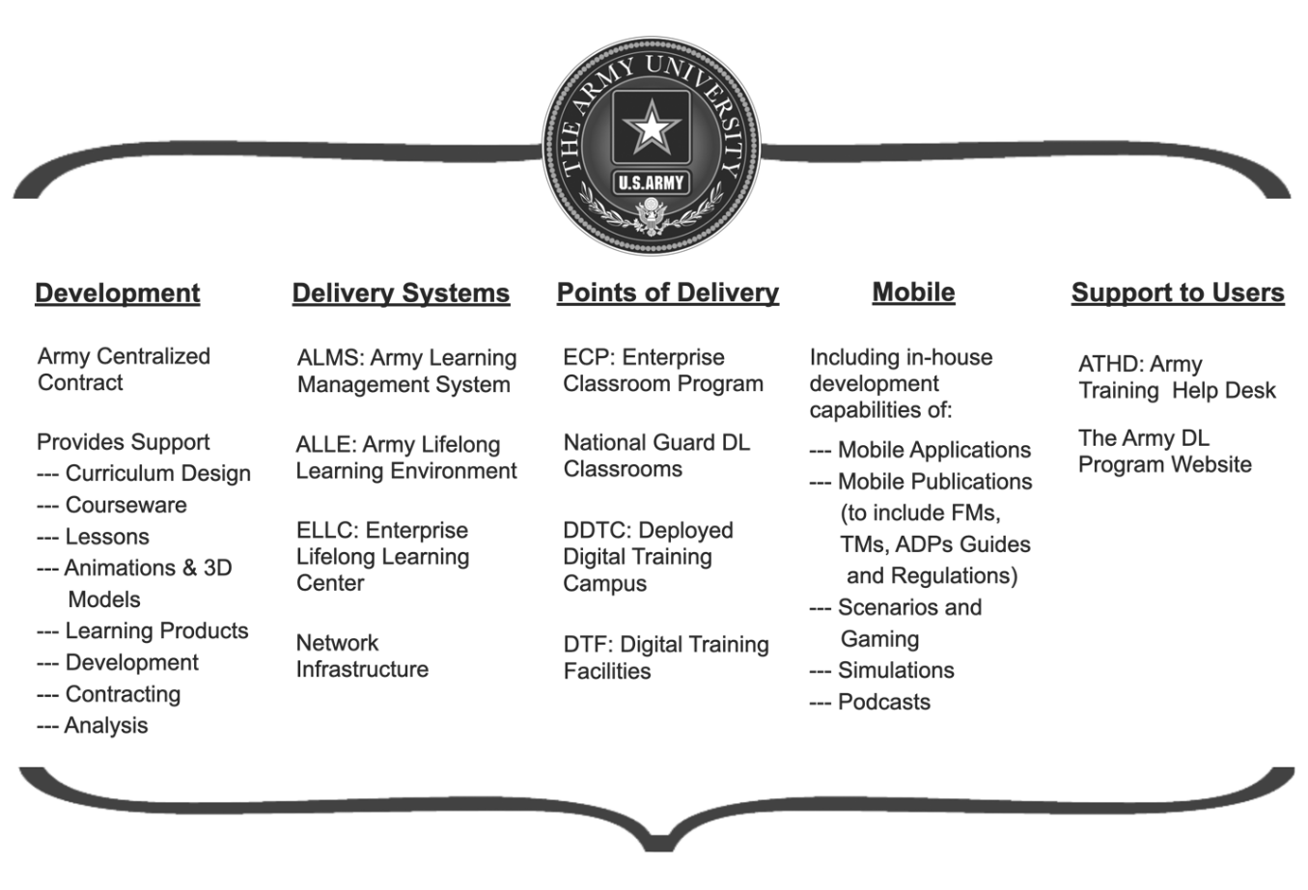

Figure 2-1. Army Distributed Learning Environment

## 2-5. Distributed learning support to multi-domain operations

The Army Distributed Learning Program supports multi-domain operations (MDO) by providing relevant training and education at the point of need, while affording learners the ability to balance efficient and flexible training with the demands of the operational environment.

## 2-6. The Army Distributed Learning Program support to the training domains

The Army Distributed Learning Program enables the Army's learning continuum to interconnect learning across the Army's three training domains (operational, institutional, and self-development). TADLP integrates operational experience into the development of rigorous and relevant content, formal and informal learning, and peer-based learning which encourages Army professionals to become lifelong learners (see figure 2-2 on pg 10). Dynamic social networks, mobile devices, and the Army Learning Content Management Capability (ALCMC) deliver Soldier-created content, institutional instruction, and self-development opportunities.

a. Operational domain. The Army Distributed Learning Program supports the first priority of the integrated training environment, the operational domain's brigade-level (and below) collective training at home station. DL supports the operational domain by providing training and education opportunities to units, leaders, and Soldiers. DL accomplishes this through rapid creation, distribution, experiential-based training content, scenarios and the establishment of dynamic social learning networks. These networks will provide reach-back and on-demand capabilities to prepare units, Soldiers, and leaders to prevail in MDO.

b. Institutional domain. The Army Distributed Learning Program supports the institutional domain’s four major functions: IMT, PME, CES, and functional training. An Army social learning network will connect the Operating Force with the Generating Force to capitalize on recent operational experiences and lessons learned to rapidly revise and adapt content for developing new curriculum for IMT, PME, and CES. The use of synchronous, asynchronous, mobile DL delivery strategies and social learning networks will enable the field to exchange: doctrine, lessons learned, tactics, techniques and procedures, and other critical information through its reach-back and on-demand content capabilities. By leveraging social learning and expanded synchronous capabilities, centers of excellence (COE) support individual and unit training events at home station more effectively and efficiently than at present.

c. Self-development domain. The self-development domain includes planned, competency-based, goal-oriented learning that reinforces and expands the depth and breadth of an individual’s knowledge and self/situational awareness, which supports adaptability. It complements operational and institutional learning while enhancing professional competence. This strategy enables self-development activities that allow for planned and unplanned individual preparation, sustainment, and leader development throughout the learner’s career to include time in the institutional and operational domains. DL supports this domain with a myriad of asynchronous products such as electronic books, audiobooks, podcasts, educational gaming, and performance-based simulations.

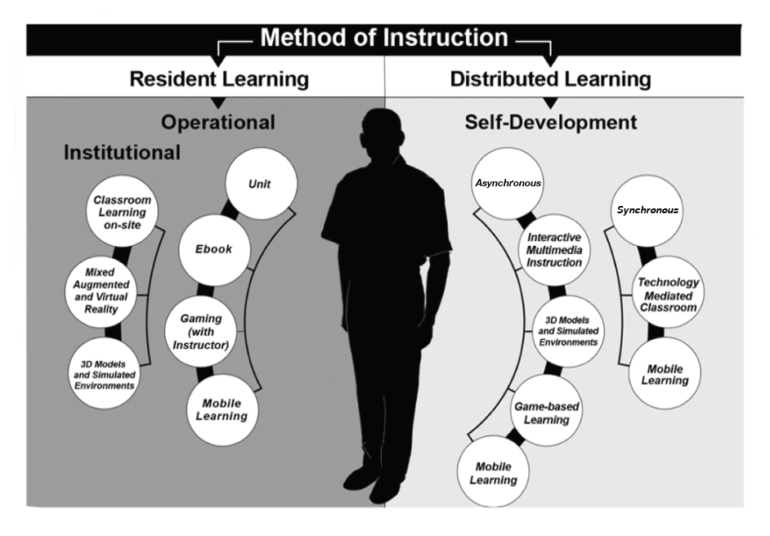

Figure 2-2. Distributed learning support to training domains

## 2-7. The Army Distributed Learning Program supports the Army Learning Concept – Training and Education

TRADOC Pamphlet (TP) 525-8-2, the Army Learning Concept for Training and Education (ALC-TE), calls for the development of adaptable Soldiers and leaders, adaptive delivery systems, and sustained adaptation to bolster an enterprise facilitating a career-long continuum of learning. It must provide a learning environment with instructional strategies, expert facilitators, and technologies that support the learner. The ALC-TE is to provide “quality, relevant, and effective learning experiences through outcome-oriented instructional strategies that foster thinking, initiative, and provide operationally relevant context which extends learning beyond the learning institution in a career-long continuum of learning through the significantly expanded use of network technologies.”

a. Curricula and learning products should include emerging technologies enhancing DL media content such as IMI, mobile applications, gaming, cognitive aiding tools, and embedded training.

b. Learner-centric training and education requires institutional Army facilities to support remote locations. The ability to distribute learner-centric training and education that optimizes human performance (such as through a cloud-based system to individuals at the point of need) must be commonplace. However, training and education development may remain centralized for cost considerations.

c. The VPDE will deploy innovative and emerging technologies with the potential to revolutionize technological advances and drive transformation. These technologies will provide better self-discovery, peer-to-peer interaction, and experience-based learning in support of the ALC-TE. VPDE employs associated technologies permitting active learning using automated and adaptive information extraction, assimilation, and management to provide learners with the ability to become adaptive and critical thinkers able to solve complex problems in uncertain operational environments.

d. Some of the key DL characteristics of the ALC-TE environment include the following:

(1) ALCMC-supported, context-based, collaborative, and problem-centered instruction with assessments.

(2) Evaluations, tracking, and feedback.

(3) Blended learning, adaptive learning, and technology-delivered instruction.

(4) Consolidated repository of DL CW (see Appendix A, Related Publications, Central Army Registry (CAR)).

(5) Simulated environments integrated into DL products or used for blended learning.

(6) Performance support applications developed for mobile internet delivery.

## 2-8. Distributed learning empowered by the Army Learning Concept

The rapid development of computer and communication technologies has enabled new instructional strategies such as:

a. Platforms to provide stand-alone and reusable learning objects, video, game-based scenarios, digital tutors, and assessments that are tailored for learners.

b. Immersive technologies through augmented, virtual, and mixed realities.

c. Social media, multiplayer online games, and other emerging technologies. DL leverages the power of information and communication technologies (such as simulation, IMI, video, and electronic learning (e-learning)) and can be either real time (synchronous) or non-real time (asynchronous).

d. Alternative delivery methods to support Soldiers and DA Civilians serving in austere environments with little or no bandwidth by offering training and education products via removable optical media such as Blu-ray disc, digital video disc (DVD), and compact disc read-only memory (CD-ROM).

e. Content that expands the depth and breadth of an individual's knowledge, skills, and attitudes using the latest in mobile technology, wireless infrastructure, and devices.

f. Instruction enhanced by technology that employs adaptive learning strategies and computer-based tutoring (no human instructor) to accelerate learning and education for Soldiers and DA Civilians.

g. Mobile learning that provides digital content through which learners engage and construct knowledge in a social manner. Mobile learning allows Soldiers and DA Civilians to build dynamic vertical and horizontal social networks for formal and informal information sharing.

h. Delivery of Army doctrine in a learner-centric and interactive format adapted to the way people learn in a digitally-enabled society and ensure it is available to the user at the point of need.

## 2-9. Distributed learning content types

Department of Defense Instruction (DODI) 1322.26 defines DL as learning content and systems mediated with technology and accessed through a network or portable media. It is distributed in the context of information technology and information (for example, learning content) shared through any network. DL is distributed/delivered using a variety of media tools and technologies.

a. The use of ICW guided by DOD includes two approaches known as computer-assisted instruction (CAI) and computer-managed instruction (CMI). The difference between the two approaches is the degree of instructor involvement and management of the learning process.

b. The dominant approach used by Army DL is IMI, an umbrella term applied to a group of predominantly interactive, electronically delivered training, education, and support products which include CAI and CMI. DL CW includes all instructional media (synchronous, asynchronous, and blended) that use IMI as the method of instructional delivery.

c. Distributed learning CW includes ICW, electronic guides, electronic testing, NET, electronic performance support systems (EPSS), CAI, CMI, electronic job aids (JA), interactive video, virtual and augmented reality, and other interactive instruction using a technology interface. It also includes: 3D modeling, simulation, interactive training technologies, mobile learning applications, adaptive learning strategies such as intelligent tutoring system (ITS), and serious gaming when appropriately used within the instructional environment. Serious games are games with training and education content that use elements of artificial intelligence to identify users’ knowledge in order to advance the game appropriately.

d. Distributed learning includes mobile publishing, originally identified as interactive digital publications to include interactive electronic technical manuals, electronic publications, and enhanced electronic books. Mobile publishing not only incorporates the traditional text/higher-order interactivity formula but furthers the spectrum to maintain relevancy in a new technological age. Mobile publishing uses new frameworks and technologies such as electronic home and mobile assistants to gain access and, when necessary, assistive ‘read aloud’ publications. Mobile publishing will adjust and grow with the capabilities in the modern world to give Soldiers and DA Civilians the additional edge in the training and operational environments.

e. Distributed learning CW excludes simulators, part-task training devices in which actual equipment or simulated equipment not integral to the CW is required for instructional performance, and computer-controlled training capabilities embedded in actual equipment. It also excludes IMI and CW developed in a non-digital format or media (for example, paper, film, and analog magnetic tape).

f. Distributed learning content types (see table 2-1 on pg 14) are those that VPDE assesses as the most mature learning technologies. They have enhanced defined processes, standards, and specifications; robust tools to reduce labor costs; and are more likely to have available instructional systems or computer science experts to assist in development, implementation, and evaluation.

g. Learning technologies such as simulation in instructional environments may have little or no approved standards and specifications, fewer or no support tools, and little or no access to computer science simulation experts. These technologies may require greater resources in terms of that expertise in those particular technologies to develop, implement, and evaluate.

| Table 2-1 Distributed learning content types | | |
| --- | --- | --- |
| **Type** | **Delivery** | **DL/BL Products** |
| Interactive courseware (ICW) | * Blu-ray, CD-ROM, DVD (standalone) | * Browser launched (executable files) |
| Electronic management tools | * EPSS * Learning management system (LMS) * Course management system * Learning content management system (LCMS)* * Job aids | * Web-downloadable (that is, content for offline instruction)   Web-ready (that is, Hypertext markup language (HTML), Extensible markup Language Synchronous, etc.)   * Computer-managed instruction (CMI) * Computer-assisted instruction (CAI)* |
| Mobile publications | * Central Army Registry (CAR) * Web viewable or downloadable * Electronic Assistant * Commercial gaming consoles * Mobile device * TRADOC Application Gateway (TAG) | * Army publications (FMs, PAMs, ARs, etc.) * Audiobooks, interactive reviews * Progressive web apps * Apps for performance, information, micro learning |
| Mobile learning applications | * Electronic assistant * Commercial gaming consoles * Mobile Device * TAG * Defense Information Systems Agency Application Store * Commercial application stores |
| Simulation in instructional environment | * Reality training * Serious games * VR goggles * Integrated digital environment | * VR * Augmented reality * Mixed reality * First person tactical training games * Leader tactical training games * Language and culture training games |
| *\*Blended learning* | | |

## 2-10. Delivery media technologies

Analysis of delivery media is a critical part of the design and development process. The list below includes the most common media selections.

a. A learning management system (LMS) is a typical run time system (RTS) used to deliver training and education as asynchronous, synchronous, and blended. It manages learning information, provides learning collaboration, scheduling, and career planning capabilities in both resident and non-resident courses. An LMS provides the following capabilities:

(1) Registering and enrolling students.

(2) Monitoring assessments and student progress.

(3) Distributing, delivering, storing, and presenting learning products.

(4) Maintaining training/education records.

(5) Providing collaboration capabilities for both the student and instructor/facilitator.

(6) Collecting and storing feedback and evaluations.

(7) Maintaining a database of learning products and resources.

b. A learning content management system (LCMS) is very similar to an LMS with one major difference—an LMS is capable of managing both classroom and e-learning and usually does not provide a course authoring capability except as part of a larger suite of tools. An LCMS is focused on course delivery and management of that process. It offers a course manager greater flexibility in structuring the course as well as authoring course items such as threaded discussions and exams.

c. IMI delivered via CD-ROM or DVD as asynchronous instruction or as Web-based training as asynchronous or synchronous instruction.

d. Mobile learning is delivered via handheld mobile devices such as smartphones, tablets, or wearables. Mobile learning content can be delivered as a native application, can be downloaded, and viewed without connectivity to the internet, or can be a web application that does not require all the learning content downloaded to the device. The web application requires connectivity whereas the native application requires storage space on the device.

e. Collaboration Tools. Blended learning can be enabled by collaborative tools that provide synchronous interaction between instructors/facilitators, students, and peer-to-peer learning.

# Chapter 3

# Distributed Learning Processes

## 3-1. Distributed learning and the Training Operations Management Activity

TRADOC Pamphlet 350-70-9 describes the budgeting and resourcing procedures and guidance support for Army training and education. This pamphlet applies to TRADOC activities and The Army School System training battalions responsible for managing, developing, and implementing learning products. TADLP is comprised of Army wide courseware development, the Army e-Learning Program, and the ALCMC.

a. DL is the delivery of standardized individual, collective, and self-development learning products to Soldiers and units at the right place and right time through the application of multiple means and technologies. DL may be used in either resident or non-resident training. DL may involve synchronous, blended, and asynchronous student-instructor or student-to-content interactions.

b. Non-resident DL may be used as a prerequisite prior to attending a resident training course or as a phased approach for a functional or PME course. For HQDA directed and self-development non-resident DL quota managed courses, training managers at training locations are required to document student input and graduates within Army Training Requirements and Resource System (ATRRS).

c. The Training Operations Management Agency (TOMA) reviews, validates, and documents Training Resources Analysis System (TRAS) actions for non-resident DL, resident, active duty for training, and inactive duty training courses. TOMA’s purpose is to ensure accurate course strategies are documented in ATRRS and all necessary resources required to conduct training are captured during the annual Structured Management Decision Review.

(1) Using lessons that apply DL technology internally to a resident course/phase/module does not mean that the phase course will be designated as DL. For example: administering lessons through a computer lab during a resident course utilizing DL content as part of the learning strategy does not make the course DL (non-resident).

(2) A resident course and a non-resident course can be instructed at the same time within a resident class setting (some students in class with the instructor while other non-resident students use DL to communicate with the resident class). However, due to resourcing, separate course administrative data (CAD)/program of instruction (POI) are required and ATRRS will reflect separate course schedules.

(3) A completed supplemental information sheet will accompany CAD/POI submission of a stand-alone non-resident DL course/phase. Development and submission of supplementary information provides answers to address to whom, how, when, and where it will be provided. See TRADOC Pamphlet 350-70-9 for the stand-alone non-resident DL supplementary information requirements that provide information needed to document the course/phase in ATRRS.

(4) A non-resident DL course/phase will have a "(DL)" placed at the end of the course number. This number will be used in all TRAS documents.

d. The Army’s centralized contract for DL requires management by VPDE which includes registration, prioritization, and final approval by the Army University Provost. Proponents are encouraged to use the Army's centralized contract for DL; however, they may elect to leverage other contract vehicles. Proponents complete and manage their own acquisition management oversight (AMO) packages following guidance on the TADLP website: <https://tadlp.tradoc.army.mil>. To catalog DL products and prevent duplication, all proponents will register their intent to develop DL regardless of in-house or contracted development.

(1) The proponent must obtain approval for the course by submitting the CAD/POI with supporting current supplemental information for the entire course (Non-Resident DL and resident portions) to TOMA. Supplemental information submitted with the CAD/POI is critical to ensure the course/phase is documented correctly in ATRRS and to manage the implementation of the non-resident DL course/phase. The academic hours are a normal part of the CAD/POI submission. The "maximum time to complete" shall be computed for each self-paced module/lesson within a DL non-resident phase and the total expected time for the phase will be reported in the CAD of the POI. If the DL non-resident phase also includes group-paced video tele-training (VTT), the time for the self-paced will be added to that of the VTT for one total time scheduling. If the self-paced module/lesson is a prerequisite for the VTT, the "maximum time to complete" for the self-paced portion must be reported separately.

(2) The TOMA TRAS analyst will enter the revised course in ATRRS as a proposed course until the proponent informs TOMA that the courseware is ready for implementation.

(3) DL is delivered from Army Learning Content and Management Capability, which includes Army Learning Management System (ALMS), Enterprise Lifelong Learning Center, and other approved delivery platforms.

e. Maximum time to complete. This is the maximum time allowed for a student to complete a phase of self-paced instruction. It is defined as 130 percent of the computed academic time for the self-paced instruction, plus, in the case of max phase time, any non-self-paced instruction in the phase. The 30 percent add-on time allows for scheduling difficulties beyond the control of the students or instructor/facilitator.

f. Army courses are identified as either resident or non-resident at the time a POI is developed. A course is considered Resident if both students and instructor are present in the classroom. If any portion of the course is taught via DL, then the course is designated Non-resident. Distributed learning products are described as synchronous, blended (further described in subparagraph (2) and (3) below), and asynchronous. The first two indicate instructor to student engagement while the last indicates no instructor involved.

(1) **Synchronous, resident, is real time**. Synchronous strategies include traditional classroom instruction where instructors and students are together at the same place and the same time. This strategy is also known as traditional and face to face.

(2) **Synchronous, non-resident, blended**. In this strategy, also known as instructor-led, the resident instructor is ONLINE at the same time with distributed students. This strategy includes some technology mediated content consumed in the course. This strategy is described as Virtually Synchronous.

(3) **Mixed, non-resident, blended**. This strategy has geographically dispersed students accessing the virtual classroom environment at different times than the instructor. The instructor/facilitator may use a combination of asynchronous or synchronous instruction using classroom technology. The instructor facilitates the learning event. This strategy is a mix of virtually synchronous and fully asynchronous.

(4) **Asynchronous, non-resident, distributed**. In this strategy there is no instructor and the student interacts with the content of the course. Distributed learning shifts the burden of learning from the instructor to the student. Asynchronous DL is more common because it creates an on-demand student learning experience. Unlike synchronous DL, students consume learning on their own schedule. This strategy is fully asynchronous. For more information on levels of interactivity, see para 4-2.

g. For resourcing purposes, the planned levels of interactivity are binned to facilitate resourcing of the products. The four bins are Simple, combining levels 0 and 1; Moderate, level 2; Complex, level 3, and artificial reality and VR, level 4. Combining levels 0 and 1 with similarities in number of production hours and cost is more practical for resourcing. Gaming and VR, which is overly complex in design with many production hours, stands alone in its own category for resourcing. Distributed and blended learning resource planning includes requirements associated with the development, transmission, and sustainment of distributed and blended learning products. See Figure 3-1.

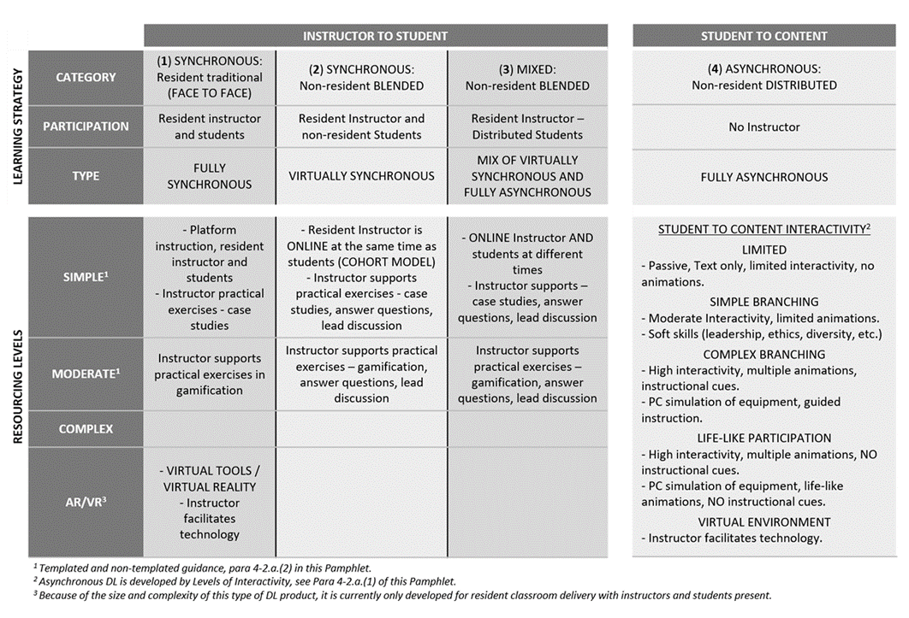

Figure 3-1. Resourcing levels of distributed learning

h. Information presented in figure 3-1 indicates the level of content interactivity that can be used in either synchronous or asynchronous strategies. Content developed and used with an instructor present could range from simple PowerPoint to videos or animations to enhance learning. Interactivity is more important in asynchronous strategies where no instructor is present to elaborate or provide context.

i. For levels of interactivity zero to two, with software authoring tools available on the market, CoEs or schools can easily enter content development with low cost and low entry level skills. As complexity of the content increases, so does the cost of development and the skill level required to do the work. For more information, see para 4-2.

j. The VPDE approves program funds through the registration, prioritization, and approval process. Proponents (that is, requiring activities (RAs)) are encouraged to use the Army's preferred contracts for DL. However, they may elect to leverage other contract vehicles but must conform to Army standards and specifications.

## 3-2. The Training Development Capability (TDC)

As discussed in para 3-1, the proponent must generate a CAD and/or POI for their training and education products. The TDC is the system developed by the Army to assist in the structured development of learning objectives, tasks, and topics that support training and education products.

a. Proponents submit all phases of a specific course at the same time.

b. One POI supports a single course or phase. Example: Engineer Captains Career Course contains Phase 1 DL for the common core, Phase 2 resident, Phase 3 DL and Phase 4 BL (resident). Therefore, a single POI supports Phase 1, another POI is needed for Phase 2 etc. Phases 1, 3, and 4 should include (DL) in the course number (TP 350-70-9).

c. Calculate DL instructor contact hours and include in the POI and associated lesson plans (see TP 350-70-9).

*Note.* See TP 350-70-1, TP-350-70-7, TP 350-70-9, and TP 350-70-14 for additional guidance.

## 3-3. Registration, prioritization, and approval process

VPDE is responsible for the Army’s preferred contracts for DL products, which include mobile learning content and applications.

a. The TADLP contracting process (see figure 3-2 on pg 21) begins with identification of topics and mandatory or critical tasks that must be taught or updated. The decision to use DL is part of the proponent’s site selection process for each task.

b. VPDE prepares a tasking order (TASKORD) once per year soliciting DL requirements from the TRADOC centers and schools. The TASKORD directs each proponent to enter requirements via a registration website.

c. VPDE prioritizes the requirements and prepares a 1-n list for review by the Army University Provost.

d. The Army University Provost reviews the list and the development recommendations from the VPDE and finalizes a 1-n list for development that fiscal year.

e. VPDE communicates the final approved list to proponents. If the proponents desire to use the Army preferred contract, they begin development of their AMO package.

f. As part of the process, an integrated product team from VPDE will assist all proponents in providing key inputs for development. This team will work with proponents to help them prepare the requirements for the contract, which sets up the process for success. The team consists of an instructional systems specialist, a contracting officer’s representative (COR), and a computer scientist.

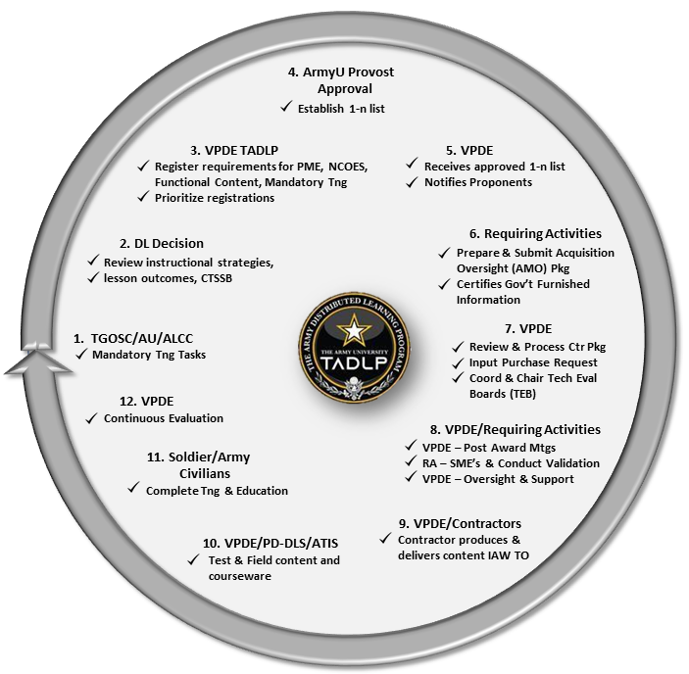

Figure 3-2. The Army Distributed Learning Program contracting process

## 3-4. VPDE tasking order

VPDE requests requirements annually for development of DL products from proponents. These agencies include proponent centers/schools, National Guard Bureau (NGB), United States Army Reserve (USAR), DA, and other Army commands/agencies. The TASKORD to these agencies includes the VPDE approved requirements submission criteria.

a. Proponents use the TADLP website to register their requirements (link provided in annual TASKORD). This site provides a convenient one-stop location to register all requirements to include mobile and interactive publications.

*Note.* Agencies funding their own unique DL requirements must also register their requirements so they can receive VPDE contracting assistance.

b. Proponents should conduct an in-depth analysis of the DL requirement and prioritize projected ICW needs before registration.

c. Proponent agencies submit requirements with their relative priority endorsed by the commandant or other delegated authority.

d. When a proponent school requests cancellation or removal of a product from the DL prioritized list, the school commandant, or designated representative, signs and forwards the request to the VPDE with supporting rationale that justifies removal. The VPDE adjusts the DL prioritized list, where appropriate.

e. Proponents should only submit true requirements and not placeholders. Submitting placeholders wastes valuable resources and delays processing time.

f. Unit commanders and special interest groups may also submit and receive consideration for DL CW and content prioritization.

g. Proponents may submit required mandatory training in accordance with AR 350-1 for DL development.

h. The VPDE conducts CW verification and prioritization during the annual program management reviews whereby all agencies verify and validate their respective requirements.

i. The VPDE reviews DL requirements, establishes priorities, and incorporates them into the DL prioritized requirements list. The prioritized list also includes the following command guidance:

(1) Courses that support leader development.

(2) Courses that support mission command.

(3) Courses that support MDO.

j. The VPDE will then forward the annual requirements list to the requisite Combined Arms Center (CAC) Army University and TRADOC levels of leadership for final validation and approval.

k. The overarching requirement to improve the readiness of the force requires that the DL development effort focuses on individual training/education courses that support the military occupational specialty (MOS) qualification levels of AA and RC units. The Army commands (ACOMs), including the Chief, NGB, and the Chief, USAR, report specific training/education needs to the VPDE.

## 3-5. Contract process

TRADOC COEs and schools as well as other Army activities can use the Army’s preferred contract for DL (see “[Contract Basics](https://tadlp.tradoc.army.mil/development/process.html)”) on the TADLP website. TRADOC entities will compete for annual funding while activities outside of TRADOC must fund their DL requirements internally. Both should follow local resource management processes to develop their AMO packages.

a. VPDE coordinates with proponents on development of the AMO package for their prioritized products. Proponents are defined as RAs within the AMO process.

b. RAs identify the types of delivery media to be developed, the approximate number of instructional hours (per media type), determine the desired instructional and assessment strategy, and build the performance work statement (PWS). A signed memorandum from the director of training is required to validate the requirement.

c. The VPDE assists the RA in development of the PWS by answering questions about delivery platform, instructional and technical standards, and assessment strategies. VPDE also assists in the preparation of the RA’s independent government cost estimate as part of the acquisition package for each course contracted for development. VPDE assists in the development of additional documents for the AMO as requested by RAs.

d. DL funding and contractor support only begins after RAs certify their documentation and government furnished information (GFI) as adequate.

e. Contracted DL projects require a concerted upfront effort to achieve an effective solicitation process. Contractors need to know the availability, quantity, and quality of GFI/government furnished materials (GFM) before they submit a bid on a task order. A member of the VPDE team contacts RAs to help with this part of the process. VPDE will coordinate receipt and review of GFI or GFM as appropriate. The VPDE team reviews and certifies that the technical GFI and GFM is enough to enable the contractor to perform the task successfully.

f. The RAs prepare an acquisition package for CAC approval or follow their local approval process.

g. Once the AMO is approved, VPDE completes the acquisition package with local contracting offices. VPDE and an onsite COR from the RA performs contract oversight (see figure 3-3 on page 24).

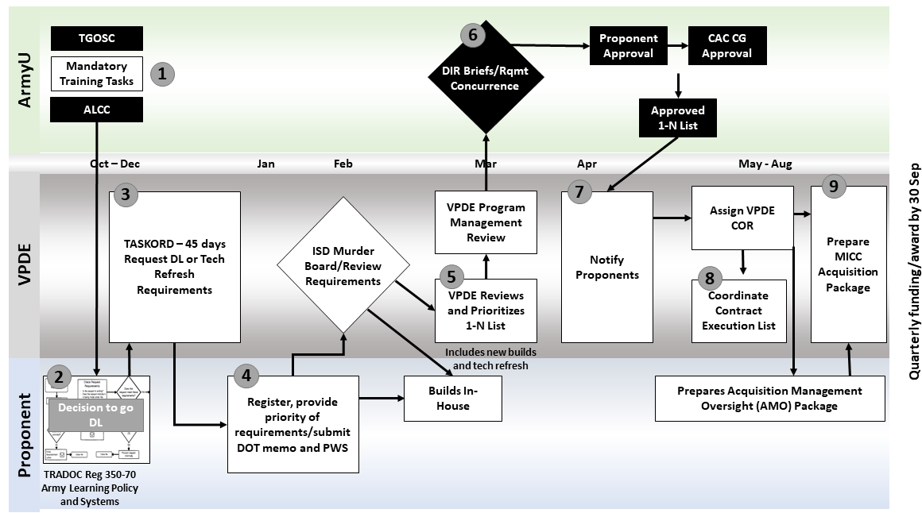

Figure 3-3. Distributed learning requirements and resourcing model

## 3-6. Mobile products registration and development process

a. The VPDE mobile nomination and development process begins with ADDIE steps described in TR 350-70 series (see figure 3-4 on pg 24). All requirements must be met before distributing mobile products.

(1) Mobile Application (App) nomination is open continuously.

(2) Proponent nominates through the TADLP registration website.

(3) Approval board meets to discuss nominations and determine priority of development.

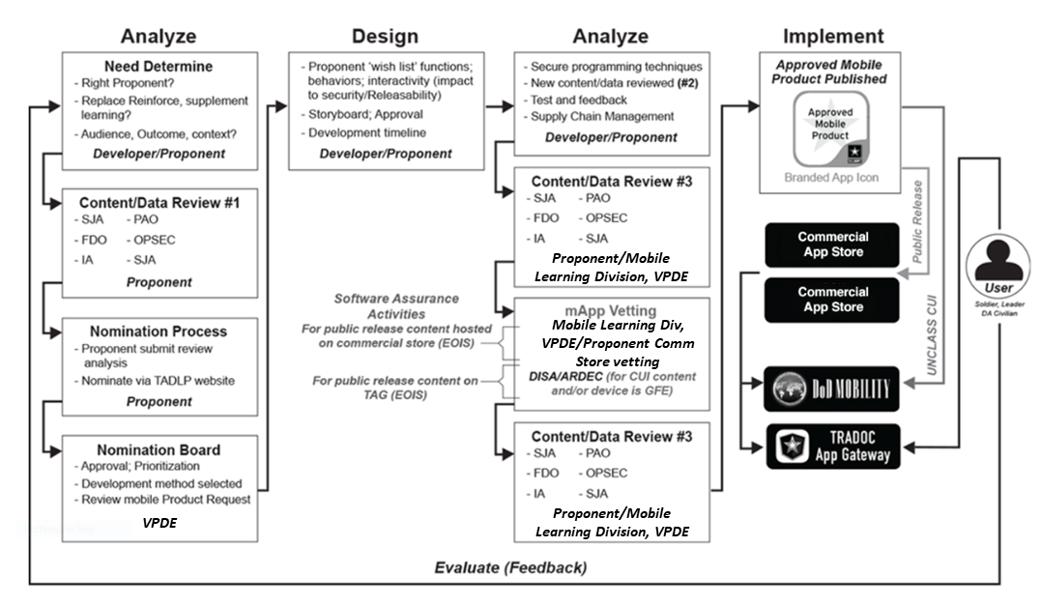

Figure 3-4. Mobile products registration and development process

b. The overall development process and activities at a high level include:

(1) Analysis. Determine if the task/topic is: proponent appropriate and technically feasible; legal; replaces, reinforces, or supplements learning content; meets a priority requirement; and resources are available and approved.

*Note.* Review of existing products that have met the Army standards is conducted by the Mobile Division after nomination.

(2) Design. Translate task/topic lists into learning objectives; design assessment and evaluation plan; develop assessment and evaluation plan; determine required technical guidelines and standards for development; and develop final storyboards.

(3) Develop. Convert outputs from design phase into finished product.

(4) Implement. Implement by restriction according to content classifications.

(5) Evaluate. Validate training objectives are met, ensure information assurance (IA) and legal requirements are met, and perform vulnerability assurance.

(6) Maintain. Review annually and revise, update, or replace if needed; and collect user feedback and make available to developer to refine/tailor mobile product based on user experience.

c. Army proponents develop and validate instruction delivered through the mobile products development and registration process. This process ensures:

(1) New and revised training or education products conform to law and with IA requirements.

(2) Mobile learning products may replace, reinforce, or supplement existing training and leader education.

(3) Mobile learning products function as designed.

(4) The instructional objectives for primary learning applications are fully developed to ensure learning transfer is possible.

(5) No duplication of mobile applications takes place, requestors of Apps own the information within the App, and both the proponent and HQDA are willing to take the risk associated with the mobile application.

d. See Chapter 5 for more information on mobile learning.

# Chapter 4

# Distributed Learning and ADDIE

## 4-1. Distributed Learning and the Analysis, Design, Development, Implementation, and Evaluation Process

The ADDIE process for DL addresses each phase through the lens of technology enabled delivery. The determination to create a DL or traditional learning product begins in the analysis phase of ADDIE. DL CW should be stable, planned, and required by a diverse or physically disbursed audience. Planning for DL development is a complex process. See [Guide for Planning your DL Project](https://atiam.train.army.mil/catalog/search?current=true&search_terms=guide%20for%20planning%20your%20dl%20project)) in the CAR. DL should be used for content that does not require smell or touch. The method of learner assessment is another factor to consider when determining whether DL is appropriate (see figure 4-1 on pg 27) for ADDIE steps for this process).

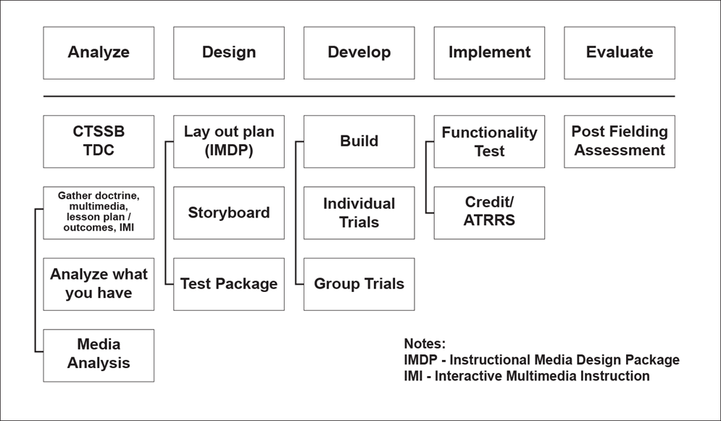

Figure 4-1. Analysis, design, development, implementation, and evaluation process for distributed learning

## 4-2. Distributed learning analysis

The training developer conducts an individual task/topic analysis for each critical individual task/topic to derive knowledge, skills, attitudes, and activities needed to perform the task/topic. Task/topic analysis data for critical tasks serve as the foundation for development of all subsequent individual training products. The Army uses a critical task site selection board (CTSSB) to assist in this process. CTSSB members identify the tasks and gaps or training needs and the instructional problem or gap; determine the appropriate modality (resident or DL) and the target audience characteristics; establish the desired outcomes; review existing knowledge of the learners; consider the content, context, and media; and develop an evaluation plan. Curriculum developers similarly identify critical learning requirements to support educational programs and products.

a. Selection of modality. Once the need is identified, further analysis is required to determine modality for delivery: asynchronous, synchronous and blended. Blended can also be delivered entirely online while offering some face-to-face using technology. Factors to consider when selecting modality are:

(1) Design for interaction. Defined levels of interactivity are only as good as the platform chosen for delivery. Higher level activities, such as virtual tools using VR, may only be appropriate for classroom delivery.

(2) Stable content. DL CW usually requires longer development time and higher costs. For this reason, content planned for this type of development should be stable and not be subject to frequent change. It is reasonable to think of shelf life for content as three years or less.

(3) Target audience analysis. Analysis of the target audience for DL is not unlike the analysis for resident CW. The analysis must take into consideration the age, education, reading level, and experience (job assignments) of a typical learner using the learning content. Army audiences are defined in terms of military occupational specialty, area of concentration and skill level; however, greater detail is required for DL CW. Focus on the range of individual qualifications and all relevant physical, mental, physiological, biographical, and motivational dimensions of learners using the developed content. In addition to these traditional factors, DL requires an audience comfortable with the technology used to deliver the content.

(4) Use of all senses. If the analysis determines the requirement for either a sense of smell (olfactics) or a sense of touch (haptic), then DL may not be the best choice. Newer technology may offer solutions to this limitation in the future.

(5) Evaluation of DL. Evaluations, as part of the learning model in TP 525-8-2, ensure learning occurred to standard and that the course is still meeting the needs of the Army. Post-instruction surveys allow both learners and their supervisors to give the developer/course manager feedback that learning occurred to the standard prescribed in the course. Collect survey results electronically to enable efficient and accurate accounting enabling rapid response to curriculum change. In addition, direct job observation and graduate interviews can provide valuable evaluation data.

(6) Degree of instructor/facilitator involvement. Developers must determine if instructor/facilitator involvement is required and if so, the level of involvement. TP 525-8-2 places strong emphasis on the use of blended learning. Blended learning is defined most frequently as online or technology-delivered instruction combined with face-to-face instruction. It blends efficiencies and effectiveness of IMI with the expert guidance of an instructor/facilitator and can include the added social benefit of peer-to-peer interactions. CW developers must understand the role of the intended CW by considering the level of involvement instructors/facilitators will have with learners.

b. Content analysis. Content developed for delivery across the Web uses a different design paradigm than that of traditional computer-based instruction (CBI).

(1) Content must be delivered in small chunks, easily handled by an LMS, and easily managed by learners.

(2) Content must be optimized for the Web requiring modest bandwidth without sacrificing quality.

(3) Chunking is decomposing content into the smallest intelligible chunk so the parts can be woven into differing learning structures. The parts can be a lesson, module, or even a complete course. Content can be chunked based on topic, time, task, or other factors. Chunking is all the parts and pieces of a course without the structure that links them together.

(4) The process of chunking content can lead to efficiency and effectiveness in the delivery of the content and, ultimately, can provide the components of adaptive learning products. Chunked content is referred to as topics within the LMS.

c. Typical course structure. Once the chunked pieces are identified, they are developed as stand-alone "topics," not linked or sequenced in any way. This linkage will take place once the topics are loaded into an LMS. The course structure starts to take place with modules and prerequisites all defined within that space. See figure 4-2 that depicts a typical course structure example.

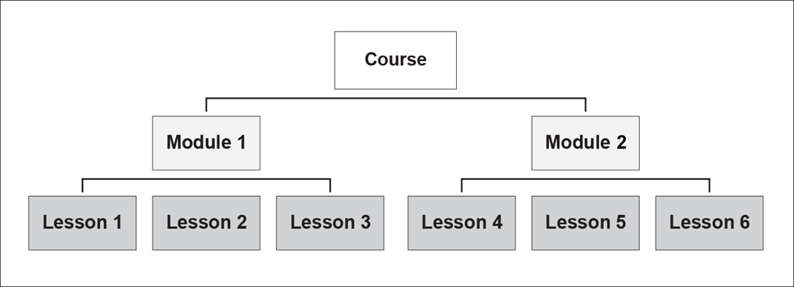

Figure 4-2. Course structure example

(1) The end goal is that each content topic should be an independent learning object so that the LMS/content management system renders only what is required in the lesson.

(2) Topics should be relevant and coherent. The cognitive duration of a topic should be limited in the number of steps or to a specific time span such as 40-50 minutes. The topic should be self-contained, meaning it should be an independent learning content object.

(3) Develop all DL CW with reusability in mind. Create small chunks of content and appropriately identify those through the use of metadata which increases likelihood of reuse.

(4) Bandwidth limitations of Army and mobile networks have further necessitated chunking of CW content.

(5) Figure 4-3 depicts how lessons become topics when the structure is left to the LMS.

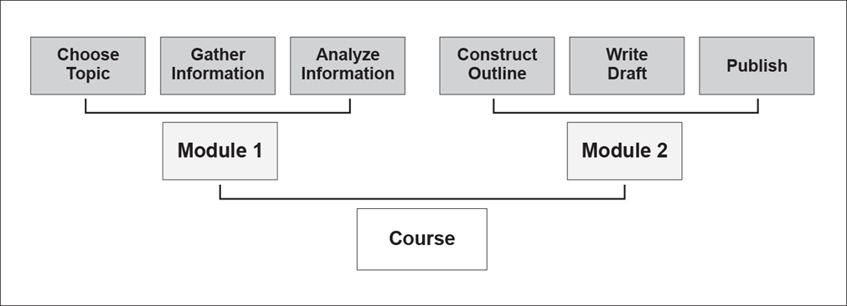

Figure 4-3. Lessons as topics in computer-managed instruction

## 4-3. Distributed learning design

During the design phase of the ADDIE process, information collected in the analysis phase is used to develop details about when, where, and how desired learning outcomes are achieved. Terminal learning objectives (TLOs) and enabling learning objectives (ELOs) are identified and course structure and sequencing are considered. During the design phase, storyboards are assembled, instructional strategies are selected, and assessment plans are developed. Outputs from the design phase are used to provide the framework for the development phase.

a. Fundamental design principles for DL. The fundamental principles for DL CW follow a prescriptive process, providing essential guidance for developers to follow in applying their own imagination, creativity, and intuition to the CW design process. Developers should consider the design and implementation of the graphical user interface and how it instructs the learner to navigate the CW. Proponent and contractor developers and quality assurance/quality control (QA/QC) reviewers should follow the design principles described below.

(1) Establishing interaction of learners with course content is a key factor in both the cost and effectiveness of IMI). Select the appropriate levels of interactivity, from passive to immersive, based on instructional goals (see Table 4-1, Levels of interactivity).

| Table 4-1 Levels of interactivity | | | | |
| --- | --- | --- | --- | --- |
| **Level** | **Interactive categories** | | | |
| **Sensory stimulus** | **Branching** | **Learning level** | **Participation** |
| **0** | Simple (narration, text, graphics, and charts) | None (linear) | Knowledge (Remember) | Passive (Reactive) |
| **1** | Moderate (video clips, emulations, and touch screen) | Simple (single paths to original point) | Comprehend (Understand) | Limited (Coactive) |
| **2** | Complicated (simulation, scenarios, and multiple screens) | Compound (multiple paths to original point) | Application (Decide) | Substantial (Proactive) |
| **3** | Complex (simulation, gaming, and other players) | Complex (multiple paths to logical conclusion) | Analyze (Compare) | Total (Anticipatory) |
| **4** | Chaotic (virtual/augmented reality, multimedia, and artificial intelligence) | Complex (multiple paths to logical conclusion) | Evaluate (Conclude) | Total (Immersive) |

(a) Level 0 Interactivity, Passive. The learner acts solely as a receiver of information. Level 0 interactivity typically requires the learner to do the following:

* Read text on screen or listen to limited narration.
* View graphics, photographs, illustrations, simple charts, and diagrams.
* Initiate simple animated demonstrations of operations and/or procedures when cued.
* Use navigation buttons to progress in a linear sequence forward and back through the instruction.
* Demonstrate very limited, if any, recall of information.

(b) Level 1 Interactivity, Limited participation. In Level 1, the learner recalls information and responds to instructional cues. Level 1 interactivity typically allows/requires the learner to do activities similar to the following:

* Exercise some control over the presentation of content (for example, access hyperlinks to navigate a related series of screens; select an icon or avatar to hear tips, techniques, and procedures; discover information via an image map with multiple hotspots).
* Participate in drill and practice activities. Perform simple procedures to complete tasks and/or operate systems, sub-systems, or equipment (for example, use the mouse to manipulate a dial setting or drag a vehicle gearshift into the correct position).
* Demonstrate recall, comprehension, and simple application of information in both formative and summative assessments/evaluations.
* Process feedback in the form of simple equipment animation or verbal/textual information. Self-remediate by reviewing content via an alternative presentation or method of instruction.

(c) Level 2 Interactivity, Substantial participation. In Level 2, the learner applies information to scenarios and interacts with simulations. Level 2 typically allows/requires the learner to do the following:

* Exercise substantial control over a nonlinear presentation to explore, discover, process, and respond to complex information, often alternating between multiple screens to keep pace with the instruction.
* Participate in a limited real-time simulation of performance or gaming in an operational setting.
* Process scenario-based instructional cues, make decisions and/or take actions, and respond to rapidly presented, authentic consequences to progress through multiple levels of branched instruction and/or accomplish complex tasks that emulate real job performance.
* Analyze, apply, synthesize, and/or evaluate complex information and perform complex skills within acceptable parameters (for example, time limits, number of errors) in both formative and summative assessments/evaluations.
* Process feedback in the form of intrinsic consequences.
* Self-remediate by making different choices or taking alternative actions to progress through branched instruction.

(d) Level 3 Interactivity, Real-time participation. In Level 3, the learner engages in a life-like set of complex cues and responses such as in the following:

* Exercise total control over the presentation. The learner operates in the environment without instructional cues. This level is used to simulate highly complex operational and maintenance procedures that often support certification.
* Maximum flexibility and multi-level branching allow a high degree of interactivity in the form of simulator and gaming environments. This level is capable of real-time simulation of performance in the operational setting. After action and natural consequences are given based on performance.
* This level incorporates artificial intelligence components and employs state-of-the art technology for simulation and communication.
* Used for computer evaluation of learner performance and intellectual skills using computer-based predictive and performance test items. Capability to generate time and error scores for performance test items.
* The learner operates in a game-like environment that may involve other players and/or computer-generated team players.
* The learner works in an environment simulating decision-making events incorporating multiple tasks.

(e) Level 4 Interactivity, Immersive environment. In Level 4, the learner engages in a real-life scenario responding to sensory cues with or using immersive multimedia or computer-simulated virtual or augmented reality.

* A computer replicated environment, real or imagined, in which the learner moves and responds to sensory cues.
* A computer simulated environment replicating the learner’s physical presence and environment in a way that allows the user to interact using sight, touch, hearing, and smell. Maximum flexibility and multi-level branching allow a high degree of interactivity in a real-time simulation of performance in the operational setting. After action and natural consequences are given based on performance.
* Incorporates artificial intelligence components and employs state-of-the-art technology for simulation and communication.
* The learner operates in a game-like environment that may involve other players and/or computer-generated team players.
* The learner works in an environment simulating decision-making, incorporating multiple tasks.

*Note.* The more complex the level of interactivity the more computing resources are required.

(2) Many COEs and schools do have the capability to develop Levels 0 and 1. The following information is provided for those who can.

(a) Asynchronous DL development options include: Templated DL, non-templated DL, and personal computer (PC) simulations.

* + Templated DL refers to the design and development of content using an authoring tool. These tools provide a technical framework that allows course content to play on various learning management systems. Authoring tools in many cases reduce the requirement for programming experience in the development and implementation of DL.
  + Non-templated DL refers to the design and development of content without the use of authoring tools. This means some technical skills may be required for success in not only building the product but also in its successful delivery. Many open-source tools are used with non-templated DL.
  + PC simulation refers to courseware that depicts a process or procedure in a virtual environment that allows student interaction. Simulations can range from quite simple to the overly complex.

(b) For more complex DL development, centers and schools can still request support from the Army’s preferred contract managed by VPDE or local contract options.

(3) Address the fundamental requirements of adult learners, which are to:

(a) Understand why they should learn what is taught. Adult learners require an explanation on the purpose of the instruction.

(b) Direct their time and activities. Adult learners should be in charge of timing, if possible.

(c) Share their experiences to enrich the instruction.

(d) Use what they have learned by adding storytelling and sharing.

(e) Use a problem-centered approach to learning. State the problem and encourage innovation of thought.

(f) Have confidence in their ability to perform the skill or task taught.

(4) Motivate learners:

(a) Design DL courses to grab the learners' attention and stimulate curiosity within the first 2 minutes of instruction.

(b) Provide context to the learners by describing the importance of the course content.

(c) Influence the learners' attitudes concerning the subject and identify what they should know or do.

(5) Give learners control. Whenever possible, allow learners to:

(a) Branch to different sections, exit a lesson, reenter at a specific segment of instruction, and move backward in the lesson for review.

(b) Manage the pace of presentation.

(c) Choose among practical exercises and optional assessment questions.

(d) Involve learners with active and meaningful instruction.

(e) Actively involve learners during the middle of the instructional period (when recall is at its lowest point) by including a mix of learner-learner, learner-content, and learner-instructor/facilitator interactions.

(f) Involve learners in role-playing scenarios, problem solving, and case studies designed to grab and hold attention. Create checks on learning throughout the instruction that foster the learners’ reflections on their own past experiences in which they're able to relate to the course instruction.

(6) Provide feedback that:

(a) Is prompt and meaningful.

(b) Is frequent and available when the learner needs it.

(c) Tells or shows why a response was correct or incorrect and provides feedback.

(d) Indicates improvement since the learner's last assessment.

(e) Is followed by new action.

(7) Use the following DL course design techniques to illustrate, demonstrate, or visualize learning objectives by:

(a) Using graphics, pictures, animation, or video to illustrate or demonstrate action, rather than using text or a talking head.

(b) Using animation to demonstrate processes that are difficult to visualize from verbal descriptions, or are too costly, too dangerous, or impractical for video.

(c) Using video to demonstrate procedures requiring motion and stimulate critical thinking and discussion.

(d) Triggering image visualization by telling stories, relating examples of action, and using analogies.

(8) Use the following course design guidelines for presentation:

(a) The character font and size combination is the most important attribute of text legibility on video displays. Use light to medium-colored backgrounds with a text color that yields a text-to-background contrast ratio in the range of 8:1 to 10:1 to enhance legibility.

(b) Pleasing colors on a video display include any shade of medium blue background with white or black text. Other desirable medium-tone background shades include: green, salmon, medium purple, gray, and tan.

(c) Combinations of complementary colors of the same value/hue are difficult to read and are annoying to learners. Examples include blue/orange, red/green, and yellow/violet. Red and green combinations should be avoided because male-pattern color blindness is most prevalent in distinguishing between these two colors. See [Army Business Rules and Best Practices for Distributed Learning Development Guide](https://rdl.train.army.mil/catalog/go/100.ATSC/FCB2B04A-3376-4379-97F9-D26E9D31C630-1659025412212) for additional guidance regarding compliance for assisting individuals with disabilities that would impede regular access to DL CW (e.g., 508 information). All Army DL products shall be compliant with the Revised 508 Standards and Web Content Accessibility Guidelines.

(9) The following techniques provide structure to the learning experience. Ensure DL CW designs:

(a) Introduce the lesson by presenting its full context. In other words, explain what came before, what comes now, what comes next, and why this subject is important.

(b) Remain consistent with learning objectives, lesson plan content, checks on learning, and assessment items to build learner trust and confidence in course material.

(c) Improve learner performance on comprehensive post-assessments by beginning lessons with recall pre-assessments (essay exam, fill-in-the-blanks, and matching). Performance on recall pre-assessments often exceeds those involving recognition, that is, multiple-choice exams.

(d) Relate the learning objective to the context of the total subject. Present instruction using a whole-part-whole sequence to result in quicker learning than presentations that use a part-whole sequence (in other words, starting with details and building to the general topic).

(e) Begin the lesson with a practice session that calls for a response to a situation. End the lesson with a discussion of the theory involved.

(f) Provide indicators of where the learner is in the lesson and in the course to reduce problems that occur when DL learners lose track of their place in electronic instruction.

(g) Include periodic review sessions, such as after an hour, a day, a week, or a month.

(h) Conclude the learning experience by providing for a transfer of the knowledge, skill, or task learned to the learners' jobs.

b. Sharable Content Object Reference Model (SCORM). Part of the analysis of content requires consideration of the [SCORM standard](https://www.adlnet.gov/projects/scorm) (see [Advanced Distributed Learning](https://www.adlnet.gov/projects/scorm/) website). SCORM is comprised of a collection of interrelated technical specifications and designed to meet the DOD’s high-level requirements for creating interoperable, plug-n-play, browser-based e-learning content.

(1) SCORM is a packaging and communication standard for Web-delivered content. Packaging refers to the standard followed when compressing the content into a .zip format. SCORM uses the package interchange file with a .zip extension.

*Note.* The important thing to remember about SCORM is that it is for Web-based CW. If it does not need to play on the Web, it does not need to be SCORM conformant.

(2) SCORM is the model for development and Sharable Content Objects (SCOs) represent the content objects used within the model. The SCO can be a learning objective, a module, or a media asset.

(3) SCOs are reusable learning objects that are launched and tracked by communicating with an LMS. A SCO separated from an LMS is simply a collection of assets (pictures, video, text, and audio). SCOs should be developed to support specific instructional objectives, and an entire course could be a SCO if there is no instructional reason to break it into smaller pieces.

(4) There are limitations inherent in SCORM that can influence DL development decisions. For example, SCORM specifications allow the content to communicate with an LMS, but not with other content. If the SCO is allowed to communicate with other content, then reuse of that SCO is limited to other CW that would also allow that communication. This limitation enables content discovery for reuse in other CW.

(5) Another important consideration for the development team is the concept of SCO dependence. To improve reusability, SCOs are designed independent of learning context. To attain this freedom from content, SCOs are usually formed from the smallest part of learning content (for example, an animation depicting electrical troubleshooting instead of the complete lesson in electrical diagnostics). A complete lesson may have references too specific for other developers to use. The SCO is considered dependent if the graphic design elements or the sequence and navigation design are tied to a specific context or content.

(6) Learning content is generally developed as courses, modules, or lessons—each full of resources such as animations, simulations, graphics, video, and audio. New technical standards were developed to open these resources to discovery and reuse. These standards allow for separation of all the pieces of learning content, making it available to other developers. Reusable learning objects are small chunks of learning content tagged with descriptive labels (metadata) and made discoverable by other developers. Other benefits include:

(a) Use existing content to create new courses for all government developers.

(b) Use multiple delivery channels (Internet, intranet, print, etc.).

(c) Provide efficient and cost-effective content revisions by easily updating content.

(d) Improve course development efficiently and in a timely manner.

(e) Assemble new courses from existing content, in whole or in part.

c. Instructional Media Analysis. This type of analysis may be required for selection of multimedia and delivery media for the DL product (see DI-SESS-81526C (<https://assist.dla.mil/>)) for preparation instructions for the content and format of the Instructional Media Package). Evaluate the level of accuracy determined during the examination against the contract.

(1) Determine the sensory stimulus requirements to ensure their accuracy and completeness for supporting each of the specified learning objectives.

(2) Determine the recommended instructional media delivery system data to ensure capabilities support the learning objective stimulus requirements.

(3) Review the instructional media delivery system functional characteristics data to determine the traceability to the sensory stimulus requirement.

(4) Determine the functional characteristics data to ensure characteristics are stated in performance terms.

(5) Determine the media selection analysis data to ensure the primary and alternate methods and media support the instructional media requirements.

(6) Review the training systems support considerations data to ensure concepts, goals, and constraints controlling the design of media are supportable. Evaluate the data using a pass/fail method as specified in the contract.

(7) Determine the data contained in the appendices to ensure sufficient detail is applied to complement the instructional media requirements document.

(8) Review the media selection analysis data to ensure all requirements are considered regarding CW object interoperability across platforms and systems.

(9) Review media selection analysis data to ensure requirements for operating the course using various LMSs are considered.

d. Instructional media design package (IMDP). In designing the learning product, some key decisions are needed early in the process to assure the right set of technical standards are applied and followed.

(1) The IMDP provides a blueprint to guide the developers through this complex process. It is developed by the contractor and reviewed and approved by the proponent. For in-house development, an IMDP should be prepared by the proponent to serve as the blueprint for development. The IMDP:

(a) Is prescribed by data item description DI-SESS-81520B (<https://assist.dla.mil/>).

(b) Provides the overall course structure format, description of the hierarchy to include sub-structure, sequencing, global properties, SCOs, external references, and metadata tagging conventions for target delivery platform.

(c) Provides a summary description of the content, lesson strategies, and assessment strategies.

(d) Identifies the sequence of learning objectives.

(e) Prepares the DL design specifications.

(f) Provides a method to obtain school management review and approval.

(2) The IMDP is a demonstration of the plan to develop CW. The goal should be a clear description of the proposed course design and delivery method. Every DL course design should contain minimum essential design elements. The IMDP should demonstrate an understanding of instructional design, the instructional goals of the lessons, and a plan to implement the goals with sound delivery methods. Evaluation criteria are based on a GO or NO GO method. The IMDP:

(a) Ensures CW object interoperability, reusability, and internet protocol compatibility across platforms and systems.

(b) Provides a list of tasks taught and supported (learning objectives). Provides reviewers a chance to visualize the plan before the start of development.

(c) Offers reviewers and developers a platform for discussion of the development plan.

(d) Provides a way to make changes that will not affect work already completed.

(e) Provides lesson flow diagram and course diagram (see figure 4-4 on pg 39).

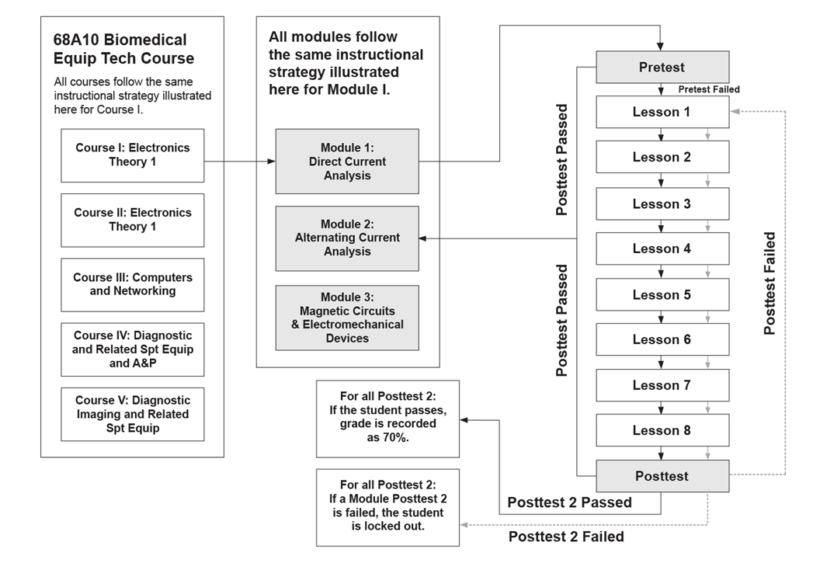

Figure 4-4. Example courseware flow

(f) Provides assessment strategy.

(3) The IMDP components template assists reviewers of CW in completing a structured review of either contracted or in-house development. The template is self-explanatory and only requires the reviewer to provide comments and check a GO or NO GO to the items on the list.

e. Assessment Strategies. Assessments (also known as pretests and posttests) are a critical part of instructional design and, as such, are part of the IMDP. Assessments should always begin with a specific, clear, and measurable objective. How do you know learning took place? What questions will be asked to measure learning? What is the objective measurement to be used? What types of assessments can be used?

(1) Assessments are usually divided into two categories, direct and indirect.

(2) Direct assessment measures actual behavior or performance outcomes; indirect assessment measures attitudes, perceptions, or feelings.

(3) Army DL uses pre- and post-assessments to measure performance and after course surveys to measure satisfaction and attitudes.

(4) Lesson pre-assessments allow learners to skip content that has already been mastered and are critically important for adult learners.

(5) Pre-assessments are also used to provide learners with a chance to self-evaluate their prior knowledge. Pre-assessments do not allow skipped content.

(6) Diagnostic pre-assessments are used to determine what knowledge learners already possess and to structure the learning experience around content that has not yet been mastered. This is commonly referred to as branching.

(7) Post-assessments measure learning outcomes.

(8) Mastery assessments are designed to determine the level of knowledge and understanding that a learner possesses once content has been completed. Mastery assessments measure the final learner outcome of training/education provided in the CW.

(9) Diagnostic post-assessments allow remediation. If learners fail on certain learning objectives in the post-assessments, they will be redirected to remediation for the objective that was not mastered. Diagnostic post-assessments provide control over the sequence of remedial lessons or learning objectives based on learner performance.

f. Test packages (as defined by [DI-SESS-81525C](https://atiam.train.army.mil/catalog/search?current=true&search_terms=%23TEST_PACKAGES) (Test Packages) https://assist.dla.mil/))

are learning objectives (a statement of the behavior or performance expected of a trainee as a result of a learning experience) expressed in terms of the behavior, the conditions under which it is to be exhibited, and the standards to which it will be performed or demonstrated.

(1) Review the test items to determine they are enough to measure a learner's achievement of the related learning objectives.

(2) Review test items to determine whether each learning objective has been evaluated sufficiently to support variations in tests.

(3) Review test item answers to ensure that the data is traceable to the supporting reference and that the answers are correct.

(4) Review instructions to the examinee to ensure that all guidance to be followed while taking the test is complete, pertinent, and necessary.

(5) Review instructions to determine if safety considerations have been addressed.

(6) Review testing plan to determine that the knowledge and performance tests are scheduled at logical intervals.

(7) Review testing plan to determine that the review, remediation, and retesting procedures will provide adequate opportunity for learners to achieve the learning objectives.

(8) Review cross-reference chart to determine whether the relationships among test item, lesson topic, learning objective, training task, and job task are correct.

(9) Review testing procedures for Web-based testing to ensure the security and protection of tests, test items, and learner responses.

(10) Review types of tests and rationale to determine that the test type chosen supports the measurement of learner characteristics and performance.

(11) Review grading method and rationale to determine if it supports the assignment of value to learner performance and the purpose of the test.

(12) Review capability and structure of test and test item metadata that support SCOs and the LMS to determine interoperability.

(13) Ensure all exam packages are separate SCOs. The exception is for “stealth” assessment using branched scenarios.

## 4-4. Distributed learning development

The development phase is the process of converting outputs from the design phase into a finished learning product. For DL, the development phase is the process of moving from an accepted IMDP to actual development of the products contained in the plan.

a. Course Structure.

(1) Once all the storyboards are complete and approved for topics, tasks, or lessons, the next step involves building the course structure. How will the learner move through the course or curriculum? What are the prerequisite lessons? Does it make sense to force the learner through the content or can control of sequencing be left to the learner? The course map provides the visual that allows all members of the development team to see the design. The course map provides:

(a) Course structure.

(b) Courseware flow.

(c) Prerequisite steps.

(d) Remediation paths.

(e) Instructional branching.

(2) When developing DL, developers may use a mixture of instructional techniques and delivery media. These may be delivered to the learner in a variety of timed events. For example, there may be a pre-resident phase in which the learner is required to read materials in preparation for the resident phase. There may be a post-resident phase in which content is available for a refresher or sustainment of gained skills and knowledge.

b. Content Structuring and Sequencing.

(1) Course structure is usually provided by the LMS. The LMS can store prerequisites, read-ahead material, and even material for refresher training.

(2) Learner-centric designs may leave the structure to the learner which means access to the material, sequence, and pace at which it is accessed is left to the learner.

(3) An LMS is a Web-based information system that delivers learning content, manages learning information, provides learning collaboration, scheduling, and career planning capabilities in both resident and non-resident courses. An LMS provides the following capabilities:

(a) Registering and enrolling learners.

(b) Monitoring assessments and learner progress.

(c) Distributing, delivering, storing, and presenting learning products.

(d) Maintaining training/education records.

(e) Providing collaboration capabilities for both the learner and instructor/facilitator.

(f) Collecting and storing feedback and evaluations.

(g) Maintaining a database of learning products and resources.

(4) An LCMS is very similar to an LMS with one major difference—an LMS can manage both classroom and e-learning and usually does not provide a course authoring capability except as part of a larger suite of tools. An LCMS is focused on course delivery and management of that process. It offers a course manager greater flexibility in structuring the course as well as authoring course items such as threaded discussions and exams.

(5) SCORM-conformant CW can be delivered on either an LMS or an LCMS, but adjustments may be required.

c. Instructional Strategy (Technical Implementation of Assessment Strategy). For Web-based SCORM-conformant IMI CW, the following design strategies may be used:

(1) Strategy 1: Linear lesson sequencing without assessments is a simple course structure with linear sequencing from one lesson to the next. There are no pre-assessments or post-assessments, and linear sequencing is used between ELOs within the lesson.

(2) Strategy 2: Linear lesson sequencing with assessments is a simple course structure with optional phase/module level mastery pre-assessment and a single phase/module level master post-assessment. There is one attempt on the post-assessments and no remediation is given.

(3) Strategy 3: Linear lesson sequencing with two post-assessments. This strategy contains an optional phase/module level master pre-assessment and two phase/module level mastery post-assessments. There is one attempt for post-assessments one and two. There will be remediation back to all content upon failure of the first post-assessment.

(4) Strategy 4: Diagnostic master post-assessment structure. This strategy contains a mastery phase/module level pre-assessment, linear sequencing between lessons, a single diagnostic post-assessment with unlimited attempts, and remediation back to failed objectives.

(5) Strategy 5: Diagnostic mastery phase/module level pre-assessment. The sequencing in this strategy is based on pre-assessment performance. Branching within the lesson is based on learner performance in checks-on-learning. There are two mastery level post-assessments with a single attempt at each and no remediation.

d. Storyboard development. A storyboard is a design tool for planning a production and obtaining production approvals. In development, the storyboard assists in ensuring design elements identified as essential are included in the plan. Develop storyboards in a Word document, database, or in a special purpose storyboarding tool. Storyboards for IMI are visual representations of the layout of data on the screen (Figure 4-5 on page 44). Storyboarding is prescribed by DI SESS-81526C (<https://assist.dla.mil/>). Storyboard data are required for all DL products as follows:

(1) Detailed computer programming instructions for interactivity, branching, and CW performance.

(2) Description of a photo shoot to identify the visual image displayed (that is, still, motion, and sequence). Provide simulation sequence number for each shot in the order that the video will be presented.

(3) Special effects (for example, animation, rollovers, delayed reveals, highlight, video, avatars, audio, and holograms).

(4) Transitions such as wipe, dissolve, or fade to black.

(5) Words or text displayed as a visual.

(6) Description of animation, video, audio, or simulation.

(7) Test item data such as stem text, distractors, feedback, and remediation plan.

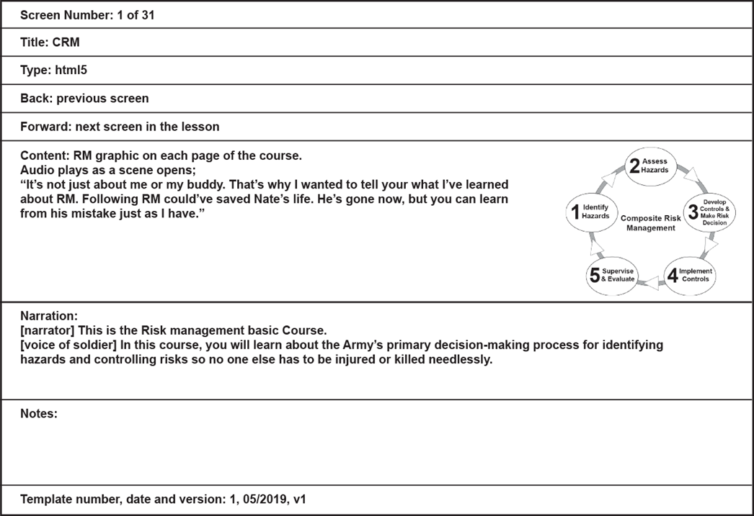

Figure 4-5. Example storyboard frame

*Note.* For other delivery models, a wireframe may not be required. Consult with VPDE for more information.

## 4-5. Distributed learning implementation

The implementation plan describes how the content will be delivered and should be part of the IMDP. DL leverages various technologies and delivery techniques to distribute instruction to learners. An essential element of the DL CW and the content development process is to select the most effective technique to present the learning products. As communications capabilities and multimedia technologies constantly evolve, VPDE will incorporate state-of-the-art delivery technologies that are cost and instructionally efficient to satisfy operational requirements.

a. CBI usually refers to IMI CW, CD-ROM or DVD. These courses employ techniques that require frequent learner interaction with the CW as a means of facilitating learning. CBI includes both individual and group-paced interactive instruction combined with multimedia presentations. Interactive learner-centered instruction is performance-based instruction which requires learners to practice what they learn, receive immediate feedback on their performance, and take assessment(s) on the material. Learners' performance is measured using criterion-referenced assessments. CBI maximizes individual or group learning through the use of multiple instructional methods. It allows learners to practice learning steps/activities (LSAs) and tasks without injuring personnel or damaging equipment. Learners may progress through the content at their own pace as well as repeat lessons until they achieve the established performance standards. Selection of this method includes an executable file and is not playable on an Army network.

b. Web-based, SCORM-conformant, asynchronous or synchronous, self-paced IMI, also known as CMI, should be selected when all lessons/tasks in a course are going to be delivered as Web-based, self-paced instruction. This CW supports credited mandatory training, credited self-development learning products, and/or refresher/sustainment training. It can also support the delivery of a DL phase prior to a resident course.

c. Web-based instructor/facilitator in the loop, also known as CAI can be either synchronous or asynchronous instruction and delivered as a: webinar, video, collaboration, virtual classroom, or demonstration. This implementation plan should be selected if the delivery method will include a virtual classroom (LMS/LCMS) to supplement resident face-to-face instruction by providing learner materials, learner-to-learner collaboration, threaded e-mail forums, and/or a digital drop box for assignments.

d. Virtual classrooms provide the digital workspace and tools for instructor/facilitator-led assignments, ability to conduct or facilitate discussions following specific lessons, provide additional assignments, track progress, mentor learners, and encourage learner motivation. Virtual classrooms do not require learners and instructor to be together in the classroom at the same time. The cohort model is designed to allow a group of learners to work together to meet their learning objective. Cohort model learners must adhere to a more rigid course schedule with specific start and end times for completing blocks of Web-based asynchronous IMI content. This allows the instructor/facilitator to conduct or facilitate discussions following specific lessons, provide additional assignments, track progress, and ensure learners stay on schedule. The typical cohort model is HQDA-directed training with learners accessing the Web-based IMI CW while in a digital training facility, at home, or in the office. The learner enters the CW thorough the LCMS. The IMI trains the basic foundation of a task/TLO. The instructor facilitates discussions, provides references, and assists learners who are having CW problems. Learner tracking and record keeping is required for the IMI phase.

(1) This implementation option might also be used within a virtual classroom using a combination of synchronous or asynchronous collaboration. The instructor/facilitator can include a virtual workspace allowing learners to work together. This option includes review of IMI, map exercises, document editing, brainstorming, video and audio exchange using voice over Internet protocol, and desktop sharing.

(2) The virtual classroom might also be used in instances that are non-credit producing for delivery of Web-based, synchronous, informal presentation of information, instruction, or mentoring. The instructor/facilitator is in one location providing this information to a small number of dispersed learners.

e. Computer or Web-based simulations and/or gaming CW are delivered on CD-ROM or DVD. These can be highly ICW or can be computer-based simulations that play best in this media. They may also be games used as a practice environment for mission rehearsal or unit training.

f. Simulation systems offer realistic training in a safe, efficient, and effective manner. They offset the restrictions imposed upon live training and the use of high technology weapons systems that result from safety considerations, environmental sensitivities, and higher training costs.

g. Developers must choose an appropriate implementation platform. Table 4-2 contains information regarding the course characteristics that should be used to identify the LMS or LCMS destination best suited for a course. The criteria do not constitute concrete rules but rather characteristic-based guidance.

| Table 4-2 Implementation platforms | | | |
| --- | --- | --- | --- |
| Course characteristics | LMS  (Army Learning Management System) | LCMS  (Enterprise Lifelong Learning Center) | Comments |
| 1. Certificate required. | ✓ | ✓ |  |
| 2. Required and/or credit-producing training. | ✓ | ✓ |  |
| 3. Collaboration tool. | ✓ | ✓ |  |
| 4. Learning products containing a valid assessment or other measurement instrument. | ✓ | ✓ |  |
| 5. *SCORM-conformant content (v2004 4th edition and earlier). | ✓ | ✓ |  |
| 6. Non-SCORM conformant content. | ✓ | ✓ | Both systems can deliver non-SCORM content, but SCORM is recommended for all CW for potential migration of CW between systems. |
| 7. Self-development learning product. | ✓ | ✓ |  |
| 8. Resident learning product. | ✓ | ✓ |  |
| 9. Blended learning product. | ✓ | ✓ | Blended is defined as CW presented with an instructor present or facilitating. In this instance both systems can deliver blended products. |
| 10. Instructor facilitated learning product (requires drop box, grade book, threaded discussion, chat or instant messaging all embedded within the course). |  | ✓ | Both systems can deliver this type of product, but an LCMS is best used for this purpose. |
| 11. DL product. | ✓ | ✓ |  |
| 12. Phase learning product. | ✓ | ✓ |  |
| 13. Quota-managed training. | ✓ | ✓ |  |
| 14. ATRRS-managed, automated communication for tracking of assignment, registration, or completion. | ✓ | ✓ |  |
| 15. Separation of content by, center, school, or proponent allowing for branding of platform for individual proponents. |  | ✓ | Both systems use domains to separate content by schools, but only the LCMS offers branding. |
| 16. Courses that do not require synchronous learning. | ✓ |  | Both systems can deliver this type of product, but an LMS is best used for this purpose. |
| 17. Courses that do not contain video or contain only small videos (no larger than 25 megabyte). | ✓ |  | 25 megabyte is used as a standard and is heavily dependent on bandwidth. |
| 18. Access to previously completed training and education, that is, persistent access. | ✓ |  |  |
| *Although the SCORM Conformant tool validates 4th edition and earlier, the Army requires 3rd edition SCORM only. | | | |

## 4-6. Distributed learning evaluation (quality control and validation)

a. Courseware Validation. Validation is the quality control process that determines if learning products and components perform as intended, the course/CW complies with all applicable policy and guidance, and that personnel receiving the instruction can perform the objective to standard. All DL courses and CW must be validated which includes content validation, assessment validation, and instructional validation. Instructional validation is conducted using learners who are representative of the target population for group trials (GT). During these trials, technical observations are captured and reported back to developers for remediation.

b. Critical Activities. It is impractical to conduct an intense analysis of all aspects of a course or CW at one time; therefore, developers should focus on specific aspects throughout the development process. Validation is also known as formative evaluation, field test, pilot test, or alpha test. DL products are given intense scrutiny during validation to produce effective and efficient training. Validation determines if the training product and supporting materials perform as intended. The five critical validation activities include: criticality standards, content validation, individual trials (IT), GT, and operational tryouts.

c. Criticality Standards. Determine the percentage of volunteers who must pass each objective on the first attempt of the training to determine if the training is valid for each objective. Criticality standards can be identified as storyboards are reviewed. See TP 350-70-14 for establishing criticality standards.

(1) Provide objective basis for validation requirements.

(2) Prevent selection of validation requirements that are too high or too low.

*Note.* Use the JA ITP 01 02 Job Aid, Criticality Standards for Rating Learning Objectives v1, on the Training and Education Developer Toolbox ([TED-T](https://cacmdc.army.mil/armyu/TEDT/Job%20Aids%20%20Analysis/Forms/AllItems.aspx)) webpage to assist with the criticality standards.

d. Content Validation. Content validation is an iterative process that continues throughout development and originates in the design phase. Changes or corrections to doctrine become more difficult as the technical product is developed.

(1) Assemble subject matter expert (SME) support and consider a TO to keep a SME in place to support the work if necessary.

(2) Ensure thorough reviews during the period of design (storyboards).

(3) Ensure content (doctrine) is correct, clear, uses current references, and includes all the critical information.

(4) Avoid training substandard/unclear content.

(5) Eliminate problems early.

(6) Analyze information within the instructional materials to determine if it is technically, tactically, doctrinally, and stylistically accurate, appropriate, and applicable for the intent of the training.

(7) Optimally, conduct content validations immediately after the material in each learning activity is drafted.

(8) Content validation supports the QA/QC function by identifying and eliminating deficiencies before work begins. An educational unit is validated at the objective level. Validate that the lesson (educational unit) teaches the TLO, as well as all the ELOs.

(9) Eliminate all problems with content prior to going to IT. Taking products to IT or GT that contain content problems can cause inefficient training development, which may result in course/CW that does not train accurate doctrine.

(10) Assessment validation is produced during the design phase of the ADDIE process to ensure efficient and effective training. Design, develop, and validate the assessments as soon as the objectives are written.

*Note.* Use the JA VALIDTN 02 01, Course/CW Content Validation Data Collection Sheet, on the [TED-T](https://cacmdc.army.mil/armyu/TEDT/Job%20Aids%20Validation/Forms/AllItems.aspx) webpage to assist with course/CW content validation.

e. ITs. Ensure that the learning activities are delivered as intended. A learning activity can appear sound in design but fail technically or fail on the intended delivery platform when tried by the learner population.

(1) Provide first chance to test operability of software on the equipment. In all cases, this operations test is done on the fielding platform in a safe test environment.

(2) Allow volunteers to replace target audience members; however, they must go through the entire course as if they were a learner with at least one taking a negative path (failure) to test the way the content treats failure of a learner.

(3) The number of volunteers varies but should include one expert and one novice in the topic area. The third member can be a contractor who can take the negative path.

(4) Eliminate inadequate training activities.

(5) Test software to verify that it will load and play before going to GT.

(6) Determine if the product provides the mandated training. Developers should analyze how effective the individual learning activities are and how well those activities fit together to accomplish an objective.

(7) If a major problem is found during IT, revise and conduct a new trial to ensure that no additional problems were introduced during the revision process. Eliminate all problems at the objective level prior to incurring the expense of conducting GT.

*Note.* Use the JA VALIDTN 03 01, Volunteer Data Collection Individual Trials, on the [TED-T](https://cacmdc.army.mil/armyu/TEDT/Job%20Aids%20Validation/Forms/AllItems.aspx) webpage to assist with IT.

f. GTs. GTs provide statistical validity that the lessons teach the objectives. The number of participants varies but should be a representative sample of the target audience. There should be both experts and novices in the group.

(1) Supports analysis of each question, assessment, etc.

(2) Provides data needed to establish academic and total times.

(3) Provides final chance to test operability.

(4) Provides basis for acceptance of lessons.

(5) Provides enough validity for initial implementation using volunteers.

(6) Focuses on how well the learners learn the TLO and how well the various learning activities support the mastery of the TLO. This validation activity produces the statistical verification that the lesson provides valid training.

(7) Eliminates problems prior to going to the expense of conducting operational tryouts and exposing actual learners to inaccurate or ineffective training.

***Note****.* Four data collection instruments/Job Aids to support this process: (JA VALIDTN 07 01, Volunteer Data Collection Group Trials; JA VALIDTN 09 01,Volunteer IMI Courseware Group Trials; JA VALIDTN 08 01, Instructor Observer Data Collection Group Trials; and JA VALIDTN 11 02, [Sequential](https://cacmdc.army.mil/armyu/TEDT/Job%20Aids%20Validation/JA_VALIDTN_11_01_Sequential-Validation_final.doc) Validation) are available on the [TED-T](https://cacmdc.army.mil/armyu/TEDT/Job%20Aids%20Validation/Forms/AllItems.aspx) webpage.

g. Functional testing. Army DL is more than an instructional product; it is a technical one and the content is delivered in a technical environment. For that reason, the process used for IT and GT under validation differs slightly. In addition to these first technical reviews of the content and how it functions in the intended environment, in most cases there is functional testing or final independent testing on the fielding platform.

(1) Functional testing may differ depending upon the delivery platform.

(2) Functional testing is conducted to ensure no malicious code is introduced on Army systems.

(3) Functional testing of assessment packages ensures compliancy with SCORM which is needed to report learner success.

h. Operational tryouts. Operational tryouts provide first opportunity to survey the entire phase/course with the complete target audience. Operational tryouts are usually conducted six months after fielding.

i. Validation records. Each of the validation activities produces a set of records that documents the results of the validation activity, the decisions made based on those results, and the actions taken to rectify any problems found during the validation. It is important that all these records are maintained. The records consist of the worksheets used for the trial; the questionnaires/interview sheets the volunteers and instructors/facilitators/observers completed; summary sheets; validation reports; and a complete list of the changes made based on the validation results. The records provide a starting point for the next revision. They also provide proof that the training is valid in case the quality of the training is questioned. Validation records must be provided to obtain recognition of the courses from the American Council of Education.

j. Quality control criteria. This pamphlet includes quality control criteria for the validation of products and tasks in the form of standards and performance measures.

k. End of course survey. Surveying learners provides critical information on the success of DL, course design, interactivity choices, technical issues, etc. Surveys may be given directly to learners or sent to the learners’ next assignment to measure unit satisfaction with the training.

# Chapter 5

# Mobile Learning

## 

## 5-1. Mobile learning environment

Although mobile learning is a content type under DL, there are unique features that require a special section of this pamphlet. The differences begin with the environment.

a. The TRADOC mobile learning environment shown in figure 5-1 includes the various user populations and devices, a diverse group of potential developers, products, and hosting environments.

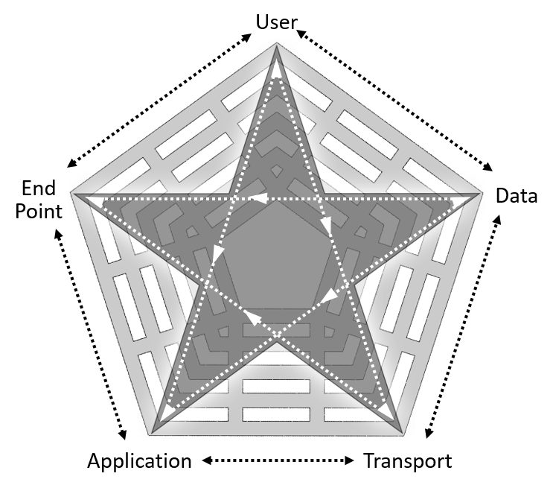

Figure 5-1. Mobile learning environment

b. At the top of the pyramid are the mobile product users. This user population, both CAC and non-CAC eligible learners, include Soldiers of all ranks, branches, and components; DA Civilians; contractors; and may also include the Joint Force, other DOD organizations, foreign military learners, and select DA Civilian populations. They perform training and education activities on their mobile devices at all locations of work and personal life. These environments include TRADOC classrooms, Army offices, homes, and deployed locations. Under some conditions cellular data or Wi-Fi signals are strong, but disconnected, intermittent, and low-bandwidth (DIL) conditions are the norm in austere environments both inside and outside of the Continental United States. Regardless of the environment, TRADOC users expect to have access to training and educational materials at the point of need. That may mean content is preloaded/cached to work “offline” in a DIL environment, or that users can download/ view new content under normal bandwidth conditions. Users also expect to be able to work from the platform to which they are accustomed, such as Android, iOS, or Windows.

c. TRADOC schools and COEs use a mix of mobile and desktop/laptop devices, all with a variety of platforms and ownership models. Traditionally, the Army performs training and education on Windows desktops/laptops. However, that may change with the adoption of newer versions of operating systems, where the incorporation of mobile form factors such as tablets and hybrids has blurred the lines between laptops and tablets.

d. The commercial adoption of smartphones and tablets also leads today’s Warfighters to expect that they can use these devices to perform their duties. The term “consumerization” describes the growing tendency for new instructional technology to emerge first in the consumer market and then spread into business and government organizations. Consumerization drives mobile device usage throughout the government. Since Soldiers benefit from using mobile devices in their daily lives, they expect the same convenience when performing their Army duties. Therefore, TRADOC offers course content and training material via these devices, heavily dominated by Android and iOS. Soldiers also want the flexibility to use their personal smart devices to avoid carrying multiple devices and still have access to a full range of features versus the limited subset of capabilities available from a locked-down government furnished equipment device.

e. Developers have the critical task during analysis and design to determine how to make the mobile content available to their targeted users. Developers can include instructors, instructional designers, training developers, Soldiers, proponents, or other external agencies using a variety of ways to develop apps or other mobile content. The most common types of products include reference material, digital publications, performance support/job aids, and perhaps primary instruction. These products can be hosted in a variety of locations including both public and non-public accessible locations.

f. Developers are required to follow DOD, HQDA, and TRADOC policies, directives, and regulations to protect sensitive data, preserve privacy, and ensure content accuracy, releasability, and appropriateness while ensuring the mobile products’ functionality, performance, reliability, and availability.

g. Developers within the learning enterprise vary in skill, tool sets, and exposure to mobile content development (that is, Java, Java Android, HTML, JavaScript, and mobile web). The Mobile Learning Division (MobDiv), VPDE team is responsible for training shortfalls identified for mobile application (app) development teams. MobDiv, VPDE will provide necessary governance to comply with HQDA and DOD policy and provide development training, a development capability, and commercial, DOD, and TRADOC hosting environments via approved, centralized licenses. Periodic updated training and tool sets will be provided to these identified teams when deemed necessary by the MobDiv.

## 5-2. Mobile application compliance

a. Any mobile application (proponent developed, contracted, built by VPDE MobDiv)

using, accessing, or creating Army data must be tested and approved before it will be permitted to operate on the Department of Defense Information Network-Approval (DODIN-A). The MobDiv, VPDE, Army University, is in place to provide expert full cycle capability from requirements to development to testing to distribution and sustainment. Mobile apps coming through the MobDiv capability are built and sustained in accordance with DOD and Federal Standards such that these apps can operate on a DOD managed mobile device. The MobDiv process incorporates the regulations of the Defense Information Systems Agency and receives approval by DA Chief Information Officer/G-6 before release. Proponent and contracted developed mobile apps must do the following to establish compliancy:

(1) Submit email to MobDiv, VPDE, to notify of third-party app incoming for review. The email subject line should identify the title of the app. The body of the email should detail the purpose of the app and the gap it is filling for either training or operational needs. The team will send the requestor artifacts which require leadership signature and are required as part of the delivery packages for DA CIO/G6. In certain circumstances, MobDiv will reach out to the requestor if they do not own the information detailed in the app or if the app is duplicative.

(2) Deliver unpackaged raw code. While .ipa and .apk packaging can be submitted if available, the delivery of only these types of files will not meet compliancy. If it is developed in a third-party tool which does not allow raw code submittal, MobDiv will discuss with submitter and attempt to triage the issue. The app will have to be redeveloped if the raw code delivery is not possible. Typically, this issue arises with third party, non-coder, and online solutions which have been shown in the past to open permissions of user’s devices to malicious code.

(3) Deliver all appropriate showcase, icon, and screenshot images according to respective commercial marketplace standards. Also submit a well-developed and detailed paragraph regarding the app for all marketplace "Application Information" sections.

(4) Identify the tool and tool version used in the development of the mobile app. Out of date tool versioning leads to cybersecurity threats and as such requires proper identification before MobDiv vetting and submittal of app to DA CIO/G6.

b. Proponents interested in having MobDiv develop a mobile app for them should email the requirement.

# Appendix A References

Unless otherwise indicated, TRADOC publications and forms are available on the TRADOC Administrative Publications website at <https://adminpubs.tradoc.army.mil/>. DA publications and forms are available on the Army Publishing Directorate website at <https://armypubs.army.mil/>.

**Section I  
Required Publications**

AR 350-1  
Army Training and Leader Development

TRADOC Regulation 350-70  
Army Learning Policy and Systems

**Section II  
Related Publications**

A related publication is a source of additional information. The user does not have to read a related reference to understand this publication.

29 USC 794d  
Section 508 of the Rehabilitation Act as amended by Rehabilitation Act Amendments of 1998 (Available at <https://www.section508.gov/>)

Advanced Distributed Learning website

(Available at <https://www.adlnet.gov/>)

Army Business Rules and Best Practices for Distributed Learning Development Guide (Available at <https://assist.dla.mil/>)

AR 25-1  
Army Information Technology

**DA PAM 25–403**

Army Guide to Recordkeeping

DI-SESS-81520B

Instructional Media Design Package (Available at <https://assist.dla.mil/>)

DI-SESS-81525C

Test Package (Available at <https://assist.dla.mil/>)

DI-SESS-81526C

Instructional Media Package

(Available at <https://assist.dla.mil/>)

DODI 1322.26  
Distributed Learning (DL) (Available at https://www.esd.whs.mil/DD/DoD-Issuances/)

Library of Congress Circular 92  
Copyright Law of the United States and Related Laws Contained in Title 17 of the United States Code (Available at <http://www.copyright.gov/title17/index.html>)

Military Handbook (MIL-HDBK) 29612-4A

Guidance for Acquisition of Training Data Products and Services (Available at <https://assist.dla.mil/>)

TADLP website

(Available at <https://tadlp.tradoc.army.mil>)

TED-T website

(Available at <https://cacmdc.army.mil/armyu/TEDT/Pages/Toolbox.aspx>)

TP 350-70-1   
Training Development to Support the Operational Domain

TP 350-70-3  
Faculty and Staff Development

TP 350-70-7  
Army Educational Processes

TP 350-70-9  
Budgeting and Resourcing

TP 350-70-13  
System Training Integration

TP 350-70-14

Training and Education Development in Support of the Institutional Domain

TP 525-8-2  
The U.S. Army Learning Concept for Training and Education 2020-2040

TRADOC Supplement 380-5  
Department of the Army Information Security Program

**Section III  
Prescribed Forms**

This section contains no entries.

**Section IV  
Referenced Forms**

DA Form 2028  
Recommended Changes to Publications and Blank Forms

# Glossary

**Section I  
Abbreviations**

AA Active Army

ADDIE analysis, design, development, implementation and evaluation

ALCMC Army Learning and Content Management Capability

ALC-TE Army Learning Concept – Training and Education

ALMS Army Learning Management System

AMO acquisition management oversight

App application

AR Army regulation

ATRRS Army Training Requirements and Resource System

CAC U.S. Army Combined Arms Center

CAD course administrative data

CAI computer assisted instruction

CAR Central Army Registry

CBI computer based instruction

CD-ROM compact disc read-only memory

CES Civilian Education System

CMI computer managed instruction

COE center of excellence

COR contracting officer’s representative

CTSSB critical task site selection board

CW courseware

DA Department of the Army

DL distributed learning

DOD Department of Defense

DODI Department of Defense instruction

DVD digital video disc

e-learning electronic learning

ELO enabling learning objective

EPSS electronic performance support system

GFI government-furnished information

GFM government-furnished material

GT group trial

HQDA Headquarters Department of the Army

IA information assurance

ICW interactive courseware

IMDP instructional media design package

IMI interactive multimedia instruction

IMT initial military training

IT individual trial

ITS intelligent tutoring system

JA job aid

LCMS learning content management system

LMS learning management system

LSA learning steps/activities

MDO Multi-Domain Operations

MobDiv Mobile Division

MOS military occupational specialty

NET new equipment training

NGB National Guard Bureau

pg page

PME professional military education

POI program of instruction

PWS performance work statement

QA/QC quality assurance/quality control

RA requiring activity

RC Reserve Component

RRS-A records retention schedule – Army

RTS run time system

SCORM sharable content object reference model

SME subject matter expert

TAG TRADOC application gateway

TADLP the Army Distributed Learning Program

TASKORD tasking order

TATS Total Army Training System

TDC training development capability

TED-T training and education developer toolbox

TLO terminal learning objective

TOMA Training Operations Management Agency

TP TRADOC pamphlet

TR TRADOC regulation

TRADOC U.S. Army Training and Doctrine Command

TRAS Training Resources Analysis System

USAR United States Army Reserve

VR virtual reality

VPDE Vice Provost for Digital Education

VTT video tele-training

**Section II  
Terms**

**Adaptive learning**  
Learning that allows the learner to tailor the learning experience. The learner controls content and sequence, allowing full exploration and inquiry. The CW uses hypertext and hypermedia to personalize the experience. Users have the ability to define their own learning goals and to decide the learning steps or alternative paths to take.

**Animation**   
The simulation of movement produced by displaying a series of successive images on the screen.

**Army Learning Management System**    
A management administration system designed to track learner performance over time, provide information concerning performance trends, record individual and group performance data, schedule instruction, and provide support for other learning product management functions.

**Asynchronous (e-learning)**    
Instructional software, integrating a combination of text, graphics, animation, sound, and video delivered via the Web. The presentation may require active user interaction with the software in the form of questions, simulations, virtual reality (VR), or games; or it may only require passive interaction to navigate through lessons. The learner has control of location and pace of learning. Consists of Web-based learning products, online games, and simulations.

**Authoring**   
Using a software package (sometimes called authoring systems, authoring language, or authoring tools) to create CW.

**Blended learning**  
A mix of synchronous and asynchronous media and methodologies to best meet the instructional goal. A blended learning approach could be a DL phase and a resident phase, or it could be a Web-based asynchronous phase followed with a Webinar synchronous phase. The combination of collaborative and independent learning enhances the learning process. Blended learning takes advantage of the strengths of both types of DL. Using blended learning solutions for course design allows a wider range of options to find the right balance of resources, learning strategies, and technology.

**Branching page**  
IMI page that contains hyperlinks along with next and back links that the learner may visit.

**Collaborative learning**  
Allows people to come together to participate in discussion and group-based activities. Collaborative learning involves the joint construction of meaning through interaction with others. Collaboration can be divided into synchronous (instructor/facilitator involved) and asynchronous (self-paced).

**Computer-based training**

Computer-based training (CBT) is delivered via computer. The learner interacts with the computer usually with the mouse or keyboard. The computer provides the stimulus to which the learner responds. The computer analyzes the response and provides feedback to the learner. The content is stored on the computer and the learner must use that computer. The content may come from the Web, CD-ROM, portable storage media, or downloaded on the computer itself. Also known as computer-based instruction.

**Computer or web-based simulations and/or gaming**

These products are delivered on CD-ROM, DVD or are available for download. These can be highly ICW or can be computer-based simulations that play best in this media. They may also be games used as a practice environment for mission rehearsal or unit training.

**Content**   
Text, visual, and audio elements of CW.

**Course map**   
A flowchart showing the sequences and relationships among modules and lessons in the instructional program.

**Distributed learning**

DL is the delivery of standardized individual, collective, and self-development training to units, Soldiers, leaders, and DA Civilians at the right place and right time, using multiple means and technologies, with synchronous, asynchronous, and blended student-instructor interaction.

**Electronic performance support system**  
EPSS refers to applications designed to run simultaneously with other applications or embedded within other applications that provide support for the user in accomplishing specific tasks. An EPSS may provide needed information, present job aids, and deliver just-in-time, context-sensitive instruction on demand. A Web-based performance support system is an EPSS that uses Web technology to deliver support in an enterprise environment.

**Enabling learning objective**   
A learning objective that supports the TLO. It must be learned or accomplished to learn or accomplish the TLO. It consists of an action, condition, and standard. ELOs are identified when designing the lesson. A TLO does not have to have ELOs, but it may have more than one.

**Government furnished information**   
Information provided by the government to support contract development. This information includes documents, specifically instructional materials in print or data format, supplied to the contractor/developer before and during the execution of the contract. For example, if a proponent decides to contract out the development of a course, the proponent would provide the contractor with the analysis and design data as critical inputs to the development phase.

**Group trials**

GT is part of the instructional validation of courseware. GT is a process used to validate a lesson/lesson plan’s individual objectives, based on observations and statistical analysis. For DL, GT are conducted after the development phase and prior to functional testing. GT is conducted with a representative learner population and is the final technical implementation of the product before functional testing.

**Hotspots**   
Graphics or text with embedded hyperlinks, often used on branching pages.

**Independent learning**   
Self-paced; allows the learners to study at their own pace. It provides just-in-time, anywhere, anytime instruction. The learners are responsible for their own pacing, direction, and location.

**Individual trials**

Individual trials (IT) are the process that starts looking at the educational sufficiency of instructional materials. For DL, IT is conducted after the design phase and prior to GT. IT is conducted with a small representative population and is the first technical implementation of the product.

**Instructional media design package**    
Contains the design documentation for the development and production of instructional media learning product materials.

**Interactive courseware**

Computer controlled CW that relies on trainee input to determine the pace, sequence, and content of training delivery, using more than one type of medium to convey the content of instruction. Interactive courseware can link a combination of media to include, but not limited to, programmed instruction, videotapes, slides, film, text, graphics, digital audio, animation, and up to full-motion video, to enhance the learning process.

**Interactive multimedia instruction**

Loosely defined as computer-based technology integrating a combination of, but not limited to, text, graphics, animation, sound, and video. It predominantly applies to interactive, electronically delivered instruction and instructional support products. The term is used to describe a learning environment in which the instructional content prompts the learner to interact by using mouse clicks and rollovers. The level of engagement varies based on the techniques used to display information, navigate, or branch. The ICW component of IMI has been embraced in learning environments, because it combines the interactivity and management features of CBI with the benefits of realistic audio and video. IMI applications are developed in many forms, including tutorials, simulations, VR, expert systems, Web-based or CD-ROM-based self-paced instruction, Web-based collaborative learning, and two-dimensional personal computer-based simulations or games, as well as "just-in-time" instruction embedded in performance support systems. Refer to Military Handbook (MIL-HDBK) 29612-4A, DODI 1322. 20, and TR 350-70 for more information.

**Intelligent Tutoring System**

ITS is a computer system that provide immediate and customized instruction or feedback to learners, usually without requiring intervention from a human teacher.

**Learning Content Management System**

An LMS that uses a proprietary authoring system and stores the source files used to create executable files is an LCMS. An LCMS is used for instructors to create learning presentation by the class. An instructor can import learning content from the stored source files to organize and publish the class material.

**Learning Management System**

The typical RTS used to deliver asynchronous DL defined as a computer system that may include capabilities to register learners, schedule learning resources, control and guide the learning process, analyze, and report learner performance, and schedule and track learners. An LMS has the capability to manage all facets of learning presentation, delivery, and completion.

**Mobile publishing**

Mobile publishing – cutting edge technological capabilities upgrading access and use of doctrinal and educational publications in the operational and training environments.

**Protocol**  
A standard procedure for regulating data transmission between computers.

**Repository**  
A storage device for digital information (content).

**Rollover**  
A rollover is any object that changes in appearance when the user points to it or clicks it. Each appearance, or state, of a rollover is made with cascading style sheet and text or may be made using different images. Four states can be used when creating a rollover: Up, Over, Down, and Over Down. Sometimes referred to as a mouse over.

**Sharable content object**   
A learning object represents the smallest unit of instruction. A learning object is any entity (digital or non-digital) which can be used, reused, or referenced during technology-supported learning.

**Sharable Content Object Reference Model**   
Specifies a framework for content that meets the following requirements for Web-based content: interoperability, accessibility, reusability, durability, maintainability, and adaptability.

**Simulation**  
Any representation or imitation of reality simulating part of a system, the operation of a system, and the environment in which a system will operate are three common types. There are virtual and constructive simulations.

**Storyboards**Illustrations and explanations of the screens the user will see and how the learner will interact and navigate through the application. They are a communication tool for the developers, programmers, graphic artists, and SMEs.

**Synchronous (e-learning)**  
Often called "virtual face-to-face,” e-learning is real-time communication where learners interact at the same time in a virtual mode with the instructor/facilitator or with other learners. It is collaborative instruction integrating a combination of the instructor/facilitator, other learners, text, graphics, animation, sound, and video delivered via the Web. It may include instructor/ facilitator-led simulations and games or simulations and games played by multiple players at the same time. It may include collaborative software, chat, instant messaging, white boards, and file sharing, with possibly a combination of different methods being used. The instructor/facilitator controls learning and interacts with the learners. The learner meets with the instructor/facilitator or other learners in a collaborative forum using interactive desktop conferencing software.

**Task order**A contract document for ordering services contracts.

**Topic**

As used in the Pamphlet refers to a lesson, task, or course. Reference to topic in the ALMS or as CMI is a reference to structure of a course in that system.

**Virtual**

Virtual describes an immersive multimedia or computer-simulated reality.

**Virtual reality**

Virtual reality (VR), is also known as immersive multimedia or computer-simulated reality, is a computer technology that replicates an environment, real or imagined, and simulates a user's physical presence and environment in a way that allows the user to interact with it. Virtual realities artificially create sensory experience, which can include sight, touch, hearing, and smell. Most up-to-date virtual realities are displayed either on a computer screen or with a special VR headset (also called head mounted display), and some simulations include additional sensory information and focus on real sound through speakers or headphones targeted towards VR users.

**Web-based training**   
WBT is individualized instruction delivered over computer networks and displayed by a Web browser. WBT is not downloaded CBT, but rather on-demand instruction stored in a server and accessed across a network. Web-based instruction can be updated very rapidly, and access to the instruction can be controlled by the training/education provider.

**Web browser**  
A browser is an application that provides a way to look at and interact with all the information on the World Wide Web. Technically, a Web browser uses HTTP to make requests of Web servers throughout the Internet on behalf of the browser user.

**Webinar**  
Seminar or instruction conducted over the World Wide Web. It is a type of Web conferencing. A webinar is 'live' in the sense that information is conveyed according to an agenda, with a starting and ending time. In most cases, the presenter or instructor/facilitator may speak over a standard telephone line, pointing out information being presented on screen, and the audience/learner can respond over their own telephones. Collaborative software also adds many additional features that can be used (chat, whiteboards, questions/polling, application sharing, etc.).

**Section III  
Special Abbreviations and Terms**

**1-n**

1-n is a notation used to indicate some number greater than 0. The *n* represents the unknown number.