**Department of the Army TRADOC Pamphlet 380-10**

**Headquarters, United States Army**

**Training and Doctrine Command**

**Fort Eustis, Virginia 23604-5700**

**10 July 2019**

**Security**

**Foreign Disclosure Operations Manual**

FOR THE COMMANDER:

OFFICIAL: THEODORE D. MARTIN

Lieutenant General, U.S. Army

Deputy Commanding General/

Chief of Staff



WILLIAM T. LASHER

Deputy Chief of Staff, G-6

**History.** This publication is a new United States Army Training and Doctrine Command (TRADOC) pamphlet.

**Summary.** This pamphlet provides guidance for implementing the Army Foreign Disclosure Program within TRADOC.

**Applicability.** This pamphlet applies to all TRADOC organizations and activities.

**Proponent and exception authority.** The proponent of this pamphlet is the Deputy Chief of Staff, G-2. The proponent has the authority to approve exceptions or waivers to this supplement that are consistent with National Disclosure Policy and other controlling laws and regulations.

**Suggested improvements**. Users are invited to send comments and suggested improvements on DA Form 2028 (Recommended Changes to Publications and Blank Forms) directly to the Deputy Chief of Staff, G-2 (ATIN-SD), 950 Jefferson Avenue, Fort Eustis, Virginia 23064-5740. Suggested improvements may also be submitted using DA Form 1045 (Army Ideas for Excellence Program (AIEP) Proposal).

**Distribution.** This pamphlet is available in electronic media only at the TRADOC Administrative Publications website (<https://adminpubs.tradoc.army.mil/>).

Summary of Change

TRADOC Pamphlet 380-10

Foreign Disclosure Operations Manual

This new pamphlet, dated 10 July 2019-

o Provides clear guidance on how to complete standard foreign disclosure requirements (chap 1).

o Provides guidance on how the Write for Disclosure Policy will be applied within United States Army Training and Doctrine Command (chap 2).

o Provides guidance on the use of both the Foreign Disclosure Management System and the Foreign Training Requirements Dashboard (chaps 3 and 4).

**Contents**

**Page**

Chapter 1 Introduction 5

1-1. Purpose 5

1-2. References 5

1-3. Explanation of abbreviations and terms 5

1-4. Foreign disclosure (FD) scope 5

1-5. Records management requirements 5

1-6. Foreign disclosure background 5

Chapter 2 United States (U.S.) Army Training and Doctrine Command (TRADOC) Write for Disclosure (W4D) 7

2-1. FD and W4D 7

2-2. FD functions 7

2-3. The W4D Process 8

2-4. Sharing information 12

2-5. Foreign government information (FGI) 12

2-6. Document marking 12

2-7. Additional marking guidance 14

2-8. Contact Officer (CO) release authority 14

2-9. FD assistance 14

Chapter 3 The Foreign Disclosure Management System (FDMS) 14

3-1. FDMS purpose 14

3-2. FDMS location 14

3-4. Foreign disclosure functional points to consider 15

3-5. Submitting a disclosure request in FMDS 16

3-6. FDMS libraries and references 17

Chapter 4 The Foreign Training Request Dashboard (FTRD) 18

4-1. FTRD purpose 18

4-2. FTRD location 18

4-3. FTRD overview 18

Appendix A References 19

Appendix B Records management requirements 21

Glossary 21

**Figure List**

Figure 2-1. Document review process flowchart 9

Figure 3-1. FDMS Main page 15

Figure 3-2. Edit icon example 16

Figure 4-1. FTRD Main page 19

**Table List**

Table 2-1. FD guidance for TRADOC COs 10

Table 2-2. FD guidance for TRADOC COs for exercises 11

Table 2-3. Examples of Banner Line and Portion Markings 13

This page intentionally left blank

# Chapter 1

# Introduction

## 1-1. Purpose

This pamphlet provides detailed guidance for the common application of the Write for Disclosure (W4D) process within United States (U.S.) Army Training and Doctrine Command (TRADOC) and the use of the Foreign Disclosure (FD) Management System (FDMS). This guidance was developed to support foreign disclosure officers (FDOs) and personnel who need to understand how to properly share with foreign government representatives.

## 1-2. References

See appendix A.

## 1-3. Explanation of abbreviations and terms

See the glossary.

## 1-4. Foreign disclosure (FD) scope

This pamphlet provides "how-to" guidance for all TRADOC personnel creating new products to include doctrinal publications, information papers, or other types of written products that may be appropriate or useful to share with foreign government representatives so that those products can be adequately or appropriately marked for sharing with limited to no FDO involvement. Additionally, when no disclosure guidance exists, this pamphlet outlines how TRADOC personnel will submit requests for disclosure via FDMS for all documents that are deemed to be controlled unclassified information (CUI) and are not appropriate for public release. TRADOC does not currently have an FDMS on Secret Internet Protocol Router Network (SIPRNET). Requests to review classified military information (CMI) for foreign disclosure will be handled via email coordination on the SIPRNET.

## 1-5. Records management requirements

As decreed by AR 25–400–2, the records management (recordkeeping) requirements for all record numbers, associated forms, and reports are included in the Army’s Records Retention Schedule-Army (RRS–A). Detailed information for all related record numbers, forms, and reports associated with AR 25–30 are located in RRS–A at <https://www.arims.army.mil>. (See records management requirements in para 2–12.)

## 1-6. Foreign disclosure background

a. FDO. An FDO is a DA member appointed to oversee and control coordination and approval of specific disclosures of CMI and CUI. FDOs will be of sufficient military or civilian rank to make disclosure decisions on behalf of their organization’s commander. FDOs are authorized for appointment to the lowest command or agency level that is the proponent for Army-originated, Army-developed, or Army-derived CMI and CUI, and that routinely discloses U.S. CMI to foreign governments or international organizations in support of approved Army international programs or operational activities. Only an FDO can authorize disclosure of both CMI and CUI. FD is an inherently governmental function, therefore contractor personnel may not perform the duties of a FDO.

(1) FDO appointments will be in writing. ACOMs, ASCCs, and direct reporting units (DRUs) will certify that all personnel identified as FDOs have completed the required FDO certification training. FDOs or personnel within the security chain of command will not serve concurrently as contact officers (COs) for foreign liaison officers (FLOs), Military Personnel Exchange Program (MPEP) personnel, or Cooperative Program Personnel participants.

(2) All FDOs are required to complete the “Army Foreign Disclosure Officer Certification Course” and the “International Program Security Requirements Course” online and provide proof of completion to HQDA, DCS, G-2 through the ACOM, ASCC, or DRU. A copy of the training certificates and FDO appointment orders will also be uploaded to SENTRY as part of the SENTRY account creation process.

(3) All TRADOC FDOs must:

(a) Be thoroughly familiar with the provisions and requirements set forth in AR 380-10 and this pamphlet.

(b) Serve as the primary point of contact for all command, organization, and/or activity foreign disclosure issues to include those related to the International Visits Program and issues of misconduct.

(c) Prepare command, organization, and/or activity foreign disclosure education and training in accordance with AR 380-10, paragraph 2–12.

(d) Ensure command, organization, and/or activity foreign disclosure related information posted in the SENTRY database is up to date.

(e) Obtain and maintain a Foreign Visit System (FVS) account on the Security Policy Automation Network located on the SIPRNET or seek a waiver from the HQDA, DCS, G–2. Accounts may be requested via email from the [DOD FVS office](mailto:DTSASPANSupport@dtsa.mil?subject=FVS%20Account%20Request).

(f) Oversee the activities of all command, organization, and/or activity appointed foreign disclosure representatives (FDRs).

(g) Maintain and use a TRADOC FDMS.

b. FDR. An FDR is an individual designated in writing who assists and advises the FDO on all disclosure matters. FDRs can be either DA members or Army-employed contractor personnel. FDRs may be appointed at any level of command to provide foreign disclosure assistance and recommendations. FDRs will not make CMI disclosure decisions. FDRs are required to complete the “Army Foreign Disclosure Officer Certification Course”. The authority for FDRs who are DA members to disclose CUI will be in accordance with local policies and procedures. FDRs who are contractor personnel will not make any disclosure decisions.

c. CO. COs are personnel outside of the security field who are trained and appointed in writing by the CO’s supervisor to oversee and facilitate all contacts, requests for information, consultations, access, and other activities of foreign nationals who are assigned to a DA component or subordinate organization as extended visitors under the Army's International Visits Program. A copy of the CO’s appointment orders will be loaded into the FDMS. An example order is also contained in the CO page of the [FDMS website](https://oeenterprise.army.mil/fdms/CONTACT%20OFFICERS/Forms/AllItems.aspx).

# Chapter 2

# United States (U.S.) Army Training and Doctrine Command (TRADOC) Write for Disclosure (W4D)

## 2-1. FD and W4D

To meet the requirements of the current and future coalition security environment, the U.S. Army must improve our ability to share critical information with Allies and Partners. TRADOC personnel must use W4D to ensure the widest dissemination possible and to maximize information sharing with Allied and Partner Nations. These efforts support multinational interoperability, compatibility and standardization during combined military operations and exercises.

## 2-2. FD functions

a. FD is the conveying of CMI, CUI, or unclassified information in any manner (oral, visual or documentary) to an authorized representative of a foreign government or international organization. AR 380-10 and DODI 5230.11 provides guidance on all aspects of foreign disclosure.

b. FD does not include the sharing of information with the media, the public, academia, or private companies or organizations. Information sharing to those organizations must be coordinated through the supporting public affairs office (PAO).

c. TRADOC personnel will develop CMI, CUI and unclassified products in a form that can be shared, at a minimum, with the Five Eyes (FVEY) partner nations of USA, Australia, Canada, New Zealand and the United Kingdom, while also considering the need to share with other partner nations, international organizations, or authorized foreign entities. TRADOC personnel will develop products solely for U.S. consumption only by exception. The W4D guidelines (see below) maximize this sharing.

d. TRADOC personnel will streamline information sharing to the degree practical as permitted by policy, instruction, regulation, and approved Delegation of Disclosure Authority Letters. COs will coordinate with their supporting FDOs to review any guidance materials that may apply to their exchange or liaison officers.

e. Disclosure of information orally or visually to FVEY FLOs and MPEP personnel will be made through the Foreign Officer’s assigned CO (who is certified and appointed) and other key personnel only when certain criteria are met and only after completing the one-time Foreign Disclosure training available on the SIPRNET or from the supporting FDO. COs who support FVEY FLOs or MPEPs need to contact their supporting FDO to request access to this training and supporting information. Documentary disclosure of CMI will be approved by the supporting FDO only. When in doubt, COs will consult their supporting FDO.

f. Disclosure of CMI to nations other than FVEY requires approval by the supporting FDO.

g. Information disclosed during official visits will be conveyed orally or visually by the U.S. knowledgeable individual, visit POC, briefing officer, or escort officer. All documentary disclosures require approval by the supporting FDO and authority to hand carry CUI materials must be specified on the embassy’s visit request.

## 2-3. The W4D Process

a. Prior to Writing:

(1) Determine audience: Who is the intended nation or coalition? (Contact your FDO to ascertain disclosure authority/classification eligibility.)

(2) Determine desired classification level for classified product or handling restrictions for unclassified product.

(3) Select source documents that are releasable to the intended foreign audience. Avoid Not Releasable to Foreign Nationals (NOFORN) or other caveated source documents.

(4) Obtain originator/FDO approval for restricted information prior to using it in your document.

b. Write the Document:

(1) Write for the broadest audience, i.e. write for all FVEY nations vice just one FVEY nation. When possible, create releasable products at the same time as the U.S.-only version.

(2) Cite source documents used in the production of the document. Don’t just list sources, match the source to specific sections of the document using footnotes or endnotes. When possible, segregate classified information in separate paragraphs from unclassified information to simplify portion marking and releasability.

(3) Portion mark documents in accordance with AR 380-5 and DODM 5200.01. Portion mark the document correctly and carefully.

(4) If you have any questions about derivative markings, contact your security manager or information security officer.

c. After Completion/Prior to Disclosure:

(1) Consult figure 2-1: Document Review Process Flowchart (below). If the intended audience is the public, obtain public release approval from your supporting PAO. If an unclassified document has previously been approved for public release by a PAO, foreign disclosure approval is not required prior to release to partner nations. In accordance with DODM 5200.01 “Unclassified information previously approved for release to the public may be shared with any foreign government or organization.”

(2) If the content cannot be approved for public release and foreign disclosure determination is required, follow the guidance in tables 2-1 and 2-2 or consult the supporting FDO.

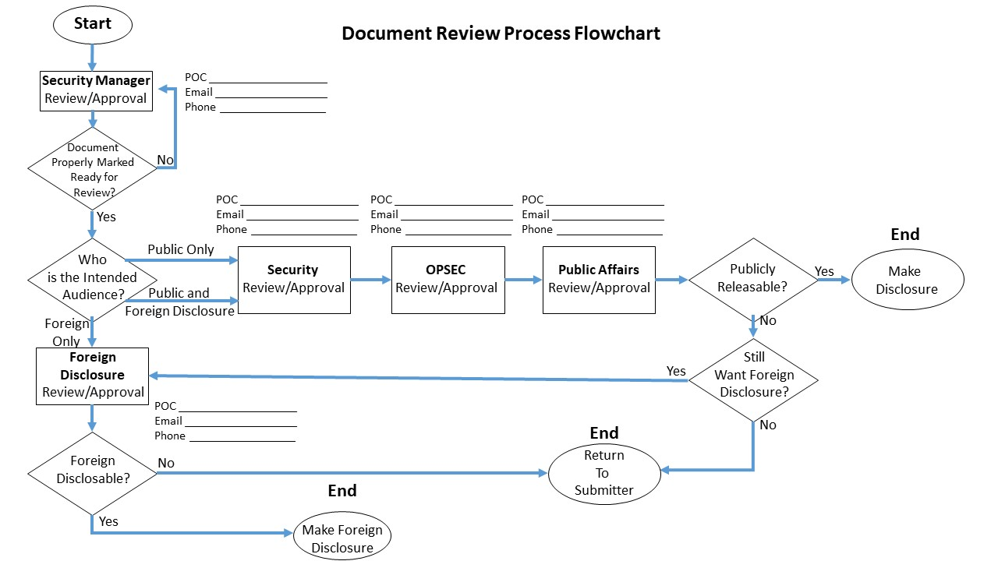

Figure 2-1. Document review process flowchart

d. Information to Avoid:

(1) The use of NOFORN information will preclude documents from release to Partner Nations. If you believe your source document is improperly marked NOFORN, contact your Security Manager or supporting FDO for assistance.

(2) Foreign government information (FGI). When FGI is used, it must be segregated into a separate paragraph for portion marking purposes, see paragraph 2-5 below.

(3) Information that is highly critical of foreign governments or foreign government officials.

(4) Statements of U.S. intent to defend or not defend, or attack or not attack, particularly in identifiable regions in foreign countries.

(5) Contingency plans that involve other countries.

(6) Information contained in the Commander’s critical information list (CIL).

(7) Personally identifiable information or Privacy Act Protected information.

(8) Draft or pre-decisional information or information containing any other handling caveat or marking that would limit distribution.

Table 2-1.   
FD guidance for TRADOC COs

|  |  |  |  |
| --- | --- | --- | --- |
| FD Guidance for TRADOC COs | | | |
| Information1 | Recipients | FDO Involvement | Disclosed by |
| Caveated or Uncaveated CMI | Other than FVEY | FDO approval required in accordance with NDP-1 | FDO |
| Documentary Disclosure of Uncaveated CMI | FVEY | FDO approval required in accordance with NDP-1 | FDO |
| Oral/Visual Disclosure of Uncaveated CMI | FVEY | FDO approval not required under certain circumstances2 | CO2 |
| CUI (FOUO) | FVEY NATO Countries All TRADOC FLOs | No FDO approval required | CO2 |
| Unclassified | FVEY NATO Countries All TRADOC FLOs | No FDO approval required | CO2 |
| 1. Does not include system information under the authority of a system Program Manager.  2. After completing mandatory one-time FD training on SIPRNET or from supporting FDO. | | | |

Table 2-2.   
FD guidance for TRADOC COs for exercises

|  |  |  |  |
| --- | --- | --- | --- |
| FD Guidance for TRADOC Exercises and Events | | | |
| Information1 | Recipients | FDO Involvement | Disclosed by |
| Caveated or Uncaveated CMI | Other than FVEY | FDO approval required in accordance with NDP-1 or EXORD Annex T (Foreign Disclosure) | FDO |
| Documentary Disclosure of Uncaveated CMI | FVEY | FDO approval required in accordance with NDP-1 or EXORD Annex T (Foreign Disclosure) | FDO |
| Oral/Visual Disclosure of Uncaveated CMI | FVEY | FDO approval not required in certain circumstance2 (See EXORD Annex T, Foreign Disclosure) | Exercise FDO2 |
| CUI (FOUO) | FVEY NATO Countries All TRADOC FLOs | No FDO approval required (See EXORD Annex T, Foreign Disclosure) | Exercise FDO2 |
| Unclassified | FVEY NATO Countries All TRADOC FLOs | No FDO approval required (See EXORD Annex T, Foreign Disclosure) | Exercise FDO2 |
| 1. Does not include system information under the authority of a system Program Manager.  2. After completing mandatory one-time FD training on SIPRNET or from supporting FDO. | | | |

## 2-4. Sharing information

Prior to sharing information, ensure the foreign government representative has a need to know, has the necessary clearance, and has a means to control/transmit/store the information in accordance with U.S. security standards before giving them custody of the material.

## 

## 2-5. Foreign government information (FGI)

FGI is information provided by another nation to the U.S. Government. The providing nation may have provided this information in confidence and may have restrictions on its further dissemination by the U.S. These possible restrictions must be determined, and permission must be received from the providing nation, before the information may be shared with other nations. Consult your supporting FDO when dealing with FGI.

## 2-6. Document marking

Documents approved for foreign disclosure must be banner and portion marked in accordance with AR 380-5 and DODM 5200.01.

a. Authorized for release to (REL TO)

(1) In accordance with DoDM 5200.01-V2, Change 3 (14 May 19) Within the DoD, the AUTHORIZED FOR RELEASE TO or REL TO control marking is authorized for use on all classified military or Defense CUI information that has been determined by an authorized disclosure official, in accordance with established foreign disclosure policies, to be releasable, or that has been released through established foreign disclosure procedures and channels, to the foreign country and/or international organization indicated.

(2) Foreign release or disclosure of the material, in any form, to the nations specified in

the REL TO marking is authorized without originator or FDO approval. Disclosure to nations not

specified in the REL TO marking is authorized only after obtaining permission from an FDO or the information originator.

(3) REL TO shall be used with TOP SECRET, SECRET, CONFIDENTIAL, or CUI.

(4) The format for REL TO banner and portion markings is [classification]//REL TO

[country codes]. Trigraph country codes shall be listed first (USA first, followed by other

countries in alphabetical order), followed by coalition or international organization tetragraph

codes in alphabetical order. Each code shall be separated from the next by a comma and space. See table 2-3 for examples of banner lines and portion markings.

(5) “USA” attached to “REL TO” means that the information is U.S.-originated and may

be released to U.S. citizens who meet the standards for access to classified information and the

restrictions imposed by any other caveats and who have a need to know. “REL TO USA”

without any other countries listed is not an approved marking.

(6) The portion marking “REL” may be used when the countries to which the portion marked information is releasable are the same as the countries listed in the REL TO in the banner

line. If countries are different, the portion marking must list all countries that are applicable.

(7) REL TO shall not be used with NOFORN in the banner line. When a document

contains both NOFORN and REL TO portions, use NOFORN in the banner line.

(8) REL TO should be used in the banner line only when the entire document is releasable to the countries listed. Otherwise, information not authorized for release may be inadvertently released. Users should additionally note that there is differing guidance between the DoD and the IC on the overall classification of a classified document containing both REL TO information and information without either REL TO, [Releasable by Information Disclosure Official (RELIDO)](https://fas.org/irp/offdocs/dcid8-memo.html) or NOFORN markings (hereinafter referred to as “uncaveated information”)

and on the treatment of documents where there is no common country listed throughout the

REL TO portions.

(a) Within the DoD, except for national intelligence information under the control of the Defense Intelligence Components, if a document contains portions with REL TO markings and portions with uncaveated information, the banner line shall contain only the U.S. classification (e.g., SECRET). Additionally, for documents containing REL TO portions, if the document is not fully releasable to at least one country other than USA (i.e., there is no common country listed throughout the document’s portions), the banner line shall reflect, in addition to any other required caveats, simply the U.S. classification (i.e., the banner line shall not contain the REL TO marking). This marking standard shall be applied by the Defense Intelligence Components when the information is military intelligence.

(b) Intelligence Community Directive 710, “Classification Management and Control Markings System,” June 21, 2013, requires intelligence under the purview of the DNI to be explicitly marked for foreign release. A combination of REL TO and uncaveated national intelligence information (i.e., information under the purview of the DNI) is to be marked as NOFORN in the banner line (e.g., SECRET//NOFORN). Likewise, where there is no common country listed in the REL TO portions, NOFORN is to be applied in the banner line. As NOFORN may be used only on intelligence information, this IC practice is not permitted for DoD organizations that are not elements of the IC.

Table 2-3.   
Examples of Banner Line and Portion Markings

|  |  |
| --- | --- |
| Banner Line | Portion Marking |
| CONFIDENTIAL//REL TO USA, FRA, AUS | (C//REL TO USA, FRA, AUS) |
| SECRET//REL TO USA, FVEY | (S//REL)1 |
| UNCLASSIFIED//FOUO/REL TO USA, FVEY | (U//FOUO/REL)1 |
| 1 When the portion marking releasability matches the Banner marking exactly, it is permissible to only put ((Classification abbreviation)/REL) to save space. | |

b. Distribution statements contained in AR 380-5 such as distribution statements B-F that begin with “Distribution authorized to U.S. Government…” DO NOT impact our ability to share this information with partner nations (see DoDD 5230.25, Withholding of Unclassified Technical Data from Public Disclosure). These distribution restriction statements may not be modified to inform foreign disclosure. When in doubt, consult your supporting FDO.

c. U.S. ONLY. A U.S. ONLY marking indicates no foreign requests for this publication will be entertained at any time. The use of this marking requires careful consideration on the part of the proponent.

## 2-7. Additional marking guidance

For additional marking guidance, see AR 380-5 and DODM 5200.01, Vol 1-4.

## 2-8. Contact Officer (CO) release authority

Upon completion of the mandatory one-time Foreign Disclosure training, COs will be authorized to release information in accordance with tables 2-1 and 2-2.

## 2-9. FD assistance

If you require further assistance, contact your supporting FDO.

# Chapter 3

# The Foreign Disclosure Management System (FDMS)

## 3-1. FDMS purpose

FDMS is a user friendly SharePoint portal designed for requesters to submit unclassified products for a disclosure review with the intention of sharing this information with partner nations or international organizations. FDMS stores all submissions for future retrieval. FDMS is searchable by FDOs. The submitter only sees products he or she submitted; however, once a release determination has been made by the FDO, the submitter receives an email notification of the approval which contains a link to the determination. The FDMS system on Non-classified Internet Protocol Router Network (NIPRNET) is approved for the submission of unclassified information only. Although FDMS was created for TRADOC and TRADOC personnel use it, it can be accessed and used by any CAC card holder.

## 3-2. FDMS location

a. The FDMS website is <https://oeenterprise.army.mil/fdms/SitePages/Home.aspx>. First time users must request an account which takes about 1 minute to complete.

b. Create an account by selecting the Account Request Hyperlink underneath CAC Login pop up. Requestors are asked several questions and then given immediate access to FDMS.

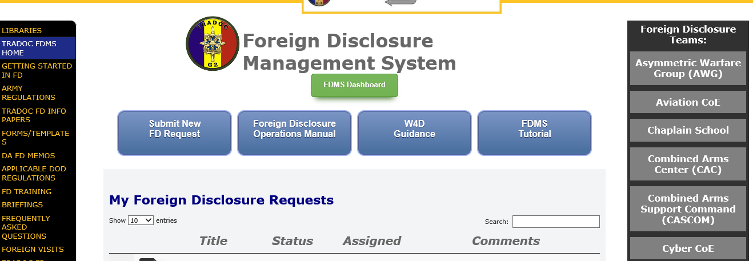

Figure 3-1. FDMS Main page

**3-3. FDMS functions**

a. Upon account creation, users are able to access these useful features on the FDMS Home Page.

(1) These are the Buttons across the center of the page:

(a) Submit New FD Request

(b) FD Operations Manual

(c) W4D Guidance

(d) FDMS Tutorial

(2) Left Column tabs:

(a) ARMY REGULATIONS (Army Publishing Directorate)

(b) DA FD MEMOS

(c) APPLICABLE DOD REGULATIONS

(d) FOREIGN VISITS

## 3-4. Foreign disclosure functional points to consider

Before creating a submission, please consider the following points:

* What is the benefit to the U.S.?
* What are the security risks associated with this disclosure?
* How will the product be shared (oral/visual/documentary)?
* Who is the intended audience?
* What is the venue for the disclosure and is there an expectation that the hosting organization will video tape/broadcast/post the information?
* Who is the proponent for the product?
* Has the product already been approved for disclosure to the proposed audience? If yes, has anything been changed?
* Is the information deemed to already be in the public domain? For example, was the information placed on a public facing website by the authorized proponent?

## 3-5. Submitting a disclosure request in FMDS

Use the following process to submit a disclosure request:

(1) Select the appropriate TRADOC Foreign Disclosure Team from the right column (i.e. proponent for the information) from the drop down menu. The submission will be sent to that FDMS site. If uncertain of the proponent of the information, please select TRADOC HQ for an assessment and staffing.

(2) The submission request form will then pop up. Fill out the form. Be as specific as possible when filling out the form and particularly when creating the title. A distinctive and informative title facilitates identification and retrieval, if needed, later.

(3) Resource documents are materials that direct or support the exchange/release or were used to create the product under review. An example of a resource document includes specific guidance memos; specific doctrine/regulations/pamphlets from which information was drawn; specific books, magazines, or other written media; International agreements or memorandums of understanding/agreement supporting or requiring the disclosure. Upon submission, FDMS will generate an email notifying the Foreign Disclosure staff of the new request.

(4) The responsible foreign Disclosure Office will assign the review internally. FDMS will generate an automatic email informing the submitter that the request is in progress and identify the assigned FDO.

(5) Once the review is completed, FDMS will generate an email notifying the submitter of the approval which will contain a link to the submission.

(6) If modifications or additional information is needed, the submitter will receive an e-mail with a link to the FDMS homepage with associated FDO comments and/or guidance.

(7) You can then use the edit item icon on the left side of the entry to reopen and edit the item.



Figure 3-2. Edit icon example

(8) Once the recommended changes have been made, attach the updated file on the original request form and click the save button. The reviewing FDO will be notified of the resubmission by the FDMS system.

(9) After the FDO has completed the review, FDMS will generate an email notifying the submitter of the approval which will contain a link to the determination.

## 3-6. FDMS libraries and references

With FDMS you will have access to following libraries:

a. Getting started in FD: This library has the initial steps required for any individual who has just been identified to be an FDO/FDR.

b. Army Regulations: This is a link to the Army Publishing Directorate to support easy access to approved Army publications.

c. TRADOC FD Information Papers: These are informative papers intended to provide FD personnel with an information resource which they can also re-label as their own and distribute locally when necessary.

d. Forms/templates: These include examples of FDO appointment orders, request forms for the Foreign Visit System, and a DD Form 2875 template for the CO to complete to request NIPRNET access for extended foreign visitors.

e. DA FD memos: This library contains several memos or other guidance provided by DA G-2, Foreign Disclosure.

f. Applicable DOD regulations: This library contains a link to the Executive Services Directorate page which is the repository for DOD issuances and forms.

g. FD training: This library contains several products created by the HQ, TRADOC FD Office to help inform and train FDOs and FDRs.

h. Briefings: This contains additional products from HQ, TRADOC Foreign Disclosure to help inform and assist FDOs/FDRs.

i. Frequently asked questions: All libraries are subject to change. This library houses common questions posed to the foreign disclosure Office and, when appropriate, new questions and answers will be posted.

j. Foreign visits: This library contains background information.

k. TRADOC FD contact list: This is a list of all TRADOC FDOs and selected FDRs.

l. Quarterly conferences: TRADOC FD hosts a quarterly information event on the Defense Collaboration Services system. These events are intended to share information on the latest changes affecting FDOs, FDRs, and COs. This portal contains the historical repository of slides and associated reference materials from these events.

m. FD Calendar: this item includes dates and events of interest to the TRADOC FD community.

# Chapter 4

# The Foreign Training Request Dashboard (FTRD)

## 4-1. FTRD purpose

FTRD is a portal-based tracking and tasking system. It lists training options available on the Military Articles and Services List that foreign countries can or have requested. The purpose of FTRD is to request and retain a FD review and history of courses on Military Articles and Services List to eliminate redundant disclosure reviews of the same course material and to incorporate international military students into U.S. training as quickly as possible and for as many training modules as appropriate. FTRD is primarily a tool for the Security Assistance Field Training Activity (SATFA) to submit courses for disclosure review. The courses are tasked to the appropriate TRADOC Center of Excellence responsible for preparing and presenting the training and may also be concurrently tasked to the program executive office (PEO) FDO that has oversight of the equipment. Both proponents must work together to provide a legal disclosure determination. Requests tasked via FTRD are considered to be formal taskings and need to be answered within the suspense window. Requests for extension may be submitted via email to the HQ TRADOC Foreign Disclosure Office when extenuating circumstances exist.

## 4-2. FTRD location

a. The FTRD webpage is <https://oeenterprise.army.mil/fdms/SitePages/FTRDashboard.aspx>. First time users must request an account.

b. Create an account by selecting the Account Request Hyperlink underneath CAC Login pop up. Requestors are asked several questions and then given immediate access to FTRD.

## 4-3. FTRD overview

a. The FTRD portal consists of a main display, new request form, Center and School pages, and search function. When SATFA creates a new training request, they staff the request directly to the school house based on the Army Training Requirements and Resource System school code. The request then populates to the center or school page and a notification email is generated by the system. Currently, the school has to go outside of FTRD to coordinate with the PEO or program manager; however, PEO pages will eventually be incorporated into FTRD and into the workflow. The center or school then generally has 30 days to conduct coordination and a disclosure review of the associated training materials.

b. Typically, a disclosure review will evaluate the publications referenced and their disclosure status, the military equipment as well as information on what has or has not been sold to the requesting foreign country, and an assessment of which lessons are appropriate for the requesting country to attend based on PEO and foreign military sales data. The deliverable into FTRD is the total number of restricted hours. It is incumbent upon the school house to identify to their instructors what information/lessons/modules are restricted and cannot be taught to some or all international military students.

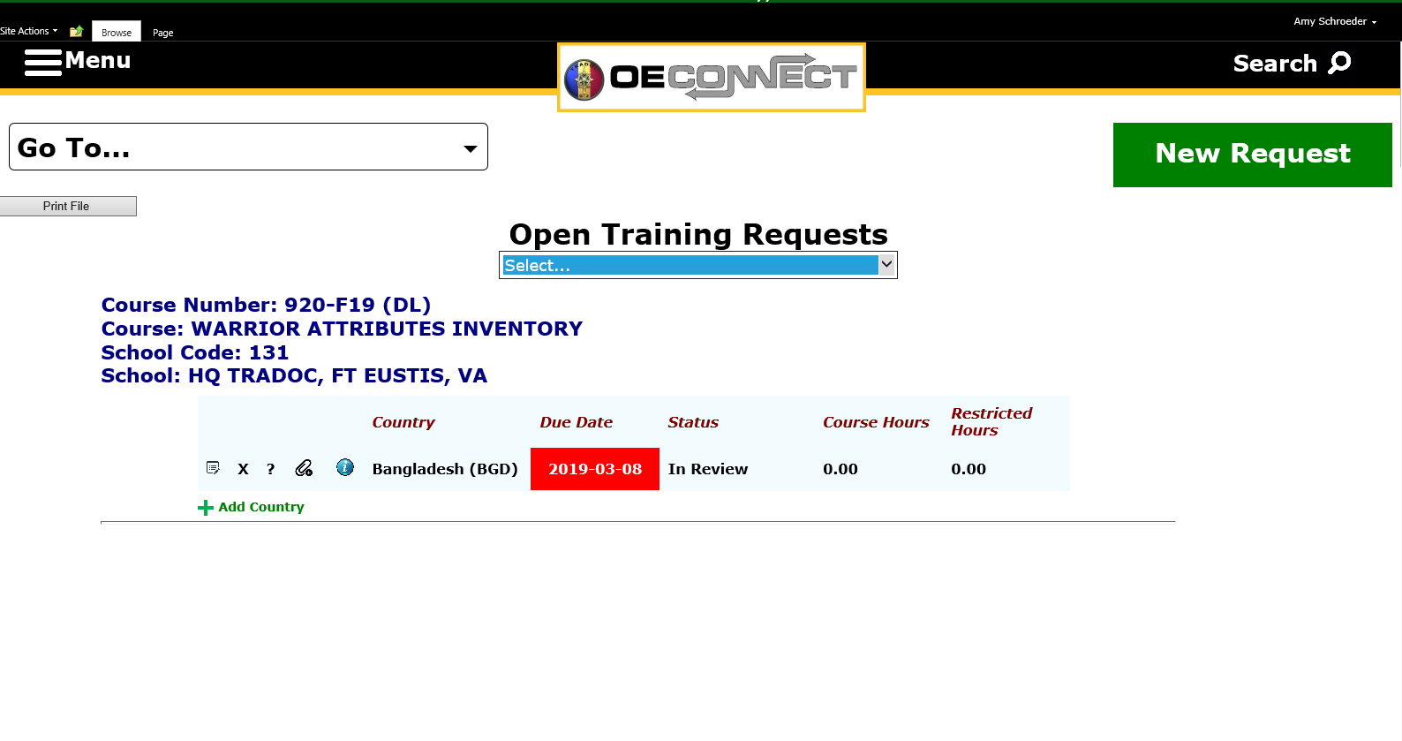

Figure 4-1. FTRD Main page

# 

# Appendix A

# References

**Section I**

**Required Publications**

ARs, DA Pams, ADPs, ADRPs, Army Techniques Publications (ATP), FMs, and DA Forms are available at [https://armypubs.army.mil](https://armypubs.army.mil/). TRADOC publications and forms are available at <https://adminpubs.tradoc.army.mil>.

Army Regulation 380-10

Foreign Disclosure and Contact with Foreign Representatives

DoD Manual 5200.01

DoD Information Security Program, Volume 1 – 4

**Section II**

**Related publications**

Army Regulation 12–15

Joint Security Cooperation Education and Training

Army Regulation 550–51

International Agreements

Army Regulation 614–10

Army Military Personnel Exchange Program with Military Services of Other Nations

DoD Instruction 2040.02

International Transfers of Technology, Articles, and Services

DoD 5105.38–M

Security Assistance Management Manual (SAMM)

DoD Instruction 5200.01

DoD Information Security Program and Protection of Sensitive Compartmented Information

DoD Directive 5230.11

Disclosure of Classified Military Information to Foreign Governments and International Organizations, 16 June 1992

DoD Directive 5230.20

Visits and Assignment of Foreign Nationals, 22 June 2005

DoD Directive 5230.24

Distribution Statements on Technical Documents, 23 August 2012; change 28 April 2016

DoD Directive 5230.25

Withholding of Unclassified Technical Data from Public Disclosure, 23 August 2012; change 28 April 2016

DoD Instruction 5200.39

Critical Program Information (CPI) Protection within the Department of Defense

DoD Directive 5530.3

International Agreements

DoD Directive 5400.07

DoD Freedom of Information Act (FOIA) Program EAR, Export Administration Regulations (15 CFR 768 et seq.) (Available at <http://www.access.gpo.gov/bis/ear/ear_data.html>.)

AECA, Arms Export Control Act (22 USC 2778–2780)

(Available at <http://www.pmddtc.state.gov/regulations_laws/aeca.html>.)

Executive Order 13526

Classified National Security Information

(Available at <http://www.archives.gov/federal-register/index.html>.)

NSDM 119

Disclosure of Classified United States Military Information to Foreign Governments and International Organizations, 20 July 1971

(Available at <https://www.nixonlibrary.gov/virtuallibrary/documents/nsdm/nsdm_119.pdf>)

**Section III**

**Prescribed Forms**

This section contains no entries.

**Section IV**

**Referenced Forms**

DD Form 2875

System Authorization Access Request

# 

# Appendix B

# Records management requirements

Detailed information for all related record numbers, forms, and reports associated with AR 25–30 are located in RRS–A at <https://www.arims.army.mil>.

Completed DD Form 2875s requesting access for foreign visitors will be maintained by the originating office under ARIMS RRS-A record number 25h, record title System access records (requiring special accountability for access), record description these records are created as part of the user identification and authorization process to gain access to systems. Records are used to monitor inappropriate systems access by users. Includes records such as: user profiles, log-in files, password files, audit trail files and extracts, system usage files, cost-back files used to assess charges for system use. These are user identification records associated with systems which are highly sensitive and potentially vulnerable. Excludes records relating to electronic signatures and does not include monitoring for agency mission activities such as law enforcement. Disposition of the DD Form 2875s requires the record be retained for 6 years, even after password is altered or user account terminated. Destroy 6 years after the after event takes place. General Records Schedule 3.2, item 31 (DAA-GRS-2013-0006-0004).

# 

# Glossary

**Section I**

**Abbreviations and terms**

ACOM Army Command

AKO Army Knowledge Online

ASCC Army Service Component Command

CAC common access card

CIL critical information list

CMI classified military Information

CO contact officer

CUI controlled unclassified information

DISAM The Defense Institute of Security Assistance Management

DRU direct reporting unit

FD foreign disclosure

FDMS Foreign Disclosure Management System

FDO foreign disclosure office or officer

FDR foreign disclosure representative

FGI foreign government information

FLO foreign liaison officer

FOUO for official use only

FTRD Foreign Training Request Dashboard

FVEY Five Eyes

FVS Foreign Visit System

MPEP Military Personnel Exchange Program

NATO North Atlantic Treaty Organization

NIPRNET Non-classified Internet Protocol Router Network

NOFORN Not Releasable to Foreign Nationals

PAO public affairs officer

PEO program executive officer

REL TO authorized for release to

SATFA Security Assistance Training Field Activity

SENTRY DA G-2 Foreign Disclosure Repository of Record

SIPRNET Secret Internet Protocol Router Network

STEPP Security Training, Education, and Professionalization Portal

TKE TRADOC: Knowledge Environment

TRIGRAPH A three-letter marking representing a specific country

W4D TRADOC’s Write For Disclosure Program

**Section II**

**Terms**

**Five Eyes (FVEY)**

Common tetragraph referring to the five major English-speaking nations of Australia, Canada, New Zealand, United Kingdom, and United States.

**REL TO**

Handling/marking caveat indicating that a product can be released to a specific country or organization

**Section III**

**Special Terms**

This section contains no information