**Department of the Army *TRADOC Pamphlet 385-1**

**Headquarters, United States Army**

**Training and Doctrine Command**

**Fort Eustis, Virginia 23604-5700**

**15 February 2019**

**Safety**

**THE TRADOC MODEL SAFETY PROGRAM AND SELF-ASSESSMENT GUIDE**

FOR THE COMMANDER:

OFFICIAL: THEODORE D. MARTIN

Lieutenant General, U.S. Army

Deputy Commanding General/

Chief of Staff



WILLIAM T. LASHER

Deputy Chief of Staff, G-6

**History.** This publication is an expedite revision. The portions affected by this revision are listed in the summary of change.

**Summary.** This pamphlet serves as the basis for doctrine development and organizing, implementing, resourcing, and assessing safety and occupational programs within the U.S. Army Training and Doctrine Command (TRADOC).

**Applicability.** This pamphlet applies to TRADOC centers of excellence and schools, subordinate organizations, and contractors operating within TRADOC operational environments.

**Proponent and exception authority.** The proponent for this regulation is the Deputy Commanding General/Chief of Staff. The proponent has the authority to approve exceptions or waivers to this regulation that are consistent with controlling law and regulations. The proponent may delegate this authority in writing, to a division chief with the proponent agency or its direct reporting unit or field-operating agency, in the grade of colonel or the civilian equivalent. To request an exception or waiver to this regulation, send a written request to [usarmy.jble.tradoc.mbx.hq-tradoc-g-1-4-safety-office@mail.mil](mailto:usarmy.jble.tradoc.mbx.hq-tradoc-g-1-4-safety-office@mail.mil) prior to initiating deviation. Identify specific conflicts with regulation and provide justification for the request and alternate measures. Include a thorough assessment of the associated risk with the request.

*This regulation supersedes TRADOC Pamphlet 385-1, dated 6 January 2012.

**Suggested improvements.** Users are invited to send comments and suggested improvements on Department of the Army (DA) Form 2028 (Recommended Changes to Publications and Blank Forms) directly to Commander, TRADOC (ATCS-S), 950 Jefferson Avenue, Fort Eustis, VA 23604-5700 or [usarmy.jble.tradoc.mbx.hq-tradoc-g-1-4-safety-office@mail.mil](mailto:monr.atcs-s@conus.army.mil).

**Distribution.** This pamphlet is available in electronic media only at the TRADOC Administrative Publications website <http://adminpubs.tradoc.army.mil/>).

**Summary of Change**

TRADOC Pamphlet 385-1

The TRADOC Model Safety Program and Self-assessment Guide

This expedite revision, dated 15 February 2019-

o Updates procedures and standards to be in compliance with Army Regulation 385-10 (throughout).

o Updates procedures and standards to be in compliance with 29 Code of Federal Regulation 1910 (throughout).

o Updates procedures and standards to be in compliance with 29 Code of Federal Regulation 1926 (throughout).

o Updates procedures and standards to be in compliance with United States Army Training and Doctrine Command Regulation 385-2 (throughout).

o Updates procedures and standards to comply with leader development with Army Regulation 350-1 (throughout).

This revision, dated – 6 January 2012

o Updates procedures and standards to be in compliance with Army Regulation 385-10.

o Updates procedures and standards to be in compliance with 29 Code of Federal Regulation 1910.

o Updates procedures and standards to be in compliance with 29 Code of Federal Regulation 1926.

**Contents**

**Page**

Chapter 1 Introduction 7

1-1. Purpose 7

1-2. References 7

1-3. Explanation of abbreviations and terms 7

Chapter 2 Safety Program Overview 7

2-1. Standard 7

2-2. Safety program success 8

Chapter 3 Safety Program Elements 8

3-1. Risk management 8

3-2. Inspections, assessments, and evaluations 9

3-3. Hazard abatement 10

3-4. Accident reporting, investigation, and analysis 10

3-5. Education, training, and safety awareness 10

3-6. Branch safety/risk management integration 11

3-7. Additional/Collateral duty safety program 11

3-8. Safety and Occupational Health Advisory Council (SOHAC) 11

3-9. Emergency action plans 11

3-10. Initial military training (IMT) 12

3-11. Motor vehicle accident prevention 12

Chapter 4 Self-Assessment Guide 12

4-1. Implementation and use 12

4-2. Standards/documentation 12

4-3. Application 13

Appendix A References 13

Appendix B Self-Assessment Guide 18

Appendix C Conditioning/Obstacle Course Criteria 90

Appendix D 132Rappel Tower Site Inspection Criteria 132

Appendix E Quantitative Measures 135

Glossary 137

**Figure List**

Figure C-1. IMT conditioning/endurance course evaluator information checklist 90

Figure C-2. Obstacles for jumping 93

Figure C-3. Obstacles for dodging 93

Figure C-4. Obstacles for vertical climbing and surmounting 94

Figure C-5. Obstacles for horizontal traversing 94

Figure C-6. Obstacles for crawling 95

Figure C-7. Obstacle for vaulting 95

Figure C-8. Obstacle for balancing 95

Figure C-9. IMT obstacle course evaluator information 96

Figure C-10. The tough one 102

Figure C-11. Inverted rope descent/the slide for life 105

Figure C-12. Confidence climb 107

Figure C-13. Skyscraper 109

Figure C-14. Belly robber 110

Figure C-15. The Tarzan 111

Figure C-16. Low belly over 112

Figure C-17. The dirty name 114

Figure C-18. The tough nut 114

Figure C-19. Belly crawl 115

Figure C-20. Inclining wall 116

Figure C-21. Swing, stop, and jump 117

Figure C-22. Six vaults 118

Figure C-23. Easy balancer 119

Figure C-24. Low wire 120

Figure C-25. Belly buster 121

Figure C-26. Hip-hip 122

Figure C-27. Reverse climb 123

Figure C-28. The weaver 124

Figure C-29. Balancing logs 125

Figure C-30. Island hoppers 126

Figure C-31 Obstacle Information 131

Figure D-1. Rappel tower site inspection information 132

**Table List**

Table B-1. Program management 19

Table B-2. Strategic Planning, Army Safety Program Structure, Safety Program Evaluation, Councils, and Committees 26

Table B-3. Accident investigation, reporting, and analysis 27

Table B-4. Contracting Safety 30

Table B-5. Range, explosive, and ammunition safety 31

Table B-5. Range, explosive, and ammunition safety 32

Table B-6. Public, Family, Child, and Youth, Off Duty Recreation, and Seasonal Safety 36

Table B-7. Radiation safety 37

Table B-8. Safety awards and promotions 42

Table B-9. Systems safety management 43

Table B-10. Education and training 47

Table B-11. Branch and proponency 50

Table B-12. Aviation safety 54

Table B-13. Motor vehicle accident prevention 67

Table B-14. IMT/military training, operations and tactical safety 71

Table B-15. Workplace safety, industrial operations, inspections, hazards analysis, and countermeasures development 78

Table B-16. Electrical Safety 81

Table B-17. Identification of Radiation, Inert Munitions and Ammunition Components, Museums/Displays 88

Table C-1. General administrative inspection criteria checklist 91

Table C-2. General inspection criteria checklist 91

Table C-3. IMT obstacle course administrative general inspection criteria 97

Table C-4. IMT obstacle course general inspection criteria 98

Table C-5. The tough one checklist 101

Table C-6. Inverted rope descent/the slide for life 103

Table C-7. Confidence climb checklist 106

Table C-8. Skyscraper checklist 108

Table C-9. Belly Robber checklist 110

Table C-10. The Tarzan checklist 111

Table C-11. Low belly over checklist 112

Table C-12. The dirty name checklist 113

Table C-13. The tough nut checklist 114

Table C-14. Belly crawl checklist 115

Table C-15. Inclining wall checklist 116

Table C-16. Swing, stop, and jump checklist 117

Table C-17. Six vaults checklist 118

Table C-18. Easy balancer checklist 119

Table C-19. Low wire checklist 120

Table C-20. The belly buster checklist 121

Table C-21. Hip-hip checklist 122

Table C-22. Reverse climb checklist 123

Table C-23. The weaver checklist 124

Table C-24. Balancing logs checklist 125

Table C-25. Island hoppers checklist 126

Table C-26. Fitness tower checklist 127

Table D-1. Rappel tower inspection criteria checklist 133

Table E-1. Quantitative Measures for integrating the Army Safety Program 135

**This page intentionally left blank**

# Chapter 1

# Introduction

## 1-1. Purpose

a. This publication provides commanders and safety managers a model for a safety and occupational health program, defines standards, and addresses those basic safety program elements necessary for implementation of effective safety and accident prevention programs as outlined in Army Regulation (AR) 385-10 and U.S. Army Training and Doctrine Command (TRADOC) Regulation 385-2. Commanders may tailor this publication to meet their needs and local conditions to accomplish the TRADOC mission.

b. The self-assessment guide provides commanders and safety managers a standardized method to assess the scope and effectiveness of a comprehensive safety and occupational health program. The self-assessment guide consists of several checklists that provide a systematic method to assess safety program implementation. Additionally, because no checklist is all inclusive, safety professionals must utilize applicable safety laws, statutes, codes, and regulations to assist the command and leaders in implementing an effective and compliant safety program.

## 1-2. References

Required and related publications are listed in appendix A.

## 1-3. Explanation of abbreviations and terms

Abbreviations and special terms used in this pamphlet are explained in the glossary.

# Chapter 2

# Safety Program Overview

## 2-1. Standard

The TRADOC Model Safety Program is based on the legal and regulatory requirements of the Occupational Safety and Health Act of 1970, Department of Defense (DOD) Instruction ([DODI) 6055.1](http://www.dtic.mil/whs/directives/corres/html/60551.htm), AR 385-10, applicable laws, statues, and codes as implemented by TRADOC Regulation 385-2. Public law, executive orders, DODIs, and Army regulations direct actions to furnish employees with places and conditions of employment that are free from recognized hazards causing, or likely to cause, death or serious physical harm; and apply risk management strategies to eliminate accidents, death, and occupational illnesses. Commanders at all levels will provide employees with places and conditions of employment that are free from recognized hazards likely to cause death or serious physical harm, and establish procedures to ensure employees are not subjected to restraint, interference, coercion, discrimination, or reprisal for filing a report of an unsafe or unhealthful working condition. An effective program is:

a. Comprehensive in application, built around and addresses all core functions and enduring missions of the Army and TRADOC.

b. Adequately resourced, staffed, and funded to support the Army and TRADOC mission.

c. Ensure leaders, supervisors, managers, and individuals are empowered with the requisite training, authority, information, and resources to execute their duties safely.

d. Universal in scope, providing effective support to current operations, yet remaining sufficiently flexible to support future operations. Not a static program, the safety program is tailored to the existing operational environment and updated as required by accident experience and lessons learned.

## 2-2. Safety program success

The ability to implement, manage, and measure an effective safety program, and the ultimate success of the model program depend on three enduring threads of continuity:

a. Ownership. Personal involvement of commanders, leaders, and supervisors at each level of command/organization sets the focus and direction of safety program and accident prevention efforts. It empowers Soldiers and workers with the authority to implement the safety mission.

b. Oversight. A qualified safety manager (as defined in AR 385-10 and the Office of Personnel Management (OPM) standards), with direct and unimpeded access to the commander, is essential. This ensures commanders maintain a situational awareness of the effectiveness of risk management implementation and safety program effectiveness, and reinforces the credibility of the safety manager in dealing with other staff elements.

c. Standards. The safety program document sets the standard for each individual safety program and sub-elements of that program. A written safety program document clearly defines the commander’s intent, fixes responsibility and accountability, and formally defines requirements for acceptable performance.

# Chapter 3

# Safety Program Elements

## 3-1. Risk management

a. Risk management is the Army’s primary decision making process for identifying hazards and controlling risks across the full spectrum of Army missions, functions, operations, and activities. A risk management based safety program puts into place a systematic, disciplined, management process that focuses on priorities so that the mission is accomplished without unnecessary risk. Risk management:

(1) Fosters initiative and further freedom of action by defining risk parameters within which an operation must remain, rather than imposing unnecessary restrictions or limitations on leaders.

(2) Creates an operational climate that promotes mission accomplishment with minimal risk.

(3) Is dependent upon two critical elements for effectiveness:

(a) First, leaders must understand the decision making process of risk management.

(b) Second, there must be a system in place to effectively deal with changes in mission or activity risk levels due to changes in circumstances or conditions.

b. Commanders/commandants must ensure risk management is institutionalized in all school training products, and courses. Service school graduates must be trained and proficient in assessing and managing risk in both training and operational environments. A risk management structure and control system must also be in place to ensure on the ground leadership presence at the appropriate level for all high and medium risk training. Leaders must also clearly define risk decision authority to include the role/responsibility in the approval process for executing high and medium risk training, ensure the conduct of initial and periodic on the ground review or “lane proofing” of all recurring training activities, provide clear guidance on where risk decision authority lies, and where possible, get risk decisions ahead of time where risk is known and understood. Risk decision authority must be clearly understood and enacted. The primary tenets of effective risk management are that commanders accept no risk unless the potential benefit outweighs the potential loss and that risk decisions are made at the appropriate level. Appropriate risk decision authority (residual risk) in accordance with TRADOC Regulation 385-2 follows:

(1) Extremely high risk: Senior commander of general officer grade. General officer commandants/commanders can also approve extremely high-risk.

(2) High risk: Colonel or equivalent as designated by the senior commander of general officer grade.

(3) Medium risk: Lieutenant Colonel or equivalent and Command Sergeant Major Noncommissioned Officer (NCO) Academy commandants, as designated by the first O-6 (or equivalent) or above in the chain of command.

(4) Low risk: As designated by the first O-6 (or equivalent) or above in the chain of command.

c. Commanders should establish and publish a risk management standard that incorporates this guidance and designates risk decision authority consistent with TRADOC criteria. Risk decisions are based on the residual risk of an activity, after application of appropriate control measures. They are briefed one level up the chain of command from the decision maker.

## 3-2. Inspections, assessments, and evaluations

Safety assessments and evaluations are important tools in effectively identifying hazards and controlling risk and provide a safe and healthful workplace. Safety assessments may be the result of an unusual occurrence or an out of the ordinary planned activity. In all cases, inspections, assessments, and evaluations are oriented toward the identification of hazards or measuring the effectiveness of accident prevention efforts, not the effectiveness of the command or leadership. An aggressive safety and occupational health inspection program ensures that all workplaces are inspected on an annual basis. See paragraph 4-1b for implementation and use of inspections.

## 3-3. Hazard abatement

Law and regulation direct that hazards be eliminated on a “worst first” basis. To ensure that the worst hazards are corrected first, coordinate the listing of all safety and occupational related hazards with the appropriate safety office for integration into a single garrison hazards abatement log maintained by the garrison safety manager. Hazards may be identified by a variety of means, such as inspections, accidents, routine maintenance and repair operation, or requests (work orders/job orders, customer reports, etc.) for repair or replacement of material or facilities. To ensure all hazards are correctly assessed and included in the garrison hazard abatement log, ensure the safety manager reviews and validates all work orders, job orders, or requisitions that have a safety or occupational health connection. Once a violation or hazard is identified, the safety manager or a qualified safety professional must ensure it is risk assessed in terms of hazards severity and accident probability. This assessment is expressed in terms of a risk assessment code (RAC) which identifies the relative seriousness of the hazard. Prepare a garrison abatement plan for each RAC 1 or 2 hazard when the correction exceeds 30 days.

## 3-4. Accident reporting, investigation, and analysis

Accident investigations and careful analysis of accident information provides the safety manager with the means to identify potential sources of future accidents and to develop and implement countermeasures. Ensure the command accident prevention program also supports the Garrison Civilian Personnel Office’s effort to reduce injuries and occupational illnesses. In addition to the accident reports Department of the Army (DA) Pamphlet (DA Pam) 385-40 requires near-miss information is important in identifying hazards before they can result in serious damage or injury. Trained additional duty safety officers (ADSOs) or collateral duty safety officers (CDSOs), and first-line supervisors are the best sources for this information. Other important sources of accident information are military police blotter reports, hospital admission and discharge sheets, sick call slips, and estimated cost of damage reports from the General Services Administration and unit motor pools. When collected, organized, and analyzed, this information may yield valuable data on potential problems or hazards, education/training shortfalls, motivation or leadership issues, procedural or standard inadequacies, or other potential problem areas. These potential problems, hazards, or shortfalls may often go unnoticed or undetected, because individual units and organizations view them as isolated instances. A successful accident prevention program will be one in which accident data and statistics are used strictly for accident prevention purposes, not to attempt to document command or leadership effectiveness.

## 3-5. Education, training, and safety awareness

The prevention of accidents and the associated mission impact and loss of resources is the responsibility of every member of the Army team. Law and regulation require training for all Army personnel, Soldiers and Civilians, commensurate with their duties and responsibilities. The most effective accident prevention program recognizes this and sustains an extensive, ongoing program of safety training to educate, motivate, and raise safety awareness. Commanders, leaders, and supervisors at all levels, as well as individual Soldiers and Civilian employees, are important in the accident prevention process. The effectiveness of their contributions, however, depends on their knowledge and understanding of safety and risk management and their responsibility in the Army Safety Program.

## 3-6. Branch safety/risk management integration

Integration of safety and risk management into Army doctrine, organizations, training, materiel, leadership and education, personnel, and facilities is inherent in the worldwide branch safety mission. Unlike safety managers within other Army commands, TRADOC safety managers have worldwide branch safety mission responsibility. In addition to the safety and risk management integration mission, branch safety managers monitor the operations, training, equipment, and tactics, techniques, and procedures within their specific branch. For this reason, TRADOC standards dictate that the qualified command safety and occupational health manager is rated by, and reports directly to the senior commander, school commandant, or respective chief of staff.

## 3-7. Additional/Collateral duty safety program

The trained ADSO/CDSO is essential to the safety manager’s ability to reach all levels of command, gather accident prevention information, identify hazards, and meet legal and regulatory requirements. Additional/collateral duty safety personnel may conduct inspections of low risk workplaces, but only when they are trained to identify hazards and recommend appropriate abatement action. A good safety program provides training in addition to the online ADSO/CDSO course, so that trained safety professionals are free to devote their time and energy to dealing with the more serious safety issues that require extensive technical expertise. ADSO/CDSOs collect accident reports for their activities or units. They are the local commander’s safety representative and an important source of information at the grass root level in gauging the effectiveness of the commander’s safety program.

## 3-8. Safety and Occupational Health Advisory Council (SOHAC)

An active SOHAC, chaired by the commander/commandant/chief of staff, meeting at least semiannually, and composed of military and civilian management and operating personnel membership, is necessary for the effective interchange of safety and occupational health information. Participation of the commander/commandant/chief of staff demonstrates command support and sets the tone for the safety/accident prevention program. Command visibility and active participation in the safety council sends a powerful message to subordinate commanders and staff on the importance of safety.

## 3-9. Emergency action plans

Preplanned, coordinated, and regularly tested emergency action, disaster preparedness, and written pre-accident plans are proven methods to minimize loss of life and property damage due to natural or man-made disasters. Commanders/commandants should coordinate and integrate their needs into garrison emergency action, disaster preparedness, and pre-accident plans as appropriate to their mission. Safety managers should develop, coordinate, publish, and test pre-accident plans for both ground and aviation accidents and assist the garrison in development, coordination, and maintenance of emergency action and disaster preparedness plans.

## 3-10. Initial military training (IMT)

The safety and well-being of Soldiers during their IMT is critical to the success of the TRADOC training mission. Soldiers arriving at Army reception battalions come from many backgrounds and in different levels of physical condition. Similarly, cadets and newly-appointed officers also exhibit some of that diversity. Consequently, some may be at a greater risk of injury/illness. Safety directors with an IMT mission should develop and implement an aggressive accident prevention strategy to provide these Soldiers a training environment that facilitates their transition from civilian to military life.

## 3-11. Motor vehicle accident prevention

An enduring threat and a serious problem to TRADOC and the Army is the tragic loss of Soldiers and Civilian workers in vehicle accidents. Privately owned vehicle (POV) accidents continue as the single leading cause of accidental death for our Soldiers, Civilians, and their Family members. This needless loss of life demands actions. Commands with aggressive motor vehicle accident prevention strategies and programs enjoy greater success at reducing the incidence of motor vehicles and POV accidents than those commands that do not. All successful motor vehicle and POV accident prevention programs start with active command involvement. Other program elements common to an effective POV prevention programs include driver/rider training initiatives, a functioning POV task force, motorcycle mentorship, and the involvement of the first-line leaders. Leaders must make every effort to use other available tools to combat the rising incidence of vehicular accidents.

# Chapter 4

# Self-Assessment Guide

## 4-1. Implementation and use

a. Safety assessments and evaluations are important tools to effectively identify hazards and control risk. Orient inspections, assessments, and evaluations on identification of hazards or assessment of the effectiveness of accident prevention efforts, not the effectiveness of the command or leadership.

b. An aggressive safety and occupational health inspection program ensures that all workplaces are inspected on an annual basis. Facilities or operations involving special hazards are inspected more frequently. Qualified safety and occupational health professionals conduct inspections and provide written reports of violations to the head of the activity or the commander of the unit/organization inspected. The self-assessment guide and associated checklists in appendix B provide commanders and safety managers an effective tool to document the scope and effectiveness of their safety and accident prevention efforts.

## 4-2. Standards/documentation

Documentation of program elements serves as an indication of program effectiveness. Documentation such as local policies, regulations, or standard operating procedures (SOPs); however, do not in themselves ensure program implementation. Ensure documentation is relevant, current, and in accordance with the appropriate standards. Make sure users are familiar with their existence and content; and the standards are applied and enforced.

## 4-3. Application

The self-assessment guide (appendix B) and conditioning/obstacle course criteria (appendix C) consist of a series of checklists that provide a systematic, standardized means to evaluate/assess the compliance of program elements with directives, legal standards, and regulations. Each provides the user the appropriate reference for the requirement, as well as recommended documentation to assess implementation. The self-assessment guide is not all inclusive of every safety requirement required by public law, statute, and regulation. Safety office personnel will research applicable public law, statutes, and regulation that pertain to your command and situation to ensure compliance.

# Appendix A

# References

**Section I**

**Required Publications**

AR 25-400-2

The Army Records Information Management System (ARIMS)

AR 40-5

Preventive Medicine

AR 95-1

Flight Regulations

AR 350-1

Army Training and Leader Development

AR 385-10

The Army Safety Program

AR 385-63

Range Safety

AR 420-1

Army Facilities Management

AR 500-3

U.S. Army Continuity of Operations Program Policy and Planning

ATP 5-19

Risk Management

DA Pam 385-10

Army Safety Program

DA Pam 385-16

System Safety Management Guide

DA Pam 385-24

The Army Radiation Safety Program

DA Pam 385-30

Risk Management

DA Pam 385-40

Army Accident Investigation and Reporting

DA Pam 385-61

Toxic Chemical Agent Safety Standards

DA Pam 385-63

Range Safety

DA Pam 385-64

Ammunition and Explosives Safety Standards

DA Pam 385-65

Explosive and Chemical Site Plan Development and Submission

DA Pam 385-90

Army Aviation Accident Prevention

Department of Defense Directive 5000.1

The Defense Acquisition Team

Department of Defense Directive 6055.9E

Explosives Safety Management and DOD Explosives Safety Board

DODI 6055.1

DOD Safety and Occupational Health (SOH) Program

DODI 6055.04

DOD Traffic Safety Program

Field Manual (FM) 6-0

Commander and Staff Organization and Operations

FM 7-22

Army Physical Readiness Training

Technical Bulletin MED 530

Tri-Service Food Code

Title 29 Code of Federal Regulations (CFR) 1910

Occupational Safety and Health Standards

Title 29 CFR 1926

Safety and Health Regulations for Construction

Title 29 CFR 1960

Basic Program Elements for Federal Employees Occupational Safety and Health Administration

TRADOC Regulation 350-6

Enlisted Initial Entry Training Policies and Administration

TRADOC Regulation 350-16

Drill Sergeant and Advanced Individual Training Platoon Sergeant Programs

TRADOC Regulation 350-29

Prevention of Heat and Cold Casualties

TRADOC Regulation 350-70

Army Learning Policy and Systems

TRADOC Regulation 385-2

U.S. Army Training and Doctrine Command Safety and Occupational Health Program

"Operational and Training Facilities" Corps of Engineers Drawing Number DEF 028-13-95

National Fire Protection Association (NFPA) 72

National Fire Alarm and Signaling Code

**Section II**

**Related Publications**

AR 15-6

Procedures for Investigating Officers and Boards of Officers

AR 50-6

Chemical Surety

AR 70-1

Army Acquisition Policy

AR 75-1

Malfunctions Involving Ammunition and Explosives

AR 200-1

Environmental Protection and Enhancement

AR 215-1

Military Morale, Welfare, and Recreation Programs and Nonappropriated Fund Instrumentalities

AR 335-15

Management Information Control System

AR 600-8-22

Military Awards

AR 672-20

Incentive Awards

AR 690-950

Career Management

AR 700-141

Hazardous Materials Information Resource System

AR 870-20

Army Museums, Historical Artifacts, and Art

DODI 6050.05

DOD Hazard Communication (HAZCOM) Program

DODI 6055.06

DOD Fire and Emergency Services (F&ES) Program

DODI 6055.07

Mishap Notification, Investigation, Reporting and Recordkeeping

DODI 6055.08

Occupational Ionizing Radiation Protection Program

DODI 6055.11

Protecting Personnel from Electromagnetic Fields

DODI 6055.12

Hearing Conservation Program (HCP)

DODI 6055.15

DOD Laser Protection Program

Technical Bulletin MED 575

Recreational Water Facilities

TC 5-210

Military Float Bridging Equipment

TC 21-21

Water Survival Training

TC 21-24

Rappelling

TC 21-305

Training Program for Wheeled Vehicle Accident Avoidance

Title 29 CFR 1926.59

Hazard Communication

**Section III**

**Prescribed Form**

This section contains no entries.

**Section IV**

**Referenced Forms**

DD Form 2977

Deliberate Risk Assessment Worksheet

DA Form 1045

Army Ideas for Excellence Program (AIEP) Proposal

DA Form 2028

Recommended Changes to Publication and Blank Forms

DA Form 2609

Historical Property Catalog

DA Form 2696

Operational Hazard Reports

DA Form 4754

Violation Inventory Log

DA Form 4755

Employee Report of Alleged Unsafe or Unhealthful Working Conditions

DA Form 5752-R

Rope Log (Usage and History)

DA Form 7306

Worksheet for Telephonic Notification of Ground Accident

Occupational Safety and Health Administration Form 300

Log of Work-Related Injuries and Illnesses

Standard Form 91

Motor Vehicle Accident Report

# Appendix B

# Self-Assessment Guide

**B-1. Program management**

Program management is a core element of the TRADOC safety program. Program management requirements apply to all TRADOC operations and activities in accordance with AR 385-10, applicable laws, statutes, codes, and regulations. The self-assessment checklist for program management appears in table B-1.

Table B-1

Program management

|  |  |  |  |  |
| --- | --- | --- | --- | --- |
|  |  | **YES** | **NO** | **Remarks** |
| 1 | Has commander/commandant established a safety and occupational health program to protect personnel, equipment, and facilities that is emphasized, resourced, and ensures a vital organization-wide safety program that includes: |  |  |  |
|  | (1) General safety requirements (Required) |  |  |  |
|  | (2) Strategic planning, safety program structure, safety program evaluation, councils, and committees (Required) |  |  |  |
|  | (3) Accident investigation and reporting (Required) |  |  |  |
|  | (4) Contracting safety (Required) |  |  |  |
|  | (5) Explosives/range safety management (Mission dictated) |  |  |  |
|  | (6) Public, family, off-duty recreation and seasonal safety (Required) |  |  |  |
|  | (7) Radiation safety management (Mission dictated) |  |  |  |
|  | (8) Safety awards program (Required) |  |  |  |
|  | (9) System safety management (Mission dictated) |  |  |  |
|  | (10) Training requirements (Required) |  |  |  |
|  | (11) Motor vehicle accident prevention (Required) |  |  |  |
|  | (12) Force mobilization (Mission dictated) |  |  |  |
|  | (13) Tactical safety (Mission dictated) |  |  |  |
|  | (14) Safe cargo operations (Required) |  |  |  |
|  | (15) Aviation safety management (Mission dictated) |  |  |  |
|  | (16) Occupational safety and health program (Required) |  |  |  |
|  | (17) Workplace inspections (Required) |  |  |  |
|  | (18) Industrial operational safety (Required) |  |  |  |
|  | (19) Emergency planning and response (Required) |  |  |  |
|  | (20) Infectious agents and toxins (Mission dictated) |  |  |  |
|  | (21) Chemical agent safety management (Mission dictated) |  |  |  |
|  | (22) Marine activities (Mission dictated) |  |  |  |
|  | (23) Medical safety (Mission dictated) |  |  |  |
|  | (24) Facility reuse and closure (Required) |  |  |  |
|  | (25) Electrical safety (Required) |  |  |  |
|  | (26) (AR 385-63) Range safety program (Mission dictated) |  |  |  |
|  |  |  |  |  |
|  | Standard: AR 385-10, paragraph 1-4aa(9), Table 1-1 |  |  |  |
|  |  |  |  |  |
|  | Documentation: Safety regulations, SOPs, memorandums, and training records. |  |  |  |

**Table B-1**

**Program management, continued**

|  |  |  |  |  |
| --- | --- | --- | --- | --- |
|  | **Program Management continued** | **YES** | **NO** | **Remarks** |
| 2 | Does the commander/commandant have a single source safety and occupational health regulation/  program document that prescribes policy, responsibilities, and key safety and occupational health principles? |  |  |  |
|  |  |  |  |  |
|  | Standard: AR 385-10, paragraph 1-1, 1-5a-d, 1-6, 1-9 |  |  |  |
|  |  |  |  |  |
|  | Documentation: Command safety regulations, SOP, memorandums, and training records. |  |  |  |
|  |  |  |  |  |
| 3 | Is the command safety office/organization funded and fully resourced to execute all responsibilities and functions designated in respective safety regulation to assure safety program effectiveness? |  |  |  |
|  |  |  |  |  |
|  | Standard: AR 385-10, paragraph 2-6d-j; TRADOC Regulation 385-2, paragraphs 5-2b (2) and 5-7(c). |  |  |  |
|  |  |  |  |  |
|  | Documentation: Budget/Table of Distribution and Allowances (TDA) |  |  |  |
|  |  |  |  |  |
| 4 | Does the safety manager develop policy and procedures for the integration of safety and occupational health, risk management, and accident prevention activities of the command? |  |  |  |
|  |  |  |  |  |
|  | Standard: DA Pam 385-10, paragraph 3-2c(4) |  |  |  |
|  |  |  |  |  |
|  | Documentation: Policies, SOPs, and regulations. |  |  |  |
|  |  |  |  |  |
| 5 | Has commander/commandant co-located mission and garrison safety resources into a single safety organization reporting to the senior commander? |  |  |  |
|  |  |  |  |  |
|  | Standard: TRADOC Regulation 385-2, paragraph 1-4e(3). |  |  |  |
|  |  |  |  |  |
|  | Documentation: Regulation, SOP, policy, organizational diagram, and TDA. |  |  |  |

**Table B-1**

**Program management, continued**

|  |  |  |  |  |
| --- | --- | --- | --- | --- |
|  | **Program Management continued** | **YES** | **NO** | **Remarks** |
| 6 | Is the senior safety director a member of the commander’s/commandants special staff reporting directly to the commander or the chief of staff? |  |  |  |
|  |  |  |  |  |
|  | Standard: AR 385-10, paragraphs 1-4aa(3), 2-6e: TRADOC Regulation 385-2, Glossary, Section II |  |  |  |
|  |  |  |  |  |
|  | Documentation: Organizational chart/rating chart. |  |  |  |
|  |  |  |  |  |
| 7 | Do the safety director/manager and other safety professionals meet OPM standards for the positions of Occupational Safety and Health, GS 0018/0803? |  |  |  |
|  |  |  |  |  |
|  | Standard: AR 385-10, paragraph 2-7d |  |  |  |
|  |  |  |  |  |
|  | Documentation: Review job descriptions and personal certifications and qualifications. |  |  |  |
|  |  |  |  |  |
| 8 | Are safety professionals receiving required training to perform their duties in accordance with 29 CFR 1960? |  |  |  |
|  |  |  |  |  |
|  | Standard: AR 385-10, paragraph 10-4; 29 CFR 1960; TRADOC Regulation 385-2, paragraphs 14-3,14-4 |  |  |  |
|  |  |  |  |  |
|  | Documentation: Individual development plans and training records. |  |  |  |
|  |  |  |  |  |
| 9 | Are command procedures/requirements published and implemented to ensure effective public, family, child and youth, off-duty recreation, seasonal, and sports safety programs? Do procedures/requirements identify responsibilities for all subordinate organizations? |  |  |  |
|  |  |  |  |  |
|  | Standard: AR 385-10, chapter 6; DA Pam 385-10, chapter 5; TRADOC Regulation 385-2, paragraph 13-5 |  |  |  |
|  |  |  |  |  |
|  | Documentation: Regulations, SOPs, and memorandums. |  |  |  |

**Table B-1**

**Program management, continued**

|  |  |  |  |  |  |
| --- | --- | --- | --- | --- | --- |
|  | **Program management continued** | **YES** | **NO** | | **Remarks** |
| 10 | Has the commander/commandant established, resourced, and implemented a safety program for water recreational activities to include boating (lifeguards present)? |  | |  |  | |
|  |  |  | |  |  | |
|  | Standard: AR 385-10, paragraphs 6-6 and 6-7;TRADOC Regulation 385-2, paragraph 9-2a(4) |  | |  |  | |
|  |  |  | |  |  | |
|  | Documentation: Regulations, SOPs, lesson plans, and attendance records. |  | |  |  | |
|  |  |  | |  |  | |
| 11 | Does the commander/commandant develop and administer promotional programs and procedures to increase awareness of the specific hazards associated with the change of seasons and celebration of holidays? |  | |  |  | |
|  |  |  | |  |  | |
|  | Standard: AR 385-10, paragraph 6-4; TRADOC Regulation 385-2, 13-5d |  | |  |  | |
|  |  |  | |  |  | |
|  | Documentation: Promotional items on hand, safety memorandums, advertisements (i.e., safety shows) and training documentation. |  | |  |  | |
|  |  |  | |  |  | |
| 12 | Does the safety office review command directed safety requirements for sporting events? |  | |  |  | |
|  |  |  | |  |  | |
|  | Standard: AR 385-10, paragraph 6-11 |  | |  |  | |
|  |  |  | |  |  | |
|  | Documentation: Risk assessments, safety information on sporting activities, submission of safety requirements to the installation safety office. |  | |  |  | |
|  |  |  | |  |  | |
| 14 | Has a SOHAC or Soldier and Army Civilian Employee Safety Committee been established that meets at least semiannually? |  | |  |  | |
|  |  |  | |  |  | |
|  | Standard: AR 385-10, paragraphs 2-23 and 2-24, TRADOC Regulation 385-2, paragraph 1-8 |  | |  |  | |
|  |  |  | |  |  | |
|  | Documentation: Signed minutes and attendance roster from council. |  | |  |  | |

**Table B-1**

**Program management, continued**

|  |  |  |  |  |  |  |
| --- | --- | --- | --- | --- | --- | --- |
|  | **Program management (continued)** | **YES** | **NO** | | **Remarks** | |
| 15 | Do subordinate units not staffed with safety professionals appoint additional/collateral duty safety personnel by written orders? |  |  | |  | |
|  |  |  |  | |  | |
|  | Standard: AR 385-10, paragraph 2-6g |  |  | |  | |
|  |  |  |  | |  | |
|  | Documentation: Audit, inspections, evaluation reports, or copies of current additional duty orders. |  |  | |  | |
|  |  |  |  | |  | |
| 16 | Does the safety office provide additional training to ADSOs and CDSOs? |  |  | |  | |
|  |  |  |  | |  | |
|  | Standard: AR 385-10, paragraph 10-8(b); TRADOC Regulation 385-2, Appendix B |  |  | |  | |
|  |  |  |  | |  | |
|  | Documentation: Lessons plans, attendance rosters, and certificate of completion of training. |  |  | |  | |
|  |  |  |  | |  | |
| 17 | Does the command ensure that ADSOs/CDSOs are: Appointed by commander on written orders in accordance with AR 385-10? |  |  | |  | |
|  |  |  |  | |  | |
|  | Standard: AR 385-10, paragraph 2-6g |  |  | |  | |
|  |  |  |  | |  | |
|  | Docu Documentation: Review ADSO/CDSO roster and  orders. |  |  | |  | |
|  |  |  |  |  | |
| 18 | Has the commander/commandant established accountability for safety and occupational health through the performance evaluation system and performance counseling sessions? |  |  |  | |
|  |  |  |  |  | |
|  | Standard: AR 385-10, paragraph 1-5c(5) |  |  |  | |
|  |  |  |  |  | |
|  | Documentation: Policies, memorandums, regulations, and SOPs. |  |  |  | |

**Table B-1**

**Program management, continued**

|  |  |  |  |  |
| --- | --- | --- | --- | --- |
|  | **Program management (continued)** | **YES** | **NO** | **Remarks** |
| 19 | Is the safety office represented on the Emergency Planning Team/Crisis Action Team/Continuity of Operations Program? |  |  |  |
|  |  |  |  |  |
|  | Standard: DA PAM 385-10 paragraph 10-4, AR 500-3. |  |  |  |
|  |  |  |  |  |
|  | Documentation: Attendance roster and minutes from Emergency Planning Team meetings. |  |  |  |
|  |  |  |  |  |
| 20 | Have formal agreements been developed with tenant or other organizations where required? |  |  |  |
|  |  |  |  |  |
|  | Standard: AR 385-10, paragraph 2-4e; TRADOC Regulation 385-2, paragraph 1-6a. |  |  |  |
|  |  |  |  |  |
|  | Documentation: Memorandum of agreement. |  |  |  |
|  |  |  |  |  |
| 21 | Have commanders of battalion and battalion-equivalent organizations, initiated enrollment into the Army Readiness Assessment Program within 90 days of assumption of command and completed all program requirements to date? |  |  |  |
|  |  |  |  |  |
|  | Standard: AR 385-10, paragraph 1-5c(14) |  |  |  |
|  |  |  |  |  |
|  | Documentation: U.S. Army Combat Readiness Center (USACRC) Army Readiness Assessment Program Report, tracking database, documentation of completion. |  |  |  |
|  |  |  |  |  |
| 22 | Have leaders at all levels established specific safety-related guidance and a command climate that promotes safety and health during pre and post mobilization/  integration? |  |  |  |
|  |  |  |  |  |
|  | Standard: AR 385-10, chapter 12; TRADOC Regulation 385-2, chapter 16. |  |  |  |
|  |  |  |  |  |
|  | Documentation: Written command guidance. |  |  |  |

**Table B-1**

**Program management, continued**

|  |  |  |  |  |
| --- | --- | --- | --- | --- |
|  | **Program management (continued)** | **YES** | **NO** | **Remarks** |
| 23 | Are cargo operations conducted safely in accordance with public law, statutes, and regulation? |  |  |  |
|  |  |  |  |  |
|  | Reference: AR 385-10, chapter 14; TRADOC Regulation 385-2, paragraph 13-1 |  |  |  |
|  |  |  |  |  |
|  | Documentation: Command guidance and risk assessments on hand. |  |  |  |
|  |  |  |  |  |
| 24 | Does safety director ensure commander/supervisor implementation of industrial safety requirements? |  |  |  |
|  |  |  |  |  |
|  | Reference: AR 385-10, Chapter 15; TRADOC Regulation 385-2, paragraph 13-3. |  |  |  |
|  |  |  |  |  |
|  | Documentation: Safety inspections of operation on file. |  |  |  |
|  |  |  |  |  |
| 25 | Does safety director with an individual mobilization mission oversee and monitor mobilization safety program in accordance with applicable regulations? |  |  |  |
|  |  |  |  |  |
|  | Reference: AR 385-10, chapter 12; TRADOC Regulation 385-2, chapter 16 |  |  |  |
|  |  |  |  |  |
|  | Documentation: Individual mobilization training support packages (TSPs), SOPs, regulations, or policy on hand. |  |  |  |

**B-2. Strategic Planning, Army Safety Program Structure, Safety Program Evaluation, Councils, and Committees**

Strategic Planning, Army Safety Program Structure, Safety Program Evaluation, Councils, and Committees provide supervision of Armywide safety and occupational health risk management, establish strategic planning and direction, and strategic goals and metrics for the Army Safety Program. Initiates program reviews, taskings, studies, and evaluations, to ensure the Army Safety Program adheres to DA and DoD Safety and Occupational Health policies and strategic goals and complies with statutory requirements. The self-inspection checklist for strategic planning, army safety program structure, safety program evaluation, councils, and committees appears in table B-2.

Table B-2

Strategic Planning, Army Safety Program Structure, Safety Program Evaluation, Councils, and Committees

|  |  |  |  |  |
| --- | --- | --- | --- | --- |
|  |  | **YES** | **NO** | **Remarks** |
| 1 | Has the commander/commandant established strategic goals, metrics and plans required to achieve goals addressed as a section in the safety and occupational health regulation/program document. Are there annual organizational accident prevention goals and objectives that incorporates Army and TRADOC annual goals and objectives? |  |  |  |
|  |  |  |  |  |
|  | Standard: AR 385-10, paragraph 2-1; DA Pam 385-10, paragraph 2-1 |  |  |  |
|  |  |  |  |  |
|  | Documentation: Goals and strategic plan on hand and implemented. |  |  |  |
|  |  |  |  |  |
| 2 | Does the safety manager assist all elements of the command in the implementation of the strategic safety plan? |  |  |  |
|  |  |  |  |  |
|  | Standard: DA Pam 385-10, paragraph 3-2c(2) |  |  |  |
|  |  |  |  |  |
|  | Documentation: Published strategic safety plan. |  |  |  |
|  |  |  |  |  |
| 3 | Is the safety office structured and staffed to administer a safety and occupational health program that is based upon the organization’s mission, goals, objectives, and statutory requirements? |  |  |  |
|  |  |  |  |  |
|  | Standard: AR 385-10, paragraphs 2-5a, 2-6a, and 2-6b; DA Pam 385-10, paragraph 3-3 |  |  |  |
|  |  |  |  |  |
|  | Documentation: TDA |  |  |  |

**B-3. Accident investigation, reporting, and analysis**

Collection and analysis of accident/incident information is critical to the accident prevention process and takes place at several levels of command. The safety office is the command/activity focal point for review of accident investigations, collection and analysis of accident/incident information, and the development of timely and effective countermeasures. The self-assessment checklist at table B-3 is provided to assist in this effort.

Table B-3

Accident investigation, reporting, and analysis

|  |  |  |  |  |
| --- | --- | --- | --- | --- |
|  |  | **YES** | **NO** | **Remarks** |
| 1 | Has the commander/commandant developed and established standards and procedures to implement an accident investigation program within their command? |  |  |  |
|  |  |  |  |  |
|  | Standard: AR 385-10, paragraph 1-4aa |  |  |  |
|  |  |  |  |  |
|  | Documentation: Command safety documentation (i.e., regulation, standard memorandum, etc.) |  |  |  |
|  |  |  |  |  |
| 2 | Does the safety manager develop metrics for rate of accident occurrence, severity and cost for recording and review with the commander as part of the commander’s regular oversight process? |  |  |  |
|  |  |  |  |  |
|  | Standard: AR 385-10, paragraph 2-9 |  |  |  |
|  |  |  |  |  |
|  | Documentation: Accident trends and analysis. |  |  |  |
|  |  |  |  |  |
| 3 | Does the commander/commandant review accident trends and analysis with safety committee (including subordinate commanders, directors, and managers) and discuss resolutions to causation factors? |  |  |  |
|  |  |  |  |  |
|  | Standard: AR 385-10, paragraph 2-24 |  |  |  |
|  |  |  |  |  |
|  | Documentation: Copy of trends and analysis and minutes for command safety council. |  |  |  |
|  |  |  |  |  |
| 4 | Has commander/commandant developed local training for accident reporting, investigation requirements, and analysis? |  |  |  |
|  |  |  |  |  |
|  | Standard: 29 CFR 1960; AR 385-10, paragraph 1-4aa(14) |  |  |  |
|  |  |  |  |  |
|  | Documentation: Training programs. |  |  |  |

**Table B-3**

**Accident investigation, reporting, and analysis, continued**

|  |  |  |  |  |
| --- | --- | --- | --- | --- |
|  | **Accident investigation, reporting, and analysis (continued)** | **YES** | **NO** | **Remarks** |
| 5 | Are all accidents reported, investigated, and analyzed? |  |  |  |
|  |  |  |  |  |
|  | Standard: AR 385-10, paragraph 3-2; TRADOC Regulation 385-2, paragraphs 1-4e(6), 2-1a |  |  |  |
|  |  |  |  |  |
|  | Documentation: Check accident feeder reports against files. |  |  |  |
|  |  |  |  |  |
| 6 | Is the safety office a member of the Federal Employees’ Compensation Act working group? Does a council exist? |  |  |  |
|  |  |  |  |  |
|  | Standard: TRADOC Regulation 385-2, paragraph 2-1b |  |  |  |
|  |  |  |  |  |
|  | Documentation: Check meeting roster. |  |  |  |
|  |  |  |  |  |
| 7 | Are fatality review boards (FRB) and fatality after accident reviews completed (FAAR)? |  |  |  |
|  |  |  |  |  |
|  | Standard: TRADOC Regulation 385-2, paragraph 2-6b |  |  |  |
|  |  |  |  |  |
|  | Documentation: Check submission dates of fatality after accident reviews. |  |  |  |
|  |  |  |  |  |
| 8 | Does the safety office have a system for receiving feeder reports? |  |  |  |
|  |  |  |  |  |
|  | Standard: TRADOC Regulation 385-2, paragraph 2-7(a). |  |  |  |
|  |  |  |  |  |
|  | Documentation: Copy of feeder reports from military police blotters, serious incident reports, estimated cost of damage reports, admission and disposition sheets, Standard Form 91(s) Motor Vehicle Accident Report), staff judge advocate claims data, marine casualty reports, casualty reports, and emergency operation center reports. |  |  |  |

**Table B-3**

**Accident investigation, reporting, and analysis, continued**

|  |  |  |  |  |
| --- | --- | --- | --- | --- |
|  | **Accident investigation, reporting, and analysis (continued)** | **YES** | **NO** | **Remarks** |
| 9 | Does the safety office identify trends and problem areas to develop injury prevention countermeasures by disseminating command accident data? |  |  |  |
|  |  |  |  |  |
|  | Standard: TRADOC Regulation 385-2, paragraph 2-7b(3) |  |  |  |
|  |  |  |  |  |
|  | Documentation: Reports, briefs, or meeting minutes addressing accident analysis and trends. |  |  |  |
|  |  |  |  |  |
| 10 | Does the safety office maintain Occupational Safety and Health Administration (OSHA) Form 300 (Work-Related Injuries and Illnesses) and post a copy of the OSHA Form 300-A? |  |  |  |
|  |  |  |  |  |
|  | Standard: 29 CFR 1904.7(b)(3); AR 385-10, paragraph 3-8b(4)(b); TRADOC Regulation 385-2, paragraph 2-7c |  |  |  |
|  |  |  |  |  |
|  | Documentation: Copy of OSHA Form 300 or equivalent and copy of OSHA Form 300-A. |  |  |  |
|  |  |  |  |  |
| 11 | Are all required accidents/incidents immediately reported on DA Form 7305-R (Worksheet for Telephonic Notification of Aviation Accident/Incident) or DA Form 7306-R (Worksheet for Telephonic Notification of Ground Accident) through appropriate channels to the TRADOC Safety Office? |  |  |  |
|  |  |  |  |  |
|  | Standard: TRADOC Regulation 385-2, paragraph 2-2(b) |  |  |  |
|  |  |  |  |  |
|  | Documentation: Reports on hand. |  |  |  |
|  |  |  |  |  |
| 12 | Are all Class A and B on-duty accidents investigated by an accident investigation board? |  |  |  |
|  |  |  |  |  |
|  | Standard: AR 385-10, paragraph 3-14a; TRADOC Regulation 385-2, paragraph 2-5 |  |  |  |
|  |  |  |  |  |
|  | Documentation: Written accident investigation board orders/results. |  |  |  |

**Table B-3**

**Accident investigation, reporting, and analysis, continued**

|  |  |  |  |  |
| --- | --- | --- | --- | --- |
|  | **Accident investigation, reporting, and analysis (continued)** | **YES** | **NO** | **Remarks** |
| 13 | Are accident findings and recommendations from the USACRC concerning branch issues and systems responded to within assigned suspense? |  |  |  |
|  |  |  |  |  |
|  | Standard: DA Pam 385-40, paragraph 4-3 |  |  |  |
|  |  |  |  |  |
|  | Documentation: Documentation of corrective action taken. |  |  |  |
|  |  |  |  |  |
| 14 | Does the safety director provide the TRADOC Exposure Report as requested by the TRADOC Safety Director? |  |  |  |
|  |  |  |  |  |
|  | Standard: TRADOC Regulation 385-2, paragraph 2-7(d) |  |  |  |
|  |  |  |  |  |
|  | Documentation: Documentation of completed TRADOC Exposure Reports. |  |  |  |

**B-4. Contracting Safety**

Contracting Safety establishes that all contract activities will be conducted in a safe and healthful manner that minimizes accidents and impact on Army operations and members of the public. Contacts stipulate contractors must comply with applicable Federal, State, and local codes and standards, including safety and occupational health requirements, as well as any procedures and contract safety requirements and processes. Technical requirements and processes for contract safety management, oversight, and control processes are outlined in DA Pam 385-10. The self-inspection checklist at table B-4 is provided to assist in this effort.

Table B-4

Contracting Safety

|  |  |  |  |  |
| --- | --- | --- | --- | --- |
|  |  | **YES** | **NO** | **Remarks** |
| 1 | Is safety integrated into the contracting process? Are contracts in accordance with the requirements and are they reviewed by safety office? |  |  |  |
|  |  |  |  |  |
|  | Standard: AR 385-10, chapter 4 |  |  |  |
|  |  |  |  |  |
|  | Documentation: Copies of contracts. |  |  |  |
|  |  |  |  |  |
|  |  |  |  |  |
| 2 | Does contracting officer representative monitor contractor’s safety and training program? |  |  |  |
|  |  |  |  |  |
|  | Standard: AR 385-10, paragraph 4-3(a) |  |  |  |
|  |  |  |  |  |
|  | Documentation: Written record of meetings with contracting officer representative and contractors. |  |  |  |

**B-5. Range, explosive, and ammunition safety**

The degree of success of the ammunition surveillance and explosives safety programs depends upon management visibility, organizational structure, and quality assurance specialist, ammunition surveillance (QASAS) personnel staffing to mitigate a hazardous situation. The ultimate goal is to ensure ammunition and explosives are safe and serviceable for storage, transportation, and use by Soldiers.

a. Commanders should ensure that the QASAS/explosives safety functions are staffed with sufficient qualified personnel to support the mission and to provide for daily ammunition surveillance and explosives safety operations as required by Army standards.

b. Commanders will ensure that QASAS personnel and safety specialists are provided required refresher training to keep up to date with the latest weapon and ammunition technology.

c. An effective range safety program:

(1) Enhances safe, realistic, live-fire training.

(2) Prevents fratricide in live-fire training.

(3) Protects civilian and military populations who live and work in the vicinity of live-fire training ranges.

(4) Protects the environment from the effects of live-fire training.

d. Commanders develop range safety regulations and/or SOPs, integrating appropriate risk management processes and procedures.

e. Qualified safety specialists inspect all explosives and training complexes on a semiannual basis. High-risk training operations should be inspected more often as the risk dictates.

f. Report and investigate all incidents or accidentsinvolving arms, ammunition and explosives with firing units.

g. Commander use the self-assessment checklist in table B-5 to ensure their program meets all applicable guidance.

Table B-5

Range, explosive, and ammunition safety

|  |  |  |  |  |
| --- | --- | --- | --- | --- |
|  |  | **YES** | **NO** | **Remarks** |
| 1 | Has the responsible commander/commandant established a Range Safety Program? |  |  |  |
|  |  |  |  |  |
|  | Standard: AR 385-63, paragraph 1-4p |  |  |  |
|  |  |  |  |  |
|  | Documentation: Range safety program documents. |  |  |  |

Table B-5

Range, explosive, and ammunition safety, continued

|  |  |  |  |  |
| --- | --- | --- | --- | --- |
|  | **Range, explosive, and ammunition safety (continued)** | **YES** | **NO** | **Remarks** |
| 2 | Has the responsible commander/commandant established an Explosive Safety Management Program? |  |  |  |
|  |  |  |  |  |
|  | Standard: AR 385-10, paragraph 5-1 and DA Pam 385-64, paragraph 1-5b |  |  |  |
|  |  |  |  |  |
|  | Documentation: Explosive safety program documents. |  |  |  |
|  |  |  |  |  |
| 3 | Has the responsible commander/commandant established a memorandum of agreement or policy that outlines the Explosive Safety Management Program requirements and responsibilities of both garrison and mission? |  |  |  |
|  |  |  |  |  |
|  | Standard: AR 385-10, paragraph 5-1 and DA Pam 385-64, paragraph 1-5c(1) |  |  |  |
|  |  |  |  |  |
|  | Documentation: Explosive safety program policy and memorandum of agreement documents. |  |  |  |
|  |  |  |  |  |
| 4 | Has the responsible commander/commandant ensured the explosive/range safety staff is appropriate for the unit’s mission and are they properly trained and qualified? |  |  |  |
|  |  |  |  |  |
|  | Standard: AR 385-10, paragraph 5-1 and DA Pam 385-64, paragraphs 1-5b, 1-5c |  |  |  |
|  |  |  |  |  |
|  | Documentation: Unit TDA and assignment rosters, and training records. |  |  |  |
|  |  |  |  |  |
| 5 | Has the responsible commander forwarded a copy of range waivers, exemptions, and deviations, Certificates of Risk Acceptance, and Certificates of Compelling Reason to HQ TRADOC Safety? |  |  |  |
|  |  |  |  |  |
|  | Standard: TRADOC Regulation 385-2, paragraph 6-3b |  |  |  |
|  |  |  |  |  |
|  | Documentation: Range deviation log. |  |  |  |

**Table B-5**

**Range, explosive, and ammunition safety, continued**

|  |  |  |  |  |
| --- | --- | --- | --- | --- |
|  | **Range, explosive, and ammunition safety (continued)** | **YES** | **NO** | **Remarks** |
| 6 | Are range deviations, Certificates of Risk Acceptance, and Certificate of Compelling Reasons current, complete, and approved at the appropriate level? |  |  |  |
|  |  |  |  |  |
|  | Standard: AR 385-63, paragraph 3-2; DA Pam 385-63, paragraph 1-5; DA Pam 385-64, paragraphs 1-6b(11), 1-13, TRADOC Regulation 385-2, paragraph 6-3a |  |  |  |
|  |  |  |  |  |
|  | Documentation: Copy of all range waiver, exemptions, and deviations, Certificates of Risk Acceptance and Certificate of Compelling Reasons. |  |  |  |
|  |  |  |  |  |
| 7 | Does the safety office review all new TRADOC range/explosive facility construction? Are plans coordinated through garrison safety for site planning and to ensure that the installation master plan is annotated with Explosive Safety Management Program requirements? |  |  |  |
|  |  |  |  |  |
|  | Standard: AR 385-10, paragraph 5-6; DA Pam 386-64, paragraphs 1-6b(8), (12), (14), and 1-11; TRADOC Regulation 385-2, paragraph 6-2c(5), 6-2d |  |  |  |
|  |  |  |  |  |
|  | Documentation: Range safety SOP, copy of range waivers, and proof of safety office review of new range/explosive facilities construction. |  |  |  |
|  |  |  |  |  |
| 8 | Are approved explosive safety site plans available and up-to-date for storage facilities? |  |  |  |
|  |  |  |  |  |
|  | Standard: DA Pam 385-64, chapter 4 |  |  |  |
|  |  |  |  |  |
|  | Documentation: Validate installation explosive safety site plans for accuracy. |  |  |  |
|  |  |  |  |  |
| 9 | Is a process in place that ensures the risk management process is applied to all training/operations prior to occupying range a complex or an explosive facilities? |  |  |  |
|  |  |  |  |  |
|  | Standard: AR 385-63, paragraph 2-7; AR 385-10, paragraph 5-3(a) |  |  |  |
|  | Documentation: Standard, SOP, or risk assessment. |  |  |  |

**Table B-5**

**Range, explosive, and ammunition safety, continued**

|  |  |  |  |  |
| --- | --- | --- | --- | --- |
|  | **Range, explosive, and ammunition safety (continued)** | **YES** | **NO** | **Remarks** |
| 10 | Do commanders comply with installation special use airspace requirements for live-fire training? |  |  |  |
|  |  |  |  |  |
|  | Standard: AR 385-63 |  |  |  |
|  |  |  |  |  |
|  | Documentation: Range regulations/SOP. |  |  |  |
|  |  |  |  |  |
| 11 | Are new baffled firing ranges approved by the appropriate command? |  |  |  |
|  |  |  |  |  |
|  | Standard: AR 385-63, paragraph 2-2c |  |  |  |
|  |  |  |  |  |
|  | Documentation: Approval letter. |  |  |  |
|  |  |  |  |  |
| 12 | Does the responsible commander/commandant have a process for approving “burst offset” firing techniques? |  |  |  |
|  |  |  |  |  |
|  | Standard: DA Pam 385-63, paragraph 5-2b |  |  |  |
|  |  |  |  |  |
|  | Documentation: Approval process for “burst offset” firing techniques. |  |  |  |
|  |  |  |  |  |
| 13 | Has the responsible commander/commandant established procedures for the approval of nonstandard ammunition before purchase? |  |  |  |
|  |  |  |  |  |
|  | Standard: AR 385-63, paragraph 2-3 |  |  |  |
|  |  |  |  |  |
|  | Documentation: Nonstandard ammunition approval process. |  |  |  |
|  |  |  |  |  |
| 14 | Are ammunition and explosive material stored in licensed locations and quantity/distance limits maintained? |  |  |  |
|  |  |  |  |  |
|  | Standard: AR 385-10, paragraph 5-7(c); DA Pam 385-64, chapter 5 |  |  |  |
|  |  |  |  |  |
|  | Documentation: Review installation Standard Army Ammunition System-Modification explosives safety report. |  |  |  |

**Table B-5**

**Range, explosive, and ammunition safety, continued**

|  |  |  |  |  |
| --- | --- | --- | --- | --- |
|  | **Range, explosive, and ammunition safety (continued)** | **YES** | **NO** | **Remarks** |
| 15 | Are ammunition and explosives storage facilities inspected annually? |  |  |  |
|  |  |  |  |  |
|  | Standard: AR 385-10, paragraph 5-3; DA Pam 385-64, paragraph 1-9 |  |  |  |
|  |  |  |  |  |
|  | Documentation: Review inspection reports by QASAS and safety for findings and recommendations. |  |  |  |
|  |  |  |  |  |
| 16 | Has lightning protection system and bonding for explosive facilities been visually inspected and electrically tested in accordance with DA Pam 385-64, appendix D? |  |  |  |
|  |  |  |  |  |
|  | Standard: DA Pam 385-64, paragraphs 17-27 and 17-28 |  |  |  |
|  |  |  |  |  |
|  | Documentation: Review lightning protection system inspection records and electrical test results. |  |  |  |
|  |  |  |  |  |
| 17 | Are the correct storage fire/chemical symbols displayed? |  |  |  |
|  |  |  |  |  |
|  | Standard: DA Pam 385-64, paragraphs 6-14 and 6-16 |  |  |  |
|  |  |  |  |  |
|  | Documentation: Visually check storage sites/facilities to verify correct signage. |  |  |  |
|  |  |  |  |  |
| 18 | Are SOPs developed, current, and used for all arms, ammunition and explosives operations? |  |  |  |
|  |  |  |  |  |
|  | Standard: DA Pam 385-64, paragraph 2-4 |  |  |  |
|  |  |  |  |  |
|  | Documentation: Review of SOP to ensure workers have information necessary to perform their task safely and that required procedures are identified. |  |  |  |
|  |  |  |  |  |
| 19 | Have personnel working with or transporting arms, ammunitions and explosives received required training? |  |  |  |
|  |  |  |  |  |
|  | Standard: AR 385-10, paragraph 10-10b; DA Pam 385-64, paragraph 1-8, and 20-2 |  |  |  |
|  |  |  |  |  |
|  | Documentation: Review training rosters. |  |  |  |

**B-6. Public, Family, Child, and Youth, Off Duty Recreation, and Seasonal Safety**

Public, family, child, and youth, and recreation safety are an essential parts of the Army Safety Program. Our programs must continually emphasize accident prevention awareness during all on-/off-duty recreational programs for Soldiers, DA Civilians, and their Families. As in all aspects of military planning and operations, risk management applies to public and recreational activities. Soldiers and DA Civilians must be reminded that injuries and fatalities occurring during off-duty time are detrimental to combat effectiveness. The public, family, child and youth, recreation, and seasonal safety self-inspection checklist at table B-6 is provided to assist in this effort.

Table B-6. Public, Family, Child, and Youth, Off Duty Recreation, and Seasonal Safety

|  |  |  |  |  |
| --- | --- | --- | --- | --- |
|  |  | **YES** | **NO** | **Remarks** |
| 1 | Safety director ensures public, family, off-duty recreation, and seasonal safety programs are implemented for the command. |  |  |  |
|  |  |  |  |  |
|  | Reference: AR 385-10, TRADOC Regulation 385-2, paragraph 13-5 |  |  |  |
|  |  |  |  |  |
|  | Documentation: Written public, family, off-duty, recreational, and seasonal safety policy, SOP, and regulation on hand. |  |  |  |

**B-7. Radiation safety**

a. The TRADOC Radiation Protection Program safeguards personnel from unnecessary exposure to ionizing and non-ionizing radiation through:

(1) Control of radiation sources.

(2) Personnel training.

(3) Surveys and monitoring.

(4) Documentation of radiation emissions.

(5) Medical examinations and bioassays.

b. Commanders ensure there is positive control of potential health hazards resulting from the procurement, possession, storage, transportation, use, and disposal of radioactive materials or equipment capable of producing potentially hazardous ionizing or non-ionizing radiation. The checklist at table B-7 is provided to assist in this effort.

Table B-7

Radiation safety

|  |  |  |  |  |
| --- | --- | --- | --- | --- |
|  |  | **YES** | **NO** | **Remarks** |
| 1 | Does the commander/commandant have a radiation safety program? |  |  |  |
|  |  |  |  |  |
|  | Standard: AR 385-10, paragraph 1-4aa(5), 7-2a |  |  |  |
|  |  |  |  |  |
|  | Documentation: Radiation safety SOP. |  |  |  |
|  |  |  |  |  |
| 2 | Does the commander/commandant designate, in writing, a radiation staff safety officer? |  |  |  |
|  |  |  |  |  |
|  | Standard: AR 385-10, paragraph 1-4aa(5) |  |  |  |
|  |  |  |  |  |
|  | Documentation: Radiation staff safety officer appointment memorandum. |  |  |  |
|  |  |  |  |  |
| 3 | Has the commander forwarded a copy of radiation deviations to HQ TRADOC? |  |  |  |
|  |  |  |  |  |
|  | Standard: AR 385-10, paragraph 1-4aa(5); DA Pam 385-24, paragraph 1-4i(5)(b) |  |  |  |
|  |  |  |  |  |
|  | Documentation: Central registration of deviations. |  |  |  |
| 4 | Has the commander/commandant established written policies and procedures for radioactive commodities as necessary to ensure compliance with radiation safety requirements in applicable technical publications? |  |  |  |
|  |  |  |  |  |
|  | Standard: AR 385-10, paragraph 7-2a |  |  |  |
|  |  |  |  |  |
|  | Documentation: Radioactive commodities policy and procedures. |  |  |  |
|  |  |  |  |  |
| 5 | Does the commander/commandant ensure compliance with conditions of Army Materiel Command-held radioactive commodity Nuclear Regulatory Commission (NRC) licenses and Army Radiation Authorizations (ARA) to include ensuring all personnel using radioactive material are aware of applicable regulations and conditions as appropriate? |  |  |  |
|  |  |  |  |  |
|  | Standard: AR 385-10, paragraph 7-2b |  |  |  |
|  |  |  |  |  |
|  | Documentation: SOPs for Army Materiel Command-held radioactive commodities. |  |  |  |

**Table B-7**

**Radiation safety, continued**

|  |  |  |  |  |
| --- | --- | --- | --- | --- |
|  | **Radiation Safety (continued)** | **YES** | **NO** | **Remarks** |
| 6 | Does the command have approved applications for new, renewals, or amendments to ARA? |  |  |  |
|  |  |  |  |  |
|  | Standard: AR 385-10, paragraph 7-6; DA Pam 385-24 paragraphs 1-4i(1), 1-4i(3) |  |  |  |
|  |  |  |  |  |
|  | Documentation: Copy of ARAs/amendments. |  |  |  |
|  |  |  |  |  |
| 7 | Does the commander/commandant ensure that all the NRC licenses, ARAs, and Army Radiation Permits for radioactive materials and machine produced ionizing radiation equipment are available? |  |  |  |
|  |  |  |  |  |
|  | Standard: AR 385-10, paragraph 7-5a |  |  |  |
|  |  |  |  |  |
|  | Documentation: Copy of license, authorizations, permits. |  |  |  |
|  |  |  |  |  |
| 8 | Is the commander/commandant in compliance with appropriate NRC licenses and ARA requirements? |  |  |  |
|  |  |  |  |  |
|  | Standard: AR 385-10, paragraph 7-6b; DA Pam 385-24, paragraphs 1-4j(6), 1-4i(1) |  |  |  |
|  |  |  |  |  |
|  | Documentation: Copy of current NRC/ARA license. |  |  |  |
|  |  |  |  |  |
| 9 | Has the commander/commandant established written policies and procedures to assure compliance with applicable Federal, DOD, and Army radiation safety regulations and directives? |  |  |  |
|  |  |  |  |  |
|  | Standard: AR 385-10, Chapter 7 |  |  |  |
|  |  |  |  |  |
|  | Documentation: Policies and procedures for radiation safety (emergency reaction plans as necessary and procedures for investigating and reporting radiation accidents, incidents, and overexposures). |  |  |  |

**Table B-7**

**Radiation safety, continued**

|  |  |  |  |  |
| --- | --- | --- | --- | --- |
|  | **Radiation safety (continued)** | **YES** | **NO** | **Remarks** |
| 10 | Does the commander/commandant assure that an internal (i.e., the Radiation Safety Officer or local acting Inspector General) or external agent (i.e., the Surgeon General or an Radiation Safety Officer from another command) or agency audits the radiation safety program annually? |  |  |  |
|  |  |  |  |  |
|  | Standard: DA Pam 385-24, paragraphs 1-4j(6), 1-4i(5)(d), 1-4k(2)(c) |  |  |  |
|  |  |  |  |  |
|  | Documentation: Audit report. |  |  |  |
|  |  |  |  |  |
| 11 | Has the commander/commandant established an installation Radiation Safety Committee? (as per NRC license requirements or as need dictates, the Radiation Safety Committee provide information on issues to command and are audited by command) |  |  |  |
|  |  |  |  |  |
|  | Standard: AR 385-10, paragraph 2-22c(3) |  |  |  |
|  |  |  |  |  |
|  | Documentation: Installation Radiation Safety Committee meeting minutes. |  |  |  |
|  |  |  |  |  |
| 12 | Does the commander/commandant maintain an inventory of radiation sources as higher headquarters directs and in accordance with requirements of NRC licenses, Army reactor permits, Army radiation authority, and technical publications? |  |  |  |
|  |  |  |  |  |
|  | Standard: AR 385-10, paragraph 7-5g |  |  |  |
|  |  |  |  |  |
|  | Documentation: Inventory of radiation sources. |  |  |  |
|  |  |  |  |  |
| 13 | Has the commander/commandant established and employed procedures to assure that captured, purchased, borrowed, or otherwise obtained foreign equipment and materiel are surveyed for radioactive material and that appropriate actions are taken following discovery of any radioactive material in those items? |  |  |  |
|  |  |  |  |  |
|  | Standard: AR 385-10, paragraph 7-5j |  |  |  |
|  |  |  |  |  |
|  | Documentation: SOP for foreign equipment and materials. |  |  |  |

**Table B-7**

**Radiation safety, continued**

|  |  |  |  |  |
| --- | --- | --- | --- | --- |
|  | **Radiation safety (continued)** | **YES** | **NO** | **Remarks** |
| 14 | Has the commander/commandant established and employed procedures to ensure that there is a Light Amplification by Stimulated Emission of Radiation (LASER) Safety Program established and a designated LASER Safety Officer in writing? |  |  |  |
|  |  |  |  |  |
|  | Standard: DA Pam 385-24, paragraphs 3-3 |  |  |  |
|  |  |  |  |  |
|  | Documentation: LASER Safety Policy. |  |  |  |
|  |  |  |  |  |
| 15 | Does the commander/commandant maintain an inventory of Class 3b and Class 4 LASER as higher headquarters directs and in accordance with requirements? |  |  |  |
|  |  |  |  |  |
|  | Standard: DA Pam 385-24, paragraph 3-1h |  |  |  |
|  |  |  |  |  |
|  | Documentation: Policies and procedures for non-ionizing radiation safety. |  |  |  |
|  |  |  |  |  |
| 16 | Does the commander/commandant ensure LASER accidents are reported to the Tri-service hotline and the U.S. Army Public Health Command (Provisional) and follow accident reporting procedures? |  |  |  |
|  |  |  |  |  |
|  | Standard: DA Pam 385-24, paragraph 5-3a; DA Pam 385-40, paragraph 5-4c(2)(b) |  |  |  |
|  |  |  |  |  |
|  | Documentation: Policies and procedures for non-ionizing radiation safety. |  |  |  |
|  |  |  |  |  |
| 17 | Does the commander/commandant report excess “military-exempt” LASERs to the Defense Reutilization and Marketing Service for utilization screening within DOD? |  |  |  |
|  |  |  |  |  |
|  | Standard: DA Pam 385-24, paragraph 1-4g(6) |  |  |  |
|  |  |  |  |  |
|  | Documentation: Excess military-exempt LASER SOP. |  |  |  |

**Table B-7**

**Radiation safety, continued**

|  |  |  |  |  |
| --- | --- | --- | --- | --- |
|  | **Radiation safety (continued)** | **YES** | **NO** | **Remarks** |
| 18 | Has the commander/commandant established and employed procedures to ensure that there is a Radiofrequency Radiation (RFR) Safety Program established and have designated a RFR Safety Officer in writing? |  |  |  |
|  |  |  |  |  |
|  | Standard: DA Pam 385-24, paragraphs 1-4k(1) and 1-4k(2) |  |  |  |
|  |  |  |  |  |
|  | Documentation: RFR safety policy and procedures. |  |  |  |
|  |  |  |  |  |
| 19 | Does the commander/commandant ensure RFR accidents are reported to U.S. Army Public Health Command (Provisional) and follow accident reporting procedures? |  |  |  |
|  |  |  |  |  |
|  | Standard: DA Pam 385-24, paragraph 6-1a(3)(b); DA Pam 385-40, paragraph 5-4c(2)(a) |  |  |  |
|  |  |  |  |  |
|  | Documentation: RFR safety policy and procedures. |  |  |  |
|  |  |  |  |  |
| 20 | Are radiation handlers/users trained in safe working conditions and operating procedures in accordance with applicable regulations and directives? |  |  |  |
|  |  |  |  |  |
|  | Standard: AR 385-10, paragraph 10-10a |  |  |  |
|  |  |  |  |  |
|  | Documentation: Lesson plans, training roster, and schedule of classes. |  |  |  |
|  |  |  |  |  |
| 21 | Do Radiation Safety Officers receive required radiation protection training? Has training been completed before Radiation Safety Officer /LASER Safety Officer/RFR Safety Officer assumes the Radiation Safety Program responsibilities? Is refresher training occurring annually/and retraining after significant regulatory change or every 5 years? |  |  |  |
|  |  |  |  |  |
|  | Standard: AR 385-10, paragraph 10-10; DA Pam 385-24, paragraph 1 |  |  |  |
|  |  |  |  |  |
|  | Documentation: Certificate of completion of refresher training; lesson plans/program of instructions/TSPs and schedule of classes. |  |  |  |

**B-8. Safety awards and promotion**

Safety awards and promotion are an effective part of a safety program that enhance Army operations and improve safety and risk management awareness through recognition and promotion of individual and organizational accident prevention methods and successes. See table B-8 for the self-assessment checklist for promotion and awards.

Table B-8

Safety awards and promotions

|  |  |  |  |  |
| --- | --- | --- | --- | --- |
|  | **Safety awards and promotions (continued)** | **YES** | **NO** | **Remarks** |
| 1 | Does the command publish holiday, seasonal, and special hazard safety alerts, messages, and bulletins to raise safety awareness during periods of increased risk, or alert the commander of special seasonal hazards? |  |  |  |
|  |  |  |  |  |
|  | Standard:  AR 385-10, paragraph 6-4 |  |  |  |
|  |  |  |  |  |
|  | Documentation: Copy of safety messages, safety alerts, etc. |  |  |  |
|  |  |  |  |  |
| 2 | Does the safety office budget, procure and issue promotional items after review by command legal counsel? |  |  |  |
|  |  |  |  |  |
|  | Standard:  AR 385-10 paragraph 10-9; TRADOC Regulation 385-2, paragraph 5-7 |  |  |  |
|  |  |  |  |  |
|  | Documentation: SOP, policy letters, and inventory of items on hand. |  |  |  |
|  |  |  |  |  |
| 3 | Does commander have an active safety awards program? |  |  |  |
|  |  |  |  |  |
|  | Standard:  AR 385-10, chapter 8; TRADOC Regulation 385-2, paragraph 5-2b(1) |  |  |  |
|  |  |  |  |  |
|  | Documentation: Program documentation, copies of awards. |  |  |  |
|  |  |  |  |  |
| 4 | Do commanders at all levels promote and implement the Safety Awards Program? |  |  |  |
|  |  |  |  |  |
|  | Standard: AR 385-10, chapter 8; TRADOC Regulation 385-2, paragraph 5-3 |  |  |  |
|  |  |  |  |  |
|  | Documentation: Safety and occupational health council, staff meetings, e-mail, local papers, flyers, posters, etc. |  |  |  |

**Table B-8**

**Safety awards and promotions, continued**

|  |  |  |  |  |
| --- | --- | --- | --- | --- |
|  | **Systems safety (continued)** | **YES** | **NO** | **Remarks** |
| 5 | Does the safety office distribute educational and marketing information on the Army’s Safety Awards Program? |  |  |  |
|  |  |  |  |  |
|  | Standard: AR 385-10, paragraph 8-7; TRADOC Regulation 385-2, paragraph 5-7 |  |  |  |
|  |  |  |  |  |
|  | Documentation: Promotion and educational material. |  |  |  |
|  |  |  |  |  |
| 6 | Does the safety office have an active unit safety certification program? |  |  |  |
|  |  |  |  |  |
|  | Standard: AR 385-10, paragraph 8-6 |  |  |  |
|  |  |  |  |  |
|  | Documentation: Unit safety certificates. |  |  |  |

**B-9. Systems safety management**

System safety applies engineering and management principles, criteria, and techniques to achieve acceptable mishap risk, within the constraints of operational effectiveness, time, and cost, throughout all phases of the life cycle of systems or facilities. Commanders implement system safety engineering and management policies consistent with their missions and apply and tailor system safety to all Army systems and facilities and integrate system safety into other manpower and personnel integration concerns. A systems safety checklist is provided at table B-9.

Table B-9

Systems safety management

|  |  |  |  |  |
| --- | --- | --- | --- | --- |
|  |  | **YES** | **NO** | **Remarks** |
| 1 | Has the commander implemented a system safety engineering and management policy consistent with the proponent mission? |  |  |  |
|  |  |  |  |  |
|  | Standard: AR 385-10, paragraph 9-2; DA Pam 385-16 paragraphs 1-4, 5-1, 5-3 and 5-4; TRADOC Regulation 385-2, paragraph 4-2 |  |  |  |
|  |  |  |  |  |
|  | Documentation: Copy of system safety engineering and management policy and knowledge of policy at directorate and unit level. |  |  |  |

**Table B-9**

**Systems safety management, continued**

|  |  |  |  |  |
| --- | --- | --- | --- | --- |
|  | **Systems safety management (continued)** | **YES** | **NO** | **Remarks** |
| 2 | Does the system safety engineer on the TDA meet the OPM standards for safety engineer GS-0803 series? |  |  |  |
|  |  |  |  |  |
|  | Standard: DA Pam 385-10, paragraph 3-2a(2),  table 3-1 |  |  |  |
|  |  |  |  |  |
|  | Documentation: Review systems safety engineer job description. |  |  |  |
|  |  |  |  |  |
| 3 | Is systems safety represented in all phases of combat developments? |  |  |  |
|  |  |  |  |  |
|  | Standard: AR 385-10, paragraph 9-8; DA Pam 385-16, paragraph 1-4a; TRADOC Regulation 385-2, paragraph 4-2b |  |  |  |
|  |  |  |  |  |
|  | Documentation: Material requirement documents. Evidence of coordination with proponent Directorate of Combat Development. |  |  |  |
|  |  |  |  |  |
| 4 | Does the safety office ensure safety of use messages, ground precautionary messages, safety of flight, and aviation safety action messages to include safety releases, confirmations, and assessments are disseminated? |  |  |  |
|  |  |  |  |  |
|  | Standard: DA Pam 385-16 |  |  |  |
|  |  |  |  |  |
|  | Documentation: Copies of message are at unit level, combat developers, and/or proponent school for action. |  |  |  |
|  |  |  |  |  |
| 5 | Does the safety office have a process to ensure a safety releases are issued and disseminated to the user prior to pretest troop training for local tests, experiments, appraisals, and demonstrations involving troops and Soldier support equipment? |  |  |  |
|  |  |  |  |  |
|  | Standard: TRADOC Regulation 385-2, paragraph 4-4d(2) |  |  |  |
|  |  |  |  |  |
|  | Documentation: Copy of safety release, SOP, written procedures, and policies. |  |  |  |

**Table B-9**

**Systems safety management, continued**

|  |  |  |  |  |
| --- | --- | --- | --- | --- |
|  | **Systems safety management (continued)** | **YES** | **NO** | **Remarks** |
| 6 | Are processes established to review and ensure that all residual hazards controlled by procedures or training are addressed in the training products and associated publications for those systems? |  |  |  |
|  |  |  |  |  |
|  | Standard: AR 385-10, paragraph 9-2; DA Pam 385-16 |  |  |  |
|  |  |  |  |  |
|  | Documentation: Residual hazards addressed in program of instructions, lesson plans, and field manuals. Review or validation on hand. |  |  |  |
|  |  |  |  |  |
| 7 | Does school/proponent/system safety review all modifications of mission profiles and capability documents for safety impact and are the results reported to the combat developer? |  |  |  |
|  |  |  |  |  |
|  | Standard: DA Pam 385-16 |  |  |  |
|  |  |  |  |  |
|  | Documentation: Policy on review of mission profile modifications and capability documents. |  |  |  |
|  |  |  |  |  |
| 8 | Upon discovering an unsafe condition with a piece of Army equipment does the unit/school/branch, notify the proponent command of the system and the TRADOC Safety Systems Engineer? |  |  |  |
|  |  |  |  |  |
|  | Standard: DA Pam 385-16 |  |  |  |
|  |  |  |  |  |
|  | Documentation: Copy of notification to proponent. Systems engineer or representative has documentation. |  |  |  |
|  |  |  |  |  |
| 9 | Does unit/school/proponent identify, through the accident reporting system, inadequacies contributing to an accident and analyze these inadequacies to ensure that safety compromising trends are identified? |  |  |  |
|  |  |  |  |  |
|  | Standard: DA Pam 385-16 |  |  |  |
|  |  |  |  |  |
|  | Documentation: Accident report equipment analysis, Safety of Use Message, Ground Precautionary Messages, etc. |  |  |  |

**Table B-9**

**Systems safety management, continued**

|  |  |  |  |  |
| --- | --- | --- | --- | --- |
|  | **Systems safety (continued)** | **YES** | **NO** | **Remarks** |
| 10 | Does the commander/commandant ensure that equipment safety risks are accepted at a level of management authority commensurate with the risk in accordance with AR 70-1 and DA Pam 385-30? |  |  |  |
|  |  |  |  |  |
|  | Standard: AR 70-1, paragraph 1-5; AR 385-10, paragraph 9-2(i); DA Pam 385-30, paragraph 4-11g; TRADOC  Regulation 385-2, paragraph 4-3 |  |  |  |
|  |  |  |  |  |
|  | Documentation: System Safety Risk Assessment (SSRA) for all risks exceeding the criteria for “low” risk. |  |  |  |
|  |  |  |  |  |
| 11 | Are preliminary hazard lists developed to identify specific hazards during the concept phase for development of systems? |  |  |  |
|  |  |  |  |  |
|  | Standard: DA Pam 385-16; TRADOC Regulation 385-2, paragraph 4-2 |  |  |  |
|  |  |  |  |  |
|  | Documentation: Copy of preliminary hazard lists for new systems under development. |  |  |  |
|  |  |  |  |  |
| 12 | Do safety office personnel participate in Systems Safety Working Groups, if applicable? |  |  |  |
|  |  |  |  |  |
|  | Standard: TRADOC Regulation 385-1, paragraph 4-2;  DA Pam 385-16 |  |  |  |
|  |  |  |  |  |
|  | Documentation: Written or electronic lists of reported systems hazards and attendance of systems safety working group. |  |  |  |
|  |  |  |  |  |
| 13 | Has the safety engineer or designee coordinated with ATEC to ensure proper documentation is provided for the testing and acquisition of Commercial Off The Shelf and Non-Developmental Item systems at their proponent? |  |  |  |
|  |  |  |  |  |
|  | Standard: TRADOC Regulation 385-1, Chapter 4; DA Pam 385-16, paragraph 4-7 |  |  |  |
|  |  |  |  |  |
|  | Documentation: Safety releases, confirmations, and SSRA (where applicable) are provided before testing and part of acquisition and fielding. |  |  |  |

**B-10. Education and training**

Commanders and/or supervisors shall ensure that required safety education and training is scheduled, conducted, and documented, including but not limited to, personal protective equipment; general safety requirements specific to the operation; risk management mitigation techniques and controls; special safety requirements; lessons learned from previous operations; procedures for reporting and responding to accidents; identification of all known and perceived accidents. See table B-10 for the self-assessment checklist for education and training.

Table B-10

Education and training

|  |  |  |  |  |
| --- | --- | --- | --- | --- |
|  | **Education and training** | **YES** | **NO** | **Remarks** |
| 1 | Are leaders provided specialized training to enable them to execute their safety and occupational health and risk management leadership responsibilities properly? |  |  |  |
|  |  |  |  |  |
|  | Standard: AR 385-10, paragraph 10-5 |  |  |  |
|  |  |  |  |  |
|  | Documentation: Training requirements, lesson plans, and attendance rosters. |  |  |  |
|  |  |  |  |  |
| 2 | Have leaders and managers integrated risk management into all Army processes and operations? |  |  |  |
|  |  |  |  |  |
|  | Standard: AR 385-10, paragraph 10-3(a); TRADOC Regulation 385-2, paragraph 1-5c |  |  |  |
|  |  |  |  |  |
|  | Documentation: Review SOPs, policies, regulation, lesson plans, and operation orders. |  |  |  |
|  |  |  |  |  |
| 3 | Does the safety office monitor the command to ensure all Army personnel are provided risk management training in areas needed for safe and efficient execution of their tasks? |  |  |  |
|  |  |  |  |  |
|  | Standard: AR 385-10, paragraph 10-2 |  |  |  |
|  |  |  |  |  |
|  | Documentation: Inspection reports that document risk management training for instructors, cadre, training developers, combat developers, and drill sergeants, etc. |  |  |  |

**Table B-10**

**Education and training, continued**

|  |  |  |  |  |
| --- | --- | --- | --- | --- |
|  | **Education and training (continued)** | **YES** | **NO** | **Remarks** |
| 4 | Does the safety office conduct evaluations to ensure that personnel receive adequate training to perform their duties in accordance with 29 CFR 1960? |  |  |  |
|  |  |  |  |  |
|  | Standard: 29 CFR 1960; AR 385-10, paragraph 10-4 |  |  |  |
|  |  |  |  |  |
|  | Documentation: Inspections and reports. |  |  |  |
|  |  |  |  |  |
| 5 | Have commanders and other required personnel completed the online Commander’s Safety Course have documentation on hand? |  |  |  |
|  |  |  |  |  |
|  | Standard: AR 385-10, paragraph 10-6 |  |  |  |
|  |  |  |  |  |
|  | Documentation: Certificate of Completion. |  |  |  |
|  |  |  |  |  |
| 6 | Does the command have a written Hazard Communication Program that is implemented and maintained at each level of activity and are workers receiving hazard communication training? |  |  |  |
|  |  |  |  |  |
|  | Standard: AR 385-10, paragraph 16-2d(2); DA Pam 385-10, paragraph 14-2 |  |  |  |
|  |  |  |  |  |
|  | Documentation: Written program, training records, lesson plans, and attendance rosters. |  |  |  |
|  |  |  |  |  |
| 7 | Does commander/commandant representative evaluate subordinate commands to ensure safety policies and procedures are established to ensure employees are provided required job training? |  |  |  |
|  |  |  |  |  |
|  | Standard: 29 CFR 1960; AR 385-10, paragraph 10-4 |  |  |  |
|  |  |  |  |  |
|  | Documentation: Lesson plans, attendance roster, and certificates of completion. |  |  |  |

**Table B-10**

**Education and training, continued**

|  |  |  |  |  |  |
| --- | --- | --- | --- | --- | --- |
|  | **Education and training (continued)** | **YES** | | **NO** | **Remarks** |
| 8 | Does the command require supervisors to ensure employees have sufficient training, licensure, qualification, and experience prior to assignment to a particular job or activity? | |  |  |  | |
|  |  | |  |  |  | |
|  | Standard: AR 385-10, paragraph 18-7 | |  |  |  | |
|  |  | |  |  |  | |
|  | Documentation: Policy, SOP, and Organization Inspection Program (OIP) checklist. | |  |  |  | |
|  |  | |  |  |  | |
| 9 | Have Career Program-12 careerists completed required training in accordance with current ACTEDS? | |  |  |  | |
|  |  | |  |  |  | |
|  | Standard: AR 385-10, paragraph 10-7(2) | |  |  |  | |
|  |  | |  |  |  | |
|  | Documentation: Completed individual development plans in Army Career Tracker, certificates of completion. | |  |  |  | |
|  |  | |  |  |  | |
| 10 | Does the organization activity career program manager provide advice, guidance, and support to local careerists? |  | |  |  |
|  |  |  | |  |  |
|  | Standard: AR 385-10, paragraph 10-7(2) |  | |  |  |
|  |  |  | |  |  |
|  | Documentation: Completed Individual Development Plans in Army Career Tracker, certificates of completion, guidance support tracking. |  | |  |  |

**B-11. Branch and proponency**

Integration of safety and risk management into doctrine, organizations, training, materiel, leadership, education, personnel, facilities. Including policies essential to the worldwide branch mission.

a. The designated branch safety manager should work for, be rated by, and report directly to the commander, school commandant, or the respective chief of staff.

b. The safety office covers the full spectrum of occupational safety and health, systems safety, schoolhouse support, risk management integration, and worldwide branch safety proponency. The self-assessment checklist for branch safety is provided at table B-11.

Table B-11

Branch and proponency

|  |  |  |  |  |
| --- | --- | --- | --- | --- |
|  |  | **YES** | **NO** | **Remarks** |
| 1 | Are accident findings and recommendations from the USACRC concerning branch issues and systems reviewed and responded to within required suspense? |  |  |  |
|  |  |  |  |  |
|  | Standard: DA Pam 385-40, paragraph 4-3 |  |  |  |
|  |  |  |  |  |
|  | Documentation: Documentation of review and response. |  |  |  |
|  |  |  |  |  |
| 2 | Is risk management integrated into school products, operations, branch systems/materiel and reviewed by the designated safety and occupational health officer and/or systems safety engineer? |  |  |  |
|  |  |  |  |  |
|  | Standard: TRADOC Regulation 385-2, paragraph 1-5 |  |  |  |
|  |  |  |  |  |
|  | Documentation: School products (i.e., technical manuals, field manuals, TSPs, lesson plans, policy, and doctrine). |  |  |  |
|  |  |  |  |  |
| 3 | Are all hazards controlled by procedures or training addressed in the training manual and technical manuals for those systems? |  |  |  |
|  |  |  |  |  |
|  | Standard: AR 385-10, paragraph 1-4r(4); TRADOC Regulation 385-2 paragraph 4-2g |  |  |  |
|  |  |  |  |  |
|  | Documentation: Lesson plans, program of instructions, System Training Plans (STRAPS), and technical manuals. |  |  |  |

**Table B-11**

**Branch and proponency, continued**

|  |  |  |  |  |
| --- | --- | --- | --- | --- |
|  | **Branch and Proponency (continued)** | **YES** | **NO** | **Remarks** |
| 4 | Are instructors, cadre, training developers, combat developers and drill sergeants trained in the application of the risk management process? How was this training accomplished? |  |  |  |
|  |  |  |  |  |
|  | Standard: AR 385-10, chapter 10; TRADOC Regulation 350-70; TRADOC Regulation 385-2 paragraph 1-5 |  |  |  |
|  |  |  |  |  |
|  | Documentation: Attendance rosters, certificates of completion. |  |  |  |
|  |  |  |  |  |
| 5 | Is risk management applied to all training and is it approved at the appropriate level. Is a current copy of the risk assessment worksheet maintained at the training site? |  |  |  |
|  |  |  |  |  |
|  | Standard: AR 385-10, paragraph 10-1; TRADOC Regulation 350-6, paragraph 3-27 |  |  |  |
|  |  |  |  |  |
|  | Documentation: Observe training, review deliberate, and daily risk assessments. |  |  |  |
|  |  |  |  |  |
| 6 | Have the requirements of DA Pam 385-30 been applied to the hazard assessment, prioritization, and correction processes? |  |  |  |
|  |  |  |  |  |
|  | Standard: AR 385-10, paragraph 17-4 |  |  |  |
|  |  |  |  |  |
|  | Documentation: Copy of hazard assessment and RAC assignments. |  |  |  |

**Table B-11**

**Branch and proponency, continued**

|  |  |  |  |  |
| --- | --- | --- | --- | --- |
|  | **Branch and Proponency (continued)** | **YES** | **NO** | **Remarks** |
| 7 | Does the school monitor the development of branch specific material and develop a position on materiel developer’s SSRA for proponent materiel systems and materiel changes? |  |  |  |
|  |  |  |  |  |
|  | Standard: AR 385-10, paragraph 9-2; DA Pam 385-16, paragraph 2-6; TRADOC Regulation 385-2, paragraph 4-2a |  |  |  |
|  |  |  |  |  |
|  | Documentation: Memorandum stating position. Involvement in SSRA development and staffing. |  |  |  |
|  |  |  |  |  |
| 8 | Are risk management techniques applied to eliminate or control hazards associated with proponent products/  systems/materiel? |  |  |  |
|  |  |  |  |  |
|  | Standard: TRADOC Regulation 385-2, paragraph 1-5 |  |  |  |
|  |  |  |  |  |
|  | Documentation: Policy, technical manuals, field manuals, memorandums, and safety of use messages. |  |  |  |
|  |  |  |  |  |
| 9 | Have school documents and training products such as TSPs, lesson plans, field manuals, technical manuals, and STRAPS reviewed by the designated safety and occupational health official. |  |  |  |
|  |  |  |  |  |
|  | Standard: TRADOC Regulation 385-2, paragraphs 1-5f(1) and 4-2a.; TRADOC Regulation 350-6, paragraph 3-27a(2) |  |  |  |
|  |  |  |  |  |
|  | Documentation: Documents signed by safety and occupational health official. Branch concurrence/sign off on STRAP review on the STRAP writing tool system. |  |  |  |

**Table B-11**

**Branch and proponency, continued**

|  |  |  |  |  |
| --- | --- | --- | --- | --- |
|  | **Branch and Proponency (continued)** | **YES** | **NO** | **Remarks** |
| 10 | Are instructors, cadre, drill sergeants, supervisors, training developers trained in the application of the risk management process annually? How was this training accomplished? |  |  |  |
|  |  |  |  |  |
|  | Standard: TRADOC Regulation 385-2, paragraph 4-2a(9) |  |  |  |
|  |  |  |  |  |
|  | Documentation: Attendance rosters, certificates of completion, and lesson plans. |  |  |  |
|  |  |  |  |  |
| 11 | Is risk management integrated into all technical and leader development training within the branch? |  |  |  |
|  |  |  |  |  |
|  | Standard: TRADOC Regulation 385-2, paragraph 1-5e |  |  |  |
|  |  |  |  |  |
|  | Documentation: TSPs, lesson plans, and training schedules. |  |  |  |
|  |  |  |  |  |
| 12 | Is risk management conducted for all military operations and approved at the appropriate level, and is a current copy of the risk assessment worksheet maintained at the training site? |  |  |  |
|  |  |  |  |  |
|  | Standard: TRADOC Regulation 385-2, paragraph 1-5d(4). |  |  |  |
|  |  |  |  |  |
|  | Documentation: Observe training, review deliberate, and daily risk assessments. |  |  |  |
|  |  |  |  |  |
| 13 | Are RACs assigned to each lesson plan and TSPs? |  |  |  |
|  |  |  |  |  |
|  | Standard: TRADOC Regulation 385-2, paragraph 4-2a(6). |  |  |  |
|  |  |  |  |  |
|  | Documentation: RACs are assigned to lesson plans, TSPs. |  |  |  |

**B-12**

**Aviation safety**

a. Aviation operations are an important part of TRADOC operations. Aviation safety is a major subprogram of the Army Safety and Occupational Health Program and provides increased combat power and efficiencies for the commander. Aviation is an inherently dangerous business with many facets of mission risk. This makes safety at all levels of utmost importance. Aviation Safety Program requirements apply to all Army operations and personnel participating in aviation activities and to all who operate and/or maintain Army aircraft (manned or unmanned). TRADOC organizations conducting/supporting aviation operations will have an active and effective aviation safety program with fully engaged leadership.

b. Table B-12 applies to all TRADOC aviation units (both manned and unmanned) and TRADOC units with aviation assets assigned.

Table B-12

Aviation safety

|  |  |  |  |  |
| --- | --- | --- | --- | --- |
|  |  | **YES** | **NO** | **Remarks** |
| 1 | Is there a school trained aviation safety officer (ASO) assigned to the TDA, Table of Organization and Equipment, Modified Table of Organization and Equipment; authorized full-time position? |  |  |  |
|  |  |  |  |  |
|  | Standard: AR 385-10, 1-4aa(4); DA Pam 385-90, paragraph 1-4j(2) and 3 |  |  |  |
|  |  |  |  |  |
|  | Documentation: Copy of TDA. |  |  |  |
|  |  |  |  |  |
| 2 | Is there a safety-trained NCO or qualified individual appointed by the unit commander, in writing, to assist the safety manager in aviation units? |  |  |  |
|  |  |  |  |  |
|  | Standard: DA Pam 385-90, paragraph 1-4j (3)(d); TRADOC Regulation 385-2, paragraph 3-2a(7) |  |  |  |
|  |  |  |  |  |
|  | Documentation: A certificate of completion for the ADSO course, local training, AAPC, and appointment orders for the aviation safety NCO. |  |  |  |

**Table B-12**

**Aviation safety, continued**

|  |  |  |  |  |
| --- | --- | --- | --- | --- |
|  | **Aviation safety (continued)** | **YES** | **NO** | **Remarks** |
| 3 | Has an appropriately trained additional duty aviation safety officer been appointed in aviation organizations without authorized ASO positions, and in non-aviation organizations, not staffed with full-time safety personnel to perform safety and accident prevention functions for the commander? |  |  |  |
|  |  |  |  |  |
|  | Standard: AR 385-10, paragraph 1-4aa(4); DA Pam 385-90, paragraph 1-4j(3)(c); AR 385-10, paragraph 2-5d; DA Pam 385-10, paragraph 3-3f |  |  |  |
|  |  |  |  |  |
|  | Documentation: Check appointment orders and ADSO course completion certificate (within 90 days of appointment). |  |  |  |
|  |  |  |  |  |
| 4 | At brigade level and below, does the ASO work directly for and rated by the commander? |  |  |  |
|  |  |  |  |  |
|  | Standard: DA Pam 385-90, paragraph 1-4j (3); AR 385-10, paragraph1-4aa(4) |  |  |  |
|  |  |  |  |  |
|  | Documentation: Unit rating scheme. |  |  |  |
|  |  |  |  |  |
| 5 | Has the commander established a written safety philosophy that incorporates goals, objectives, and priorities? Is it in the quarterly training guidance? |  |  |  |
|  |  |  |  |  |
|  | Standard: DA Pam 385-90, paragraphs 2-3 and 1-4j(5); AR 385-10, paragraph 15-2a(2) |  |  |  |
|  |  |  |  |  |
|  | Documentation: Check the commander’s safety philosophy for completeness and review quarterly training guidance. |  |  |  |
|  |  |  |  |  |
| 6 | Does the ASO maintain current unit safety functional files and are procedures for safety files and administration established in the SOP? |  |  |  |
|  |  |  |  |  |
|  | Standard: AR 25-400-2, paragraph 1-7; AR 385-10, paragraph 17-2; TRADOC Regulation 385-2, paragraph 1-6b |  |  |  |
|  |  |  |  |  |
|  | Documentation: Functional files and SOP. |  |  |  |

**Table B-12**

**Aviation safety, continued**

|  |  |  |  |  |
| --- | --- | --- | --- | --- |
|  | **Aviation safety (continued)** | **YES** | **NO** | **Remarks** |
| 7 | Does the safety manager maintain a current library of safety regulations, accident prevention directives, and instructional materials? |  |  |  |
|  |  |  |  |  |
|  | Standard: DA Pam 385-90, paragraph 1-4m(6)(h) |  |  |  |
|  |  |  |  |  |
|  | Documentation: Check access to current regulations in printed or electronic format. Recommending printed copies of the minimum daily core regulations (385 series). |  |  |  |
|  |  |  |  |  |
| 8 | Does the ASO maintain safety bulletin boards with:  (1) The names of the Commander, ASO, and Aviation Safety NCO.  (2) The names of command support and safety-related program managers.  (3) The most recent Commander’s Safety Council and Executive Safety Council, as applicable).  (4) The unit and next higher Commanders’ Safety Philosophies.  (5) Blank DA Forms 2696, Operational Hazard Report (OHR); (6) Blank DA Forms 4755s? |  |  |  |
|  |  |  |  |  |
|  | Standard: DA Pam 385-90, paragraphs 1-4m(6), 2-4f |  |  |  |
|  |  |  |  |  |
|  | Documentation: Check all safety bulletin boards for required information. |  |  |  |
|  |  |  |  |  |
| 9 | Has the safety manager established written procedures for the awards program, to include procedures for impact awards? Has there been a legal review? |  |  |  |
|  |  |  |  |  |
|  | Standard: AR 385-10, chapter 8; DA Pam 385-10, chapter 6 paragraph 1-6 |  |  |  |
|  |  |  |  |  |
|  | Documentation: Verify all applicable safety awards programs are functioning. Policy and evidence of issue during the evaluation period (unit, individual, and impact). Ensure the program is funded down to the unit level. Review the SOP to find if this area is covered. If this area is not recognized, ask the ASO. |  |  |  |

**Table B-12**

**Aviation safety, continued**

|  |  |  |  |  |
| --- | --- | --- | --- | --- |
|  | **Aviation safety (continued)** | **YES** | **NO** | **Remarks** |
| 10 | Does the safety manager maintain historical documentation of awards presented to the unit and individuals? |  |  |  |
|  |  |  |  |  |
|  | Standard: AR 25-400-2, paragraph 1-7; TRADOC Regulation 385-2, paragraph 1-6b |  |  |  |
|  |  |  |  |  |
|  | Documentation: Check for historical records of awards being presented to the unit and individuals and maintained on file for 6 years. |  |  |  |
|  |  |  |  |  |
| 11 | Does the command have a written crew endurance program? Is the crew endurance policy being adhered to? |  |  |  |
|  |  |  |  |  |
|  | Standard: AR 25-400-2, paragraph 1-7a, b; DA Pam 385-90 paragraph 2-10f |  |  |  |
|  |  |  |  |  |
|  | Documentation: SOPs or policy letters and risk assessment worksheets. |  |  |  |
|  |  |  |  |  |
| 12 | Does the ASO ensure deliberate risk assessment worksheets are completed and reviewed for all training/operations? |  |  |  |
|  |  |  |  |  |
|  | Standard: TRADOC Regulation 385-2, paragraph1-5d(4) |  |  |  |
|  |  |  |  |  |
|  | Documentation: Spot check current operations and inspect historical records. |  |  |  |
|  |  |  |  |  |
| 13 | Does the commander clearly specify in writing, safety duties for staff officers, subordinate commanders, leaders, and individuals? |  |  |  |
|  |  |  |  |  |
|  | Standard: DA Pam 385-90, paragraph 1-4j(13) |  |  |  |
|  |  |  |  |  |
|  | Documentation: SOPs or policy letters. |  |  |  |

**Table B-12**

**Aviation safety, continued**

|  |  |  |  |  |
| --- | --- | --- | --- | --- |
|  | **Aviation safety (continued)** | **YES** | **NO** | **Remarks** |
| 14 | Are command-approved risk-control options integrated into the SOP as task performance standards and are all appropriate subjects addressed in the unit SOP? |  |  |  |
|  |  |  |  |  |
|  | Standard: DA Pam 385-90, paragraph 2-12 |  |  |  |
|  |  |  |  |  |
|  | Documentation: Review the SOP for inclusion of all applicable subjects and risk control options within a “how to” format. |  |  |  |
|  |  |  |  |  |
| 15 | Are procedures established to ensure the unit receives applicable aviation/non-aviation safety messages for assigned aircraft, ground vehicles, air vehicles, related systems, components, or repair parts? |  |  |  |
|  |  |  |  |  |
|  | Standard: AR 750-6, chapter 2 |  |  |  |
|  |  |  |  |  |
|  | Documentation: Check for written procedures establishing responsibility for obtaining safety action messages assigned aircraft, air vehicles, ground vehicles, related systems, components, repair parts, and ground support equipment. If nothing is found, ask the ASO or GFR about current procedures. |  |  |  |
|  |  |  |  |  |
| 16 | Does the ASO rehearse, review, and document the adequacy of the unit pre-accident plan? |  |  |  |
|  |  |  |  |  |
|  | Standard: DA Pam 385-90, paragraph 1-4m(6)(e) |  |  |  |
|  |  |  |  |  |
|  | Documentation: Review the unit/airfield SOP, pre-accident plan, record of plan preparation, as well as the rehearsal and review records kept on file. |  |  |  |
|  |  |  |  |  |
| 17 | Does the pre-accident plan specify procedures to be followed in the event of aviation and ground accidents? |  |  |  |
|  |  |  |  |  |
|  | Standard: DA Pam 385-90, paragraph 2-9b(4); FM 3-04.  300, paragraph 11-15 and Appendix E-11/ E-12 |  |  |  |
|  |  |  |  |  |
|  | Documentation: Review the pre-accident plan for procedures to be followed in the event of an accident. |  |  |  |

**Table B-12**

**Aviation safety, continued**

|  |  |  |  |  |
| --- | --- | --- | --- | --- |
|  | **Aviation safety (continued)** | **YES** | **NO** | **Remarks** |
| 18 | Are the responsibilities of aviators involved in accidents established in the SOP? |  |  |  |
|  |  |  |  |  |
|  | Standard: DA Pam 385-90, paragraph 2-12p |  |  |  |
|  |  |  |  |  |
|  | Documentation: Review the SOP to find if this area is covered. If this area is not covered, ask the ASO about current procedures established in the organization. |  |  |  |
|  |  |  |  |  |
| 19 | Are procedures established to integrate risk management into all unit aviation and ground mission planning and execution activities? |  |  |  |
|  |  |  |  |  |
|  | Standard: AR 385-10, paragraph 15-1b |  |  |  |
|  |  |  |  |  |
|  | Documentation: Review the SOP to find if this area is covered. If this area is not recognized ask the ASO about current procedures established in the organization. |  |  |  |
|  |  |  |  |  |
| 20 | Are radiological protection programs established in writing when the commander has determined that a radiological hazard or LASER hazard exists in the unit? |  |  |  |
|  |  |  |  |  |
|  | Standard: DA Pam 385-90, paragraph 3-6 |  |  |  |
|  |  |  |  |  |
|  | Documentation: Review the SOP to find if this area is covered. IF THE COMMANDER RECOGNIZES THE NEED FOR SUCH A PROGRAM ask the ASO about current procedures established in the organization. |  |  |  |
|  |  |  |  |  |
| 21 | Has the organization established procedures for handling ammunition, explosives, and/or weapons and does the ASO monitor the program? |  |  |  |
|  |  |  |  |  |
|  | Standard: DA Pam 385-90, paragraph 3-10 |  |  |  |
|  |  |  |  |  |
|  | Documentation: IF THE UNIT PERFORMS THIS FUNCTION, review the SOP to find if this area is covered and inspection/survey results. If this area is not recognized, ask the ASO about current procedures. |  |  |  |

**Table B-12**

**Aviation safety, continued**

|  |  |  |  |  |
| --- | --- | --- | --- | --- |
|  | **Aviation safety (continued)** | **YES** | **NO** | **Remarks** |
| 22 | Is command level authority of risk acceptance specified in writing? |  |  |  |
|  |  |  |  |  |
|  | Standard: DA Pam 385-90, paragraph 1-4j (6)c |  |  |  |
|  |  |  |  |  |
|  | Documentation: Check command guidance for risk acceptance level. |  |  |  |
|  |  |  |  |  |
| 23 | Are command safety council meetings conducted quarterly and the minutes maintained on file for 6 years? |  |  |  |
|  |  |  |  |  |
|  | Standard: DA Pam 385-90, paragraph 1-4j(14) and 2-4f; AR 25-400-2; TRADOC Regulation 385-2, paragraph 1-6b |  |  |  |
|  |  |  |  |  |
|  | Documentation: Check records for council minutes. |  |  |  |
|  |  |  |  |  |
| 24 | Are Abbreviated Accident Reports submitted for all applicable aviation and ground mishaps? |  |  |  |
|  |  |  |  |  |
|  | Standard: DA Pam 385-40 |  |  |  |
|  |  |  |  |  |
|  | Documentation: Review all submitted reports using Record Management Information System and spot check suspense dates with USACRC. |  |  |  |
|  |  |  |  |  |
| 25 | Are file copies maintained of Army Aviation Accident Reports (AAAR) and Army Ground Accident Reports (AGAR) submitted by the organization? |  |  |  |
|  |  |  |  |  |
|  | Standard: AR 25-400-2 |  |  |  |
|  |  |  |  |  |
|  | Documentation: Verify file copies are maintained by the Army standards. |  |  |  |

**Table B-12**

**Aviation safety, continued**

|  |  |  |  |  |
| --- | --- | --- | --- | --- |
|  | **Aviation safety (continued)** | **YES** | **NO** | **Remarks** |
| 26 | Does the ASO review aircraft accident reports and OHR to help implement corrections? |  |  |  |
|  |  |  |  |  |
|  | Standard: DA Pam 385-90, paragraphs 1-4m(6)(d) and 2-7c |  |  |  |
|  |  |  |  |  |
|  | Documentation: Review the accidents and hazard logs to verify the ASO’s actions. |  |  |  |
|  |  |  |  |  |
| 27 | Is follow-up action documented on operational hazard reports to include the responsible commander’s signature and are completed reports maintained on file for 6 years? |  |  |  |
|  |  |  |  |  |
|  | Standard: DA Pam 385-90, paragraphs 2-7c(6); TRADOC Regulation 385-2, paragraph 1-6b |  |  |  |
|  |  |  |  |  |
|  | Documentation: Check submitted OHRs. Ensure the suspense's have been met and the commander has signed the completed OHR 10 working days; files are maintained for 6 years. |  |  |  |
|  |  |  |  |  |
| 28 | Are required aviation accident prevention survey procedures covered in the SOP and all functional areas inspected annually? |  |  |  |
|  |  |  |  |  |
|  | Standard: AR 385-10, paragraph 15-3; DA Pam 385-90, paragraphs 2-11 |  |  |  |
|  |  |  |  |  |
|  | Documentation: Check for documentation of annual accident prevention surveys. All applicable functional areas must be surveyed and hazards tracked for the unit to receive credit for a complete survey. |  |  |  |

**Table B-12**

**Aviation safety, continued**

|  |  |  |  |  |
| --- | --- | --- | --- | --- |
|  | **Aviation safety (continued)** | **YES** | **NO** | **Remarks** |
| 29 | Are copies of previous safety surveys maintained on file for 6 years? |  |  |  |
|  |  |  |  |  |
|  | Standard: TRADOC Regulation 385-2, paragraph 1-6b |  |  |  |
|  |  |  |  |  |
|  | Documentation: Review files in the organization indicating the completion of the surveys (6 years of records). |  |  |  |
|  |  |  |  |  |
| 30 | Are functional or sub areas surveyed within 60 days of a new program manager being appointed? |  |  |  |
|  |  |  |  |  |
|  | Standard: DA Pam 385-90, paragraph 1-4j(16) |  |  |  |
|  |  |  |  |  |
|  | Documentation: Review the survey files and compare them to appointment orders. |  |  |  |
|  |  |  |  |  |
| 31 | Does the foreign object damage officer/NCO delegate specific areas and ensure monthly inspections of all unit areas? |  |  |  |
|  |  |  |  |  |
|  | Standard: DA Pam 385-90, paragraph 2-8d (2) |  |  |  |
|  |  |  |  |  |
|  | Documentation: Check the unit’s foreign object damage area delegation and survey records. |  |  |  |
|  |  |  |  |  |
| 32 | Are fire risk management surveys reviewed for hazardous conditions to be included in the organizations hazard tracking system? |  |  |  |
|  |  |  |  |  |
|  | Standard: DA Pam 385-90, paragraph 2-11 |  |  |  |
|  |  |  |  |  |
|  | Documentation: Check fire risk management surveys (AR 420-1, paragraph 25-27) are completed in accordance with fire chief’s program, copies maintained by unit, and appropriate hazards added to the hazard log. |  |  |  |

**Table B-12**

**Aviation safety, continued**

|  |  |  |  |  |
| --- | --- | --- | --- | --- |
|  | **Aviation safety (continued)** | **YES** | **NO** | **Remarks** |
| 33 | Does the ASO monitor unit aviation maintenance programs and address uncorrected hazards on the hazard tracking system? |  |  |  |
|  |  |  |  |  |
|  | Standard: DA Pam 385-90, paragraph 3-9 |  |  |  |
|  |  |  |  |  |
|  | Documentation: Check to see if the ASO reviews shop inspections/other reports and puts uncorrected hazards on the hazard log. |  |  |  |
|  |  |  |  |  |
| 34 | Does the safety manager monitor the Aviation Life Support Equipment program to ensure all deficiencies that are not corrected by Aviation Life Support Equipment personnel are tracked on the unit’s hazard tracking system? |  |  |  |
|  |  |  |  |  |
|  | Standard: DA Pam 385-90, paragraph 3-11 |  |  |  |
|  |  |  |  |  |
|  | Documentation: Check surveys and council minutes for Aviation Life Support Equipment evaluations. |  |  |  |
|  |  |  |  |  |
| 35 | Does the ASO review accident/incident reports and investigations, equipment improvement reports, product quality deficiency reports, and safety action messages for uncorrected hazards to be included on the units’ hazard tracking system? |  |  |  |
|  |  |  |  |  |
|  | Standard: DA Pam 385-90, paragraph 1-4m(6)(d) |  |  |  |
|  |  |  |  |  |
|  | Documentation: Review AAARs, AGARs, DA Form 285s, DA Form 4755s, OHRs, product quality deficiency reports, equipment improvement reports, and all other sources that may be good sources of unreported hazards. |  |  |  |

**Table B-12**

**Aviation safety, continued**

|  |  |  |  |  |
| --- | --- | --- | --- | --- |
|  | **Aviation safety (continued)** | **YES** | **NO** | **Remarks** |
| 36 | Has the organization implemented a file or log of hazards and maintained them for 6 years or until no longer needed? |  |  |  |
|  |  |  |  |  |
|  | Standard: DA Pam 385-90, paragraph 2-10(f); TRADOC Regulation 385-2, paragraph 1-6b |  |  |  |
|  |  |  |  |  |
|  | Documentation: Check organization’s files for a hazard tracking system that meets requirements. |  |  |  |
|  |  |  |  |  |
| 37 | Are all uncorrected hazards detected during accident prevention surveys entered on the hazard tracking system, DA Form 4754 or equivalent? Is a hazard abatement plan completed for RAC 1 and 2 hazards when corrective action exceeds 30 days? |  |  |  |
|  |  |  |  |  |
|  | Standard: DA Pam 385-10 paragraph 8-5 |  |  |  |
|  |  |  |  |  |
|  | Documentation: Check hazards to determine if the uncorrected hazards were entered into the hazard log and an abatement plan was completed on RAC 1 and 2 hazards when correction exceeds 30 days. |  |  |  |
|  |  |  |  |  |
| 38 | Are current hazards (including Aviation Accident Prevention Survey findings) reviewed at the Command Safety Council and are follow-up actions taken to correct noted deficiencies? |  |  |  |
|  |  |  |  |  |
|  | Standard: DA Pam 385-10, paragraph D-4(e); DA Pam 385-90, paragraphs 2-4a, 2-4f, and 2-10(c). |  |  |  |
|  |  |  |  |  |
|  | Documentation: Check the hazard log and ensure most deficiencies are being logged. Check the suspense system to ensure it is current. Validate survey review with council minutes. |  |  |  |

**Table B-12**

**Aviation safety, continued**

|  |  |  |  |  |
| --- | --- | --- | --- | --- |
|  | **Aviation safety (continued)** | **YES** | **NO** | **Remarks** |
| 39 | Are minutes of the Command Safety Council meetings published with action officers and suspense dates assigned to action items? |  |  |  |
|  |  |  |  |  |
|  | Standard: DA Pam 385-90, paragraph 2-4f |  |  |  |
|  |  |  |  |  |
|  | Documentation: Review the council minutes noting the assignment of action, action officers and suspense dates for open items. |  |  |  |
|  |  |  |  |  |
| 40 | Are the Command/Enlisted Safety Councils established with appropriate membership and do they meet at least quarterly? |  |  |  |
|  |  |  |  |  |
|  | Standard: DA Pam 385-90, paragraphs 1-4j(14) |  |  |  |
|  |  |  |  |  |
|  | Documentation: Review the orders or SOPs and check minutes. |  |  |  |
|  |  |  |  |  |
| 41 | Are safety council meeting minutes signed by the commander and distributed, to include posting to the safety bulletin board and forwarding to the next higher headquarters? |  |  |  |
|  |  |  |  |  |
|  | Standard: DA Pam 385-90, paragraph 2-4f |  |  |  |
|  |  |  |  |  |
|  | Documentation: Check the distribution list on the minutes or cover memo, e-mail forwarding, safety board, and the signature block. |  |  |  |
|  |  |  |  |  |
| 42 | Does the safety manager organize the Command Safety Council? |  |  |  |
|  |  |  |  |  |
|  | Standard: DA Pam 385-90, paragraph 2-4b |  |  |  |
|  |  |  |  |  |
|  | Documentation: Review the council orders and or council minutes to ensure that the ASO is functioning as the council’s organizer/recorder. |  |  |  |

**Table B-12**

**Aviation safety, continued**

|  |  |  |  |  |
| --- | --- | --- | --- | --- |
|  | **Aviation safety (continued)** | **YES** | **NO** | **Remarks** |
| 43 | Are the procedures for the safety councils established in the SOP? |  |  |  |
|  |  |  |  |  |
|  | Standard: DA Pam 385-90, paragraph 1-4j(6) |  |  |  |
|  |  |  |  |  |
|  | Documentation: Review the SOP to find if this area is covered. If this area is not recognized, ask the ASO. |  |  |  |
|  |  |  |  |  |
| 44 | Has the commander established a safety education and training program in writing that ensures safety training is conducted monthly for full-time organizations and quarterly for all others? |  |  |  |
|  |  |  |  |  |
|  | Standard: AR 385-10, paragraph 15-5; DA Pam 385-90, paragraphs 2-4g and 2-12 |  |  |  |
|  |  |  |  |  |
|  | Documentation: AR 385-10, paragraph 15-5; DA Pam 385-90, paragraph 2-4g. |  |  |  |

**B-13. Motor vehicle accident prevention**

a. Most motor vehicle accidents are caused by driver error. Proper selection, training, and supervision can reduce the incidence of these errors. Commanders are ultimately responsible for the implementation of effective motor accident prevention efforts within their commands and should ensure the individuals they select as drivers are well trained, motivated, and supervised. This includes responsibility for operation of POVs by members of their commands. See table B-13 for a motor vehicle accident prevention safety checklist.

b. Commanders should:

(1) Comply with requirements of 23 CFR 1230, DODI 6055.04, and AR 385-10.

(2) Develop and prescribe local procedures for the safe operation of motor vehicles.

(3) Develop and execute training, education, and motivation programs for motor vehicle operation.

(4) Ensure motor vehicle activities and accident data are collected and analyzed.

Table B-13

Motor vehicle accident prevention

|  |  |  |  |  |
| --- | --- | --- | --- | --- |
|  |  | **YES** | **NO** | **Remarks** |
| 1 | Does commander/commandant administer a Motor Vehicle Accident Prevention program? |  |  |  |
|  |  |  |  |  |
|  | Standard: AR 385-10, paragraph 7-2 |  |  |  |
|  |  |  |  |  |
|  | Documentation: Motor Vehicle Accident Prevention document (i.e., safety regulation, training, education, and motivation programs). |  |  |  |
|  |  |  |  |  |
| 2 | Does the commander/commandant ensure supervisors are enforcing standards of performance for vehicle operations of Army motor vehicle operations and periodically assessing driver performance? |  |  |  |
|  |  |  |  |  |
|  | Standard: AR 385-10, paragraphs 11-2b |  |  |  |
|  |  |  |  |  |
|  | Documentation: OIP report, training records, and SOPs. |  |  |  |
|  |  |  |  |  |
| 3 | Have commanders established procedures for safe operation of motor vehicles on and off Army installations and contractor vehicles on post? |  |  |  |
|  |  |  |  |  |
|  | Standard: AR 385-10 paragraph 11-3a(1)(2) |  |  |  |
|  |  |  |  |  |
|  | Documentation: Motor Vehicle Accident Prevention documents, SOPs, and regulations. |  |  |  |
|  |  |  |  |  |
| 4 | Do commanders ensure that motorcycle and moped operators are required to comply with established Army motorcycle safety requirements? |  |  |  |
|  |  |  |  |  |
|  | Standard: AR 385-10, paragraph 11-9 |  |  |  |
|  |  |  |  |  |
|  | Documentation: Motor vehicle accident prevention program, appropriate license and personal protective equipment. |  |  |  |

**Table B-13**

**Motor vehicle accident prevention, continued**

|  |  |  |  |  |
| --- | --- | --- | --- | --- |
|  | **Motor vehicle accident prevention (continued)** | **YES** | **NO** | **Remarks** |
| 5 | Do commanders ensure Driver Education Program, and Army Traffic Safety Training Programs (ATSTP) applicable to Soldiers and Civilians are implemented? |  |  |  |
|  |  |  |  |  |
|  | Standard: AR 385-10, paragraph 11-7 |  |  |  |
|  |  |  |  |  |
|  | Documentation: Motor vehicle education program SOP, policy, OIP findings and recommendations, and remedial action taken. |  |  |  |
|  |  |  |  |  |
| 6 | Is the ATSTP fully implemented (Introductory (Advanced Individual Training (AIT) students complete 1-hour DVD), Local Area Hazards, Intermediate, and Remedial Driver Training)? |  |  |  |
|  |  |  |  |  |
|  | Standard: AR 385-10, paragraph 11-7 |  |  |  |
|  |  |  |  |  |
|  | Documentation: Attendance roster and lesson plans. <https://atiam.train.army.mil/> The ATSTP Introductory course for AIT is located on the Central Army Registry |  |  |  |
|  |  |  |  |  |
| 7 | Do commanders conduct privately-owned motor vehicle safety inspections? |  |  |  |
|  |  |  |  |  |
|  | Standard: AR 385-10, paragraph 11-8 |  |  |  |
|  |  |  |  |  |
|  | Documentation: Motor vehicle inspection program SOP, policy, OIP findings and recommendations, and remedial action. |  |  |  |
|  |  |  |  |  |
| 8 | Are motorcycle operators, prior to operation of any motorcycle, completing a Motorcycle Safety Foundation or Motorcycle Safety Foundation based approved motorcycle rider safety course? |  |  |  |
|  |  |  |  |  |
|  | Standard: AR 385-10, paragraph 11-9b(1) |  |  |  |
|  |  |  |  |  |
|  | Documentation: Certificate of completion, lesson plans, and attendance roster. |  |  |  |

**Table B-13**

**Motor vehicle accident prevention, continued**

|  |  |  |  |  |
| --- | --- | --- | --- | --- |
|  | **Motor vehicle accident prevention (continued)** | **YES** | **NO** | **Remarks** |
| 9 | Are commander’s utilizing TRADOC Statement of Motorcycle Operator Responsibilities at appendix E? |  |  |  |
|  |  |  |  |  |
|  | Standard: TRADOC Regulation 385-2, paragraph 8-4(b) |  |  |  |
|  |  |  |  |  |
|  | Documentation: Will be maintained by supervisory personnel designated by the commander for future reference. Checked during OIP findings. |  |  |  |
|  |  |  |  |  |
| 10 | Are all TRADOC military members prohibited from using cell phones while driving unless hands free? |  |  |  |
|  |  |  |  |  |
|  | Standard: TRADOC Regulation 385-2, paragraph 8-10 |  |  |  |
|  |  |  |  |  |
|  | Documentation: Motor Vehicle Accident Prevention Regulation, SOP, and policy. |  |  |  |
|  |  |  |  |  |
| 11 | Has the command implemented a straggler control policy? |  |  |  |
|  |  |  |  |  |
|  | Standard: TRADOC Regulation 385-2, paragraph 8-8a |  |  |  |
|  |  |  |  |  |
|  | Documentation: Regulation, SOP, and policy. |  |  |  |
|  |  |  |  |  |
| 12 | Do all DOD vehicles, including government-owned and contractor-operated vehicles required to pass an annual safety inspection? |  |  |  |
|  |  |  |  |  |
|  | Standard: AR 385-10 paragraph 11-3c |  |  |  |
|  |  |  |  |  |
|  | Documentation: Safety inspections. |  |  |  |

**Table B-13**

**Motor vehicle accident prevention, continued**

|  |  |  |  |  |
| --- | --- | --- | --- | --- |
|  | **Motor vehicle accident prevention (continued)** | **YES** | **NO** | **Remarks** |
| 13 | Does command have the appropriate traffic safety clothing for traffic guards and Soldiers? |  |  |  |
|  |  |  |  |  |
|  | Standard: TRADOC Regulation 385-2, paragraph 8-9, table 8-1 |  |  |  |
|  |  |  |  |  |
|  | Documentation: Regulation, SOP, and policy. |  |  |  |

**B-14. Initial military training (IMT)/military training, operations and tactical safety**

a. The safety of the IMT Soldier is critical to the success of the TRADOC mission to provide the Army with military occupational specialty qualified Soldiers. Initial entry Soldiers are subject to stress and risk in the IMT environment because the living conditions, physical demands, and training tasks are unfamiliar and the Soldier is untried.

b. Close, consistent oversight and supervision by qualified drill sergeants, platoon sergeant, instructors, and cadre; responsive medical support; and living and training facilities free from known hazards are inherent requirements of the safety structure in place to protect the IMT Soldier. An effective mission-oriented safety program, together with regular, standardized evaluations of the IMT environment, effective training programs, and enforcement of training standards ensures a successful soldierization program that sets high standards, provides positive role models, and reinforces essential Soldier skills.

c. Safety and risk management is vital component to the training Soldier due to the high-risk training events that may be in encountered in advance or specialty schools such as drill sergeant, airborne, and ranger.

d. The risk levels associated with military training within Army and TRADOC schools are based upon a predetermined number of qualified instructors. When the ratio of students to instructors changes, the risk assessment must be relooked to ensure that the level of risk for the training remains within acceptable limits. Use table B-14 as a guideline for self-assessment in these areas.

Table B-14

IMT/military training, operations and tactical safety

|  |  |  |  |  |
| --- | --- | --- | --- | --- |
|  |  | **YES** | **NO** | **Remarks** |
| 1 | Does the safety office maintain a list of high-risk training? Do safety office personnel review training products for risk management integration? |  |  |  |
|  |  |  |  |  |
|  | Standard: TRADOC Regulation 385-2, paragraph 1-4h(5) and (6) |  |  |  |
|  |  |  |  |  |
|  | Documentation: School products (i.e., technical manuals, field manuals, TSPs, lesson plans, policy, doctrine, etc.). List of all high-risk training events/risk assessments for all high-risk training and list of hazards of training materials and systems. |  |  |  |
|  |  |  |  |  |
| 2 | Are there sufficient instructors/assistant instructors present to conduct training in accordance with the requirements of the subject TSPs? |  |  |  |
|  |  |  |  |  |
|  | Standard: TRADOC Regulation 350-6, paragraph 3-4(a) |  |  |  |
|  |  |  |  |  |
|  | Documentation: Copy of TSP and lesson plans. |  |  |  |
|  |  |  |  |  |
| 3 | When the number of instructors and/or assistant instructors drops below the number specified in the TSP, is the risk assessment updated and approved at the appropriate level? |  |  |  |
|  |  |  |  |  |
|  | Standard: TRADOC Regulation 350-6, paragraph 3-4 |  |  |  |
|  |  |  |  |  |
|  | Documentation: Updated risk assessment. |  |  |  |
|  |  |  |  |  |
| 4 | Are drill sergeant ratios maintained in accordance with TRADOC standards? |  |  |  |
|  |  |  |  |  |
|  | Standard: TRADOC Regulation 350-16, paragraph 2-14 |  |  |  |
|  |  |  |  |  |
|  | Documentation: Copies of company status report. |  |  |  |

**Table B-14**

**IMT/military training, operations and tactical safety, continued**

|  |  |  |  |  |
| --- | --- | --- | --- | --- |
|  | **IMT/military training operations and tactical safety (continued)** | **YES** | **NO** | **Remarks** |
| 5 | Are drill sergeants assigned additional duties that divert them from their primary mission of training Soldiers? |  |  |  |
|  |  |  |  |  |
|  | Standard: TRADOC Regulation 350-16, paragraph 2-9a |  |  |  |
|  |  |  |  |  |
|  | Documentation: Copies of additional duty appointment orders and or duty rosters for drill sergeant. |  |  |  |
|  |  |  |  |  |
| 6 | Is a minimum of one certified combat lifesaver (CLS) drill sergeant or cadre member and one CLS aid bag present during training per platoon? |  |  |  |
|  |  |  |  |  |
|  | Standard: TRADOC Regulation 350-6, paragraph 3-32 |  |  |  |
|  |  |  |  |  |
|  | Documentation: Drill sergeant/cadre training records, spot check CLS bags. |  |  |  |
|  |  |  |  |  |
| 7 | Are CLSs equipped with the appropriate supplies available to provide the necessary first aid and emergency medical care? |  |  |  |
|  |  |  |  |  |
|  | Standard: TRADOC Regulation 350-6, paragraph 3-32 |  |  |  |
|  |  |  |  |  |
|  | Documentation: Spot check CLS bags. |  |  |  |
|  |  |  |  |  |
| 8 | Does the commander/commandant address medical support requirements in the planning, preparation, and execution of all training activities? |  |  |  |
|  |  |  |  |  |
|  | Standard: TRADOC Regulation 350-6, Appendix H |  |  |  |
|  |  |  |  |  |
|  | Documentation: Written plan, policy, and regulation (the goal for Medical Support to Training is for injured personnel to be at an emergency medical support facility within 1 hour). |  |  |  |

**Table B-14**

**IMT/military training, operations and tactical safety, continued**

|  |  |  |  |  |
| --- | --- | --- | --- | --- |
|  | **IMT/military training operations and tactical safety (continued)** | **YES** | **NO** | **Remarks** |
| 9 | Has the commander/commandant assessed and certified the adequacy of their medical support to training at least annually to ensure the capability of ground and air medical evacuation? |  |  |  |
|  |  |  |  |  |
|  | Standard: TRADOC Regulation 350-6, paragraph 5-5 c; TRADOC Regulation 385-2, paragraph 11-4b |  |  |  |
|  |  |  |  |  |
|  | Documentation: Medical support plan, and copies of exercise after action reports to medical support assessment. |  |  |  |
|  |  |  |  |  |
| 10 | Has the commander/commandant rehearsed their medical support plan (casualty response, evacuation, and treatment) for high-risk training at least semiannually, with focus on responding to a training catastrophe? |  |  |  |
|  |  |  |  |  |
|  | Standard: TRADOC Regulation 350-6, paragraph 3-31c; TRADOC Regulation 385-2, paragraph 11-4b(3) |  |  |  |
|  |  |  |  |  |
|  | Documentation: Copies of exercise after action reports. |  |  |  |
|  |  |  |  |  |
| 11 | Are instructors and cadre qualified in the proper operation and training on the rappel tower, obstacle, confidence, bayonet, and pugil courses? |  |  |  |
|  |  |  |  |  |
|  | Standard: TRADOC Regulation 350-6, paragraph 3-1e |  |  |  |
|  |  |  |  |  |
|  | Documentation: Copy of instructor certification. |  |  |  |
|  |  |  |  |  |
| 12 | Is risk management integrated into all technical and leader development training and operations throughout the professional military and civilian education programs? |  |  |  |
|  |  |  |  |  |
|  | Standard: AR 350-1, table G-2; TRADOC Regulation 385-2, paragraph 1-5 |  |  |  |
|  |  |  |  |  |
|  | Documentation: TSP, lesson plans, training schedules, etc. |  |  |  |

**Table B-14**

**IMT/military training, operations and tactical safety, continued**

|  |  |  |  |  |
| --- | --- | --- | --- | --- |
|  | **IMT/military training operations and tactical safety (continued)** | **YES** | **NO** | **Remarks** |
| 13 | Is risk management applied to all training and approved at the appropriate level, and is a current copy of the risk assessment worksheet maintained at the training site? |  |  |  |
|  |  |  |  |  |
|  | Standard: TRADOC Regulation 350-6, paragraph 3-27; TRADOC Regulation 385-2, paragraph 1-5 |  |  |  |
|  |  |  |  |  |
|  | Documentation: Observe training, review deliberate, and daily risk assessments. |  |  |  |
|  |  |  |  |  |
| 14 | Does the risk assessment maintained at the training site reflect current conditions? |  |  |  |
|  |  |  |  |  |
|  | Standard: TRADOC Regulation 385-2, paragraph 1-5; ARP 5-19 |  |  |  |
|  |  |  |  |  |
|  | Documentation: Copy of current risk assessment. |  |  |  |
|  |  |  |  |  |
| 15 | Is there a lesson plan/TSP at ranges and training areas? |  |  |  |
|  |  |  |  |  |
|  | Standard: TRADOC Regulation 350-70 |  |  |  |
|  |  |  |  |  |
|  | Documentation: Copy of the lesson plan/TSP. |  |  |  |
|  |  |  |  |  |
| 16 | Is there adequate billeting floor space per trainee (72 net square feet per Basic Combat Training/One Station Unit Training Soldier; 90 net square feet per AIT Soldier is the desired goal, unless the AIT is located at an Army Training Center)? |  |  |  |
|  |  |  |  |  |
|  | Standard: TRADOC Regulation 350-6, para. 3-36a(4)a-e |  |  |  |
|  |  |  |  |  |
|  | Documentation: Floor plans, visual inspection, etc. |  |  |  |
|  |  |  |  |  |
| 17 | Has commander ensured that military personnel involved in training in or around water are swim tested and non-swimmers are identified? |  |  |  |
|  |  |  |  |  |
|  | Standard: TRADOC Regulation 385-2, paragraph 9-2a(1) |  |  |  |
|  |  |  |  |  |
|  | Documentation: Swim test results and SOP. |  |  |  |

**Table B-14**

**IMT/military training, operations and tactical safety, continued**

|  |  |  |  |  |
| --- | --- | --- | --- | --- |
|  | **IMT/military training operations and tactical safety (continued)** | **YES** | **NO** | **Remarks** |
| 18 | Does the safety director provide staff oversight of the water program to include monitoring appropriate cadre/staff to ensure all instructors involved in teaching or overseeing training or operations in or around water receive training in water operations and hazards before teaching students? |  |  |  |
|  |  |  |  |  |
|  | Standard: AR 385-10, 13-8; DA Pam 385-10 chapter 12; TRADOC Regulation 385-2, paragraph 9-2 b(1)(2) |  |  |  |
|  |  |  |  |  |
|  | Documentation: Regulation, SOPs, audits, training schedules, and attendance rosters. |  |  |  |
|  |  |  |  |  |
| 19 | Do commanders in the grade of O-6 and above approve deviations from SOP/TSP, and lesson plans for tactical water operations? |  |  |  |
|  |  |  |  |  |
|  | Standard: AR 385-10, paragraph 13-8 |  |  |  |
|  |  |  |  |  |
|  | Documentation: SOP, TSP, policy for deviation. |  |  |  |
|  |  |  |  |  |
| 20 | Has commander/commandant established directives addressing specific safety procedures/requirements for all tactical water training or operations prior to conducting water operation? |  |  |  |
|  |  |  |  |  |
|  | Standard: AR 385-10 paragraphs 13-8, 22-1; TRADOC Regulation 385-2, paragraph 9-2a(3) |  |  |  |
|  |  |  |  |  |
|  | Documentation: Regulation, SOP, and memorandums. |  |  |  |
|  |  |  |  |  |
| 21 | Are the following environmental hazard assessed using risk management process and appropriate methods taken to minimize risk? High altitude; disease vectors; contaminated food and water; poor air quality; heat; cold. |  |  |  |
|  |  |  |  |  |
|  | Standard: AR 385-10, paragraph 13-9 |  |  |  |
|  |  |  |  |  |
|  | Documentation: Regulation, SOP, memorandum, and risk assessment. |  |  |  |

**Table B-14**

**IMT/military training, operations and tactical safety, continued**

|  |  |  |  |  |
| --- | --- | --- | --- | --- |
|  | **IMT/military training operations and tactical safety (continued)** | **YES** | **NO** | **Remarks** |
| 22 | Does commander enforce discipline in bivouac areas to minimize accidents and provide procedures for: site selection; camouflage; field sanitation; generators; field mess operations; storage of flammables; fire extinguishers; grounding of equipment; restriction/control of motor vehicles? |  |  |  |
|  |  |  |  |  |
|  | Standard: AR 385-10, paragraph 13-10 |  |  |  |
|  |  |  |  |  |
|  | Documentation: TSP, SOP, regulation, and risk assessment worksheet. |  |  |  |
|  |  |  |  |  |
| 23 | Does the commander ensure that all combative training is conducted by instructors certified at the appropriate level who adhere to the risk management process and instructional framework? |  |  |  |
|  |  |  |  |  |
|  | Standard: AR 350-1, paragraph 1-25d |  |  |  |
|  |  |  |  |  |
|  | Documentation: TSP, lesson plan, SOP, instructors' certifications. |  |  |  |
|  |  |  |  |  |
| 24 | Is the required protective equipment available, serviceable, and in the appropriate sizes to fit training Soldier? |  |  |  |
|  |  |  |  |  |
|  | Standard: TRADOC Regulation 350-6, Appendix K-6 |  |  |  |
|  |  |  |  |  |
|  | Documentation: Visually inspect protective equipment to ensure it is available in sizes appropriate to the needs of the training. |  |  |  |
|  |  |  |  |  |
| 25 | Are only space heaters authorized by the U.S. Army Soldier Systems Center in use? |  |  |  |
|  |  |  |  |  |
|  | Standard: TRADOC Regulation 385-2, paragraph 11-3 |  |  |  |
|  |  |  |  |  |
|  | Documentation: Regulation SOP, memorandum, and observation. |  |  |  |
|  |  |  |  |  |

**Table B-14**

**IMT/military training, operations and tactical safety, continued**

|  |  |  |  |  |
| --- | --- | --- | --- | --- |
|  | **IMT/military training operations and tactical safety (continued)** | **YES** | **NO** | **Remarks** |
| 26 | Are traffic and column guards provided with serviceable reflective vests or belts? |  |  |  |
|  |  |  |  |  |
|  | Standard: TRADOC Regulation 385-2, paragraph 8-9 |  |  |  |
|  |  |  |  |  |
|  | Documentation: Observation. |  |  |  |
|  |  |  |  |  |
| 27 | Is vehicle access to running routes controlled during physical training hours? |  |  |  |
|  |  |  |  |  |
|  | Standard: TRADOC Regulation 385-2, paragraph 8-7b |  |  |  |
|  |  |  |  |  |
|  | Documentation: Observation. |  |  |  |
|  |  |  |  |  |
| 28 | Do commanders/commandants have a severe weather/  lightning protection plan prepared on hand for each field training site and/or range? |  |  |  |
|  |  |  |  |  |
|  | Standard: TRADOC Regulation 385-2, paragraph 11-6 |  |  |  |
|  |  |  |  |  |
|  | Documentation: Written plan on hand. |  |  |  |

**B-15. Workplace safety, industrial operations, inspections, hazard analysis, and countermeasures development**

Inspections measure adequacy and/or determine effectiveness of controls in achieving workplace safety. In TRADOC, training areas, classrooms, and ranges may be the place of work. Safety managers collect, review, and analyze data from various sources to identify trends, systemic deficiencies, or profiles for use in establishing program initiatives and priorities. Safety managers develop countermeasures to correct deficiencies and/or eliminate or reduce hazards. The self-assessment checklist for workplace safety, inspections, hazard analysis, and countermeasures development is found at table B-15.

Table B-15

Workplace safety, industrial operations, inspections, hazards analysis, and countermeasures development

|  |  |  |  |  |
| --- | --- | --- | --- | --- |
|  |  | **YES** | **NO** | **Remarks** |
| 1 | Has the safety director ensured that a job hazard analysis has been conducted and level of risk identified for all workplaces that include industrial operations, safe cargo operations, training areas, and other applicable operations? |  |  |  |
|  |  |  |  |  |
|  | Standard: AR 385-10; chapters 1, 3-5, 7, 10, 13-18, 21, 22; DA Pam 385-10, paragraphs 8-2, 8-3, 8-5; DA Pam 385-30, paragraph 2-12 |  |  |  |
|  |  |  |  |  |
|  | Documentation: Written or electronic list indicating buildings, facilities, and operations with level of risks assigned. |  |  |  |
|  |  |  |  |  |
| 2 | Are civilian and military operations conducted in accordance with requirements such as: safe cargo, marine activities, radiation, and industrial operations, etc., in order to provide a safe and healthful workplace? |  |  |  |
|  |  |  |  |  |
|  | Standard: AR 385-10, chapters 1, 3-5, 7, 10, 13-18, 21, and 22; DA Pam 385-10 |  |  |  |
|  |  |  |  |  |
|  | Documentation: Regulation, SOPs, TSPs, memorandum. |  |  |  |
|  |  |  |  |  |
| 3 | Has commander/commandant developed and implemented a safety and occupational health inspection program audit that ensures each subordinate organization is evaluated at least every 12 to 18 months? |  |  |  |
|  |  |  |  |  |
|  | Standard: AR 385-10, paragraph 2-11 |  |  |  |
|  |  |  |  |  |
|  | Documentation: Inspection schedules and reports. |  |  |  |

**Table B-15**

**Workplace safety, industrial operations, inspections, hazards analysis, and countermeasures development, continued**

|  |  |  |  |  |
| --- | --- | --- | --- | --- |
|  | **Workplace safety, inspections, hazards analysis, and countermeasures development (continued)** | **YES** | **NO** | **Remarks** |
| 4 | Are barracks inspected at least annually by a qualified safety and health professional or competent specially trained personnel? Are dining facilities inspected at least semiannually by safety, fire department, and preventive medicine? |  |  |  |
|  |  |  |  |  |
|  | Standard: AR 385-10, paragraph 17-6a, g; AR 40-5, paragraph 1-7d(2); DA Pam 40-11, 5-20; TRADOC Regulation 350-6 L-2 a and b |  |  |  |
|  |  |  |  |  |
|  | Documentation: Copies of inspection reports. |  |  |  |
|  |  |  |  |  |
| 5 | Are qualified safety and occupational health professionals or specially trained competent personnel conducting the inspections? |  |  |  |
|  |  |  |  |  |
|  | Standard: AR 385-10, paragraph 17-6a |  |  |  |
|  |  |  |  |  |
|  | Documentation: Training records. |  |  |  |
|  |  |  |  |  |
| 6 | Is the safety office using performance indicators and matrices in executing their inspection program? |  |  |  |
|  |  |  |  |  |
|  | Standard: AR 385-10, paragraph 2-9c |  |  |  |
|  |  |  |  |  |
|  | Documentation: Inspection reports and performance indicators. |  |  |  |
|  |  |  |  |  |
| 7 | Does the safety office validate all RAC 1 or RAC 2 work orders/projects? |  |  |  |
|  |  |  |  |  |
|  | Standard: DA Pam 385-10, paragraph 8-5 |  |  |  |
|  |  |  |  |  |
|  | Documentation: Review hazard abatement plan and safety inspection reports. |  |  |  |

**Table B-15**

**Workplace safety, industrial operations, inspections, hazards analysis, and countermeasures development, continued**

|  |  |  |  |  |
| --- | --- | --- | --- | --- |
|  | **Workplace safety, inspections, hazards analysis, and countermeasures development (continued)** | **YES** | **NO** | **Remarks** |
| 8 | Does the safety office have a system established and implemented to ensure corrective action is completed in a timely manner? |  |  |  |
|  |  |  |  |  |
|  | Standard: DA Pam 385-10, chapter 8 |  |  |  |
|  |  |  |  |  |
|  | Documentation: Copies of response indicating corrective action and verification. |  |  |  |
|  |  |  |  |  |
| 9 | Is there a program or policy for reporting unsafe or unhealthful conditions? |  |  |  |
|  |  |  |  |  |
|  | Standard: AR 385-10, paragraph 17-9 |  |  |  |
|  |  |  |  |  |
|  | Documentation: Copies of DA Form 4755 (Report of Alleged Unsafe or Unhealthful Working Conditions). |  |  |  |
|  |  |  |  |  |
| 10 | Does the commander/commandant have a policy in place requiring supervisors to develop an accident prevention and response plan for each activity under their direct control and administration? |  |  |  |
|  |  |  |  |  |
|  | Standard: AR 385-10, paragraph 18-6 |  |  |  |
|  |  |  |  |  |
|  | Documentation: SOP, policy, and regulations. |  |  |  |
|  |  |  |  |  |
| 11 | Are facility fire alarms and smoke detectors installed, serviceable, and tested periodically? |  |  |  |
|  |  |  |  |  |
|  | Standard: National Fire Protection Association 72 – National Fire Alarm Code, and 29 CFR 1910.164 (b)(2), (c)(2) |  |  |  |
|  |  |  |  |  |
|  | Documentation: Inspect and test equipment. |  |  |  |

**Table B-15**

**Workplace safety, industrial operations, inspections, hazards analysis, and countermeasures development, continued**

|  |  |  |  |  |
| --- | --- | --- | --- | --- |
|  | **Workplace safety, inspections, hazards analysis, and countermeasures development (continued)** | **YES** | **NO** | **Remarks** |
| 12 | Is personal protective equipment provided, used, and maintained in a sanitary and reliable condition? |  |  |  |
|  |  |  |  |  |
|  | Standard: DA Pam 385-10, paragraph 8-2, table C-3; 29 CFR 1910.132-138; 1910.147 |  |  |  |
|  |  |  |  |  |
|  | Documentation: Maintenance documentation available on personal protective equipment. |  |  |  |

**B-16. Electrical Safety**

The electrical safety program is one of the required elements of AR 385-10, Table 1-1, Part 3 “Supporting the garrison and the industrial base.” Electrical Safety requirements apply to all TRADOC operations and activities and are in accordance with AR 385-10 and applicable laws, statutes, codes, and regulations. This is a shared program that involves all stakeholders (mission, garrison, tenant units, the military and civilian population working and living) on the installation. The checklist for electrical safety is in table B-16 and lists the minimum requirements for an electrical safety program.

Table B-16

Electrical Safety

|  |  | **YES** | **NO** | **Remarks** |
| --- | --- | --- | --- | --- |
| 1 | Does the senior commander ensure that all commanders, directors, and managers, at all levels, include electrical safety in safety and occupational health publications and documents? |  |  |  |
|  |  |  |  |  |
|  | Standard: AR 385-10, paragraph 25-2d; DA Pam 385-26, paragraph 1-2; TRADOC Regulation 385-2, paragraph 15-3a |  |  |  |
|  |  |  |  |  |
|  | Documentation: Installation safety and occupational health document, policy letters, and SOPs. |  |  |  |

**Table B-16**

**Electrical Safety, continued**

|  |  |  |  |  |
| --- | --- | --- | --- | --- |
|  | **Electrical Safety (continued)** | **YES** | **NO** | **Remarks** |
| 2 | Does the senior commander emphasize in safety and occupational health publications and documents the importance of training that enforces the reporting and prevention of electrical related accidents/incidents (electrocution, shock, “tingle”) in their organization. |  |  |  |
|  |  |  |  |  |
|  | Standard: AR385-10, paragraph 25-2d; DA Pam 385-26, paragraph 1-6; and “Note”, TRADOC Regulation 385-2, paragraph 15-3a |  |  |  |
|  |  |  |  |  |
|  | Documentation: Installation safety and occupational health document, policy letters, and SOPs. |  |  |  |
|  |  |  |  |  |
| 3 | Has the senior commander appointed a person to exercise “Authority Having Jurisdiction” who is able to provide technical knowledge/expertise on electrical systems, codes, and standards and be the determining authority to establish local code and standard requirements? |  |  |  |
|  |  |  |  |  |
|  | Standard: AR 385-10, paragraph 25-3a; DA Pam 385-26, paragraph 1-7; TRADOC Regulation 385-2, paragraph 15-3b |  |  |  |
|  |  |  |  |  |
|  | Documentation: Installation safety and occupational health document and appointment memos/letters. |  |  |  |
|  |  |  |  |  |
| 4 | Does the installation safety and occupational health document require SOPs for frequently-performed hazardous electrical operations that have been identified through job safety analyses in accordance with AR 385-10? |  |  |  |
|  |  |  |  |  |
|  | Standard:  AR 385-10, paragraph 25-3d(1); DA Pam 385-26, paragraph 1-3; TRADOC Regulation 385-2, paragraph 15-4a |  |  |  |
|  |  |  |  |  |
|  | Documentation: Installation safety and occupational health document and SOPs. |  |  |  |

**Table B-16**

**Electrical Safety, continued**

|  |  |  |  |  |
| --- | --- | --- | --- | --- |
|  | **Electrical Safety** | **YES** | **NO** | **Remarks** |
| 5 | Does the installation conduct safety evaluations of assigned units and tenants to ensure supervisors of electrical related operations develop standard electrical safety operating procedures? |  |  |  |
|  |  |  |  |  |
|  | Standard: AR 385-10, paragraphs 17-6, 25-2c, and 25-3c(3); DA Pam 385-26, paragraph 1-8; TRADOC Regulation 385-2, paragraph 15-4b |  |  |  |
|  |  |  |  |  |
|  | Documentation: Installation safety and occupational health document and evaluation reports. |  |  |  |
|  |  |  |  |  |
| 6 | Are all personnel involved/working in electrical related operations trained to the appropriate level? |  |  |  |
|  |  |  |  |  |
|  | Standard: AR 385-10, paragraph 25-4; DA Pam 385-26, paragraph 1-5; TRADOC Regulation 385-2, 15-4g |  |  |  |
|  |  |  |  |  |
|  | Documentation: Review of job hazard analysis/training documentation, and installation safety and occupational health document. |  |  |  |
|  |  |  |  |  |
| 7 | Are training records maintained on the electrical safety training and reoccurring annual training? |  |  |  |
|  |  |  |  |  |
|  | Standard: AR 385-10, paragraph 25-3d(2); DA Pam 385-26, paragraph 1-5, TRADOC Regulation 385-2, paragraph15-4e |  |  |  |
|  |  |  |  |  |
|  | Documentation: Review of employee training files. |  |  |  |
|  |  |  |  |  |
| 8 | Are all supervisors ensuring electrical safety requirements and risk management is applied to mitigate electrical safety hazards? |  |  |  |
|  |  |  |  |  |
|  | Standard: AR 385-10, paragraph 25-3d; DA Pam 385-26, paragraph 1-9; TRADOC Regulation 385-2, paragraph 15-4i |  |  |  |
|  |  |  |  |  |
|  | Documentation: Installation safety and occupational health document, SOPs, job hazard analysis, and risk management worksheets. |  |  |  |

**Table B-16**

**Electrical Safety, continued**

|  |  |  |  |  |
| --- | --- | --- | --- | --- |
|  | **Electrical Safety** | **YES** | **NO** | **Remarks** |
| 9 | Are all training products reviewed to ensure they include electrical safety guidance? |  |  |  |
|  |  |  |  |  |
|  | Standard: AR 385-10, paragraphs 25-2d, 25-3dc(3), and 25-4c; TRADOC Regulation 385-2, paragraph 15-4(l) |  |  |  |
|  |  |  |  |  |
|  | Documentation: Installation safety and occupational health document, documentation of reviews of training products. |  |  |  |
|  |  |  |  |  |
| 10 | Is an Energized Electrical Work Permit document required/completed for all electrical work conducted in the Limited Approach Boundary or Arc Flash Boundary of energized electrical conductors or on circuit parts ≥ 50 volts or higher or where an electrical hazard exists? |  |  |  |
|  |  |  |  |  |
|  | Standard: DA Pam 385-26, paragraph 3-7; TRADOC Regulation 385-2, paragraph 15-4d |  |  |  |
|  |  |  |  |  |
|  | Documentation: Installation safety and occupational health document and Energized Electrical Work Permit documents. |  |  |  |
|  |  |  |  |  |
| 11 | Is risk accepted at the appropriate level? |  |  |  |
|  |  |  |  |  |
|  | Standard: DA Pam 385-30, paragraph 4-11c; TRADOC Regulation 385-2, paragraph 1-5h |  |  |  |
|  |  |  |  |  |
|  | Documentation: Installation safety and occupational health document and senior commander policy on risk acceptance. |  |  |  |
|  |  |  |  |  |
| 12 | Are training events tailored to the employee’s work environment? |  |  |  |
|  |  |  |  |  |
|  | Standard: AR 385-10, paragraph 25-4b; DA Pam 385-26, paragraphs 1-4 and 1-5; TRADOC Regulation 385-2, paragraph 15-4g |  |  |  |
|  |  |  |  |  |
|  | Documentation: Training documents, job hazard analysis, and risk management documents. |  |  |  |

**Table B-16**

**Electrical Safety, continued**

|  |  |  |  |  |
| --- | --- | --- | --- | --- |
|  | **Electrical Safety** | **YES** | **NO** | **Remarks** |
| 13 | Are all personnel made aware of electrical hazards in their environment? |  |  |  |
|  |  |  |  |  |
|  | Standard: AR 385-10, paragraph 25-4a; DA Pam 385-26, paragraph 1-5b; TRADOC Regulation 385-2, paragraph 15-4h |  |  |  |
|  |  |  |  |  |
|  | Documentation: Training documents, job hazard analysis, and risk management documents. |  |  |  |
|  |  |  |  |  |
| 14 | Have all personnel been trained to recognize and protect themselves from electrical hazards. |  |  |  |
|  |  |  |  |  |
|  | Standard: AR 385-10, paragraph 25-4a; DA Pam 385-26, paragraph 1-5b; TRADOC Regulation 385-2, paragraph 15-4b |  |  |  |
|  |  |  |  |  |
|  | Documentation: Installation safety and occupational health document, training records, and training products. |  |  |  |
|  |  |  |  |  |
| 15 | Are all electrical related operations covered by an approved risk management worksheet and job hazard analysis? |  |  |  |
|  |  |  |  |  |
|  | Standard: AR 385-10, paragraph 25-3d(3); DA Pam 385-26, paragraph 1-9; TRADOC Regulation 385-2, paragraph 15-4i |  |  |  |
|  |  |  |  |  |
|  | Documentation: Risk management worksheets and job hazard analysis. |  |  |  |

**Table B-16**

**Electrical Safety, continued**

|  |  |  |  |  |
| --- | --- | --- | --- | --- |
|  | **Electrical Safety** | **YES** | **NO** | **Remarks** |
| 16 | Are electrical hazard analysis conducted by qualified supervisors on facility electrical distribution systems or electrical equipment/devices within the Limited Approach Boundary of **energized** conductors or circuit parts. |  |  |  |
|  |  |  |  |  |
|  | Standard: DA Pam 385-26, paragraph 3-4; TRADOC Regulation 385-2, paragraph 15-4d |  |  |  |
|  |  |  |  |  |
|  | Documentation: Risk management worksheets and job hazard analysis. |  |  |  |
|  |  |  |  |  |
| 17 | Are electrical hazard analysis conducted by qualified supervisors on working within the Arc Flash Boundary of electrical equipment, in accordance with NFPA 70E? |  |  |  |
|  |  |  |  |  |
|  | Standard: DA Pam 385-26, paragraph 3-4; TRADOC Regulation 385-2, paragraph 15-4k |  |  |  |
|  |  |  |  |  |
|  | Documentation: Risk management worksheets and job hazard analysis. |  |  |  |
|  |  |  |  |  |
| 18 | Are Lock Out-Tag Out procedures in place to safeguard employees when working on or near **de-energized** electrical circuits and equipment? |  |  |  |
|  |  |  |  |  |
|  | Standard: AR 385-10, paragraph 18-16; DA Pam 385-26, paragraph 3-6 |  |  |  |
|  |  |  |  |  |
|  | Documentation: Inspect lock out/tagout workplaces to evaluate procedures and required documentation in accordance with workplace SOP and/or regulation. |  |  |  |

**Table B-16**

**Electrical Safety, continued**

|  |  |  |  |  |
| --- | --- | --- | --- | --- |
|  | **Electrical Safety** | **YES** | **NO** | **Remarks** |
| 19 | When working on **energized** electrical circuits/ equipment, is a job safety briefing conducted by a **qualified** (*see definition of qualified person, DA Pam 385-26,para 1-4*) person-in-charge and does it cover, at a minimum, the basic requirements as listed in DA Pam 385-26, paragraph 3-5a? |  |  |  |
|  |  |  |  |  |
|  | Standard: DA Pam 385-26, paragraph 3-5 |  |  |  |
|  |  |  |  |  |
|  | Documentation: Installation safety and occupational health, job hazard analysis, Energized Electrical Work Permit, risk management documentation, and attendance records of safety briefing. |  |  |  |
|  |  |  |  |  |
| 20 | Is there a policy in place that states that, whenever it is feasibly possible, electrical circuits and equipment will be **de-energized** prior to conducting work? **Energized** work will not be conducted unless it has been determined by “Authority Having Jurisdiction” that de-energizing is not possible and an Energized Electrical Work Permit is required. |  |  |  |
|  |  |  |  |  |
|  | Standard: DA Pam 385-26, paragraph 3-2 |  |  |  |
|  |  |  |  |  |
|  | Documentation: Installation safety and occupational health document, senior commander policy, and SOPs. |  |  |  |
|  |  |  |  |  |
| 21 | Is all electrical equipment used, either listed by a National Recognized Testing Laboratory or approved by “Authority Having Jurisdiction”? |  |  |  |
|  |  |  |  |  |
|  | Standard: DA Pam 385-26, paragraph 2-1b |  |  |  |
|  |  |  |  |  |
|  | Documentation: Equipment spec sheets and equipment data plates. |  |  |  |

**B-17. Identification of Radiation, Inert Munitions and Ammunition Components, Museums/Displays**

1. General:War trophies, museum display items, training aids, and the use of inert ammunition and components for public demonstrations, or office display may represent a significant hazard if these items are not free of all explosive material or chemical fillers.

2. Policy:

a. Ammunition and explosive items will not be rendered inert except by technically qualified personnel in accordance with established procedures.

b. Ammunition and ammunition components will be identified and certified as inert in accordance with DA Pam 385-64.

c. Items on museum display must be certified as inert and that certification annotated on the DA Form 2609, Historical Property Catalog, or its electronic equivalent, for that item.

d. The self-assessment checklist for Identification of Radiation, Inert Munitions and Ammunition Components, Museums/Displays is found at table B-17.

Table B-17

Identification of Radiation, Inert Munitions and Ammunition Components, Museums/Displays

|  |  |  |  |  |
| --- | --- | --- | --- | --- |
|  | **Identification of Radiation, Inert Munitions and Ammunition Components, Museums/Displays** | **YES** | **NO** | **Remarks** |
| 1 | Is each item of ammunition or component that is part of a permanent museum display inspected by explosive ordnance disposal personnel or other personnel familiar with explosives? |  |  |  |
|  |  |  |  |  |
|  | Standard: DA Pam 385-64, paragraph 3-5d |  |  |  |
|  |  |  |  |  |
|  | Documentation: DA Form 2609 or its electronic equivalent, for item annotated as inert. |  |  |  |
|  |  |  |  |  |
| 2 | Does the DA From 2609 or its electronic equivalent record the date of inspection and inspecting unit? |  |  |  |
|  |  |  |  |  |
|  | Standard: DA Pam 385-64, paragraph 3-5d |  |  |  |
|  |  |  |  |  |
|  | Documentation: DA Form 2609 or its electronic equivalent, for item annotated. |  |  |  |

**Table B-17**

**Identification of Radiation, Inert Munitions and Ammunition Components, Museums/Displays, continued**

|  |  |  |  |  |
| --- | --- | --- | --- | --- |
|  | **Identification of Radiation, Inert Munitions and Ammunition Components, Museums/Displays** | **YES** | **NO** | **Remarks** |
| 3 | Has the museum curator annotated in the remarks section of the DA Form 2609 that the item was found to be or made inert? |  |  |  |
|  |  |  |  |  |
|  | Standard: DA Pam 385-64, paragraph 3-5d |  |  |  |
|  |  |  |  |  |
|  | Documentation: DA Form 2609 or its electronic  equivalent, for item annotated |  |  |  |
|  |  |  |  |  |
| 4 | Has the museum established a Hazard Communication/ Global Harmonized System program? |  |  |  |
|  |  |  |  |  |
|  | Standard: AR 870-20 paragraph 1-15c |  |  |  |
|  |  |  |  |  |
|  | Documentation: Copy of written Hazard Communication/ Global Harmonized System Program. |  |  |  |
|  |  |  |  |  |
| 5 | Are museum employees trained in accordance with 29CFR1200? |  |  |  |
|  |  |  |  |  |
|  | Standard: AR 870-20, paragraph 1-16c(6) |  |  |  |
|  |  |  |  |  |
|  | Documentation: Documented training for employees. |  |  |  |
|  |  |  |  |  |
| 6 | Are items in the museum's collection containing radioactive material licensed with the NRC or controlled with an internal Army permit? |  |  |  |
|  |  |  |  |  |
|  | Standard: AR 870-20, paragraph 1-16d |  |  |  |
|  |  |  |  |  |
|  | Documentation: Copy of NRC License or Army Radiation Authorization. |  |  |  |
|  |  |  |  |  |
| 7 | Have radiological surveys of artifacts containing radiation or areas in which they are stored conducted per the conditions of the license or permit? |  |  |  |
|  |  |  |  |  |
|  | Standard: AR 870-20, paragraph 1-16d |  |  |  |
|  |  |  |  |  |
|  | Documentation: Copy of radiological survey. |  |  |  |

# Appendix C

# Conditioning/Obstacle Course Criteria

**C-1. Conditioning/obstacle course criteria**

Conditioning/endurance course inspection and standardization criteria (see figures C-1 through C-31 and tables C-1 through C-26).

**IMT Conditioning/Endurance Course Evaluator Information Checklist**

**Course: _____________________________________________________________________**

**Location: ____________________________________ Date of Inspection: ______________**

**Inspector:**

**Name: _______________________________Organization: ________________________**

**POC Name: ___________________________Organization:________________________**

**Phone: ____________________________________________________________________**

1. Courses will be evaluated to identify any safety hazards/concerns. Deficiencies found during the inspection will be annotated and corrective actions initiated by the responsible organization. Physical training structures will inspected annually for structural integrity and maintained to standard.

2. This evaluation will also assist in standardizing courses used at TRADOC activities.

3. Obstacle Category: Conditioning and Endurance.

Note: Surface refers to the area beneath and around obstacles to include travel lanes and at least 6 feet to the sides of obstacles presenting a fall hazard. Impact absorbing material depth under obstacles is 18 inches for sand, 12 inches of shredded rubber, and 24 inches for saw dust. Sand and sawdust must be tilled or turned at least annually to combat settling and ensure impact absorbance.

4. Standards for conditioning/endurance courses are a combination of those found in Engineer Drawing DEF 028-13-95, Obstacle Course Layout Plan; FM 7-22, Army Physical Readiness Training, and TRADOC Regulation 350-6.

Figure C-1. IMT conditioning/endurance course evaluator information checklist

Table C-1

General administrative inspection criteria checklist

|  |  |  |  |  |
| --- | --- | --- | --- | --- |
|  | **AREA** | **STANDARD** | **NO** | **NO**  **GO** |
| 1 | Training requirement | a. Training event is supported by TSP, program of instruction, or lesson plan. |  |  |
| b. SOPs are published and on hand at each course. |  |  |
| 2 | Administrative | Condition service logs are maintained on all ropes used for surmounting and suspension. |  |  |
| 3 | Risk management | a. Generic risk assessment worksheet maintained onsite. |  |  |
| b. Daily risk assessment worksheet is onsite during training identifying hazards associated with personnel, equipment, and environment. |  |  |
| 4 | Inspections | a. Copy of last safety inspection report conducted by professional safety staff onsite. |  |  |
| b. Copy of daily pre-operations inspection maintained at site. |  |  |
| c. Existing deficiencies are documented and maintained by the responsible organization. |  |  |
| d. Copy of current work orders maintained by responsible organization. |  |  |
| 5 | Accident trends | A list of all injuries sustained on obstacles is maintained by responsible organization and safety office. |  |  |
|  | Remarks: |  |  |  |

Table C-2

General inspection criteria checklist

|  |  |  |  |  |
| --- | --- | --- | --- | --- |
|  | **AREA** | **STANDARD** | **GO** | **NO GO** |
| 1 | Wood timbers | a. There are no signs of rot, warping, severe weathering, or impact damage. |  |  |
| b. No protruding nails or splinters that may cause injury when obstacle is negotiated. |  |  |
| c. All timbers are connected securely together to prevent movement when put under stress. |  |  |
| 2 | Wall boards | a. All boards are securely attached to structure with proper hardware (bolts and nuts). |  |  |
| b. All boards free of protruding nails, splinters, rot, or damage. |  |  |
| c. Edges of boards rounded/smooth where used to support individual’s weight. |  |  |
| 3 | Hardware | a. All bolts, nuts, and washers in place and of the designated type, size, and placement. |  |  |
|  |  | b. All anchors are made of three or more galvanized guy wire. |  |  |
|  |  | c. Take-up galvanized turnbuckles are used at anchor points of each cable to allow adjustment. |  |  |
|  |  | d. All cable clamps are positioned with U-bolt placed on the dead or short end of cable. |  |  |
| 4 | Fiber ropes | a. All ropes are free of rips, tears, cuts, frays, rot, or unraveled sections. |  |  |
|  |  | b. All ropes designed for surmounting are 1.5 inches in diameter. |  |  |
|  |  | c. Ropes are securely mounted to supporting timbers with ends tied and taped. |  |  |
|  |  | d. Ends of ropes are tied in a knot or wrapped to prevent fraying. |  |  |
|  |  | e. Condition/service logs are maintained on all ropes used for surmounting and suspension. |  |  |
| 5 | Design | Professional safety staff reviews obstacle construction plans. |  |  |

|  |  |  |  |  |
| --- | --- | --- | --- | --- |
|  | **AREA** | **STANDARD** | **GO** | **NO**  **GO** |
| 6 | Fall protection | a. The surface under conditioning obstacles will be free of any tripping hazard and covered with sand or saw dust. |  |  |
| b. Any obstacle requiring negotiation at an elevated level (in excess of 6 feet) will have impact absorbing material beneath it and around it at least 5 feet from the edges. |  |  |
| c. Forged steel hooks are used to fasten nets to its supports. |  |  |
| d. Nets are weight tested after initial installation and before being used as a fall protection system, whenever relocated, after major repair and every 6 months. The drop-test shall consist of a 400 pound (180 kg) bag of sand 30 or - 2 inches (76 + or - 5 cm) in diameter dropped into the net from the highest walking/working surface at which employees are exposed to fall hazards, but not from less than 42 inches (1.1 m) above that level. When the commander can demonstrate that it is unreasonable to perform the drop-test required by 29 CFR 1926.502 (c)(4)(i), the commander (or a designated competent person) shall certify that the net and net installation is in compliance with 29 CFR 1926.502(c)(4)(i) by preparing a certification record prior to the net being used as a fall protection system. The certification record must include an identification of the net and net installation for which the certification record is being prepared; the date that it was determined that the identified net and net installation were in compliance with 29 CFR 1926.502 (c)(3) and the signature of the person making the determination and certification. The most recent certification record for each net and net installation shall be available at the training site for inspection. |  |  |
| e. All nets are suspended below high obstacles (in excess of 10 feet) have padding or small mesh material to prevent limbs from penetrating net |  |  |
| f. All padding is in good condition with no tears, holes, or loose material to trip personnel when dismounting. |  |  |
| g. All pole-vaulting pads are placed properly at base of designated high obstacles. |  |  |
| 7 | Padding | a. All safety padding attached to timbers is in good condition without signs of damage. |  |  |
| b. All pads are securely attached to the timber supports to prevent movement when impacted. |  |  |
| 8 | Base contain-ment box | a. Base containment box is adequate to contain all absorbent material located at base of obstacle. |  |  |
| b. Containment box does not display signs of rot, damage, or instability. |  |  |
| c. Containment box extends far enough from dismount point of obstacle to prevent creating a tripping hazard. |  |  |
| d. Containment box is filled with either 18 inches of sand, 12 inches of shredded rubber, or 24 inches of sawdust. |  |  |
| 9 | Surfaces | All surfaces beneath low obstacles are free of hazards that have the potential to cause injury when crawled upon. |  |  |
| 10 | Condition | a. Designated course is free of tripping hazards. |  |  |
| b. Course surface is well maintained to prevent injury in case of falls. |  |  |
| c. Course surface is raked and policed prior to each use. |  |  |
| d. Course surface is free of large rocks, stones, or concrete materials that may cause injury in the event of a fall. |  |  |
| 11 | Safety | Safety Office staff conducts semiannual inspections. |  |  |
|  | Remarks: |  |  |  |

**Table C-2**

**General inspection criteria checklist, continued**

**C-2. Obstacle specific design criteria**

The following criteria supplement sketches found in FM 7-22, and DA Corps of Engineer Drawing DEF 028-13-95, Obstacle Course Layout Plan.

a. Climbing ropes that are 1 1/2 inches wide and either straight or knotted.

b. Walls 7 or 8 feet high.

c. Ground covering should be maintained to prevent excessive erosion and compaction.

d. This criteria applies to the following specific obstacle courses:

(1) Obstacles for jumping (see figure C-2).

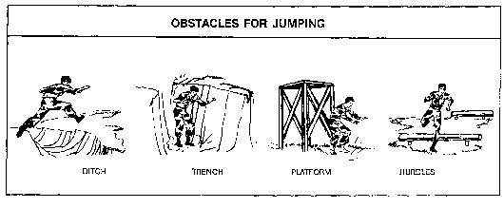

Figure C-2. Obstacles for jumping

(2) Obstacles for dodging (see figure C-3).

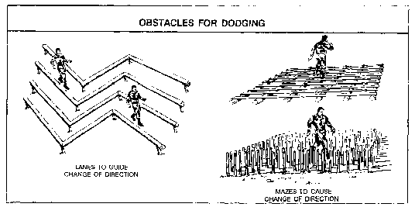

Figure C-3. Obstacles for dodging

(3) Obstacles for climbing and surmounting (see figure C-4).

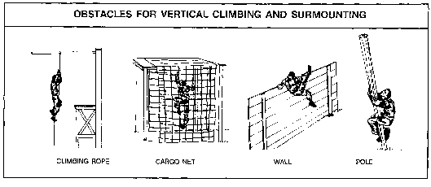

Figure C-4. Obstacles for vertical climbing and surmounting

(4) Horizontal traversing (see figure C-5).

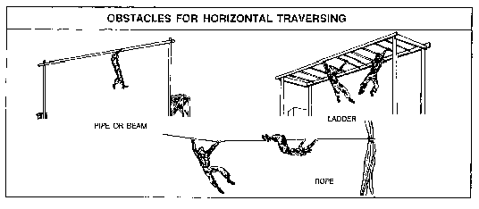

Figure C-5. Obstacles for horizontal traversing

(5) Obstacles for crawling (see figure C-6).

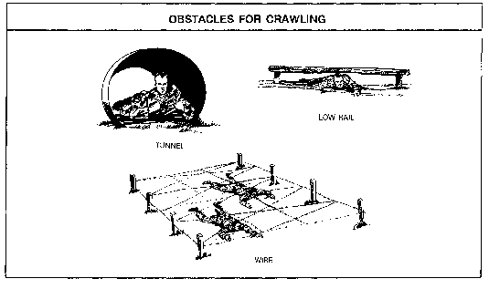

Figure C-6. Obstacles for crawling

(6) Obstacles for vaulting (see figure C-7).

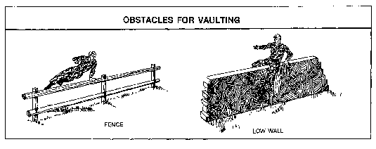

Figure C-7. Obstacle for vaulting

(7) Obstacles for balancing (see figure C-8).

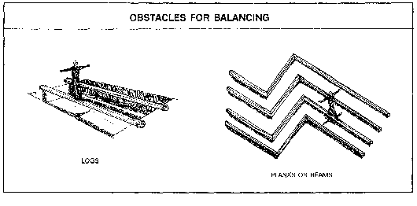

Figure C-8. Obstacle for balancing

**C-3. IMT obstacle course checklist**

Figure C-9 provides an obstacle course inspection and standardization criteria.

a. See table C-3 for the IMT obstacle course administrative general inspection criteria.

b. See table C-4 for the IMT obstacle course general inspection criteria.

**IMT Obstacle Course Evaluator Information**

**Obstacle Course: _____________________________________________________________**

**Location: ____________________________________ Date of Inspection: ______________**

**Inspector:**

**Name: _______________________________ Organization: ________________________**

**POC:**

**Name: _______________________________ Organization: _________________________**

**Phone: ____________________________________________________________________**

1. Courses will be evaluated to identify any safety hazards/concerns. Deficiencies found during the inspection will be annotated and corrective actions initiated by the responsible organization.

2. This evaluation will also assist in standardizing courses used at TRADOC activities.

3. Obstacle categories: standard, nonstandard, and other.

Note: Where indicated on checklist, “fall protection” refers to devices or systems emplaced beneath obstacles and at least 6 feet to the sides of obstacles presenting a fall hazard, to prevent injury during falls; “fall arrest systems” are devices attached to personnel to limit the distance of falls; and “surface” refers to the area beneath and around obstacles, to include travel lanes. Impact absorbing material depth under obstacles is 18 inches for sand, 12 inches of shredded rubber, and 24 inches for saw dust. Sand and sawdust must be tilled or turned at least annually to combat settling and ensure impact absorbance.

4. Standards for Conditioning/Endurance Courses are a combination of those found in FM 7-22; Engineer Drawing DEF 028-13-95, Obstacle Course Layout Plan; and TRADOC Regulation 350-6.

Figure C-9. IMT obstacle course evaluator information

Table C-3

IMT obstacle course administrative general inspection criteria

|  |  |  |  |  |  |
| --- | --- | --- | --- | --- | --- |
|  | **AREA** | | **STANDARD** | **GO** | **NO**  **GO** |
| 1 | Training requirement | | a. Training event is supported by TSP, program of instruction, or lesson plan. |  |  |
| b. SOPs are published and on hand at each course. |  |  |
| 2 | Administrative | | a. All ropes used for surmounting and suspension have condition service logs available. |  |  |
| b. Weight testing logs are maintained for nets. |  |  |
| 3 | | Risk Management | a. Generic risk assessment is completed and maintained on training site. |  |  |
| b. Daily risk assessment is completed and onsite during training, identifying hazards associated with personnel, equipment, and environment. |  |  |
| 4 | | Inspections | a. Copy of last professional safety staff’s safety inspection report is onsite. |  |  |
| b. Copy of daily inspection is maintained at training site. |  |  |
| c. A list of all current deficiencies is maintained by the responsible organization. |  |  |
| d. Copies of current work orders are maintained by the responsible organization. |  |  |
| 5 | | Accident trends | A list of all injuries sustained on obstacles is maintained by the responsible organization and safety office. |  |  |
|  | | Remarks: |  |  |  |

Table C-4

IMT obstacle course general inspection criteria

|  |  |  |  |  |
| --- | --- | --- | --- | --- |
|  | **AREA** | **STANDARD** | **GO** | **NO GO** |
| 1 | Wood timbers | a. There are no signs of rot, warping, severe weathering, or impact damage. |  |  |
| b. There are no protruding nails or splinters to cause injury when obstacle is negotiated. |  |  |
| c. All timbers are securely connected together without excess separation between joints. |  |  |
| 2 | Wall boards | a. All boards are securely attached to structure with proper hardware. |  |  |
| b. All boards free of protruding nails, splinters, rot, or damage. |  |  |
| c. Edges of boards rounded/smooth where used to support individual’s weight. |  |  |
| 3 | Hardware | a. All bolts, nuts, and washers are in place and of the designated type/size/placement. |  |  |
| b. All anchors are made of 3-strand galvanized guy wire or larger. |  |  |
| c. Take-up galvanized turnbuckles are used at anchor points of each cable to allow for adjustment. |  |  |
| d. Anchor cables are not used to support obstacles not properly constructed or improperly emplaced in the ground. |  |  |
| e. All cable clamps are positioned with U-bolt placed on the dead or short end of cable. |  |  |
| 4 | Fiber ropes | a. All ropes are free of rips, tears, cuts, frays, rot, or unraveled sections due to age, excessive wear, or contact with the ground. |  |  |
| b. All ropes designed for surmounting are 1.5 inches in diameter. |  |  |
| c. Ropes are securely mounted to supporting timbers with ends tied/taped. |  |  |
| d. Ends of ropes are tied in a knot or wrapped to prevent fraying. |  |  |
| e. Condition/service logs are maintained on all ropes used for surmounting and suspension. |  |  |
| 5 | Design | Obstacle adheres to blue print specifications. |  |  |
|  | Remarks: |  |  |  |

**Table C-4**

**IMT obstacle course general inspection criteria, continued**

|  |  |  |  |  |
| --- | --- | --- | --- | --- |
|  | **AREA** | **STANDARD** | **GO** | **NO GO** |
| 6 | Fall protection | a. All nets meet American National Standards Institute (ANSI) load bearing standard for personnel (ANSI 10.11/OSHA 1926.105) 3.5-inch nylon mesh, 17,500 pounds impact resistant. |  |  |
| b. All nets designed for fall protection extend 8 feet out from point of potential fall. (See 29 CFR 1926.105 (a).) |  |  |
| c. Forged steel hooks are used to fasten nets to its supports. |  |  |
| d. Nets are weight tested after initial installation and before being used as a fall protection system, whenever relocated, after major repair and every 6 months. The drop-test shall consist of 400 pound (180 kg) bag of sand 30 + or - 2 inches (76 + or - 5 cm) in diameter dropped into the net from the highest walking/working surface at which employees are exposed to fall hazards, but not from less than 42 inches (1.1 m) above that level. When the commander can demonstrate that it is unreasonable to perform the drop-test required by 29 CFR 1926.502 (c)(4)(i), the commander (or a designated competent person) shall certify that the net and net installation is in compliance with 29 CFR 1926.502(c)(4)(i) by preparing a certification record prior to the net being used as a fall protection system. The certification record must include an identification of the net and net installation for which the certification record is being prepared; the date that it was determined that the identified net and net installation were in compliance with 29 CFR 1926.502 (c)(3) and the signature of the person making the determination and certification. The most recent certification record for each net and net installation shall be available at the training site for inspection. |  |  |
| e. All nets are suspended below high obstacles (in excess of 10 feet) have padding or small mesh material to prevent limbs from penetrating net. |  |  |
| f. Pole-vaulting pads are in good condition with no tears, holes, or loose material, which can trip personnel when dismounting. |  |  |
| g. All pole-vaulting pads are placed properly at base of designated high obstacles. |  |  |
| 7 | Padding on timbers | a. All padding on timbers is in good condition without signs of damage. |  |  |
| b. Pads are securely attached to the timber supports to prevent movement when impacted. |  |  |
| 8 | Base contain- ment box | a. Base containment box is adequate for containment of absorbent material located at base of obstacle. |  |  |
| b. Containment box does not display signs of rot, damage, or instability. |  |  |
| c. Containment box is large enough to dismount from obstacle without causing injury. |  |  |
| d. Containment box is filled with either 18 inches of sand, 12 inches of shredded rubber, or 24 inches of sawdust. |  |  |
| 9 | Surfaces | All surfaces beneath low obstacles are free of hazards with the potential to cause injury. |  |  |
| 10 | Course condition | a. Designated course is free of tripping hazards. |  |  |
| b. Course surface is well maintained to prevent injury in case of falls. |  |  |
| c. Course surface is raked and policed prior to each use. |  |  |
| d. Course surface is free of large rocks, stones, or concrete materials that may cause injury in the case of a fall. |  |  |
| 11 | Safety | Professional safety staff reviews obstacle construction plans and conducts semiannual inspections. |  |  |
|  | Remarks: |  |  |  |

**C-4. Obstacle course specific inspection criteria**

a. The accompanying checklists and sketches supplement FM 7-22 and DA Corps of Engineer Drawings DEF 028-13-95, Obstacle Course Layout Plan, and TRADOC Regulation 350-6. They serve as minimum construction/safety standards for obstacle courses used by IMT facilities.

b. The “jump and land” and “swinger” are not included and will not be used. These obstacles are conducive to lower extremity injuries.

c. Safety equipment (nets, pads, and ground covering) should be procured from reliable sources, inspected and tested frequently, and replaced before deterioration/failure.

d. Tables and figures are provided for specific courses.

(1) See table C-5 and figure C-10 for “the tough one.”

Table C-5.

The tough one checklist

|  |  |  |  |  |
| --- | --- | --- | --- | --- |
|  | **AREA** | **STANDARD** | **GO** | **NO**  **GO** |
| 1 | Wood timbers | a. There are no signs of rot, warping, severe weathering, or impact damage. |  |  |
| b. All timbers meet specified dimensions as stated in engineer drawings and TRADOC Regulation 350-6. |  |  |
| c. There are no protruding nails or splinters that may cause injury when obstacle is negotiated. |  |  |
| d. All timbers are connected securely together without excess separation between joints. |  |  |
| 2 | Hardware | All bolts, nuts, and washers are in place and of the designated type, size, and placement. |  |  |
| 3 | Design | Professional safety staff reviews obstacle construction plans. |  |  |
| 4 | Fall protection | a. All nets meet ANSI load bearing standard for personnel (ANSI 10.11/OSHA 1926.105) 3.5-inch nylon mesh, 17,500 pounds impact resistant. |  |  |
| b. All nets designed for fall protection extend 8 feet out from point of potential fall. (See 29 CFR 1926.105 (a).) |  |  |
| c. Forged steel hooks are used to fasten net to its supports. |  |  |
| d. Nets are weight tested after initial installation and before being used as a fall protection system, whenever relocated, after major repair and every 6 months. The drop-test shall consist of 400 pound (180 kg) bag of sand 30 + or - 2 inches (76 + or - 5 cm) in diameter dropped into the net from the highest walking/working surface at which employees are exposed to fall hazards, but not from less than 42 inches (1.1 m) above that level. When the commander can demonstrate that it is unreasonable to perform the drop-test required by 29 CFR 1926.502 (c)(4)(i), the commander (or a designated competent person) shall certify that the net and net installation is in compliance with 29 CFR 1926.502(c)(4)(i) by preparing a certification record prior to the net being used as a fall protection system. The certification record must include an identification of the net and net installation for which the certification record is being prepared; the date that it was determined that the identified net and net installation were in compliance with 29 CFR 1926.502 (c)(3) and the signature of the person making the determination and certification. The most recent certification record for each net and net installation shall be available at the training site for inspection. |  |  |
| e. Pole-vaulting pads are in good condition with no tears, holes, or loose material, which can trip personnel when dismounting. |  |  |
| f. Pole-vaulting pads are placed properly at base of designated obstacles. |  |  |
| 5 | Base containment box | a. Base containment box is adequate for containment of absorbent material located at base of obstacle. |  |  |
| b. Containment box does not display signs of rot, damage, or instability. |  |  |
| c. Containment box is large enough to dismount from obstacle without causing injury. |  |  |
| Remarks: | | | | |

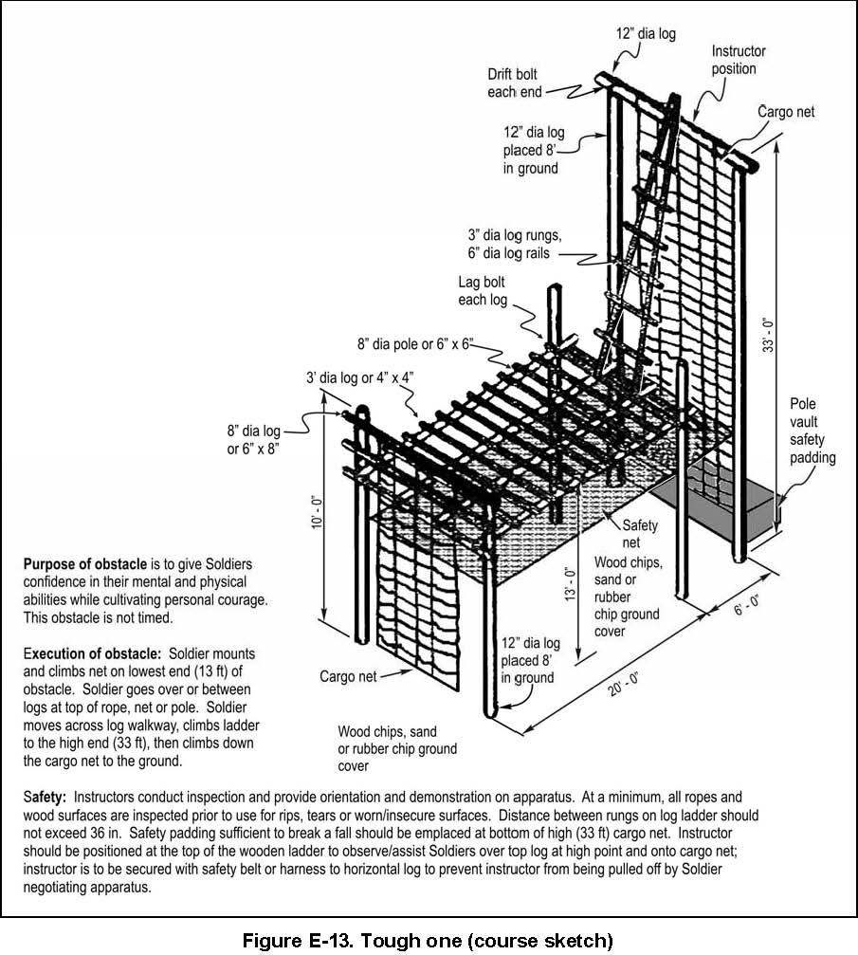

Figure C-10. The tough one

(2) See table C-6 and figure C-11 for the “inverted rope descent/the slide for life.”

Table C-6

Inverted rope descent/the slide for life

|  |  |  |  |  |
| --- | --- | --- | --- | --- |
|  | **AREA** | **STANDARD** | **GO** | **NO GO** |
| 1 | Wood Timbers | a. There are no signs of rot, warping, severe weathering, or impact damage. |  |  |
| b. All timbers meet specified dimensions as stated in engineer drawings and TRADOC Regulation 350-6. |  |  |
| c. There are no protruding nails or splinters that may cause injury when obstacle is negotiated. |  |  |
| d. All timbers are connected securely together without excess separation between joints. |  |  |
| 2 | Hardware | a. All bolts, nuts, and washers are in place and of the designated type and size. |  |  |
| b. All anchors are made of 3-strand galvanized guy wire or larger. |  |  |
| c. Take-up galvanized turnbuckles are used at anchor points of each cable to allow for adjustment. |  |  |
| d. Anchor cables are not used to support obstacles not properly constructed or improperly emplaced in the ground. |  |  |
| e. All cable clamps are positioned with U-bolt placed on the dead or short end of cable. |  |  |
| 3 | Fiber ropes | a. All ropes are free of rips, tears, cuts, frays, rot, or unraveled sections due to age, excessive wear, or contact with the ground. |  |  |
| b. All ropes designed for surmounting are 1.5 inches in diameter. |  |  |
| c. Ropes are securely mounted to supporting timbers with ends tied and taped. |  |  |
| 4 | Design | Professional safety staff reviews obstacle construction plans. |  |  |

**Table C-6**

**Inverted rope descent/the slide for life, continued**

|  |  |  |  |  |
| --- | --- | --- | --- | --- |
|  | **AREA** | **STANDARD** | **YES** | **NO** |
| 5 | Fall protection | a. All nets meet ANSI load bearing standard for personnel (ANSI 10.11/OSHA 1926.105) 3.5-inch nylon mesh, 17,500 pound impact resistant. |  |  |
| b. All nets designed for fall protection extend 8 feet out from edge of obstacle. (See 29 CFR 1926.105 (a).) |  |  |
| c. Forged steel hooks are used to fasten net to its supports. |  |  |
| d. Nets are weight tested after initial installation and before being used as a fall protection system, whenever relocated, after major repair and every 6 months. The drop-test shall consist of 400 pound (180 kg) bag of sand 30 + or - 2 inches (76 + or - 5 cm) in diameter dropped into the net from the highest walking/working surface at which employees are exposed to fall hazards, but not from less than 42 inches (1.1 m) above that level. When the commander can demonstrate that it is unreasonable to perform the drop-test required by 29 CFR 1926.502 (c)(4)(i), the commander (or a designated competent person) shall certify that the net and net installation is in compliance with 29 CFR 1926.502(c)(4)(i) by preparing a certification record prior to the net being used as a fall protection system. The certification record must include an identification of the net and net installation for which the certification record is being prepared; the date that it was determined that the identified net and net installation were in compliance with 29 CFR 1926.502 (c)(3) and the signature of the person making the determination and certification. The most recent certification record for each net and net installation shall be available at the training site for inspection. |  |  |
| e. All nets suspended below high obstacles (excess of 10 feet) have padding or small mesh material to prevent limbs from penetrating mesh. |  |  |
| f. Pole-vaulting pads are in good condition with no tears, holes, or loose material, which can trip personnel when dismounting. |  |  |
| g. Pole-vaulting pads are properly placed at base of designated obstacles. |  |  |
| 6 | Base contain- ment box | a. Base containment box is adequate for containment of absorbent material located at base of obstacle. |  |  |
| b. Containment box does not display signs of rot, damage, or instability. |  |  |
| c. Containment box is large enough to dismount from obstacle without causing injury. |  |  |
|  | Remarks: |  |  |  |

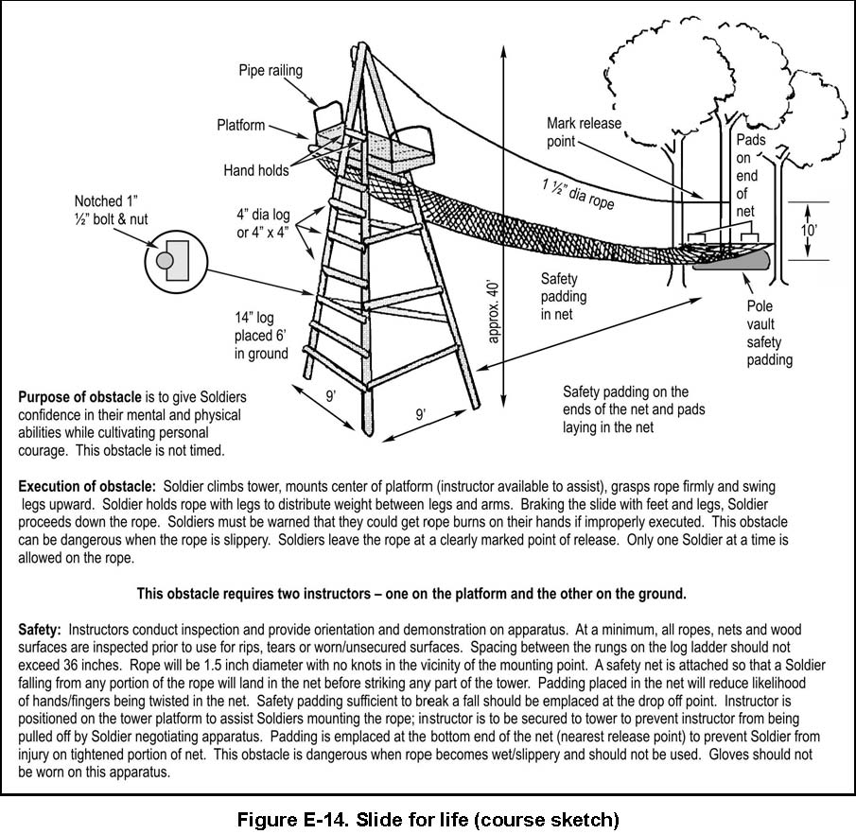

Figure C-11. Inverted rope descent/the slide for life

(3) See table C-7 and figure C-12 for the “confidence climb.”

Table C-7

Confidence climb checklist

|  |  |  |  |  |
| --- | --- | --- | --- | --- |
|  | **AREA** | **STANDARD** | **GO** | **NO GO** |
| 1 | Wood timbers | a. There are no signs of rot, warping, severe weathering, or impact damage. |  |  |
| b. All timbers meet specified dimensions as stated in engineer drawings and TRADOC Regulation 350-6. |  |  |
| c. There are no protruding nails or splinters that may cause injury when obstacle is negotiated. |  |  |
| d. All timbers are securely connected together without excess separation between joints. |  |  |
| 2 | Hardware | a. All bolts, nuts, and washers are in place and of the designated type and size. |  |  |
| b. All anchors are made of 3-strand galvanized guy wire or larger. |  |  |
| c. Take-up galvanized turnbuckles are used at anchor points of each cable to allow for adjustment. |  |  |
| d. Anchor cables are not used to support obstacles not properly constructed or improperly emplaced in the ground. |  |  |
| e. All cable clamps are positioned with U-bolt placed on the dead or short end of cable. |  |  |
| 3 | Design | Professional safety staff reviews obstacle construction plans. |  |  |
| 4 | Fall protection | a. Pole-vaulting pads are in good condition with no tears, holes, or loose material, which can trip personnel when dismounting. |  |  |
| b. All pole-vaulting pads are properly placed at base of designated obstacles. |  |  |
| 5 | Base contain-  ment box | a. Base containment box is adequate for containment of absorbent material located at base of obstacle. |  |  |
| b. Containment box does not display signs of rot, damage, or instability. |  |  |
| c. Containment box is large enough to dismount from obstacle without causing injury. |  |  |
| Remarks: | | | | |

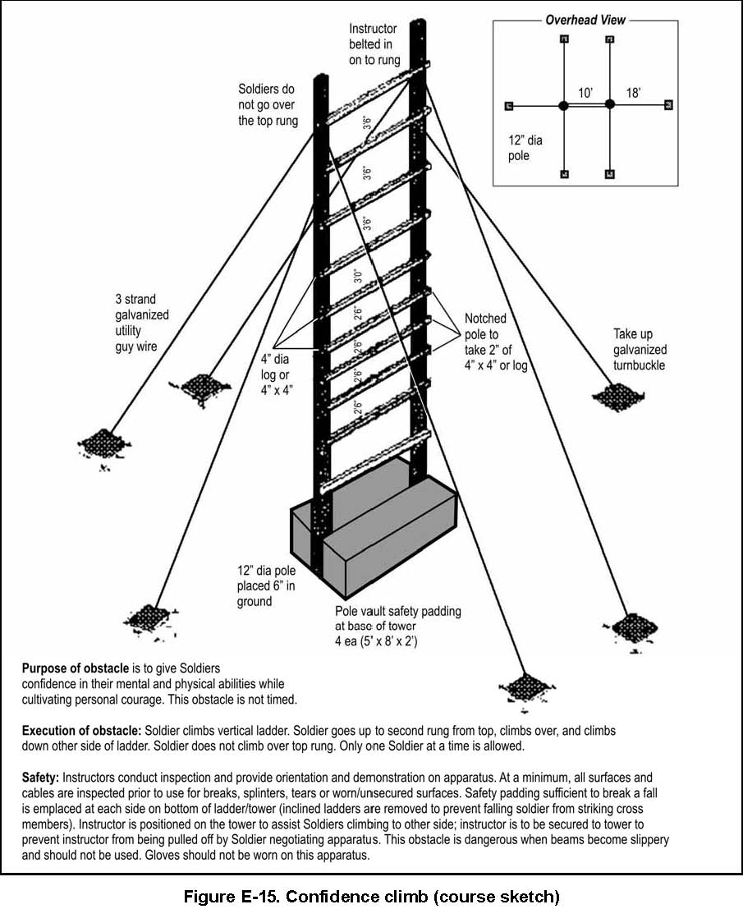

Figure C-12. Confidence climb

(4) See table C-8 and figure C-13 for the “skyscraper.”

Table C-8

Skyscraper checklist

|  |  |  |  |  |
| --- | --- | --- | --- | --- |
|  | **AREA** | **STANDARD** | **GO** | **NO GO** |
| 1 | Wood timbers | a. There are no signs of rot, warping, severe weathering, or impact damage. |  |  |
| b. All timbers meet specified dimensions as stated in engineer drawings. |  |  |
| c. There are no protruding nails or splinters that may cause injury when obstacle is negotiated. |  |  |
| d. All timbers are securely connected together without excess separation between joints. |  |  |
| 2 | Hardware | a. All bolts, nuts, and washers are in place and of the designated type and size. |  |  |
| b. All anchors are made of 3-strand galvanized guy wire or larger. |  |  |
| c. Take-up galvanized turnbuckles are used at anchor points of each cable to allow for adjustment. |  |  |
| d. Anchor cables are not used to support obstacles not properly constructed or improperly emplaced in the ground. |  |  |
| e. All cable clamps are positioned with U-bolt placed on the dead or short end of cable. |  |  |
| 3 | Design | Professional safety staff reviews obstacle construction plans. |  |  |
| 4 | Fall protection | a. All nets meet ANSI load bearing standard for personnel (ANSI 10.11/  OSHA 1926.105) 3.5-inch nylon mesh, 17,500 pounds impact resistant. |  |  |
| b. All nets designed for fall protection extend 8 feet out from point of potential fall. (See 29 CFR 1926.105 (a).) |  |  |
| c. Forged steel hooks are used to fasten net to its supports. |  |  |
| d. Nets are weight tested after initial installation and before being used as a fall protection system, whenever relocated, after major repair and every 6 months. The drop-test shall consist of 400 pound (180 kg) bag of sand 30 + or - 2 inches (76 + or - 5 cm) in diameter dropped into the net from the highest walking/working surface at which employees are exposed to fall hazards, but not from less than 42 inches (1.1 m) above that level. When the commander can demonstrate that it is unreasonable to perform the drop-test required by 29 CFR 1926.502 (c)(4)(i), the commander (or a designated competent person) shall certify that the net and net installation is in compliance with 29 CFR 1926.502(c)(4)(i) by preparing a certification record prior to the net being used as a fall protection system. The certification record must include an identification of the net and net installation for which the certification record is being prepared; the date that it was determined that the identified net and net installation were in compliance with 29 CFR 1926.502 (c)(3) and the signature of the person making the determination and certification. The most recent certification record for each net and net installation shall be available at the training site for inspection |  |  |
| e. All nets suspended below high obstacles (excess of 10 feet) have padding to prevent limbs from penetrating net. |  |  |
| f. Pole-vaulting pads are in good condition with no tears, holes, or loose material, which can trip personnel when dismounting. |  |  |
| g. Pole-vaulting pads are properly placed at base of designated obstacles. |  |  |

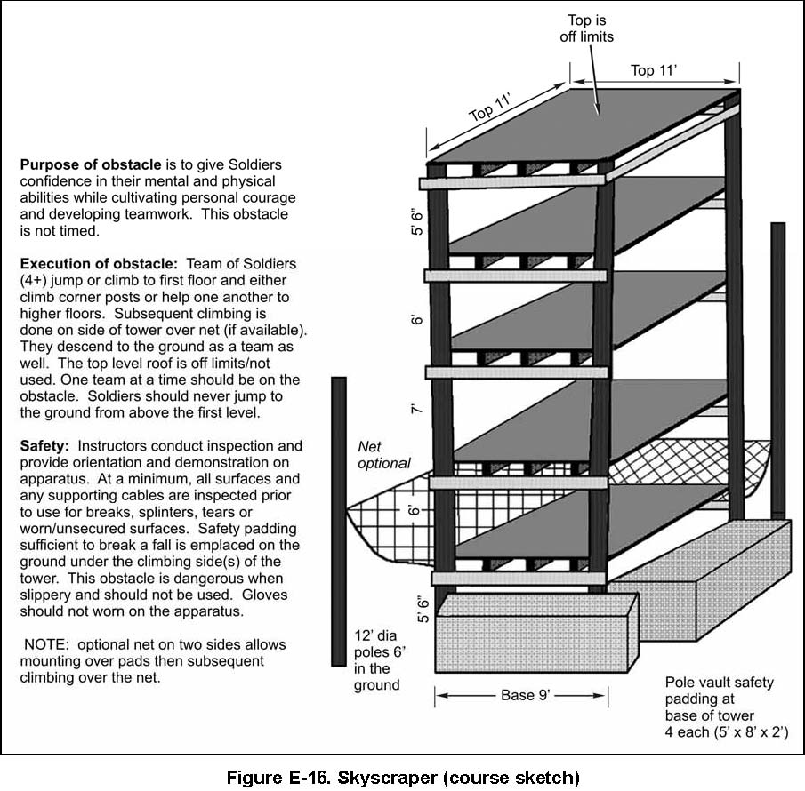

Figure C-13. Skyscraper

(5) See table C-9 and figure C-14 for the “belly robber.”

Table C-9

Belly Robber checklist

|  |  |  |  |  |
| --- | --- | --- | --- | --- |
|  | **AREA** | **STANDARD** | **GO** | **NO GO** |
| 1 | Wood timbers | a. There are no signs of rot, warping, severe weathering, or impact damage. |  |  |
| b. All timbers meet specified dimensions as stated in engineer drawings. |  |  |
| c. There are no protruding nails or splinters that may cause injury when obstacle is negotiated. |  |  |
| d. All timbers are securely connected together without excess separation between joints. |  |  |
| e. All timbers are free of chemical coatings or substances that affect Soldier’s ability to negotiate obstacle. |  |  |
| 2 | Hardware | All bolts, nuts, and washers are in place and of the designated type and size. |  |  |
| 3 | Design | Professional safety staff reviews obstacle construction plans. |  |  |
| Remarks: | | | | |

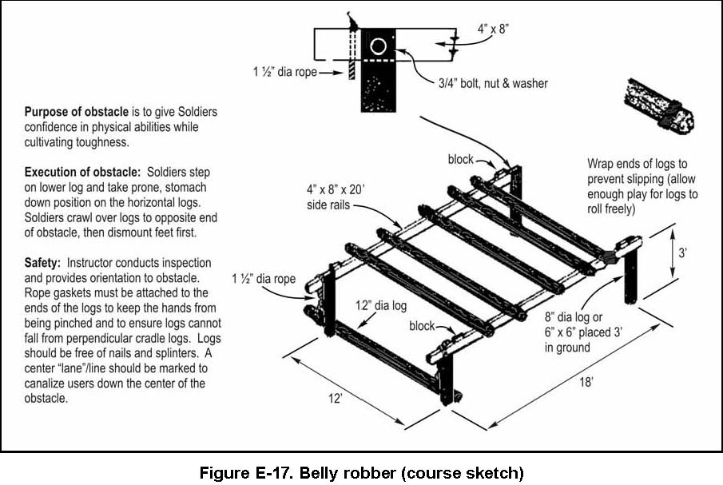

Figure C-14. Belly robber

(6) See table C-10 and figure C-15 for “the Tarzan.”

Table C-10

The Tarzan checklist

|  |  |  |  |  |
| --- | --- | --- | --- | --- |
|  | **AREA** | **STANDARD** | **GO** | **NO GO** |
| 1 | Wood timbers | a. There are no signs of rot, warping, severe weathering, or impact damage. |  |  |
| b. All timbers meet specified dimensions as stated in engineer drawings and TRADOC Regulation 350-6. |  |  |
| c. There are no protruding nails or splinters that may cause injury when obstacle is negotiated. |  |  |
| d. All timbers are securely connected together without excess separation between joints. |  |  |
| e. Rungs on horizontal ladder are modified to support gender integrated training (diameter is reduced to accommodate smaller hand sizes). |  |  |
| 2 | Hardware | All bolts, nuts, and washers are in place and of the designated type and size. |  |  |
| 3 | Design | Professional safety staff reviews obstacle construction plans. |  |  |
| Remarks: | | | | |
|  | | | | |

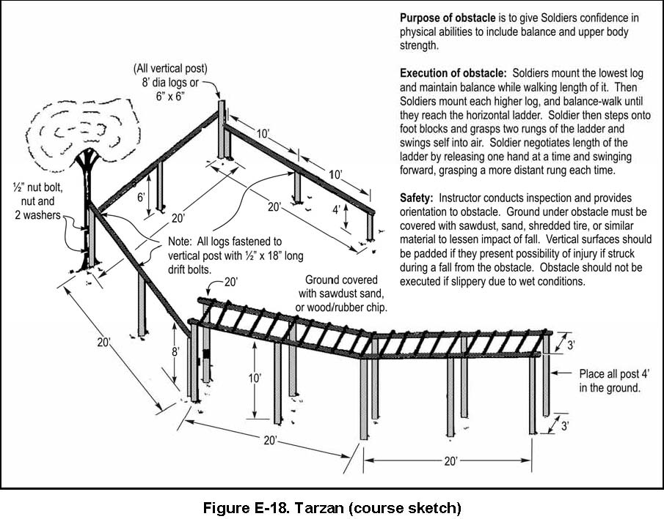

Figure C-15. The Tarzan

(7) See Table C-11 and Figure C-16 for the “Low belly over.”

Table C-11

Low belly over checklist

|  |  |  |  |  |
| --- | --- | --- | --- | --- |
|  | **AREA** | **STANDARD** | **GO** | **NO GO** |
| 1 | Wood timbers | a. No signs of rot, warping, severe weathering, or impact damage. |  |  |
| b. All timbers meet specified dimensions as stated in engineer drawings. |  |  |
| c. There are no protruding nails or splinters that may cause injury when obstacle is negotiated. |  |  |
| d. All timbers are securely connected together without excess separation between joints. |  |  |
| e. All timbers are free of chemical coatings or substances that affect Soldier’s ability to negotiate obstacle. |  |  |
| 2 | Hardware | All bolts, nuts, washers are in place and of the designated type/size. |  |  |
| 3 | Fiber ropes | All ropes are free of rips, tears, cuts, frays, rot, or unraveled sections due to age, excessive wear, or contact with the ground. |  |  |
| 4 | Design | Professional safety staff reviews obstacle construction plans. |  |  |
| 5 | Padding on timbers | a. All padding on timbers is in good condition no signs of damage. |  |  |
| b. Pads are securely attached to the timber supports to prevent movement when impacted. |  |  |
| Remarks: | | | | |

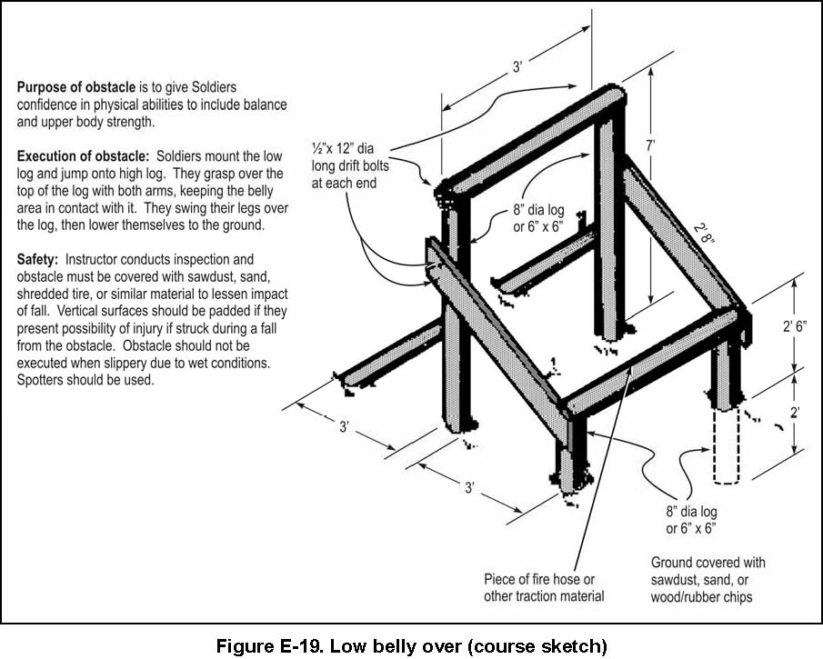

Figure C-16. Low belly over

(8) See table C-12 and figure C-17 for “the dirty name.”

Table C-12

The dirty name checklist

|  |  |  |  |  |
| --- | --- | --- | --- | --- |
|  | **AREA** | **STANDARD** | **GO** | **NO GO** |
| 1 | Wood timbers | a. There are no signs of rot, warping, severe weathering, or impact damage. |  |  |
| b. All timbers meet specified dimensions as stated in engineer drawings. |  |  |
| c. There are no protruding nails or splinters that may cause injury when obstacle is negotiated. |  |  |
| d. All timbers are securely connected together without excess separation between joints. |  |  |
| 2 | Hardware | All bolts, nuts, and washers are in place and of the designated type and size. |  |  |
| 3 | Design | Professional safety staff reviews obstacle construction plans. |  |  |
| 4 | Padding on timbers | a. All padding on timbers is in good condition without signs of damage. |  |  |
| b. Pads are securely attached to the timber supports to prevent movement when impacted. |  |  |
| 5 | Base contain-ment box | a. Base containment box is adequate for containment of absorbent material located at base of obstacle. |  |  |
| b. Containment box does not display signs of rot, damage, or instability. |  |  |
| c. Containment box is large enough to dismount from obstacle without injury. |  |  |
| Remarks: | | | | |

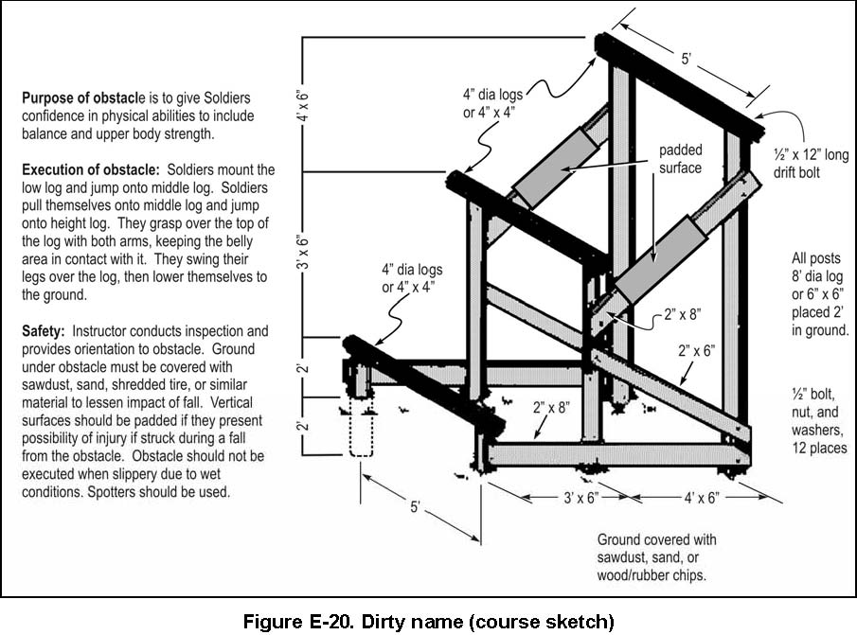

Figure C-17. The dirty name

(8) See table C-13 and figure C-18 for “the tough nut.”

Table C-13

The tough nut checklist

|  |  |  |  |  |
| --- | --- | --- | --- | --- |
|  | **AREA** | **STANDARD** | **GO** | **NO GO** |
| 1 | Wood timbers | a. There are no signs of rot, warping, severe weathering, or impact damage. |  |  |
| b. All timbers meet specified dimensions as stated in engineer drawings. |  |  |
| c. There are no protruding nails or splinters that may cause injury when obstacle is negotiated. |  |  |
| d. All timbers are securely connected together without excess separation between joints. |  |  |
| e. All timbers are free of chemical coatings or substances that affect Soldier’s ability to negotiate obstacle. |  |  |
| 2 | Hardware | All wire/bolts are of the designated type and size. |  |  |
| 3 | Design | a. Professional safety staff reviews obstacle construction plans. |  |  |
| b. Center height of “X” does not exceed 30 inches. |  |  |
| Remarks: | | | | |

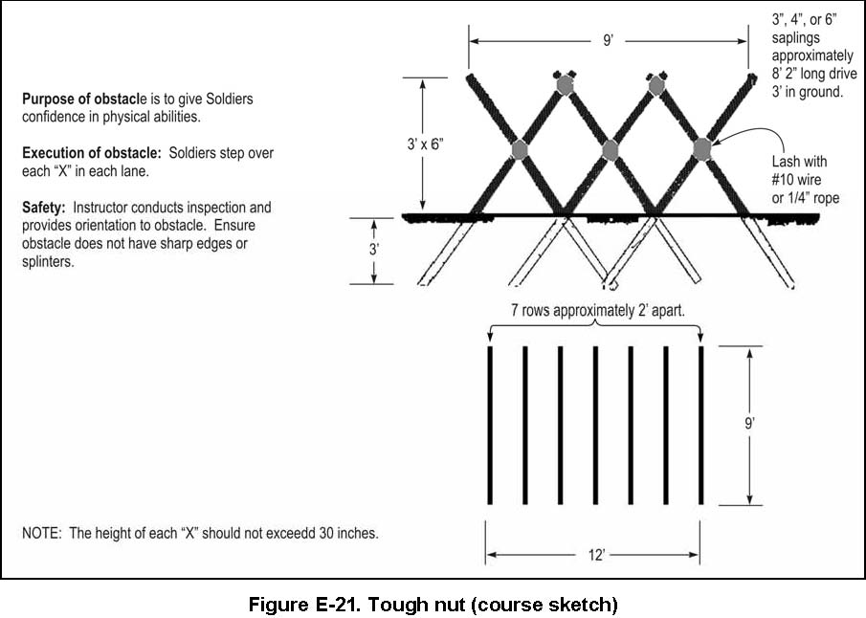

Figure C-18. The tough nut

(9) See table C-14 and figure C-19 for the “belly crawl.”

Table C-14

Belly crawl checklist

|  |  |  |  |  |
| --- | --- | --- | --- | --- |
|  | **AREA** | **STANDARD** | **GO** | **NO GO** |
| 1 | Wood timbers | a. There are no signs of rot, warping, severe weathering, or impact damage. |  |  |
| b. All timbers meet specified dimensions as stated in engineer drawings. |  |  |
| c. There are no protruding nails or splinters that may cause injury when obstacle is negotiated. |  |  |
| 2 | Hardware | All wires, screws, or nails are in place and of the designated type and size. |  |  |
| 3 | Design | Professional safety staff reviews obstacle construction plans. |  |  |
| 4 | Surfaces | All surfaces beneath low surfaces are free of hazards with the potential to cause injury. |  |  |
| Remarks: | | | | |

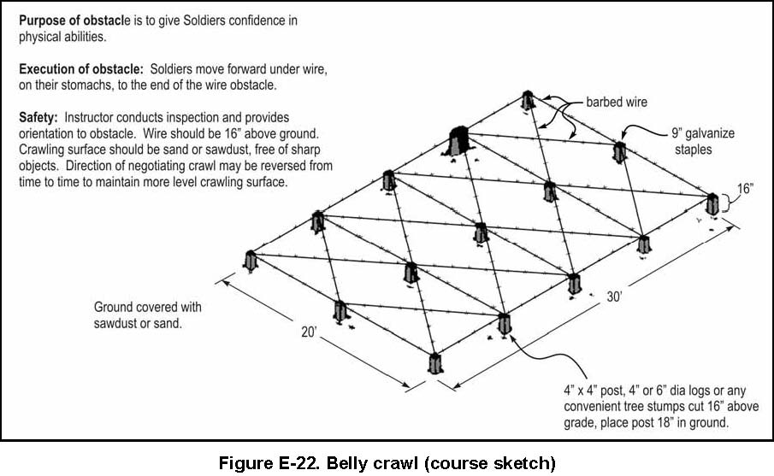

Figure C-19. Belly crawl

(10) See table C-15 and figure C-20 for the “inclining wall.”

Table C-15

Inclining wall checklist

|  |  |  |  |  |
| --- | --- | --- | --- | --- |
|  | **AREA** | **STANDARD** | **GO** | **NO GO** |
| 1 | Wood timbers | a. There are no signs of rot, warping, severe weathering, or impact damage. |  |  |
| b. All timbers meet specified dimensions as stated in engineer drawings. |  |  |
| c. There are no protruding nails or splinters that may cause injury when obstacle is negotiated. |  |  |
| d. All timbers are securely connected together without excess separation between joints. |  |  |
| 2 | Wall boards | a. All boards are securely attached to structure with proper hardware. |  |  |
| b. All boards free of protruding nails, splinters, rot, or damage. |  |  |
| c. Edges of boards rounded/smooth where used to support individual’s weight... |  |  |
| 3 | Hardware | a. All bolts, nuts, and washers in place and of the designated type, size, and placement. |  |  |
| b. All cable clamps are positioned with U-bolt placed on the dead or short end of cable. |  |  |
| 4 | Design | Professional safety staff reviews obstacle construction plans. |  |  |
| Remarks: | | | | |

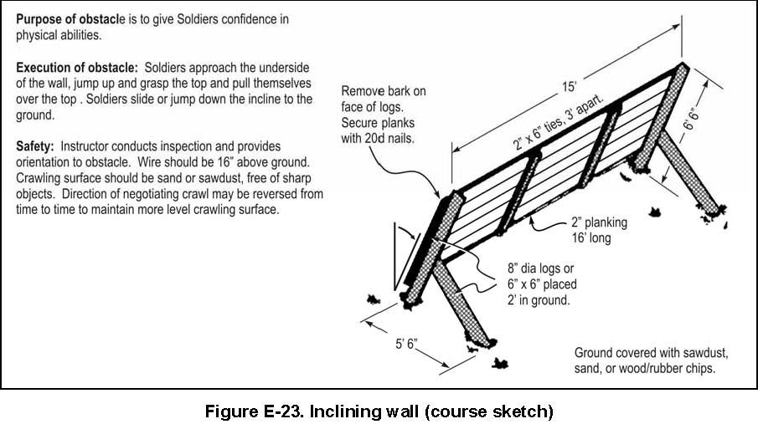

Figure C-20. Inclining wall

(10) See table C-16 and figure C-21 for the “swing, stop, and jump.”

Table C-16

Swing, stop, and jump checklist

|  |  |  |  |  |
| --- | --- | --- | --- | --- |
|  | **AREA** | **STANDARD** | **GO** | **NO GO** |
| 1 | Wood timbers | a. There are no signs of rot, warping, severe weathering, or impact damage. |  |  |
| b. All timbers meet specified dimensions as stated in engineer drawings. |  |  |
| c. There are no protruding nails or splinters that may cause injury when obstacle is negotiated. |  |  |
| d. All timbers are securely connected together without excess separation between joints. |  |  |
| e. All timbers are free of chemical coatings or substances that affect Soldier’s ability to negotiate obstacle. |  |  |
| 2 | Hardware | a. All bolts, nuts, and washers are in place and of the designated type and size. |  |  |
| b. Surmounting ropes have knots at ends or are taped to prevent fraying. |  |  |
| 3 | Fiber ropes | All ropes are free of rips, tears, cuts, frays, rot, or unraveled sections due to age, excess wear, or contact with the ground. |  |  |
| 4 | Design | Professional safety staff reviews obstacle construction plans. |  |  |
| 5 | Padding on timbers | a. All padding on timbers is in good condition without signs of damage. |  |  |
| b. Pads are securely attached to the timber supports to prevent movement when impacted. |  |  |
| 6 | Base containment box | a. Base containment box is adequate for containment of absorbent material located at base of obstacle. |  |  |
| b. Containment box does not display signs of rot, damage, or instability. |  |  |
| c. Containment box is large enough to dismount from obstacle without causing injury. |  |  |
| Remarks: | | | | |

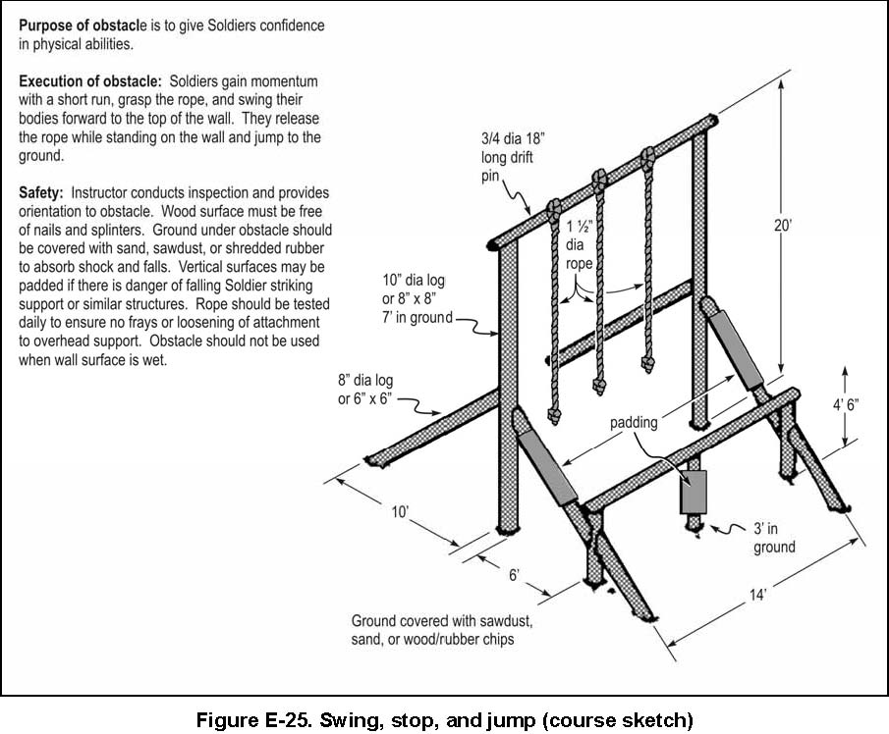

Figure C-21. Swing, stop, and jump

(11) See table C-17 and figure C-22 for the “six vaults.”

Table C-17

Six vaults checklist

|  |  |  |  |  |
| --- | --- | --- | --- | --- |
|  | **AREA** | **STANDARD** | **GO** | **NO GO** |
| 1 | Wood timbers | a. There are no signs of rot, warping, severe weathering, or impact damage. |  |  |
| b. All timbers meet specified dimensions as stated in engineer drawings. |  |  |
| c. There are no protruding nails or splinters that may cause injury when obstacle is negotiated. |  |  |
| d. All timbers are securely connected together without excess separation between joints. |  |  |
| e. All timbers are free of chemical coatings or substances that affect Soldier’s ability to negotiate obstacle. |  |  |
| 2 | Hardware | All bolts, nuts, and washers are in place and of the designated type and size. |  |  |
| 3 | Design | Professional safety staff reviews obstacle construction plans. |  |  |
|  | | | | |
| Remarks: | | | | |

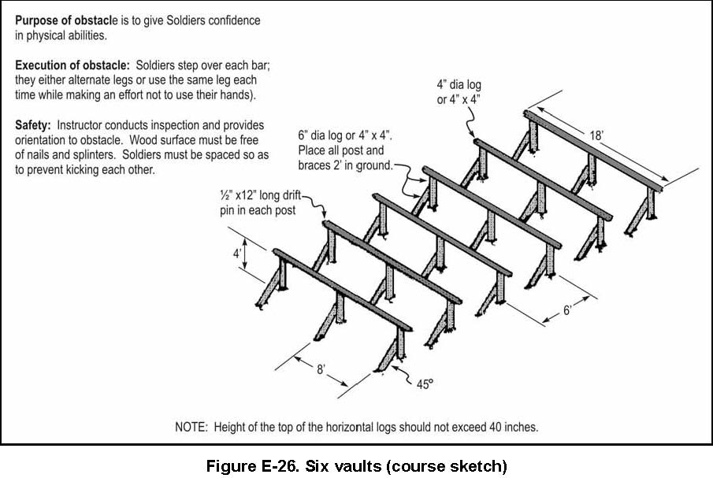

Figure C-22. Six vaults

(12) See table C-18 and figure C-23 for the “easy balancer.”

Table C-18

Easy balancer checklist

|  |  |  |  |  |
| --- | --- | --- | --- | --- |
|  | **AREA** | **STANDARD** | **GO** | **NO GO** |
| 1 | Wood timbers | a. There are no signs of rot, warping, severe weathering, or impact damage. |  |  |
| b. All timbers meet specified dimensions as stated in engineer drawings. |  |  |
| c. There are no protruding nails or splinters that may cause injury when obstacle is negotiated. |  |  |
| d. All timbers are securely connected together without excess separation between joints. |  |  |
| e. All timbers are free of chemical coatings or substances that affect Soldier’s ability to negotiate obstacle. |  |  |
| 2 | Hardware | All bolts, nuts, and washers are in place and of the designated type and size. |  |  |
| 3 | Design | Professional safety staff reviews obstacle construction plans. |  |  |
| 4 | Base contain-ment box | a. Base containment box is adequate for containment of absorbent material located at base of obstacle. |  |  |
| b. Containment box does not display signs of rot, damage, or instability. |  |  |
| c. Containment box is large enough to dismount from obstacle without causing injury. |  |  |
| Remarks: | | | | |

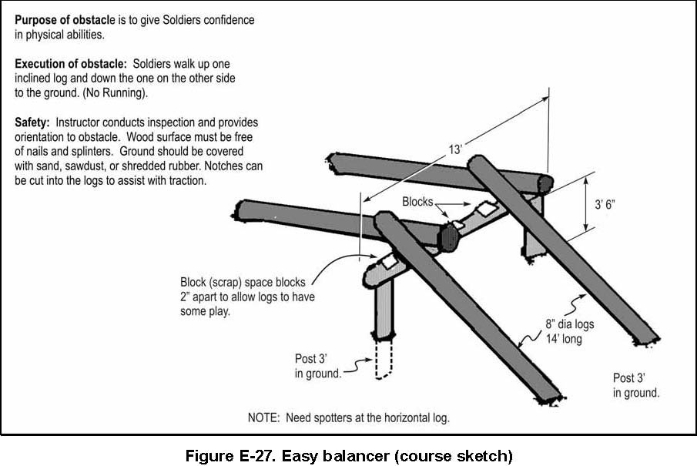

Figure C-23. Easy balancer

(13) See table C-19 and figure C-24 for the “low wire.”

Table C-19

Low wire checklist

|  |  |  |  |  |
| --- | --- | --- | --- | --- |
|  | **AREA** | **STANDARD** | **GO** | **NO GO** |
| 1 | Wood timbers | a. There are no signs of rot, warping, severe weathering, or impact damage. |  |  |
| b. All timbers meet specified dimensions as stated in engineer drawings. |  |  |
| c. There are no protruding nails or splinters that may cause injury when obstacle is negotiated. |  |  |
| d. All timbers are securely connected together without excess separation between joints. |  |  |
| 2 | Hardware | All wire, nails, or screws are in place and of the designated type and size. |  |  |
| 3 | Design | Professional safety staff reviews obstacle construction plans. |  |  |
| 4 | Surfaces | All surfaces beneath low obstacles are free of hazards with the potential to cause injury. |  |  |
| Remarks: | | | | |

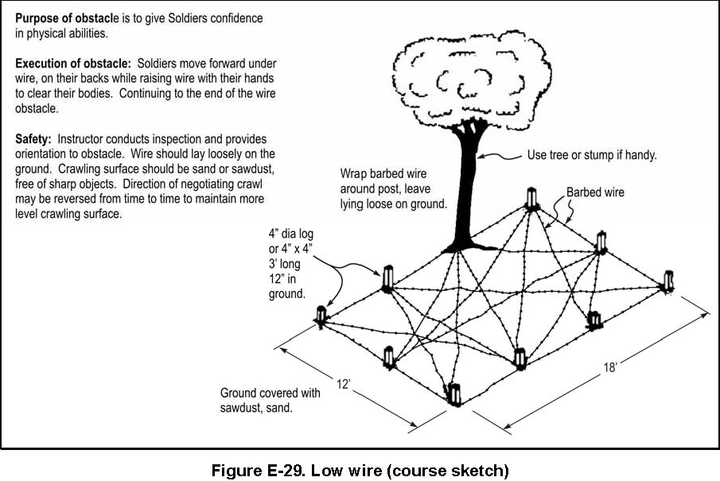

Figure C-24. Low wire

(14) See table C-20 and figure C-25 for “the belly buster.”

Table C-20

The belly buster checklist

|  |  |  |  |  |
| --- | --- | --- | --- | --- |
|  | **AREA** | **STANDARD** | **GO** | **NO GO** |
| 1 | Wood timbers | a. There are no signs of rot, warping, severe weathering, or impact damage. |  |  |
| b. All timbers meet specified dimensions as stated in engineer drawings. |  |  |
| c. There are no protruding nails or splinters that may cause injury when obstacle is negotiated. |  |  |
| d. All timbers are securely connected together without excess separation between joints. |  |  |
| e. All timbers are free of chemical coatings or substances that affect Soldier’s ability to negotiate obstacle. |  |  |
| 2 | Hardware | a. All bolts, nuts, and washers are in place and of the designated type/size. |  |  |
| b. Soldiers are warned to keep hands and fingers away from parts of log resting on cradle. |  |  |
| c. Soldiers are informed not to rock or roll log while others are negotiating obstacle. |  |  |
| 3 | Design | Professional safety staff reviews obstacle construction plans. |  |  |
| 4 | Base containment box | a. Base containment box is adequate for containment of absorbent material located at base of obstacle. |  |  |
| b. Containment box does not display signs of rot, damage, or instability. |  |  |
| c. Containment box is large enough to dismount from obstacle without causing injury. |  |  |
| Remarks: | | | | |

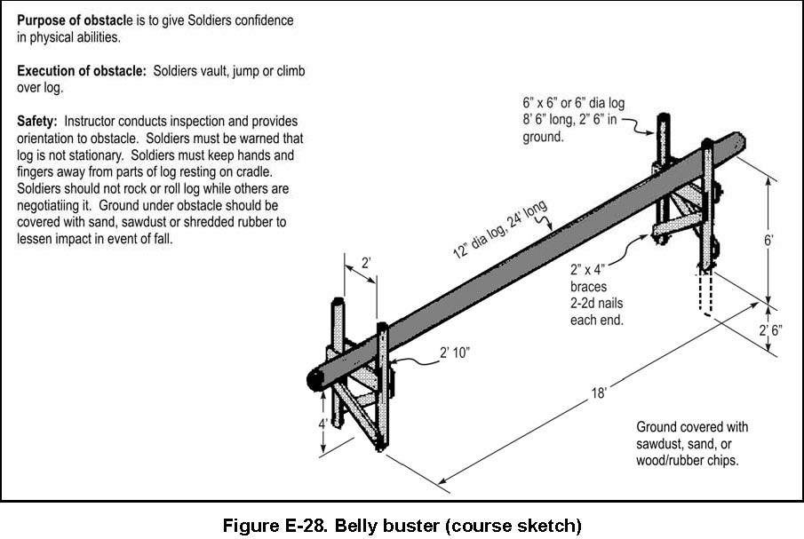

Figure C-25. Belly buster

(15) See table C-21 and figure C-26 for “the belly buster.”

Table C-21

Hip-hip checklist

|  |  |  |  |  |
| --- | --- | --- | --- | --- |
|  | **AREA** | **STANDARD** | **GO** | **NO GO** |
| 1 | Wood Timbers | a. There are no signs of rot, warping, severe weathering, or impact damage. |  |  |
| b. All timbers meet specified dimensions as stated in engineer drawings. |  |  |
| c. There are no protruding nails or splinters that may cause injury when obstacle is negotiated. |  |  |
| d. All timbers are securely connected together without excess separation between joints. |  |  |
| e. All timbers are free of chemical coatings or substances that affect Soldier’s ability to negotiate obstacle. |  |  |
| 2 | Hardware | All bolts, nuts, and washers are in place and of the designated type and size. |  |  |
| 3 | Design | Professional safety staff reviews obstacle construction plans. |  |  |
| 4 | Surfaces | All surfaces beneath low obstacles are free of hazards with the potential to cause injury. |  |  |
| Remarks: | | | | |

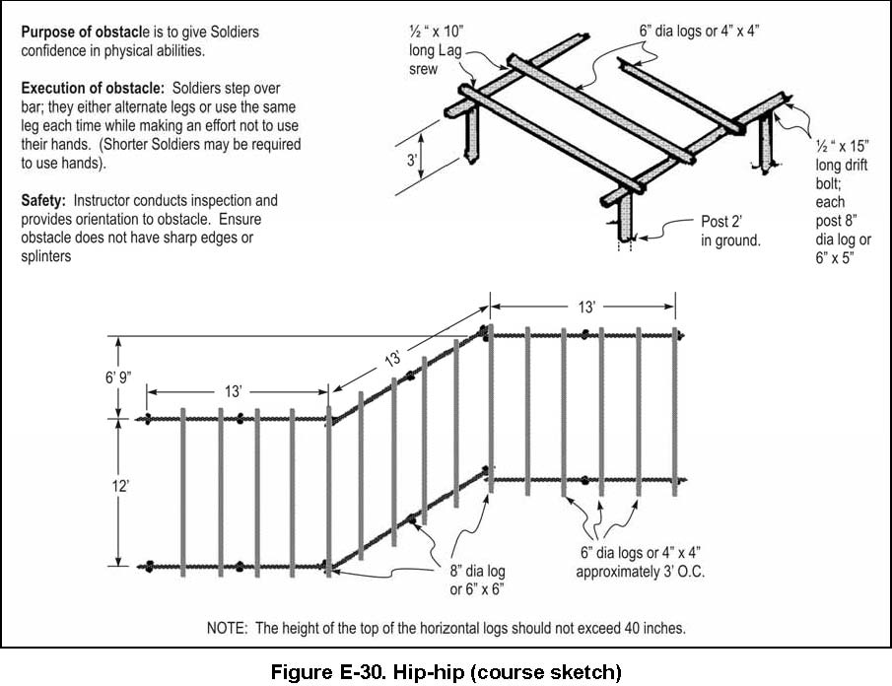

Figure C-26. Hip-hip

(16) See table C-22 and figure C-27 for the “reverse climb.”

Table C-22

Reverse climb checklist

|  |  |  |  |  |
| --- | --- | --- | --- | --- |
|  | **AREA** | **STANDARD** | **GO** | **NO GO** |
| 1 | Wood timbers | a. There are no signs of rot, warping, severe weathering, or impact damage. |  |  |
| b. All timbers meet specified dimensions as stated in engineer drawings. |  |  |
| c. There are no protruding nails or splinters that may cause injury when obstacle is negotiated. |  |  |
| d. All timbers are securely connected together without excess separation between joints. |  |  |
| e. All timbers are free of chemical coatings or substances that affect Soldier’s ability to negotiate obstacle. |  |  |
| 2 | Hardware | All bolts, nuts, and washers are in place and of the designated type and size. |  |  |
| 3 | Design | Professional safety staff reviews obstacle construction plans. |  |  |
| 4 | Padding on timbers | a. All padding on timbers is in good condition without signs of damage. |  |  |
| b. Pads are securely attached to the timber supports to prevent movement when impacted. |  |  |
| 5 | Base containment box | a. Base containment box is adequate for containment of absorbent material located at base of obstacle. |  |  |
| b. Containment box does not display signs of rot, damage, or instability. |  |  |
| c. Containment box is large enough to dismount from obstacle without injury. |  |  |
| Remarks: | | | | |

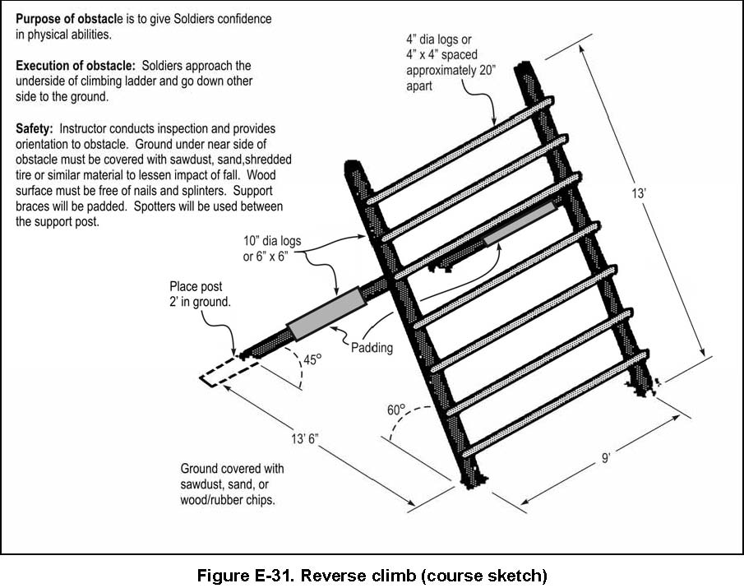

Figure C-27. Reverse climb

(17) See table C-23 and figure C-28 for “the weaver.”

Table C-23

The weaver checklist

|  |  |  |  |  |
| --- | --- | --- | --- | --- |
|  | **AREA** | **STANDARD** | **GO** | **NO GO** |
| 1 | Wood timbers | a. There are no signs of rot, warping, severe weathering, or impact damage. |  |  |
| b. All timbers meet specified dimensions as stated in engineer drawings. |  |  |
| c. There are no protruding nails or splinters that may cause injury when obstacle is negotiated. |  |  |
| d. All timbers are securely connected together without excess separation between joints. |  |  |
| e. All timbers are free of chemical coatings or substances that affect Soldier’s ability to negotiate obstacle. |  |  |
| 2 | Hardware | All bolts, nuts, and washers are in place and of the designated type and size. |  |  |
| 3 | Design | Professional safety staff reviews obstacle construction plans. |  |  |
| 4 | Base containment box | a. Base containment box is adequate for containment of absorbent material located at base of obstacle. |  |  |
| b. Containment box does not display signs of rot, damage, or instability. |  |  |
| c. Containment box is large enough to dismount from obstacle without causing injury. |  |  |
| Remarks: | | | | |

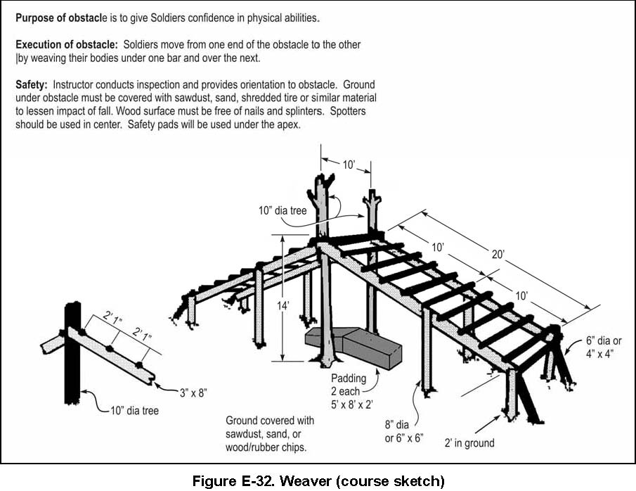

Figure C-28. The weaver

(18) See table C-24 and figure C-29 for the “balancing logs.”

Table C-24

Balancing logs checklist

|  |  |  |  |  |
| --- | --- | --- | --- | --- |
|  | **AREA** | **STANDARD** | **GO** | **NO GO** |
| 1 | Wood timbers | a. There are no signs of rot, warping, severe weathering, or impact damage. |  |  |
| b. All timbers meet specified dimensions as stated in engineer drawings. |  |  |
| c. There are no protruding nails or splinters that may cause injury when obstacle is negotiated. |  |  |
| d. All timbers are securely connected together without excess separation between joints. |  |  |
| e. All timbers are free of chemical coatings or substances that affect Soldier’s ability to negotiate obstacle. |  |  |
| 2 | Hardware | All bolts, nuts, and washers are in place and of the designated type and size. |  |  |
| 3 | Design | Professional safety staff reviews obstacle construction plans. |  |  |
| Remarks: | | | | |

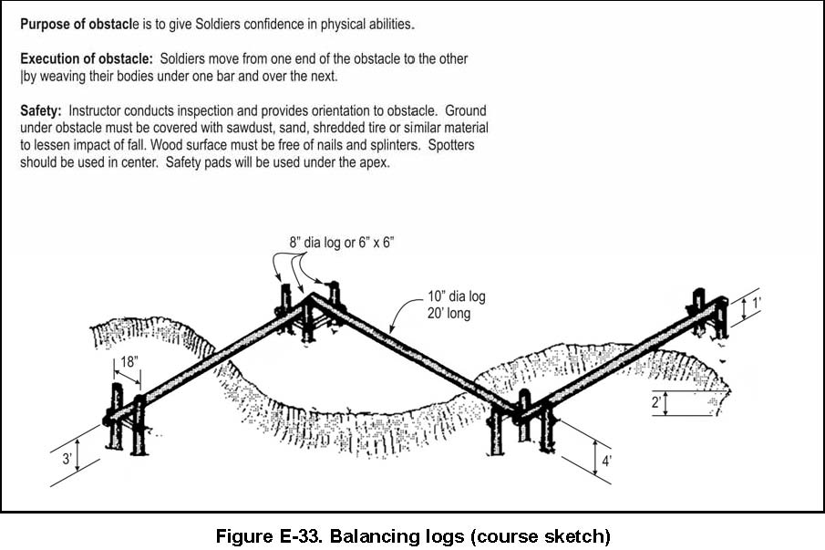

Figure C-29. Balancing logs

(19) See table C-25 and figure C-30 for the “island hoppers.”

Table C-25

Island hoppers checklist

|  |  |  |  |  |
| --- | --- | --- | --- | --- |
|  | **AREA** | **STANDARD** | **GO** | **NO GO** |
| 1 | Wood timbers | a. There are no signs of rot, warping, severe weathering, or impact damage. |  |  |
| b. All timbers meet specified dimensions as stated in engineer drawings. |  |  |
| 2 | Design | Professional safety staff reviews obstacle construction plans. |  |  |
| Remarks: | | | | |

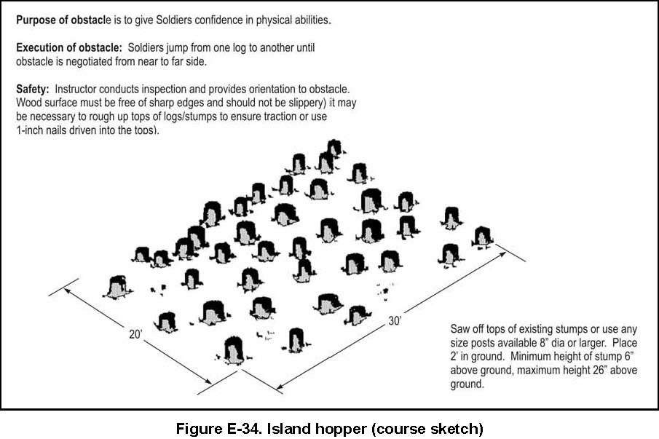

Figure C-30. Island hoppers

(20) See table C-26 for the “fitness tower.”

Table C-26

Fitness tower checklist

|  |  |  |  |  |
| --- | --- | --- | --- | --- |
|  | **Area** | **Standard** | **GO** | **NO GO** |
| 1 | Adminis-tration | Copies of engineer drawings are maintained at the local safety office/facility engineers. |  |  |
| 2 | Wood timbers | a. There are no signs of rot, warping, severe weathering, or impact damage. |  |  |
| b. All timbers meet specified dimensions as stated in engineer drawings and TRADOC Regulation 350-6. |  |  |
| c. There are no protruding nails or splinters that may cause injury when obstacle is negotiated. |  |  |
| d. All timbers are connected securely together without excess separation between joints. |  |  |
| e. All timbers are free of chemical coatings or substances that affect Soldier’s ability to negotiate obstacle. |  |  |
| 3 | Hardware | a. All bolts, nuts, and washers are in place and of the designated type and size. |  |  |
| b. All anchors are made of 3-strand galvanized guy wire. |  |  |
| c. Take-up galvanized turnbuckles are used at anchor points of each cable to allow for adjustment. |  |  |
| d. Anchor cables are not used to support obstacles not properly constructed or improperly emplaced in the ground. |  |  |
| e. All cable clamps are positioned with U-bolt placed on the dead or short end of cable. |  |  |
| f. All attachment points are tested to ensure each will support 1.5 times usage weight. |  |  |
| g. Certified rappel masters inspect all ropes used for rappelling prior to each use. |  |  |
| h. Ropes used for surmounting are all 1.5 inches in diameter. |  |  |
| 4 | Design | Professional safety staff reviews obstacle construction plans. |  |  |
| 5 | Fall protection | a. All areas in and around tower facility are covered with non-compressed wood chips, mulch, sawdust, or shredded tire rubber. |  |  |
| b. All nets designed for fall protection extend 8 feet out from point of potential fall. (See 29 CFR 1926.105 (a).) |  |  |
| c. Forged steel hooks are used to fasten net to its supports. |  |  |
| d. Nets are weight tested after initial installation and before being used as a fall protection system, whenever relocated, after major repair and every 6 months. The drop-test shall consist of 400 pound (180 kg) bag of sand 30 + or - 2 inches (76 + or - 5 cm) in diameter dropped into the net from the highest walking/working surface at which employees are exposed to fall hazards, but not from less than 42 inches (1.1 m) above that level. When the commander can demonstrate that it is unreasonable to perform the drop-test required by 29 CFR 1926.502 (c)(4)(i), the commander (or a designated competent person) shall certify that the net and net installation is in compliance with 29 CFR 1926.502(c)(4)(i) by preparing a certification record prior to the net being used as a fall protection system. The certification record must include an identification of the net and net installation for which the certification record is being prepared; the date that it was determined that the identified net and net installation were in compliance with 29 CFR 1926.502 (c)(3) and the signature of the person making the determination and certification. The most recent certification record for each net and net installation shall be available at the training site for inspection. |  |  |
| e. Nets with padding are placed beneath all suspended bridges. |  |  |
|  |  |  |  |  |

**Table C-26**

**Fitness tower checklist, continued**

|  |  |  |  |  |
| --- | --- | --- | --- | --- |
|  | **AREA** | **STANDARD** | **GO** | **NO GO** |
| 6 | Rappel-ling | a. Instructors working at the top of tower are secured to tower with fall arrest system/attached harness. |  |  |
| b. Only certified and current rappel masters conduct rappel operations. |  |  |
| c. All anchor points have been tested to a minimum of 5,400 pounds dead weight. (29 CFR 1926.104 (b)) |  |  |
| d. All anchor points are secure and free of damage. |  |  |
| e. Top edge of rappel wall is padded to protect rope from cuts or abrasion. |  |  |
| f. Protective padding at top of rappel wall is tightly secured on all edges. |  |  |
| g. Rappel wallboards are free of damage, rot, protruding nails, and secured to tower with proper hardware. |  |  |
| h. Rappel landing area is free of obstructions and hazards. |  |  |
| i. Landing areas extends an uninterrupted distance of 15 feet from base of tower. |  |  |
| j. Landing area is cushioned with 24 inches of noncompressed wood chips, mulch, sawdust, 18 inches of sand, or 12 inches of shredded tire rubber. |  |  |
| k. Landing area cushioning material held in place by a containment barrier (timbers/sand bags). |  |  |
| 7 | Ladders | a. All ladders are inspected for structural integrity. |  |  |
| b. Rungs spacing on ladders do not exceed 36 inches. |  |  |
| c. Nets are placed under all rope bridges. |  |  |
| d. Nets are weight tested after initial installation and before being used as a fall protection system, whenever relocated, after major repair and every 6 months. The drop-test shall consist of 400 pound (180 kg) bag of sand 30 + or - 2 inches (76 + or - 5 cm) in diameter dropped into the net from the highest walking/working surface at which employees are exposed to fall hazards, but not from less than 42 inches (1.1 m) above that level. When the commander can demonstrate that it is unreasonable to perform the drop-test required by 29 CFR 1926.502 (c)(4)(i), the commander (or a designated competent person) shall certify that the net and net installation is in compliance with 29 CFR 1926.502(c)(4)(i) by preparing a certification record prior to the net being used as a fall protection system. The certification record must include an identification of the net and net installation for which the certification record is being prepared; the date that it was determined that the identified net and net installation were in compliance with 29 CFR 1926.502 (c)(3) and the signature of the person making the determination and certification. The most recent certification record for each net and net installation shall be available at the training site for inspection. |  |  |
| e. Nets used for fall protection have padding installed to prevent limbs from passing through webbing. |  |  |
| Remarks: | | | | |

**C-5. Fall Protection**

a. Fall protection will be provided for those obstacles designated as high, or have the ability to cause injury during a fall, or required by design.

b. The areas under and around obstacles will be covered with an impact reducing material appropriate for preventing serious injury in the event a Soldier falls while negotiating subject obstacle.

c. When purchasing fall protection equipment required for an obstacle, installations will ensure equipment meets or exceeds standards without creating a greater hazard. Where impact-reducing material is required, sand, wood chips, saw dust, or shredded tire rubber is sufficient.

d. Below are required essential items of fall protection, identified by obstacle.

(1) “The tough one”

(a) Wood chips/sand/or shredded rubber beneath obstacle.

(b) Pole vault safety pad placed at base of obstacle.

(c) Safety net placed beneath obstacle, extended 8 feet out from point of potential fall. All netting will be rated for outside use and meet OSHA specifications for fall protection.

(d) Eye bolt or hook for instructor safety harness positioned at top of obstacle.

(2) “Inverted rope descent/slide for life”

(a) Instructor platform with eye bolt or metal hook to secure safety harness.

(b) Net placed beneath the length of descent rope.

(c) Padding placed on net beneath descent rope.

(d) Pads at end of net near release point.

(e) Pole vault pad at the base of release point.

(f) The area under and around (minimum of 6 feet) obstacles covered with impact reducing material.

(3) “Confidenceclimb”

(a) Eye bolt or hook for instructor’s safety harness at top of obstacle.

(b) Pole vault padding on both sides at base of obstacle (4 each @ 5 feet x 8 feet x 2 feet).

(c) Ground around base of obstacle covered with impact reducing material.

(4) “Skyscraper”

(a) Pole vault padding at base of tower.

(b) Netting extended from first level (optional).

(5) “Belly robber” Ground beneath obstacle covered with impact reducing material.

(6) “The Tarzan” Ground beneath obstacle covered with impact reducing material.

(7) “Low belly over”

(a) Ground covered with impact reducing material.

(b) Tops of side rails covered with padding.

(8) “The dirty name”

(a) Padding on tops of upper side braces.

(b) Ground beneath obstacle covered with impact reducing material.

(9) “The tough nut” Ground beneath obstacle covered with impact reducing material (optional).

(10) “Belly crawl” Ground beneath obstacle covered with impact reducing material.

(11) “Inclining wall” Ground beneath obstacle covered with impact reducing material.

(12) “High step over” Ground beneath obstacle covered with impact reducing material.

(13) “Swing, stop, and jump”

(a) Padding on tops of front support logs.

(b) Ground beneath obstacle covered with impact reducing material.

(14) “Six vaults” Ground beneath obstacle covered with impact reducing material.

(15) “Easy balancer” Ground beneath obstacle covered with impact reducing material.

(16) “Low wire” Ground beneath obstacle covered with impact reducing material.

(17) “The belly buster” Ground beneath obstacle covered with impact reducing material.

(18) “Hip-hip” Ground beneath obstacle covered with impact reducing material.

(19) “Reverse climb”

(a) Padding on the tops of rear support logs.

(b) Ground beneath obstacle covered with impact reducing material.

(20) “The weaver”

(a) Pole vault padding beneath center of obstacle.

(b) Ground beneath obstacle covered with impact reducing material.

(21) “Balancing logs” Ground beneath obstacle covered with impact reducing material.

(22) “Island hopper”Ground beneath obstacle covered with impact reducing material.

e. Safety equipment (nets, pads, and ground covering) should be procured from reliable sources. If shredded rubber is used, get samples prior to purchasing. Several companies are selling shredded rubber contaminated with petroleum products that may cause allergic reaction in some people, and tires with steel belts that may cause cuts and abrasions. When procuring netting, ensure provider includes design specifications and usage restrictions.

f. To ensure maximum life of safety equipment, inspect on a regular interval, store away from extreme weather conditions when possible, and maintain equipment using hardware and materials recognized by American National Standards.

g. See figure C-31 for required obstacle information.

**Obstacle information**

Total number of obstacles: ______________

Number of standard obstacles: _______________

Number of nonstandard obstacles: _______________

Number of modified obstacles: _______

Total injuries occurring at each obstacle course:

Remarks:

Figure C-31 Obstacle Information

# Appendix D

# Rappel Tower Site Inspection Criteria

D-1. Rappel tower site inspection criteria

The minimum inspection criteria for towers and other facilities utilized for military rappelling training is shown in figure D-1 and table D-1.

Name, title, organization, and phone number of inspectors:

Date of inspection:

Name and location of tower:

Date of tower construction:

Built by:

Owned by:

Last date of any MAJOR modifications:

(If applicable, list modification, and by who performed, in addition to date; otherwise state not applicable.)

Date of previous inspection:

Name, title, and organization of previous inspector:

Is a copy of previous inspection available?

Name, title, organization, and phone number of local point of contact:

Date of last structural inspection:

Date of last anchor point load test:

Signature of inspectors:

Figure D-1. Rappel tower site inspection information

Table D-1

Rappel tower inspection criteria checklist

|  |  |  |  |  |  |
| --- | --- | --- | --- | --- | --- |
|  | **AREA** | **STANDARD** | **YES** | **NO** | **NA** |
| 1 | Inspect | a. Is the tower structurally sound?  Do structural support members appear serviceable, free from deterioration, breaks, or damage? |  |  |  |
| b. Are there any signs of insect infestation? [29 CFR 1910.141(a)(5)] |  |  |  |
| c. Are bolts that connect structural members or support cables serviceable and properly connected/tightened? |  |  |  |
| d. Are stairs or ladders firmly attached to the tower? |  |  |  |
| e. Do stairs/fixed ladders comply with OSHA standards? [29 CFR 1910.24 and 29 CFR 1910.27] |  |  |  |
| f. Are all areas marked in yellow that pose a potential trip hazard or head hazard? [29 CFR 1910.144(a)(3)] |  |  |  |
| g. Are the tower platform and all rappel rope stations accessible without having to climb over any obstacles (guard rails, support cables, etc.)? |  |  |  |
| h. Is the tower deck free of slip/trip hazards such as water, protruding nails/bolts/splinters, loose equipment, etc.? [29 CFR 1910.141(a)(3)(ii) and 29 CFR 1910.141(a)(3)(iii)] |  |  |  |
| i. Are the tower deck and any open areas (above 4’) not actively being used for rappelling, guarded with guardrails? [29 CFR 1910.23(c)(1)] |  |  |  |
| j. Are all guard rails a minimum of 42” high and capable of withstanding a side force of 200 pounds? [29 CFR 1910.23(e)(1) and 29 CFR 1910.23(e)(3)(iv)] |  |  |  |
| k. Are toe boards or similar barriers installed in all areas where personnel could pass underneath? [29 CFR 1910.23(c)(1)] |  |  |  |
| l. Do all tower rope stations have primary and secondary anchor points? |  |  |  |
| m. Are all anchor points in serviceable condition and free of corrosion, sharp edges, burrs, or grooves that could cut or damage ropes? |  |  |  |
| n. Have all anchor points been designed to ensure that they will accommodate a dead weight of at least 5400 pounds for each Soldier attached?  [29 CFR 1926.104, (b)] |  |  |  |
| o. Is the rappel wall face area free of protruding nails, bolts, or splinters? |  |  |  |
| p. Is the rappel wall face area free of broken, loose, decayed, or missing boards? |  |  |  |
| q. Is padding material in place on all edges that ropes and/or personnel cross? |  |  |  |
| r. Is the edge padding in good condition and securely fastened? |  |  |  |
| s. Is the edge padding free from protruding nails, bolts, or other fasteners that could fray or cut ropes or injure rappellers? |  |  |  |
| t. Are all structural areas of the tower properly padded that a rappeller might contact during rappel operations? |  |  |  |
| u. Is the structural padding in serviceable condition, securely fastened, and free from protruding nails, bolts, or fasteners? |  |  |  |
| v. Is the landing area free of obstructions and hazards? |  |  |  |
| w. Does the landing area extend an uninterrupted distance of 15 feet from the tower base and at least 2 feet beyond the width of the base with cushioning material in the event of a fall? |  |  |  |
| x. Is the landing area adequately cushioned in case of a fall (24 inches of non-compressed wood chips, mulch, or sawdust; 12 inches of commercially produced shredded rubber; or safety pads that offer similar fall protection)? |  |  |  |
| y. Has the cushioning material in the landing area been loosened up prior to use and, if large numbers of students are rappelling, are procedures in place and equipment available to loosen it up again during training? |  |  |  |

**Table D-1**

**Rappel tower inspection criteria checklist, continued**

|  |  |  |  |  |  |
| --- | --- | --- | --- | --- | --- |
|  | **AREA** | **STANDARD** | **YES** | **NO** | **NA** |
| 2 | Physical security and fire protection criteria | a. Is there a positive locking device on the ladder/steps or a locked fence around the tower that denies unauthorized access to the tower? |  |  |  |
| b. Is there a prominently displayed warning sign that discourages unauthorized use of the tower (for example, WARNING: OFF LIMITS TO UNAUTHORIZED PERSONNEL)? |  |  |  |
| c. Are NO SMOKING signs posted at the tower to preclude potential ignition of cushioning materials? |  |  |  |
| 3 | Risk Manage-ment and training considera-tions | a. Is there a current risk management worksheet on file and available onsite? |  |  |  |
| b. Has the risk management worksheet been reviewed, approved, and signed at the appropriate level? |  |  |  |
| c. Is the tower within 1 hour of an advanced trauma life support facility? |  |  |  |
| d. Are certified combat life support or medical personnel and a dedicated medical vehicle onsite to render emergency medical aid and evacuation, if required? |  |  |  |
| e. Is training conducted in accordance with Training Circular 21-24 and the appropriate TSP? |  |  |  |
| f. Is there a current SOP available that delineates requirements for instructors, students, support personnel, and other requirements? |  |  |  |
| g. Are properly “certified” instructors available to conduct rappel training? (**IF NO, DO NOT CONDUCT RAPPEL TRAINING!)**  Name(s):  Location and date of certification: |  |  |  |
| 4 | Ropes and equipment | a. Are rappel ropes serviceable and properly inspected and stored? |  |  |  |
| b. Are rope inspections and usage properly documented on DA Form 5752-R (Rope Log (Usage and History))? |  |  |  |
| c. Are snap links serviceable (no excessive rust, sharp edges, improper gate opening and closing, excessive pin movement, missing pins, etc.)? |  |  |  |
| d. Are properly sized, serviceable, heavy leather gloves, and protective headgear available for rappellers? |  |  |  |

# Appendix E

# Quantitative Measures

The purpose of the Table E-1 is to quantitatively measure the overall effectiveness of management controls for integrating the Army Safety Program into business processes and mission execution.

Table E-1

Quantitative Measures for integrating the Army Safety Program



**Notes:**

1. Compliance with evaluation criteria is rated on a scale of 0 to 4. A rating of 4 indicates best practices a new gold standard, a rating of 3 indicates all aspects of requirements are met, a rating of 2 indicates key, but not all, requirements are met, a rating of 1 indicates lesser, but not key, requirements are met, and a rating of 0 indicates the program failed to meet any significant requirements.

2. The table shown depicts how the rating for each program element (PE) and the overall assessment is automatically calculated as each category is scored.

3. The legend at the top right of the appendix gives an example of how to calculate the assessment rating manually. The rating, column I for each PE is calculated by adding columns C through G then dividing the total/number, column H by the number of questions in column B.

4. Using PE 1 of this appendix for example if there is a total of three Best Practice/New Gold Standard in column C that number is multiplied by four equaling twelve. Repeat this procedure for each category in PE 1. As the columns are populated place the total in column H then divide by the number of questions in column B. The rating in column I for that PE is calculated and color coded.

5. To calculate N/A answers adjust the number questions in column B for that PE to reflect lessor that amount when dividing the total. For instance if there are 25 questions for that PE and you have 10 N/As then the total number of questions is now 15. In circumstances when a whole PE is N/A then place –N/A (PE 1-N/A) in column A next to PE 1 and leave columns B through H blank.

6. For N/A answer on the active excel worksheet place a zero in total/number column H so no to lose the formula and repeat note 5. A division error (#DIV/0!) for the PE in rating column I will appear but that’s ok it does not affect the overall rating. If a new process or procedure require checklist(s) items for that PE be answered then fill in the columns accordingly. When working with the active excel worksheet fill columns C through G first then number of questions in column B.

7. To get the overall assessment rating (row 36) as the table is populated repeat procedures adding columns C through G then dividing the total/number column H by the grand number of questions in column B. Remember adjust the number of N/A questions in column B to lessor the original amount if required.

# Glossary

**Section I**

**Abbreviations**

ADSO additional duty safety officer

AIT advanced individual training

ANSI American National Standards Institute

AR Army Regulation

ARA Army radiation authorizations

ASO aviation safety officer

CDSO collateral duty safety officer

CFR Code of Federal Regulations

CLS combat lifesaver

DA Department of the Army

DA Pam Department of the Army Pamphlet

DOD Department of Defense

DODI Department of Defense Instruction

DVD digital versatile disc

FM field manual

IMT initial military training

LASER Light Amplification by Stimulated Emission of Radiation

NCO noncommissioned officer

NRC Nuclear Regulatory Commission

OHR operational hazard report

OPM Office of Personnel Management

OSHA Occupational Safety and Health Act

POV privately owned vehicle

QASAS quality assurance specialist ammunition surveillance

RAC risk assessment code

RFR radiofrequency radiation

SOHAC Safety and Occupational Health Advisory Council

SOP standard operating procedure

SSRA System Safety Risk Assessment

TDA table of distribution and allowance

TRADOC U.S. Army Training and Doctrine Command

TSP training support package

USACRC U.S. Army Combat Readiness Center

**Section II**

**Terms**

**Branch proponent**

The service school that has primary responsibility for developing concepts, doctrine, tactics, training, techniques, procedures, organizational designs, and materiel requirements for a particular branch in the Army.

**branch safety proponency**

School commandants are the safety officers for their branch, responsible for integrating safety into the development and employment of service school products (for example, doctrine, organizations, training, materiel, leadership and education, personnel, and facilities) and monitoring safety performance of branch units and proponent materiel systems worldwide.

**explosives**

All items of ammunition; propellants, liquid and solid; high and low yield explosives; pyrotechnics; and substances associated with the foregoing that present real and potential hazards to life or property. The term includes any device or assembly of devices that contains an explosive material. Examples are bombs, guided or unguided; water and land mines; depth charges; non-nuclear warheads; explosive-loaded projectiles; explosive components of aircrew escape systems; missile propellants; unguided missiles; pyrotechnic, illuminating, and signaling devices; and cartridge-actuated tools, such as stud drivers.

**manpower and personnel integration**

A comprehensive management and technical program to enhance human performance and reliability in the operation, maintenance, and use of weapon systems and equipment. Manpower and personnel integration achieves this objective by integrating the full range of human factors--engineering, manpower, personnel, training, system safety, and health hazard consideration--into the materiel development.

**residual hazard**

A hazard that was not eliminated by design.

**residual risk**

Expected loss from a residual hazard. The risk remaining after one or more cycles of risk reduction efforts.

**risk**

An expected loss or danger resulting from a hazard. Risk is expressed in terms of estimated severity and probability of injury or damage. Over time, uncontrolled HIGH level risks will produce high levels of loss.

**risk acceptance**

A formal or implied decision to accept the consequences of a risk based on a risk assessment.

**risk assessment**

Evaluation of expected consequences of a risk against the benefits to gain from accepting the risk.

**risk management**

Making trade off decisions between potential/expected loss/injury versus the mission benefit of accepting the residual risk. Risk management supports the commander's overall estimate and decision-making process. The objective is to accomplish the mission safely by identifying and eliminating unnecessary risk.

**safety assessment report**

A formal, comprehensive summary of the safety data collected during the design and development of a system. It includes the hazard potential of the item; provides risk assessments; and recommends procedures or other corrective actions to reduce the exposure or consequences of these hazards.

**safety awareness**

A consciousness of hazards, and the knowledge to avoid them or minimize their effect. Safety awareness training gives leaders the knowledge and motivation to accomplish the mission, while not unnecessarily jeopardizing the lives of personnel or readiness of equipment. Safety awareness leads to a proactive approach that uses risk management to evaluate the risks and eliminate those with inadequate benefits.

**safety lesson learned**

A safety or health-related warning, based on experience, which can be applied to current and future operations and systems to prevent recurrence of the hazard.

**system safety risk assessment (SSRA)**

A document that comprehensively evaluates the residual risks of an operation, activity, or materiel system and documents their acceptance by the materiel developer and combat developer.

**Section III**

**Special Abbreviations and Terms**

This section contains no entries.