**Department of the Army *TRADOC Regulation 350-18**

**Headquarters, United States Army**

**Training and Doctrine Command**

**Fort Eustis, VA 23604-5700**

**1 May 2018**

**Training**

**THE ARMY SCHOOL SYSTEM (TASS)**

FOR THE COMMANDER:

OFFICIAL: PAUL M. BENENATI

Major General, U.S. Army

Deputy Chief of Staff



BRETT E. REISTER

COL, U.S. Army

Acting Deputy Chief of Staff, G-6

**History**. This publication is a major revision. The portions affected by this revision are listed in the summary of change.

**Summary**. This regulation prescribes policy and guidance for The Army School System (TASS).

**Applicability**. This regulation applies to Regular Army (RA), Army National Guard (ARNG), and U.S. Army Reserve (USAR) agencies responsible for managing or conducting training and education courses.

**Proponent and exception authority.** The proponent of this regulation is the Deputy Chief of Staff (DCS), G-3/5/7, Training Operations Management Activity (TOMA). The proponent has authority to approve exceptions or waivers to this regulation consistent with controlling law and regulation. The proponent may delegate this authority in writing, to a subordinate division chief

*This regulation supersedes TRADOC Regulation 350-18, dated 21 July 2010.

in the grade of Colonel or the civilian equivalent. Activities may request a waiver to this regulation by providing justification that includes a full analysis of the expected benefits and must include formal review by the activity’s senior legal officer. All waiver requests will be endorsed by the commander or senior leader of the requesting activity and forwarded through their higher headquarters to the policy proponent. Overseas commands with USAR schools should forward exceptions through the United States Army Reserve Command (USARC) DCS, G-3/5/7 to U.S. Army Training and Doctrine Command (TRADOC), DCS, G-3/5/7.

**Management control process**. This regulation follows applicable requirements of Army Regulation (AR) 11-2, Managers' Internal Control Program.

**Supplementation**. Supplementation of this regulation and establishment of command and local forms are prohibited without prior approval from the DCS, G-3/5/7, Building 950, Jefferson Avenue, Fort Eustis, VA 23604.

**Suggested improvements**. Submit suggestions for improving this publication on Department of the Army (DA) Form 2028 (Recommended Changes to Publications and Blank Forms) through channels to DCS, G-3/5/7, TOMA, (ATTG-TRI-MA), Building 950, Jefferson Avenue, Fort Eustis, VA 23604.

**Distribution**. The TRADOC publication is approved for public distribution and is available on the TRADOC Administrative Publications homepage at <http://adminpubs.tradoc.army.mil>.

**Summary of Change**

TRADOC Regulation 350-18

The Army School System

This major revision, dated 1 May 2018–

o Changes the proponent of this regulation from Reserve Component Training Integration Directorate to Deputy Chief of Staff, G-3/5/7, Training Operations Management Activity.

o Updates references, terminology, and organization titles throughout the publication.

o Updates organization and functional alignments (table 1-1).

o Updates names and responsibilities of Deputy Chief of Staff, G-3/5/7 directorates based on United States Army Training and Doctrine Command reorganization and reallocation of duties and responsibilities (para 2-3).

o Updates responsibilities in accordance with alignment to the Combined Arms Center and Army University (para 2-4 and para 2-5).

o Clarifies process to authorize Reserve Component schools to add military occupational specialty-transition, additional skill identifier / special qualification identifier, and functional courses on a one-time or permanent basis (para 3-5d).

o Adds process to conduct a pilot class/course (para 3-5e).

o Adds requirement for training proponents to issue instructor certification documents within 30 days of receiving the completed packet from the Reserve Component school (para 3-8b).

o Updates instructional products requisitioning (para 3-10).

o Updates the Training Coordination Council Workshop process (para 3-15).

o Re-institutes Training and Doctrine Command Form 350-18-2-R-E, Pre-Execution Checklist (Appendix G), for all schools under The Army School System; replaced by Army Training Requirements and Resources System automated Post Reservation Checklist (para 3-22a) for all Reserve Component units and Soldiers.

o Clarifies that the Post Reservation Checklist is automated and does not require printing or commander signature (para 3-22a).

o Adjusts timeframe to provide documentary evidence of security clearance, physical profile, and other non-routine prerequisites at the start of training (para 3-22d(1)).

o Removes requirement for disinterested individuals for appeal authorities in the student dismissal and appeals process and changes retention of student following appeals (para 3-30).

o Adds Chap 3, Section III, “TASS Training Courses”.

o Removes chap on Warrant Officer Education System Courses.

o Updates instructor qualification/certification process (para 4-3).

o Adds Chap 4, Section III, “One Army School System”.

o Adds Institutional Training Common Operation Picture (para 4-17).

o Changes Appendix B from Instructions for Training and Doctrine Command Form 350-18-1 to “Proponent Schoolhouse role in Army Total Force Policy and One Army School System”.

o Updates Appendix C, “TRADOC TASS Readiness Reporting System (TTRRS)”.

o Adds Appendix D, “The ATSC Online Ordering System”.

o Adds Appendix E, “Suggested School SOP Content/Format”.

o Adds Appendix F, “Suggested Student Dismissal Memorandums”.

o Adds Appendix G, “TRADOC Form 350-18-2-R-E (Pre-Execution Checklist (PEC))”.

o Adds Appendix H, “ATRRS Functions (OASS)”.

o Adds Appendix I, “One Army Training Management Forum (OATMF)”.

**Contents**

**Page**

Chapter 1 Introduction 9

1-1. Purpose 9

1-2. References 9

1-3. Explanation of Abbreviations and Terms 9

1-4. The Army School System (TASS) 9

1-5. TASS Organization 10

Chapter 2 Responsibilities 12

2-1. Commanding General (CG), United States (U.S.) Army Training and Doctrine Command (TRADOC) 12

2-2. Deputy Chief of Staff (DCS), G-3/5/7 13

2-3. DCS, G-3/5/7 Staff Directorates 13

2-4. Commander, Combined Arms Center 15

2-5. Army University 15

2-6. Proponent Commandants 16

2-7. Commander, Human Resources Command (HRC) 17

2-8. Commanders, OCONUS Commands (U.S. Army, Europe and U.S. Army, Pacific) 18

2-9. Director, Army National Guard (ARNG) 18

2-10. The Adjutant General (TAG) in each State 19

2-11. Commander, United States Army Reserve (USAR) Command (USARC) 19

2-12. Commanders, TASS Training Divisions 20

2-13. Commanders, TASS Training Regiments/Brigades 21

2-14. Commanders, TASS Training Centers 21

2-15. Commanders, Multifunctional Training Brigades (MFTBs) and Detachments 22

2-16. Commanders, RC Schools 22

Chapter 3 TASS Management 23

Section I Procedures 23

3-1. General 23

3-2. School standard operating procedures (SOPs) 23

3-3. Soldier Safety and Force Protection 24

3-4. Risk Assessment and Management 24

3-5. Conduct of Institutional Training and Education 24

3-6. Military occupational specialty (MOS) -transition (MOS-T) (Reclassification) 27

3-7. The Army Training System Courseware 27

3-8. Instructor Qualification and Certification 27

3-9. Instructor Grade and Experience Requirements 28

3-10. Instructional Products and Training Aids Requisitioning 28

3-11. Reproduction and Distribution 32

3-12. Test Control Procedures 32

3-13. Attendance Register 32

3-14. Maintenance of Training Support Records 33

3-15. Training Coordination Council Workshop (TCCW) 33

3-16. Army Training Requirements and Resources System (ATRRS) 34

3-17. Training and Education Resources 35

Section II Student Administration 38

3-18. Selection 38

3-19. Orders 38

3-20. Student Orientation Information 38

3-21. Physical Fitness/Weight Control 39

3-22. Enrollment and Attachment 40

3-23. Procedures for Transfer between Schools 41

3-24. Academic Retest 41

3-25. Student Academic Records 41

3-26. Student Assessments 42

3-27. Service School Academic Evaluation Report (Department of the Army (DA) Form 42

1059) 42

3-28. Student Recognition 42

3-29. Notice of Academic Removal, Denied Enrollment, or Withdrawal 43

3-30. Student Dismissal and Appeal Process 43

3-31. Recycle Policy 44

3-32. Requirements for Successful Completion 44

3-33. Constructive/Equivalent/Course/Operational Credit 44

Section III TASS Training Courses 46

3-34. Noncommissioned Education System (NCOES) Courses 46

3-35. Officer Education System (OES) Courses 46

3-36. Functional Training 46

3-37. MOS-T Course Proponent 46

3-38. Foreign Language Training 46

Chapter 4 Training and Education 47

Section I General 47

4-1. Training and Education Programs 47

4-2. Establishment and Continuance of Courses 47

4-3. Instructor Qualification/Certification 47

4-4. Visitor Folders 47

4-5. Instructor Folder 47

Section II Annual Training (AT)/Active Duty for Training (ADT) 48

4-6. AT/ADT Guidelines 48

4-7. Training Site Selection 48

Section III One Army School System 49

4-8. General 49

4-9. One Army School System (OASS) Compliant Definition 50

4-10. Equivalency 50

4-11. Responsibilities 51

4-12. MOS-T (Reclassification) 51

4-13. OASS Flag Procedures 51

4-14. OASS Scheduling Procedures 52

4-15. ATRRS Functions 52

4-16. Accreditation 52

4-17. Institutional Training Common Operational Picture (ITCOP) 52

4-18. TASS Review 53

4-19. Multi-component schools 53

Appendix A References 54

Appendix B Proponent Schoolhouse role in Army Total Force Policy and One Army School System 59

Appendix C TRADOC TASS Readiness Reporting System (TTRRS) 63

Appendix D The Army Training Support Center (ATSC) Online Ordering System 64

Appendix E Suggested School SOP Content/Format 69

Appendix F Suggested Student Dismissal Memorandums 72

Appendix G TRADOC Form 350-18-2-R-E (Pre-Execution Checklist (PEC)) 76

Appendix H ATRRS Functions (OASS) 78

Appendix I One Army Training Management Forum (OATMF) 78

Glossary 79

**Figure List**

Figure 3-1. Sample TRADOC Form 270-R-E 33

Figure B‐1. The Regimental School System 61

Figure D-1. ATSC Online Ordering logon page sample 65

Figure D-2. Account/User Information sample 65

Figure D-3. Courseware search sample 66

Figure D-4. Courseware selection sample 66

Figure D-5. Shopping Cart sample 67

Figure D-6. Step 1 Review Selected Products sample 67

Figure D-7. Step 2 Check Out, verify shipping address sample 68

Figure D-8. Step 3 Check Out, Adjust, Review & Submit Order sample 69

Figure F-1. Example Dismissal Memorandum to Student 72

Figure F-2. Example Student Dismissal Memorandum to General Officer 73

Figure F-3. Example Referred Report 74

Figure F-4. Example Student Dismissal with Appeal Option 75

Figure G-1. Sample TRADOC Form 350-18-2-R-E 76

**Table List**

Table 1-1 Functional Area Alignment 11

**This page intentionally left blank**

# Chapter 1 Introduction

## 1-1. Purpose

This regulation establishes policy, guidance, and procedures for the operation, administration, training and education support of The Army School System (TASS) schools/organizations.

## 1-2. References

Required and related publications and prescribed and referenced forms are listed in Appendix A.

## 1-3. Explanation of Abbreviations and Terms

Abbreviations used in this regulation are defined in the Glossary.

For the purpose of this regulation, the term "training" may be used throughout as a generic term to also include policy and guidance that applies equally to educationally focused units, institutions, schools, and courses.

## 1-4. The Army School System (TASS)

a. TASS is a composite school system made up of Regular Army (RA), Army National Guard (ARNG), United States (U.S.) Army Reserve (USAR), and Army civilian institutional training systems. TASS conducts initial military training (Basic Combat Training, Advanced Individual Training, One Station Unit Training, Basic Officer Leader Course (A and B)); reclassification training (military occupational specialty-transition (MOS-T)); officer, warrant officer, noncommissioned officer (NCO) and Army civilian professional development training and education (Officer Education System (OES), Warrant Officer (WO) Education System (WOES), NCO Education System (NCOES), and Civilian Education System); and functional training (ASI, Skill Qualification Identifier (SQI), Skill Identifier, and Language Identification Code). This is accomplished through standard resident, distributed learning (DL), and blended learning (combination of resident and DL) courses. Reserve Component (RC) TASS units are functionally aligned and linked to appropriate training proponents.

b. Reference Army Regulation (AR) 350-1, paragraph 3-3 for Headquarters, Department of the Army (HQDA) policy regarding TASS.

c. The Army proponents include U.S. Army Training and Doctrine Command (TRADOC) proponent schools and non-TRADOC proponent schools (example non-TRADOC proponent school: Army Medical Department Center and School).

d. The proponents serve as a link to RC TASS schools. This link ensures quality assurance (QA), instructor certification, The Army Training System (TATS) courseware availability, use of the Analysis, Design, Development, Implementation, and Evaluation (ADDIE) curriculum design method, and a DL strategy. TATS courseware ensures all Army Soldiers, regardless of component, are trained to the same standard on all critical tasks, regardless of which TASS school conducts the training or education.

e. TASS training requirements and education missions are validated during the Structure and Manning Decision Review (SMDR) process, published in the Army Program for Individual Training (ARPRINT), and documented in Army Training Requirements and Resources System (ATRRS).

f. Some TASS schools and units focus on education solutions while others focus on training. Many TASS units use a combination of training and education.

## 1-5. TASS Organization

a. Deputy Chief of Staff (DCS), G-3/5/7. Paragraph 2-2 of this regulation delineates responsibilities for the DCS, G-3/5/7. This organization is located at Headquarters (HQ), TRADOC and staffed by RA, Department of the Army (DA) civilians, ARNG, and USAR personnel.

b. Training Operations Management Activity (TOMA). Paragraph 2-3.a. of this regulation delineates duties for TOMA. This organization is located at HQ, TRADOC and staffed by RA, DA civilians, ARNG, and USAR personnel.

c. Proponents. AR 350-1, AR 5-22, and TRADOC Regulation (TR) 350-70 prescribe policy for proponents. The Training and Education Developers Toolbox (TED-T) website identifies TRADOC training and education proponents.

d. The National Guard Bureau is the resourcing and missioning agency for 50 States, the territories of Guam, the Virgin Islands, and Puerto Rico, as well as of the District of Columbia. The Adjutant General (TAG) in each State has command responsibility for ARNG schools and provides mission command of the ARNG TASS schools within their state/territory.

e. The National Guard Professional Education Center is the proponent for all ARNG unique training under School Code 922 and provides proponent-approved course material, assistance, assessment, and instructor certification for ARNG unique training.

f. The 80th Training Command (TC) (USAR) provides mission command through the TASS Training Divisions to the USAR TASS schools. The 83rd USAR Readiness Training Center provides mission command of the USAR NCO Academies (NCOAs).

g. Functional Area Alignment. The ARNG and United States Army Reserve Command (USARC) training regiments (REGTs)/brigades (BDEs) are directly linked for coordination with functionally aligned TRADOC and non-TRADOC proponents for course material, QA, accreditation, and instructor certification. They are responsible for training specified maneuver, fires and effects, Operations Support, and Force Sustainment MOS-T, Advanced Leaders Courses (ALCs), and Senior Leaders Courses (SLCs), based upon their operational warfighting roles and responsibilities (Table 1-1). They also conduct Basic Leader Course (BLC) and Master Leader Course.

Table 1-1

Functional Area Alignment

|  |  |  |  |  |  |  |  |
| --- | --- | --- | --- | --- | --- | --- | --- |
|  | ARNG | | |  | USAR | | |
|  | MOS-T | ALC | SLC |  | MOS-T | ALC | SLC |
| Maneuver Fires and Effects |  |  |  |  |  |  |  |
| ARMOR | X | X | X |  |  |  |  |
| INFANTRY | X | X | X |  |  |  |  |
| AVIATION | X | X | X |  |  |  |  |
| FIELD ARTILLERY | X | X | X |  |  |  |  |
| AIR DEFENSE ARTILLERY | X | X | X |  |  |  |  |
| ENGINEER | X | X | X |  | X | X | X |
| CHEMICAL, BIOLOGICAL, RADIOLOGICAL, AND NUCLEAR |  |  |  |  | X | X | X |
| MILITARY POLICE | X |  |  |  | X | X | X |
| SPECIAL FORCES |  |  |  |  |  |  |  |
| CIVIL AFFAIRS /PSYCHOLOGICAL OPERATIONS |  |  |  |  | X | X |  |
|  |  |  |  |  |  |  |  |
| Operations Support |  |  |  |  |  |  |  |
| SIGNAL CORPS | X | X |  |  | X | X | X |
| CYBER |  |  |  |  |  |  |  |
| MILITARY INTELLIGENCE | X | X | X |  | X | X | X |
|  |  |  |  |  |  |  |  |
| Force Sustainment |  |  |  |  |  |  |  |
| TRANSPORTATION CORPS | X |  |  |  | X | X | X |
| ORDNANCE | X | X | X |  | X | X | X |
| QUARTERMASTER | X |  |  |  | X | X | X |
| ADJUTANT GENERAL |  |  |  |  | X | X | X |
| FINANCE |  |  |  |  | X | X | X |
| HEALTH SERVICES | X |  |  |  | X | X | X |
| CHAPLAIN |  |  |  |  | X | X | X |
| JUDGE ADVOCATE GENERAL |  |  |  |  |  |  |  |

(1) ARNG Regional Training Institutions are subordinate to the respective TAG and are responsible for their ARNG TASS schools.

(2) USAR TASS BDEs are subordinate to the 80th TC (TASS) Divisions with responsibility for aligned USAR TASS battalions (BNs). OES BNs are aligned to a USAR TASS BDE subordinate to the 80th TC (TASS). USAR NCOAs are subordinate to the 83rd USAR Readiness Training Center and report to the 100th Training Division (Leader Development) a subordinate division of the 80th TC.

h. Multifunctional Training Brigades (MFTBs) are located outside the continental United States (OCONUS). These TASS training units present unique situations because of their lack of proximity to other training facilities. They offer officer and noncommissioned officer professional development courses and MOS-T to all components of the Army. MFTBs are subject to the same accreditation standards as other TASS schools. MFTBs follow the operational procedures and requirements of this regulation. MFTBs are functionally aligned with the proponents of the courses they train.

(1) USAR MFTBs located in Hawaii and Puerto Rico are under the mission command of U.S. Army, Pacific and 80th TC (TASS) respectively.

(2) ARNG MFTBs located in Puerto Rico, the Virgin Islands, Alaska, Hawaii, and Guam are under the mission command of their respective TAG.

i. NCOA, Regional Training Site Maintenance (RTSM), and Aviation.

(1) NCOAs are functionally aligned to U.S. Army Sergeants Major Academy and accredited by TRADOC Quality Assurance Office (QAO) in accordance with TR 11-21.

(2) ARNG and USAR RTSMs are functionally aligned with and assessed by the proponent QAO in accordance with TR 11-21.

(3) USAR High Tech RTSMs are functionally aligned with and assessed by the Signal proponent QAO in accordance with TR 11-21. The signal proponent QAO will coordinate with ordnance proponent QAO/QA element for ordnance courses taught at the High Tech RTSMs.

(4) Eastern ARNG Aviation Training Site, Western ARNG Aviation Training Site, High-Altitude Army Aviation Training Site, and Fixed Wing Army Aviation Training Site are functionally aligned with and assessed by the proponent QAO in accordance with TR 11-21.

j. TRADOC and non-TRADOC proponent schools and proponent school NCOAs provide proponent-approved course material, assistance, conduct assessments, and approve instructor certification.

# Chapter 2 Responsibilities

## 2-1. Commanding General (CG), United States (U.S.) Army Training and Doctrine Command (TRADOC)

a. Serve as the Army’s proponent for training, leader development and education.

b. Serve as the Army’s lead agent for accrediting all Army schools conducting training and leader development and education.

c. Serve as the proponent and/or program manager for the Army Quality Assurance Program.

d. Serve as the Army’s lead agent for TASS.

e. Establish, develop, and provide training and education programs, instructional support materials, and criteria for course standardization, and accreditation standards for TASS.

f. Enforce requirements for functional alignment of TASS with proponent schools.

## 2-2. Deputy Chief of Staff (DCS), G-3/5/7

a. Provides staff management and support to the Army’s leader development and education programs (military and Army Civilian), the TRADOC branch and functional area personnel development programs, and supports the Human Capital Enterprise.

b. Ensure implementation and institutionalization of TASS.

c. Prioritize resources to proponents to execute mission.

d. Publish TASS requirements and policy guidance.

e. Ensure implementation of the One Army School System (OASS).

f. Ensure implementation of the Institutional Training Common Operation Picture (ITCOP) website.

g. Chair the One Army Training Management Forum (OATMF) General Officer Steering Committee (GOSC).

## 2-3. DCS, G-3/5/7 Staff Directorates

**a. Director, TOMA:**

(1) Serve as the lead agent for the implementation of TASS. In coordination with the DCS, G-3/5/7, develop and publish policy and plans to meet the Army's individual training and education requirements.

(2) Manage the implementation and institutionalization of TASS.

(3) Manage, maintain, coordinate, and update OASS policies and procedures.

(4) Review policy requirements to ensure compliance between RC and proponent schools.

(5) Provide support and assistance to TRADOC QA program for RC schools.

(6) Maintain and analyze TRADOC TASS Readiness Reporting System (TTRRS) data in accordance with Appendix C.

(7) Serve as subject matter expert (SME) to CG, TRADOC on TASS and OASS. Respond to individual training and education information requests by HQDA, ARNG, USARC, CG, TRADOC, Centers of Excellence, non-TRADOC Training Proponents, and TRADOC staff directorates.

(8) Approve/disapprove course length waivers for TATS Courseware.

(9) Execute the Training Coordination Council Workshop (TCCW). (See Paragraph 3-15)

(10) Manage training ammunition for TASS through planning, programming, and execution cycles. Maintain and provide the status of training ammunition and prioritize distribution to TASS based on availability and Army needs.

(11) Develop a fiscal year Mobilization ARPRINT, manage training and training support requirements during mobilization.

(12) Chair the OATMF Council of Colonels (CoC).

(13) Coordinate with the ARNG and USARC to resolve capacity issues before the SMDR.

**b. Director, Training Integration Directorate:**

(1) Provides Army command-level staff management and oversight for the integration, coordination and synchronization of TRADOC's training and education development programs and policies, the ADDIE process implementation, Instructor of Year program, Senior Training and Education Managers Course, and TRADOC Library program.

(2) Serves as the HQ TRADOC lead for coordinating and integrating solutions to joint, interagency, intergovernmental, and multinational training issues of significance to TRADOC and the Army.

(3) Responsible for coordinating HQ TRADOC issues and requirements with HQDA G-3/5/7 (DAMO-TR) through the Training General Officer Steering Committee. Provides G-3/5/7 oversight for the TRADOC Credentialing Program.

(4) Provides analysis and develops recommendations on Army command and Army-level aviation training issues, resources, and special programs.

**c. Director, Leader Development Directorate:**

(1) Manage Army command-level staff coordination, synchronization, and integration of the leader development and education programs: OES, WOES, NCOES, and Civilian Education System, to include civilian functional training.

(2) Review, assess, coordinate, and recommend individual training and education-related programs, systems, initiatives, and policies to TRADOC senior leaders.

(3) Provide Army command-level staff management of individual tasks, instructional system design, common core training, and faculty development program.

## 2-4. Commander, Combined Arms Center

a. Represents CG, TRADOC as TRADOC’s core function lead for leader and professional development, education, lessons learned, doctrine, training development, training support, and functional training.

b. Executes the Army University Governance internal to TRADOC.

c. Synchronizes the Education Core Function and The Army University across TRADOC

d. Accredit functionally aligned Total Army School System (TASS) training battalions.

## 2-5. Army University

a. Establishes the Army Learning Enterprise (Training and Education) to deliver critical education requirements, products and services that promotes a culture which values life-long learning enabling the development of Total Army agile, innovative, and adaptive leaders.

b. Serve as the proponent for the staff and faculty development program and common training within the proponents and ATCs and Schools.

c. Serve as the proponent for instructor qualification requirements and instructor badging program.

d. Serves as the TRADOC supported organization for the evaluation of course and occupations by the American Council on Education

e. Develops, integrates, sustains, and manages the training and education development process, policy and governance documents, and workload management for Program Objective Memorandum (POM) submission.

f. Serve as lead for TRADOC Regulation 350-70, Army Learning Policy and Systems, including associated TR 350-70 series of pamphlets.

g. Manages the TRADOC Enterprise Classroom Program providing classroom technology, infrastructure and sustainment.

h. Serve as the proponent for the staff and faculty development program and common training within the proponents and ATCs and Schools.

i. Serve as the HQDA Executive Agent for implementation of The Army Distributed Learning Program.

j. Support the proponent school's development, management, and distribution of DL products.

## 2-6. Proponent Commandants

a. Army training and leader development proponents include TRADOC subordinate proponent schools, non-TRADOC proponent schools, 83rd USAR Readiness Training Center, and National Guard Professional Education Center.

(1) Establish and maintain a collaborative relationship with RC schools that conduct TRADOC and non-TRADOC training.

(2) Develop, maintain, store (e.g. in Central Army Registry; https://rdL.train.army.mil/catalog/dashboard), and provide access to training strategies, programs, and doctrine-based instructional materials/resources Combined Arms Training Strategy, Standards in Training Commission, and System Training Plans for which they are the proponent.

b. Commandants are responsible for training, education, and doctrine within their assigned proponent areas. Proponents will:

(1) Assess functionally aligned RC schools in accordance with TR 11-21 and the Army Enterprise Accreditation Standards.

(2) Execute TRADOC policy for certifying instructors consisting of, but not limited to, faculty development certification program, instructor recertification program, and other proponent specific instructor certification requirements.

(a) RC instructors will not be required to travel from their unit locations to the proponent school for the certification process (i.e. appearing for certification boards or performing on-the-job training).

(b) RC instructor candidates may be required to attend ATRRS listed Faculty Development Program courses at the proponent school if required for qualification/certification.

(c) RC instructor certification must be attainable in one TATS training year (13 Months) in accordance with TR 350-70 and TRADOC Pamphlet (TP) 350-70-3.

(3) Approve/disapprove course-related instructor student ratio, equipment or resource waiver requests and provide response within 30 days of request.

(4) Plan, program, and budget funds and other resources required to develop products/materials for proponent assessment and the supporting mission of the Army's QAO Accreditation mission of RC schools.

(5) Provide proponent-specific training and education to functionally aligned RC school personnel.

(6) Inform ARNG, USAR, functionally aligned schools, TOMA, and Army Training Support Center (ATSC) of un-forecasted changes to courseware.

(7) Submit Training Requirements Analysis System (TRAS) documents in accordance with TR 350-70 and TP 350-70-9. In accordance with AR 350-1, exceptions are U.S. Army Materiel Command schools, the U. S. Army Criminal Investigation Laboratory, the Judge Advocate General’s Legal Center and School, the Army Medical Department Center and School, and the U.S. Army John F. Kennedy Special Warfare Center and School.

(8) Participate in the TCCW in accordance with paragraph 3-15.

(9) Support the Army Learning Policy in accordance with TR 350-70 (Army Learning Policy and Systems) and the Army Learning Strategy.

## 2-7. Commander, Human Resources Command (HRC)

a. Identify training, education, and budget requirements, obtain training allocations, and issue orders for training active duty Soldiers.

b. Verify Soldiers are eligible to attend the identified TATS courses.

c. Request and manage quotas and publish orders for all active duty personnel to attend TATS courses (excluding BLC) at RC schools.

d. Provide a representative to attend the TCCW (Training Resources Arbitration Panel (TRAP) 302) and input into Total Army Centralized Individual Training Solicitation (TACITS) RA quota source requirements at RC schools for NCO professional military education (PME) courses and MOS-T.

e. Identify training, education, and budget requirements; obtain training allocations, and issue orders for training individual mobilization augmentee (IMA) and individual ready reserve (IRR) Soldiers.

f. Ensure IMA/IRR Soldiers are eligible to attend the identified course and are attached to the parent TASS school for the duration of courses.

g. Request and manage quotas and publish orders for all USAR officers/WOs to attend TATS OES.

h. Provide attachment orders to TASS schools 30 days prior to report date for IRR/IMA Soldiers.

i. Manage officer and WO professional development education requirements.

j. Manage all IRR/IMA professional development education requirements.

## 2-8. Commanders, OCONUS Commands (U.S. Army, Europe and U.S. Army, Pacific)

a. Operate the USAR TASS MFTBs under their commands in accordance with this regulation.

b. Identify and coordinate instructor requirements to support assigned missions.

c. Monitor school missions and coordinate support to reduce or eliminate identified shortfalls in facilities, instructors, courseware, equipment, and ammunition.

d. Assist units in the development of training and education requirements and monitor quota allocations.

e. Coordinate with appropriate proponent schools for all RC institutional training and education matters in their area of responsibility.

f. Monitor course data (fill rates/no shows) documented in ATRRS.

g. Coordinate annual training (AT) locations during Annual Site-Date Conference.

## 2-9. Director, Army National Guard (ARNG)

a. Resource and provide oversight to ARNG schools through TAGs.

b. Provide appropriate guidance and management oversight of all ATRRS functions within the ARNG.

c. Serve as ARNG lead agent for the TCCW process in accordance with paragraph

3-15.

d. Resource ARNG Active Guard Reserve (AGR) Soldiers of TRADOC.

e. Identify and validate ARNG requirements in TACITS and enter requirements into ATRRS in accordance with AR 350-10.

f. Assist in the TRAS staffing process by providing Concur/Nonconcur response within 60 days of request.

g. Assist in the ADDIE process of TATS courses and accreditation of TASS schools.

h. Ensure ARNG students meet prerequisites, are attached to TASS schools, and remain in classes through course completion.

i. Ensure unit commanders submit applicable training waiver requests prior to issuing orders.

j. Ensure all ARNG Soldiers travel for training with confirmed ATRRS reservations and travel orders.

k. Mission and resource ARNG TASS schools to support individual requirements identified in the ARPRINT.

l. Ensure instructor training is available to functionally aligned TASS instructors.

m. Maintain instructor data and ensure instructor scheduling as directed in Appendix C of this regulation.

n. Co-chair the OATMF Executive Steering Committee (ESC) and provide representation for the GOSC and the CoC IAW the OATMF Charter.

## 2-10. The Adjutant General (TAG) in each State

a. Mission Command of assigned TASS schools.

b. In accordance with their TASS mission, provide all instruction by ARNG forces within their state.

c. Resource subordinate units to support individual training requirements identified in the ARPRINT.

d. Ensure ARNG Soldiers meet prerequisites, possess appropriate orders, are attached to TASS schools, and remain in classes through course completion.

e. Ensure unit commanders acquire any applicable waivers prior to issuing orders.

f. Ensure all ARNG Soldiers travel for training with a confirmed reservation in ATRRS and proper orders.

## 2-11. Commander, United States Army Reserve (USAR) Command (USARC)

a. Resource and provide oversight to USAR schools through the 80th TC (TASS).

b. Provide appropriate guidance and management oversight of all ATRRS functions within the USAR.

c. Serve as USAR lead agent for the TCCW process, see paragraph 3-15 of this regulation.

d. Resource USAR AGR Soldiers assigned to TRADOC.

e. Identify and validate USAR training requirements in TACITS process and enter requirements into ATRRS in accordance with AR 350-10.

f. Assist in the TRAS staffing process by providing concur/nonconcur response within 60 days of request.

g. Assist in the ADDIE process of TATS courses and accreditation of TASS schools.

h. Ensure USAR students meet prerequisites, are attached to TASS schools, and remain in classes through course completion.

i. Ensure unit commanders submit applicable training waiver requests prior to issuing orders.

j. Ensure all USAR Soldiers travel for training with confirmed ATRRS reservations and travel orders.

k. Mission and resource USAR TASS schools to support individual requirements identified in the ARPRINT.

l. Ensure instructor training is available to functionally aligned TASS instructors.

m. Maintain instructor data and ensure instructor scheduling as directed in Appendix C of this regulation.

n. Provide representation for the OATMF ESC, GOSC and CoC IAW the OATMF Charter.

## 2-12. Commanders, TASS Training Divisions

a. Establish standing operating procedures (SOPs) for operations and training support for the school BDEs and training sites.

b. Mission Command of USAR TASS RGTs/BDEs.

c. Support the TCCW in accordance with Training Command guidance and paragraph 3-15.

d. Coordinate equipment and other instructional product availability based on resource requirements identified in the program of instruction (POI).

e. Resource subordinate units with Soldiers to meet requirements to support individual requirements identified in ARPRINT.

f. Ensure all instructors meet instructor qualifications and certification requirements set by the proponent in accordance with TR 350-70 and TP 350-70-3.

g. Maintain instructor data and ensure instructor scheduling as directed in Appendix C of this regulation.

h. Support the OASS guidance as required.

i. As directed, participate in the OATMF GOSC.

## 2-13. Commanders, TASS Training Regiments/Brigades

a. Exercise mission command or coordinating authority and provide guidance, oversight, missioning, and support to school battalions/companies/batteries, as appropriate.

b. Maintain coordination with functionally aligned proponents and implement changes in courses as soon as possible, not to exceed one year, for courses not requiring changes in resources. Ensure correct prerequisites are listed in ATRRS and submit errors to TOMA for review and forwarding to the proponent school, if necessary.

c. Establish a QAO program in accordance with AR 350-1 and TR 11-21.

d. Establish SOPs for operations and training support for the school battalions, companies, batteries, and training sites.

e. Maintain instructor data and ensure instructor scheduling as directed in Appendix C of this regulation.

f. Ensure all instructors meet instructor qualifications and certification requirements set by the proponent in accordance with TR 350-70 and TP 350-70-3.

g. Support the TCCW in accordance with paragraph 3-15.

h. Ensure ATRRS Schoolhouse screens reflect current point of contact (POC) information, prerequisites, and student attendance guidance for all courses taught.

i. As directed, participate in OATMF. Review agenda items, provide their organization’s official position at governance forum meetings, and forward a written position on changes requested to the governance forum Secretariat a minimum of one week prior to the meeting in the event the forum member is unable to attend a scheduled meeting.

## 2-14. Commanders, TASS Training Centers

Coordinate all logistic support required to support ARPRINT missions with appropriate agencies to include, but not limited, to billeting, dining facilities, transportation, training areas, maintenance, facilities, laundry services, ranges, and fuel, and provide policies and regulations for the storing and receiving of ammunition/pyrotechnics at the installation.

## 2-15. Commanders, Multifunctional Training Brigades (MFTBs) and Detachments

a. Maintain communication/coordination with appropriate proponents to ensure standards are maintained.

b. Perform all responsibilities of RC schools, as shown in paragraph 2-16.

c. Establish SOPs for operations and training support for TASS schools.

d. Establish a QAO program in accordance with AR 350-1 and TR 11-21.

e. Ensure all instructors meet instructor qualifications and certification requirements set by the proponent and ensure instructor scheduling as directed in Appendix C of this regulation.

## 2-16. Commanders, RC Schools

a. Participate in the QA process as required in accordance with AR 350-1 and TR 11-21.

b. Ensure all instructors meet instructor qualifications and certification requirements set by the proponent in accordance with TR 350-70 and TP 350-70-3.

c. Schedule and conduct classes based on the ARPRINT and approved TRAPs.

d. Ensure all instructional products are current and available in sufficient quantities to support student training requirements.

e. Supervise, monitor, observe and evaluate instruction/instructors at all sites under their command. Assist proponent school in the certification of instructors.

f. Ensure course managers/branch chiefs, or other qualified staff in the appropriate career management field (CMF) evaluate all instructors, and maintain those records in accordance with TR 350-70. Forward a copy of the instructor's evaluation results to the instructor.

g. Enter schedules for all courses, quotas, and student dates into ATRRS. Student and graduation data must be entered in accordance with AR 350-10.

h. Maintain supporting documentation of compliance with all regulatory administrative and operational requirements.

i. Perform TASS school-level ammunition management in accordance with AR 5-13 and

TR 350-8.

j. Submit requests for course waivers for instructor student ratio, equipment or resources to the proponent school or appropriate agency.

(1) Waiver requests will be submitted not later than 90 days prior to the course start date.

(2) Waivers submitted within the 90 day window must include justification for the late submission.

(3) Class cancellation or date/location changes will be announced no later than 46 days before the class start date and posted in ATRRS. A course will not be moved from a later date to one that would put them inside a 45 day window without the prior concurrence of all commands with quotas. Reference AR 350-1 (paragraph 3-3 g).

k. Perform/submit self-assessments in accordance with TR 11-21.

l. Maintain instructor data and ensure instructor scheduling as directed in Appendix C of this regulation. Ensure all instructors meet instructor qualification and certification requirements set by the proponent (Appendix C). Update qualification and certification data in TTRRS on at least a monthly basis, preferably after the Total Army Personnel Database update.

# Chapter 3 TASS Management

# Section I Procedures

## 3-1. General

This chapter contains general policies and administrative procedures for the operation, administration, and support of TASS. The procedures herein are applicable to individual institutional training. Forward exceptions to the operational procedures in this regulation to HQ, TRADOC, G-3/5/7, TOMA (ATTG-TRI-M), 950 Jefferson Ave, Fort Eustis, VA 23604-1047.

## 3-2. School standard operating procedures (SOPs)

TASS schools must develop and maintain SOPs. SOPs developed at the higher headquarters are acceptable so long as the SOP includes operational processes for the schools executing training. Appendix E provides a suggested format to assist in the process. SOPs must include, at a minimum, policy and procedures for the following:

a. Verifying student prerequisites.

b. Ensuring students, staff, and faculty comply with AR 600-9.

c. Test control and accountability.

d. Student in-processing and out-processing operations and activities.

e. Student disenrollment and appeal process.

f. Preparation and distribution of student guides.

g. Refresher and remedial training and education requirements.

h. Resourcing.

i. Ensuring safety and integrating risk management into all operations.

j. Sexual harassment/equal opportunity/sexual assault reporting policies and procedures.

k. Student attendance, counseling, and maintenance of classroom records.

l. Environmental compliance.

m. Instructor selection, qualifications, certifications, and evaluations.

n. Self-assessment process.

o. Waiver request procedures.

p. Staff and faculty development program (in accordance with TP 350-70-3).

q. Operational Security.

r. TTRRS.

## 3-3. Soldier Safety and Force Protection

Reference AR 385-10, Army Doctrine Reference Publication (ADRP) 7-0, TR 350-70, and TR 385-2.

## 3-4. Risk Assessment and Management

Reference Army Techniques Publication (ATP) 5-19, DA Pamphlet (Pam) 385-30, TR 350-70, and TR 385-2.

## 3-5. Conduct of Institutional Training and Education

a. Prerequisites for each course are published in DA Pam 611-21 (Smartbook), the POI, the course management plan, and ATRRS. Completion of student qualification and prerequisite tasks is the individual’s and unit of assignment commander’s responsibility.

b. Schools will present training and education as designed and approved by the proponent. This ensures tasks and learning objectives are taught at the appropriate skill level to the standards prescribed for each course.

c. Student learning and instructors.

(1) School staffs and faculties will supervise and support the training, education, and development of each student. Schools will provide facilities to accommodate after-hours study requirements for students.

(2) Qualified, experienced, and certified instructors conduct and supervise student learning. Student to instructor ratios will be in accordance with POI and the course management plan (CMP) requirements. Ratios will be sufficient to ensure student control, safety, supervision, and learning. Increased risk due to exceeding POI and CMP student to instructor ratios should be captured on the deliberate risk assessment worksheet and approved at the appropriate level.

(3) Instructors will tailor learning to the individual learner’s experience and competence level based on the results of pretests and/or assessments, as designed and approved by the proponent; accurate student performance measurements and/or assessments, and with timely feedback.

(4) TASS commanders will ensure the fair treatment of Soldiers. Soldiers attending MOS-T for reclassification will be afforded the same privileges as permanent party members of equal grade and will be treated with the dignity and respect due their grade. The TASS school commander determines specific privileges, based on such factors as grade, performance, self-discipline, motivation, and conduct. Permanent party privileges include: training area/on-post pass, off-post pass, overnight pass, wearing of civilian clothes during non-training hours, cell phones, pagers, electronic devices, drive or ride in privately owned vehicles, alcohol use for Soldiers of legal age, and tobacco use.

(5) ATRRS, the Army system of record for training program management, reflects report date and location. TASS schools will not alter the report date or location within 45 days of class start date without concurrence from all affected components. The window for reporting will be no less than a full day. TASS schools will include after-duty phone numbers in their welcome letters or ATRRS school header screens for Soldiers arriving after normal duty hours on the report date.

(6) Army Training Management System is the Army’s enterprise, web-based, training management system used by Regular Army and Reserve Component units and institutions use to manage training. It supports the Generating Force’s management of institutional courses and students, and the Operational Force’s management of individual (including Troop Schools) and unit training.

d. The situation may arise where a TASS school is unable to conduct a course or meet established ARPRINT. If the course is essential to unit readiness, it may become necessary for another component to assume the mission. If this occurs, the following guidelines apply:

(1) Through HQ, TRADOC, RA proponent schools may grant a one-time authorization to a different component to teach a MOS-T, ASI/SQI, or NCO PME course if circumstances warrant. The course will be loaded in ATRRS under the school code conducting the course, on a one-time basis.

(2) Proponents may grant multiple or permanent authorizations to TASS schools for functional courses, including instructor qualification courses that award 8, 5K, or X SQIs.

(3) Multiple or permanent authorizations of MOS-T, other ASI/SQI, or NCO PME courses require TRADOC G-3/5/7 approval. Request authorization through channels to TRADOC, G-3/5/7, TOMA.

(4) The component given the authorization to teach the course is responsible to verify instructor certifications and enforce standards.

e. Conducting a Pilot Class/Course at a RC Training Location

(1) Direct coordination between a TRADOC proponent school and an individual RC school will not occur until coordination has been done with ARNG-TRI and USARC G-37 and permission has been granted to conduct direct coordination.

(2) With the implementation of OASS there are additional steps in the approval, coordination, and execution of pilot courses that are conducted at RC schools. There are four situations that could be encountered when conducting a pilot at an RC school.

(a) Situation 1-The course is already being taught at the RC school(s) then a pilot of a newer version of the same course can occur with coordination between the TRADOC Proponent school, TOMA Programs Division, and the ARNG-TRI or USARC G-37 (depending on if it is a ARNG or USARC school).

(b) Situation 2- The course is being taught at the TRADOC Proponent school or at another RC school and the Proponent wants to establish a new training capability at a new RC school location. Coordination must be conducted between the Proponent school, TOMA Programs, ARNG-TRI and USARC G-37. If the new training location requires a change to the established functional area alignment (Table 1-1), the TRADOC DCS, G-3/5/7 must approve this request. The requesting organization must provide a: Memorandum of Request that provides a detailed justification for expanding the training capability, a cost benefit analysis, and concurrence letters from both the ARNG and USARC.

(c) Situation 3- The course is already being taught at a RC school and the RC command responsible for that training lane wants to stand up a course in a new location. Requests to stand up additional training capability at a new location must be coordinated with and approved by the Proponent school and TOMA Programs Division. The requesting organization must provide a Memorandum of Request that provides a detailed justification for expanding the training capability, a cost benefit analysis, and concurrence letters from both the ARNG and USARC.

(d) Situation 4- The course is new and locations for the pilot course need to be determined. Coordination must be conducted between the Proponent school, TOMA Programs, ARNG-TRI and USARC G-37. The requesting organization must provide a: Memorandum of Request that provides a detailed justification for expanding the training capability, a cost benefit analysis, and concurrence letters from both the ARNG and USARC.

## 3-6. Military occupational specialty (MOS) -transition (MOS-T) (Reclassification)

a. MOS-T (Reclassification) courses have non-MOS-specific tasks removed by the proponent, as Soldiers attending these courses have already completed initial military training and do not need to repeat basic initial military training. RA Soldiers may attend training at TASS schools if the school is accredited and offering OASS compliant classes.

(1) As appropriate, use MOS-T courses approved by proponent school commandants.

(2) Teach all critical tasks in the approved POI. In circumstances that preclude a task being taught to published standards, the school must obtain a waiver from the training proponent prior to conduct of training.

(3) The school will prepare and distribute DA Form 1059, in accordance with AR 623-3. Retain a copy at the school in accordance with AR 25-400-2.

b. TASS school MOS-T courses may be taught in an Inactive Duty Training (IDT) mode, an AT/Active Duty for Training (ADT) mode, DL, or a combination thereof, as specified in the POI.

## 3-7. The Army Training System Courseware

a. TR 350-70 provides guidance on the ADDIE process as it relates to TATS courseware.

b. A TATS course is a single course designed to train all Soldiers to the same standards and critical tasks within the Army. It includes MOS-T, ASI, SQI, Army leadership, functional, and professional development courses. The TATS course structure (phases, modules, tracks, lessons, and tests) and media ensure standardization by training all Soldiers, regardless of component, on course critical tasks to task performance standard. Method of presentation delivery modes and learning environment conditions may vary in accordance with TR 350-70.

## 3-8. Instructor Qualification and Certification

a. The proponent commandant certifies or delegates the certification of instructors in writing in accordance with TP 350-70-3 and proponent-specific requirements contained in appropriate course management plans.

b. The proponent will verify, validate and issue an instructor certificate for TASS school instructors/facilitators within 30 days of receipt of the certification packet from functionally aligned TASS schools.

c. TASS schools will maintain instructor certification documents in accordance with local SOPs and the certification/accreditation authority requirements.

d. Instructors certified by the proponent under one command or school will not be required to recertify if reassigned to or temporarily teaching at another command or school. The gaining school is required to have a copy of the proponent school certification for the course instructed.

## 3-9. Instructor Grade and Experience Requirements

Reference AR 614-200, DA Pam 611-21, TR 350-70 and appropriate POI/CMP for guidance on instructor grade and experience requirements.

## 3-10. Instructional Products and Training Aids Requisitioning

a. ATSC will furnish instructional plans, lesson guides, presentations, readings, and activities when required. The RA, ARNG, and USAR will document resource requirements and the organizations providing resources. Resource data will be shown by school name and course by the unit identification code. The resource requirements will be for the execution year.

b. Instructional products from three distinct sources support TASS schools:

(1) The visual information (VI )/training support center (TSC) system. Instructional aids, devices, and visual information products and equipment, although often required in the conduct of courses, are not included in instructor or student sets, and are not provided by ATSC. Request these items on a loan basis from the appropriate VI/TSC. All TASS schools will establish and maintain accounts with the VI/TSC serving their geographic location. Examine courseware products for required training aids, devices, simulators, and simulations (TADSS). Requests for such items will be made in sufficient time to support scheduled classes. Note that VI/TSC loans are made on a first-come, first-served basis. Adequate prior planning and coordination are essential to ensure responsive support. TASS schools will maintain copies of DA Pam 350-9 and TP 350-9 in their libraries.

(2) The Army Publication Directorate (APD). Some courses still require Army specific publications as instructor resources and/or as student texts. Such DA publications are not included in course instructor/student sets and must be requisitioned separately. All TASS schools will establish accounts with the U.S. Army Publications Distribution Center, St. Louis. AR 25-30 and DA Pam 25-40 outline procedures to establish and use DA publication accounts. Examine courseware products for required TADSS. Request needed courseware products in sufficient time to support scheduled classes.

(3) Courseware reproduction/distribution system.

(a) Reproduction and distribution of TATS courseware are requirements-based, driven by the ARPRINT and TRAP requirements. ATSC reproduces and distributes courseware based on user requests received through the online ordering system, https://idmsonline.atsc.army.mil/, and available funding.

(1) ATSC has moved TATS course material from print and warehouse courses to a Print on Demand program. Courses have been digitally uploaded and prepared for print. Courseware may be ordered up to six (6) months prior to class start date. A minimum of three (3) weeks is required to process and ship required courseware. Courseware will be shipped two weeks prior to the start of the course.

(2) Contact ATSC through usarmy.jble.tradoc.mbx.atsc-team-tats@mail.mil to request courseware not listed on the ATSC Online Ordering System. Allow a minimum of three (3) months for courses that are new or have been recently updated. This will allow ATSC to retrieve the course from the proponent school and assemble to prepare for print.

(a) For Common Faculty Development Program foundation courses which include, Foundation Instructor Facilitator Course, Intermediate Facilitation Skills Course, and Foundation Training Developer Course, submit requests through Army University, Vice Provost for Academic Affairs (VPAA), Center for Teaching and Learning Excellence (CTLE), Fort Leavenworth, KS 66027.

(b) All TATS courseware requirements are submitted using the ATSC Online Ordering System located at https://idmsonline.atsc.army.mil/. See Appendix D.

(c) Proponents may choose to reproduce, distribute, and manage TATS course material. The courseware can be multimedia and may involve distribution over video tele-training or the Internet. ATSC and responsible training proponents distribute courseware so the products will be on hand prior to the course start date. Submit courseware requisitions through the ATSC Online Ordering System.

(d) Training Development Capability is the official authoritative repository for all lesson plans and supporting instructional materials, including the latest updates from the proponents to instructional materials. Course managers can download those materials to support their instructors.

c. Initiate requisitions for course materials, for a particular phase or module, per the TATS course structure and the CMP implementation guidance; for example, a normal two-phased course, ADT phase/module, do not order at the same time as the IDT phase. Order each phase separately using ATSC Online Ordering System.

d. TAG/TASS Commands:

(1) Identify and requisition or locally reproduce all instructional products needed to conduct required classes in sufficient time to receive prior to class start dates.

(2) Establish and maintain accountability for all products received or locally reproduced.

(3) Cross-level all available products prior to forwarding requisitions.

(4) Identify, retain, conserve, cross-level, and share all instructional products.

e. Specific Courseware Responsibilities:

(1) Training proponents will monitor courseware issues and assist ATSC and TASS REGTs/BDEs to resolve problems/issues concerning courseware requisitioning, local reproduction and delivery.

(2) TASS REGTs/BDEs will:

(a) Review and approve/disapprove all justifications for issue of additional instructor sets, recoverable items in excess of authorized quantities, and all out-of-cycle requisitions and forward to ATSC.

(b) Direct inventory/accountability procedures, which enable visibility and redistribution of all available courseware.

(3) TASS schools will:

(a) Maintain a training support master file of current courseware they are chartered to teach under TASS alignment.

(b) Provide courseware inventories, as directed by TASS REGTs/BDEs.

(c) Establish test control procedure for test control officer (TCO)/test control NCO (TCNCO) that supports AR 380-5 and TP 350-70-14.

(d) Provide training proponents with orders or memorandums appointing the TCO/TCNCO, and a DA Form 1687 authorizing the TCO to request test material.

(e) Requisition test material on a separate TRADOC Form 350-18-1-R-E.

(f) Issue tests for courses upon request and in accordance with TP 350-70-14.

(g) Maintain an account with proponent for test material. Failure to comply will result in nonsupport of testing products.

(h) Establish a test control account for TATS course testing material in accordance with proponent guidelines.

f. Account Establishment/Maintenance.

(1) All TASS school codes must establish and maintain signature card accounts on DA Form 1687 with ATSC (ATIC-SAA) as necessary. An Account Manager will be assigned to manage personnel authorized to use the ATSC Online Ordering System.

(2) Update and submit DA Form 1687 by 1 October of each year. Delete, modify or add changes to the ATSC Online Ordering System and submit a new form when personnel, address, or other changes occur which affect the DA Form 1687. Update ATSC Online Ordering System with changes to POC, telephone numbers, and addresses, in order to ensure timely and efficient shipment of courseware.

g. Requisitioning Procedures.

(1) Use ATSC Online Ordering System (Appendix D) to request courseware for both IDT and AT phases.

(2) Requisitions for course materials should be initiated for only one phase/module at a time (for example, a normal two-phased course, the ADT phase should not be ordered at the same time as the IDT phase). Requirements for the additional phase(s)/module(s) may be significantly different from initial enrollment in the first phase. For those courses that have all phases scheduled consecutively in sequence (back to back) order the entire course at one time. In those cases, it is extremely important to conserve and bring the course materials to the ADT portion of the course; a second requisition for the same class will not be honored.

(3) Instructor sets, in their entirety, are accountable/recoverable items, as are some student materials. If a course has been taught by TASS school code in the preceding 3 years, requisitions for additional instructor sets/materials and recoverable student materials must be justified based on increased student load and/or additional instructors. Justification for additional or replacement recoverable materials must be provided.

(4) In the event of canceled or rescheduled courses, increases or decreases in enrollment, or training site changes, notify ATSC by the most expeditious means available so that shipments in progress can be adjusted accordingly. Follow-up telephonic changes with hard-copy requests.

(a) When a change in training (delivery) location occurs and the change is not reported in sufficient time to redirect courseware shipment(s), TASS school commander is responsible for receiving the shipment(s) and transporting to the proper training location.

(b) If a course/requirement is canceled, but the notification is not made in sufficient time to stop shipment of courseware, TASS school commander will report, as necessary, any excess to TASS regiment/BDE.

(c) If material requirements increase after the initial request has been processed, TASS school code must inform ATSC at least 30 days prior to the course date.

h. Inventory/Cross-Leveling Procedures.

(1) Schools will inventory all courseware quarterly and copies of all inventories will be kept at TASS REGTs and BDEs. Print on Demand was initiated to reduce school and ATSC warehousing of courseware and to ensure current, relevant, courseware is provided. Courses should be ordered six months prior to class starting date for new courseware and a minimum of 3 weeks prior to start date for unchanged courseware to ensure the most recent courseware is available to students.

(2) All course materials not required by TASS school code for the conduct of current year training will be identified to TASS REGTs/BDEs for cross-leveling to meet other current year requirements.

(3) TASS REGTs/BDEs will supervise the cross-leveling of courseware within their regions and will report, as necessary, to ATSC any excess materials for cross-leveling among other regions. ARNG TASS SMEs will provide guidance on cross leveling within their CMF.

## 3-11. Reproduction and Distribution

See paragraph 3-10b (3) and AR 350-1. The TRADOC goal is to maximize technology; therefore, courseware will be provided in digital format when possible.

## 3-12. Test Control Procedures

Reference TP 350-70-14 and proponent SOPs.

## 3-13. Attendance Register

Each training site will maintain student attendance by using Digital Training Management System Course Manager Class Roster or TRADOC attendance record (TRADOC Form 270-R-E, Figure 3-1). Distribution will include:

a. Original to TASS school.

b. Copy in the visitor folder in each classroom (Digital Training Management System Course Manager Class Roster).



Figure 3-1. Sample TRADOC Form 270-R-E

## 3-14. Maintenance of Training Support Records

Maintain training support records at each school code site, as required by the proponent school.

## 3-15. Training Coordination Council Workshop (TCCW)

a. The TCCW is a RC individual training requirements determination and pre-validation process conducted and hosted by TRADOC, G-3/5/7, TOMA and supported by HQDA G-3/5/7, G-1, HRC, USARC and ARNG.

(1) The TCCW includes a series of CMF workshops executed course-by-course to align RC and RA individual training requirements against the total RC TASS training capacity; and to cross-level RC training requirements across RC TASS training schools between Compo 2 (ARNG) and Compo 3 (USAR).

(2) These workshops provide a venue to cross-level RC training requirements to support the TRAP and TACITS processes for final validation by each component. TACITS results are provided for the current fiscal year plus 4 (4 years out) in support of the SMDR. TRAP results support training execution in the current FY upcoming execution year.

(3) To support the OASS in accordance with The OASS Implementation Guidance. See Chapter 4 for OASS.

b. Responsibilities:

(1) Proponents: During the TCCW, proponents will be prepared to address course currency and equivalency issues, future courseware changes, accreditation issues, and present new schoolhouse information to the field.

(2) TASS schools: Prior to the TCCW, TASS schools will coordinate with proponent schools to identify and resolve major capability discrepancies. TASS RC institutions will resolve major training capability discrepancies with their Training Commands (TASS)

(Leader Readiness)/State HQ, and USARC/ARNG. TASS schools will support the OASS implementation as required.

(3) The USAR and ARNG will ensure that training directorate representative, including SMEs, are prepared to participate in the TCCW by providing accurate capabilities through ATRRS. Component representatives will be prepared to prioritize and negotiate inter-component cross-leveling of requirements and capacity to include RA MOS transition requirements as provided by HRC and HQDA. Support the OASS implementation as required.

(4) The current TACIT data in ATRRS is the primary working information for the TCCW. The final TACIT data is used to develop the prescribed ATRRS report that is presented at the SMDR. It records the training and education requirements and variable course data required to develop the ARPRINT.

(5) The Army must fully utilize the entire existing TASS base capacity to resolve course constraints. If RA schools within TASS are unable to accommodate projected load, they must recommend alternative solutions. Part of the analysis should include an analysis of reserve schools within the OASS as a means to accommodate active component requirements that exceed proponent capabilities. HRC will identify constrained courses and regionally aligned training requirements, in order for TASS schools to more efficiently develop the ARPRINT.

## 3-16. Army Training Requirements and Resources System (ATRRS)

a. ATRRS is an automation system that directly supports the TCCW and SMDR process. The system generates the ARPRINT, which is the mission and resourcing document for the Army training base. ATRRS provides the tool that permits personnel, resource, and training managers (representing Army staff, field agencies, and training Army commands) to size the training base and to schedule and reserve training seats to assist in maintenance of personnel readiness.

b. Reference AR 350-10, the governing regulation for ATRRS.

## 3-17. Training and Education Resources

a. TASS schools are responsible for obtaining all resources associated with conducting courses.

b. TASS schools are responsible for establishing an installation support agreement/memorandum of understanding in accordance with the TASS cross-component resourcing memorandum of understanding to facilitate borrowing equipment or facilities (when and where required).

c. When instructors and/or equipment to support courses are insufficient for all students or teams to perform to standard, the following considerations apply:

(1) If instructor availability falls below the established instructor student ratio, a proponent waiver is required to conduct the course.

(2) If the specified equipment or acceptable substitutions are not available, a proponent waiver is required to conduct the course.

(3) An exception to policy/waiver must be approved by the proponent before the start of scheduled course.

(4) If resource constraints degrade training to the point that award of the MOS cannot be justified, follow guidance in AR 350-1 for non-conducting courses.

d. When a TASS school instructor performs IDT at a class location other than the normal duty station (NDS), and outside normal commuting distance (as defined in Joint Federal Travel Regulations), the instructor is authorized travel/per diem from either the NDS or residence, depending on departure point when directed to perform duty at a site other than the NDS.

(1) The NDS for TASS school instructors is defined as the primary duty location where the instructor spends the majority of his/her time teaching. If the instructor does not spend the majority of his/her time at any one location within a fiscal year, then the TASS school commander must designate the NDS either as the TASS school HQ or a teaching site. This is true whether the TASS school commander has designated the school HQ or a teaching site as an NDS.

(2) If the NDS is the teaching site, then the instructor would be entitled to travel/per diem to the school HQ. However, if the TASS school commander has designated the NDS to be the school HQ, the instructor is not entitled to reimbursement for travel to the TASS school HQ.

e. USARC and ARNG will develop school missions during the SMDR in accordance with AR 350-1. The Director, ARNG (DARNG) and CG, USARC are represented at the SMDR. No school is given a mission unless its component agrees to provide the resources to execute the mission.

f. In accordance with AR 350-1 schools will not cancel scheduled classes because of resource constraints during the execution year, unless all components with quotas agree to the cancellation, or it is determined by HQDA that the necessary resources cannot be made available. It is the responsibility of the requesting component to move or zero out ATRRS quotas associated with the canceled or non-conducted classes.

g. Schools receive no reimbursement for students unless a TRAP action has been initiated and agreed upon in advance, regardless of the service or component of the student. Each Army component is responsible for providing sufficient resources for the number of students programmed to attend its schools as identified by ARPRINT. Resources, for the purpose of this regulation, are defined as-

(1) Manpower (staff and faculty).

(a) Each component may provide personnel support to the other components, within the limits of their resources and installation support agreement, to accomplish the TASS mission.

(b) Reimbursement among the military pay appropriations (National Guard Pay Appropriations and Reserve Pay Appropriations), for services provided by one component in support of another component, may occur under certain circumstances. Obtain sufficient Funded Reimbursement Authority through the normal budgetary process. In order to ensure this authority is available, negotiate local support agreements and report up the chain of command for aggregation and incorporation into budget submissions. ARNG and HQ, USARC will issue instructions to subordinate activities on procedures to report locally negotiated support agreements.

(c) ARNG and HQ, USARC will review and reconcile the amounts that drive the requirement for Funded Reimbursement Authority and will incorporate into budget submissions. ARNG and USARC must approve all memorandums of agreement to ensure there are sufficient funds available in the Funded Reimbursement Authority in year of execution. Once approved, the funds are locked-in for that support. ARNG and USARC then provide an open allotment fund site for the orders.

(d) ARNG and HQ, USARC will negotiate summary level agreement concerning overall reimbursement between National Guard Pay Appropriations and Reserve Pay Appropriations. In the year of execution, a military interdepartmental purchase requests will be exchanged between ARNG and HQ, USARC to effect the reimbursement. Lower echelons will not be required to process reimbursements but will receive adjustments to their direct funding based on support agreements. Direct any questions concerning reimbursement among the military pay appropriations to resource management channels.

(e) Operations and maintenance, Army; operations and maintenance, Army Reserve; and operations and maintenance, National Guard funds may be used to pay the travel and per diem costs of borrowed instructors or other personnel, regardless of component.

(2) Facilities.

(a) The component with the school mission is responsible for providing the facilities necessary to conduct courses, without reimbursement.

(b) When a school wishes to conduct a course at facilities owned by another component, it will reimburse, via Department of Defense (DD) Form 448 (military interdepartmental purchase requests), the supporting installation or facility; however, a school may develop a memorandum of agreement (MOA) with another component school to preclude this requirement.

(c) The components are not responsible for providing facilities and services without reimbursement for walk-on students in excess of the scheduled class size shown in ATRRS. Walk-on students in excess of the scheduled class size may be transferred to another class or returned to their units of assignment if another class is not available. The components may agree to provide the resources necessary to accommodate walk-on students up to the maximum class size.

(3) Billeting and food service.

(a) Installation commanders will make every effort to billet students on post. Installation commanders will not require students to maintain course-related bachelor officer quarters/bachelor enlisted quarters for which the student must pay unless the student is in temporary duty status.

(b) Billeting will be provided to students from all components on an equitable basis. This is not to preclude the use of limited billeting but to ensure that billeting accommodations are distributed fairly regardless of component or unit affiliation.

(c) Provide students with a statement of non-availability when government quarters are not available. Students will be reimbursed through normal per diem claim procedures.

(d) Schools will provide government meals to students where possible.

(e) Furnish meals at government expense to entitled personnel, regardless of the component. In no case will a student from one component be required to pay a different amount than a student from another component in the same or like training status.

(f) Provide a statement of non-availability to students who are charged for meals. Students will be reimbursed for charged meals through normal per diem claim procedures. Do not issue students from one Army component non-availability statements for the same course in which government meals are made available to students from another component.

(4) Equipment, to include operational tempo.

(a) Reference AR 700-131 which governs short-term loan of equipment.

(b) Reference Department of Defense (DOD) Directive (DODD) 1225.6 which governs long-term loan of equipment.

(c) The borrower will pay all costs associated with the use of borrowed equipment. Costs include preparation for issue and turn-in, transportation to and from the lender, operational tempo, and repairs (to include parts and manpower). Return borrowed equipment to the lender in the same condition it was received. The borrower will transfer funds to the lender to make repairs if the borrower does not have repair capability.

(d) Borrowed equipment will pass a technical inspection at the organizational level, prior to shipment, both to and from the borrower. The condition of borrowed and returned equipment must normally meet operator maintenance standards. However, TASS organizations may agree to terms and conditions different from operator maintenance standards, when it is beneficial for a school to use equipment for training purposes that does not meet the standards. Conduct a joint technical inspection with representatives from both the borrowing and lending units present. If a joint technical inspection is not possible, the borrower and lender will sign a memorandum of acceptance before shipping the equipment.

(5) Supplies:

(a) Personal clothing (uniform) requirements will be determined by the school and posted in ATRRS. The school will not issue personal clothing. A student's unit of assignment will ensure they report for training with the required individual clothing and equipment.

(b) Class V. HQ, TRADOC, TOMA is the one-source contact to HQDA (DAMO-TRO) for all POI-driven class V requirements in support of the TASS.

# Section II Student Administration

## 3-18. Selection

AR 350-1, AR 600-8-19, and National Guard Regulation (NGR) 600-200 address the selection process and criteria for resident training and education courses.

## 3-19. Orders

Students will not travel or report for institutional courses (IDT, ADT, or AT) without proper orders. For training at/near home station courses (within 50 miles), the ATRRS Automated Training Application System along with a DA Form 4187 or a memorandum from the Commander authorizing the Soldier to attend the course, will serve as the order. Commanders will ensure Soldiers receive orders a minimum of 30 days prior to their report date. Soldiers upgraded from wait status to reservation status on ATRRS will receive their orders prior to departing home station.

## 3-20. Student Orientation Information

All TASS commanders will post their student orientation information under their respective school codes on the schoolhouse information screen in ATRRS. Information will be current at all times. Units and students may access the student orientation material on the ATRRS catalog, https://atrrs.army.mil. Information will include the following:

a. Course scope and prerequisites.

b. Billeting, meals, financial, and support information.

c. Clothing, equipment, documents, other items required for course attendance, and a listing of prohibited items.

d. Post and local community information including appropriate telephone numbers.

## 3-21. Physical Fitness/Weight Control

a. Reference AR 600-9 and AR 350-1 which defines body composition and physical fitness standard training requirements.

(1) If the Soldier passes a Record Army Physical Fitness Test (APFT) within 60 days of class start no additional APFT is required before attending the course.

(2) If the Record APFT is not within 60 days of the class start then the Soldier is required to pass an APFT before attending the course.

(3) Soldiers who are unable to pass a Record APFT within 60 days of the class start will be deferred from the course IAW AR 350-1, Chapter 3, paragraph 3-17.

b. Soldiers attending MOS-T reclassification, will follow the guidance contained in

AR 350-1.

c. RA and AGR Soldiers with a permanent designator of P3 (one or more medical conditions that require significant limitation of military duty) or P4 (one or more medical condition of such severity as to drastically limit military duty) in their physical profile, must include a copy of the complete results of their MOS Administrative Retention Review (MAR2) and including DA Form 3349 (physical profile) when reporting for school in accordance with AR 350-1. (Note: MAR2 replaces the MOS/Medical Retention Board).

d. Troop program unit (battle training assembly)/traditional Soldiers with a permanent designator of P3 or P4 in their physical profile, as a minimum, must include a copy of the DA Form 3349 (MAR2 results are pending) or the completed MAR2 if accomplished. DA Forms 3349 must include Army doctor approved alternative aerobic event for the APFT. Soldiers who have been awarded medical limitations by a MAR2 or similar medical authority (in accordance with AR 40-501) and are allowed to retain their occupational classification will be eligible to attend appropriate courses and train within the limits of their profile, provided they can meet all course graduation requirements.

## 3-22. Enrollment and Attachment

a. Prerequisites: Unit commanders will ensure all Soldiers, including walk-ons, enrolled in institutional training meet course prerequisites utilizing either TRADOC Form 350-18-2-R-E Pre-Execution Checklist (PEC) (for AC schools and Soldiers) or the ATRRS automated post reservation checklist (PRCL) (for RC schools and Soldiers). The PEC is available as an automated, fillable PDF document and is an accreditation item for QA purposes. The PRCL is an automated function within ATRRS and will not be required to be printed, signed or included as part of any student packet.

b. The purpose of these tools is to ensure that unit commanders have prepared Soldiers for school attendance by defining course prerequisites, admission requirements, and administrative information.

c. RC sending units will have until two (2) days prior to the course report date to complete the PRCL in ATRRS. Cancellation of the student reservation will occur if the PRCL is incomplete. It is the sending unit’s responsibility to ensure that the student meets all course prerequisites. Alert messages will inform the students command and ATRRS users on the status of the PRCL.

d. The PEC/PRCL are working documents and tools for commanders to ensure Soldiers are fully qualified and prepared to attend courses. The unit commander must further certify the completion of prerequisite testing/assessment. They are to be used as the commander’s verification that the Soldier meets routine and special course prerequisites.

(1) Documented evidence of security clearance, physical profile, and other non-routine prerequisites are required when reporting to the school. Soldiers reporting for courses without the required documented evidence have 72 hours from the class start to provide required documents to course administrators. Soldiers attending IDT courses have until close of business (COB) Saturday of the second multiple unit training assembly. Failure to provide required documents in the established time will result in the Soldier being disenrolled and returned to their unit.

(2) Prior to the student’s arrival for training, the student’s unit will process training waivers through the unit chain of command to the proponent for final approval. Students requiring waivers must report with the approved waiver in-hand. Commander, HRC will ensure IMA/IRR students are eligible to attend the identified course.

(3) When a commander releases a student to attend TASS school classes, the student will be required to attend all scheduled classes. Commanders, at all levels, will ensure that students meet all course prerequisites and are not removed from classes for other duties.

(4) DL, Blended, or correspondence course students who are academically eligible and meet course prerequisites may apply through appropriate channels to attend TASS AT/ADT phases of Intermediate Level Education (ILE).

(5) Regular Army Soldiers and Soldiers serving on active status may attend RC TASS courses provided the course is OASS compliant and meets requirements listed in AR 350-1.

## 3-23. Procedures for Transfer between Schools

Students meeting enrollment prerequisites may transfer from one TASS school to another. They will be accepted at any time to complete the remaining phase(s)/module(s) of a course, provided they submit evidence of satisfactory participation for the phase(s)/module(s) completed. Losing TASS school commander will send a copy of the student record to the gaining TASS school. The losing TASS school will retain the student record in accordance with AR 25-400-2.

## 3-24. Academic Retest

TASS school commanders will ensure students are tested and retested in accordance with the Individual Student Assessment Plan for the course being presented.

## 3-25. Student Academic Records

a. The TASS school commander is responsible for ensuring all student input/output data is posted to ATRRS in accordance with AR 350-10.

b. Maintain and destroy student records in accordance with AR 25-400-2.

c. TASS school will maintain individual records, in accordance with AR 350-1 for at least 12 months after the completion of training (24 months for students dismissed/disenrolled from a course). Student records must contain the following documents:

(1) Student observation reports.

(2) All counseling records, to include initial, performance, leadership, end-of-course assessments, and individual developmental action plans.

(3) Leadership position evaluations.

(4) APFT results on DA Form 705 (as required for professional development courses and selected functional courses).

(5) Other student performance evaluations.

(6) Copy of any waivers Soldier needed to attend course.

(7) Academic Evaluation Report (AER) (DA Form 1059).

(8) DA Form 3349 with MAR2 results, if applicable.

(9) AT/ADT/temporary duty order.

d. Course completion documentation information made on a graduate’s records will not differentiate between modes of course completion (i.e. resident, blended, or DL).

## 3-26. Student Assessments

a. Instructors/facilitators will measure student performance in accordance with TR 350-70 and training development (task) proponent-provided Individual Student Assessment Plan.

b. Instructors will conduct developmental counseling in accordance with ADRP 6-22 and ATP 6-22.1 as required by the POI and CMP.

c. Designated instructors will consolidate and analyze each student's performance assessments near the end of the course and at intervals appropriate to course length as determined by the commander. Instructors will provide students documented feedback at completion of each evaluation or test. Course managers/senior instructors or other school personnel knowledgeable on course requirements will counsel students on consequences for failure on evaluations in accordance with course management and student assessment plans. Instructors will use results to determine ratings for AER and course academic records and reports.

## 3-27. Service School Academic Evaluation Report (Department of the Army (DA) Form

## 1059)

a. TASS schools will prepare a DA Form 1059 in accordance with AR 623-3, DA Pam 623-3, and proponent’s policy for each student upon successful completion or dismissal from each phase (unless phases are taught back to back) or course (as listed below).

b. MOS-T (Reclassification) courses, NCO PME courses, and OES courses will receive DA Form 1059 from the training institution upon completion of each phase or dismissal regardless of delivery method. ALC and SLC will receive DA Form 1059 upon completion of each resident training phase.

## 3-28. Student Recognition

a. TASS schools will issue diplomas or certificates of completion to all students on successful completion of courses to students who meet course completion criteria established by the student assessment plan for a TATS course.

b. Certificates and diplomas will contain:

(1) Complete course title and course identification number.

(2) Student's full name, grade, course, or phase, and beginning and completion dates of the course and hours.

c. Commanders/commandants may issue locally produced certificates to students who successfully complete courses. They may also issue certificates for constructive, equivalent, or operational credit. Reference paragraph 3-33.

## 3-29. Notice of Academic Removal, Denied Enrollment, or Withdrawal

Follow guidance in accordance with AR 350-1.

## 3-30. Student Dismissal and Appeal Process

a. Reference AR 350-1, AR 623-3, the student evaluation plan and the CMP which outline procedures for student dismissal.

b. The Commandant or designated representative has the authority to dismiss students from a course.

c. In addition to AR 350-1, the student appeal process is as follows:

(1) The supervisor will advise the student that an appeal must be submitted within seven (7) duty days following receipt of written notification of the dismissal action.

(2) The student will acknowledge by endorsement receipt of the written notification of dismissal action within two (2) duty days.

(a) Appeals will be forwarded to the commander or school commandant who will refer the proposed action and the appeal to the Staff Judge Advocate to determine legal sufficiency of the dismissal decision. All appellate actions will become part of the student’s case file. Commanders and commandants will make their final decision on dismissals after considering the SJA’s recommendation.

(b) In cases where no SJA is available, the action will be forwarded to the first GO in the chain of command.

(c) Students who elect to appeal will remain actively enrolled in the course pending disposition of their appeals, provided there are at least three training days remaining for the course/phase.

(d) Students who elect to appeal and have less than three training days left will return to their units for disposition if unable to resolve given time constraint. If the disposition is favorable, they may return to the next available class at the point of their dismissal to the same school or transfer to another school to complete remaining course requirements. Commandants and commanders will provide the complete student academic record to the receiving school, while maintaining a copy in their files in accordance with paragraph 3-27.

(e) Students who elect to appeal will remain actively enrolled in the course pending disposition of their appeals, unless there are less than three (3) training days left in class (see paragraph 3-30b (2) d of this regulation). In cases where the decision of the appeal is delayed, students will participate in graduation ceremonies; however, the DA 1059 will be withheld until final adjudication.

d. See Appendix F for example dismissal documents.

## 3-31. Recycle Policy

a. Academic recycles. After coordination with HRC, ARNG, USARC, and/or individual's unit, commandants may recycle a student once to a follow-on class, if available. Academic recycle should be limited to extraordinary circumstances when a student shows significant potential and Army needs dictate.

b. Medical or emergency recycles. Commandants may recycle students who (through illness, injury, emergency leave, or other unavoidable absence) miss a significant portion (beyond the scope of after-hours make up or remedial training/testing) of evaluated training required for graduation, following coordination with HRC, ARNG, USARC, and/or individual's unit.

## 3-32. Requirements for Successful Completion

a. Meet course graduation requirements specified in the Individual Student Assessment

Plan/CMP.

b. For ILE, receive a satisfactory assessment on all transcript reportable items, as specified in the Student Assessment Plan.

c. For Army Medical Department Center and School courses, the TASS school must report modules successfully completed to Army Medical Department Center and School, Health Readiness Center of Excellence for preparation of course diplomas.

## 3-33. Constructive/Equivalent/Course/Operational Credit

a. In accordance with AR 350-1 the DCS, G-3/5/7 has delegated authority to approve or disapprove all AC/RC Officers, NCO and Army Civilian Corps requests for constructive and equivalent credit requests for Basic Officer Leadership Courses, CCC, ILE, Warrant Officer Education courses, nonresident ILE, and NCO PME waivers, and Civilian Education System Basic, Intermediate and Advanced Courses to the Director of Training, G-37/TR.

b. Individuals who meet the applicable course prerequisites and are otherwise eligible to attend a course may qualify for the following types of course credit:

(1) Constructive credit may be granted to individuals in lieu of course attendance based on previous leadership experience and/or past academic/training experiences. In all cases TRADOC or the proponent school will assess the individual’s past comprehensive military or civilian experience against established course Terminal Learning Objectives/Learning Objectives. Individuals must possess the same skills and qualifications as course graduates.

(2) Equivalent credit may be granted to individuals in lieu of course attendance based on courses possessing comparable Terminal Learning Objectives/Learning Objectives. Terminal Learning Objective/outcome assessments are performed by TRADOC or the respective proponent school. Individuals must possess the same skills and qualifications as course graduates.

(3) Operational credit may be granted to individuals in lieu of course attendance based on operational experiences.

c. Personnel awarded course credit will be considered for promotion, assignment, or other personnel actions on the same basis as graduates of the course concerned.

d. Requests for credit will be submitted on a fully completed and signed DA Form 4187

(Personnel Action) and include an outline of the individual’s prior leadership and technical training and experiences as they relate to the critical terminal learning objective. Include a commander’s verification of body composition compliance (DA Form 5500/DA Form 5501) with the most recent APFT result (DA Form 705 (Army Physical Fitness Test Scorecard)) copies of the last three (3) officer or academic evaluations reports (if available), a copy of DA Form 4037 (Officer Record Brief), and any other relevant supporting documentation. Submit the request through command channels, their component personnel command, to the HQDA DCS, G–3/5/7 Director of Training. The component personnel commands are listed as follows:

(1) RA (AC and USAR): Commander, HRC for officer and warrant officer and NCO PME courses. For Judge Advocate courses send the request to CG, the Judge Advocate General’s Legal Center and School.

(2) ARNG: Chief, National Guard Bureau/DARNG, for officer, warrant officer, and NCO PME courses.

e. Soldiers receive the same credit for successful completion of courses conducted at an RC TASS school or at training proponent when the conditions in paragraphs 1, 2, and 3 below are met. Completion documentation information made on a graduate's records will not differentiate between modes of course completion. The following conditions must be in place to ensure standards are met:

(1) Courses are conducted at the proponent or proponent-accredited RC TASS school.

(2) Instructors are proponent certified.

(3) TATS courseware is used.

(4) Course is OASS compliant.

# Section III TASS Training Courses

## 3-34. Noncommissioned Education System (NCOES) Courses

Course requirements, instructor qualifications, student prerequisites, and completion standards are found in ATRRS, in the CMP, and in the course POI. AR 350-1and TR 350-70 address requirements for the NCO Academy environment.

## 3-35. Officer Education System (OES) Courses

AR 350-1, TR 350-70 and ATRRS address most course requirements, instructor qualifications, student prerequisites, and completion standards. The proponent for Warrant Officer Candidate School, Warrant Officer Staff Course, and Warrant Officer Senior Staff Course is the Warrant Officer Career Center, Fort Rucker, AL.

## 3-36. Functional Training

TASS Institutions may conduct functional training with written approval from the proponent commandant for the particular course and all course information must be correctly and properly entered into ATRRS.

## 3-37. MOS-T Course Proponent

The appropriate proponent outlines course requirements, instructor certifications requirements, student prerequisites, and course completion requirements for MOS-T courses. This information can also be found in ATRRS, in the CMP, and in the course POI.

## 3-38. Foreign Language Training

a. Proponents for language-required MOSs are the U.S. Army Intelligence Center of Excellence and U.S. Army John F. Kennedy Special Warfare Center and School.

b. The Commandant, Defense Language Institute Foreign Language Center exercises technical control (criteria, standards, procedures for screening applicants, testing, texts, instructional aides, assessment of proficiency, and instructor qualifications) over the Defense Foreign Language Program, which consists of foreign language programs or courses conducted directly by, or under contract, for the DOD components for the training of DOD or DOD-sponsored personnel.

c. Specific requirements for nonresident foreign language refresher training are also contained in AR 350-20, which defines nonresident, foreign language training as any foreign language training program or course of instruction operated by service/agency installations and RA or RC commanders.

# Chapter 4 Training and Education

# Section I General

## 4-1. Training and Education Programs

TASS schools will prepare and maintain yearly training plans, programs, and training calendars.

## 4-2. Establishment and Continuance of Courses

Reference TR 350-70, Chapter 6, paragraph 6-6, Course Management.

## 4-3. Instructor Qualification/Certification

Reference TR 350-70, Chapter 8, Faculty and Staff Development (FSD), and TP 350-70-3, Chapter 4, paragraph 4, skill identifiers/SQIs.

## 4-4. Visitor Folders

a. The course manager or senior instructor will ensure that all classrooms have a visitor folder at a table or desk in the rear of the classroom or field training area. These folders will include, at a minimum:

(1) Visitor sign-in log.

(2) Class roster (Digital Training Management System or ATRRS R2 report minus social security numbers).

(3) The current training schedule.

(4) The CMP and current lesson plan.

(5) Feedback/observation forms for class visitors.

(6) DD Form 2977 Deliberate Risk Assessment Worksheet. Risk assessment worksheets will be completed in accordance with TR 385-2 and ATP 5-19.

b. Automated versions of the Visitor folder are authorized.

## 4-5. Instructor Folder

Reference TP 350-70-3, Chapter 3, paragraph 3-2. Military, Civilian Instructor/Facilitator and Developer Records management

# Section II Annual Training (AT)/Active Duty for Training (ADT)

## 4-6. AT/ADT Guidelines

a. Complete out processing for students in time for individuals to return to their homes (plus allowable travel time) by the end of the AT/ADT period.

b. Agencies issuing orders will ensure all personnel have orders in their possession at least 30 days before leaving for AT/ADT/temporary duty. Exceptions are Soldiers upgraded from wait status to reservation status in ATRRS. For those Soldiers, issue orders at the earliest possible time. Orders will include the reporting date and the earliest and latest times for reporting. TASS schools conducting AT/ADT will not modify the orders of the issuing HQ except to correct names or social security numbers. Verify report date and time with ATRRS prior to issuing orders.

c. To facilitate planning and maintain the highest quality of instruction, TASS schools commanders, or their designated representatives, are authorized direct communication with instructors from other TASS schools that have been designated to support their mission. The host TASS schools should determine AT/ADT instructor reporting dates. Prior to requesting/issuing instructor assignment orders, the instructor's unit of assignment should confirm the instructor dates with the host TASS school.

## 4-7. Training Site Selection

a. ARNG/USARC:

(1) Select training sites to ensure required facilities, equipment, and support for each specific course are available to meet course standards. Civilian educational institutions/schools may be used when suitable military facilities are not available. Contracts for such facilities will be on a competitive bid basis per regulations.

(2) Attend the site/date conference (as applicable).

(3) Coordinate directly with:

(a) Training site commanders.

(b) Proponent commandants.

(c) Responsible DA staff agencies.

(d) Civilian institutions/schools.

(e) Installation manager when leasing specific facilities from a civilian institution/school.

b. ARNG/USARC will appoint a site representative at contract or consolidated training locations where AT/ADT phases are conducted. This individual is the direct representative of that component and will coordinate the required support for their school during AT/ADT. As a minimum, the representative's duties are to:

(1) Arrive at the site in time to complete inventories and prepare materials for issue.

(2) Report shipping shortages/overages to the appropriate distributor immediately upon receipt.

(3) Issue each school the products needed to support AT/ADT.

(4) Set up controls for issuing and returning accountable instructional products.

(5) Set up controls for properly safeguarding tests and returning instructional aids.

(6) Serve as the POC with Forces Command, TRADOC, U.S. Army Medical Command, U.S. Army Special Operations Command, Continental U.S. Army, ARNG, USARC, proponents, and TASS schools conducting AT/ADT.

(7) Ensure the site is properly closed; return materials, as required, to appropriate agencies; inventory and store material at the site; and notify the appropriate agencies and the responsible control HQ of quantities on hand and storage location.

c. Host Installation Commanders:

(1) Program and provide required installation support.

(2) Plan and provide equipment support for formal TASS school training programs based on pre-AT/ADT requirements.

(3) Host pre-AT/ADT conferences as early as possible, preferably in the first quarter of the training year, and inform Forces Command (AFOP-OT) and TRADOC (ATOM-O) of instructional equipment and support requirements.

# Section III One Army School System

## 4-8. General

The One Army School System is comprised of RC and RA institutions that utilize training resources to train Soldiers in the most efficient and effective manner possible without regard to component. One Army School System is more responsive to the mission by using various delivery means, to provide relevant and realistic institutional training. One Army School System is designed to maximize training capacity across the Army, support the Army Learning Model 2015 and enhance multi component training opportunities where feasible.

## 4-9. One Army School System (OASS) Compliant Definition

Whenever possible, courses will be developed to be OASS compliant. OASS courses will meet this criteria.

a. It is The Army Training System-Courseware (TATS-C) compliant. TATS courses teach all the critical tasks/topics required for qualification. Course length and academic hours may vary due to differences in the length of RC and AC training days or omission of non-critical, redundant, and reinforcement tasks for RC conducted courses. Regardless of configuration, the courses must cover the same critical tasks/topics required for qualification, as determined by the Critical Task Site Selection Board (CTSSB). Tasks not listed on the approved Individual Critical Task List are not critical and not required to be trained by the RC.

b. It is a course taught only at AC/proponent schools where student density, course length, equipment, security, or other considerations preclude RC schools from teaching the course. This includes courses taught in a single 14-day phase or multiple phases (scheduled consecutively) that enable RC students to attend during non-consecutive two week ADT periods, unless longer single or multiple phases have RC concurrence. Courses that exceed a two week ADT period will require a TATS-C waiver.

c. Or, it is a TATS-C course taught at a fully Army accredited RC School in a single phase or multiple, consecutively scheduled phases, at the same location and with POI required equipment that allows AC personnel to attend with no breaks between phases. All course phases will be completed during the same Fiscal Year. This specifically eliminates TATS-C compliant courses that offer phases in the IDT mode.

d. Equipment is the same for all like type courses (as identified in the POI), or equipment substitution is identified IAW Supply Bulletin 700-20, Appendix I (unless the Proponent Commandant determines that the substitution is not sufficient to meet the course requirements).

e. All Soldiers can attend regardless of the component conducting the course.

f. It is Army accredited and meets Army Enterprise Accreditation Standards IAW AR 350-1 and TR 11-21.

g. Course is listed on the OASS Compliant Course Report.

## 4-10. Equivalency

a. OASS TATS-C may include training for enlisted MOS-T, ASI, SQI, skill identifier, officer/warrant officer qualification, PME, Army professional development or functional courses. TATS-C courses may be conducted completely at AC or RC locations, or at a combination of AC and RC locations, if density, length, equipment, security, instructor qualifications or other considerations preclude RC schools from teaching the course.

b. When configured for RC schools in an OASS environment, TATS-C must teach the critical tasks / topics required for qualification and execute all reinforcement training, culminating training exercises and hands on simulations as required by the POI thus creating an equivalent environment with acceptable variance. Course length and academic hours may vary due to differences in the length of RC and AC training days.

c. Regardless of configuration, the courses must cover the same critical tasks, as determined by the CTSSB, and meet the same terminal learning objectives, conditions, validation criteria, and quality assurance standards as that of its AC counterpart. If any course cannot meet this criteria, it will not be executed at the RC location. RC participation in CTSSB is required. An OASS TATS-C course produces the same graduation certificate as a course taught at an AC location. The Commandant of each proponent school will approve all POIs, and the Individual Critical Task List.

## 4-11. Responsibilities

a. Course Proponent will determine if a course is TATS Compliant based on established criteria. (See Appendix H, paragraph 1).

b. TOMA will update the master course administrative data (C8) TATS Flag in ATRRS for each course phase as required.

c. USARC G-37 and ARNG G-37 are responsible for adding course phases to

USAR/ARNG schools, updating the OASS compliant flag, and maintaining the school course administrative data in ATRRS.

## 4-12. MOS-T (Reclassification)

Regular Army In-service re-classification (MOS-T) must use RC schools whenever possible if TATS-C course is available. An in-service reclassification Soldier may not attend Advanced Individual Training when a TATS-C course is available unless it is more cost effective or more efficient. RA Soldiers will not attend classes offered in IDT status.

## 4-13. OASS Flag Procedures

USARC G-37 and ARNG G-37 (TRI-TASS) will annually evaluate TASS school locations prior to the TCCW to determine if they meet OASS course requirements. In order to set the OASS Flag to yes, the following criteria must be satisfied:

a. The course is TATS compliant (TATS Flag = Yes).

b. All phases of the course exist at the same training location.

c. The school will have the approved equipment.

d. The school must be capable of scheduling the classes in consecutive course phases back to back in order to accommodate AC students.

## 4-14. OASS Scheduling Procedures

a. TASS schools are responsible for scheduling classes in ATRRS. In order to schedule classes for OASS (All components) the scheduler must synchronize classes in all phases of the course:

(1) Assign the same Class Number to all classes/phases which are scheduled back to back in a course.

(2) Schedule the class end date in a preceding course phase to correspond with the class start date of the class in the following course phase. There will be no more than 2 calendar days between class end and start dates for sequentially phased courses.

(3) Ensure that the class OASS Back to Back (OASSB2B) indicator is set to yes in the classes which are scheduled for OASS.

(4) Classes will not be cancelled/non-conducted without coordinating with HRC, USARC, and ARNG. DAMO-TR will be the approval authority for classes that have RA Soldiers scheduled to attend.

(5) All multiple phase classes must be completed during the same fiscal year.

(6) Multiple phase classes must have the same number of quotas allocated to each phase for RA requirements.

b. Coordination will occur at the TCCW to support the Select-Train-Educate-Promote methodology for Low Density ALC and SLC courses. Course taught less than twelve times a year will be identified and the ATRRS schedules will be coordinated between the proponent school and the RC to align class schedules to support monthly (preferred) or quarterly training options to support Soldier promotions.

## 4-15. ATRRS Functions

OASS ATRRS functions can be found in Appendix H.

## 4-16. Accreditation

Schools must meet Army accreditation standards as determined by TRADOC QAO to utilize OASS.

## 4-17. Institutional Training Common Operational Picture (ITCOP)

a. ITCOP provides Commanders a training tool that visually represents training opportunities for their Soldiers. ITCOP utilizes three dashboards, which:

(1) Visually illustrates available training seats 0-120 days prior to class start date.

(2) Focuses on NCOES and MOS-T seat availability, by MOS, CMF, and location.

(3) Provides ATRRS-linked information which is updated once a day.

(4) Provides leaders with accurate fill rate data.

(5) Supports the OASS.

(6) Lists OASS compliant courses.

b. ITCOP can be accessed via the internet at

https://www.atrrs.army.mil/LogonCenter/Logon.aspx?appnm=ITCOP

## 4-18. TASS Review

a. TRADOC G-3/5/7 (TOMA), ARNG –TR, and USARC G-37 will conduct a review of the TASS infrastructure every five years to ensure that the institutional training base is properly aligned to meet the Army’s institutional training requirements. Recommendations for re-alignment (increase/decrease) of training infrastructure will be presented to the OATMF for decision. If concurrence cannot be made at the OATMF, it will be referred to the GOSC for decision. The site selection process will be used to identify courses for re-alignment.

b. Site Selection Process

(1) The site selection criteria will be used in the site selection process. The site selection criteria is based upon five major criteria (Infrastructure, Manning, Equipment, Past performance, Convenience) and nine sub-categories (Billets, Dining Facility, Equipment/Like Equipment/In lieu of Equipment, TADSS, Quality Assurance rating, Through put/Graduation rate, School initiated non-conducts, Proximity to TRADOC school, and proximity to an airport. These criteria will be used to develop a 1-N ranking to identify the training locations that should be used to meet the ARPRINT requirements of the Army (RA, ARNG, USAR). Any changes to the site selection major criteria or sub-categories must be approved by the OATMF.

(2) The Site Selection Adjudication Panel will consist of a designated COL/GS-15 representative from the following organizations: Voting Members- TRADOC G-3/5/7, TOMA Director (Chair), USARC G-37, ARNG-TR, TRADOC Deputy Commanding General (DCG)-USAR, TRADOC DCG- ARNG; Non-Voting Members- HQDA G1, HRC, Installation Management Command, TRADOC G8. Any courses that cannot be adjudicated will be forwarded to the OATMF GOSC.

(3) ATRRS C9 screen will be updated to reflect only those locations that were selected in the Site Selection process.

## 4-19. Multi-component schools

a. The intent of the multi-component school is to maximize the efficient use of personnel, facilities, and resources. The table of distribution and allowances (TDA) will include manpower positions from any combination of at least two of the Army components (Active, Army National Guard, and Army Reserve). The positions can be a combination of Active Duty, AGR, troop program unit, or Man-Day Soldiers. High density courses require AGR Soldiers, where low density courses that have infrequent training can more effectively accomplish the training mission utilizing troop program unit or Man-Day Soldiers.

b. School Code: When two or more existing schools exist on or near the same installation, it will be determined through the OATMF which school code will be kept to designate the multi-component school. Factors to consider when making this determination will include, but not be limited to: Training Lane, Infrastructure, Number of Certified Instructors, and QAO accreditation.

c. TDA positions: The component that has the selected school code will maintain the Commandant position. The designation of the remaining key positions (Deputy Commandant, Senior Instructor, etc.) will be determined based upon the student percentage by component. The OATMF will be utilized to adjudicate any issues.

# Appendix A References

**Section I  
Required Publications**

ADRP 6-22

Army Leadership

ADRP 7-0

Training Units and Developing Leaders

AR 5-13

Total Army Munitions Requirements and Prioritization Policy

AR 5-22

The Army Force Modernization Proponent System

AR 25-30

Army Publishing Program

AR 25-400-2

The Army Records Information Management System (ARIMS)

AR 40-501

Standards of Medical Fitness

AR 350-1

Army Training and Leader Development

AR 350-10

Management of Army Individual Training Requirements and Resources

AR 380-5

Department of the Army Information Security Program

AR 385-10

The Army Safety Program

AR 600-9

Army Body Composition Program

AR 614-200

Enlisted Assignments and Utilization Management

AR 623-3

Evaluation Reporting System

AR 700-131

Loan, Lease, and Donation of Army Materiel

ATP 5-19

Risk Management

ATP 6-22.1

The Counseling Process

DA Pam 25-40

Army Publishing Program Procedures

DA Pam 350-9

Index and Description of Army Training Devices

DA Pam 611-21

Military Occupational Classification and Structure

DA Pam 623-3

Evaluation Reporting System

Supply Bulletin 700-20

Army Adopted/Other Items Selected for Authorization/List of Reportable Items

TED-T

Training and Education Developers Toolbox

TR 10-5

U.S. Army Training and Doctrine Command

TR 11-21

TRADOC Implementation of the Army Quality Assurance Program

TR 350-8

Training Ammunition

TR 350-70

Army Learning Policy and Systems

TP 350-9

TRADOC Training Devices for Army-wide Use

TP 350-70-3

Staff and Faculty Development

TP 350-70-9

Budgeting and Resourcing

TP 350-70-14

Training and Education Development in Support of the Institutional Domain

TR 385-2

U.S. Army Training and Doctrine Command Safety and Occupational Health Program

One Army Training Management Forum Charter, 23 APR 15

**Section II  
Related Publications**

Army Directive 2012-18

Military Occupational Specialty Administrative Retention Review (MAR2)

AR 1-201

Army Inspection Policy

AR 15-6

Procedures for Administrative Investigations and Boards of Officers

AR 135-200

Active Duty for Missions, Projects, and Training for Reserve Component Soldiers

AR 140-10

Assignments, Attachments, Details, and Transfers

AR 335-15

Management Information Control System

AR 350-28

Army Exercises

AR 420-1

Army Facilities Management

AR 600-3

The Army Personnel Development System

AR 600-8-104

Army Military Human Resource Records Management

AR 612-201

Initial Entry/Prior Service Trainee Support (RCS MILPC-17 (R1))

AR 670-1

Wear and Appearance of Army Uniforms and Insignia

DA Pam 385-30

Risk Management

DA Pam 600-3

Commissioned Officer Professional Development and Career Management

DODD 1225.06

Equipping the Reserve Forces

DODD 5160.41E

Defense Language Program (DLP)

DOD Instruction 1322.20

Development and Management of Interactive Courseware (ICW) for Military Training

Field Manual 6-22

Leader Development

Field Manual 7-22

Army Physical Readiness Training

Forces Command Regulation 350-21

Visits to Forces Command Active and RC Installations, Centers, and Units

NGR 350-1

ARNG Training

NGR 600-8-104

Military Personnel Information Management/Records

NGR 600-100

Commissioned Officers—Federal Recognition and Related Personnel Actions

NGR 600-101

Warrant Officer—Federal Recognition and Related Personnel Actions

NGR 600-200

Enlisted Personnel Management

Public Law 102-190

National Defense Authorization Act for Fiscal Years 1992 and 1993, Title V, sections 414 (commonly called "Title VII") and 521; as amended by Public Law 102-484, National Defense Authorization Act for Fiscal Year 1993, Sections 511 and 1132; as further amended by Public Law 103-160, National Defense Authorization Act for Fiscal Year 1994, Section 517.

Public Law 103-160

National Defense Act for Fiscal Year 1994, Sections 515 and 521 (amending chap 307 of title 10, United States Code).

Title 18, United States Code, Section 1385

Use of Army and Air Force as posse comitatus

TP 350-70-7

Army Educational Processes

TR 350-6

Enlisted Initial Entry Training (IET) Policies and Administration

TR 350-16

Drill Sergeant and Advanced Individual Training Platoon Sergeant Programs

TR 350-28

United States Army Reserve (USAR) Support to the Generating Force

TR 350-36

Basic Officer Leader Training Policies and Administration

TR 600-21

Faculty Development and Recognition Program

**Section III  
Prescribed Forms**

TRADOC Form 270-R-E

Institutional Attendance Register

(Paragraph 3-13b)

TRADOC Form 350-18-2-R-E

Unit Pre-execution Checklist

(Paragraph 3-22a)

**Section IV  
Referenced Forms**

DA Form 705

Army Physical Fitness Test Scorecard

DA Form 1059

Service School Academic Evaluation Report

DA Form 1687

Notice of Delegation of Authority – Receipt for Supplies

DA Form 3349

Physical Profile

DA Form 4187

Personnel Action

DD Form 2977

Deliberate Risk Assessment Worksheet

# Appendix B

# Proponent Schoolhouse role in Army Total Force Policy and One Army School System

“If we went to theater today it wouldn’t take us long to find a HMMWV with three Soldiers in it. One from the AC, one from the USAR and one from the National Guard. We can’t justify training them to a different standard, on different equipment, in different facilities and treating them and their families to a different standard of life.” - BG Paul Benenati, Cdr, 102nd Training Division - 4 DEC 2010

**B-1 The School Commandant/Chief of Branch**

The school commandant at a multi-branch Center of Excellence (CoE) is assigned branch proponent (AR 5-22) and chief of branch responsibilities (in single branch CoEs, the CoE CG performs these functions) as specified in TR 10-5. The Chief of Branch function is a Total Army function that includes all three components. As a combined team of Commandant, Regimental Command Sergeant Major (or other senior NCO) and the Regimental Chief Warrant Officer, this leadership team becomes the center of gravity for the branch/Regiment.

**B-2 Responsibilities**

a. Overall. The primary responsibilities of the School Commandant/Chief of Branch are defined in TRADOC 10-5 to execute training, leader and professional development and education, and manage personnel proponent requirements. In addition, they may assist the CG, TRADOC in the branch-specific determination and validation of requirements, in designing, developing, and integrating force capabilities for the Army and in providing branch-specific doctrine and doctrine, organization, training, materiel, leadership and education, personnel, facilities, and policy input to support the force modernization proponent.

b. POIs. As the Chief of Branch, the Commandants are responsible for the development and sustainment of POIs and all courseware, ensuring that whenever possible, courses are developed to the standards of the OASS.

(1) Each course must be developed with one common set of critical tasks, delivered in either a DL, resident, or blended (DL plus resident) delivery option, ensuring that necessary equipment and facilities identified in the various POIs are available and adequate to meet standards.

(2) All courses must have a single common standard for successful completion, regardless of delivery method, and should be developed simultaneously.

c. Additional Responsibilities. Commandants/Chiefs of Branch are also responsible for:

(1) Instructor certification within their branch.

(2) Providing the technical assessment portion for Quality Assurance accreditation.

(3) The proper use of TASS personnel and facilities, including the coordination of instructor exchange programs, to enhance the quality and depth of instruction at all approved training sites.

(4) The operational relevance of the curriculum through the collection, analysis, and integration of lessons learned and development of realistic scenarios that reflect the operational environment.

(5) Serving as the SME in the development of basis of issue plans for equipment at all approved training sites. Resourcing of these plans follows the normal processes by component for equipment resourcing, but ensuring that the proper equipment and quantities are identified for all approved training sites requires the expertise of the proponent.

(6) Participate with the Army Reserve and National Guard to develop resourcing strategies that support ARPRINT or TRAP actions for approved training sites when required to meet the required student load.

d. Multi-component. They perform these functions for all branch schoolhouses and instructors, at all approved training sites (regardless of component) and must maintain visibility of the metrics for all courses taught by each component schoolhouse within their branch.

**B-3 Mission Command**

a. Relationships. Commandants typically provide mission command for one or more assigned training brigades and ensure that the school maintains the highest instructional delivery standards (by working closely with the TRADOC staff and QAO). For most proponents there is either a Title 10 US Army Reserve TASS Brigade aligned with them, a National Guard Regional Training Institution/Battalion that conducts training to their published standard, or a combination of both (as depicted below in figure B-1).

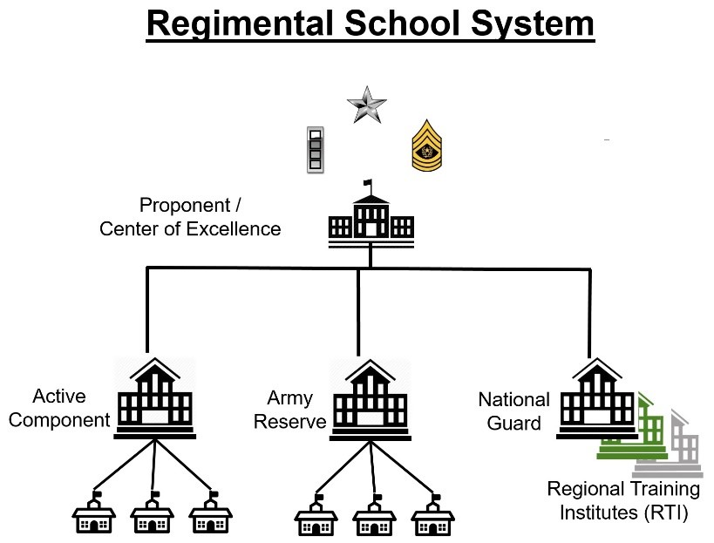

Figure B‐1. The Regimental School System

These entities operate under the principles of the One Army School System, the standards published in the POI for each class and in accordance with the published policies and guidance of the Commandant.

b. Subject Matter Expertise. The Commandant, operating as the Chief of Branch, is ultimately responsible for ensuring that all training is conducted to a single high-quality standard and must maintain a close and integrated working relationship with the leadership of all organizations that conduct training in that branch’s specific career management fields. This is done through SME involvement from the proponent, in coordination with QAO teams that conduct assessments and accreditation. Commandants must closely monitor the accreditation status of all training site locations and organizations conducting training for their regiment, regardless of component. Proponent SME teams should continuously assess the CMF technical portion of all courses to ensure their compliance, applicability and relevance to the POI standard.

c. Resource Sharing. The Commandants, through their various staff entities, must proactively work with the leadership of all component schools conducting their CMF training to explore and implement feasible and practical options that share Active Component and Reserve Component equipment, personnel and facility resources to more efficiently meet the complete student load and mission set throughout all of their branch training. The goal should be to minimize the need for course waivers by working cooperatively with each of the component schoolhouse leaders to ensure the uniform application and utilization of required resources. The sharing of resources within a CMF schoolhouse (personnel, facilities and equipment) is highly encouraged.

**B-4. Program of instruction (POI) Development, Revision and Resourcing**

a. POI Reviews. Commandants must have a continual process that reviews all POIs to maintain currency, accuracy and relevance. This process must not exclude any course delivery method or effect the basic tenets of the OASS. In most all cases, Soldiers from any component may enroll in a course taught in any delivery method, by any component.

b. POI Development Systems and Processes. The automated Training Development Capability is the primary system used by TRADOC schools and centers to create, edit, and manage all training and education products as it provides the necessary links to other Army systems that determine requirements necessary for the conduct of training. This includes all aspects of TRAS inputs to adequately define all course requirements and costs for inclusion by the components in their funding requests. Without completing all steps in the POI development, update and approval process, courses will not be adequately resourced. This begins with a multi-component critical task and site selection process that includes multi-component representatives from the generating and operational force to identify those tasks that are critical to achieving the desired proficiency. Critical task proficiency must be measured in the achievement of a competency level and not stated in terms of time. Complete requirements and criteria to accomplish these tasks are found in TR 350-70, TP 350-70-14 and related publications and references. This process pertains to all components operating within a particular branch and is implemented under the guidance of the school commandant. POI updates must adhere to all applicable TRADOC policy, guidance and approvals.

c. Engagements. To ensure complete visibility over resourcing, equipment, personnel and facility issues, the maximum participation of both Army Reserve and National Guard personnel aligned with the proponent schoolhouse is encouraged at all proponent meetings, conferences, planning sessions, etc. Army Reserve schools in the 80th and 108th Training Commands are operational control to TRADOC and all schools must comply with POIs and other published instructional guidance, provided that it is properly resourced. Commandants should encourage their staffs to include all Army Reserve and National Guard training facilities that conduct their branch training in all site visits and reserve component personnel in instructor professional development opportunities. The principles of Army Total Force Policy and the OASS should be applied to the maximum extent possible to achieve increased efficiencies and cost savings.

# Appendix C TRADOC TASS Readiness Reporting System (TTRRS)

**C-1. General**

a. The TTRRS provides the chain of command a snapshot on the current readiness (manning and training) of instructors in TASS schools. The system uses current TDAs and data from personnel databases (Integrated Total Army Personnel Database, Total Army Personnel Database - Guard, Total Army Personnel Database – Reserve) and ATRRS to determine personnel assigned to instructor positions and their current qualifications.

b. The TTRRS is designated the system of record for instructor certification. Schools are required to ensure their personnel's data is complete and accurate as some certification requirements are not verifiable through current databases. Schools are also required to enter borrowed or contracted instructors manually. Proponents may require additional databases of record.

**C-2. Guidance**

Organizations listed below will ensure the following functions are performed.

a. TRADOC, TOMA:

(1) Monitor the TTRRS to ensure it is current and changes to TDAs and/or other database systems are incorporated or properly linked to the system.

(2) Support training requirements for ARNG and USAR users through an online tutorial.

(3) Control access to the system for TRADOC and for ARNG and USARC designated senior POCs responsible for controlling ARNG and USAR user access.

b. Proponent Schools:

(1) Determine and publish instructor certification requirements.

(2) Determine TTRRS access policy and procedures for their organization.

(3) Designate a POC to control access for local users.

(4) Coordinate with TRADOC TOMA for recommended changes/additions to the system.

c. ARNG and USARC:

(1) Designate a senior POC to control access for respective users and to be the POC to TRADOC for coordination and/or issues that may arise.

(2) Ensure any TDA or operational changes affecting TASS schools and instructors are provided to TRADOC, TOMA prior to the effective date.

(3) Ensure personnel responsible for data entry are trained.

(4) Monitor compliance by subordinates to ensure accuracy and integrity of data.

(5) Coordinate with TRADOC, TOMA for recommended changes/additions to the system.

d. TASS schools:

(1) Ensure instructor data is complete and current.

(2) Complete the fields required to be maintained by the respective schools.

(3) Manually enter all data for borrowed and contracted instructors.

(4) Ensure the instructor scheduling data is maintained for each course and class.

Note: To prevent proliferation of non-doctrinal terms/processes that create confusion in the training development and training environments, proponents, contractors, or government/private institutions/ individuals working training development and training policy, processes, products, and procedures (to include, but not limited to TASS training strategy/initiatives/plans) will not incorporate terminology or processes that are not in accordance with this regulation and training doctrine/training development doctrine unless approved by DCS, G-3/5/7.

# Appendix D The Army Training Support Center (ATSC) Online Ordering System

The ATSC Online Ordering System allows ATSC customers the ability to order TATS courseware for RC and National Guard Bureau. This system provides the customer with one interface, thereby streamlining the process. The customer can search and select available products, place orders, track shipments, and manage their account.

**D-1. New Accounts**

To establish an account a DA Form 1687, Notice of Delegation of Authority – Receipt for Supplies, downloadable from the ATSC Online Ordering System, must be filled out and e-mailed to usarmy.jble.tradoc.mbx.atsc-team-tats@mail.mil. The Account Manager for the area will be contacted by ATSC personnel. The Account Manager will be responsible for adding approved account users to the online ordering system and supplying new users with the link to access the Online Ordering System.

**D-2. Online Ordering System**

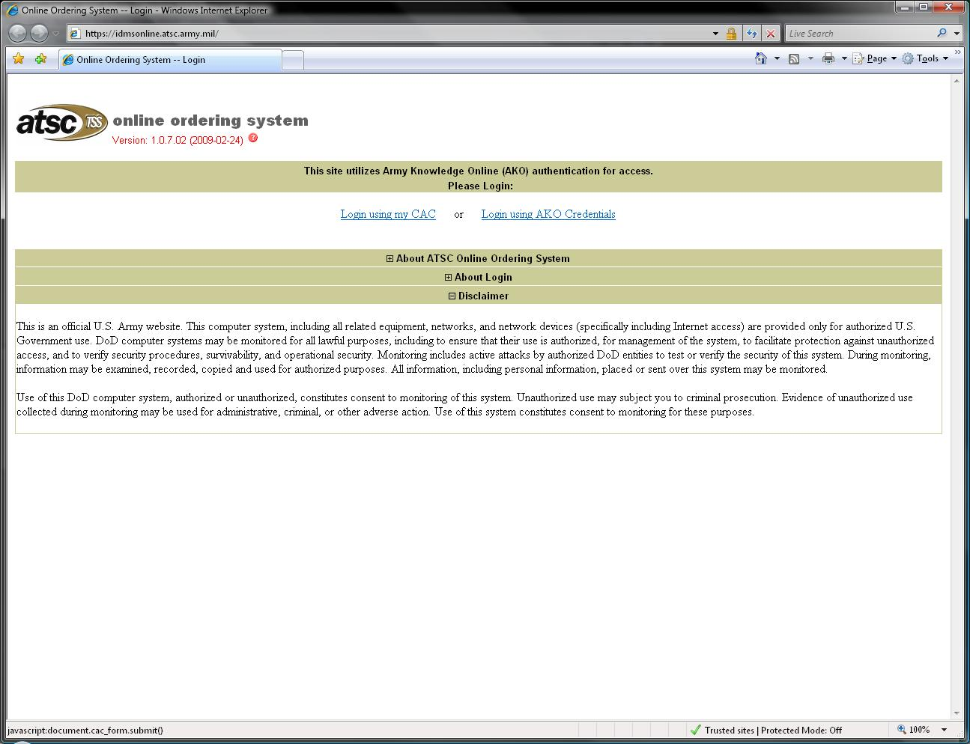

Figure D-1. ATSC Online Ordering logon page sample

Access link and log in with common access card.

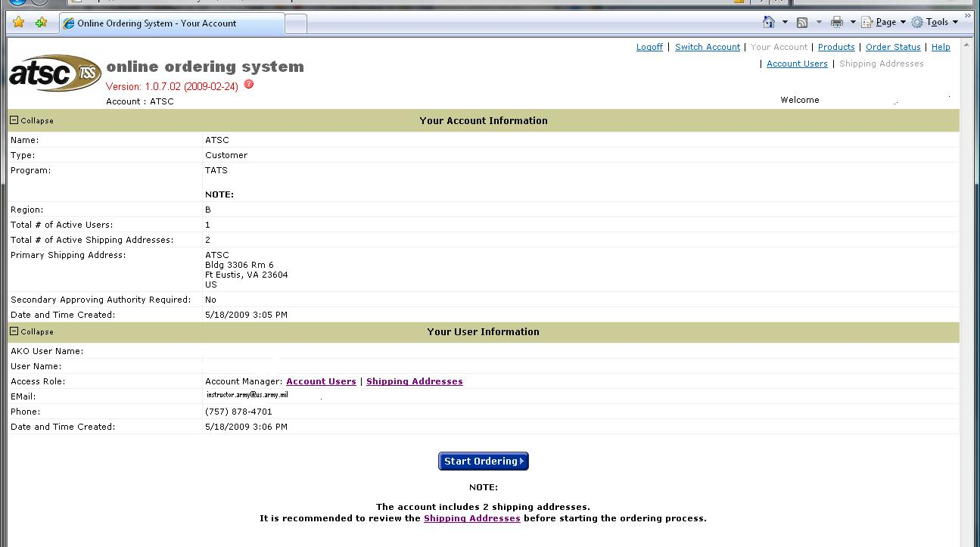

Figure D-2. Account/User Information sample

Verify Account and User Information. Select ‘Start Ordering’ at the bottom of the page. If the account user or shipping address is incorrect contact your account manager.

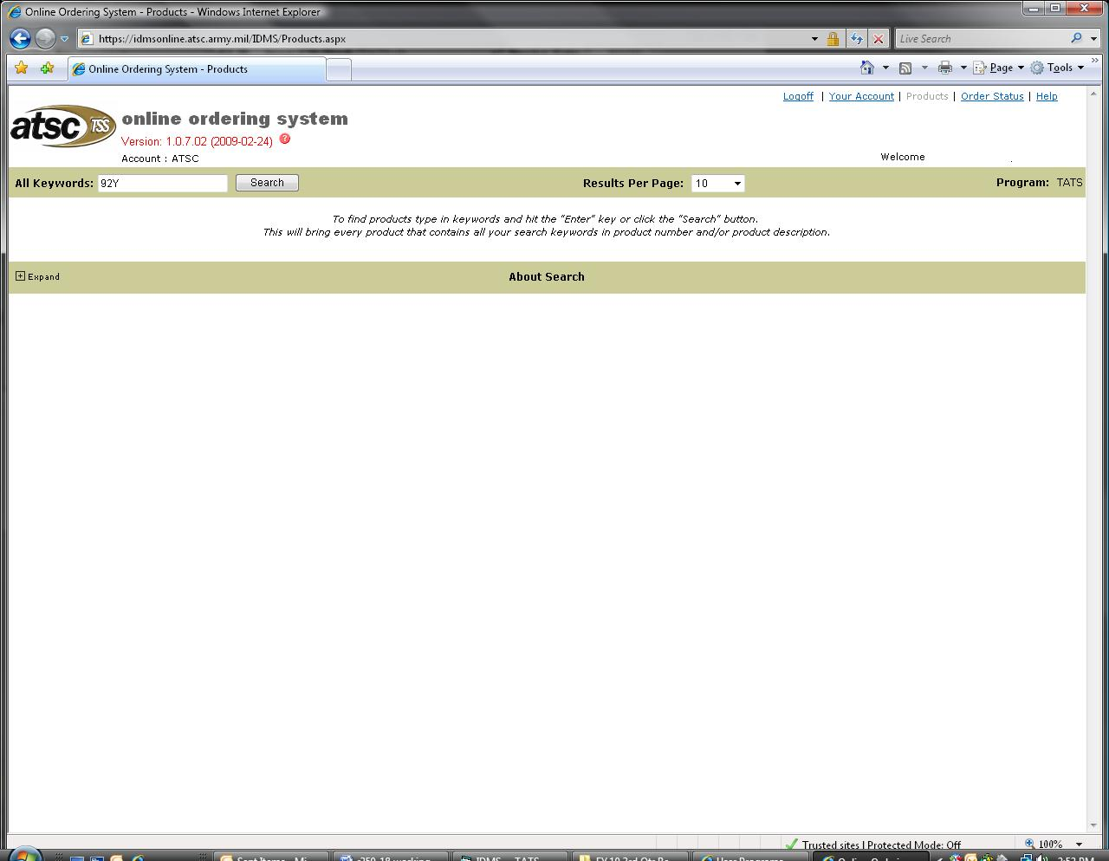

Figure D-3. Courseware search sample

Key in title or MOS in ‘All keywords’ block then click on ‘Search’ button.

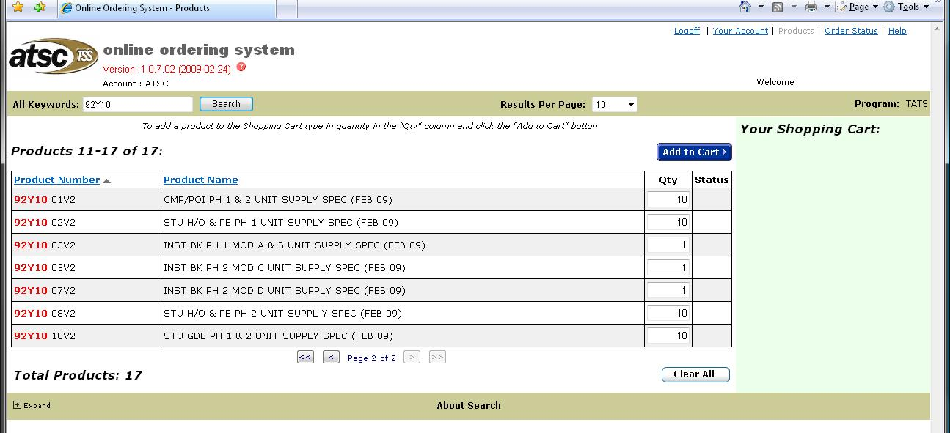

Figure D-4. Courseware selection sample

Enter amount needed in ‘Qty’ box for each product required. Click on ‘Add to Cart’ to add products to cart before going to next page of products.

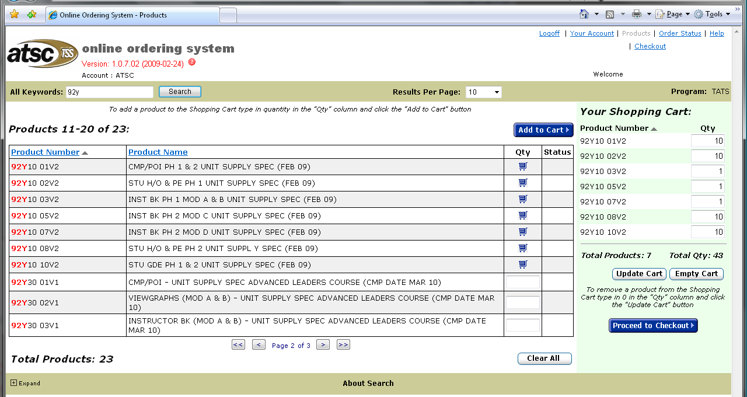

Figure D-5. Shopping Cart sample

Your shopping cart may be viewed on right hand side of page. Review shopping cart to ensure that all items have been added. When finished, click on ‘Proceed to Checkout.’

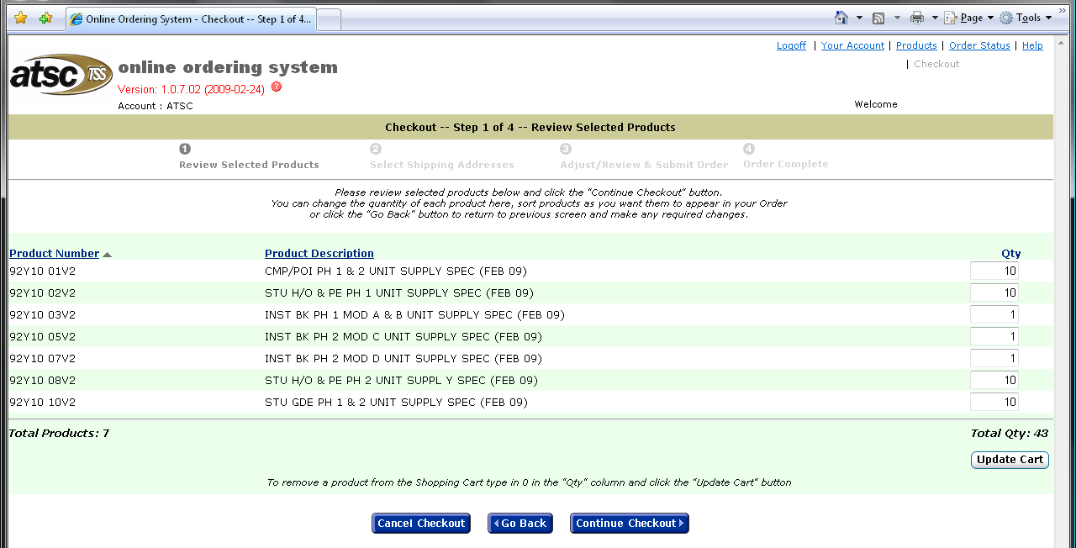

Figure D-6. Step 1 Review Selected Products sample

Review selected products. You can change the quantity of each product, sort products as you want them to appear in your order or click the ‘go back’ button to return to the previous screen. Once you have completed any changes select the ‘continue checkout’ button.

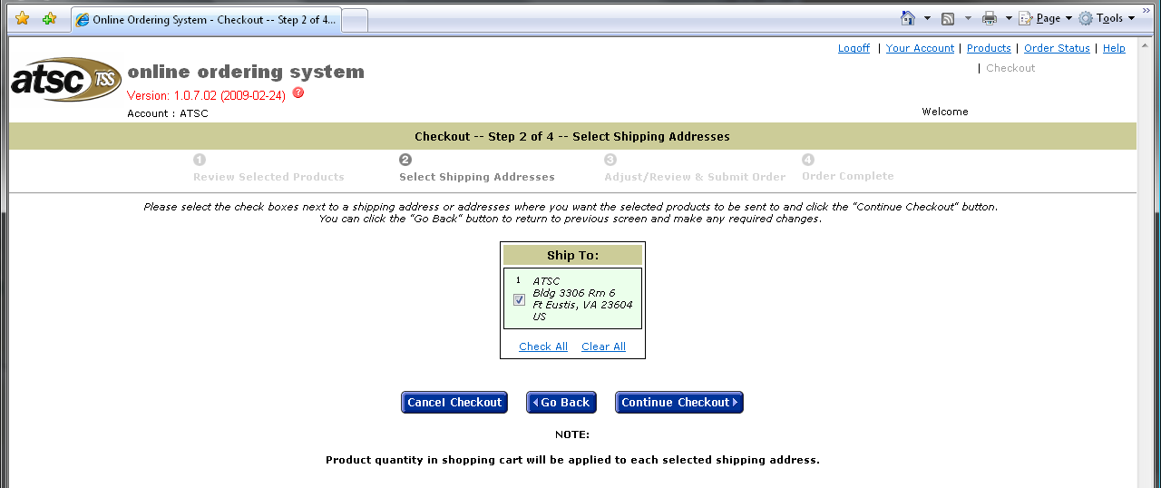

Figure D-7. Step 2 Check Out, verify shipping address sample

Select and verify shipping address(es). If the shipping address required is not available for selection contact your Account Manager. Once you have selected the shipping address(es) select the ‘continue checkout’ button.

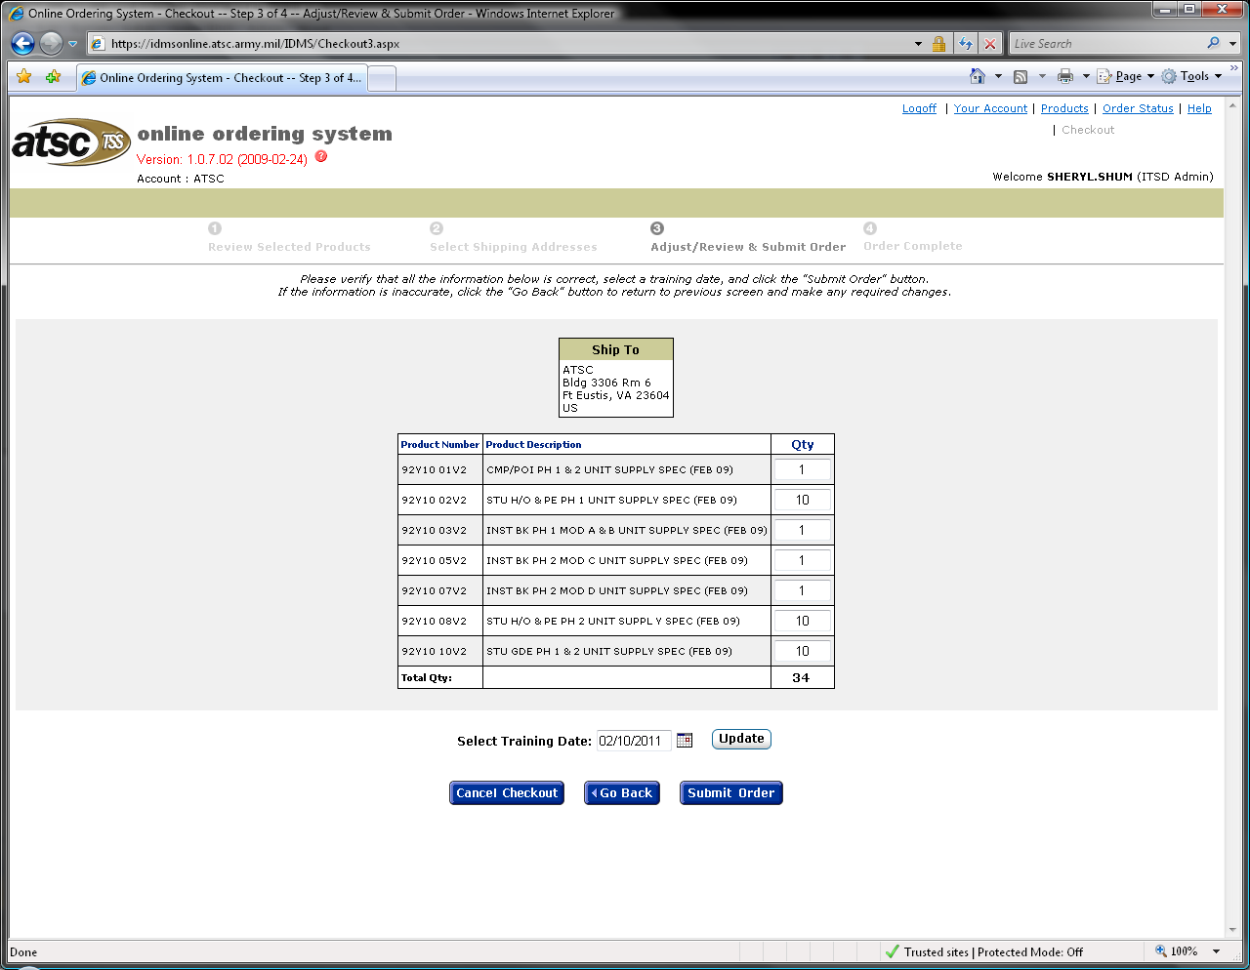

Figure D-8. Step 3 Check Out, Adjust, Review & Submit Order sample

Review your order and select the training date (Must be a minimum 3 weeks out to allow for processing and shipping.) Click the ‘Submit Order’ button. Your order number will appear on the next screen. Click ‘Order Complete’. This will take back to ‘Your Account Information.’ You may check your ‘Order Status’ at top right.

# Appendix E Suggested School SOP Content/Format

This is provided as an aid to schools in structuring their SOPs and content that should be considered for inclusion. It is not intended to be all-inclusive or directive in nature.

1. Organizational Structure

a. Mission

b. Organizational Chart(s)

c. Duties and Responsibilities

d. Command Policies and Guidance

2. Staff and Faculty Selection and Development

a. Sponsorship

b. Selection and Assignment Prerequisites

c. Training and Certification

d. Mentorship, Observations, and Counseling

e. Education and Self Development

f. Recognition and Incentives

3. Student and Class Administration

a. Verifying student prerequisites

b. Welcome Letters

c. In-Processing/Out-Processing

d. Student Guides, Classroom Conduct, and Honor Code

e. Academic Records

f. Student Denials, Dismissals, and Appeals

g. Counseling

h. Evaluations, Testing, Refresher, and Remedial Training

i. Billeting, Meals, and basic allowance for subsistence recoupment

4. Test control and accountability

a. Duties and Responsibilities

b. Access Control

c. TCO/A-TCO Appointments and Reliefs

d. Procurement and Inventories

e. Sign out, Sign In, and Security

f. Security

g. Loss or Compromise

h. Testing procedures

i. Scoring and Rebuttal Procedures

j. Records

5. Staff, Faculty, and Student Physical Fitness and Height Weight Standards

6. Quality Assurance Program

a. Master Evaluation Plans and Schedules

b. Internal and External Assessments / Accreditations

c. Self- Assessment Process

d. Corrective Action Plans and Reporting Procedures

7. Risk Management, Safety, and Environmental Compliance

8. Sexual harassment/equal opportunity/sexual assault policies and procedures

9. Supplies and Services

a. Property Accountability

b. Command Supply Discipline Program

c. Supply

d. Maintenance

e. Arms room

f. Communications Security

g. Organizational Clothing and Individual Equipment

h. Ammunition

i. Hazardous Materials

j. Inventories

10. Operational Security & Social Media

11. Lessons Learned Integration

a. Procurement

b. Integration

c. Counter Improvised Explosive Device Training

d. Cultural Foreign Language

e. Operational Environment

f. Staff and Faculty Training

12. Information Management

a. Army Records Information Management System

b. Information Assurance

c. Information Security

13. Conduct of Training

a. Training Schedules

b. Resourcing Equipment, Ranges, and Facilities

c. Waivers

# Appendix F Suggested Student Dismissal Memorandums

**F-1. Dismissal Memorandum to Student (Denial of Enrollment)**

Dismissal memos to the student will be in this format unless otherwise specified herein. Reasons for dismissal could be academic, height and weight failure, APFT failure, personal conduct, medical, hardship or failure to meet the pre-requisites.

OFFICE SYMBOL Date

MEMORANDUM FOR **RANK LAST NAME, FIRST NAME MI**

SUBJECT: Counseling and Denial of Enrollment from the **COURSE NAME AND CLASS NUMBER** (e.g. BLC Class 001-15)

1. In accordance with AR [350-1](http://www.apd.army.mil/pdffiles/r350_1.pdf), Army Training and Leader Development, paragraph 3-15, this memorandum serves as official notification that the **NAME OF YOUR ORGANIZATION** denied your enrollment into the **NAME OF COURSE** for **REASON FOR DISMISSAL (e.g. non fulfillment of course prerequisites, medical, hardship reasons)**.

2. I, **RANK FIRST NAME MI LAST NAME,** understand that I am being released for non-fulfillment of course prerequisites. I have been counseled and understand the corrective actions that must be taken so I may return to this course in the future. Soldier’s initials: __________

3. Direct any questions concerning the action to the undersigned at (123) 456-7890.

JOHN W. DOE

CSM, USA

Commandant

Figure F-1. Example Dismissal Memorandum to Student

**F-2. Student Dismissal Memorandum to General Officer Memorandum**

Dismissal memos for any reason to the first General Officer in the chain of command will be the same as the example.

OFFICE SYMBOL Date

MEMORANDUM FOR FIRST GENERAL OFFICER IN CHAIN OF COMMAND ADDRESS

SUBJECT: Counseling and Denial of Enrollment from the COURSE NAME AND CLASS NUMBER (e.g. BLC Class 001-15)

1. I denied enrollment to RANK FIRST NAME MI LAST NAME a Soldier in your command for REASON FOR DISMISSAL (e.g. non fulfillment of course prerequisites, medical, hardship reasons).

2. RANK LAST NAME orders should reflect a release date of 00 January 2015.

3. Direct questions to the undersigned at com: (123) 456-7890 or DSN: 000-0000.

JOHN W. DOE

CSM, USA

Commandant

CF:

SOLDIERS COMMAND (e.g. COMMANDER, 108TH REGT 8 BN (TRANS), 180 COMMERCIAL AVENUE, JACKSON, MS 39209-3423)

Figure F-2. Example Student Dismissal Memorandum to General Officer

**F-3. Referred Report (Failed Exams. Army Physical Fitness Test (APFT), HT/WT, etc.)**

OFFICE SYMBOL Date

MEMORANDUM FOR **RANK FIRST NAME MI LAST NAME**

SUBJECT: Counseling and Notification of Referred Report for the **COURSE NAME, COURSE NUMBER, CLASS NUMBER** (e.g. BLC Class 001-15)

1. Under provisions of AR 623-3, Academic Evaluation Reporting System, Paragraph 3-27, I am referring to you for acknowledgement of the enclosed DA Form 1059, Academic Evaluation Report (AER) for the period of DATES OF COURSE.

2. The specific reason for your referral is: **REFERRED REASON (e.g. failed the initial test and retest of evaluation/Violation of AR 600-9)**.

3. You must acknowledge receipt of this referred AER and submit any comments by return endorsement if needed.

4. If comments are submitted, you are hereby advised that said comments do not constitute an appeal or Commander’s Inquiry. Such requests must be submitted separately under the provisions of AR 623-3.

5. Any comments submitted must be limited to matters directly related to the content on the referred report. Enclosures are not authorized and will be withdrawn prior to forwarding the report, referral, acknowledgement, and comments to the Official Military Personnel File custodian.

Encl JOHN W. DOE

DA Form 1059 COL, EN

Commandant

I acknowledge receipt of my referred report and comments are provided below.

FIRST NAME MI. LAST NAME

RANK, USAR

COURSE NAME Student

Comments:

Figure F-3. Example Referred Report

**F-4. Student Dismissal with Appeal Option**

OFFICE SYMBOL Date

MEMORANDUM FOR RANK FIRST NAME MI LAST NAME

SUBJECT: Counseling and Denial of Enrollment from the COURSE NAME AND CLASS NUMBER (e.g. BLC Class 001-15)

1. In accordance with AR [350-1](http://www.apd.army.mil/pdffiles/r350_1.pdf), Army Training and Leader Development, Paragraph 3-15, Student Dismissal. This serves as official notification of your dismissal and right to appeal. If you appeal, it must be submitted in writing within 7 days after receipt of this written notification. Dismissal from this course may have a negative impact on you future military service.

2. I officially release you from the COURSE NAME, COURSE CLASS NUMBER and the SCHOOLHOUSE NAME for academic reasons. You failed the initial test and retest of “Communicate in Writing” evaluation.

3. I, RANK FIRST NAME MI. LAST NAME, understand that I am being released for academic reasons: I failed the initial test and retest of “Communicate in Writing” evaluation. I have been counseled and understand the corrective actions that must be taken so I may return to this course in the future. Soldier’s initials: _______

4. I (do / do not) elect to appeal. Soldier’s initials: _______

JOHN W. DOE

CSM, USA

Commandant

Figure F-4. Example Student Dismissal with Appeal Option

# Appendix G TRADOC Form 350-18-2-R-E (Pre-Execution Checklist (PEC))

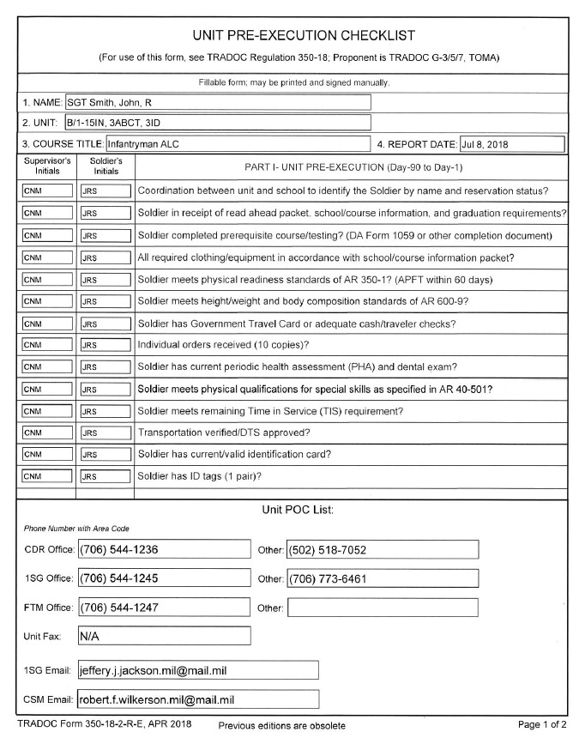

SAMPLE

Figure G-1. Sample TRADOC Form 350-18-2-R-E

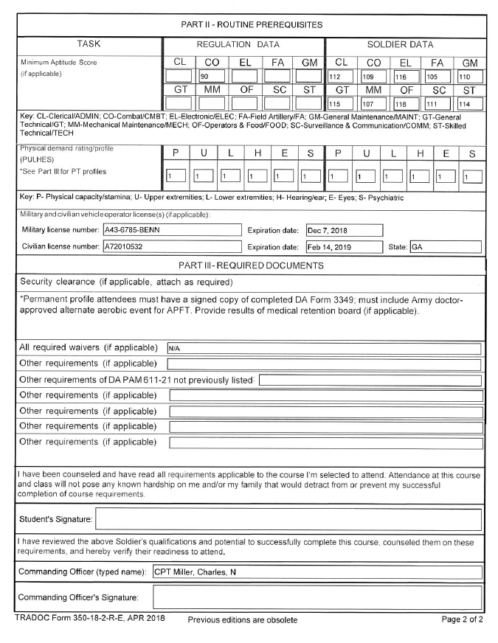

SAMPLE

**Figure G-1. Sample TRADOC Form 350-18-2-R-E, continued**

# Appendix H ATRRS Functions (OASS)

H-1. C8: TATS Flag Pop-up definition: Data Element: TATSFLAG. Definition:

TATS courses contain all critical tasks for qualification as determined by the CTSSB. Critical tasks may be configured in one or more course phases. Ref: TR 350-70.

H-2. C9: OASS Compliant definition: Data Element: OASSFLAG. Definition: One Army

School System Compliant means the course is designed for attendance by all Army Components. Standards include: All TATS critical tasks, phases consistent with RC TATS year or RC concurrence, phases at same location, approved equipment, TR 350-70. The C9 OASS Compliance check will correspond to the OASS Compliant Course report. Courses and locations that are not on the OASS Compliant Course report will not be selected as OASS compliant.

H-3. C3: OASS Back to Back pop-up definition: Data Element: OASSB2B. Definition: The

OASSB2B field indicates which classes in OASS Compliant courses are set up for attendance by all Army components.

(a) The OASSB2B indicator can be set to "Yes" only if the school course is OASS compliant (C9 OASS compliant flag). OASS compliant courses are designed for attendance by all Army components.

(b) When the OASSB2B indicator = "Yes", the class is set up for all Army components.

The class is either a single phase or a sequence of course class phases scheduled back-to-back, each class being at the same location with approved equipment.

(c) When classes in phased-course instances are not scheduled back-to-back at the same location, the OASSB2B indicator should be set to "No". The OASSB2B indicator will always be "No" for courses which are not OASS compliant.

# Appendix I

# One Army Training Management Forum (OATMF)

a. The OATMF is a means for all components to review, discuss, and action items which impact the Total Army Institutional Training and Education mission. The forum consists of an ESC, a GOSC, and a CoC.

b. The objectives of the forum are to identify, integrate, and coordinate the Total Army Institutional Training and Education mission, ensuring the mission is planned, programmed, and executed effectively and efficiently across all components. The forum will also facilitate accomplishment of functional and technical responsibilities across TASS.

c. TRADOC G-3/5/7 TOMA is the lead for OATMF management. TOMA will develop and manage timeline milestones, facilitate meetings, staff all actions, and produce documents in support of the ESC, GOSC, and CoC forums.

(1) CoC: convenes quarterly to review, discuss, and action items that impact the Total Army Institutional and Education mission, e.g., the TRAS, TASS, SMDR, TRAP, the Analysis of Change Cell, OASS, Functional Course Review, Training Base Expansion, and the TCCW. The CoC is led and chaired by the Director, TOMA and co-chaired by the TRADOC DCG, USAR, Chief of Staff and the TRADOC DCG, ARNG, Chief of Staff. In addition to the chair and co-chairs, voting members include the USARC G-37 and the ARNG G-3.

(2) GOSC: convenes on an as needed basis to review, discuss, and consider recommended actions from the OATMF CoC. The GOSC is led and chaired by the TRADOC DCS, G-3/5/7. GOSC voting members include the USARC G-3/5/7 and the Special Assistant to the Director, ARNG.

(3) ESC: convenes on an as needed basis to review, discuss, and consider recommended actions from the OATMF GOSC. The ESC is led and chaired by the TRADOC DCG and co-chaired by the DARNG and the DCG (Support), USARC. ESC voting members include the TRADOC DCG, USAR; TRADOC, DCG, ARNG; and the TRADOC DCS G-3/5/7.

d. Voting members. OATMF chairs and co-chairs also serve as voting members. In the event of a tie in addressing an issue, the chair casts the deciding vote.

e. Non-voting members/Invitees. Other organizations or individuals may be invited to attend a management forum, provided a member sponsors them and their attendance is coordinated with the respective management forum chair. Organizations that provide functional or technical expertise to a management forum are non-voting participants. Non-voting members are encouraged to participate and provide recommendations for consideration by the forum.

# Glossary

**Section I  
Abbreviations**

ADDIE Analysis, Design, Development, Implementation, and Evaluation

ADT Active Duty for Training

AER Academic Evaluation Report

ALC Advanced Leaders Course

AGR Active Guard Reserve

APFT Army Physical Fitness Test

AR Army regulation

ARNG Army National Guard

ARPRINT Army Program for Individual Training

ASI Additional Skill Identifier

AT Annual Training

ATRRS Army Training Requirements and Resources System

ATSC Army Training Support Center

BDE brigade

BLC Basic Leader Course

BN battalion

CG commanding general

CMF Career Management Field

CMP Course Management Plan

CoC Council of Colonels

CTSSB Critical Task Site Selection Board

DA Department of the Army

DARNG Director, ARNG

DCG Deputy Commanding General

DCS Deputy Chief of Staff

DL Distributed Learning

DOD Department of Defense

DODD Department of Defense Directive

ESC Executive Steering Committee

GOSC General Officer Steering Committee

HQ Headquarters

HQDA Headquarters, Department of the Army

HRC Human Resources Command

IDT Inactive Duty Training

ILE Intermediate Level Education

IMA Individual Mobilization Augmentee

IRR Individual Ready Reserve

ITCOP Institutional Training Common Operational Picture

MAR2 Military Occupational Specialty Administrative Retention Review

MFTB Multifunctional Training Brigade

MOS military occupational specialty

MOS-T military occupational specialty – transition (Reclassification)

NCO noncommissioned officer

NCOA Noncommissioned Officer Academy

NCOES Noncommissioned Officer Education System

NDS Normal Duty Station

NGR National Guard Regulation

OASS One Army School System

OASSB2B One Army School System Back-to-Back

OATMF One Army Training Management Forum

OCONUS Outside the Continental United States

OES Officer Education System

PEC Pre-Execution Checklist

PME professional military education

POC point of contact

POI program of instruction

PRCL Post Reservation checklist

QA Quality Assurance

QAO Quality Assurance Office

RA Regular Army

RC Reserve Component

REGT regiment

RTSM Regional Training Site – Maintenance

SLC Senior Leaders Course

SMDR Structure and Manning Decision Review

SME subject matter expert

SOP standard operating procedure

SQI Special Qualification Identifier

TACITS Total Army Centralized Individual Training Solicitation

TADSS training aids, devices, simulators, and simulations

TAG The Adjutant General

TASS The Army School System

TATS The Army Training System

TATS-C The Army Training System-Courseware

TC Training Command

TCCW Training Coordination Council Workshop

TCNCO Test Control Noncommissioned Officer

TCO Test Control Officer

TDA table of distribution and allowances

TOMA Training Operations Management Activity

TP TRADOC pamphlet

TR TRADOC regulation

TRADOC U.S. Army Training and Doctrine Command

TRAP Training Resources Arbitration Panel

TRAS Training Requirements Analysis System

TSC Training Support Center

TTRRS TRADOC TASS Readiness Reporting System

U.S. United States

USAR U.S. Army Reserve

USARC U.S. Army Reserve Command

VI visual information

WO warrant officer

WOES Warrant Officer Education System

**Section II**

**Terms**

This section contains no entries.

**Section III**

**Special Abbreviations and Terms**

This section contains no entries.