**Department of the Army TRADOC Regulation 350-28**

**Headquarters, United States Army**

**Training and Doctrine Command**

**Fort Eustis, Virginia 23604-5711**

**30 November 2015**

**Army Reserve**

**UN****ITED STATES ARMY RESERVE (USAR)**

**SUPPORT TO THE GENERATING FORCE**

FOR THE COMMANDER:

OFFICIAL: KEVIN W. MANGUM

Lieutenant General, U.S. Army Deputy Commanding General/

Chief of Staff



RICHARD A. DAVIS

Senior Executive Service

Deputy Chief of Staff, G-6

**History.** This is a new United States (U.S.) Army Training and Doctrine Command (TRADOC) regulation.

**Summary.** This regulation provides specific policy, responsibilities, and guidance for the planning, execution, and support for programmed and non-programmed TRADOC training missions supported by the 108th Training Command.

**Applicability.** This regulation applies to the active Army (AA) and the Army Reserve (USAR). Specifically, this regulation applies to all commands and individuals involved in supervision, operation, and training of Army Reserve training elements supporting TRADOC missions.

**Supplementation.** Supplementation of this regulation and establishment of command and local forms are prohibited without prior approval from TRADOC, TOMA, ATTN: ATTG-TRI-MR, 950 Jefferson Avenue, Fort Eustis, Virginia 23604.

**Suggested improvements.**  The proponent for this regulation is the Commander, United States Army Training and Doctrine Command (TRADOC), G-3/5/7, Army Training Operations Management Activity (TOMA). Send comments and suggested improvements on DA Form

*This publication supersedes TRADOC Regulation 140-3, dated 8 February 2000.

2028 (Recommended Changes to Publications and Blank Forms) to Commander, TRADOC, G3/5, TOMA, ATTN: ATTG-TRI-MR, Fort Eustis, Virginia 23604.

**Availability.** This publication is available on the TRADOC Homepage at

<http://www-tradoc.army.mil/tpubs/>.

Summary of Change

This new regulation, dated 30 November 2015 –

o Updates mission, organization and the responsibilities for the utilization of the 108th Training Command in support of initial military training (chap 1).

o Updates the concept of support (chap 2).

o Updates operational responsibilities for support of annual programmed training requirements (chap 3).

o Updates support of un-programed training requirements (chap 4).

o Updates support of Reserve Officers’ Training Corp (chap 5).

o Updates information on source documents for mobilization and training base expansion (chap 6).

**Contents**

**Page**

Chapter 1 Introduction 5

1-1. Purpose. 5

1-2. References. 5

1-3. Explanation of abbreviations. 5

1-4. Responsibilities. 5

1-5. 108th Training Command (Initial Entry Training (IET)). 8

1-6. Training concepts. 8

1-7. Coordination. 9

Chapter 2 Concept of Support 9

2-1. General. 9

2-2. Mission. 9

2-3. Training. 9

2-4. Annual training (AT). 10

2-5. Annual Training scheduling. 10

2-6. Unit Alignments. 11

Chapter 3 Support of Annual Programmed Training Requirements 11

3-1. General. 11

3-2. Operational responsibilities. 11

3-3. Echo Company support. 13

3-4. Other Support 14

Chapter 4 Support of Un-programmed Training Requirements 14

4.1. General. 14

4-2. Mission Analysis and Request for Support. 15

Chapter 5 Reserve Officers’ Training Corps (ROTC) Support 16

5-1. General. 16

5-2. Operational responsibilities. 17

5-3. United States Army Reserve (USAR) personnel support requirements for ROTC CST. 18

Chapter 6 Mobilization and Training Base Expansion 18

6-1. General. 18

6-2. Mobilization. 18

Appendix A References 19

Appendix B Active duty for operational support (ADOS)-Active component (AC) Process 20

Appendix C Execution Order (EXORD) Development Process 21

Appendix D Fiscal year Center of Excellence (CoE)/ATC Mission Support Requirements Format 22

Appendix E Mobile Training Team (MTT) Visitation Requirements 23

Appendix F USAR Drill Sergeant/Instructor Status Report 23

Appendix G ECHO Company Execution 24

Appendix H ROTC Training Mission Support 25

Glossary 25

**Figure List**

**Page**

Figure B-1. ADOS-AS Process 20

Figure C-1. EXORD Development Process 21

Figure D-1. Mission support requirements format 22

Figure G-1. Echo Company model 24

Figure G-2. BCT Echo Company model 25

# Chapter 1

# Introduction

1-1. Purpose.This regulation provides specific policy, guidance, and responsibilities for the United States (U.S.) Army Reserve 108th TC (Initial Entry Training (IET)) to execute and support U.S. Army Training and Doctrine Command’s (TRADOC’s) peace-time and contingency missions. The 108th TC (IET) supports TRADOC’s training base expansion by providing cadre support to the Centers of Excellence (CoEs), the U.S. Army Training Center (USATC), Reserve Officers’ Training Corps (ROTC), and United States Military Academy (USMA).

1-2. References. References and forms. See appendix A.

1-3. Explanation of abbreviations. Explanation of abbreviations and terms. See glossary.

## 1-4. Responsibilities.

a. Commanding General (CG), TRADOC:

(1) Determine and coordinate training support mission requirements for the 108th Training Command.

(2) Ensure all Institutional Training (IT) missions are planned and programmed through the Structure Manning Decision Review (SMDR) process.

(3) Ensure all un-programmed missions are validated through the USATCs.

(4) Coordinate funding and training resources for U.S. Army Reserve (USAR) support and un-resourced requirements.

(5) Publish the TASKORD to support the 108th Training Command’s (IET) annual mission requirements not later than February of the planning year (Appendix D contains the Execution Order (EXORD) development process).

(6) Establish, develop, and provide training doctrine.

(7) Establish and maintain peacetime and contingency planning alignments of USAR training elements with CoEs and the USATC for training support.

(8) Recommend changes in 108th Training Command (IET) force structure to U.S. Army Reserve Command (USARC).

(9) Encourage direct communication between the CoEs, the USATC and aligned units.

(10) Monitor 108th TC (IET)’s strength, training readiness, military occupational specialty (MOS) qualification, drill sergeant (DS) and instructor strength and qualification.

(11) Provide funding for certification teams (from the USATC and CoEs).

b. CG, USARC:

(1) Exercise administrative control of the 108th Training Command (IET) in accordance with the operational control memorandum of agreement.

(2) Review TRADOC programmed mission requirements for the 108th Training Command (IET). Validate and program resources in support of annual training mission requirements. Review requirements that exceed programmed annual missions; coordinate through U.S. Army Forces Command and TRADOC for required additional resources.

(3) Resource and validate unit and personnel readiness. Monitor unit strength, training readiness, Medical Protection System (MEDPROS) status, MOS qualification, Drill Sergeant (DS) and instructor strength, and qualification. Ensure units are fully trained and prepared for annual training and mobilization as training support elements.

(4) Coordinate with TRADOC for missions and with U.S. Army Forces Command on command, administrative, and support issues.

c. CG, U.S. Army Center for Initial Military Training (USACIMT):

(1) Oversees the execution of initial military training.

(2) Establishes the standards for initial military training and Warrior Tasks and Battle Drills.

(3) Establishes training requirements for all Drill Sergeants.

d. CG, 108th Training Command (IET):

(1) Conduct support to Active Army mission in accordance with TRADOC EXORD; ensure units are trained and resourced to execute specified missions and contingency institutional training missions.

(2) Validate subordinate training units’ capability to execute TRADOC mission requirements and ensure resources are sufficient to execute the designated missions.

(3) Plan, program, and coordinate funding and resourcing for training support and missions.

(4) Coordinate mission requirements with TRADOC/Training Operations Management Activity (TOMA), USARC, USACIMT, CoEs, the USATC, U.S. Army Cadet Command (USACC), and USMA as appropriate.

(5) Foster and maintain partnerships between subordinate elements and their supported active Army (AA) organizations.

(6) Conduct an After Action Review (AAR) at the conclusion of the annual mission and forward results to TRADOC/TOMA.

(7) Maintain capacity of units to certify new Drill Sergeants on level 1 Combatives after graduation from the US Army Drill Sergeant Academy.

(8) Be prepared to support un-programmed missions.

(9) Submit USAR Drill Sergeant/Instructor status report in accordance with Appendix F

e. CG, USACC:

(1) Plan, develop, and coordinate mission support requirements for execution of Cadet Initial Entry Training (CIET) and Cadet Leader Course (CLC). Provide requirements to TRADOC (TOMA/Training Base Augmentation Division (TBAD)) for coordination not later than May of the planning year.

(2) Coordinate funding and resources required to support Army Reserve training support elements. Army Reserve Soldiers will execute mission support utilizing USARC programmed statutory annual training (AT) authorizations/funding for the initial 14 days of Soldier utilization.

(3) Publish exercise Operations Orders, mission guidance, and training materials not later than six months prior to execution. Provide projected committee and support requirements to TOMA/TBAD not later than May of the planning year.

(4) Coordinate with Headquarters, Department of the Army (HQDA) for request for forces and/or Execution Order (Department of the Army EXORD) to direct USAR support for CLC and CIET missions.

(5) Hosts CIET, CLC, pre-CIET/CLC conference(s) and AAR and invites support organizations and agencies to participate.

(6) Forward results of After Action Review at the conclusion of the annual USAR support mission to TRADOC/TOMA not later than September.

f. CGs, CoEs and the USATC:

(1) Commanders will utilize the Echo Company model (Appendix G) to execute USAR supported basic combat training (BCT) starts.

(2) Establish and maintain relevant, cohesive, functioning partnerships with the 108th TC (IET) aligned units. Establish an environment which allows USAR personnel and units to execute the Army IET mission along with their active component (AC) counterparts.

(3) Determine and submit reception and committee support requirements to TRADOC/TOMA not later than January of the planning year.

(4) Assume command of affiliated 108th TC (IET) units and personnel upon their arrival at the CoEs/USATC.

(5) Conduct AT coordination with supporting elements of the 108th TC (IET) (IPR in October, monthly telecon planning meetings, and site surveys). Schedule USAR mission support requirements in accordance with TRADOC EXORD.

(6) Ensure life support is coordinated and available for USAR personnel supporting the TRADOC mission.

(7) Act as operational and/or technical sponsor to provide technical and doctrinal support.

(8) Ensure resources are available for use by USAR personnel in support of the mission.

(9) Conduct an AAR at the conclusion of each Echo Company mission and forward results to TRADOC (USACIMT and TOMA) and the 108th Training Command (IET).

1-5. 108th Training Command (Initial Entry Training (IET)). The mission of the 108th TC (IET) is to augment and support the AA execution of IET to support Army requirements. The Army Reserve provides BCT companies, one station unit training (OSUT) augmentation, committee instructors and reception support to assist CoEs and USATCs in the execution of their annual IET mission. The 108th TC (IET) supports USACC in the execution of the ROTC CLC and CIET and Chaplains Basic Officer Leader Course. In addition to these TRADOC missions, the 108th TC (IET) also provides augmentation in support of the USMA, US Merchant Marine Academy (USMMA), and various training exercises.

1-6. Training concepts. The overall training goal is to achieve and maintain a state of training readiness that ensures a unit can carry out its assigned annual training support and mobilization missions efficiently and effectively. Within that overall priority, the following training goals are established:

a. Training brigades and battalions. Prepare to augment or expand the USATC or CoEs and conduct BCT and OSUT, as directed by TRADOC Mobilization and Operations Planning and Execution System (TMOPES).

b. Reception Battalions. Prepare to augment or establish reception operations at the USATC and CoEs, and receive and process individuals entering the Army, or individual ready reserve (IRR) Soldiers being processed for retraining/refresher training at a USATC and CoEs.

c. ROTC Battalions. Prepare to augment one or more ROTC Region Headquarters and conduct ROTC summer camp training.

d. All will--

(1) Ensure that sufficient DSs and instructors are assigned, qualified, and certified in their specialties.

(2) Ensure that unit personnel are qualified in their duty MOS skill level.

1-7. Coordination. Direct coordination between TRADOC/TOMA, USACIMT, USARC, 108th Training Command (IET), USACC, USATC and the CoEs is authorized and encouraged to ensure effective training support.

# Chapter 2

# Concept of Support

2-1. General. An integral part of the Army’s generating force, the 108th TC (IET) is structured to augment TRADOC at Continental United States (CONUS) based CoEs and the USATC. The units can be mobilized for contingency support to provide IET or other Army training or training support missions. As part of annual training, the organization executes its primary mission by providing support to the Army.

2-2. Mission. Initial Entry Training. The 108th TC (IET) provides dedicated training support to TRADOC during peacetime and mobilization. The specific mission requirements are a coordinated effort between the Department of the Army, G-1 (HQDA, G-1), TRADOC/TOMA, USACIMT, CoEs, the USATC, USACC, USMA and USMMA. Subordinate units will be prepared to augment or expand a CoE or the USATC and conduct BCT, OSUT as directed by TMOPES. Units will also be prepared to augment or establish reception operations at a CoE and/or the USATC and receive/process IRR Soldiers for training and mobilization. Additionally, 108th TC (IET) will be prepared to support USMA summer training and USACC ROTC annual training exercises and USMMA.

2-3. Training. Units will develop yearly training programs to support mission, qualification, and certification requirements. Inactive Duty Training (IDT) will include mandated Leader, Instructor and Drill Sergeant training requirements, as well as Army and USARC mandated training. Where practical, units should coordinate with local ATC’s or other DoD activities to execute IDT training programs that improve the unit’s ability to accomplish its mobilization mission. The culmination of IDT training will result in fully qualified, certified Soldiers, prepared to support themission.

a. Soldier Readiness. Units develop their Yearly Training Plan based on annual EXORD requirements. Leaders, Drill Sergeants, Instructors, and Soldiers supporting IET must meet and maintain the standards and prerequisites identified in Army Regulation (AR) 614-200, TR 350-6, TR 350-16 and TR 350-70. They must also be proficient in applicable programs of instruction and CoE/USATC Standing Operating Procedures (SOP).

b. Training Goals.The overall goal is to achieve and maintain a state of training readiness that ensures a unit can perform its assigned mission during annual training or periods of mobilization.

## 2-4. Annual training (AT).

a. The primary focus of AT for the 108th TC (IET) is conduct of IET that trains for their mobilization mission. Therefore, 108th TC (IET) AT should include actual processing and training of IET soldiers at the CoEs and the USATC. Priority of peacetime training support missions after IET is ROTC mission support. CoE/ and USATC missions should be conducted every year. The following AT missions are appropriate:

Mission Method

(1) IET (a) Echo Company (E Co)

(b) Training Base Expansion (TBE)

(c) Unit Displacement (UD)

(d) Individual Augmentation Training

(e) Establishment or Augmentation of Reception

Elements

(2) Cadet Leadership Course Support As required

(3) Cadet Initial Entry Training Support As required

(4) USMA Summer Training Support As required

(5) USMA Intercession Support As required

(6) USMA Preparatory Support As required

(7) US Merchant Marine (a) Leadership, MOS, individual and crew served

Academy Train-up weapons qualification per Department of the

Army Pamphlet 350-38

(b) Counterpart training

b. The most effective AT for reception elements is augmentation of U.S. Army Reception Stations (USARECSTAs). Utilizing reserve component (RC) personnel assets expands the processing capability of the active Army reception and provides additional support required during surge.

## 2-5. Annual Training scheduling.

a. The 108th TC (IET) exist to perform IET and receptions operations. The 108th TC (IET) performs the following peacetime missions at TRADOC installations:

* TBE (E Co)
* Committee augmentation
* Reception augmentation

The 108th TC (IET) also supports CLC and CIET at Fort Knox, KY. Additionally, they support TRADOC installations during CALL FORWARD exercises and similar installation designed TBE exercises.

2-6. Unit Alignments.In order to minimize turbulence and gain efficiency in planning and execution, each 108th Training Command (IET) training brigade is aligned with a CoE/USATC. It is preferred that RC training battalions be retained whole, and aligned with their sister AC training battalions.

# Chapter 3

# Support of Annual Programmed Training Requirements

3-1. General.Annual training requirements are programmed through the Army Planning, Programming, Budgeting, and Execution process. TRADOC publishes a mission EXORD to the 108th Training Command (IET) for support to its programmed mission requirements. TRDOCs major program training event is executed through the Echo Company Support model.

## 3-2. Operational responsibilities.

a. TRADOC will--

(1) Assign training load to USATCs and 108th TC (IET).

(2) Recommend start dates.

b. CoEs/USATC will--

(1) Coordinate training dates with affiliated divisions to include mobile training team (MTT) visit(s) for CoE and the USATC validation of DS units. MTT visitation requirements are outlined in Appendix E.

(2) Program Echo Company operating costs into the installation budget.

(3) Provide Echo Company AC structure as indicated in Appendix G.

(4) Identify which AC battalions will contain an Echo Company, and provide facilities and equipment to rotating USAR companies. The AC battalion will maintain facilities and equipment during periods when no USAR companies are present.

(5) Ensure training areas, ranges, and other required facilities are requested/reserved for the USAR support cycle.

(6) Provide annual input for DS certification for the 108th TC (IET) and validates the certification.

(7) Provide each Echo Company with one permanent party (PP) Training NCO and one PP Supply NCO to provide continuity as needed throughout the year, and full time during execution of each Echo Company cycle.

(8) During mission execution, provide each Echo Company with three AC personnel (Training NCO, Supply NCO, and one senior leader (e.g. CO, XO, 1SG or other senior NCO) in the company headquarters, and one or two AC Drill Sergeants per platoon. The displaced USAR leader will backfill the AC leader who moved to the Echo Company, see Appendix G.

(9) Commanders will utilize the Echo Company model (Appendix G) to execute USAR supported BCT starts.

(10) Provide USAR evaluations on each Echo Company cycle. Each Echo Company start will be provided a cumulative AAR evaluation for the RC battalion.

(11) AC BN will provide feedback on observed leadership attributes of the USAR leadership team (Co Commander, XO and 1SG) to the USAR battalion.

(12) Identify suitable on post lodging for Echo Company Cadre.

c. USARC will--

(1) Attend the IET and ROTC Scheduling Conferences, along with the CoEs, the USATCs and 108th TC (IET).

(2) Provide funding for MTT assistance visits that exceed validation visits. (USATC will fund MTTs to validate that the units are prepared to conduct execution to Army standards).

d. 108th TC (IET) Subordinate Divisions will--

(1) Provide USAR companies for command and control of trainees and DS cadre at applicable BCT or OSUT sites.

(2) Provide a minimum of 12 certified DSs per company.

(3) Assist CoEs and the USATC when requested in validation and certification of DSs.

(4) Cross-level unit personnel as required.

(5) Conduct pre-execution conference with C0Es and the USATC to coordinate mission details as required.

(6) Coordinate with installation support organizations as required.

(7) USAR battalions participate in the scheduling of IET increments.

(8) Provide augmenting USAR training companies to round out the Echo Company battalion during AT periods.

(9) Rotating units. The rotating unit commander will assume command and control and be responsible for the conduct of training and have Uniform Code of Military Justice authority over BCT/OSUT trainees during their AT periods. (NOTE: Paragraph 9 text is unchanged from TR 140-3)

3-3. Echo Company support.The Echo Company Model is designed to augment CoEs and the USATC with USAR personnel for the purpose of conducting BCT and OSUT. The majority of Echo Company missions are during the summer surge (MAY-SEP), but support is conducted on a year-round basis. The term “Echo Company” in this context refers to any AC company that has been augmented with and commanded by Army Reserve personnel for the purpose mentioned above and is not necessarily intended to reflect the accurate name of the company involved. Hence, an Echo Company could conceivably have the official designation of any letter such as Alpha, Bravo, Charlie, and etc. Echo Company organizational model is shown in Appendix G. Department of the Army, G-1 determines the annual IET requirement for TRADOC. Once the training year requirements are finalized, TOMA coordinates with USACIMT, USATC, and 108th Training Command (IET) to analyze support requirements. The 108th Training Command (IET) supports this mission with Soldiers in AT status (17 day cycles). USATCs include the USAR elements in their plans and will align these resources in the organization structure as the “E” Company of an AA Training Battalion.

a. Physical facilities. The rotating USAR company will be physically located in the facilities provided by the CoEs/ATC.

b. Dining facilities. Echo Company dining facilities will be operated in the same manner as other host CoEs and the USATC dining facilities.

c. Command relationships. Operational control of the AA Echo Company Continuity Team, less Uniform Code of Military Justice, will pass to each successive USAR company commander.

d. Utilization of USAR battalion headquarters personnel during AT.

(1) Training battalion headquarters are an integral part of the Echo Company planning process, CoEs/USATC training brigades will incorporate BN staff personnel in the execution of the IET mission (biannual at a minimum) to provide an opportunity for the battalions to train the battalion headquarters personnel to execute their strategic mission. Fragmented AT, for the purpose of assisting the CoE/USATC BCT battalion headquarters, is an efficient way to utilize RC battalion headquarters personnel.

(2) It is also possible for the USAR training brigades to do a limited AT with their AC training brigade counterpart, but it is not required. Although individual augmentation/counterpart training is strongly encouraged between headquarters, coordination and evaluation of such will be done at the CoEs and the USATC level only.

e. Installation support increases. There will be no increase in scheduled Army Program for Individual Training (ARPRINT) loads. Thus, there will be no increases required in installation support personnel, equipment, contracts or similar support.

3-4. Other Support

a. OSUT.Department of the Army, G-1 determines the annual IET requirement for TRADOC. If additional OSUT structure is required in support of the OSUT missions, the 108th Training Command (IET) will provide augmentation by rotating OSUT units into the CoEs in an Annual Training status (17 day cycles). If the requirement only calls for additional Drill Sergeants or other Cadre to augment AA OSUT Companies, the 108th Training Command (IET) will provide OSUT augmentation by cycling the required Soldiers into the training BDEs as required, but utilization of company cadre is desired.

b. Reception Battalion. Reception Battalion support is a direct result of the HQDA, G-1 IET fill load mission requirements. Once the IET requirement is determined, CoEs and the USATC will review their capability and determine when augmentation by USAR Reception Battalion elements is required. The requirement is then tasked directly to the 108th Training Command (IET) via EXORD. The 108th TC (IET) then tasks the appropriate Training Divisions to provide specific support elements.

c. Committee augmentation.Committee support is a direct result of the HQDA, G-1 IET fill load mission requirements. Once the IET requirement is determined, USATCs review their capability and determine when augmentations by Army Reserve committee elements are required. The requirement is forwarded to TOMA. The requirement is issued via annual EXORD. The 108th TC (IET) will task the appropriate Training Divisions to identify specific elements to support the requirement.

# Chapter 4

# Support of Un-programmed Training Requirements

4.1. General.Un-programmed missions are training requirements that have neither been resourced nor planned for the current fiscal year. Upon receipt of requirements, mission analysis must be completed to determine the scope and resources required for execution. The requirement is coordinated through TRADOC/TOMA, USARC, and USAR Training Commands. Un-programmed training requirements, supported by USAR, will likely require Soldiers to be placed on extended AT or active duty for operational support (ADOS) orders. An agency requesting un-programmed institutional training support will clearly identify the training requirement, scope, and resourcing requirements. The requirement must identify the timelines, anticipated student loads, instructor/personnel unique qualifications, and start and projected end dates. This detailed plan will be forwarded to TRADOC, G-3/5/7. If TRADOC, G-3/5/7 determines that the request will be supported by the 108th TC (IET), then the action is forwarded to TRADOC/TOMA for coordination and missioning. See paragraph 4.2a and 4.2b for more information on tours and Appendix D for the format and data required to coordinate support.Examples of un-programmed or un-resourced training requirements include:

a. Training Resources Arbitration Panel (TRAP). The TRAP process manages and implements budget and execution year training program adjustments and identifies the resources required to execute the adjusted mission. Upon receipt of the TRAP, TOMA in coordination with CoEs and the USATCs and schools conduct detailed analysis and coordinate the training mission requirements and related resources to enable execution. If TOMA determines the USAR support required is through Mobilization, an request for forces will be send to HQDA.

b. IRR Refresher Training**.** The IRR Refresher Training mission is an un-programmed training mission to support contingency operations (CO). The training provides mobilized IRR Soldiers with refresher training in basic combat skills and critical MOS/AOC specific tasks. Requirements are resourced in a TRAP action from HQDA, G-1 and processed through TBAD.

c. Retiree Recall. When a retiree is recalled, the retiree will require processing and refresher training. The requirement to provide this processing will be coordinated through TOMA for execution and tasking. This mission closely follows common combat skills provided to IRR Soldiers. If support is required from the USAR, then TOMA will coordinate the requirement with 108th Training Command (IET). TBAD forwards requirements to the school to determine what personnel and equipment will be required to support the TRAP. Upon receiving the requirements, TRADOC/TOMA develops an request for forces and forwards it to HQDA for funding.

4-2. Mission Analysis and Request for Support. The SMDR is an annual process for the Army to identify, program, and validate Army training requirements. Final product of the SMDR is the ARPRINT, which is TRADOCs Institutional Training and Education mission for a given fiscal year. USATCs review their plans and coordinate with TOMA for required USAR support. CoE and USATC requirements for USAR support and augmentation should be identified to TOMA not later than April of the planning year. TRADOC, G-3/5/7/TOMA/TBAD will analyze, coordinate, and mission the 108th TC (IET). When possible, all missions will be executed as part of the Reserve Soldiers’ AT. When training missions exceed the 108th TC (IET) capability, TRADOC/TOMA will determine how the additional requirement will be processed. Options for bringing Reserve Soldiers on active duty to support institutional mission requirements include: Annual Training; ADOS-AC; CO-ADOS; or Mobilization. See Appendix E for the format and data required to coordinate USAR support.

a. ADOS-AC. When developing the requirement for ADOS-AC support, the tasked unit Commander should first pursue the option of mobilization as described in paragraph 3.2.3. When mobilization is not available, the requirement can be submitted as ADOS-AC and forwarded to TRADOC/TOMA, TBAD. TBAD will coordinate with the TRADOC staff, USARC, and HQDA, G-1 to validate the requirement and assist in identifying required funding. Similar to a mobilization, the unit Commander will ensure each individual has completed all administrative requirements, to include submission of the Soldier’s information into Tour of Duty/Department of the Army Mobilization Processing System – Administrative. Upon approval from HQDA, G-1, the Commander, Human Resources Command (HRC), will issue ADOS-AC orders and/or extension orders.

b. CO-ADOS. When developing the requirement for CO-ADOS support, the tasked unit Commander should first pursue the option of mobilization as described in paragraph 3.2.3. When mobilization is not available and the requirement is in support of a contingency operation, the requirement can be submitted as CO-ADOS and then forwarded to TOMA/TBAD. TBAD will coordinate with the TRADOC staff, USARC, and HQDA, G-3 (DAMO-ODM) to validate and approve the requirement. Similar to a mobilization, the unit Commander will ensure each individual has completed all administrative requirements, to include submission of the Soldier’s information into Tour of Duty/Department of the Army Mobilization Processing System – Administrative. Upon approval from HQDA, G-3, the Commander, HRC will issue CO-ADOS orders. The HQDA, G-3 (DAMO-ODM) revalidates and approves extensions.

c. Mobilization. Planning and executing TRADOC’s Training Base Expansion (TBE) during peacetime and upon mobilization requires the augmentation of the Army Reserves to support the ATCs and TRADOC School’s mission. Augmentation requirements are met primarily by the mobilization of Army Reserve training elements but can also be provided by HRC or contracted support. The MOB ARPRINT is the primary planning document for TBE during all levels of mobilization. Mission support above and beyond the programmed MOB ARPRINT normally comes in the form of a TRAP action. Upon mobilization, HQDA will develop actual training requirements for execution and provide them to TRADOC via the TRAP process, just as during peacetime. Manpower required above HQDA ability to source will be included in TRADOC’s submission of a Request for Forces. During Presidential Recall and Partial Mobilization, TRADOC executes in-processing and pre-deployment certification training for involuntarily mobilized members of the Individual Ready Reserves (IRRs) and voluntary Retiree Recalls, as directed at selected installations. TRADOC continues reception processing and training programmed peacetime initial military training requirements simultaneously during Presidential Recall and partial mobilization. During Full Mobilization, Active Army Reception Battalions, together with mobilized elements of the Army Reserve Reception Companies, will be task-organized to expand total reception capability at designated mobilization USATCs. For planning purposes, Full Mobilization will only follow sequential progression through Presidential Recall and Partial Mobilization. Refer to TMOPES for TRADOC specific planning and execution of mobilization operations.

# Chapter 5

# Reserve Officers’ Training Corps (ROTC) Support

5-1. General. The ROTC support program is designed to augment selected ROTC Regions with USAR personnel for the purpose of conducting ROTC training events. Primary emphasis will be placed on augmentation of ROTC training committees, but may include individual and unit augmentation of other ROTC Cadet Summer Training (CST). Augmentation of other ROTC CST support requirements will involve training that complements or sustains the unit’s METL. USAR personnel support missions for ROTC CST will be forwarded through the TRADOC DCoS – G-3/5/7 and the TOMA. Support requests for ROTC CST will be made available to TRADOC G-3/5/7 TOMA eighteen months out to enable those USAR units to submit funding requirements in their annual command operating budget (COB). This is important in order to give the 108th TC (IET) staff adequate time to plan and program the support that their subordinate divisions will provide.

## 5-2. Operational responsibilities.

a. TRADOC will--

1. Direct ROTC CST personnel support mission to 108th TC (IET).

(2) Provide USAR personnel support requirements for ROTC CST to the 108th TC (IET).

(3) Provide ROTC CST start and end dates to 108th TC (IET).

b. Cadet Command will--

(1) Develop and validate ROTC CST support requirements.

(2) Provide USAR personnel support requirements for ROTC CST to TRADOC G-3/5/7 TOMA.

(3) Determine and disseminate ROTC CST start and end date(s).

(4) Provide ROTC CST technical and doctrinal guidance.

(5) Ensure appropriate ROTC regional commands and BDEs:

1. Coordinate training dates with the 108th TC;

(b) Include 108th TC (IET) personnel when determining ROTC CST billeting, mess, and transportation support requirements;

(c) Program USAR ROTC CST support operating costs into the installation budget;

(d) Certify USAR Division ROTC certification programs.

(e) Provide each USAR battalion and committee group an AAR from the Training Committee Chief through the Regional Headquarters to TRADOC G-3/5/7 TOMA and the 108th TC (IET) headquarters.

c. The 108th Training Command (TC) will—

(1) Coordinate training dates and rehearsals with headquarters, Cadet Command, G-3, usually based on agreements made at the pre-camp conference held at Ft Knox, KY in January or February before the conduct of CST.

(2) Provide command and control and/or coordinate support responsibilities for USAR personnel supporting ROTC CST.

(3) In coordination with ROTC Committee Chief, certify USAR ROTC training committee personnel.

(4) Provide adjunct faculty as Assistant Professors of Military Science and Military Science Instructors to select colleges and universities.

5-3. United States Army Reserve (USAR) personnel support requirements for ROTC CST. ROTC CST is conducted at Ft. Knox, KY and consists of CIET and the CLC. USAR personnel support requirements for ROTC CST are based on projected cadet training loads. An example of support requirements is listed in appendix H (ROTC Mission Support).

# Chapter 6

# Mobilization and Training Base Expansion

6-1. General. During periods of crisis that require the Army to significantly increase capacity in the institutional training base, the Army may respond by executing plans established through the Army Mobilization and Operations Planning and Execution System (AMOPES). AMOPES provides the procedure necessary to plan and execute Army Reserve Component's support to CO. AMOPES provides a source document for issuing policy, procedures, guidance, and planning assumptions for several functional areas, including training, mobilization, deployment, redeployment, and sustainment. The supporting plan for TRADOC is the TMOPES.

## 6-2. Mobilization.

a. Partial Mobilization. During Partial Mobilization, elements of the Training Commands will be required to augment the USATCs and/or proponent schools to meet mission requirements. The 108th Training Command’s (IET) ATC training base augmentation mission is primarily focused on pre-deployment certification training of mobilized IRR Soldiers. The 80th Training Command (TASS) (80th TC (TASS)) focuses on both execution of their SMDR mission, as well as augmenting proponents to enable execution of the increased AC throughput mission. Units will be mobilized in accordance with TMOPES.

b. Full Mobilization. This level of Mobilization is unlikely, but if declared, during Full Mobilization the entire training base converts to mobilization posture. Both the 108th Training Command (IET) and 80th TC (TASS) are assigned to headquarters, TRADOC and their subordinate units augment and expand USATCs and/or proponent schools as required. Units will be mobilized in accordance with TMOPES.

# Appendix A

# References

**Section I**

**Required Publications**

AR 135-200

Active Duty for Missions, Projects, and Training for Reserve Component Soldiers

AR 135-210

Order to Active Duty as Individuals for Other Than a Presidential Selected Reserve Call-up, Partial or Full Mobilization

AR 614-200

Enlisted Assignments and Utilization Management

TR 350-6

Enlisted Initial Entry Training Policies and Administration

TR 350-16

Drill Sergeant Program

TR 350-36

Basic Officer Leaders Course Training Policies and Administration

TR 350-70

Army Learning Policy and Systems

**Section II**

**Related Publications**

AR 350-1

Army Training and Leader Development

TR 10-5-8

Initial Military Training Center of Excellence

TR 350-10

Institutional Leader Training and Education

**Section III**

This section contains no entries.

# Appendix B

# Active duty for operational support (ADOS)-Active component (AC) Process

**Instructor augmentation**

**TRADOC G-3 monitors progress and provides guidance as required**

**SM may arrive 1-4 weeks prior to CS depending on qualification status**

**1. a. School (proponent) IDs shortage or new requirement based on mission (TRAP) increase**

**Working DRAFT as of 1 Sep 2015**

**POC: TRADOC G-3/5/7, TOMA ,Training Base Expansion and Mobilization Branch**

**14.a. Instructor(s) arrive for duty at AC installation**

**14.b. Instructor completes in-processing**

**1.b. School provides manpower requirement to HRC/TOMA (TRAP workbook)**

**Instructor augmentation**

**Instructor shortfall**

**CS-300**

**14.c. Instructor completes school certification process and CT**

**15. Class starts**

**Point of Contact (POC): TRADOC G-3/5/7, TOMA, Training Base Expansion and Mobilization Branch**

**Instructor shortfall**

**CS-300**

**CS-240**

**CS-120**

**CS-90**

**12. Soldier inputs his/her packet (upload documents) in the ToD system**

**6. TBE&MOB works in coordination with RC action officers to determine available instructor pool**

**3.a. TBE&MOB assesses 80th and 108th TC’s potential for USAR support via TRRS**

**1.b. School provides manpower requirement to HRC/TOMA (TRAP workbook)**

**3.b. TBE&MOB sends WARNO to Reserve Component (RC) action officers**

**5. HRC provides response to School/TOMA Ops Division**

**7. School scopes number and type (AC, RC, CME) instructor and time frame needed to finalize request**

**4. The Reserve Component notifies the respective Operations Division to vet instructor capabilities for support**

**2. G-1 confirms ADOS-AC funding availability**

**1. a. School (proponent) IDs shortage or new requirement based on mission (TRAP) increase**

**8. G-8 validates school request (TRAP workbook)**

**9.a. School POC provides 5Ws not later than 120 days prior to required arrival date of volunteer instructors**

**9.b. School/CoE POC loads Tour of Duty position(s), emails position IDs to TRADOC G-1 for validation**

**11. Reserve Component provides Battle Roster of certified volunteer instructors**

**10. TRADOC G-1 validates position in ToD**

**13.b. School provides CTC schedule to include pop-up CTC if necessary**

**13.a. School POC works in coordination with USAR and ARNG to identify fully qualified applicants**

**Tour of Duty processing**

**14.b. Instructor completes in-processing**

**14.a. Instructor(s) arrive for duty at AC installation**

**14.c. Instructor completes school cert process**

**Approximate backward planning from Class Start**

**15. Class starts**

***- HRC publishes and distributes orders***

***- Department of the Army G-1 approves request***

***- HRC recommends approval/disapproval in Department of***

***the Army Mobilization Processing System – Administrative***

***- TRADOC G-1 approves request***

***- School emails packet(s) per ADOS checklist to TRADOC G-1***

***- CoE/School POC approves volunteer instructor(s)***

***- RC/ARNG Unit Commander releases instructor(s)***

***- Instructor(s) accept position(s) in ToD***

***-TRADOC G-1 approves instructor(s) in ToD***

Figure B-1. ADOS-AS Process

# Appendix C

# Execution Order (EXORD) Development Process



Figure C-1. EXORD Development Process

# Appendix D

# Fiscal year Center of Excellence (CoE)/ATC Mission Support Requirements Format

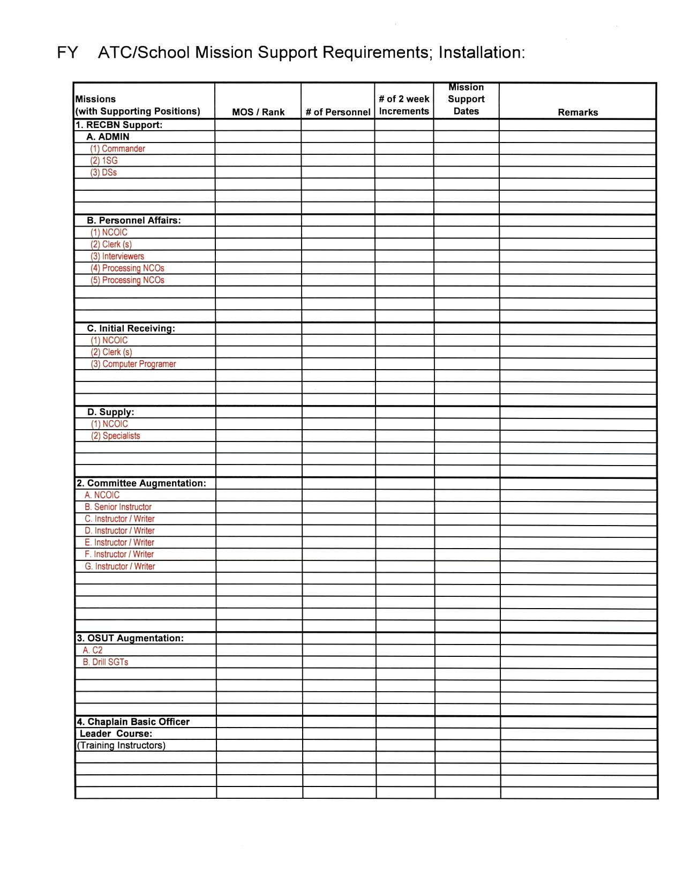

Figure D-1. Mission support requirements format

# Appendix E

# Mobile Training Team (MTT) Visitation Requirements

1. This appendix prescribes procedures and policies for MTT visitation.

2. The purpose of the MTT is to thoroughly prepare, train, and, if required, to certify unit cadre for upcoming AT missions. MTTs for training groups and reception battalions should follow the same timeline as those for other units.

3. The MTT requirement is completed when the CoE or the USATC commander certifies that the USAR training units are prepared to conduct the mission to Army standards.

4. MTT visits will be scheduled as required when funding is available. The number of DSs on an MTT varies based upon the size and composition of the unit visited and an estimate of the unit's needs. The CoE or the USATC commander will determine composition of MTTs.

a. Each battalion MTT visit will be executed 3-6 months prior to the mission. In addition to the upcoming mission, this visit will focus on drill sergeant platform/hands on teaching ability and task organization of the unit.

b. Subsequent MTT visits will be scheduled and configured based on specific unit needs assessed during the initial visit.

c. USAR commander and staff visits to the CoEs and the USATC should be considered and utilized as appropriate. This type of visit can provide AC and RC units a better understanding of each other’s units and how each conducts business.

d. Alternative methods for MTT train-up and coordination should also be used when available (i.e. video teleconference (VTC).

e. The USAR Division commander will certify all individual DSs and instructors. (CoEs and the USATC will certify the USAR Division certification program). MTTs may be scheduled for assistance if required and if funds are available.

f. The appropriate CoE or the USATC commander will approve USAR Division Drill Sergeant Certification Programs prior to any MTT visits.

# Appendix F

# USAR Drill Sergeant/Instructor Status Report

1. General. The USAR Drill Sergeant/Instructor Status Report provides timely, standardized, and accurate data with which to assess the quantity, quality, qualification, and readiness of USAR training personnel essential to the mobilization mission of USAR training base units.

2. Procedures.

a. Reporting units. Reports will be submitted by the 108th Training Command (IET).

b. Submission schedule. Reports will be submitted monthly. Reports will be forwarded to arrive at HQ USARC and TRADOC G-3/5/7 TOMA not later than the 10th of the month.

c. Only units organic to the reporting unit will be included in strength figures. Training commands, the drill sergeant school, and special training units will be included. Reception battalions will not be included.

# Appendix G

# ECHO Company Execution

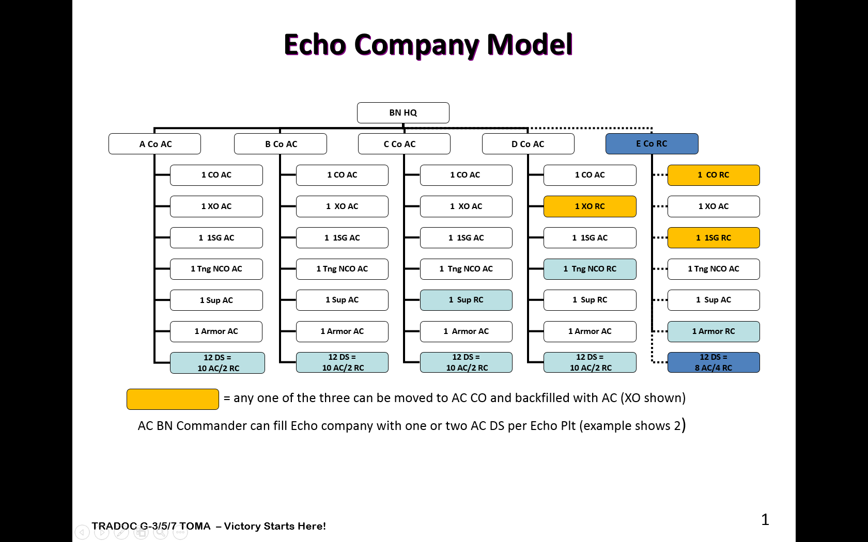

Figure G-1. Echo Company model

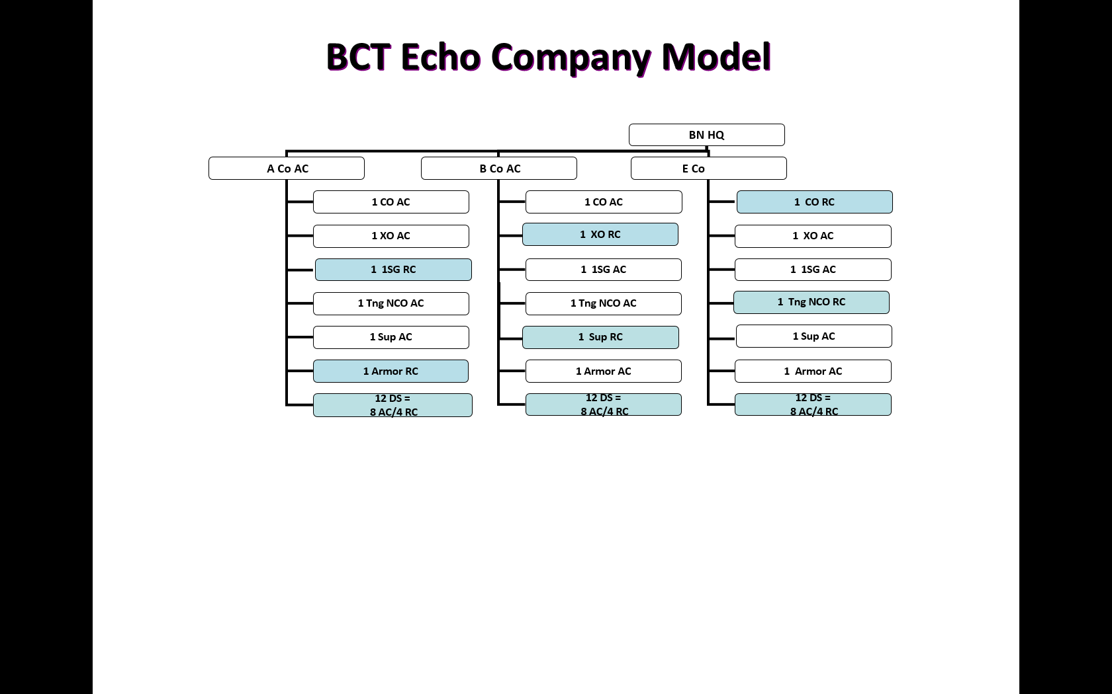

Figure G-2. BCT Echo Company model

# Appendix H

# ROTC Training Mission Support

The 108th TC (IET) augments training committees for the purpose of conducting ROTC annual cadet leader training missions. Typical training committees augmented by 108th TC (IET) instructors are listed below:

* Individual Tactical Training (ITT)
* Land Navigation
* Basic Rifle Marksmanship (BRM)
* Nuclear, Biological, Chemical (NBC)
* Hand Grenade
* Machine Gun

# Glossary

**Section I**

**Abbreviations**

AA active Army

AAR after action review

AC active component

ADOS active duty for operational support

AR Army regulation

ARPRINT Army Program for Individual Training

AT annual training

BCT basic combat training

CG Commanding General

CIET Cadet Initial Entry Training

CLC Cadet Leader Course

CO contingency operations

CoE Center of Excellence

DS drill sergeant

EXORD Execution Order

HQDA Headquarters, Department of the Army

HRC Human Resources Command

IDT Inactive Duty Training

IET Initial Entry Training

IRR individual ready reserve

MOS military occupational specialty

MTT mobile training team

OSUT one station unit training

POC point of contact

RC reserve component

ROTC Reserve Officers’ Training Corps

SMDR Structure Manning Decision Review

TBAD Training Base Augmentation Division

TMOPES TRADOC Mobilization and Operations Planning and Execution System

TOMA Training Operations Management Activity

TRADOC U.S. Army Training and Doctrine Command

TRAP Training Resource Arbitration Panel

USMA United States Military Academy

U.S. United States

USACIMT U.S. Army Center for Initial Military Training

USACC U.S. Army Cadet Command

USAR U.S. Army Reserve

USARC U.S. Army Reserve Command

USATC U.S. Army Training Center

USMMA U.S. Merchant Marine Academy

**Section II**

**Terms**

**Active Duty (AD)**

Full-time duty in the active Military Service of the U.S.. A general term applied to all active Military Service, but not including full-time National Guard duty.

**Active duty for training**

AD that is used for training members of the RC to provide trained units and qualified persons to fill the needs of the Armed Forces in time of war or national emergency and such other times as national security requires. Active duty for training includes AT, special tours of active duty for training, school tours, and initial duty for training performed by non-prior service enlistees.

**Annual Training (AT)**

The minimal period of training Reserve members must perform each year to satisfy the training requirements associated with their RC assignment.

**Full Mobilization**

Mobilization in time of war or national emergency declared by the Congress of all RC units in the existing force structure; all individual, standby, and retired Reservists; retired AC military personnel; and the resources needed for their support. Full mobilization is directed by the Congress in those situations requiring the expansion of the AA to meet the requirements of a war or other national emergency involving an external threat to national security. Units, individual Reservists, and retirees may be ordered to active duty for the period of the emergency plus six months thereafter.

**Inactive duty training (IDT)**

Authorized training performed by a member of an RC not on AD or ADT status. Consisting of regularly scheduled unit training periods or equivalent training performed by RC members in connection with the prescribed activities of the RC of which they are a member.

**Initial entry training (IET)**

Training presented to new enlistees with no prior military service. It is designed to produce disciplined, motivated, physically fit Soldiers ready to take their place in the Army in the field. This training consists of BCT, AIT, and OSUT.

**Military occupational specialty (MOS)**

The specific mix of DS MOS required in BCT and OSUT to improve the quality of training.

**Mobilization**

The process by which the Military Services or part of them are brought to a state of readiness for war or other national emergency. This includes activating all or part of the RC as well as assembling and organizing personnel, supplies, and materiel.

**One Station Unit Training (OSUT)**

IET conducted at one installation, in one unit, under the same cadre, with an integrated program of instruction tailored to a specific MOS.

**Partial Mobilization**

Mobilization by the President of not more than 1 million Ready Reservists for no longer than 24 months, pursuant to section 12302 of Title 10, U.S. Code and the resources needed for their support to meet the requirements of a war or other national emergency involving an external threat to the national security or of a domestic emergency.

**Reserve Component (RC)**

Members and units of the Army National Guard and Army Reserve.