# Department of the Army *TRADOC Regulation 350-50-3

# Headquarters, United States Army

**Training and Doctrine Command**

**Fort Eustis, Virginia 23604-5700**

# 12 July 2023

**Training**

# Mission Command Training Program

FOR THE COMMANDER:

MARIA R. GERVAIS

Lieutenant General, U.S. Army

Deputy Commanding General/

Chief of Staff

OFFICIAL:



WILLIAM T. LASHER

Deputy Chief of Staff, G-6

**History.** This publication is a major revision, implementing AR 350-50 and evolving techniques for exercise planning, preparation, and execution of Mission Command Training Program exercises. This regulation is directed in AR 350- 50.

**Summary.** This regulation outlines the organization and procedures of the Mission Command Training Program. It also prescribes policies, procedures, and responsibilities for headquarters and commands conducting training supported by the Mission Command Training Program. This regulation also stipulates requirements for Army commands to support the training events of subordinate training audiences. The current operational environment compels joint training with other services and combined training with allied/multinational partners when available. While this document is directive for the Mission Command Training Program, it is written with regard to cross-service and combined training where that participation is within the Mission Command Training Program guidelines.

**Applicability.** This regulation applies to Army units (Regular Army, U.S. Army Reserve, and Army National Guard) involved in training with the Mission Command Training Program. When applicable, this regulation specifically addresses differences between these components.

**Proponent and exception authority.** The proponent of this regulation is the Deputy Commanding General, Combined Arms Center-Training. The proponent has the authority to

*This regulation supersedes TRADOC Regulation 350-50-3, dated 19 April 2018.

approve exceptions or waivers to this regulation that are consistent with controlling law and the proponent may delegate this approval authority in writing, to a division chief with the proponent agency or its direct reporting unit or field operating agency, in the grade of colonel or the civilian equivalent. Activities may request a waiver to this regulation by providing justification that includes a full analysis of the expected benefits and must include formal review by the activity’s senior legal officer. All waiver requests will be endorsed by the commander or senior leader of the requesting activity and forwarded through their higher headquarters to the policy proponent.

**Army management internal control program**. This regulation does not contain management internal control provisions.

**Supplementation.** Supplementation of this regulation is prohibited without prior approval from the Deputy Commanding General, Combined Arms Center-Training, 633 McClellan Ave. (Attn: ATZL-CT); Fort Leavenworth, KS 66027.

**Suggested improvements.** Send comments and suggested improvements on DA Form 2028 (Recommended Changes to Publications and Blank Forms) directly to Combined Arms Center-Training Headquarters, 633 McClellan Ave. (Attn: ATZL-CT); Fort Leavenworth, KS 66027. Suggested improvements may also be submitted to [usarmy.leavenworth.cac.mbx.cac-t-operations@army.mil](mailto:usarmy.leavenworth.cac.mbx.cac-t-operations@army.mil).

**Availability.** This regulation is distributed electronically and is available on the TRADOC Administrative Publications homepage at: [http://adminpubs.tradoc.army.mil/.](http://adminpubs.tradoc.army.mil/)

# Summary of Changes

TRADOC Regulation 350-50-3

Mission Command Training Program

This major revision, dated 12 July 2023 -

o Updates the Mission Command Training Program mission, key tasks, organizational design, and capacity planning considerations (chap 1).

o Updates reporting to the Center of Army Lesson Learned (para 2-9).

o Updates the Mission Command Training Program planning and execution framework to support the execution of a warfighter exercise (chap 3).

o Updates After Action Reviews/Final Exercise Reports take home package provided to a senior training audience (para 3-5).

o Updates reflect implementation of Regionally Aligned and Modernization Model (throughout).

o Changes Mission Command Training to Academics (throughout).

# Contents

**Page**

Chapter 1 Introduction 5

1-1. Purpose 5

1-2. References 5

1-3. Explanation of Abbreviations and Terms 5

1-4. Responsibilities……………………………………………………………………………5

1-5. Records Management……………………………………………………………………...5

1-6. The Mission Command Training Program Mission and Key Tasks 5

1-7. Organizational Design 7

1-8. Planning, Programming, Budgeting, and Execution 10

Chapter 2 Responsibilities and Requirements to Supported Commands 16

2-1. The Chief of Staff of the Army 16

2-2. The Department of the Army Deputy Chief of Staff, G-3/5/7 17

2-3. Commanding General, United States Army Training and Doctrine Command 17

2-4. Commanding General, United States Army Forces Command 17

2-5. Director, Army National Guard 18

2-6. Commanding General, U.S. Army Combined Arms Center 18

2-7. Deputy Chief of Staff for Intelligence (G-2), TRADOC 18

2-8. Deputy Command General, U.S. Army Combined Arms Center-Training 19

2-9. Commander, Mission Command Training Program 19

2-10. National Simulation Center 20

2-11. TRADOC Capability Manager – Integrated Training Environment 21

2-12. Exercise Director 21

2-13. Warfighter Exercise Senior Training Audience 22

2-14. Other Supporting Commands 23

Chapter 3 Warfighter Exercise Planning and Execution 25

3-1. General 25

3-2. Training Methodology 26

3-3. Warfighter Exercise Planning 28

3-4. Warfighter Exercise Execution 32

3-5. After Action Reviews and Final Exercise Reports 41

3-6. Visits to Exercises and Events 41

Chapter 4 [Army Service Component Command Training Exercise Coordination   
and](#_bookmark43) Execution 42

4-1. Overview 42

4-2. Army Service Component Command Event Scheduling 43

Chapter 5 Simulations, Models, and Army Mission Command Systems 43

5-1. Overview 43

5-2. Models and Simulations 44

5-3. Simulation Operations 44

5-4. Rules and workarounds 44

5-5. Command, control, computers, communication, and intelligence systems 44

5-6. Mission Command Training Program information management 44

Appendix A References 45

Glossary 47

# Figure List

Figure 1-1. The Mission Command Training Program Organization and Support Structure 7

Figure 1-2. Example of Warfighter Exercise Troop List Template (Corps) 12

Figure 1-3. Example of Warfighter Exercise Troop List Template (Two Divisions) 13

Figure 1-4. Example of Warfighter Exercise Troop List Template (One Division) 14

Figure 3-1. Warfighter Exercise Event Life Cycle 26

Figure 3-2. Example of a Warfighter Exercise Timeline 32

Figure 3-3. Example of a Warfighter Exercise Control Group Structure 34

Figure 3-4. Warfighter Exercise Work Cells 36

Figure 3-5. Warfighter Exercise Response Cells 37

Figure 3-6. Example of an Exercise Control Group/Higher Command Battle Rhythm 38

# Chapter 1 Introduction

# 1-1. Purpose

This regulation prescribes the objectives, concepts of operation, responsibilities, policies, and planning guidance for the Mission Command Training Program (MCTP) in support of multi- echelon warfighter exercises (WFXs), Army Service Component Command (ASCC)/Combatant Commander Exercises, and pre-deployment exercises (when directed by United States Army Forces Command (FORSCOM)).

# 1-2. References

See Appendix A for references.

# 1-3. Explanation of Abbreviations and Terms

Abbreviations and special terms used in this regulation are explained in the glossary.

# 1-4. Responsibilities

See Chapter 2.

# 1-5. Records management

The records management requirement for all record numbers, associated forms, and reports required by this publication are addressed in the Records Retention Schedule- Army (RRS-A). Detailed information for all related record numbers, forms, and reports are located in Army Records Information Management System (ARIMS)/RRS-A at <https://www.arims.army.mil>. If any record numbers, forms, and reports are not current, addressed, and/or published correctly in ARIMS/RRS-A, see DA Pamphlet 25-403 for guidance.

# 1-6. The Mission Command Training Program (MCTP) Mission and Key Tasks

a. Mission. MCTP is the premier deployable combat training center for implementing,

observing, coaching, and facilitating collective training opportunities and leadership experiences

for Commanders and staffs to plan, prepare, fight, and win during Large Scale Combat

Operations (LSCO). The MCTP supports the execution of five exercise variants, each focused

on enhancing unit readiness and leader development.

b. WFX. The MCTP designs and executes multi-echelon, multi-component warfighter

exercises focused on tactical corps and divisions formations as major units of action during

LSCO. WFXs are scheduled by FORSCOM on behalf of the Chief of Staff of the Army (CSA).

Each WFX is tailored to provide expeditionary-focused, realistic, demanding training, and

leader development opportunities by integrating joint, interagency, intergovernmental,

multinational (JIIM) operations against near-peer threats in a multi-domain contested

environment. The WFX program is the CSA’s exercise program and a significant training event

within the Regionally Aligned and Modernization Model (ReARMM). Instead of emphasis on

individual enabling brigades such as artillery, aviation, and sustainment, these brigades are now

viewed in the context of corps and division formations. Primacy is now placed on the vertical

integration of Warfighting Functions throughout the depth of the formation and their horizontal

synchronization to achieve corps and division endstates. The MCTP provides Highly Qualified

Experts-Senior Mentors (HQE-SMs) and observer coach/trainers (OC/T) to tactical corps and

division formations with subordinate units and enablers organized by Warfighting Function

(WfF) during WFXs. MCTP Operations Group OC/Ts are also organized by WfF to facilitate

mission command training through 24-hour coverage for unit command groups, staff, and key

leaders in their respective command posts, and integrating cells throughout the WFX.

Additionally, each WFX senior training audience (corps and/or division) with its subordinate

formations receives an academic session facilitated by their respective Operations Group and

HQE-SM(s). Each facet of the WFX is designed to build and sustain unit readiness and

enhance leader development. The MCTP only supports non-standard unit ramp-up and/or

command post exercises (CPX) that occur in preparation for participation as a senior training

audience in an MCTP WFX when requested and funded by the unit.

c. ASCC Exercises. The MCTP, when directed, supports ASCCs, field armies, corps, or

divisions designated as an Army Force command as part of an ASCC or geographic combatant

command exercise. The MCTP can form the core of a Joint Staff, Operational Plans and

Interoperability Directorate (J-7) supported or geographic combatant command augmented joint

observer training team (JOTT) for units designated as a Joint Force Land Component

Command or Joint Task Force (JTF) as part of the exercise. The MCTP OC/T requirement for

an ASCC exercise is defined as: ASCC designated training audience staff. MCTP OC/Ts

and HQE-SMs facilitate mission command training through 24-hour coverage of: key leaders,

command group, command posts, and staff/warfighting function and integrating cells

throughout the ASCC exercises. The MCTP support package does not include exercise

designers and academic seminar(s). Synchronization and scheduling of MCTP support will be

codified at each FORSCOM Army Synchronization and Resourcing Conference (ASRC)

during the MCTP scheduling segment to include refinements and updates to the existing and

future MCTP schedule.

d. Mission Readiness Exercise (MRX). MCTP, when directed, supports the deploying

Army unit’s culminating training event(s) directed by Commanding General (CG),

FORSCOM. In exercises for units designated to be a Joint Force Land Component Command

or JTF headquarters, MCTP forms the core of a JOTT with support from the Joint Staff (JS)

Joint Force Development Directorate (J-7) and augmentation from the supported geographic

combatant command. MCTP OC/Ts facilitate mission command training during an MRX

through 24-hour coverage of: designated training audience staff, key leaders, command

group, command posts, and staff/warfighting function and integrating cells throughout the

MRX.

e. Contingency Operations. The MCTP, when directed, provides staff assistance to Army

units allocated in support of contingency operations. The MCTP OC/T requirement for a

Contingency Operation will be based off the type of unit covered and level of support requested

by the unit and approved by FORSCOM.

f. JTF-enabling WFX. When directed, the JTF-enabling WFX is a non-standard WFX that

enables a designated Army headquarters to become formally certified as a JTF by the

requesting Combatant Command. The JTF-enabling WFX is a nested, multi-echelon, multi-

component exercise, scheduled during the FORSCOM ASRC, which includes additional joint

context and unified action partner participation. The senior training audience(s) in a JTF-

enabling WFX are corps and select division headquarters as a joint training audience with

functional and multi- functional support brigades as Army subordinate units. The supported

Combatant Command or ASCC publishes an exercise force requirement in the Joint Training

Information Management System (JTIMS) that specifically requests the Army to provide a

mission command headquarters (such as, division, corps, operational field army or

combination) expressly for the purpose of subsequent JTF certification as the desired end state.

The JTF-enabling WFX must be supported by the JS/J-7 deployable training team or ASCC-

provided equivalent working in coordination with MCTP to form the JOTT and the Combatant

Command or ASCC provides the higher command (HICOM). This event relies upon the

unified action partner participation identified in the senior training audience’s joint manning

document and MCTP’s exercise support manning/equipping document (ESMED) to establish

the senior training audience’s boards, bureaus, centers, cells, and working groups and the

higher, adjacent, and supporting mission command structure with which they interact. Also

includes other government agencies and multinational partners. Routinely, MCTP receives

United States Marine Corps, United States Navy, United States Air Force (USAF), United

States Space Command, and United States Special Operations Command augmentation to

create the necessary response cells. Post-event, the supported ASCC works with its combatant

command and with FORSCOM to coordinate the senior training audience’s sustainment

training and recertification as a JTF-capable headquarters.

# 1-7. Organizational Design

The MCTP consists of a headquarters, and four Operation Groups (OPS GRPs). The organization consists of military, DA Civilians, and support contractors enabling the design and execution of exercises. The MCTP’s military OC/Ts are military education level four branch-qualified officers, warrant officers, and non-commissioned officers who have successfully completed the MCTP OC/T training and certification requirements within the standards established by U.S. Army Training and Doctrine Command (TRADOC). All elements, with the exception of the HQE-SMs with relevant operational experience in the area for which they are observing, are garrisoned at Fort Leavenworth, Kansas.

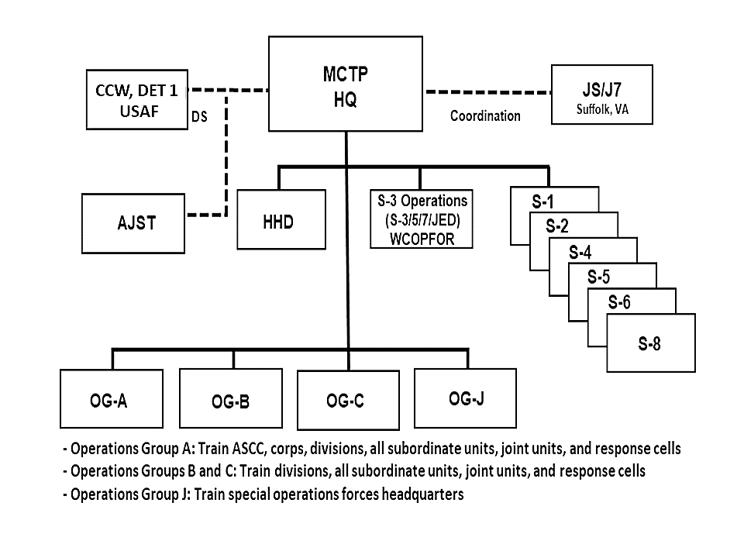

# Figure 1-1. The MCTP Organization and Support structure

a. MCTP Headquarters and Headquarters Detachment (HHD). The Headquarters provides mission command, administration, and resource management for the organization. The HHD directs the administrative and Soldier training aspects of the MCTP and supports the primary staff by facilitating the environment in which they operate and in turn supports the MCTP command group in leading the program.

(1) S-3 provides direct support to exercise design, planning, exercise control, and

management of corps and/or division WFXs and MRXs, when directed. S-3 provides

general support to OPS GRPs for other exercises based on requirements. S-3 consists of the

S-33, S-35, S-3/7, the Joint Effects Division (JED), and the World Class Opposing Forces

(OPFOR). The Director of Operations is also the chief exercise controller and the exercise

control group chief of staff during WFX execution.

* 1. The S-33 monitors, synchronizes, and controls the stimulation of training units during the execution of the WFX. S-33 ensures supporting elements that are not designated as primary training units (for example, HICOM, response cells, et cetera.) are properly manned, equipped, trained, and rehearsed in preparation for the exercise. S-33 manages the synchronization and timing of exercise Master Scenario Event List (MSEL) injects. S-33 ensures the senior training units have an opportunity to meet their stated training objectives and outcomes based on the guidance of the exercise director (EXDIR), chief controller, and OPS GRP chiefs. S-33 only supports WFXs.
  2. The S-35 is responsible for the creation of the complex operational environment under the doctrinal operational variables for WFXs. S-35 also controls the irregular threat forces and role-players during the exercise. Additionally, S-35 coordinates and integrates unified action partner support to the exercise in order to meet operational training guidance and unit training objectives. S-35 only supports WFXs.
  3. The S-3/7 simultaneously leads and synchronizes five WFX plan, prepare, and execute cycles each fiscal year that integrate JIIM partners in support of Army senior leader training objectives in order to provide corps, division, and functional/multifunctional support brigade commanders and staffs the opportunity to plan, prepare, fight, and win during LSCO. S-3/7 is also the proponent for the management, design, and accuracy of the ESMED and the Sim Control Plan (SCP).
  4. JED coordinates and integrates fires and Information Advantage Division (IAD) support to the exercise in order to meet operational training guidance and unit training objectives. The IAD contains subject matter experts who produce MSEL injects to replicate multi-domain operations in the exercise such as space operations, special technical operations, media, cyber-electromagnetic activity, inform and influence activities, and military information support operations. JED only supports WFXs.
  5. The World Class OPFOR (WCOPFOR) provides a “free thinking,” near-peer competitive, operational level hybrid threat in a multi-domain contested and diverse geographical operational environment that challenges the execution of collective tactical tasks by Army brigades, divisions, corps, and service components while stressing and challenging the ability of commanders and staffs to guide, integrate, and synchronize Army forces throughout the conduct of LSCO. The WCOPFOR are accredited by the TRADOC Deputy Chief of Staff for Intelligence (G-2) and operate under the doctrine outlined in Training Circular 7-100 series describing the Hybrid Threat. The OPFOR threat characteristics conform to the guidance of the TRADOC G-2 in order to represent the most current threat capabilities outlined in the TRADOC World Wide Equipment Guide. The WCOPFOR has a coordinating relationship with the Army Cyber Command’s Information Warfare/Cyber Opposing Forces (IW/Cyber OPFOR) and the Space and Missile Defense Command’s Army Space Training Division for WFX planning and execution. WCOPFOR only supports WFXs.

(2) S-6 is responsible for the integration of the communications systems of the MCTP and

the simulation into the exercise. The MCTP Chief Information Officer (CIO) is responsible for

delivering the stimulation/simulation to the exercise and is the final authority for controlling the

simulation and/or federation of simulations used in exercises.

b. OPS GRP A, B and C. OPS GRPs focus on tactical corps and divisions with their

subordinate formations organized by WfF during WFXs. When directed, they support ASCC

exercises. Each OPS GRP can observe, coach, and train one senior training audience (corps or

division headquarters) and its subordinate formations per exercise. OPS GRPs are organized by

warfighting functions to support the vertical integration of WfFs in the senior training audiences’

formations with a Chief of OPS GRP (COG), Chief Observer Trainer, and a Chief of Operations.

c. OPS GRP J observes, coaches, and trains Army special operations forces (SOF) operational level headquarters during WFXs. OPS GRP J also observes, coaches and trains Conventional Force (CF) commanders and staffs in SOF/CF integration, interoperability, and interdependence during WFXs. OPS GRP J provides SOF scenario development and design, integrates SOF doctrine, concepts, and procedures, and serves as the SOF Response Cell / SOF HICOM during WFXs. OPS GRP J can observe, coach, and train one SOF operational level headquarters (HQ) per exercise. OC/Ts are military education level four branch-qualified officers, warrant officers, and non-commissioned officers who have SOF background and experience (for example, Civil Affairs, military information support operations, and Special Forces).

d. Command and Control Wing, Detachment 1 (CCW, DET 1). Serves as the MCTP USAF liaison to USAF elements participating in combat training, codified under the Chief of Staff of the Air Force, Joint Training Transformation Initiative, and Joint National Training Capability events. The CCW, DET 1 observes, coaches, and trains commanders, staffs, and their USAF airpower operations liaison elements in the integration of airpower and application of joint firepower. The CCW, DET 1 commander serves as the Deputy Exercise Director for Airpower, also known as the Chief of Airpower, during WFXs. Based on the MCTP priorities and CCW, DET 1 resources, each OPS GRP is supported by USAF OC/Ts, exercise control, and planning staff to ensure accurate USAF air and space capabilities and doctrine are represented. This relationship is based on

AFI 10-204 and AAFIF MOU.

e. Army Joint Support Team (AJST). The TRADOC and Combined Arms Center (CAC) lead for joint air-ground operations, education, and training, including both the mission command processes and the joint command and control processes associated with joint air operations (for example, close air support, air interdiction, airspace control, joint targeting, common operational picture, and integrated air and missile defense). AJST educates and trains the MCTP personnel in support of joint air-ground operations requirements. AJST support is integral to the MCTP organization and function. It provides expertise, systems, OC/Ts, and coordinates for battlefield coordination detachment (BCD) support to the MCTP events to provide a battlefield coordination detachment response cell (with augmentation) when a full BCD is not required. During the execution and assessment phases of exercise training events, the AJST provides observations and other relevant input on all aspects of Joint Air- Ground Integration relevant to both operations and Mission Command Information System (MCIS) employment for the MCTP leadership and respective OC/Ts.

f. Highly Qualified Experts-Senior Mentors (HQE-SMs). Also known as the Senior Mentor program. Managed by the US Army Civilian Senior Leader Management Office (CSLMO). Senior mentors are retired general officers appointed by the CSA and the Chief of Staff of the Air Force. MCTP senior mentors coach, teach, and mentor senior training audience commanders and their command groups through the operations process and execution of the exercise. Senior mentors partner with WfF chiefs when subordinate training audience formations are organized by WfF. Additionally, HQE-SMs oversee doctrinal standardization within exercise training events, participate in the academic seminars, and provide holistic feedback to the Army’s senior leadership. The MCTP commander assigns each HQE- SM to every training event for each exercise senior training audience and/or WfF in accordance with Army Directive 2011-13.

# 1-8. Planning, Programming, Budgeting, and Execution

The MCTP’s exercises are scheduled in accordance with FORSCOM business rules at the ASRC out to six years. The MCTP uses Combat Training Center (CTC) program funds to resource MCTP costs associated with each exercise.

1. Capacity. The MCTP designs, coordinates, and executes five multi-echelon embedded WFXs and support to five ASCC exercises per fiscal year. An MRX is executed in lieu of a WFX as directed by FORSCOM. When manned at 100% of table of distribution and allowances (TDA) authorized OC/Ts, WFXs consist of up to a corps and division or two division HQs, two sustainment commands, up to six functional/multifunctional support brigades, and a SOF HQ.
   1. When manned at 100% of TDA authorized OC/Ts, the fiscal year training capacity of the WFX program accommodates:
      1. Up to two corps or other operational-level headquarters.
      2. Up to eight RA/RC division headquarters (minimum five RA and two RC).
      3. Thirty functional/multifunctional support brigades/Army National Guard (ARNG) brigade combat team HQs.
      4. Ten Sustainment commands and/or brigades.
      5. Up to three SOF operational level HQs.
   2. Up to five ASCC exercises (for example, COMBINED COMMAND POST TRAINING, AVENGER TRIAD, INTERNAL LOOK, and AUSTERE CHALLENGE) are distributed for execution among the MCTP OPS GRPs.
   3. TRADOC G1 advocates for permanent party manning of MCTP OPS GRPs consistent with Army Manning Guidance and Priorities. TRADOC as a goal must ensure manning for all MCTP OPS GRPs to 100% during planning and execution of all exercises. They will do so via internal augmentee OC/Ts (AOC/Ts) tasking for all requirements that the rotational unit is unable to support.
2. Reduction in the MCTP manning reduces capacity for exercise planning, because

personnel involved in planning are also involved in the execution of exercises.

1. AOC/Ts must be on location and complete in- processing no later than three days

prior to the start of the exercise to receive standard MCTP OC/T training and integration into the exercise.

* 1. Other considerations in planning capacity are:
     1. MCTP conducts OC/T training and certification twice annually to eligible officers and

non-commissioned officers assigned or attached to MCTP.

* + 1. MCTP requires equipment shipping time of up to 14 days for overseas shipments and up to five days for continental United States exercises.
    2. MCTP requires up to 15 days for WFX equipment setup, workstation controller training, and associated pre-start of exercise (STARTEX) activities.

1. MCTP submits annual program objective memorandum (POM) command and critical requirements as part of the management decision evaluation package (MDEP) mission command training program (TCBC) to the training (TT) program evaluation group for inclusion in the Headquarters, Department of the Army (HQDA) annual budget submission to Congress.

1. MCTP POM submission is bound to the constraints of TDA authorization and directed

annual training capacity of the CTC program. MCTP has no financial capability to support above capacity.

# Figure 1-2. Example of MCTP WFX Troop List Template (Corps)

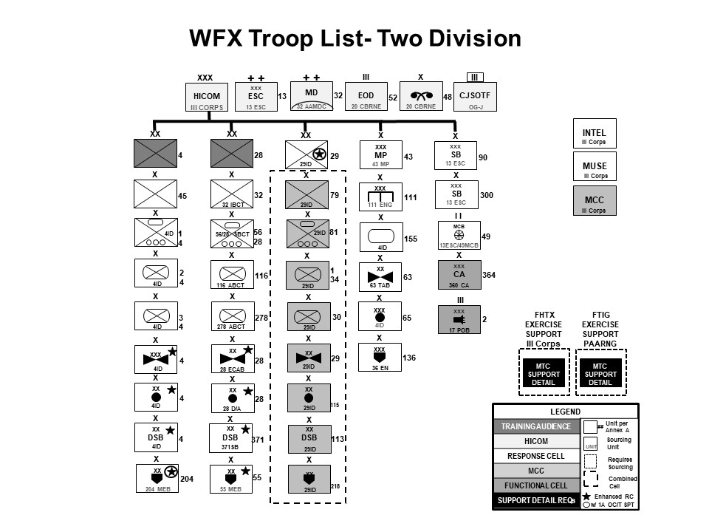

**Figure 1-3. Example of MCTP WFX Troop List Template (Two Divisions)**

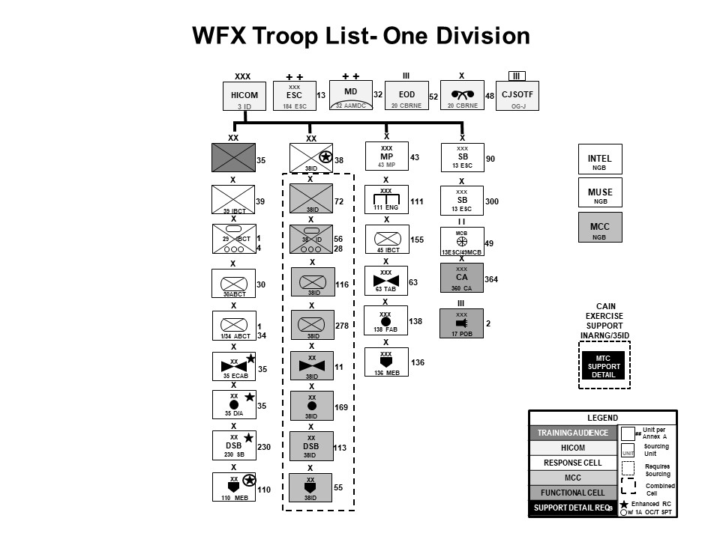

# Figure 1-4. Example of MCTP WFX Troop List Template (One Division)

* 1. The MCTP conducts embedded exercises distributed over three permanent sites (Fort Leavenworth, KS; Fort Gregg-Adams, VA; and Hurlburt Field, FL). MCTP routinely distributes the exercise network to no more than three additional training unit garrison locations. Additional satellite locations with limited simulation capability may be accommodated for the unit replicating the maneuver, sustainment, and SOF HICOMs. Sites beyond this capacity incur significant risk in the ability of the MCTP to resource simulation equipment and execute exercise control to ensure desired training objectives are met.
  2. Simulation model support for unit ramp-up training events and CPXs is coordinated through, and provided by, the Global Simulation Capability (GSC) of the National Simulation Center (NSC), Combined Arms Center- Training (CAC-T), Ft. Leavenworth, KS. When available, the MCTP only supports non-standard unit ramp-up and/or CPX that occur in preparation for participation as a senior training audience in an MCTP WFX when requested and funded by the unit.
  3. MCTP directly coordinates for Defense Logistics Agency (DLA), Army Material Command, United States Army Special Operations Command, and other supporting commands as outlined in para. 2-14 for support to WFXs.

1. Scheduling Constraints. All the MCTP exercises and supported training events are scheduled at the ASRC by FORSCOM. The MCTP Commander, through deliberate planning, may elect to exceed the MCTP planned capacity if the situation provides additional flexibility for the MCTP to plan, resource, and execute around known constraints.
   1. Requests for non-standard, out-of-cycle, un-programmed training events (for example, CPX, Risk Reduction Event (RRE), et cetera) must be submitted in writing by the training audience through the Army command (ACOM)/chain of command to the respective proponent (HQDA for ASCC events or FORSCOM for WFXs) for approval at least 12 months prior to exercise execution. The training audience is responsible for all additional costs associated with the variance from standard exercise support.
   2. All Units requesting additional MCTP support for RREs, contingency operations and other unforeseen events must provide a fund cite/source at the time of request. This is necessary because RREs and contingency operations are not programmed as part of the normal MCTP POM cycle and are not funded by the CTC program. Funding includes exercise costs associated with travel, lodging, and per-diem as well as any other costs associated with MCTP support to planning events. Additional MCTP support funding applies to both MCTP personnel, MCTP support contractors, and HQE-SMs.
   3. Approving Authorities. HQDA G-3/5/7 is the approval authority for all requests for MCTP non-standard support associated with ASCC exercises. CG, FORSCOM (ATTN: G- 3/5/7) is the approval authority for all requests of MCTP non-standard support for non-ASCC exercises. Unforeseen requests include, but are not limited to, support of RREs, contingency operations and any other request not scheduled in accordance with chapter 1, paragraph 1-6, section b (Scheduling Constraints). Units will resolve funding for such requests prior to approval by HQDA. Major Army commands forward requests through FORSCOM; include outside the continental United States country clearance data if applicable. Requests will include a fund cite/source, and exact costing data, determined by MCTP and the requesting unit. FORSCOM provides a recommendation and forwards the request through HQDA (DAMO-TR) to the HQDA G-3/5/7.
2. Resourcing.
   1. HQDA provides funds to ASCCs, ACOMs and the National Guard Bureau for WFXs, WFX academics, and ASCC exercises. Training unit costs above all costs directly programmed for exercise planning event travel and per-diem is a unit bill and is funded with the unit’s home station funding.
   2. HQDA provides TRADOC funding for the MCTP military, DA Civilian, Army support contractor support, and travel to support annual exercise training requirements to include the authorized event life cycle (ELC).
   3. MCTP uses JTIMS and the Joint Training Coordination Program (JTCP), respectively, to request and to fund many of the capabilities enabling joint training. MCTP is eligible to participate in the JTCP by maintaining its program accreditation and technical site certification through the Joint National Training Capability. JTIMS and JTCP allow the MCTP to directly request other service and Special Operations Command support along with the corresponding funding from Joint National Training Capability.
   4. Additional MCTP resourcing and required augmentation:
      1. The MCTP requires AOC/T support for all exercises if not manned to 100% or if training unit requirements exceed the rank and skill requirements of the MCTP TDA. In accordance with Army Regulation 350-50, TRADOC, as a goal, will fill 100% of the MCTP OPS GRPs personnel requirements through permanent party assignment. TRADOC will coordinate with the rotational unit’s ACOM or ASCC to fill individual MCTP rotational OC/T shortfalls for 80 percent of authorized TDA positions within the approved troop list which TRADOC is unable to support. The training unit ACOM will source all AOC/T requirements above the MCTP TDA to meet approved training objectives. The MCTP will provide required AOC/Ts sourcing requirements to TRADOC on/about W-75.
      2. For Operational Capability Assessments and Joint exercises, the ACOM, directing or supporting, will resource or coordinate for joint augmentation required to form a JOTT. Specific request of augmentation will be provided to the ACOM no later than W- 180.
      3. ACOMs will also source personnel to fulfill exercise control group (ECG) requirements, which include but are not limited to the EXDIR and staff, HICOM response cell, the maneuver and sustainment control cells, echelon above division or corps functional cells, subordinate response, and MTC exercise support personnel.
   5. Outside agencies requesting the MCTP assistance with data collection, information gathering, et cetera will reimburse the MCTP for any additional costs directly resulting from this collection effort. The training unit must concur with requests for outside agency participation.
   6. Training or exercise participation of foreign government agencies will be in accordance with AR 350-50.
   7. The WFX senior headquarters training audience is responsible for consolidating the Field Budget Estimates for participating units and distributing funds provided by FORSCOM for each WFX accordingly.

# Chapter 2

**Responsibilities and Requirements to Supported Commands**

Responsibilities and requirements are nested with AR 350-50, institutionalized in this regulation, and reinforced through the Army Synchronization and Resourcing Process.

# 2-1. The Chief of Staff of the Army

The sole approval authority for:

1. WFX cancellation.
2. Changes to operational training guidance used in the WFX design process.

# 2-2. The Department of the Army Deputy Chief of Staff, G-3/5/7

1. Approves participation of foreign military units at MCTP exercises in accordance with AR 350-50.
2. Ensures MCTP staffing and manning changes are in accordance with the HQDA manning

guidance.

1. Requests Joint and Special Operations personnel required to meet training guidance and directives as outlined in the ESMED produced for each exercise.
2. Approves all un-forecasted requests for MCTP support as explained in paragraph 1-6, (b) above.

# 2-3. Commanding General, United States Army Training and Doctrine Command (TRADOC)

1. Establishes priorities for the allocation of TRADOC resources identified to support the MCTP.
2. Provides AOC/Ts to backfill the MCTP TDA shortfalls in support of standard exercises.
3. The Director, CTC Directorate, on behalf of CG, TRADOC, plans and executes the CTC accreditation process in coordination with FORSCOM and United States Army Europe and Africa (USAREUR-AF) and develops an accreditation report every two years in accordance with

AR 350-50.

# 2-4. Commanding General, United States Army Forces Command (FORSCOM)

1. Sources required training support, and response cell personnel, special skilled personnel, and AOC/Ts required above the MCTP TDA as outlined in the ESMED when modular subordinate units cannot fill those positions.
2. Schedules WFXs within the MCTP capacity to meet ReARMM unit life cycle requirements.
3. Approves exercise locations for major subordinate commands.
4. Appoints EXDIR for major subordinate command’s WFX at the ASRC and confirmed at the exercise working group #1 (EWG#1) conducted no earlier than W-300.
5. Enforces training unit responsibilities and the MCTP planning guidance to training audiences.
6. Approves WFX training objectives.
7. Serves as approval authority for changes in time or location of the ELC to include the academic seminar and associated venue for senior training audiences.

# 2-5. Director, Army National Guard

1. Sources required training support, and response cell personnel as outlined in the ESMED when modular subordinate units cannot fill those positions.
2. Schedules major subordinate command’s WFXs with FORSCOM at the ASRC.
3. Approves exercise locations which meet Department of Defense Risk Management Framework for Information Technology and authority to operate requirements for major subordinate commands.
4. Enforces training unit responsibilities and the MCTP planning guidance to rotational units. Responsible to backfill training audiences and/or response cell units that reclama an ASRC- directed WFX assignment unless otherwise relieved by FORSCOM.

# 2-6. Commanding General, U.S. Army Combined Arms Center (CAC)

1. Executes oversight of the MCTP in accordance with CSA, HQDA, FORSCOM, and TRADOC directives.
2. Provides required Title 10 support to the MCTP.
3. Resources the MCTP personnel requirements.
4. Develops training and curriculum resources to support the MCTP mission and OC/T training based on emerging doctrine.

# 2-7. Deputy Chief of Staff for Intelligence (G-2), TRADOC

1. Researches, prepares, and updates the Decisive Action Training Environment (DATE) and hybrid threat concept and doctrine to include products from the National Ground Intelligence Center.
2. Prepares the base OPFOR threat characteristics for the WCOPFOR to derive specific exercise threat characteristics in order to accomplish exercise objectives.
3. Conducts accreditation and assistance visits for the WCOPFOR in accordance with

AR 350-50.

1. Provides intelligence support to WCOPFOR requests for information.
2. Assists the MCTP in developing workarounds and/or simulation requirements to integrate operational environment variables into exercises.
3. Provides relevant targeting databases based on the operational environment(s) developed in the common base scenario(s).
4. Coordinates the design of the operational environment and provides Intelligence, Surveillance, and Reconnaissance (ISR) support to MCTP exercises.

# 2-8. Deputy Commanding General, U.S. Army Combined Arms Center-Training (CAC-T)

1. Manages overall MCTP program training and support requirements necessary to train Army units and leaders for LSCO.
2. Serves as approval authority for orientation visits to the MCTP exercise events (see paragraph 3-6, c.1.)
3. Oversees and approves the execution of the MCTP budget for exercises.

# 2-9. Commander, MCTP

1. Responsible for planning and execution of the MCTP exercises.
2. Applies the CTC concept of operations to all MCTP exercises (see AR 350-50, chap 1).
3. Supervises development of scenarios for use in WFXs.
4. Ensures WCOPFOR portrays accurate hybrid threat doctrine and threat characteristics.
5. Ensures proper conduct and coordination of the ELC.
6. Ensures simulation capability, to include hardware requirements, that supports training exercises.
7. Approves all ECG decisions regarding personnel, equipment, or facilities for each WFX.
8. Develops, publishes, and distributes rules, parameters, and workarounds that govern the MCTP operations using the associated simulation programs.
9. Assigns responsibility to OPS GRPs for planning, coordination, and execution of each exercise.
10. Ensures OPS GRPs conduct OC/T certification and AOC/T training.
11. Serves as the Deputy EXDIR for division/corps WFXs, responsible to the EXDIR for the command, control and supervision of WFX academics and exercise planning, preparation, and execution. During the execution of the WFX, in the absence of the MCTP Commander, the Director of Operations serves as the Deputy EXDIR.
12. Exercises operational control of the Mission Training Complex(s) (MTC) facilities, equipment, and player/controller personnel throughout train up, execution, and termination.
13. Identifies and develops logistical requirements to support academics and exercise operational needs. Requirements include equipment availability and transportation, technical and maintenance support, and personnel augmentee requirements.
14. Responsible for controlling, manning, equipping, and executing support contracts at the McHugh Training Center, Fort Leavenworth, KS.
15. Responsible for the collection of observation and trends. Conduct annual reporting to the Center for Army Lessons Learned.
16. Assigns HQE-SMs to senior training audiences and/or WfF.

# 2-10. National Simulation Center (NSC)

The Global Simulation Capability (GSC) of the NSC provides the following to MCTP:

* 1. Gives priority for support to MCTP missions.
  2. Provides communications and network support during MCTP WFXs.
  3. Provides space in the Regional Simulation Center facility for WCOPFOR and CIO in

support of MCTP WFXs.

* 1. Provides Battlefield Visualization full motion video to MCTP and the training audience

from the simulation into training unit command posts.

* 1. Provides software and hardware maintenance support for simulation systems used by

MCTP.

* 1. Stores and ships through the MCTP contract simulation hardware and storage media in

support of WFXs, as required.

* 1. Annually reviews the memorandum of agreement (MOA) during the first quarter of each

fiscal year which outlines responsibilities with MCTP. The MOA is updated as required.

* 1. Collaborates with MCTP in the attempt to resolve simulation problems either through

defined processes, work arounds or requirements through the TRADOC Proponent Office for

Constructive Simulations (TPO-C) to Program Executive Office Simulation, Training, and

Instrumentation (PEO-STRI) to make the necessary changes to the simulation software.

* 1. The Logistics Exercise Simulation Directorate, a subordinate of the National Simulation

Center and located at Ft. Gregg-Adams, VA, provides the following:

1. Sustainment/Logistics simulation (LOGFED) and exercise design support.
2. Stimulation of designated sustainment mission command systems or processes.
3. Training and oversight of unit personnel serving as LOGFED workstation operators.
4. Training of selected MCTP personnel on the use of LOGFED.
5. Installation, configuration, maintenance, and assistance in the installation of LOGFED hardware/architecture at the exercise site/MTC.
6. Local Area Network/Wide Area Network support.
7. Joint Deployment Logistics Model technical support at the exercise site/MTC.

# 2-11. TRADOC Proponent Office- Constructive (TPO-C)

TPO-C provides simulation model and help desk support to MCTP missions.

# 2-12. Exercise Director (EXDIR)

1. WFX EXDIR Defined. The EXDIR is a general officer appointed by the CG, FORSCOM and approved by the CSA. The EXDIR is the chief representative and delegated decision maker of Army senior leaders. The EXDIR will:
   1. Receive WFX planning updates during planning event out-briefs for information purposes only.
   2. Review WFX training objectives and commander’s training end state for all participants.
   3. Assume control of WFX upon arrival to the WFX training location. Represent CG, FORSCOM and MCTP during the exercise.
   4. Approve STARTEX conditions. STARTEX conditions are the training and OPFOR unit locations, strength, level of engineering effort, et cetera at the start of the exercise.
   5. Ensure senior training audiences’ compliance to WFX Pre-STARTEX schedule.
   6. Provide exercise planning point of contact to MCTP upon notification of appointment.
   7. Chairs daily ECG Decision Board meetings during WFX execution in order to review and approve WCOPFOR future planning and execution, review and approve storylines and MSELs, dialogue with HQE-SMs and COGs/Directors, and approve changes in exercise conditions to stimulate training objectives.
   8. Participates in the CG, FORSCOM Commander-to-Commander dialogue sessions for corps and division (both RA and RC) WFX senior training audiences on/about W-180.
   9. Serves as WCOPFOR (Red Force) Supreme High Commander during the exercise.
   10. Serves as HICOM (Blue Force) Commander or delegates to a General Officer of the tasked HICOM unit.
   11. Approves date/time group for change of mission (including, end of WFX).
2. ASCC EXDIR is appointed by the Combatant Commander based on the scenario and echelon of senior training audience.

# 2-13. Warfighter Exercise (WFX) Senior Training Audience

1. General. A Senior Training Audience is defined as corps, divisions or special operations force headquarters in which FORSCOM allocates one OPS GRP and HQE-SM(s) to conduct academics and provides dedicated OC/T coverage during the WFX resulting in receipt of a mid-exercise after action review (MAAR) and a final after-action review (FAAR). Remaining OC/Ts are organized to support corps and/or division subordinate units and organized by WfF resulting in facilitation of instrumented MAAR and a FAAR aligned with the unit’s protection, fires/intel, and sustainment WfFs. Unit-specific informal MAAR and FAARs are also provided for initial feedback to participating units as coverage allows. All units participating in training with the MCTP will do the following:
   1. Provide a single point of contact upon notification of a scheduled exercise to assist MCTP with exercise planning and preparation.
   2. Provide final version of training objectives to MCTP no later than 30 days prior to the

Initial Planning Event (IPE). Training objectives for each exercise senior training audiences will

be consolidated at the EWG#1 (on/about W- 300) and provided to the FORSCOM commander

for review and approval.

* 1. Employ organic command post equipment and tactical network architecture as would be

employed in an austere environment. Shortages in required equipment should be addressed with

the unit’s higher headquarters or ACOM.

* 1. Resource response cell personnel and equipment as directed by FORSCOM and outlined

in the ESMED and the simulation control plan. In cases of modular unit HQ that lack subordinate

elements, the unit is responsible for coordination with their higher HQ to the ACOM for

resourcing. Units may coordinate with the supporting Installation Management Command MTC

for equipment shortfalls.

1. Provide guidance to the MCTP OPS GRP on desired end state and vision for WFX

academics no later than the EWG#1.

1. The Commander, or designated representative, will sign a MOA for the WFX

academics between the supporting MCTP OPS GRP, the training unit, and the facility manager

(facility manager is only required for academics not conducted at Fort Leavenworth, KS)

detailing the responsibilities each has regarding the conduct and support to the academics. This

MOA is signed no later than one week prior to the departure of the training unit (or MCTP for

approved exceptions) from home station.

1. The Commander or designated representative will sign a MOA for the WFX between

the training unit and the facility manager detailing the responsibilities each has regarding the

conduct and support to the WFX. MCTP will facilitate the agreement during the ELC events

as well as facilitating the discussion through the weekly exercise working groups. This MOA

is signed no later than the final planning event (FPE).

1. Senior Headquarters. At each WFX training location, one unit will be identified as the

senior headquarters. The senior headquarters (typically a corps or division) will:

* 1. Design, plan, integrate, and provide maintenance of tactical network used for the

exercise. The senior headquarters at each location ensures that all training units at their

location have complete resourcing and access for all services required for the WFX at that

location. The planning for this is done during the command, control, communications,

computers, and intelligence (C4I) working group led by the senior training unit headquarters at

all ELC events. The MCTP will ensure that the simulation network is operational and

integrated. The senior headquarters will provide a liaison officer from their G-6 or S-6 to the

ECG during WFX preparation and execution. Additionally, the senior headquarters will

establish a help desk within the MTC to integrate and maintain the tactical network in the

ECG. The senior training unit at each location is responsible for coordinating appropriate

Installation Management Command support as necessary.

1. Schedule the supporting MTC facilities, personnel, and equipment according to the

exercise timeline (27 days from setup to teardown) and within the scope of the respective

MTC operating procedures.

1. Host a site survey to allow the MCTP and other training units deploying to the training

location to develop the exercise footprint and life support requirements. The MCTP will

outline the support required of the senior headquarters in a MOA for the exercise. In

conjunction with the site survey at the main training location (defined as location of the senior

HQ within the exercise or where the EXDIR will locate during the exercise), the senior

training unit may host the IPE and, if required, a MSEL scripting effort.

1. Establish a mayor’s cell/exercise support cell and reception, staging, onward movement,

and integration plan for training units and training support personnel at each training location.

Responsible for manning the mayor cell/exercise support cell in accordance with the WFX

ESMED unless otherwise relieved by FORSCOM.

1. The senior headquarters at each exercise location is responsible for manning the

adjacent maneuver division response cell support to the maneuver control cell (MCC) in

accordance with the WFX ESMED unless otherwise relieved by FORSCOM. If a division

headquarters is the senior training audience, this requirement will be tasked to the division’s

respective corps headquarters.

# 2-14. Other Supporting Commands

To properly meet training guidance and objectives directed to CTCs, the MCTP requires joint and interagency enabler support.

1. USAF Command and Control Wing. CCW coordinates for Air Combat Command and other USAF Major Command support through Detachment 1 in direct support to the MCTP at Ft. Leavenworth. CCW provides the necessary simulation feeds to USAF command and control systems used in support of the training units and their airpower elements. CCW can provide capabilities for an air operations center response cell and, when available, a senior mentor to coach

and teach commanders and their command group on the integration of USAF assets and joint firepower.

1. Army Materiel Command (AMC). Provides area support maintenance and technical experts on MCIS and tactical network. In order to ensure successful CPX training in the WFX, training units will coordinate and source Army Materiel Command field service representatives and logistics assistance representatives for MCIS and key command post equipment maintenance. Additionally, in order to properly train sustainment units, subject matter experts from Army Contracting Command, Surface Distribution and Deployment Command, and Army Field Support Brigades are required to augment the exercise.
2. Joint Personnel Recovery Agency (JPRA). Provides doctrinal experts to assist in scripting personnel recovery events within the exercise. With prior coordination and funding, provides subject matter experts to serve as AOC/Ts as well as personnel to represent the Joint Personnel Recovery Coordination Center.
3. Air Mobility Command provides air mobility liaisons to the exercises to provide expertise to sustainment and maneuver HICOMs.
4. US Special Operations Command. Provides exercise planners to integrate special operations into each exercise. For division WFXs, these personnel will fill the role of the Special Forces Liaison Element for the training unit and oversee the actions of the SOF cell, providing control and reporting from special operations units in the simulation.
5. National Ground Intelligence Center. Provides personnel to assist in scripting of intelligence and to ensure that intelligence products to the training units are relevant for training purposes.
6. U.S. Army Space and Missile Defense Command (USASMDC). Provides exercise design, exercise control support for each ELC planning event and WFX; provides space operations focused Augmentee OC/T support for WFX academics and WFX/ASCC exercises to associated OPS GRPs; provides space forces augmentation (for example, Army Space Support Teams (ARSST)) support to the division, corps, ASCC, and other training audiences. This support thoroughly simulates key effects and resources (OPIR, SIGINT, non-lethal effects, et cetera) associated with the space domain that stimulates staffs and facilitates the achievement of training objectives. Additionally, USASMDC provides subject matter expertise support for live (GPS denial) electronic attack requests.
7. Peace Keeping and Stability Operations Institute. As the Army’s lead agent for Joint Proponency for Peacekeeping and Stability Operations, is available to assist MCTP’s interagency training specialist, by coordinating unified action partners to ensure that complex civil military issues are included in the training scenario.
8. Army Cyber Command. Provides exercise planners to support the incorporation of Cyberspace Operations. The IW/Cyber OPFOR closely coordinates with the WCOPFOR and the irregular forces to conduct cyber-electromagnetic activity against the training units. IW/Cyber OPFOR will operate under an approved rules of engagement to ensure that exercise training objectives will be met.

# Chapter 3 Warfighter Exercise Planning and Execution

# 3-1. General

1. WFX Defined. A WFX is defined as a distributed, simulation driven, multi-echelon, tactical command post exercise fought competitively against a live, free-thinking near-peer adversary designed to train and rehearse units in the ReARMM train phase as designated by FORSCOM. WFXs are directed by the CSA, scheduled by FORSCOM, and conducted by the MCTP. WFX control architecture includes an Exercise Director, Senior Mentors, Deputy Exercise Director, Chief Controller, HICOM, S-33, S-35, WCOPFOR, OC/Ts, MCTP Operations, Chief of Air power, and Chief of Special Operations Forces. It also includes division and echelons above the division (EAD) Intel, and Maneuver Control (adjacent division and alliance/coalition military formations as required), White Air Cell, Rules/Work Arounds, and SOF/Civil Affairs (CA)/military information support operations. Senior training audience units are responsible for providing personnel necessary to perform mayor cell functions including exercise security and guard force manning.
2. The standard corps/division WFX construct consists of:
   1. An approved TRADOC common base scenario, or approved exception to policy. [Proponent G-2, TRADOC]
   2. Up to three three-day planning events to conduct collaborative planning in preparation of the WFX. Planning events are conducted as outlined in Ch 3-3. [Proponent: CAC-T]
   3. Up to five days of academics for continental United States based units conducted at Fort Leavenworth, KS. Academics will be conducted at the unit’s home station for outside the continental United States units. The FORSCOM G-3/5/7 is the approval authority for all exception to policy requests. [Proponent: FORSCOM]
   4. Execution of ten exercise days under a 4-1-4-1 model, consisting of four days of decisive action training, one day of instrumented MAARs and retraining, followed by an additional four days of decisive action training, and one day of instrumented FAARs. [Proponent HQDA G-3/5/7; however, the EXDIR may approve deviations to the 4-1-4-1 model with no more than 10 total exercise days.]
   5. All corps or other operational-level headquarters’ WFXs are planned to include a Joint Special Operations Task Force or SOF training unit within the WFX. This enables conventional force/special operations forces integration, interoperability, and interdependence training (CF/SOF I3). Such exercises are authorized by HQDA for up to 12 days of execution in order to include Phase 0 through Phase II activities. [Proponent: CG, United States Army Special Operations Command (USASOC)]
3. Event life cycle (ELC). The ELC describes the process of planning, preparing and execution of the exercise. The ELC for all division headquarters and above begins approximately 300 days from date identified as STARTEX, see figure 3-1. [Note: The date of STARTEX is denoted as W-day, days prior to the STARTEX are denoted with a “-“, days following STARTEX are denoted with a “+”.]. The ELC includes three planning events: the EWG#1, the IPE, and the FPE; a coordinating event: the site survey (will be conducted in conjunction with the IPE); and two training events: the academic seminar and the WFX execution. All events, except for the IPE/site survey and execution of the WFX, are conducted via distributed digital means or at Fort Leavenworth, KS. Approved exceptions are for units permanently stationed outside the continental United States.

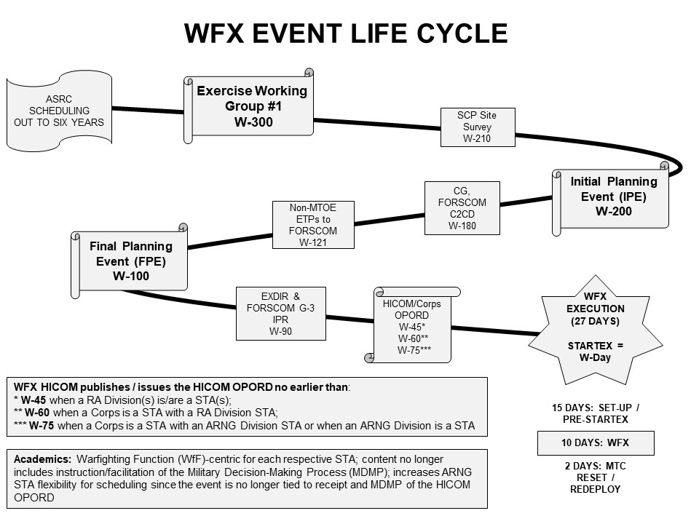

# Figure 3-1. Warfighter Exercise Event Life Cycle

# 3-2. Training Methodology

1. Directed Method. The MCTP uses CSA and CG, FORSCOM guidance and directives coupled with applicable regulations in order to:
   1. Create training experiences that enable the Army’s senior mission commanders to develop current, relevant, and campaign-quality, and expeditionary mission command instincts and skills which develop leaders and increase unit readiness.
   2. Provide an environment in which unit commanders can train to standards established in accordance with the Chairman, Joint Chiefs of Staff high interest training items, the Army Training Strategy, the Universal Joint Task List, Combined Arms Training Strategy, Army Collective Task List, FORSCOM and ACOM training guidance, and the HQDA-approved mission essential tasks.
   3. Develop tactical and operational level of war scenarios where the outcome is not assured, the consequences of tactical decisions are fully played out, and that promote initiative- oriented warfighting skills for commanders.
   4. Conduct two iterations of doctrinally based after action reviews (AAR) focused on observed performance that enable Soldier and leader self-discovery of what happened, why it happened, and how to sustain strengths and overcome weaknesses. MCTP executes the following types of AARs: instrumented (formal) and non-instrumented (informal).
   5. Stress all warfighting functions during LSCO where both lethal and non-lethal solutions could be employed.
   6. Provide a free-thinking, hybrid threat-based, near-peer OPFOR with an equal chance of

success capable of operating across all five domains.

* 1. Incorporate new emerging doctrine into all exercises, as directed.
  2. Facilitate emergency deployment readiness exercise like conditions and military decision-making process (MDMP) in a time-constrained environment.
  3. Reinforce command post (CP) agility in field conditions. CPs in the field displace as simulation model conditions dictate; simulation CP displacement effected by displacement of the respective unit’s field CP. The Headquarters and Headquarters Battalion/Company maintains, secures, and tactically emplaces/displaces the modified table of organization and equipment (MTOE) field CP multiple times during the exercise.
  4. Incorporate Lower Tactical Internet (T/I; such as, radio networks) to enable tactical communication between response cells and training audiences throughout the duration of the exercise.
  5. Sustain chemical, biological, radiological, and nuclear (CBRN) readiness; simulation model CBRN threat conditions dictate exercise participants’ mission-oriented protective posture level.
  6. Dedicate a portion of the exercise to retraining those tasks that the commander deems essential for their unit to increase proficiency. (Retraining is not an indication of failure.)

1. WFX Concept. The MCTP develops the exercise scenario derived from the operational environment outlined in the TRADOC G-2 approved common base scenario (DATE) or as directed by HQDA. The exercise scenario derivative is adapted by the MCTP from the common base scenario to meet the senior training audience commanders’ approved training objectives, desired end state, and incorporates CSA/FORSCOM/ACOM guidance. The MCTP uses a computer simulation to provide representative combat and battlefield effects during the exercise. The MCTP provides feedback to the commander in the form of detailed observations to allow for the commander’s own training assessments. Retired general officers serve as Senior Mentors lending credence to the feedback process while mentoring and coaching the exercise unit’s commanders and staffs.
2. Representing and Controlling Units. FORSCOM (United States Army Pacific (USARPAC) and USAREUR-AF for assigned Army forces) will source an immediate higher headquarters for the senior training unit(s) referred to as the HICOM, to include appropriate and distinct HICOMs for sustainment, and theater brigades. FORSCOM (USARPAC and USAREUR-AF for assigned Army forces) must also source training unit subordinate brigades, general and direct support enabling units, and flank units so that training units can train staff processes out, across, and within.
3. Simulation. Simulation models are commander and staff process drivers, not predictors of tactical success during LSCO. Units need to properly resource simulation system operators, or be prepared to accept less than desired results. The simulations do not accurately portray all aspects of terrain or warfighting function effects. Due to the limitations of simulations, units should not construe that the results from the simulations can predict true battlefield results.
4. Scenario and Exercise Assets. The exercise unit's task organization, to include all additional enabling units, is based on the modified table of organization and equipment at the time of WFX execution. Units may only use non-MTOE equipment equal to the number of systems on hand and/or to be fielded at the time of WFX execution when:

(1) Non-MTOE equipment is scheduled for fielding during the current Regionally Aligned

Readiness and Modernization Model per the Army Synchronization and Resourcing Process

and/or already on hand,

(2) MCTP validates WFX design supportability for inclusion of non-MTOE equipment, and

(3) Approved by FORSCOM for inclusion into the WFX.

1. Realistic Training Environment. The exercise unit is required to use only doctrinal modified table of organization and equipment authorized communication links between field command posts and simulation workstations. Leaders and Soldiers need to train in wartime-like environment (that is, deployed command posts will displace- “jump”- in accordance with unit standing operating procedures and CG, FORSCOM guidance, consistent with the unit level of training, and employ proper mission oriented protective posture). The approval authority for use of non-doctrinal, or non-modified table of organization and equipment communication links is the ACOM commander.
2. Unit-Led WFX Preparation Events. The MCTP schedule is developed in accordance with

the ReARMM, FORSCOM business rules, the ASRC, and HQDA, CTC-D provides funding to

the MCTP based on that schedule. The MCTP will only support non-standard unit ramp-up

and/or CPX that occur in preparation for participation as a senior training audience in an

MCTP WFX when requested and funded by the unit.

# 3-3. Warfighter Exercise Planning

1. Concept. Exercise planning is an iterative process conducted throughout the ELC. Exercise planning events have established required inputs and outputs. Outputs require informed decisions by training unit representatives at all planning events. Designated decision makers must come with guidance from commanders to the planning events in order to deliver appropriate outputs upon completion of the event. The MCTP continues the planning and refinement of the outputs to prepare inputs or scenario products at established timelines to feed the training units’ operations process. Embedded exercises use a parallel planning model for training units nested under other training units. For more details see the MCTP exercise standing operating procedure at the SharePoint website (Common Access Card required): [Exercise Control (sharepoint-mil.us)](https://armyeitaas.sharepoint-mil.us/sites/TR-CAC-CACT-MCTP-S3/SitePages/EXCON.aspx)
2. Concept Development [W-330]. The concept development initiates the ELC and the

exercise planning process. Informed by guidance from the Chief of Staff of the Army, and the CG, FORSCOM, MCTP’s S-5 completes the concept development by applying outputs from the ASRC, input provided from S-3/7, other OPS GRPs, and any input provided from projected senior training audience commanders and/or staffs. The concept development process begins with developing exercise design products that display tentative troop list (showing training audiences and response cell requirements), ECG, exercise execution timeline, exercise training locations, and the exercise plan-to-plan (the ELC with tentative dates). The concept development process culminates with the creation of the concept development brief (CDB). The CDB provides a read ahead to the EXDIR and senior training audience commanders. The CDB is primarily delivered via email to the EXDIR and is stored on the respective MCTP exercise collaboration site. The CDB contains additional coordination and guidance that prepare them for involvement in the EWG#1. All training audience commanders provide MCTP with initial training objectives (using FORSCOM approved format provided in CDB) no later than 14 days prior to the EWG#1. Units outside the senior training unit task organization are not required to nest training objectives, but failure to consider the WFX senior headquarters’ objectives may result in a disjointed aspect of the exercise; opportunities to meet training objectives may not logically develop within the exercise.

1. EWG#1 [W-300]. The EWG#1 is a one-day event via distributed means originating from the Fort Leavenworth Kansas. The EWG#1 provides a WFX overview, exercise design, guidance, and lays out unit responsibilities during the ELC to include desired outcomes and IPE product requirements. The EXDIR and senior training audience commanders are invited to receive this brief (via distributed digital means as required) and any impacts to continued planning are brought to their attention for decision and/or action. Venue establishes the framework of the exercise and marks the initiation of planning within the exercise working groups. The EWG#1 initializes all exercise timelines and locations in preparation for the detailed planning and synchronization throughout the ELC.
2. IPE and Site Survey [W-200]. The IPE is a three-day planning event that may be hosted by MCTP or the senior headquarters either in person, distributed or a combination of both. This event may be combined with a site survey. The site survey of the training location(s) is conducted following the determination of the troop list and training units at each exercise site. The MCTP has a capacity for up to three training exercise sites. The MCTP’s focus of the site survey is on the MTC space available, network capabilities, power, and life support. The senior training headquarters is responsible for allocation of command post sites to other training units. The site survey team gathers required information and compiles a briefing that is fed into the initial planning event. The IPE is also a MSEL scripting event (if required). The IPE concludes with a back-brief of the exercise design. The EXDIR and training unit commanders are invited to receive this outbrief (via distributed digital means as required). NOTE: the IPE outbrief establishes the basis for the FORSCOM Commander-to-Commander Dialogue with corps and division training audience commanders. This FORSCOM sponsored event is normally conducted at W-180 and results in approval and/or additional exercise guidance from the FORSCOM Commander.
   1. MOA is the administrative and logistical agreement between the MCTP, the senior training headquarters at each exercise location, and each exercise locations’ MTC director. The MOA assigns responsibilities for support and identifies deliverables for each of the senior corps/division training audiences and each exercise locations’ MTC. The MOA is signed by the MCTP Commander and the Chiefs of Staff of each senior training audience headquarters at each exercise location. The MOA is initiated by the MCTP S-3/7.
   2. The ESMED is a compiled listing of all supporting personnel and equipment for the exercise, to include any support to the MCTP. This list does not include the training units, only the ECG requirements for response cells provided by those units (for example, response cells, help desk, mayor cell, and security detail). The ESMED is based on the FORSCOM approved troop list and contains the duty position, rank, and occupational skill of each person required to effectively represent subordinate and flank units and their interactions with training units. The ESMED also provides a recommended number and type of Mission Command Information Systems necessary for a work or response cell to effectively depict the unit it is portraying. The MCTP produces an ESMED that is used by FORSCOM as an annex to the FORSCOM-generated Execute Order for required tasking in support of the WFX.
   3. SCP is a diagram of the MTC facilities and denotes the physical and digital support requirements of each room in the MTC to support the exercise. The SCP is based upon required space, chairs, and tables for the personnel on the ESMED and the required tactical and simulation C4I system requirements based on the required function of each cell. This document does not direct training audience networks or equipment setup. The final SCP is approved by the MCTP Commander, or designated representative, 30 days prior to the exercise execution. Any subsequent changes to the SCP must also be approved by the MCTP Commander.
3. FPE [W-100]. The FPE solidifies all concepts and finalizes draft source documents. This event is a three-day event hosted by the MCTP at Fort Leavenworth, Kansas or via distributed means as required. This event uses working groups focused on defining how the exercise will be conducted and resourced. All timelines and events within the exercise are addressed with a training timeline prior to the STARTEX, the exercise battle rhythm, and the schedule for instrumented AARs. The MCTP reviews the milestones to ensure that the current planning progress has no impacts on STARTEX. This allows units to conduct planning for shaping operations and the effects fed into the STARTEX strengths of friendly and enemy units. The FPE concludes with a back-brief of the results of the planning event. The EXDIR and senior training audience commanders are invited to receive this out-brief (via distributed digital means as required) and any impacts to continued planning are brought to their attention for decision and/or action.
4. Exercise working groups. Exercise working groups are conducted weekly throughout the ELC and are hosted/led by the MCTP S-3/7 exercise lead planner. These events begin approximately one week prior to publication of the Concept Development Brief. These weekly synchronization meetings (schedule established in the EWG#1 calling message) are conducted via distributed digital means and include participants from MCTP, training audiences, and stakeholders at all exercise locations. Topics of discussion vary weekly and are focused on finalizing coordination and synchronization not accomplished during the main ELC events (EWG#1/IPE/FPE). These events occur at an established time on either Tuesdays or Wednesdays.
5. Academics. A five day training event conducted at Fort Leavenworth, KS (see Ch.3-1,b,(3) for exceptions) which assists in developing the training unit’s command and staff team. Each senior training audience and other units, as identified, receives an academic seminar hosted by the OPS GRP providing their OC/T coverage during the WFX. MCTP OPS GRPs tailor each academic session to their respective WFX senior training audience (corps and/or division) with its subordinate training audience formations. Academic topics are established at the discretion of the senior training audience and will be organized by WfF to incorporate all subordinate formations. The senior training audience determines quantity and composition of subordinate unit participation during the week of WFX academics.
   1. Academic seminars are built around the senior training audience commander’s guidance to assist in achieving the following goals:
      1. Understanding current doctrine and its application.
      2. Improving command and staff teamwork.
      3. Providing a model for further training.
      4. Improving warfighting skills.
   2. For corps and divisions, the WFX uses the academic session as a team building event for subordinate training audiences with the limiting factor being the size of the venue to be used. Corps academics are programmed by HQDA, Combat Training Center-Directorate (CTC-D) for 63 personnel (58 academic attendees plus a five- person guard force) and division academics are programmed for 60 personnel (55 academic attendees plus a five-person guard force) at Fort Leavenworth, Kansas. Each subordinate training audiences (functional/multifunctional support brigades/ARNG brigade combat team HQs) are programmed for up to 20 academic attendees at either the corps or division academics. Units sending personnel to the academics must coordinate for the funding that is programmed from the CTC program (MDEP: TCBC) and executed by either FORSCOM, USASOC or NGB. Additional personnel are authorized to attend provided funding for any attendees is secured by the training audience.
      1. Recommended corps academic attendees: Commanding general, Deputy commanding general, Chief of Staff, CSM, G-1, G-2, G-3, G-4, G-5, G-6, USAF ALO, Adjutant General, MI brigade commander, SJA, Chaplain, Division commanders with their G-2, G-3, fire support coordinator, and G-4, ESC commander, Aviation brigade commander, Corps artillery commander, Corps engineer, Air defense artillery brigade commander, MP brigade commander, Transportation brigade commander, Signal brigade commander, Separate maneuver brigade commander, Medical brigade commander, Supporting CA and PSYOP commanders, Public Affairs Officer, IO officer, Space Operations Officer, Electronic Warfare Officer, Special operations coordinator, Special operations command and control element commander and one NCO, Corps Transportation Officer, and Logistics Assistance Office.
      2. Recommended division academic attendees: Commanding general, Assistant division

commanders, Command Sergeant Major, Maneuver brigade commanders, DIVARTY

commander, Aviation brigade commander, Division support command commander, Division

engineer, Division chemical officer, a corps representative, Echelons above division field

artillery brigade commanders, Surgeon, Division provost marshal, Chief of Staff, G-1, G-2, G-3,

G-4, G-5, G-6, USAF ALO, Separate battalion commanders, SJA, Public Affairs Officer,

Chaplain, Supporting CA and PSYOP commanders, Information operations coordinator/officer,

Space Operations Officer, Electronic Warfare Officer, Division Transportation Officer,

Logistics Assistance Office, G-1 plans officer, G-2 operations or plans officer, G-3 operations or

plans officer, G-4, plans officer, Assistant division fire support coordinator, Assistant division

engineer, Assistant division air defense officer, Assistant division aviation officer, Assistant

division signal officer, Assistant division chemical officer, Senior staff NCO, Operations clerk,

Operational law judge advocate, Division Transportation Officer/Corps Transportation Officer

and Installation Deployment Support Staff should attend.

# 3-4. Warfighter Exercise Execution

1. Pre-STARTEX Set-up and Training. This period spans fifteen days and begins with the

arrival of the MCTP and traveling units’ torch and advance parties to receive equipment

shipments. The MCTP and training units set up the simulation, exercise, and tactical networks

simultaneously and end with integration and testing. Once networks are established, MCTP

begins training subordinate response cells on the use of the simulation while training

units complete final planning, preparations, and rehearsals. Once the simulation model and

communication architectures are operational and manned with trained personnel, the EXDIR

approves the pre-determined official time of STARTEX (normally W-Day at 0600 local time).

See Figure 3-2 for an example warfighter exercise timeline.

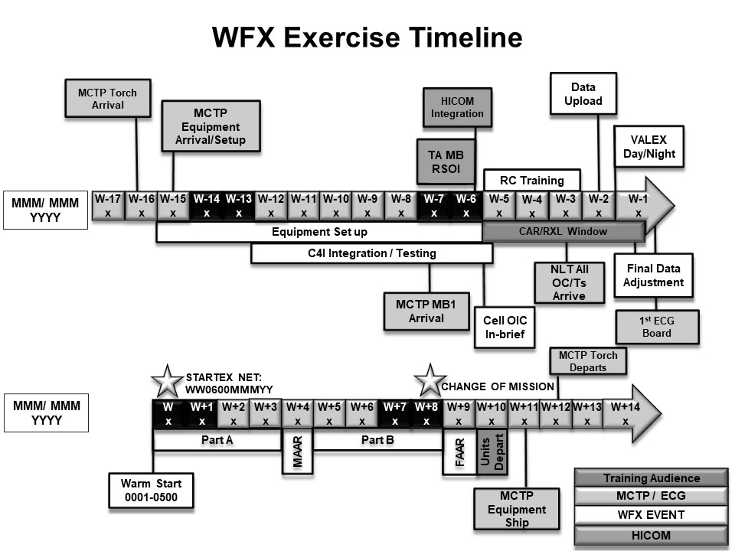

# Figure 3-2. Example of a Warfighter Exercise Timeline

b. Establishing the Exercise. The MCTP arrives to the exercise on W-15 with an advance

party to receive and distribute equipment shipments and begin set-up of the exercise control

group network and the simulation systems. The senior training audience at each exercise site

establishes the mayor’s cell with minimal manning no later than W-15. Concurrently with the

MCTP setup, training units (includes training audiences, and response cells) establish their

tactical communications networks. The MOA will specify the earliest date and time when the

networks become operational and reporting requirements for guard forces and support personnel.

The MCTP continues to phase force flow into the exercise at key points to continue improving

the exercise footprint and conduct final coordination. An initial party of OC/Ts arrives at W-10

to begin interaction with senior training audiences and observation of the MDMP. No later than

W-10, the NSC has functional simulation data feeds to the exercise and begin sending exercise

feeds from the simulation to the tactical network. No later than W-6 the tactical and simulation

networks are fully integrated in preparation for training of the support personnel in the exercise

control group.

1. ECG Training. This training prepares response cells for their support during the WFX and

provides time for MDMP and rehearsals by the subordinate, adjacent, and non- training audience

response cells (Lower Commands and HICOMs). Subordinate response cells and are collectively

referred to as lower command cells. All exercise support personnel are required to arrive and

complete reception, staging, onward movement, and integration no later than W-6 in order to be

prepared for training beginning on the morning of W-5 around 0900 local time. The MCTP

provides a daily schedule of training events and required attendees to all exercise support

personnel cell leaders. The training consists of briefings on: the exercise purpose, operational

environment, and duties, responsibilities, and procedures for response staffs. Concurrently,

simulation operators receive training on the systems they will operate during the exercise. At the

conclusion of staff and simulation operator training, there is an exercise wide communications

exercise to validate MCIS operability and communications systems. Also on W-3, the final data

for task organization, unit locations, and air tasking order will be finalized. W-2 is dedicated to

input of data and orders collected on W-3 into the simulation, known as STARTEX data load.

These are locations of units when the exercise begins with mission and operational variables in

effect. On W-1 the MCTP conducts a validation exercise (VALEX) for the response and the

ECG to validate the training conducted and ensure the simulation is stimulating MCIS

equipment. Each MCTP workstation controller (an Army support contractor) executes key

operations for the function of the cell and exercise control validates key coordination measures

between cells. On W-1, the EXDIR receives a conditions check from the MCTP ECG covering

the status of simulation, training unit communications, system, and ECG training. At the

conclusion of this conditions check (such as, ECG Decision Board), the EXDIR approves

STARTEX or the corrected conditions under which STARTEX can occur.

1. General ECG Structure. The MCTP is the core of the ECG augmented by supported

agencies outlined in paragraph 2-14 (Other Supporting Commands).

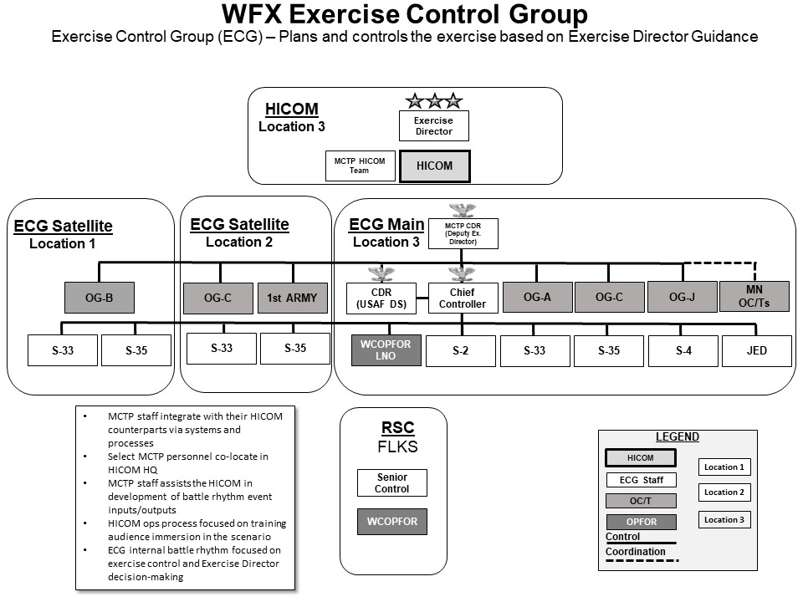

# Figure 3-3. Example of a Warfighter Exercise Control Group Structure

* 1. ECG Leadership. The EXDIR, with advice from the senior mentors, leads the ECG. The MCTP Commander is the deputy EXDIR and exercises operational control over the ECG in support of the exercise. The Director of Operations is the chief controller/chief of staff for the exercise. Chiefs of OPS GRPs aligned with senior training audiences are the primary advisors to the EXDIR regarding those units they are covering. The S-33, and S-35 provide their functional input and recommendations to the EXDIR.
  2. Maneuver HICOM Response Cell. The HICOM is a unit replicating the next higher headquarters of the senior training audience(s). During the planning and prior to the arrival of the exercise main body, the MCTP performs all HICOM functions. On an agreed upon date and time established no later than the final planning event, MCTP integrates the HICOM. The HICOM integration date is established during the ELC planning and typically occurs on W-6. Following HICOM integration with MCTP, the HICOM is responsible for all battle rhythm events, development of fragmentary orders, Intelligence Summaries, Operation Summaries and prioritization of supporting units to the senior training audience(s) and contributions to the ECG. The HICOM is manned in accordance with the ESMED and resourced with MCIS and C4I systems in accordance with the simulation control plan. HICOM manning must represent all warfighting functions of a corps staff. The HICOM is typically sourced from an ASCC staff, a corps staff, or a division staff when a corps is unavailable to support.

(3) Sustainment augmentation to HICOM Response Cell. For sustainment units, FORSCOM designates an existing theater or expeditionary sustainment command as a sustainment HICOM. This allows the MCTP to train up to two sustainment training audiences per WFX.

(4) HICOM Support Cells. HICOM support cells are manned and equipped to represent

the EAD or echelons above the corps enabling units that are in a general support or

supporting role to the respective senior training audiences. These HICOM cells participate in the

WFX battle rhythm events and coordinate operations with key staff from the senior training

audience(s) and are controlled by the ECG. For most exercises, there is a HICOM Blue Air cell

representing Air Force assets, and a SOF cell (assisted by OG-J) replicating all of the Joint

Special Operations Task Force units, civil affairs, and military information support operations.

An air defense artillery (ADA) HICOM cell may be established if there is an ADA

functional/multifunctional brigade training unit. Additional HICOM cells may be established as

required to support other atypical functional/multifunctional brigade training audiences.

(5) MCC. The MCC is an economy of force response cell manned by Army support

contractors and augmented by tasked unit Soldiers that operates under the supervision of

S-35 providing the stimulation required to achieve a realistic and holistic training operational

environment during a WFX. The MCC accomplishes its purpose through the replication of

U.S. Army units, Joint Forces, Host Nation Security Forces, and allied forces at all three levels

of war replicating units from battalion through Corps and JTF-level functional and multi-

functional brigades performing mission tasks across the range of military operations. The

MCC affords the exercise Chief Controller with a mechanism to stimulate the senior training

audience formations across all warfighting functions and a means to inject inputs into the

exercise that supports realization of the many varied training objectives of multi-echelon

training audiences. The MCC most often performs functions to portray adjacent and non-

training audience units.

(a) The MCC operates as a competitive and non-competitive (scripted), scalable group of

response cells replicating military forces in the WARSIM and providing orders, plans,

running staff estimates, role-player commanders, and other inputs to the four elements of the

Army Operations Process as required by the exercise design and/or as directed by the exercise

Chief Controller.

(b) As an economy of force group of response cells, the MCC reduces the exercise

footprint through Soldier augmentation and select MCIS eliminating the need for the tasking of

additional US Army forces to portray units during a WFX. MCIS are the means to provide the

digital feeds, inputs, outputs, running staff estimates, and mission planning products to the

senior training audience commanders, staffs, battle rhythm events, and tactical information

networks. Based on the guidance from the Director of Operations, the S-33, and the S-35, the

MCC recommends the number of role-players to serve as portrayed unit commanders, the

number and military occupational specialty of Soldier augmentation required, and the type of

select MCIS required in order to correctly portray assigned units and functions for each WFX.

Manning and equipping requirements will vary from exercise to exercise since each is a

tailored event designed to meet the specific training objectives of each WFX. The MCC

provides this information to the exercise planning teams at all three exercise planning events of

the ELC.

(6) Movement Control Battalion (MCB) Cell. The MCB cell supports the movement

control requirements of all training units. When the exercise contains a sustainment command,

the movement control battalion serves as a subordinate response cell.

(7) Work Cells. A work cell portrays each of the subordinate battalions of a Brigade

Training Audience. They are located in the Mission Training Complex and not in the field.

The work cell has an OIC and a staff that receive orders, conduct planning, input orders into

the simulation, fight the enemy, issue supplies, submit reports and interact with the training

unit commander and staff. The work cell OIC has overall responsibility for the work cell’s

ability to effectively depict the activities that stimulate their higher headquarters’ training

objectives**.** Training audiences are allowed access to their work cells via their associated

operations group(s). (See figure 3-4).

**Figure 3-4. Warfighter Exercise Work Cells**

(8) Response Cells. A response cell portrays a subordinate “non-training audience”

brigade of a division or corps. They are located in the Mission Training Complex and not in the

field. Response cells contain a commander and a staff who receive orders, plan operations, and

communicate directly with the training unit(s). The response cell commander executes operations

through the simulation system operators who fight the units in the simulation. Training audiences

are allowed access to their response cells via their associated operations group(s). Generally,

one response cell represents one subordinate unit.

(9) Response cells and work cells are collectively referred to as lower command cells. (See figure 3-5).

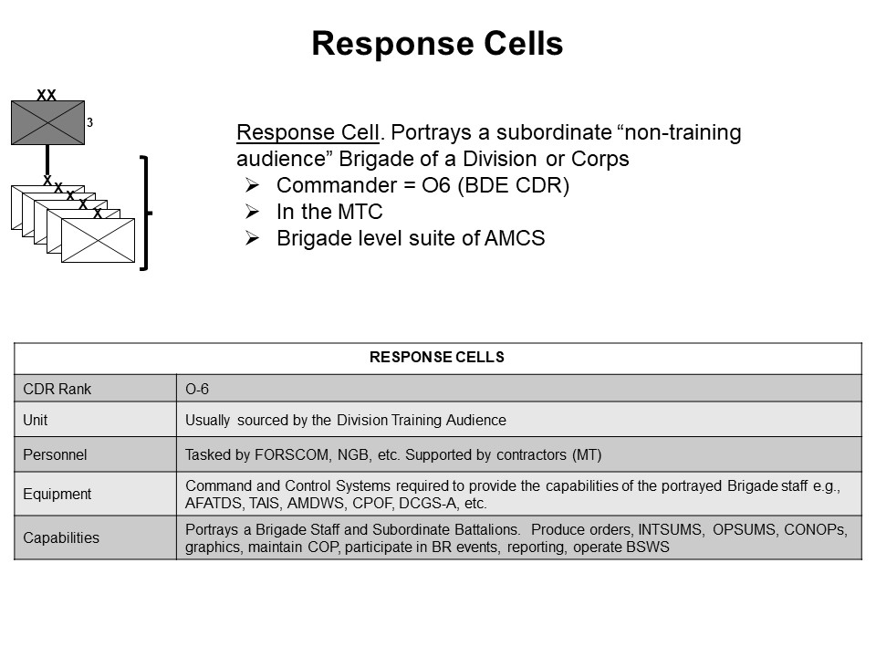

# Figure 3-5. Warfighter Exercise Response Cells

(10) Enhanced Response Cells (ERC). An ERC portrays a “non-training audience” division or brigade. The unit is located tactically in a field environment in proximity to the Mission Training Complex. The ERC will operate within its expeditionary command post systems with all mission command information systems. The ERC will link to its response cell(s) inside the Mission Training Complex via tactical communications.

(11) Remote ERC. Is an option for a division participating in a WFX in lieu of a home station CPX3 and not garrisoned at one of the two WFX senior training audience locations. The division tactical command post, main command post, and support area command post will exercise at home station and its response cell will exercise at either senior training audience Mission Training Complex location. The division is responsible for employment of tactical communications to link to the WFX HICOM and its response cells.

(12) Functional Cells. Supporting units and agencies identified during the planning of a warfighter exercise as functional cells are structured cells that perform specific task(s). These units and/or agencies are typically theater assets. These cells may be represented by a small unit or individual representatives of an Army Agency or Command. These cells may be established as a separate unit (for example, Movement Control Battalion), an agency to carry out specific management functions or coordination (for example, Surface Deployment and Distribution Command). Functional cells may perform as augmentation to the senior training audience or exercise controllers in order to provide capabilities that are compatible and complementary within the operational environment of the exercise scenario.

e. WFX Execution. The MCTP WFX execution spans a 10-day period. During the 10 day exercise, there is a pause for an instrumented MAAR for each senior training audience (corps and/or division) and its subordinate training audience formations organized by WfF. At the completion of the 10 days of training, the MCTP facilitates an instrumented FAAR for each senior training audience (corps and/or division) with its subordinate formations organized by WfF. After the instrumented FAAR, all equipment is prepared for shipment.

f. WFX Battle Rhythm. The WFX is executed in accordance with the 4-1-4-1 model consisting of four days of decisive action training, one day of instrumented MAARs and retraining, followed by an additional four days of decisive action training, and one day of instrumented FAARs. The EXDIR in consultation with the senior training audience commanders declares change of mission (COM). During the daily execution of the exercise the following events occur (see also figure 3-6 for example):

(1) HICOM Battle Rhythm. The HICOM cell(s) host various battle rhythm events to help stimulate training audience training objectives. At a minimum, the HICOM will host a daily Commander’s Update Brief and require subordinate training audiences to report current situation. Additional battle rhythm events are conducted in accordance with the HICOM Battle Rhythm Synchronization agreed upon during the ELC planning.

(2) ECG Battle Rhythm Events. The ECG conducts various events to ensure the exercise is effectively stimulating training objectives for every WFX senior training audience. These events synchronize the efforts of the S-33 and the OPS GRPs. The ECG Decision Board is the EXDIR’s venue for directing the flow and tempo of the WFX. The ECG Decision Board provides the EXDIR with an update on all aspects of the exercise and provides a forum for the EXDIR to make decisions and provide guidance.

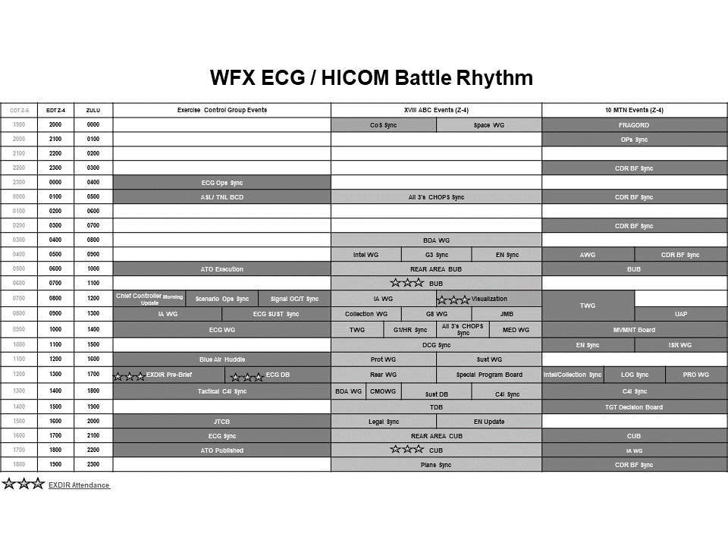

# Figure 3-6. Example of an Exercise Control Group/Higher Command Battle Rhythm

(3) OC/T Azimuth Check. Each OPS GRP conducts an azimuth check to inform the senior mentor(s) and chiefs of OPS GRPs on the daily observations inside their respective command posts.

This informs the senior mentor(s) and chiefs of OPS GRPs and assesses the training progress for subsequent recommendations to the EXDIR on changes, if any are required, to the exercise. This

event is not open to the training audiences’ liaison officer (LNO). This meeting is chaired by each COG.

(4) ECG Decision Board. This is the daily decision board for the ECG, conducted by S-33,

attended by COGs and senior training audience/WfF senior mentors, and chaired by the EXDIR. The

EXDIR is briefed on the last 24 hours of training and recommendations based on observations for

the next 48 hours. The EXDIR provides updated guidance to the ECG for the direction he wants the exercise to move toward. This event ends with the approval/disapproval of all EXDIR decision points.

(5) WCOPFOR and Scenario Synchronization. These are daily meetings hosted by the OPFOR and S-35 cells. These meetings include all of the HICOMs, HICOM support cell, OPS GRP Chief of Operations/Chief Observer Trainer, and MCC. These meetings coordinate and synchronize the EXDIR guidance into actions of HICOM, OPFOR, and enabler and flank units to force the training units or the OPFOR to conform to the desired situation for the exercise. This ensures that the exercise remains free play with as little artificiality as possible. This meeting is co-chaired by the WCOPFOR commander and the S-35.

(6) ECG Working Group. This is a daily meeting chaired by the Director of Operations/Chief Controller. This meeting includes OPS GRP representatives, HICOM, Air Component Command, the ECG, and other stakeholders as required. This meeting coordinates and synchronizes further actions directed by the EXDIR or requested by senior mentors/OPS GRPs. This meeting is the final daily opportunity for the ECG to make any administrative adjustments or coordinate operational and mission variables required to stimulate the senior training audiences’ training objectives.

(7) MSEL Synchronization. S-33 conducts a conditions check twice daily for the exercise injects on the MSEL to determine if all aspects of the inject have been coordinated with the response cells, intelligence scripters, OC/Ts, and other stakeholders. This ensures injects are complete and synchronized to have the desired impact. This meeting is co-chaired by the S-33 and S-35. Attendees include response cell MSEL managers, OPS GRP representatives, and HICOM response cell representatives.

g. Change of mission. Upon notification of COM all exercise support units not needed will clear the facilities and account for property in accordance with a published Letter of Instruction (LOI) from the ECG. The MCTP releases all cleared personnel from the ECG back to the control of their parent unit or organization. Guard forces, details, and mayor’s cell must still conduct close out operations and remain in place until specifically released by the Deputy Chief Controller from S-33. The day following the end of the exercise/COM, MCTP facilitates an instrumented FAAR for each senior training audience (corps and/or division) with its subordinate formations organized by WfF. Upon completion of the instrumented FAAR, the MCTP begins recovery and packing of its equipment, with completion two days after the end of exercise.

h. MCTP Internal AAR. Within 14 calendar days of WFX end of exercise, the MCTP conducts an internal AAR covering the planning, coordinating, and training events, which capture lessons learned and increase organizational and exercise effectiveness.

i. ELC Termination. The ELC concludes at W+30 with the delivery of the final exercise report (FER) to each senior training audience.

# 3-5. After Action Reviews (AAR) and Final Exercise Reports (FER)

1. A take home package is provided to each senior training audience at the conclusion of their respective instrumented FAAR consisting of: digitized audio/visual AAR recordings, AAR presentation products (such as., PowerPoint slides), select training briefings conducted during the WFX, and paper copies of the WCOPFOR portions of each AAR.
2. Each corps and division training audience receives a MCTP Commander approved FER from its supporting Operations Group NLT W+30. The FER addresses the senior training audience commander’s achievement of training objectives as well as the staff’s synchronization of task organized units; both organized by WfFs. OPS GRPs may provide the draft FER to the senior training audience at the FAAR. FERs are due to the MCTP Commander from the OPS GRP COG NLT W+23 for review and final approval prior to releasing the FER to the senior training audience.
3. All AAR and FER products become proprietary property of each respective senior training audience upon completion of all MCTP supported exercises in which an AAR and FER is created. MCTP will not release AAR and FER products to organizations requesting this information from MCTP. Requests for AAR and FER products shall be submitted by the requesting organization to the specific senior training audience commander(s).
4. MCTP provides AAR and FER products to the following Army commanders for historical purposes: CG, FORSCOM (ATTN: G-3/5/7); CG, TRADOC (ATTN: Commander, Center for Army Lessons Learned); Director, Army National Guard (ATTN: G-3/5/7); and CG, First Army (ATTN: G-3/5/7).

# 3-6. Visits to Exercises and Events

1. General. Every effort is made to minimize the distractions that visitors cause; however, legitimate needs for visits exist. The senior training audience commander approves all visitors to their academic seminar. Requests are required to be received by the senior training audience commander no later than six weeks prior to the first day of academics. The EXDIR and MCTP Commander approve visitors to the WFX. Requests are required to be received by the EXDIR’s HQ no later than six weeks prior to the first day of the WFX (W-Day; STARTEX). The senior training audience and the MCTP must coordinate all visits during an exercise. Visits by foreign nationals are addressed in paragraph 3-6d below.
2. Visitors to the training audience.
   1. Personnel, military and civilian, desiring to visit an exercise unit, will coordinate with the senior training audience HQ at that site. The training audience is responsible for coordinating and providing transportation, billeting, mess, escorts, field equipment, et cetera, as required for the visitors. The MCTP does not provide any visitor services.
   2. The exercise training audience will notify the MCTP Operations Officer no later than 30 days prior to the start of the exercise of all planned or projected distinguished visitors.
3. Orientation Visits to the MCTP Exercise Events.
   1. Coordinate visit requests with Deputy Commanding General, Combined Arms Center- Training (CAC-T), ATTN: ATZL-CT, 633 McClellan Ave., Ft. Leavenworth, KS 66027-1314, and provide an information copy to Commander, MCTP, ATTN: ATZL-CTB (Operations Officer), 400 Kearny Avenue, Ft. Leavenworth, KS 66027-1306. Visitors deploying to the field should arrive at the exercise with all required equipment and in the uniform specified by the EXDIR. The MCTP does not provide any visitor services.
   2. CAC-T must receive all requests to visit the MCTP exercise events no later than 60 days prior to the start of the proposed visit. Include identification of personnel, purpose of visit, and verification of visiting personnel security clearance (when scenarios are classified). Deputy Commanding General, CAC-T will provide a decision on the visit no later than 30 days prior to the proposed start date of the visit.
4. Multinational Partnerships. Procedures for coordinating foreign (non-U.S.) visitor requests will be in accordance with AR 350-50, Appendix B.

# Chapter 4

**Army Service Component Command (ASCC) Training Exercise Coordination and Execution**

# 4-1. Overview

1. Overview. The following describes MCTP Support to Divisions, Corps, Operational Field

Army and ASCC Headquarters conducted in conjunction with Joint Training opportunities in a Combatant Command (CCMD) or ASCC sponsored exercise.

1. Scheduling MCTP support to Divisions, Corps, Operational Field Army and ASCC Headquarters for Joint Training opportunities in Combatant Command (CCMD) or ASCC Sponsored Exercises is conducted at each ASRC during the MCTP schedule review. Unless otherwise prioritized by HQDA or FORSCOM or the parent ASCC; Divisions, Corps and Operational Field Army will be scheduled based on their ReARMM unit life cycle phase. Absent a timely formal request (one to three years out) from an ASCC to DAMO-TRC, MCTP coverage to the ASCC Headquarters will be scheduled on a case-by-case basis as MCTP capacity permits and as approved by CG, FORSCOM.
2. Priority of execution is to the training of a Senior Army Mission Command Headquarters at Division, Corps and Operational Field Army level that are assigned, allocated or designated Service Retained Combatant Command Aligned (SRCA) to CCMD during Joint Exercise Program events also supported by the JS/J-7. This priority of execution is intended to assist the CCMD and JS/J-7 to train Army provided JTF-capable headquarters rather than the assigned ASCC Headquarters in that role.
3. All Mission Command Headquarters are part of the Army's Regionally Aligned Forces (RAF) and identified in the current HQDA-FORSCOM Mission Alignment Order (MAO) and subject to the provisions of the Global Force Management Implementation Guidance (GFMIG). These formations represent the potential JTF-capable force pool and have priority to MCTP support when it is a directed training event to become JTF-capable or JTF-certified.
4. Standard MCTP support to an ASCC headquarters event consists of a portion of one OPS GRP with an HQE-SM package to provide an instrumented AAR to the ASCC commander and primary staff as the training audience. Funding for this package is programmed for one event per year for ARNORTH, ARCENT, USARPAC, and two for USAREUR-AF through the CTC program allocation from HQDA, CTC-D. This standard support package does not include exercise designers from MCTP and academic seminars. Standard MCTP support applies to the approved event execution dates only. Whenever possible, MCTP will send an event planner to select ASCC- hosted planning events (for example, initial, mid-point, and final planning conferences) and up to two additional planning events as requested by the ASCC. MCTP will conduct an exercise site survey in conjunction with one of the planning events. MCTP does not support unit ramp-up training events and CPX that occur in preparation for participation as a training audience in an ASCC exercise.
5. Non-standard requests or requests for additional MCTP support/coverage must be made by the ASCC directly to HQDA, G-3/5/7 (ATTN: DAMO-TRC). Non-standard requests are subject to MCTP availability and will be considered on a case-by-case basis. Unless otherwise specified, funding for non-standard or additional MCTP coverage requests is the responsibility of the ASCC headquarters.

# 4-2. ASCC Event Scheduling

The FORSCOM-published CTC Execute Order, updated after each ASRC, is the authoritative document and official MCTP support schedule. All MCTP support requests will be validated by HQDA G-3/5/7, DAMO-TRC and FORSCOM then forwarded to MCTP for action.

_______________________________________________________________________________

# Chapter 5

**Simulations, Models, and Army Mission Command Systems**

# 5-1. Overview

The MCTP employs a number of approved models and simulations to drive exercises. Simulations

assist in providing realistic, stressful training of leaders and staffs at brigade, division, and corps

levels. Orders and instructions from commanders and staffs are transferred to simulations and can

be further enhanced through role players, augmentees, and response cell staff, operators, and controllers located in the MTC. These orders produce battlefield outcomes which are either electronically, via MCIS, or manually transmitted to commanders and staffs operating in a tactical environment. The MCTP collects all information input through the simulation or model and archives it for use by analysts to support instrumented AAR themes for feedback to the training audience.

# 5-2. Models and Simulations

Models and simulations used by the MCTP consist of certified and accredited systems used for training unit commanders, staffs, command posts and HQs in CPX and leader development training events. These proven models and simulations provide robustness, rigor, stability, and fidelity. They are adaptable and flexible to sustain a prolonged exercise. The MCTP Commander has final authority concerning models and simulations used to support an exercise. They review and approve model and simulation configuration, architecture, and databases used during the exercise.

# 5-3. Simulation Operations

The MCTP Chief Information Officer is responsible for delivering the stimulation/simulation to the exercise and is the final authority for controlling the simulation and/or Federation Control of simulations used in exercises. The MCTP Commander, or designated representative, is the approval authority for all changes associated with configuration control.

# 5-4. Rules and workarounds

The MCTP utilizes rules and workarounds that are updated periodically. Rules are directives that govern the conduct of an MCTP training exercise. Workarounds are a functionality or military operation not modeled, or not adequately modeled, in the simulation(s). MCTP WARSIM Rules and Workaround Book applies equally to Blue Force, OPFOR and S-33 personnel. The intent of this document is to provide standard rules and workarounds to ensure a “level playing field” during simulation driven exercises. Simply stated, both the Blue Force and OPFOR have equal opportunity to gain advantage over one another by application of doctrine, tactics and force levels. The rules and workarounds apply equally, as appropriate, to both forces as they attempt to defeat one another in a competitive, free play environment. The MCTP recommends that all US Army simulation centers using the MCTP Aggregate Constructive exercise models (such as, WARSIM, et cetera), federated or non-federated, use this document to enhance exercises, standardize rules and workarounds, and increase the level of Soldier understanding and confidence for MCTP exercises. For more details see the current MCTP rules and workarounds document located on the MCTP’s information management portal (Common Access Card required).

# 5-5. Command, control, computers, communication, and intelligence systems (C4I) systems

The MCTP connects to and monitors tactical systems during execution of an exercise. Units will grant the MCTP access to their systems, enabling collection and monitoring of exercise information.

# 5-6. MCTP information management

1. The MCTP conducts information management for exercise planning and execution. S-3 controls information management through an exercise planning portal. Documents germane to exercise design and planning are made available to training audiences and exercise support elements following each planning event. In addition, S-3 will manage a simulated tactical web portal providing HICOM reference documents, operations plans, and fragmentary orders used in operational and tactical planning of the training units. Additionally, each exercise will have a site within the HICOM portal to manage requests for information.
2. Unit Responsibilities. Each training unit is responsible for its own information management process internal to its staff and subordinate units, both in the classified and unclassified domains, during the planning and execution phases of the WFX. Units without organic information management architecture and equipment should coordinate with the senior training audience at their exercise location to extend information management portals for the subordinates to use.
3. Portal Access. The MCTP’s information management portal is available for Common Access Card users at: <https://armyeitaas.sharepoint-mil.us/sites/TR-CAC-CACT-MCTP>.

# Appendix A

**References**

Unless otherwise indicated, TRADOC publications and forms are available on the TRADOC Administrative Publications website at <https://adminpubs.tradoc.army.mil/>. DA publications and forms are available on the Army Publishing Directorate website at <https://armypubs.army.mil/>.

**Section I**

**Required References**

Army Directive 2011-13

Employment and Management of Highly Qualified Experts and Highly Qualified Experts-Senior Mentors

AR 350-50

Combat Training Center Program

DA Pamphlet 25-403

Army Guide to Recordkeeping

Decisive Action Training Environment (DATE), Ver 3.0

(Available at <https://odin.tradoc.army.mil>)

FORSCOM Campaign Plan 2022-2024

(Available at <https://armyeitaas.sharepoint-mil.us/sites/FORSCOM-HQ>)

MCTP exercise standard operating procedure

(Available at <https://armyeitaas.sharepoint-mil.us/sites/TR-CAC-CACT-MCTP-S3/SitePages/EXCON.aspx>)

MCTP Rules and Workarounds Book FY2023

(Available on the MCTP’s information management portal at <https://armyeitaas.sharepoint-mil.us/sites/TR-CAC-CACT-MCTP>)

TC 7-100 Series

Hybrid Threat (*and other titles in series*)

# Section II

**Related References**

A related publication is a source of additional information. The user does not have to read a related reference to understand this publication.

AFI 10-204

Air Force Service Exercise Program and Support to Joint and National Exercise Program (Available at <http://www.e-publishing.af.mil/Product-Index>)

AR 525-29

Force Generation- Sustainable Readiness

Chairman of the Joint Chiefs of Staff Instructions 3500.01J

Joint Training Policy for the Armed Forces of the United States

(Available at <https://www.jcs.mil/Library/CJCS-Instructions/>)

Memorandum of Understanding Between Commander, Air Combat Command (ACC) and Commanding General, United States Army Training and Doctrine Command (TRADOC) and Commanding General, United States Army Forces Command (FORSCOM)

United States Army Mission Command Training Program (MCTP) - Table of Distribution and Allowances (TDA) 0220, UIC: W4YVAA, 04 Oct 20

# Section III

**Prescribed Forms**

This section contains no entries.

# Section IV

**Referenced Forms**

DA Form 2028

Recommended Changes to Publications and Blank Forms

# Glossary

**Section I Abbreviations**

AR Army Regulation

AAR after action review

ACOM Army command

AFI Air Force Instruction

AJST Army Joint Support Team

AOC/T augmentee observer, coach, trainer

AR Army regulation

ARNG Army National Guard

ASCC Army Service Component Command

ASRC Army Synchronization and Resourcing Conference

C4I command, control, communications, computers, and intelligence

CAC Combined Arms Center

CAC-T Combined Arms Center – Training

CD concept development

CDB concept development brief

CIO Chief Information Officer

CG Commanding General

COG Chief of Operations Group

COM change of mission

CP command post

CPX command post exercise

CSA Chief of Staff, US Army

CTC Combat Training Center

DA Department of the Army

DATE Decisive Action Training Environment

EAD echelons above the division

ECG exercise control group

ELC event life cycle

ERC Enhanced Response Cell

ESMED exercise support manning and equipping document

EXDIR Exercise Director

EWG#1 exercise working group #1

FAAR final after-action review

FPE final planning event

FER final exercise report

FORSCOM United States Army Forces Command

GSC Global Simulation Capability

HICOM higher command

HQ headquarters

HQDA Headquarters, Department of the Army

HQE-SM Highly Qualified Expert-Senior Mentor

IAD Information Advantage Division

IPE initial planning event

IW Information Warfare

JED Joint Effects Division

J-7 Operational Plans and Interoperability Directorate (Joint Staff)

JTCP Joint Training Coordination Program

JTIMS Joint Training Information Management System

JTF Joint Task Force

JOTT Joint Observer Training Team

JS Joint Staff

LOGFED Logistics Federation

LSCO Large Scale Combat Operations

MAAR mid-exercise after action review

MCC maneuver control cell

MCIS Mission Command Information System

MCTP Mission Command Training Program

MDMP military decision-making process

MOA memorandum of agreement

MRX Mission Readiness Exercise

MSEL Master Scenario Event List

MTC Mission Training Complex

MTOE modified table of organization and equipment

NSC National Simulation Center

OC/T observer, coach, trainer

OPFOR opposing force

OPS GRP Operations Group

POM program objective memorandum

ReARMM Regionally Aligned and Modernization Model

RRE Risk Reduction Event

SCP simulation control plan

SOF special operations forces

STARTEX start of exercise

TCBC battle command training program

TDA table of distribution and allowances

TRADOC United States Army Training and Doctrine Command

UIC unit identification code

USAF United States Air Force

VTC video teleconference

WARSIM Warfighter’s Simulation

WCOPFOR World Class Opposing Force

WFX warfighter exercise

WfF warfighting function

# Section II

# Terms

**instrumented AAR**

A formal AAR that includes data and information derived from virtual three-dimensional map visualization system and archival and retrieval system with presentation products generated by support contractor analysts. Instrumented AARs are executed in garrison facilities for distribution to participating outstations via secure VTC.

**non-instrumented AAR**

Also known as a “green book AAR” and provided to functional/multifunctional support brigades/commands. These AARs are informal in nature, built and facilitated by OC/Ts without support contractor-developed presentation products, and do not occur simultaneously with the supported senior training audience’s instrumented AARs.

**Risk Reduction Event**

The process to stimulate recently fielded MCIS, and/or to enable Multi-National Interoperability (MNI) and ensure supportability with the current constructive training capability federation, as fielded to the Combat Training Centers. Also called RRE.