**Department of the Army *TRADOC Regulation 600-14**

**Headquarters, U.S. Army**

**Training and Doctrine Command**

**Fort Eustis, Virginia 23604-5700**

**15 August 2023**

**Personnel - General**

**U.S. Army Training and Doctrine Command Sergeant Audie Murphy Award Program**

FOR THE COMMANDER:

MARIA R. GERVAIS

Lieutenant General, U.S. Army

Deputy Commanding General/

Chief of Staff

OFFICIAL:



WILLIAM T. LASHER

Deputy Chief of Staff, G-6

**History.** This publication is a major revision of the TRADOC Regulation 600-14, which supersedes all previous versions, changes, and amendments.

**Summary.** Prescribes administrative and regulatory guidance on the TRADOC Sergeant Audie Murphy Award Program for leaders within U.S. Army Training and Doctrine Command.

**Applicability.** This regulation applies to all U.S. Army Training and Doctrine Command organizations and elements. This includes U.S. Army Reserve and Army National Guard Noncommissioned Officers assigned or attached to U.S. Army Training and Doctrine Command.

**Proponent and exception authority.** The proponent of this regulation is the U.S. Army Training and Doctrine Command, Deputy Chief of Staff, G-1/4. The proponent has the authority to approve exceptions or waivers to this regulation based on guidance from the Command Sergeant Major and are consistent with controlling law and regulations. Activities may request a waiver to this publication by providing justification that includes a full analysis of the expected benefits and must include formal review by the activity’s senior legal officer. All waiver requests will be endorsed by the commander or senior leader of the requesting activity and forwarded through their higher headquarters to the policy proponent.

**Army management control process.** This regulation does not contain management control provisions.

*This regulation supersedes TRADOC Regulation 600-14, dated 01 February 1999 and cancels TRADOC Form 600-14-1-R, FEB 1999.

**Supplementation.** Supplementation of this regulation is prohibited, unless specifically approved by the Deputy Chief of Staff, G-1/4, U.S. Army Training and Doctrine Command, 661 Sheppard Place, ATTN: ATBO-BP, Fort Eustis, Virginia 23604.

**Suggested improvements.** Users are invited to send comments and suggested improvements on DA Form 2028 (Recommended Changes to Publications and Blank Forms) directly to the Deputy Chief of Staff, G-1/4, U.S. Army Training and Doctrine Command, 661 Sheppard Place, ATTN: ATBO-BP, Fort Eustis, Virginia 23604

**Distribution.** This regulation is available in electronic media only at the U.S. Army Training and Doctrine Command Administrative Publications website (<https://adminpubs.tradoc.army.mil>).

**Contents**

**Page**

Chapter 1 Introduction 5

1-1. Purpose 5

1-2. References 5

1-3. Explanation of abbreviations and terms 5

1-4. Records management requirements 5

Chapter 2 General Overview of the TRADOC Sergeant Audie Murphy Award 5

2-1. TRADOC Sergeant Audie Murphy Award 5

2-2. General 5

2-3. Distinction: Sergeant Audie Murphy Award versus the Sergeant Audie Murphy Club 6

Chapter 3 Eligibility and Selection Criteria 6

3-1. Eligibility 6

3-2. Selection Criteria 6

Chapter 4 Sergeant Audie Murphy Award Selection Process 7

4-1. Phase 1 7

4-2. Phase 2 7

4-3. Phase 3 7

4-4. Phase 4 8

Chapter 5 Responsibilities 10

5-1. TRADOC Adjutant General (AG) 10

5-2. TRADOC Command Sergeant Major 10

5-3. COE/Senior Mission Command Sergeant Major 10

5-4. ARNG State Command Sergeant Major 10

Chapter 6 Awards 11

6-1. Sergeant Audie Murphy Award Awardees 11

6-2. Presentation of Awards 11

6-3. Honorary Awards 12

Chapter 7 Wear and Appearance of the TRADOC SAMA Medallion 13

7-1. TRADOC Sergeant Audie Murphy Award Medallion 13

7-2. Authorization 13

7-3. When Wearing the Award is Prohibited 13

7-4. Proper Wear of the Sergeant Audie Murphy Award Medallion 13

7-5. Multiple Neck Ribbons 14

Chapter 8 Award Revocation 14

8-1. Bases for Revocation of the SAMA 14

8-2. Requests for Revocation of the SAMA 14

Chapter 9 Appeals Process 15

Appendix A References 15

Appendix B Biography of Sergeant Audie Murphy 17

Appendix C SAMA Selection Board Memorandum of Instruction 18

Appendix D Example TRADOC SAMA Nomination Packet 21

Appendix E Awards 29

Appendix F Wear and Appearance of the TRADOC SAMA Medallion 31

Glossary 32

**Figure List**

Figure B-1. Sergeant Audie Murphy Biography 17

Figure C-1. Example Memorandum of Instruction for the Final SAMA Board 18

Figure D-1. Sample Illustration of a SAMA Award Board Coversheet 23

Figure D-2. Sample SAMA Board Packet Checklist 24

Figure D-3. Example Brigade Level CSM Nomination Memorandum with instructions 25

Figure D-4. Sample Illustration of an Official DA Photo of both a Male and Female Noncommissioned Officer (NCO) 26

Figure D-5. Example biography for SAMA candidate 27

Figure D-6. Example TRADOC SAMA Selection Memorandum 28

Figure E-1. Example TRADOC SAMA Certificate of Achievement 29

Figure E-2. TRADOC Sergeant Audie Murphy Award Medallion 30

Figure E-3. TRADOC SAMA Awardee Card 30

Figure F-1. TRADOC Sergeant Audie Murphy Award Medallion Army Service Uniform Wear and Appearance 31

Figure F-2. Sergeant Audie Murphy Award Medallion Army Combat Uniform Wear and Appearance 32

# Chapter 1 Introduction

## 1-1. Purpose

This regulation provides information and establishes administrative procedures for the U.S. Army Training and Doctrine Command (TRADOC) Sergeant Audie Murphy Award (SAMA) Program. This regulation complies with the provisions of AR 600-8-22.

## 1-2. References

See appendix A.

## 1-3. Explanation of abbreviations and terms

a. Abbreviations and terms used in this regulation are in the glossary.

b. Sergeant Audie Murphy: The name of a Noncommissioned Officer (NCO) who, as a squad leader, consistently demonstrated the highest qualities of leadership, professionalism, and regard for the welfare of his Soldiers. See Appendix B for a brief biography of Sergeant Audie Murphy.

## 1-4. Records management requirements

The records management requirement for all record numbers, associated forms, and reports required by this publication are addressed in the Records Retention Schedule–Army (RRS–A). Detailed information for all related record numbers, forms, and reports are located in Army Records Information Management System (ARIMS)/RRS–A at <https://www.arims.army.mil>. If any record numbers, forms, and reports are not current, addressed, and/or published correctly in ARIMS/RRS–A, see DA Pamphlet 25-403 for guidance.

# Chapter 2 General Overview of the TRADOC Sergeant Audie Murphy Award

## 2-1. TRADOC Sergeant Audie Murphy Award

The TRADOC Sergeant Audie Murphy Award is a TRADOC authorized award (recognition device) in accordance with (IAW) AR 600-8-22, Chapter 11, regarding Command-level awards. The SAMA is an elite award for Noncommissioned Officers (NCO) whose leadership achievements and performance merit special recognition. The SAMA is a means of recognizing those NCOs who have contributed significantly to the development of a professional NCO Corps and a combat ready Army. Awardees exemplify leadership, characterized by personal concern for the needs, training, development and welfare of Soldiers, and concern for families of Soldiers. All opportunities for a service member to compete for the award will be directed/released by the Division level Command Sergeant Major (CSM) serving in a nominative position at the 2-Star level.

## 2-2. General

The SAMA is a once-in-a-career achievement award. Chapter 4 of this regulation establishes board/selection processes and board authorities.

## 2-3. Distinction: Sergeant Audie Murphy Award versus the Sergeant Audie Murphy Club

This regulation covers the criteria, policies, and procedures for award of the SAMA. This regulation does not cover how Sergeant Audie Murphy Clubs (SAMCs) operate, as these are private organizations/non-federal entities (POs/NFEs). SAMCs are not organizational units of the Department of the Army and are not entitled to any official sanction or support by TRADOC. SAMCs operating on Army installations must comply with regulatory guidance established in AR 210-22. SAMCs are self-sustaining special interest groups (commonly called Private Organizations) that operate on military installations with the written consent of the commander and governed by the applicable Army Regulations for activities such as fundraising and membership.

# Chapter 3 Eligibility and Selection Criteria

## 3-1. Eligibility

a. All Active Army, U.S. Army Reserve (USAR), and Army National Guard (ARNG) Soldiers in the ranks of Corporal through Master Sergeant (MSG)/First Sergeant (1SG), stationed on TRADOC installations or attached to TRADOC units are eligible for the SAMA.

b. USAR Soldiers who are assigned or attached to a TRADOC unit may compete for the TRADOC SAMA.

c. ARNG Soldiers who are assigned or attached to a TRADOC unit may compete for the TRADOC SAMA.

d. Service members of other armed services may compete for the TRADOC SAMA if they are assigned or attached to a TRADOC unit during a joint assignment status.

## 3-2. Selection Criteria

The final board policies and procedures will be followed as outlined in Phase 4 (para 4-4). The following are key attributes valued in the selection process.

a. Serves as a leader of character, competence and commitment, who is an example for subordinates, peers, and supervisors alike.

b. Be mature and share the values of their profession and their unit with others. Exercise sound judgment and leadership principles.

c. Display examples of professional Army ethics.

d. Strengthen and develop the Seven Army Values in Soldiers. Displays the Warrior Ethos.

e. Displays exemplary physical fitness skill.

f. No adverse action within 24-months of the initial boarding process, with the Brigade CSM Nomination Memorandum serving as the reference point for time.

# Chapter 4 Sergeant Audie Murphy Award Selection Process

It is critical that the Memorandum of Instruction (MOI) be disseminated as broadly as possible and at least 60 days prior to any SAMA board. An example of an MOI is located at Appendix C as Figure C-1. All subjects located within the MOI will be situational based.

## 4-1. Phase 1

Identifying the best potential candidate for the SAMA: Senior NCOs will recommend, thoroughly screen and evaluate all of their candidates prior to them moving to Phase 2. This will include the candidate creating the TRADOC SAMA packet. This packet will contain all information needed to conduct a thorough administrative check of the candidate along with all pertinent information needed to move to Phase 2. An example of the TRADOC SAMA nomination packet is located in Appendix D.

## 4-2. Phase 2

Preparatory Board: CSMs at the Battalion/Squadron level will conduct at a minimum, one situational based board; this will determine if the candidate meets all criteria to move to phase 3. CSMs at the Battalion/Squadron level do not need to endorse their candidates with a formal memorandum. If the candidates move to phase 3 it has implied that Battalion/Squadron level CSM has approved the advancement.

## 4-3. Phase 3

a. Initial Selection Board: The Brigade CSM will conduct a selection board. This board will challenge candidates with strictly situational based questioning. The Brigade CSM will be the president of the board and the board members will be the rank of SGM or CSM. The Brigade CSM can substitute SGM/CSM board members with SFCs or above who have been awarded the SAMA (i.e., who are SAMA recipients). The board will be comprised of all voting members to include the Brigade CSM, and will include, at least one voting member of the same sex as the candidate. However, the president of the board will have the final vote if the decision is not unanimous but a majority. Example: three members vote yes, one member votes no, in this circumstance the president makes the final decision whether the candidate meets the criteria to move on to the final selection board. Numerical scoring on subjects listed on the TRADOC Form 600-14-4 (Sergeant Audie Murphy Award Board Remarks Sheet) will determine if a candidate should continue in the selection process.

b. All board members will receive each candidate’s packet prior to the board convening.

c. Each candidate’s packet will contain at a minimum:

(1) Binder with Unit Coversheet.

(2) TRADOC SAMA Checklist.

(3) Current Department of the Army (DA)/Official Photo.

(4) A Biography of the service member.

(5) Updated and current Soldier Record Brief/Soldier Talent Profile or equivalent for USAR, ARNG and Sister Service NCOs.

(6) DA Form 2166-9-1 (NCO Evaluation Report (SGT)) or DA Form 2166-9-2 (NCO Evaluation Report (SSG-1SG/MSG)) (NCOERs) equaling a total of two rated years, unless the NCO doesn’t have two years’ time-in-grade. In this case, NCOs will provide all evaluations received for the total amount of time-in-grade. If the NCO is a Corporal (CPL) or Sergeant (SGT) and doesn’t have an Evaluation, this will be annotated on the Brigade Nomination Memorandum, endorsed by the Brigade CSM.

(7) DA Form 705-TEST (Army Combat Fitness Test Scorecard). *Note: Must achieve

90 points on all events. ACFT will be administered by the phase 3 board authority (i.e., Brigade CSM will validate ACFT results) prior to the board. If the Soldier does not pass the ACFT, they will not be authorized to compete in the SAMA board. An exception to policy (ETP) will be submitted if a Soldier cannot perform all three events.

(8) DA Form 5500 (Body Fat Content Worksheet (Male)) or DA Form 5501 (Body Fat Content Worksheet (Female)).

(9) DD Form 2266 (Hometown News Release).

(10) The Brigade CSM will formally endorse candidates that are selected to continue to the final selection board. This endorsement will be annotated on a Memorandum for Record signed by the candidate’s Brigade CSM. An example of the Brigade CSM Nomination Memorandum with instructions can be found in Appendix D, Figure D-3.

## 4-4. Phase 4

a. Final Selection Board:

(1) TRADOC Centers of Excellence (COE)/Senior Mission Command CSMs conduct the final SAMA selection boards. COE/Senior Mission CSMs will serve as the President of the Board, three additional CSM/SGMs will be appointed as board members. Each board member will come from a different subordinate Brigade. At least one of the board members will be of the same sex as the candidate. The Senior Mission CSM can substitute one board member with a SFC or above who is a SAMA recipient.

(2) The Senior Mission Command/COE CSM can appoint a Brigade CSM as the SAMA President of the Board in his or her absence. However, the Senior Mission CSM will endorse the results with his or her signature on a formal Memorandum for Record. An example of the Final Selection Board Memorandum for Record can be found in Appendix D, Figure D-6.

(3) All board members, to include the president of the board, are voting members and will determine if a candidate will be selected or not. However, the president of the board will have the final vote if the decision is not unanimous but a majority. Example: three members vote yes, one member votes no, in this circumstance the president makes the final decision whether the candidate meets the criteria for selection for the SAMA.

b. Final Phase packets consist of:

(1) Binder with Unit Coversheet.

(2) TRADOC SAMA Packet Checklist.

(3) Brigade CSM Nomination Memorandum.

(4) Current DA/Official Photo.

(5) A Biography of the service member.

(6) Updated Soldier Record Brief/Soldier Talent Profile or equivalent for USAR and ARNG NCOs. *Note: Must have an Expert Primary Weapons Qualification on SRB within 180 days of Final Selection Board or provide an Exception to Policy signed by Service Member’s Brigade CSM if a range or weapon is not available.

(7) Written essay – current topics pertaining to Army policy provided by the Board President within 48 hours of the board convening date. The essay allows board members to assess the Soldier’s cognitive critical thinking skills. Essay length will be no less than 400 words and no greater than 500 words, will be announced 48 hours prior to the board.

(8) DA Form 2166-9-1 or DA Form 2166-9-2 (NCOERs) equaling a total of two rated years, unless the NCO doesn’t have two years’ time-in-grade. In this case, NCOs will provide all evaluations received for the total amount of time-in-grade. If the NCO is a CPL/SGT and doesn’t have an Evaluation this will be annotated on the Brigade Nomination Memorandum, endorsed by the Brigade CSM.

(9) DA Form 705-TEST (Army Combat Fitness Test Scorecard). *Note: Must achieve 90

points on all events. ACFT will be administered by the final phase board authority (i.e.,

Brigade CSM will validate ACFT results) prior to the board. If the Soldier does not pass the ACFT, they will not be authorized to compete in the SAMA board. An ETP will be submitted if a Soldier cannot perform all three events.

(10) DA Form 5500 (Body Fat Content Worksheet (Male)) or DA Form 5501 (Body Fat Content Worksheet (Female)).

(11) DD Form 2266.

c. The final selection board need not select candidates if they do not meet the required standards.

d. All candidates must achieve 90 points on all ACFT events, candidates that do not achieve the required 90 points on each event will not continue on to the final selection board.

e. Non-selectees will be verbally counseled by the Board President.

f. NCOs that are assigned to TRADOC Installations that are a part of different major Army Commands (ACOM) may attend the TRADOC SAMA selection board. The results will be compiled and sent to the NCO’s appropriate ACOM for processing.

g. The President of the final selection board will forward a Memorandum for Record (Example found in Appendix D, Figure D-6) to include name, rank, truncated SSN (last four), MOS, and current unit of assignment of all new awardees to: Commander, U.S. Army TRADOC, G-1/4 Adjutant General (ATBO-BP), Fort Eustis, VA 23604.

# Chapter 5 Responsibilities

## 5-1. TRADOC Adjutant General (AG)

The TRADOC AG will exercise overall program administrative responsibilities at the ACOM level. Subordinate Commands will have procedures in place to administer the program at local levels within the appropriate CSM office and will request SAMA awards from the TRADOC,

G- 1/4, AG, Fort Eustis, VA 23669.

## 5-2. TRADOC Command Sergeant Major

The HQ, TRADOC CSM will exercise final authority for approval of any policy or procedure exceptions, to include SAMA member removal actions.

## 5-3. COE/Senior Mission Command Sergeant Major

a. The CSM at each TRADOC Subordinate Command, Installation/Unit will exercise primary staff responsibilities for the SAMA at that level.

b. Responsibility will include chairing final selection boards each quarter and the oversight, monitoring, tracking, and recording of SAMA awardees at their appropriate level.

## 5-4. ARNG State Command Sergeant Major

a. All leadership boards will be held at the State-level and the packet will be endorsed by the State Command Sergeant Major (SCSM). Once the packet has been finalized it will be e-mailed from the SCSM’s office to the TRADOC G-1/4 AG office. This only pertains to TRADOC units that have ARNG NCOs not located near an Active Duty Installation. For example, Camp Ethan Allen Training Site, Jericho, VT, which houses ARNG Instructors assigned to TRADOC’s Mountain Warfare School. This would be an example of when the ARNG SCSM could host a board for TRADOC NCOs. Alternatively, those NCOs could travel to a TRADOC installation for the final selection board.

*Note: ARNG units that are assigned to an installation run by a TRADOC Center of Excellence that do not have a Brigade level CSM or a SCSM located in the same state may be boarded with another TRADOC Brigade CSM. For example, candidates from the Warrior Training Center out of Fort Benning, GA may be boarded by a TRADOC Brigade CSM on the same installation to receive nomination to attend the final selection board. However, there will be no deviation from the phased selection process.

b. Responsibility will not be delegated to lower levels.

c. Responsibility will include chairing final selection boards each quarter and the oversight, monitoring, tracking, and recording of SAMA recipients at their appropriate level.

d. In addition, responsibilities will include publishing a MOI signed by the SCSM for gaining units of SAMA recipients departing the command.

# Chapter 6 Awards

## 6-1. Sergeant Audie Murphy Award Awardees

Presentation items for new awardees will include:

a. TRADOC Form 600-14-3 (Sergeant Audie Murphy Award Certificate of Achievement) signed by the TRADOC Commanding General and CSM. An example can be found in Appendix E.

b. TRADOC Form 600-14-2 (Sergeant Audie Murphy Award Awardee Card). An example can be found in Appendix E.

c. TRADOC Sergeant Audie Murphy Award Medallion. An image of the Medallion can be found in Appendix E.

d. Commanders at the installation level may wish to assess whether SAMA recipients might also be considered for DA awards, based on their accomplishments. Note: Award of the SAMA does not create the requirement or otherwise automatically qualify SAMA recipients for any DA awards.

## 6-2. Presentation of Awards

a. Presentation of other items to SAMA recipients (based on having been awarded the SAMA) such as gift certificates, prizes, etc., may be appropriate, as deemed by the local commander. Any such items are subject to local command guidelines, Army policy, Standards of Ethical Conduct for Employees of the Executive Branch, and the Joint Ethics Regulation. Prior to any such presentation, these items must first be reviewed by the servicing legal office.

b. A variety of publicity may be used to provide recognition for SAMA awardees, such as local media coverage and hometown news releases (DD Form 2266). Photographs of awardees should be prominently displayed.

c. A formal induction ceremony will be conducted no more than 60 days after the final SAMA selection board. As this is a once in a lifetime achievement for all NCOs and should be formally recognized at the Installation level.

## 6-3. Honorary Awards

a. Honorary awards may be extended to selected personnel (SGM/CSM, WO4 and COL or above) who fit the image of a SAMA recipient but would not normally be allowed to compete.

b. Individuals selected for honorary awards will forward a TRADOC SAMA packet along with an endorsed recommendation from the Senior Mission/COE CSM or higher. An example TRADOC SAMA packet can be found in Appendix C.

c. Candidates recommended for honorary awards must complete the four-phase selection process. Nomination TRADOC SAMA packets will be presented to the initial, intermediate, and final selection boards. (Nominees for honorary awards will not appear in person before the selection boards).

d. Candidates will be in compliance with ACFT and Army Body Composition Standards to include scoring 90 points on all ACFT events. All ACFT, Height and Weight screenings will be conducted and recorded onto DA Form 705-TEST.

e. Selection boards will use the TRADOC SAMA packet of the Senior NCO, Warrant Officer, or Commissioned Officer to make the final determination for the honorary award.

f. Honorary award recipients will receive an Honorary TRADOC SAMA Certificate of Achievement (TRADOC Form 600-14-3) and the TRADOC Sergeant Audie Murphy Award Medallion.

g. Scrutiny must be applied by the approving authority to ensure that the spirit and intent of the program is preserved. Upon approval/endorsement of the honorary awardee, the installation CSM will forward the complete recommendation packet to HQ, TRADOC, G-1 AG, for final approval.

h. Honorary awards are not guaranteed and will be rigorously evaluated.

i. Exception to the above regarding honorary awardees: Members of the Sergeant Morales Club are eligible to receive honorary recognition under the TRADOC SAMA program in a limited fashion. These individuals are eligible only for receipt of TRADOC Form 600-14-2 (SAMA Awardee card) upon verification that they are Sergeant Morales Club Members (for example, upon production of their Sergeant Morales Certificate of Achievement, Membership Card, etc. -- memorandums, copies of evaluations (NCOERs), and other awards will not be used for verification).

# Chapter 7 Wear and Appearance of the TRADOC SAMA Medallion

## 7-1. TRADOC Sergeant Audie Murphy Award Medallion

This chapter covers the authorized wear of the TRADOC Sergeant Audie Murphy Award (SAMA) Medallion on Army uniforms. The term “ribbon” is an all-inclusive term covering that portion of the suspension ribbon of a service medal or decoration that is worn instead of the service medal or decoration.

## 7-2. Authorization

a. CDRs may require the wear of authorized decorations/medallions on the following occasions:

(1) Parades, reviews, inspections, and funerals.

(2) Ceremonial and social occasions.

b. Unless directed by a CDR IAW AR 670-1, para 22–2, the SAMA medallion is worn at the option of the wearer, when not prohibited, during normal duty hours. Personnel also may wear the SAMA medallion on appropriate uniforms when off duty. Personnel are encouraged to wear the SAMA medallion on the service, dress, and mess uniforms.

c. Soldiers may wear the SAMA medallion on the Class B version of the service uniform during duty hours and when off duty, at their option.

## 7-3. When Wearing the Award is Prohibited

Wearing awards is prohibited during the following circumstances:

a. On any uniform other than those authorized in this regulation.

b. When wearing civilian clothing. Soldiers may wear the SAMA medallion on formal civilian attire at formal social functions when wearing the Army uniform is inappropriate or not authorized.

## 7-4. Proper Wear of the Sergeant Audie Murphy Award Medallion

a. Army Service Uniform (ASU). The neck ribbon is to be worn underneath the collar of both the long and short sleeve dress shirt, and the blouse. The ribbon is lying flat under the coat, just below the knot of the necktie, or just above the crossover of the neck tab. An example can be found in Appendix F, Figure F-1.

b. Army Combat Uniform (ACU). The proper wear of the SAMA medallion in ACU. The neck ribbon is to be worn underneath the collar of the ACU coat. The medallion is to be suspended on the outside of the coat. An example can be found in Appendix F, Figure F-2.

c. Army Green Service Uniform (AGSU). *Note: there will be no change to how the SAMA medallion will be worn with the Army Green Service Uniform (AGSU) “Pinks and Greens”.

## 7-5. Multiple Neck Ribbons

An individual may not wear more than two decorations with neck ribbons at one time. The decoration with the highest precedence is worn above the other. The SAMA medallion takes precedence over all other decorations with neck ribbons other than decorations with neck ribbons awarded by HQDA, such as the Medal of Honor. An example can be found in DA PAM 670-1.

# Chapter 8 Award Revocation

## 8-1. Bases for Revocation of the SAMA

Once selected for the SAMA, awardees must remain in good standing at all times by conducting themselves in a manner consistent with the NCO Creed and SAMA qualifications. Failure to uphold these standards may result in revocation of the SAMA. Adverse action for misconduct, including but not limited to the following, requires an initiation of revocation procedures:

a. Court-martial conviction.

b. Administrative separation (under conditions other than honorable and/or discharge in lieu of court-martial).

c. Finding of Guilt at a UCMJ Article 15 proceeding.

d. Relief for Cause NCOER or OER for Commissioned Officers that received the award while enlisted.

e. General Officer Memorandum of Reprimand (GOMOR).

## 8-2. Requests for Revocation of the SAMA

a. Requests for award revocation will be processed in a timely manner through the initial, intermediate, and final selection authorities.

b. The final selection authority (TRADOC CSM) will approve or disapprove the request by memorandum. A copy of the memorandum signed by the TRADOC CSM will be forwarded to the unit and the individual involved.

c. When the SAMA is revoked, and the appeals process has ended, a subsequent request will be made to the individual to voluntarily return the SAMA Certificate of Achievement and SAMA medallion to the final phase selection board authority, who will forward the items to the TRADOC SAMA Program Manager (AG). Note: The individual whose award has been revoked has the right to decline to return these items and retains the ability to keep these items; the request cannot be directive in nature nor suggest that the individual is being ordered to return the items.

d. The awarding authority must notify SAMA recipients in writing of his/her intent and justification for revoking the award. The affected Soldier is entitled to provide a response with any appropriate supporting documentation within 10 working days upon receipt of the notification of revocation. The revocation authority will consider any information provided prior to making a determination. Appeals are addressed in Chapter 9.

# Chapter 9 Appeals Process

a. The TRADOC CSM is the approval authority for all appeals.

b. Revocation of award appeals will be submitted in time to reach the approval authority within 15 calendar days after notification by Installation authorities that they intend to submit the Revocation packet to the TRADOC CSM for action. *Note: Revocation memorandums will be generated at the Battalion/Squadron level or higher.

c. Senior Mission/COE CSMs must acknowledge all appeals prior to submitting the appeal to the TRADOC SAMA Program Manager (AG). The appeal will be submitted digitally from the Senior Mission/COE CSM or a representative from the CSMs office.

d. The final approval authority for all appeals will be the TRADOC CSM. An appeals memorandum with the TRADOC CSMs decision will be sent to the Senior Mission/COE CSM for distribution.

______________________________________________________________________________

# Appendix A References

**Section I**

**Required Publications**

Unless otherwise indicated, DA publications and forms are available on the Army Publishing Directorate website at <https://armypubs.army.mil/>. TRADOC publications and forms are available on the TRADOC Administrative Publications website at <https://adminpubs.tradoc.army.mil/>.

AR 210–22

Support for Non-Federal Entities Authorized to Operate on Army Installations

AR 600-8-22

Military Awards

AR 670-1

Wear and Appearance of the Army Uniforms and Insignia

DA Pamphlet 25-403

Army Guide to Recordkeeping

DA Pamphlet 670-1

Guide to the Wear and Appearance of Army Uniforms and Insignia

**Section II**

**Referenced Publications**

This section contains no entries.

**Section III**

**Prescribed Forms**

TF 600-14-2

Sergeant Audie Murphy Award Awardee Card

TF 600-14-3

Sergeant Audie Murphy Award Certificate of Achievement

TF 600-14-4

Sergeant Audie Murphy Award Board Remarks Sheet

**Section IV**

**Referenced Forms**

DA Form 705-TEST

Army Combat Fitness Test Scorecard

DA Form 2028

Recommended Changes to Publications and Blank Forms

DA Form 5500

Body Fat Content Worksheet (Male)

DA Form 5501

Body Fat Content Worksheet (Female)

DD Form 2266

Hometown News Release Information (available at [https://www.esd.whs.mil/Directives/forms/](https://www.esd.whs.mil/DD/))

# Appendix B Biography of Sergeant Audie Murphy

Figure B-1. Sergeant Audie Murphy Biography

# Appendix C SAMA Selection Board Memorandum of Instruction

Figure C-1. Example Memorandum of Instruction for the Final SAMA Board

**Figure C-1. Example Memorandum of Instruction for the Final SAMA Board (cont.)**

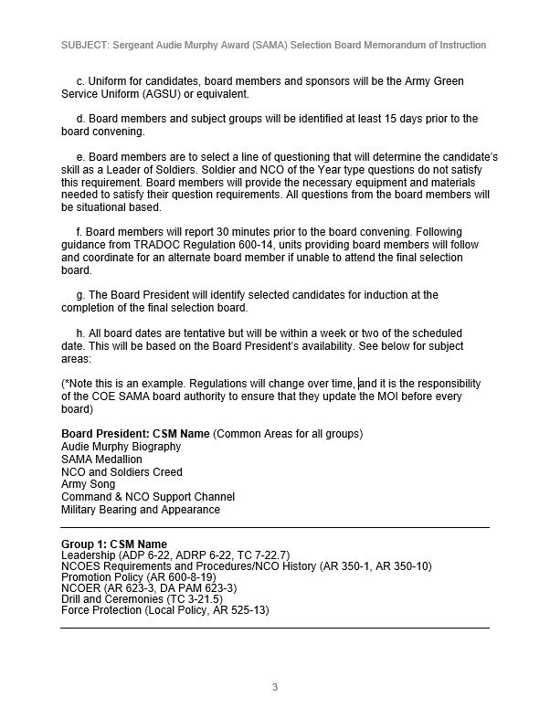

**Figure C-1. Example Memorandum of Instruction for the Final SAMA Board (cont.)**

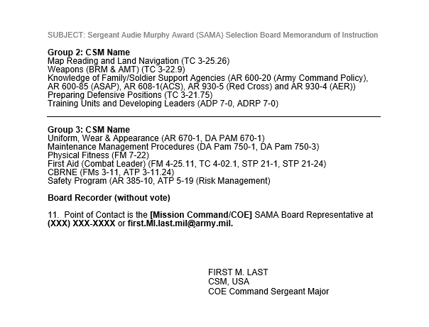**Figure C-1. Example Memorandum of Instruction for the Final SAMA Board (cont.)**

______________________________________________________________________________

# Appendix D Example TRADOC SAMA Nomination Packet

This appendix provides an example of how a TRADOC SAMA nomination packet should be prepared: Each packet will contain the following items:

1. Binder with Unit Coversheet. Must include unit crest, standard name line with Battalion and Brigade. See example in Figure D-1.

2. TRADOC SAMA Packet Checklist. See Figure D-2.

3. Brigade Level CSM Nomination Memorandum. See example memorandum with instructions in Figure D-3.

4. Current DA Photo/Official Photo. Official DA Photographs will be as current as possible to reflect the NCO’s most recent decorations and appearance. See examples in Figure D-4.

5. Service member’s Biography. See example in Figure D-5.

6. Updated Soldier Record Brief/Soldier Talent Profile or equivalent for USAR and ARNG NCOs. *Note: Must have an Expert Primary Weapons Qualification on SRB within 180 days of Final Selection Board or provide an Exception to Policy signed by Service Member’s Brigade CSM if a range or weapon is not available. Retrieve from [The Integrated Personnel and Pay System - Army](https://ipps-a.army.mil/).

7. DA Form 2166-9-1 or DA Form 2166-9-2 (NCOERs). Evaluations created in <https://evaluations.hrc.army.mil>.

8. TRADOC Selection Memorandum. See Figure D-6.

9. DA Form 705-TEST (Army Combat Fitness Test Scorecard). *Note: Must achieve 90 points on all events. ACFT will be administered by the final phase board authority (i.e., Brigade CSM will validate ACFT results) prior to the board. If the Soldier does not pass the ACFT, they will not be authorized to compete in the SAMA board. An ETP will be submitted if a Soldier cannot perform all three events. All Soldiers will score a minimum of 90 points in each event. Retrieve from [Army Publishing Directorate website](https://armypubs.army.mil/).

10. DA Form 5500 or DA Form 5501 (Body Fat Content Worksheets). This height and weight will supersede all previous Body Fat Content Worksheets.Retrieve from [Army Publishing Directorate website](https://armypubs.army.mil/).

11. DD Form 2266 (Hometown News Release). Retrieve from [DoD Executive Services Directorate website](https://www.esd.whs.mil/Directives/forms/).

12. Written essay – current topics pertaining to Army policy provided by the Board President within 48 hours of the board convening date. The essay allows board members to assess the Soldier’s cognitive critical thinking skills. Essay length will be no less than 400 words and no greater than 500 words, will be announced 48 hours prior to the board.

Figure D-1. Sample Illustration of a SAMA Award Board Coversheet

Sergeant Audie Murphy Award Board

Packet Checklist

1) Binder with Unit Coversheet

2) Brigade Level Command Sergeant Major (CSM) Nomination Memorandum

3) Current DA Photo/ Official Photo

4) Service Member Biography

5) Updated Soldier Record Brief (SRB)/Soldier Talent Profile with DA Photo

*Note: Must have an Expert Primary Weapons Qualification on SRB within 180 days of Final Selection Board or provide an Exception to Policy signed by Service Member’s Brigade CSM if a range or weapon is not available.

6) Previous DA Form 2166-9-1 (NCOER SGT) or DA Form 2166-9-2 (NCOER SSG-MSG/1SG) equaling two total years. If the NCO is a CPL/SGT and does not have an evaluation, this will be annotated on the Brigade Nomination Memorandum, endorsed by the Brigade CSM.

7) DA Form 705-TEST (Army Combat Fitness Test Scorecard). *Note: Must achieve 90 points on all events. ACFT will be administered by the applicable phase board authority (i.e., Brigade/COE/TRADOC CSM will validate ACFT results) prior to the board. If the Soldier does not pass the ACFT, they will not be authorized to compete in the SAMA board. An exception to policy will be submitted if a Soldier cannot perform all three events.

8) DA Form 5500 (Body Fat Content Worksheet (Male)) or DA Form 5501 (Body Fat Content Worksheet (Female)).

9) DD Form 2266 (Hometown News Release)

___10) Written essay – current topics pertaining to Army policy provided by the Board President within 48 hours of the board convening date. The essay allows board members to assess the Soldier’s cognitive critical thinking skills. Essay length will be no less than 400 words and no greater than 500 words, will be announced 48 hours prior to the board.

Figure D-2. Sample SAMA Board Packet Checklist

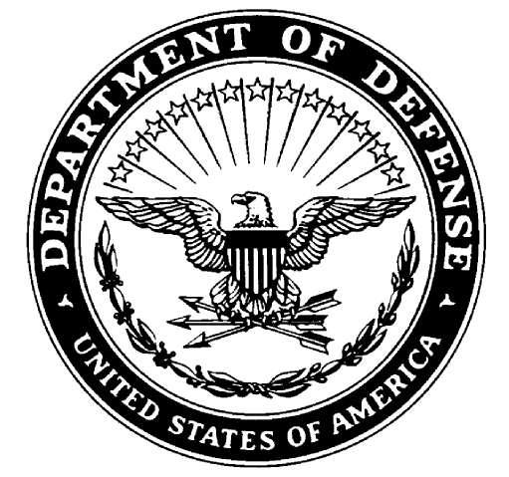**Department of the Army**

**(UNIT LETTER HEAD)**

OFFICE SYMBOL (600-8-22) Date

MEMORANDUM FOR Sergeant Audie Murphy Award (SAMA) Selection Board

SUBJECT: Letter of Nomination for **RANK, Last, First MI**

1. Letter will be 2 to 3 paragraphs with specific, quantifiable comments about the Soldier’s character and tactical and technical competence. Letters are not limited to the 3 paragraphs. Letter of Nomination not meeting these criteria will be rejected.

2. Information from the Soldier’s entire record can be used including comments about schools completed, assignments, deployments, impact awards, achievements and accomplishments.

3. Generic comments are not effective in communicating the Soldier’s attributes to the board members. If you can change the name of the person being recommended to someone else and the comments are not false, then the letter is probably too generic to communicate effectively to the board members.

4. The point of contact for this memorandum is the Brigade SAMA Representative at **(XXX) XXX-XXXX** or **first.MI.last.mil@army.mil.**

FIRST MIDDLE LAST

CSM, USA

Brigade Command Sergeant Major

Figure D-3. Example Brigade Level CSM Nomination Memorandum   
with instructions

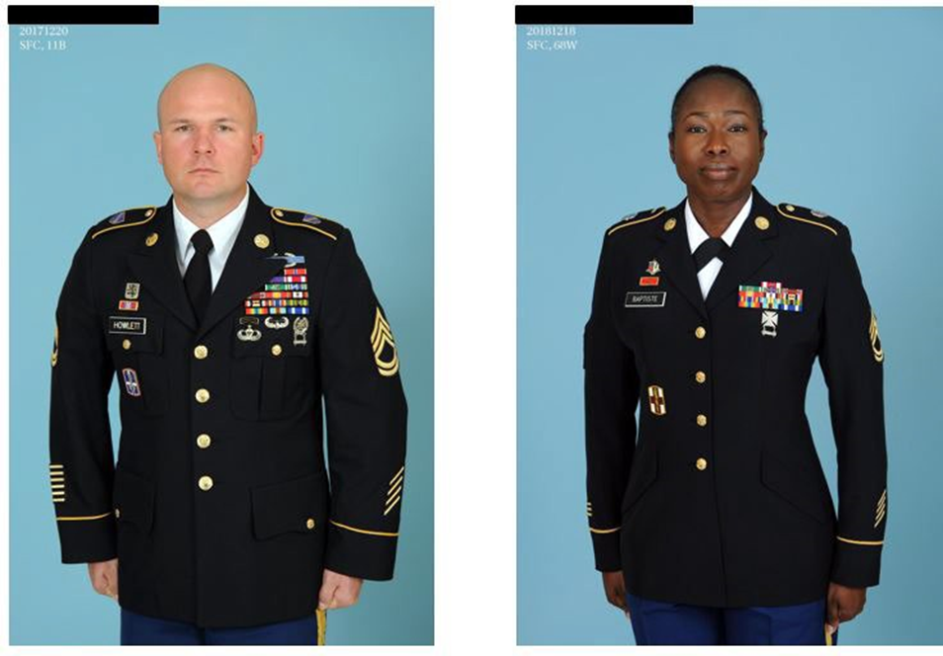

Figure D-4. Sample Illustration of an Official DA Photo of both a Male and Female  
 Noncommissioned Officer (NCO)

Biography: RANK First Last Middle Initial.

Sergeant First Class First Middle Initial Last Name is a native of Riverside California. He entered the Army in April 2005 and attended Basic and AIT at Fort Benning GA, graduating as an Infantryman.

He has served in several positions, including Team Leader, Squad Leader, Ranger Instructor and Platoon Sergeant. He is currently serving as a Training/ Advise Noncommissioned Officer in Charge of Team three, Alpha Company out of the 1st Security Force Assistance Brigade stationed at Fort Benning, GA forward deployed to Afghanistan.

SFC Last Name has served two tours overseas in Germany. His deployments include Operation Iraqi Freedom, Operation Enduring Freedom and Operation Freedom’s Sentinel. His stateside Assignments have been at Fort Hood and Fort Benning.

His military education includes; Basic Leaders Course; Advanced Leaders Course; Senior Leaders Course; Army Basic Instructors Course; Tactics Certification Course; Conduct after Capture; Security Force Assistance Advisor Course; Combatives Level 1; Airborne School; Jumpmaster; Air Assault; Mountain Warfare-Winter; and the Ranger Course.

SFC Last Name awards and decorations include the Bronze Star Medal, the Purple Heart, Meritorious Service Medal, Army Commendation Medal 9th award, Army Achievement Medal 7th award, Good Conduct Medal 4th award, National Defense Service Medal, Afghan Campaign Medal with one Campaign star, Iraq Campaign Medal with three Campaign stars, Global War on Terrorism Service Medal, NCO Professional Development Medal with Arabic numeral 3, Army Service Ribbon, Overseas Service Ribbon with Arabic numeral 5, NATO Medal, Expert Infantryman Badge, Combat Infantryman Badge, Senior Parachutist Badge, Air Assault Badge and the Ranger Tab and other service medals and ribbons.

He has been married to his wife NAME for more than three years.

Figure D-5. Example biography for SAMA candidate

Figure D-6. Example TRADOC SAMA Selection Memorandum

# Appendix E Awards

See below for SAMA award items:

1) TRADOC SAMA Certificate of Achievement. See Figure E-1.

2) TRADOC SAMA Medallion. See Figure E-2.

3) TRADOC SAMA Awardee Card. See Figure E-3.

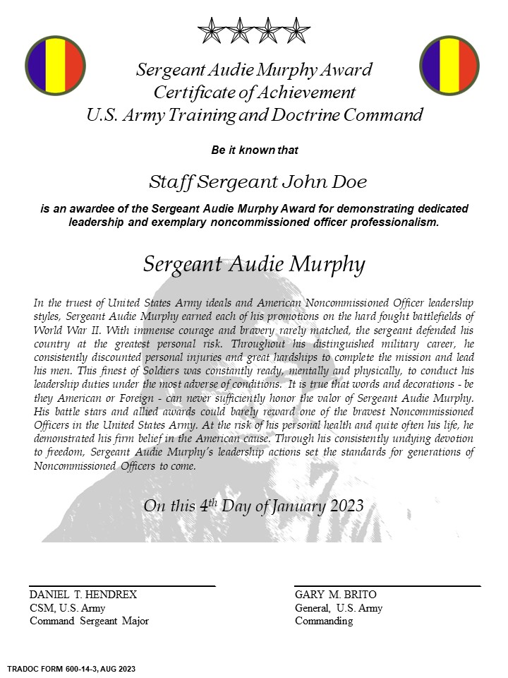

Figure E-1. Example TRADOC SAMA Certificate of Achievement

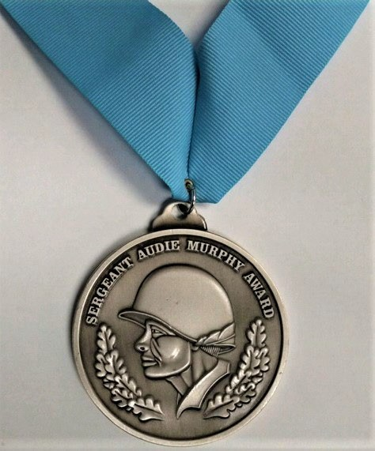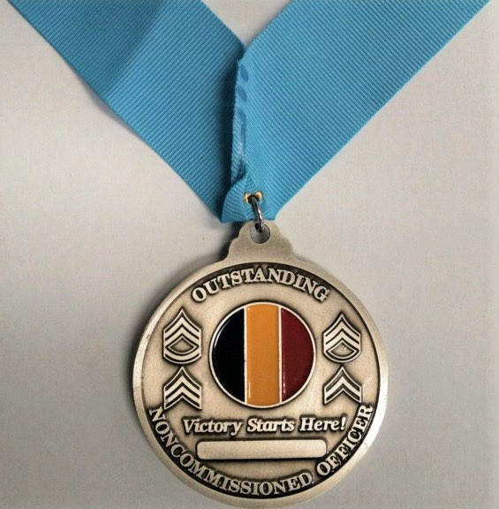

Figure E-2. TRADOC Sergeant Audie Murphy Award Medallion

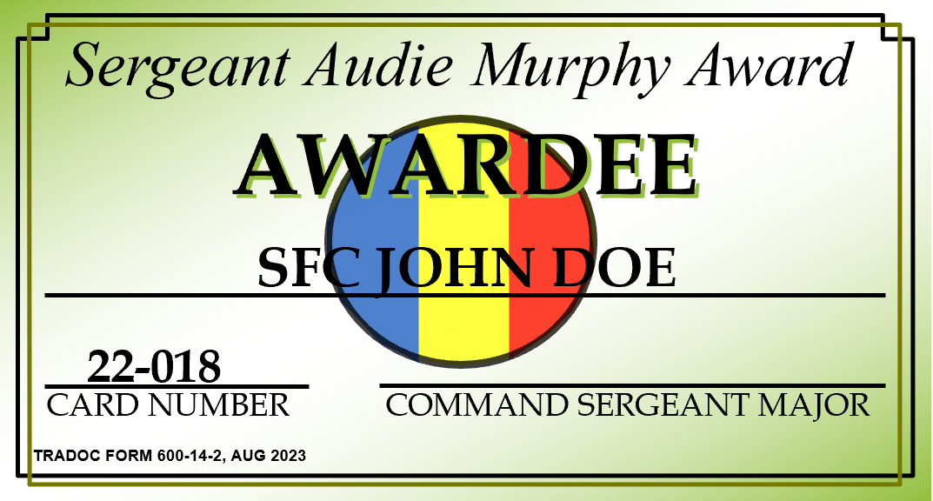

**SAMPLE**

Figure E-3. TRADOC SAMA Awardee Card

# Appendix F Wear and Appearance of the TRADOC SAMA Medallion

See below for wear and appearance of the TRADOC SAMA Medallion:

1. The proper wear of the SAMA medallion in ASU, see Figure F-1.

2. The proper wear of the SAMA medallion in ACU, see Figure F-2.

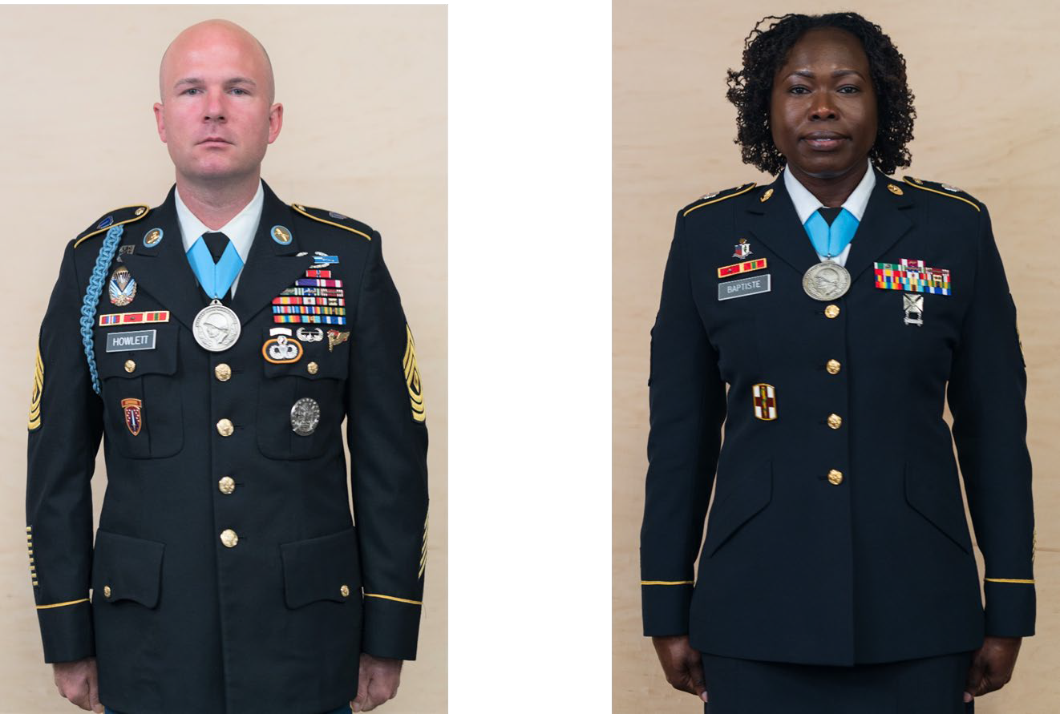

Figure F-1. TRADOC Sergeant Audie Murphy Award Medallion Army   
Service Uniform Wear and Appearance

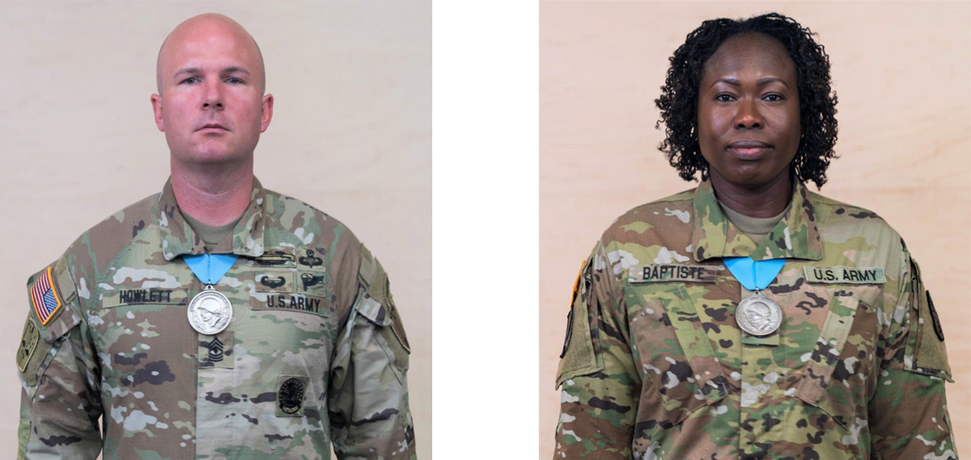

Figure F-2. Sergeant Audie Murphy Award Medallion Army Combat   
Uniform Wear and Appearance

# Glossary

**Section I**

**Abbreviations and Acronyms**

ACFT Army Combat Fitness Test

ACOM Army Command

ACU Army Combat Uniform

ASU Army Service Uniform

AR Army Regulation

ARNG Army National Guard

CBRNE Chemical, Biological, Radiological, Nuclear and High-Yield Explosives

CDR Commander

CSM Command Sergeant Major

DA Department of the Army

DA PAM Department of the Army Pamphlet

DD DoD (Form)

DUI Driving Under the Influence

SRB Soldier Record Brief

ORB Officer Record Brief

ETP Exception to policy

TRADOC U.S. Army Training and Doctrine Command

FM Field Manual

**Glossary (cont.)**

IAW In accordance with

MOI Memorandum of Instruction

NCO Noncommissioned Officer

NCOER Noncommissioned Officer Evaluation Report

PO Private Organizations

POC Point of Contact

SAMA Sergeant Audie Murphy Award

SAMC Sergeant Audie Murphy Club

SGM Sergeant Major

USAR United States Army Reserve