**Department of the Army *TRADOC Regulation 600-21**

**Headquarters, United States Army**

**Training and Doctrine Command**

**Fort Eustis, Virginia 23604-5700**

**2 May 2018**

**Personnel - General**

**FACULTY DEVELOPMENT AND RECOGNITION PROGRAM**

FOR THE COMMANDER:

OFFICIAL: PAUL M. BENENATI

Major General, U.S. Army

Deputy Chief of Staff



BRETT E. REISTER

Colonel, U.S. Army

Acting Deputy Chief of Staff, G-6

**History.** This is a major revision to United States Army Training and Doctrine Command (TRADOC) regulation 600-21. The portions of the publication affected by this revision are listed in the summary of change.

**Summary.** This regulation prescribes policies and procedures for implementing the Faculty Development and Recognition Program (FDRP).

**Applicability.** This regulation applies to all instructors who meet the requirements defined in this regulation.

**Proponent and exception authority.** The proponent for this regulation is The Army University (ArmyU).

**Army Management Control Process.** This regulation contains management control provisions, but does not identify key management controls that must be evaluated.

**Supplementation.** Supplementation of this regulation is prohibited unless specifically approved by ArmyU.

*This regulation supersedes TRADOC Regulation 600-21, dated 20 June 2016.

**Suggested improvements.** Submit changes for improving this publication on Department of the Army (DA) Form 2028 (Recommended Changes to Publications and Blank Forms) through

channels directly to the Commander, U.S. Army Combined Arms Center, Attention (ATTN):

Army University (ArmyU), Vice Provost for Academic Affairs (VPAA), Quality Assurance and Policy Governance Division (ATZL-AUA), Fort Leavenworth, KS 66027-2300, or

[usarmy.leavenworth.tradoc.mbx.armyu-fsdd-policy@mail.mil](mailto:usarmy.leavenworth.tradoc.mbx.armyu-fsdd-policy@mail.mil). Additionally, changes may be submitted via the Training and Education Developer - Toolbox (TED-T) at <https://atn.army.mil/>.

**Distribution.** This publication is available in electronic media only and is published on the TRADOC Administrative Publications web site at [http://adminpubs.tradoc.army.mil](http://adminpubs.tradoc.army.mil/).

**Summary of Change**

TRADOC Regulation 600-21

Faculty Development and Recognition Program

This major revision, dated 2 May 2018-

o Replaces all references to Instructor Development and Recognition Program with Faculty Development and Recognition Program throughout the publication.

o Removes implementation into the Noncommissioned Officer Education System to authorize participation of faculty and credentialing incentive program to Soldiers and Civilians.

o Removes Command Sergeant Major of United States Army Training and Doctrine Command responsibilities.

o Transfers the Director responsibilities from the Institute of Noncommissioned Officer Professional Development to The Army University, Vice Provost of Academic Affairs, Faculty and Staff Development Division (para 2-2).

o Removes 18-month regulation review requirement from regulation.

o Removes requirement for Institute of Noncommissioned Officer Professional Development to provide a voting member for Master Instructor Selection Boards from regulation.

o Removes all references to Institute of Noncommissioned Officer Professional Development and replaces with Army University throughout the publication.

o Removes words “Commanding Generals” from responsibility (chapter 2).

o Adds requirement to designate a unit Faculty Development and Recognition Program manager (para 2-3).

o Removes Center/Regiment/School Command Sergeant Major responsibilities (para 2-5).

o Removes Noncommissioned Officer Academy Commandant Responsibilities (para 2-6).

o Adds Faculty Development and Recognition Program Managers’ responsibility (para 2-4).

o Replaces all references to Noncommissioned Officer Education System instructors, with instructors throughout the publication.

o Updates effective date to 2 May 2018 (para 3-1).

o Removes all references to the Instructor Selection process, including the instructional chapter and supporting appendix (Instructor Application Protocol and Instructor Interview Protocol) from regulation.

o Removes ability to use alternative evaluation methods from regulation.

o Makes self-assessment and feedback a requirement (para 3-3).

o Requires that only Evaluating Instructors Course qualified personnel can conduct evaluations (para 3-3b).

o Requires lesson design/redesign only be evaluated by qualified designated personnel (para 3-3c.)

o Updates rater qualifications (Table 3-1).

o Revises requirements for all Badging Levels throughout the publication.

o Clarifies definition of Primary Instructor hours (para 3-4b).

o Adds requirement for Department of the Army Form 4856 for all instructors, prior to initiating the program (para 3-4e-2).

o Updates timeframe to a minimum of seven days between two evaluations, and an evaluation score of at least 12 for the Basic Army Instructor Badge (para 3-4e-6).

o Adds a requirement for four developmental observations for the Basic Army Instructor Badge (para 3-4e-7).

o Removes requirement to complete each badging level before departing instructor position throughout the publication.

o Revises definition of Senior Army Instructor Recognition and Badging Level (para 3-4f).

o Adds a 12-month requirement after submission of the Basic Army Instructor Badge nomination packet before attempting the Senior Army Instructor Badge (para 3-4f-2).

o Updates training requirement of Instructional Design Basic Course and the Evaluating Instructors Course after conducting a minimum of 100 Primary Instructor hours (para 3-4f-4).

o Changes the total hour requirement from 400 to 200 Primary Instructor hours after submission of the Basic Army Instructor Badge nomination packet, before initiating the Senior Army Instructor Badge (para 3-4f-5).

o Updates timeframe to a minimum of seven days between three evaluations, and an evaluation score of at least 16 for the Senior Army Instructor Badge (para 3-4f-6).

o Adds a requirement for 3 developmental observations for the Senior Army Instructor Badge (para 3-4f-7).

o Revises definition of Master Army Instructor Recognition and Badging Level (para 3-4g).

o Adds a 24-month requirement after submission of the Senior Army Instructor Badge nomination packet before attempting the Master Army Instructor Badge (para 3-4g-2).

o Changes the total hour requirement from 400 to 200 Primary Instructor hours after submission of the Senior Army Instructor Badge nomination packet, before initiating the Master Army Instructor Badge (para 3-4g-4).

o Updates timeframe to a minimum of 7 days between three evaluations, and an evaluation score of at least 20 for the Master Army Instructor Badge (para 3-4g-5).

o Adds requirement to conduct at least four Evaluating Instructors Course evaluations (para 3-4g-6).

o Adds a requirement for supervisor to notify unit Faculty Development and Recognition Program managers when an instructor initiates the Faculty Development and Recognition Program process (para 3-5b).

o Adds Basic Badge nomination packet requirements (para 3-5e).

o Adds Senior Badge nomination packet requirements (para 3-5f).

o Adds Master Badge nomination packet requirements (para 3-5g).

o Updates awarding authority to first O-6 or GS-15 in the chain of command (para 3-5k).

o Updates delegation of awarding authority for the Basic Army Instructor Badge to O-5 or GS-14 (para 3-5k).

o Authorizes the United States Army Sergeants Major Academy Commandant to award all badge levels and can delegate awarding of the Basic Army Instructor Badge and Senior Army Instructor Badge to Noncommissioned Officer Academy Commandants (para 3-5k).

o Updates and recommends ceremonies to include all badge levels (para 3-5m).

o Updates Army Physical Fitness Test waiver requirement, depending on the circumstances (para 3-6a-2).

o Updates the rescinding of badges (para 3-7).

o Adds the inclusion of instructors serving in a joint service environment (para 3-8).

o Authorizes other branches of the military to participate in the Faculty Development and Recognition Program (para 3-8b).

o Adds Instructor Development and Recognition Program transition to Faculty Development and Recognition Program parameters (para 3-9).

o Removes requirement for Institute of Noncommissioned Officer Professional Development to be on the Master Instructor Selection Board. (chap 4)

o Adds a requirement for at least one board member to hold a Master Army Instructor Badge (para 4-1c).

o Removes table 5-1, Master Instructor Board member qualifications.

o Adds a requirement for Master Instructor Board membership (para 4-1c-4).

o Removes chapter 6, coaching from regulation.

o Updates all sections of the Glossary.

o Removes Appendix E Instructor Training Matrix from regulation.

o Updates Instructor Competency Assessment Matrix (Table B-1).

o Updates the Instructor Observation Rubric (Appendix B).

o Adds the Developmental Observation Worksheet (Appendix G).

o Directs the Army learning community to use Training & Education Developer - Toolbox at <https://atn.army.mil/> in order to access Appendix B, “International Board of Standards for Training, Performance and Instruction (ibstpi) Competency and Outcomes Matrix” and Appendix D, “Instructor Observation Rubric, TRADOC Form 600-21-1”, per ibstpi Copyright and Permissions User Agreement throughout the publication.

**This page intentionally left blank**

**Content**

**Page**

Chapter 1 Introduction 9

1-1. Purpose 9

1-2. References 9

1-3. Explanation of abbreviations and terms 9

Chapter 2 Responsibilities 9

2-1. Deputy Commanding General/Chief of Staff, United States Army Training and Doctrine Command (TRADOC) 9

2-2. Army University (ArmyU), Vice Provost of Academic Affairs, Faculty and Staff Development Division (FSDD) 9

2-3. Commanders/Commandants 9

2-4. Unit Faculty Development and Recognition Program (FDRP) Managers 10

Chapter 3 Policies and Procedures 10

3-1. General 10

3-2. Instructor Competencies and Outcomes 11

3-3. Instructor Assessments 11

3-4. Instructor Recognition Requirements 12

3-5. Process 15

3-6. Instructor Recognition Waivers 17

3-7. Rescinding Instructor Recognition 18

3-8. Instructors Assigned Outside of TRADOC 18

3-9. FDRP Transition 18

3-10. FDRP Certificate Program 19

3-11. Army Career Program (CP) 32 Certificate Training Program 19

Chapter 4 Master Instructor Selection Board (MISB) 19

Appendix A References 22

Appendix B International Board of Standards for Training, Performance and Instruction (ibstpi) Competency and Outcomes Matrix 25

Appendix C Department of the Army (DA) Form 4187 Personnel Action 25

Appendix D Instructor Observation Rubric, TRADOC Form (TF) 600-21-1 33

Appendix E MISB Materials 33

Appendix F Lesson Design / Redesign Checklist, TRADOC Form (TF) 600-21-5 41

Appendix G Developmental Observation Worksheet 46

Glossary 47

**Figure List**

Figure 3-1. Instructor Progression 11

Figure C-1. DA Form 4187 26

Figure E-1. TF 600-21-2 35

Figure E-2. TF 600-21-3 40

Figure F-1. TF 600-21-5 42

Figure G-1. TF 600-21-4 46

**Table List**

**Page**

Table 3-1. Evaluator Qualifications 12

Table C-1. DA Form 4187 Instructions 27

Table C-2. Instructor Recognition Checklists 30

Table E-1. Sample Questions for MISB 36

# Chapter 1

# Introduction

## 1-1. Purpose

This regulation provides the policy and procedures for implementing the Faculty Development and Recognition Program (FDRP) and award of Army Instructor Badges (AIBs) to instructors. United States Army Training and Doctrine Command (TRADOC) recognizes the need to support instructor development and establish incentives for Soldiers (Active Duty, National Guard, and Reserve) and civilians who want to excel as instructors. The primary goal of the FDRP is to develop and grow instructor competencies. The FDRP will enable evaluators and supervisors to develop, train, and mentor instructors; providing added value to unit training when the instructor returns to the field.

## 1-2. References

Required publications and referenced forms are listed in appendix A.

## 1-3. Explanation of abbreviations and terms

Abbreviations and special terms used in this regulation are explained in the glossary.

# Chapter 2

# Responsibilities

## 2-1. Deputy Commanding General/Chief of Staff, United States Army Training and Doctrine Command (TRADOC)

The TRADOC Deputy Commanding General/Chief of Staff will approve changes to this regulation.

## 2-2. Army University (ArmyU), Vice Provost of Academic Affairs, Faculty and Staff Development Division (FSDD)

FSDD will-

a. Write, update, and obtain approval of this regulation.

b. Review proposed changes for FDRP requirements, policies, and procedures.

c. Ensure the intent of this regulation by conducting periodic quality assurance observations and briefings on the FDRP program.

## 2-3. Commanders/Commandants

Commanders/Commandants will-

a. Oversee the administration of the FDRP program.

b. Award the instructor badges to qualified instructors in their commands in accordance with Army Regulation (AR) 600-8-22, and this regulation.

c. Review and approve personnel actions to rescind the instructor badge (paragraph 3-7), if required.

d. Periodically review the effectiveness of the program and provide ArmyU recommendations to improve the program.

e. Designate a senior FDRP manager in writing.

f. Establish local procedures for participation in the FDRP, to include designating subordinate unit FDRP managers.

## 2-4. Unit Faculty Development and Recognition Program (FDRP) Managers

Unit FDRP Managers will-

a. Collect and input data to the senior FDRP manager in quarterly reports to ArmyU/FSDD.

b. Verify personnel conducting the instructor observations are qualified and designated to evaluate instructor performance in accordance with this regulation.

c. Maintain local records associated with this program for a minimum period of five years (with the exception of the Department of the Army (DA) Form 4187) in accordance with AR 25-400-2 (The Army Records Information Management System (ARIMS)).

d. Complete DA Form 4187 to document instructors who have met the requirements for each badging level.

e. Initiate personnel actions for the awarding or rescinding of AIBs.

f. Coordinate with S-1/G-1/Personnel Service Centers to process personnel actions for awarding or rescinding of instructor badges to the instructor’s Personnel File.

# Chapter 3

# Policies and Procedures

## 3-1. General

Participation in the FDRP is voluntary. Instructors assigned to an instructor billet after

2 May 2018 and teach approved content are eligible for the FDRP. Commanders, Commandants, or awarding authorities (paragraph 3-5) may assess curricula of technical instructors who support their institution, but not formally assigned, to determine their eligibility. The assessed curriculum must be congruent with the required instructor competencies (appendix B, Table B-1; located on the [Training & Education Developer - Toolbox](https://atn.army.mil/TreeViewCStab.aspx?loadTierID=2904&docID=35) (TED-T) website). Technical instructors must meet all certification requirements before the supported Commander, Commandant, or awarding authority determines eligibility. TRADOC Regulation (TR) 350-70 prescribes the instructor/facilitator certification policy for all personnel that instruct/facilitate. All instructors must meet TRADOC instructor certification requirements per TR 350-70 before becoming eligible for the instructor recognition levels outlined in this program (Figure 3-1). The FDRP contains three levels of instructor recognition, performance outcomes for each level, instructor development plans to achieve each level, and an evaluation plan to assess instructors at each level.



Figure 3-1. Instructor Progression

## 3-2. Instructor Competencies and Outcomes

Appendix B displays a list of instructor competencies with performance outcomes for each level of instructor recognition.

# 

## 3-3. Instructor Assessments

Assessments are critical for evaluating and improving performance and guiding professional development. In each successive level, instructors are assessed on how well they perform. The assessments listed in the following paragraphs provide multiple instruments for evaluating/self-evaluating instructor strengths and weaknesses, providing feedback on how they are doing in the classroom, and how they can focus on improvement.

a. Instructor Self-Assessment. Instructors will use the Instructor Observation Rubric, TRADOC Form (TF) 600-21-1 (appendix D; located on the [TED-T](https://atn.army.mil/TreeViewCStab.aspx?loadTierID=2904&docID=35) website) to help guide them in assessing and planning appropriate developmental activities. Instructors will share the self-assessment with their evaluator and compare it with the results of their most recent instructor evaluation. As the instructor’s performance improves, the correlation between the self-assessment and instructor observation results should improve.

b. Instructor Observation Rubric. Use the Instructor Observation Rubric, TF 600-21-1 (appendix D) to evaluate an instructor’s performance. Only Evaluating Instructor Course (EIC) qualified and designated personnel will conduct the evaluations as part of an instructor recognition packet. Use the observation results to update the instructor’s self-development plan to determine successful progression through the subsequent levels.

c. Lesson Design/Redesign Checklist. Instructors will use lessons from their program of instruction to meet the FDRP lesson redesign requirements, regardless of the developer course attended. Evaluation of the lesson redesign is compared to the current lesson plan. It is evaluated for evidenced-based instructional design strategies and principles, as outlined in the Lesson Design/Redesign Checklist (appendix F). Only qualified designated personnel will evaluate an instructor’s lesson design/redesign (Table 3-1). The result is documented in the instructor recognition packet for progression. Not all of the items on the checklist will apply to every lesson; therefore, a score is computed by dividing the number of items rated as “GO” by the total number of items evaluated. Instructors seeking the Senior Instructor Badge must score at least 80% when they redesign a lesson. This checklist is only used to evaluate instructor performance for the lesson redesign requirement.

Table 3-1.

Evaluator Qualifications

|  |  |  |  |
| --- | --- | --- | --- |
|  | **Item/Event** | **Evaluator(s)** | **Evaluator(s) Qualifications** |
| 1 | Instructor Observation Rubric  (TF 600-21-1) | Qualified  Designated Evaluator | Must have successfully completed the EIC) |
| 2 | Lesson Design / Redesign Checklist  (TF 600-21-5) | Qualified  Designated Evaluator | Must have successfully completed Common Faculty Development – Developer Course or Instructional Design Basic Course (IDBC) or  Faculty Development Program-3 (FDP-3) or  Advanced Training Developer Course (ATDC) |

## 

## 3-4. Instructor Recognition Requirements

a. Evaluations will be conducted by a qualified and designated evaluator (Table 3-1), in a face-to-face educational setting, utilizing only the TF 600-21-1 Instructor Observation Rubric (appendix D). Instructors who solely teach distributed learning content will need to coordinate evaluation in a distance learning setting.

b. The Commander or Commandant is responsible for maintaining a tracking system for primary instructor (PI) hours. PI hours are instructional hours allocated in the lesson plan for a single lead instructor responsible for reaching the learning objective. Instructional hours accrued teaching courses that are not part of the curriculum are not counted for FDRP progression.

c. Accumulating hours in support of the Senior Army Instructor Badge (SAIB) will commence on the day after submission of the Basic Army Instructor Badge (BAIB) nomination packet. Subsequently, instructional hours in support of the Master Army Instructor Badge (MAIB) will commence on the day after submission of the SAIB nomination packet.

d. Instructors are encouraged to request a memorandum for record (MFR) that details the PI hours and time accrued prior to departing an instructor position. Prospective Commanders or Commandants will use the MFR to validate requirements for continued FDRP progression.

e. BAIB level. Soldiers and civilians performing at this level are able to facilitate and present instruction in a variety of learning environments. Instructors closely adhere to the instruction outlined in the lesson plan and effectively prepare and execute instruction. They communicate effectively and apply various instructional methods, media, and educational

technology in order to facilitate learning and present instruction. Instructors at this level question students and provide effective feedback, promote learning retention and transfer, assess learning, and counsel students. To receive the BAIB instructors must:

(1) Meet all instructor requirements in AR 614-100 (officer only), AR 614-200 chapter 6 (enlisted only), Department of the Army Pamphlet (DA Pam) 600-3 and DA Pam 600-8.

(2) Complete the initial counseling (DA Form 4856) with supervisor.

(3) Provide a current Army Physical Fitness Test (APFT) scorecard (DA Form 705) (military only).

(4) Complete TR 350-70 instructor certification requirements by attending the Common Faculty Development – Instructor Course (CFD-IC), and accomplishing all local certification requirements.

(5) Successfully teach at least 80 hours of instruction as the primary instructor after completing TR 350-70 instructor certification requirements.

(6) Have two consecutive evaluations conducted a minimum of 7 days apart by a qualified designated evaluator, with a score of 12 or higher on the Instructor Observation Rubric TF 600-21-1 (appendix D). The instructor will conduct a self-assessment (TF 600-21-1) prior to each formal EIC evaluation feedback.

(7) Conduct four developmental observations (TF 600-21-4) of other instructors (can be outside of the instructor’s institution) and provide written feedback to supervisor for certification (appendix G).

f. SAIB level. In addition to continuing to improve instructor skills, senior instructors also use student reaction and learning data to recommend areas for instructor improvement or curriculum changes. They are able to redesign lessons to update content or implement other changes approved by the appropriate authority (e.g. course manager, training developer). To receive the SAIB instructors must:

(1) Meet all instructor requirements in AR 614-100 (officer only), AR 614-200 chapter 6 (enlisted only), DA Pam 600-3 and DA Pam 600-8.

(2) Served a minimum of 12 months as an instructor after submission of the BAIB nomination packet.

(3) Provide a current APFT scorecard DA Form 705 (military only).

(4) Complete the following training: Instruction Design Basic Course (IDBC) and the EIC, but not before conducting a minimum of 100 PI hours as a Basic Instructor. Conduct a lesson redesign after completion of IDBC, scoring at least 80% on the Lesson Design / Redesign Checklist TF 600-21-5 (appendix F). A qualified and designated evaluator (table 3-1) will conduct this evaluation.

(5) Successfully teach at least 200 hours of instruction as the primary instructor after submission of BAIB packet (280 total hours).

(6) Have three consecutive evaluations conducted a minimum of 7 days apart by a qualified designated evaluator, with a score of 16 or higher on the Instructor Observation Rubric TF 600-21-1 (appendix D). The instructor will conduct a self-assessment prior to each formal EIC evaluation feedback.

(7) Conduct three developmental observations (TF 600-21-4) of other instructors (can be outside of the instructor’s institution) and provide written feedback to supervisor for certification (appendix G).

g. MAIB level. Master instructor recognition is the highest level attained, and is representative of instructors who choose to become fully knowledgeable learning professionals. Master instructors serve on Master Instructor Selection Boards (MISBs) and are able to demonstrate an in-depth understanding of the fundamental principles of learning, design, and implementation. Master instructors are capable of designing/redesigning lessons and make evidence-based recommendations regarding instructional strategies, methods, media and technology, while continuously striving to update their knowledge of learning practices. To receive the MAIB instructors must:

(1) Meet all instructor requirements in AR 614-100 (officer only), AR 614-200 chapter 6 (enlisted only), DA Pam 600-3 and DA Pam 600-8.

(2) Have served a minimum of 24 months as an instructor after submission of the SAIB nomination packet.

(3) Provide a current APFT scorecard DA Form 705 (military only).

(4) Successfully teach at least 200 hours of instruction as the primary instructor after submission of the SAIB packet (480 total hours).

(5) Have three consecutive evaluations conducted a minimum of seven days apart by a qualified designated evaluator, with a score of 20 or higher on the Instructor Observation Rubric TF 600-21-1 (appendix D). The instructor will conduct a self-assessment prior to each formal EIC evaluation feedback.

(6) Conduct at least four EIC evaluations, providing feedback to instructors utilizing the Instructor Observation Rubric, TF 600-21-1 (appendix D).

(7) Be recommended by members of the MISB on TF 600-21-2 and TF 600-21-3 (appendix E).

# 

## 3-5. Process

Participation in the FDRP is voluntary. The instructor and their supervisory chain will manage the progression based on how well the instructor performs and completes the requirements. It is not intended within this program that every new military instructor will be able to progress through all AIB levels within a single assignment. However, instructors may continue to progress in the program during subsequent assignments.

a. Instructors may choose to participate in the FDRP any time after they complete instructor certification requirements as required by TR 350-70. An instructor that decides to participate in the program will notify their immediate supervisor who will complete a formal counseling (DA Form 4856). This ensures the instructor understands the program requirements and local procedures for documenting progress in the program.

b. The supervisor will notify the unit FDRP manager to ensure the instructor is included in future program reports.

c. The supervisor and instructor will schedule formal evaluations and document performance on the Instructor Observation Rubric (TF 600-21-1). Only designated and qualified personnel will conduct evaluations (table 3-1).

d. When an instructor has met the requirements for recognition as a basic instructor, senior instructor or master instructor, the supervisor and instructor will prepare a nomination packet (see figure C-1) with documentation that shows the instructor has completed the requirements to the FDRP manager.

e. For instructors seeking BAIB recognition the packet must contain the following:

(1) A signed counseling annotated in a Developmental Counseling Form (DA Form 4856) by both the instructor and supervisor.

(2) A current APFT scorecard DA Form 705 (military only).

(3) CFD-IC certificate.

(4) Documentation showing that instructor has completed 80 instructional hours as a PI.

(5) Two formal instructor observation rubrics (appendix D) scoring 12 points or higher, and two self-assessments. Only EIC certified evaluators conduct evaluations. The packet must also include the evaluator’s EIC certificate.

(6) Four developmental observations (appendix G).

f. For instructors seeking SAIB recognition the packet must contain the following:

(1) BAIB certification.

(2) A current APFT scorecard DA Form 705 (military only).

(3) IDBC certificate and lesson redesign certification (appendix F).

(4) EIC certificate.

(5) Documentation showing the instructor completed 200 additional hours as a BAIB PI.

Three formal instructor observation rubrics (appendix D) scoring 16 points or higher, and three self-assessments. Only EIC certified evaluators conduct evaluations. The packet must also include the evaluator’s EIC certificate.

(6) Three developmental observations (appendix G).

g. For instructors seeking MAIB recognition the packet must contain the following:

(1) SAIB certification.

(2) A current APFT scorecard DA Form 705 (military only).

(3) Documentation showing the instructor has completed 200 additional hours

as a SAIB PI.

(4) Three formal instructor observation rubrics (appendix D) scoring 20 points or higher and three self-assessments. Only EIC certified evaluators conduct evaluations. The packet must also include the evaluator’s EIC certificate.

(5) Documentation demonstrating that the instructor conducted a minimum of four EIC formal evaluations (appendix D).

(6) Master Instructor Selection Board recommendation TF 600-21-2 and TF 600-21-3 (appendix E).

h. The unit FDRP manager will review the packet to verify all requirements. For instructor recognition, the unit will prepare a DA Form 4187 (appendix C).

i. The awarding authority will review the packet, endorse the DA 4187 and return the packet to the unit FDRP manager. Civilians will be awarded a completion certificate and lapel device. There is no further processing required for civilian instructors. Both the unit FDRP manager and instructor maintain the Civilian instructor certifications. Civilians can further update their professional development by adding the certificate in their personnel records if desired.

j. The unit FDRP manager will provide the completed DA Form 4187 to the S1/G1/Personnel Service Centers in accordance with organizational procedures to process orders for the award.

k. Awarding authority is the first Colonel or GS-15 in the chain of command. Awarding of the BAIB can be delegated to Lieutenant Colonel or GS-14. Commandant of United States Army Sergeant Major Academy can award all AIB levels and can delegate awarding of the BAIB and SAIB to Noncommissioned Officer Academy Commandants. No further delegation authority is authorized.

l. Commanders or Commandants must ensure supervisors update military instructor personnel records to reflect award of the BAIB, SAIB, or MAIB and G1/S1/Personnel Service Centers send orders awarding the AIB to Human Resources Command in accordance with AR 600-8-22.

m. Units and organizations will recognize instructors who earn an AIB at regularly scheduled award ceremonies in accordance with organizational policy. Public recognition of instructors and senior leader involvement are key elements to ensuring that this program achieves the goal of promoting the continual improvement of instructor quality throughout the Army.

n. Unit FDRP managers ensure updates and any changes to instructor recognition status are reported to the senior FDRP manager in accordance with local policy. The senior FDRP manager will provide quarterly reports to ArmyU/FSDD. The format of this report will be distributed to FDRP managers by ArmyU/FSDD.

## 3-6. Instructor Recognition Waivers

a. APFT:

Exemptions to this regulation for the APFT and height/weight include the following:

(1) Soldier(s) with a permanent profile: Soldier’s limitations are recorded in their physical profile (DA Form 3349). The profiled Soldier must perform all the regular APFT events his/her medical profile permits. Soldiers who cannot do any of the aerobic events due to a physical profile cannot be tested. Such information will be recorded in their official military record. As a result, training school/institution Commanders/Commandants may waive the APFT requirements stipulated in TR 600-21 for any of the recognition and badging levels.

(2) Soldier(s) with a temporary profile: training school/institution Commander/Commandant can waive the record APFT requirements stipulated in TR 600-21 on a case-by-case basis.

(3) Commanders/Commandants may: furnish a waiver (MFR format) for the APFT. The MFR will have a brief explanation of the Soldier current medical status, without violating the Health Insurance Portability and Accountability Act (HIPAA), and the reasons why the Soldier is receiving a waiver for the APFT.

(4) Recalled retirees are not required to take the APFT. However, retirees must maintain a personal physical readiness-training program in order to stay within Army body composition standards during the period of recall. Retirees who exceed the Army body composition standards during the period of recall will enroll in the Army Body Composition Program, and cannot submit a request for any of the AIBs.

(5) Soldiers 60 years of age and older have the option of not taking the APFT; however, they must maintain a personal physical readiness program approved by a physician and remain within Army body composition standards. Soldiers 60 years of age and older who exceed the Army body composition standards will be placed in the Army Body Composition Program and cannot submit a request or be awarded any of the AIBs.

b. All other waivers concerning exceptions to this regulation are by ArmyU/FSDD. Training schools/institutions must submit a request (MFR format) for consideration.

# 

## 3-7. Rescinding Instructor Recognition

The awarding authority may revoke instructor badges if the recipient is removed from the instructor position for cause, regardless of the amount of time the individual has served in the position in a satisfactory manner. While serving in an instructor position, if an instructor fails to meet, or falls below the minimum instructor observation score (BAIB: 12; SAIB: 16; and MAIB: 20) for two consecutive evaluations during any six-month period, they will be counseled and develop a plan to remediate performance. If the instructor continues to perform unsatisfactorily over the next six months then action may be taken to rescind the instructor recognition badge. This mechanism will ensure that instructors that fail to maintain their performance level do not continue to receive instructor recognition. Instructors may appeal the rescinding action to the next level officer in the chain of command that is above the awarding authority. Once revoked, the badge will not be reinstated except by the CG, TRADOC, when fully justified.

## 

## 3-8. Instructors Assigned Outside of TRADOC

In order to support development and recognition of Soldiers and civilians assigned to instructor duty positions outside of TRADOC (to include instructors in joint service institutions); all school Commandants will exercise latitude in the use of the FDRP within their institutions. Effective 2 May 2018, all Soldiers and civilians formally assigned to a Table of Distribution and Allowance position as an instructor beyond TRADOC institutions may also participate in FDRP and be awarded instructor badges in accordance with procedures in this regulation.

a. Instructors must complete instructor certification requirements per TR 350-70 and local requirements before participation in the FDRP.

b. Other military service instructors (USAF, USMC, USN, USCG, and International) assigned to an Army institution can participate in the FDRP. However, recognition and wearing of the instructor badge will be in accordance with their own service’s regulations.

## 3-9. FDRP Transition

The Army FDRP is effective 2 May 2018. There are many distinct requirements between the previous Instructor Development and Recognition Program (IDRP) and the FDRP.

a. Noncommissioned officers currently participating in the Instructor Development and Recognition Program will have a grace period of six months (2 November 2018) to complete their next level of recognition.

b. All previous instructor certification courses (ABIC, FIFC, SGITC, IFSC, etc.) completed prior to 2 May 2018, will remain valid toward FDRP for five years from the completion date, as required in TR 350-70.

# 3-10. FDRP Certificate Program

FDRP has established a tiered recognition program to strengthen instructor competencies for Basic, Senior, and Master Levels. These recognition efforts can further be developed through the FDRP Certificate Program. Through a combination of instructor experience, certification, and completion of additional online courses, the instructor can receive undergraduate or graduate certificates. These are credentialed certificates, recognized outside of the Army, and credit hours are transferable toward completion of a Baccalaureate or Master’s Degree. Tuition Assistance may be available for the cost of this program through local education centers or GoArmyEd.com. Enrolling in the Credentialing Program can begin any time after instructor certification. FDRP managers can contact ArmyU/FSDD to coordinate instructor participation in the FDRP Certificate Program.

## 3-11. Army Career Program (CP) 32 Certificate Training Program

CP-32 developed a Certificate Training Program to foster a competent, agile and adaptive Civilian workforce involved in training and education as well as capability and doctrine development. The CP-32 Certificate Training Program is accredited by the American National Standards Institute (ANSI) as conforming to the standards of ANSI/ASTM E2659-09, Standard Practice for Certificate Programs. The ANSI accreditation grants third-party, national

and international recognition, of the CP-32 workforce as professionals in their field. The program offers five certificate tracks:

* Certificate in Army Doctrine Development
* Level 1Certificate in Army Capability Development
* Level 2 Certificate in Army Capability Development
* Level 1 Certificate in Army Training and Education Systems
* Level 2 Certificate in Army Training and Education Systems

The certificates are awarded for the completion of training, online and/or resident, and meeting an experiential requirement. CP-32 Army Civilian Training, Education and Development Systems funds may be provided to support training attendance. CP-32 professionals may contact the CP-32 office for additional information on the CP-32 Certificate Training Program.

# Chapter 4

# Master Instructor Selection Board (MISB)

Commanders or Commandants will conduct a MISB for SAIB instructors who seek recognition as master instructors. The culminating activity of the board will be an oral examination of the candidate’s knowledge and application of the instructor competencies.

a. The Commander, Commandant, or designated representative will serve as the board president and may be a voting or non-voting member. The board president must be senior in rank or duty position to every instructor attempting the MAIB.

b. The Board President will identify and appoint in writing an odd number (at least three) of unbiased voting members, and will provide a scribe to record selection board proceedings.

c. Board membership will consist of the following:

(1) One voting member must be MAIB certified. If there is not one at the institution conducting the MISB, then arrangements for an MAIB member will be made, or have one present via video teleconference.

(2) The preference is all voting members be at least one rank senior to those being considered for recognition; however, the board president has the discretion to determine if voting board members have adequate knowledge and experience to judge the instructor’s knowledge related to the instructor competencies and can be a member of the board.

(3) Whenever feasible, boards will consist of both male and female members. At least one voting member will be the same gender as the instructor. When this is not possible, the reasons are recorded as part of the board proceedings.

(4) Commanders or Commandants have the discretion to determine any additional qualifications to use for the board members at their institution; however, the following is mandatory for board members:

(a) Understand the FDRP and the five instructor competencies.

(b) Demonstrate a high level of knowledge about instruction and learning science.

d. Senior Instructors seeking MAIB recognition must meet all of the other requirements prior to attending the board.

e. Senior Instructors seeking MAIB recognition can participate in the MISB from a remote location when necessary.

f. The board members will use question and answer format only. Instructors are not required to perform hands-on tasks. Questions will focus on the instructors’ knowledge and experience related to the instructor competencies. The competencies are categorized into five domains:

(1) Professional Foundations

(2) Planning and Preparation

(3) Instructional Methods and Strategies

(4) Assessment and Evaluation

(5) Management

g. The oral examination will include questions from each of the domains to evaluate the candidate’s proficiency in the competencies. Each voting member will select a domain and question the candidate’s knowledge and experience in that specific domain. Table E-1 contains sample questions for each of the domains and associated competencies. All voting members will complete TF 600-21-2, Master Instructor Board Member Appraisal Worksheet for each master instructor candidate (figure E-1).

h. Once a board has convened, the same board members will be present during the entire board proceedings.

i. The president will call the board to order and brief it on the following rules:

(1) Each voting member has one vote.

(2) Each voting member will score the candidates in section 2, Areas of Evaluation: 2a, 2b, 2c, and 2d of TRADOC Form 600-21-2, Master Instructor Board Member Appraisal Worksheet (figure E-1).

(3) Each voting member will score the candidates response of three to five specific questions in section 2, Instructor Competency (2d), Area of Evaluation of TRADOC Form 600-21-2, Master Instructor Board Member Appraisal Worksheet, (figure E-1).

j. The recorder will record and tally the voting members’ scores for each candidate on a Master Instructor Board Recommendation, TF 600-21-3, (figure E-2). A minimum of eighty averaged points are required for MAIB recognition.

k. The board will identify candidates to be awarded recognition as a master instructor, and the board president signs a memorandum for record.

l. The president of the board will inform candidates of the board’s recommendation on the same day if possible.

m. The board will provide constructive feedback to candidates not recommended for master instructor recognition. A minimum of thirty days is required before the instructor will apply for the next MISB.

# Appendix A

# References

**Section I**

**Required Publications**

Department of Defense (DOD) 5400.11

Privacy Program

AR 25-1

Army Information Technology

AR 25-55

Department of the Army Freedom of Information Act Program

AR 27-60

Intellectual Property

AR 25-400-2

The Army Records Information Management System (ARIMS)

AR 350-1

Army Training and Leader Development

AR 350-10

Management of Army Individual Training Requirements and Resources

AR 380-5

Department of the Army Information Security

AR 600-8-19

Enlisted Promotions and Reductions

AR 600-8-22

Military Awards

AR 600-9

The Army Body Composition Program

AR 614-100

Officer Assignment Policies, Details and Transfers

AR 614-200

Enlisted Assignments and Utilization Management

AR 670-1

Wear and Appearance of Army Uniforms and Insignia

DA Pam 600-3

Officer Professional Development and Career Management

DA Pam 600-8

Military Human Resources Management Administrative Procedures

DA Pam 611-21

Military Occupational Classification and Structure

(https://www.milsuite.mil/book/groups/smartbookdapam611-21)

DA Pam 670-1

Guide to the Wear and Appearance of Army Uniforms and Insignia

Field Manual 7-22

Army Physical Readiness Training

Training Circular 25-30

Leaders Guide to After Action Reviews

TR 350-70

Army Learning Policy and Systems

**Section II**

**Related Publications**

TRADOC Pamphlet 350-70-3

Staff and Faculty Development

TRADOC Pamphlet 525-8-2

Army Learning Concept for Training and Education, 2020-2040

Klein, J. D., Spector, J. M., Grabowski, B., de la Teja, I. (2004). *Instructor competencies: standards for face-to-face, online, and blended settings*. Greenwich, CT.: Information Age Publishing.

**Section III**

**Prescribed Forms**

TF 600-21-1

Instructor Observation Rubric

TF 600-21-2

Master Instructor Board Member Appraisal Worksheet

TF 600-21-3

Master Instructor Board Recommendation

TF 600-21-4

Developmental Observation Worksheet

TF 600-21-5

Lesson Design/Redesign Checklist

**Section IV**

**Referenced Forms**

DA Form 705

APFT Scorecard

DA Form 1059

Service School Academic Evaluation Report

DA Form 2-1

Personnel Qualification Record, Part II

DA Form 2028

Recommended Changes to Publications and Blank Form

DA Form 3349

Physical Profile

DA Form 4187

Personnel Action

DA Form 4856

Developmental Counseling Form

DA Form 5500

Body Fat Content Worksheet (Male)

DA Form 5501

Body Fat Content Worksheet (Female)

CCB Civilian Career Brief

ERB Enlisted Record Brief

ORB Officer Record Brief

SRB Soldier Record Brief

# Appendix B

# International Board of Standards for Training, Performance and Instruction (ibstpi) Competency and Outcomes Matrix

To accommodate the requirements of the International Board of Standards for Training, Performance, and Instruction (ibstpi) Copyright and Permissions User Agreement, Appendix B is located at the [TED-T](https://atn.army.mil/TreeViewCStab.aspx?loadTierID=3961&docID=35) web site.

# Appendix C

# Department of the Army (DA) Form 4187 Personnel Action

Figure C-1 provides a sample of a DA Form 4187 used to award the BAIB.

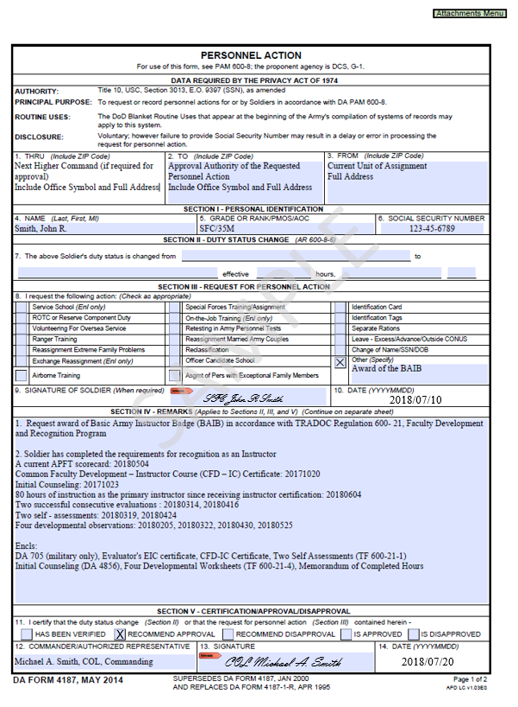

Figure C-1. DA Form 4187

Table C-1.

DA Form 4187 Instructions

|  |  |
| --- | --- |
| **4187 Basic Badge Instructions** | |
| **Section** | **Entry Requirements** |
| III-8 | Choose other: Award of BAIB |
| IV | 1. Request award of Basic Army Instructor Badge (BAIB) IN ACCORDANCE WITH TR 600- 21, Faculty Development and Recognition Program  2. Soldier has completed the requirements for recognition as an Instructor A current APFT scorecard (DA Form 705): yyyy/mm/dd (military only) Completed CFD-IC Certificate: yyyy/mm/dd Initial Counseling: yyyy/mm/dd Taught at least 80 hours of instruction as the primary instructor after completing TR 350-70 instructor certification requirements: yyyy/mm/dd Two successful consecutive evaluations : yyyy/mm/dd, yyyy/mm/dd Two self - assessments: yyyy/mm/dd, yyyy/mm/dd Four Developmental Observations: yyyy/mm/dd, yyyy/mm/dd, yyyy/mm/dd, yyyy/mm/dd  Encls:  DA 705 (military only) CFD-IC Certificate Initial Counseling (DA 4856) Memorandum of Hours Evaluator's EIC certificate Two Self Assessments (TF 600-21-1) Two Observation Rubrics (TF 600-21-1) Four Developmental Worksheets (TF 600-21-4) |

**Table C-1.**

**DA Form 4187 Instructions, continued**

|  |  |
| --- | --- |
| **4187 Senior Badge Instructions** | |
| **Section** | **Entry Requirements** |
| III-8 | Choose other: Award of SAIB |
| IV | 1. Request award of Senior Army Instructor Badge (SAIB) IN ACCORDANCE WITH TR 600- 21, Faculty Development and Recognition Program   2. Soldier has served a minimum of 12 months after BAIB packet submission: yyyy/mm/dd A current APFT scorecard (DA Form 705): yyyy/mm/dd (military only) IDBC Certificate: yyyy/mm/dd Lesson Redesign certificate: yyyy/mm/dd EIC, Certificate: yyyy/mm/dd Successfully taught at least 200 hours of instruction as the primary instructor after submission of BAIB packet (280 total hours): yyyy/mm/dd Three successful consecutive evaluations: yyyy/mm/dd, yyyy/mm/dd, yyyy/mm/dd, yyyy/mm/dd Three self - assessments: yyyy/mm/dd, yyyy/mm/dd, yyyy/mm/dd, yyyy/mm/dd Three Developmental Observation Worksheets: yyyy/mm/dd, yyyy/mm/dd, yyyy/mm/dd   Encls:  DA Form 705 (military only) IDBC Certificate Lesson Redesign Certificate Two EIC Certificates (evaluator and nominee)  Memorandum of Hours Three Self Assessments (TF 600-21-1) Three Observation Rubrics (TF 600-21-1) Three Developmental Worksheets (TF 600-21-4) |

**Table C-1.**

**DA Form 4187 Instructions, continued**

|  |  |
| --- | --- |
| **4187 Master Badge Instructions** | |
| **Section** | **Entry Requirements** |
| III-8 | Choose other: Award of MAIB |
| IV | 1. Request award of Master Army Instructor Badge (MAIB) IN ACCORDANCE WITH TR 600- 21, Faculty Development and Recognition Program   2. A current APFT scorecard (DA Form 705): yyyy/mm/dd (military only) Soldier has served a minimum of a minimum of 24 months after submitting SAIB: yyyy/mm/dd Successfully taught at least 200 hours of instruction as the primary instructor after submission of the SAIB packet: yyyy/mm/dd Three successful consecutive evaluations: yyyy/mm/dd Three self - assessments: yyyy/mm/dd Four EIC evaluations, conducted by applicant: yyyy/mm/dd Recommendation letter by members of the MISB: yyyy/mm/dd  Encls:  DA 705 (military only) Memorandum of Hours Evaluator's EIC certificate Three Observation Rubrics: (TF 600-21-1) Three Self Assessments (TF 600-21-1) Four EIC evaluations, (conducted by applicant) (TF 600-21-1) MISB board Recommendation (TF 600-21-3) |

Table C-2.

Instructor Recognition Checklists

|  |  |  |  |  |
| --- | --- | --- | --- | --- |
| Basic Army Instructor Badge Checklist | | | | |
| **Task** | **Date of Completion** | | **Verifier's Initials** | |
| CFD-IC Certificate |  |  |  |  |
| Completed all local instructor certification requirements |  |  |  |  |
| Completed Initial Counseling DA 4856 |  |  |  |  |
| Current APFT DA 705 (military only) |  |  |  |  |
| Memorandum demonstrating 80 successful hours as a primary instructor |  |  |  |  |
| Evaluator’s EIC certificate |  |  |  |  |
| **Two evaluations (TF 600-21-1), must be consecutive with minimum score of 12** |  |  |  |  |
| 1- TF 600-21-1 |  |  |  |  |
| 2- TF 600-21-1 |  |  |  |  |
| **Two Self Assessments (TF 600-21-1)** |  |  |  |  |
| 1-TF 600-21-1 |  |  |  |  |
| 2-TF 600-21-1 |  |  |  |  |
| **Four Developmental Observation Worksheets (TF 600-21-4)** |  |  |  |  |
| 1 (TF 600-21-4) |  |  |  |  |
| 2 (TF 600-21-4) |  |  |  |  |
| 3 (TF 600-21-4) |  |  |  |  |
| 4 (TF 600-21-4) |  |  |  |  |

**Table C-2.**

**Instructor Recognition Checklists, continued**

|  |  |  |  |  |
| --- | --- | --- | --- | --- |
| Senior Army Instructor Badge Checklist | | | | |
| **Task** | **Date of Completion** | | **Verifier's Initials** | |
| Current APFT DA 705 (military only) |  | |  | |
| Have served a minimum of 12 months (after BAIB packet submission) |  |  |  |  |
| Memorandum showing successfully taught at least 200 hours as PI (after BAIB submission) |  |  |  |  |
| IDBC Certificate and lesson redesign Certificate |  |  |  |  |
| EIC Certificate |  |  |  |  |
| Evaluator's EIC Certificate |  |  |  |  |
| **Three evaluations (TF 600-21-1), must be consecutive with minimum score of 16** |  |  |  |  |
| 1- TF 600-21-1 |  |  |  |  |
| 2- TF 600-21-1 |  |  |  |  |
| 3- TF 600-21-1 |  |  |  |  |
| **Three Self Assessments (TF 600-21-1)** |  | | | |
| 1-TF 600-21-1 |  |  |  |  |
| 2-TF 600-21-1 |  |  |  |  |
| 3-TF 600-21-1 |  |  |  |  |
| **Three Developmental Observations Worksheets TF 600-21-6** |  |  |  |  |
| 1 TF 600-21-4 |  |  |  |  |
| 2 TF 600-21-4 |  |  |  |  |
| 3 TF 600-21-4 |  |  |  |  |
|  |  |  |  |  |

**Table C-2.**

**Instructor Recognition Checklists, continued**

|  |  |  |  |  |
| --- | --- | --- | --- | --- |
| Master Army Instructor Badge Checklist | | | | |
|  | | | | |
| **Task** | **Date of Completion** | | **Verifier's Initials** | |
| Current APFT DA 705 (military only) |  | |  | |
| Have served a minimum of 24 months as a Senior Army Instructor (after SAIB submission) |  |  |  |  |
| Memorandum showing successfully taught at least 200 hours as PI (after SAIB submission) |  |  |  |  |
| Evaluator's EIC Certificate |  |  |  |  |
| **Three evaluations (TF**  **600-21-1), must be consecutive with minimum score of 20** |  |  |  |  |
| 1- TF 600-21-1 |  |  |  |  |
| 2- TF 600-21-1 |  |  |  |  |
| 3- TF 600-21-1 |  |  |  |  |
| **Three Self Assessments (TF 600-21-1)** |  |  |  |  |
| 1-TF 600-21-1 |  |  |  |  |
| 2-TF 600-21-1 |  |  |  |  |
| 3-TF 600-21-1 |  |  |  |  |
| **Four EIC evaluations, conducted by applicant (TF 600-21-1)** |  |  |  |  |
| 1 (TF 600-21-1) |  |  |  |  |
| 2 (TF 600-21-1) |  |  |  |  |
| 3 (TF 600-21-1) |  |  |  |  |
| 4 (TF 600-21-1) |  |  |  |  |
| Recommendation letter by members of the MISB (TF 600-21-3) |  |  |  |  |

# Appendix D

# Instructor Observation Rubric, TRADOC Form (TF) 600-21-1

To accommodate the requirements of the International Board of Standards for Training, Performance, and Instruction (ibstpi) Copyright and Permissions User Agreement, Appendix D and its associated TF 600-21-1 are located at the [TED-T](https://atn.army.mil/TreeViewCStab.aspx?loadTierID=3961&docID=35) web site.

# Appendix E

# MISB Materials

**E-1. Instructions in support of TF 600-21-2, Master Instructor Selection Board Member Appraisal Worksheet**

TF 600-21-2 is used by each voting member to record their score for each candidate at the MISB indicate whether the candidate is recommended/not recommended for recognition at the master instructor level. Instructions for filling out the form are below:

**Section 1. Administrative Data**

Item 1.a: Enter the master instructor candidate’s name (Last, First, MI).

Item 1.b: Enter the master instructor candidate’s rank/grade.

Item 1.c: Enter the training school/institution name. Item 1.d: Enter the training school/institution location.

Item 1.e: Enter the board member’s name (Last, First, MI).

**Section 2. Board Interview and Evaluation Points Awarded.**

Items 2.a-2.c: Each voting member will score the candidate in areas (2.a, 2.b, and 2.c) by entering a numerical number (1-20) in the appropriate column in section 2.

Items 2.d: Each voting member will evaluate the candidate’s knowledge of instructor domain/competencies (the competencies are categorized into five domains: (1) Professional Development; (2) Planning and Preparation; (3) Instructional Methods and Strategies; (4) Assessment and Evaluation; and (5) Management. Each voting member will ask, at a minimum, three specific question related to assigned domain/competency and enter a numerical score in area 2.d (1-40) points in the appropriate column.

Item 2.e: Each voting member will tally the total points awarded to the candidate, and enter the sum in “total points” column.

**Section 3. Recommendations.**

Items 3.a: Each voting member indicates whether they recommend/not recommend the candidate for Master Instructor recognition and badging level.

Item 3.b: Remarks. This is an optional field for each voting member to annotate comments specific to their ratings, as needed.

**Section 4. TF 600-21 Signature Authority and Date.**

Item 4.a: Voting board member signature (blue ink or digitally signed).

Item 4.b: Date (enter the date of the MISB).

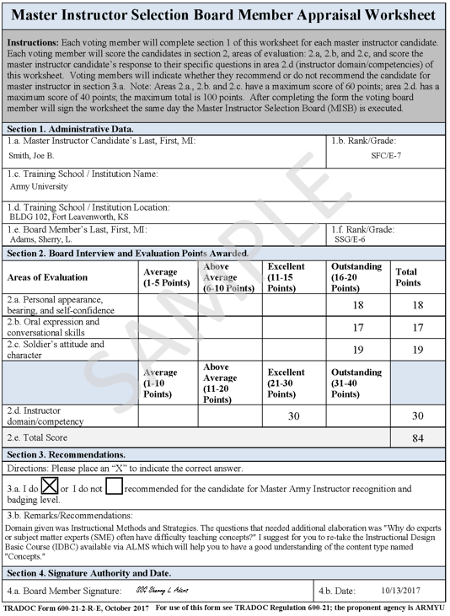

Figure E-1. TF 600-21-2

**E-2. Master Instructor Selection Board Sample Questions**

Sample Questions. The five domains, their related competencies, and some sample questions for each domain are provided below for your use. These questions are not an exhaustive list; rather they are to assist board members in developing questions. Further, the third domain, instructional methods and strategies, has the greatest number of competencies associated with the domain and board members may want to ask more questions in this domain. Board members may also want to review the instructor competencies and outcomes at the master instructor level (Note: reference the ibstpi Competency and Outcomes Matrix, see appendix D). During the MISB, members will ask at a minimum three questions per domain.

# 

Table E-1.

Sample Questions for MISB

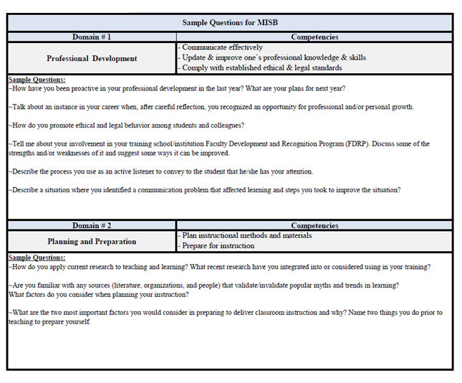

**Table E-1.**

**Sample Questions for MISB, continued**

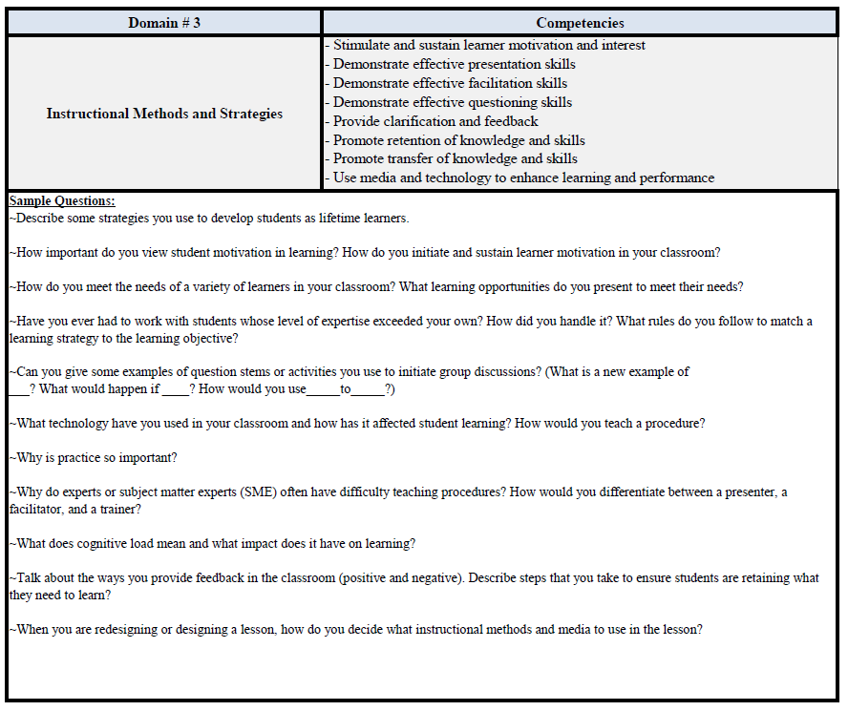

**Table E-1.**

**Sample Questions for MISB, continued**

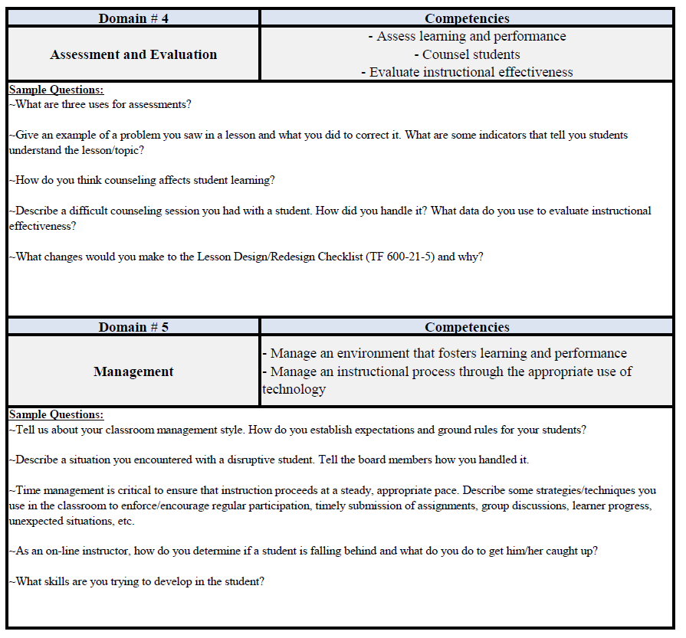

**E-3. Instructions for TF 600-21-3, Master Instructor Selection Board Recommendations**

Use TF 600-21-3 to record senior instructor’s performance at the MISB and indicate whether the candidate is recommended /not recommended for the master Army instructor recognition. Instructions for filling out the form are below:

**Section 1. Administrative Data**

Item 1.a: Enter the master instructor candidate’s name (Last, First, MI).

Item 1.b: Enter the master instructor candidate’s rank/grade.

Item 1.c: Enter the training school/institution name.

Item 1.d: Enter the training school/institution location.

**Section 2. Voting Board Members and Scores**

Item 2.a: (1-6). Enter voting board members name (Rank, Last, First, MI).

Item 2.b: Ensure each voting board member listed in item 2.a is assigned a domain.

Item 2.c: Using each of the appraisal worksheets, indicate whether the voting board member recommended the candidate for recognition at the master instructor level or not.

Item 2.d-2.e: Using each of the master instructor selection board member’s appraisal worksheets record the points each voting board member awarded in areas 2.d.1, 2.d.2, 2.d.3, and 2.d.4. Add the number of points awarded by each voting board member (columns 2.d.1., 2.d.2, 2.d.3 and 2.d.4) and enter the sum in column 2.e (totals) for each voting board member).

Item 2.f: Add all of the voting board members scores together (from column 2.e) and enter the total in (item 2.f) total board points.

Item 2.g: Divide the total board points (item 2.f) by the number of voting board member(s) (item 2.a) to calculate average points awarded (Item 2.g).

**Section 3: Recorders Administrative Information**

Item 3.a: Type/Print the recorder’s name (Last, First, MI) Item 3.b: Recorder’s rank/grade.

Item 3.c: Recorder’s signature (blue ink or digitally signed).

Item 3.d: Date of the MISB (Note: TF 600-21-3, must be completed, signed, and dated, the same day of the board execution).

**Section 4: TF 600-21-3, President of the Board Recommendation/s, Signature and Date**

Item 4.a: President of the board indicates whether the candidate is or is not recommended for the Master Army Instructor recognition and badging level by the voting board members.

Item 4.b: Signature of MISB president (or digitally signed).

Item 4.c: Enter the date of signature (Note: TF 600-21-3, must be completed, signed, and dated, the same day of the board).

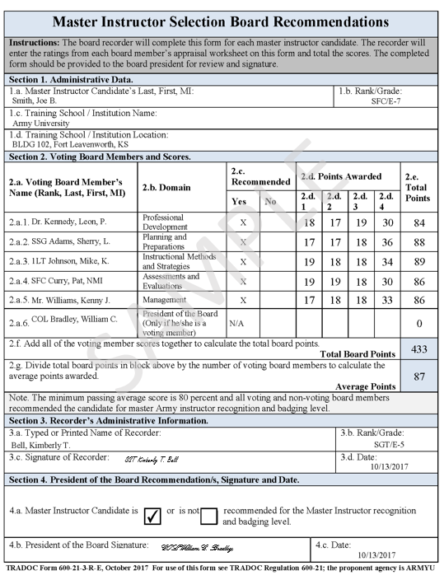

Figure E-2. TF 600-21-3

# Appendix F

# Lesson Design / Redesign Checklist, TRADOC Form (TF) 600-21-5

The purpose of the Lesson Design/Redesign project is for instructors to use a single lesson from a current and validated school/institution training support package (TSP) to meet the FDRP Lesson Design/Redesign requirement for award of the SAIB. The proposed design/redesign submitted for review, is compared to the current lesson plan (if applicable). Lesson Design/Redesign raters will evaluate the drafted lesson for its use of evidenced-based instructional design strategies, and principles. Instructors seeking the senior recognition and badging level must first complete the online or face-to-face IDBC. Lessons submitted for evaluation are reviewed using this checklist. This checklist is divided into four sections consisting of: (1) administrative information, (2) checklist, (3) score and recommendations, and (4) signature and date. Instructions for filling out the form are below:

**Section 1: Administrative data.**

Item 1.a: Enter the Instructor’s rank/last/first/middle initial.

Item 1.b: Enter lesson title in accordance with the training school/institution TSP.

Item 1.c: Enter the Lesson Design/Redesign rater’s name/last/first/middle initial.

Item 1.d: Enter the Lesson Design/Redesign rater’s rank or series position.

**Section 2: Checklist.**

Section 2 contains the content in support of the Lesson Design/Redesign project and is separated into five domains:

a. Domain # 1: Instructional Media Selection.

b. Domain # 2: Evaluating Lesson Introductions.

c. Domain # 3. Evaluating Conceptual, Process, and Procedural Knowledge Design.

d. Domain # 4. Practice, Feedback, and Assessment Design.

e. Domain # 5. Evaluating Lesson Summaries.

The five domains are comprised of 39 rating areas.

**Section 3: Total score and rater recommendations.**

Item 3.a: Total number of ratings evaluated ‘GO’, ‘NO GO’, or ‘N/A’ (Note: All of the 39 rating areas on the checklist will not apply to every lesson; however, no more than five (5) rating areas can be not applicable (N/A).

Item 3.b: A score is computed by dividing the number of rating areas rated as ‘GO’ by the total number of rating areas evaluated. Instructors seeking the SAIB must score at least 80 percent.

Item 3.c: The lesson design/redesign rater will provide instructor with remarks and recommendations to improve the lesson redesign. If the instructor fails to achieve 80 percent, the instructor will make corrections for immediate resubmission.

**Section 4:** Lesson design/redesign signature and date (YYYY/MM/DD) (ink or digitally signed).

Items 4.a. – 4.b: Lesson Design/Redesign rater signs/dates (YYYY/MM/DD) checklist (Note: the rater will sign the form regardless of whether or not the instructor receives a passing score (80% or more or not) (ink or digitally signed).

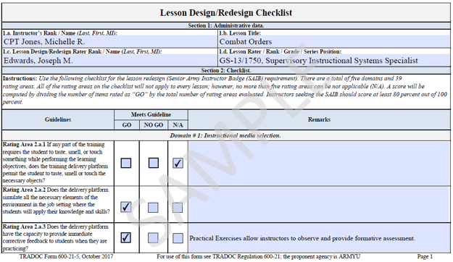

Figure F-1. TF 600-21-5

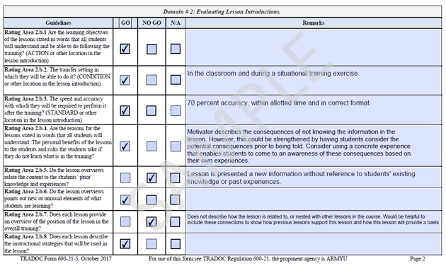

**Figure F-1. TF 600-21-5, continued**

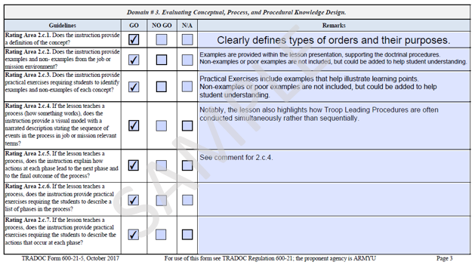

**Figure F-1. TF 600-21-5, continued**

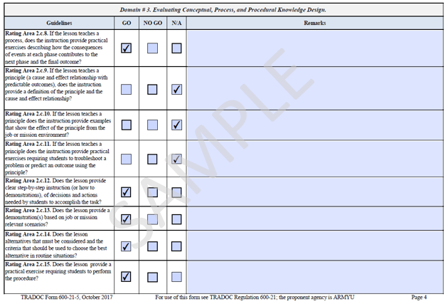

**Figure F-1. TF 600-21-5, continued**

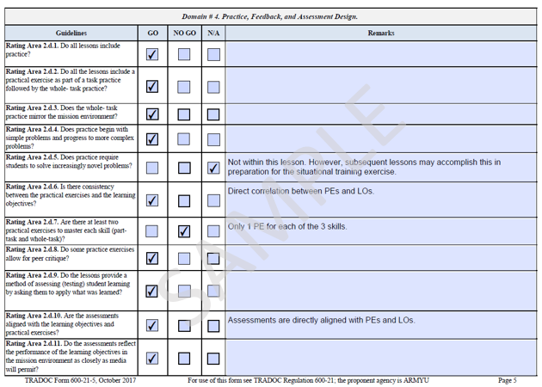

**Figure F-1. TF 600-21-5, continued**

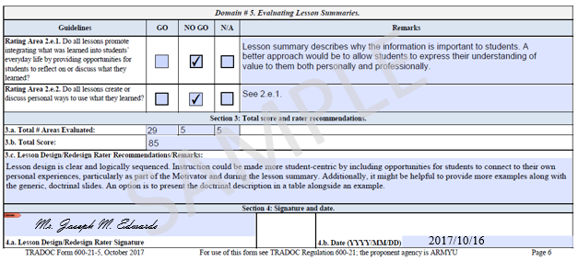

**Figure F-1. TF 600-21-5, continued**

# Appendix G

# Developmental Observation Worksheet

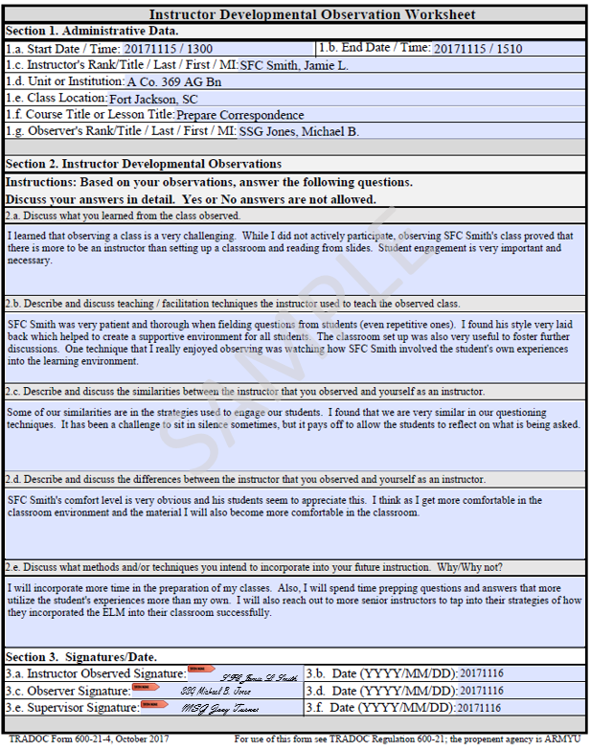

Figure G-1. TF 600-21-4

# Glossary

**Section I**

**Abbreviations**

AIB Army Instructor Badge

ANSI American National Standards Institute

APFT Army Physical Fitness Test

AR Army Regulation

ArmyU Army University

BAIB Basic Army Instructor Badge

CFD-IC Common Faculty Development – Instructor Course

CP Career Program

DA Department of the Army

EIC Evaluating Instructor Course

ELO Enabling Learning Objective

FDRP Faculty Development and Recognition Program

FSDD Faculty Staff Development Division

ibstpi International Board of Standards for Training, Performance and Instruction

IDBC Instructional Design Basic Course

MAIB Master Army Instructor Badge

MFR memorandum for record

MISB Master Instructor Selection Board

PI Primary Instructor

SAIB Senior Army Instructor Badge

TED-T Training & Education Developer - Toolbox

TF TRADOC Form

TLO Terminal Learning Objective

TR TRADOC Regulation

TSP Training Support Package

TRADOC United States Army Training and Doctrine Command

**Section II**

**Terms**

**Adult Learning**

Understanding differences teaching across all age groups, and relating the characteristics of adult learners to planning instruction.

**After Action Reviews (AARs)**

At the end of every training event or major block/module of instruction, AARs are conducted in order to improve and continually refine learning products. The type of AAR used in the FDRP is an informal AAR (Leaders Guide to After Action Reviews or TRADOC Pamphlet 350-70-3).

**Blended setting**

Blended setting is an integrated instructional approach that combines face-to-face classroom methods with technology delivered instruction provided in either a resident or nonresident environment. Blended setting includes both adaptive and learner-centric learning properties. The setting is adaptive in that it transforms the learner from a passive participant to an involved collaborator by leveraging technology to support collaboration. Additionally, the setting is learner-centric in that it uses instructional strategies that include learner-centered methods of instruction.

**Certificate Program**

A certificate program is a training program established by an agency to provide structured training course(s) to employees to meet an identified performance and developmental need.

Certificate programs award certificates after a course of study has been completed and does not generally require exhibited skill level. The certificate documents completion of the training. Successful completion of an end-of-program assessment is not a requirement for obtaining the

certificate.

**Certification Program**

A certificate program is a training program established by an agency to provide structured training course(s) to employees to meet an identified performance and developmental need.

Certificate programs award certificates after a course of study has been completed and does not generally require exhibited skill level. The certificate documents completion of the training. Successful completion of an end-of-program assessment is not a requirement for obtaining the

certificate.

**Classroom hours**

Scheduled periods when students are in a designated place under the guidance of an instructor. Classroom hours normally consist of formal classroom sessions.

**Course critiques**

End-of-course critiques are issued to students to provide them with the opportunity to provide anonymous input to help improve the course.

**Course management plan (CMP)**

The course management plan is a document that provides course managers and instructors/facilitators the information required to manage and conduct the course. It is required for courses, phases, and modules. Its development starts upon completion and approval of the course design.

**Course roster**

The course roster is created and maintained by the designated Course Manager.

**Distributed Learning (DL)**

The delivery of standardized individual, collective, and self-development training to Soldiers, civilians, units, and organizations at the right place and time through the use of multiple means and technology. Distributed learning may involve student-instructor interaction in real time (synchronous) and non-real time (asynchronous). It may also involve self-paced student instruction without benefit of an instructor.

**Enabling learning objective (ELO)**

A learning objective that supports the TLO. It must be learned or accomplished to learn or accomplish the TLO. It consists of an action, condition, and standard. Enabling objectives are identified when designing the lesson. ELOs are optional. When ELOs are used, there must be a minimum of two.

**Evaluating Instructor Course (EIC) Evaluator**

EIC certified personnel who are required to evaluate instructors using TF 600-21-1.

**Face-to-Face educational setting**

Include classroom and professional development situations such as evaluations. Furthermore, negotiating between instructors and evaluators can be conducted efficiently. A face-to-face evaluation setting allows the same message to be delivered to instructors who can then ask for clarification and listen to each other’s responses.

**Instructor professional development**

The development of an instructor is a continuous process focused on improving performance and building skills. It includes both formal and informal instruction, internal and external learning opportunities, professional development programs, performance assessments, developmental counseling, and recognition and awards.

**Learner-Centric**

Learner-centric learning is the process whereby the learner is able to create his or her own learning by appropriating and then implementing solutions to suit their own needs. The Army’s Learning Concept for Training and Education 2020-2040 (TP 525-8-2) learner-centric learning environment is characterized as a career-long learning process supported by instructors, facilitators, coaches, and mentors, and includes a composite of resources that support learner-centric learning.

**Lesson**

The basic building block of all training. The level at which training is designed in detail. The lesson is structured to facilitate learning. A lesson normally includes telling or showing the Soldiers what to do and how to do it, an opportunity for the Soldiers to practice, and providing the Soldiers feedback concerning their performance. For the purpose of FDRP, a lesson may take the form of an instructor presented lesson and/or a SGI-presented lesson.

**Primary instructor (PI)**

A PI is a single instructor who meets the qualification standards established in TR 350-70 and is responsible for reaching the learning objective.

**Program of instruction**

A program of instruction covers a course or phase. It is a requirements document that provides a general description of course content, duration of instruction, and methods and techniques of instruction. It lists resources required to conduct peacetime and mobilization training. Program of instruction: A document following a TRADOC format that contains:

a. The course administrative data.

b. The terminal learning objectives.

c. The units of instruction.

d. The duration of each unit and the enabling learning objectives.

**Proponent**

Army organization or agency assigned primary responsibility to analyze, design, develop, implement, and evaluate training, instructional materials, and training support products related to its doctrinal, combat, or logistical training responsibility and that is presented at one or more Army schools or training centers.

**Questioning Techniques**

Asking clear and pertinent questions relevant to the learning environment: ensuring questions from learners are answered and followed appropriately; using a variety of question types and levels for example, Ask, Pause, Call Evaluate Technique or Socratic Questioning Skills Technique.

**Self-assessment**

Self-assessment is a formative assessment strategy used to provide learners with the opportunity to identify their own strengths and weaknesses. Self-assessment occurs when learners evaluate the gap between their own performance and desired performance.

**Self-development**

A strategy that enables instructors to supplement their professional growth in the skills and competencies they need as leaders and technical specialists. Self-development is continuous and takes place during institutional instruction and the operational assignments.

**Skill**

The ability to perform a job-related activity that contributes to the effective performance of a task performance step.

**Technical Instructor**

An instructor not assigned as an instructor/writer but directly supports a Commandant’s academic mission, by teaching military occupational specialty specific courses.

**Terminal Learning Objective (TLO)**

The main objective of a lesson. It is the performance required of the student to demonstrate competency in the material. A TLO describes exactly what the student must be capable of performing under the stated conditions to the prescribed standard on lesson completion. There is only one TLO per lesson regardless of delivery technique or method of instruction and it has only one verb. The TLO may cover one critical task, part of a critical task (for example, a skill or knowledge), or more than one critical task. The TLO may be identical to the critical task, or there may be a disparity between them. Where there is a disparity, it is the TLO standard that the student must achieve to demonstrate competency for course completion. See learning objective and ELO.

**Training Support Package (TSP)**

A complete, exportable package integrating training products, materials, and information necessary to train one or more critical tasks. It may be very simple or complex. Its contents will vary depending on the training site and user. A TSP for individual training is a complete, exportable package integrating training products/materials necessary to train one or more individual critical tasks. A TSP for collective training is a package that is used to train critical collective and supporting individual critical tasks (including leader and battle staff).

**Transfer of Learning**

Facilitating transfer of learning by employing examples and activities, and providing opportunities to demonstrate application of knowledge or skill in realistic environments.

**Visitor’s Folder**

Participating FDRP instructors (if applicable) will have at least one visitor folder at a table or desk in the classroom or field training area. These folders will include, as a minimum:

a. Visitor sign-in log.

b. Class roster (ATRRS R2 report minus social security numbers (SSNs).

c. The current training schedule.

d. The course program of instruction/course management plan and current lesson plan.

e. Instructor credentials:

(1) Instructor certification certificate or a memorandum for record signed by the Commandant.

(2) Appropriate operator’s permit, as necessary.

(3) Instructor biography

f. Instructor Observation Rubric (TF 600-21-1)

g. Feedback/observation forms for class visitors.